**My First Android Project**

**Requirement:**

1. Find the GPS location of an android device. Write the co-ordinates to a text file
2. Identify the network connectivity of the android device. Write the result to a text file.
3. List all the apps that are installed on an android device. Write them to a text file.

**SOLUTION:**

**GPS LOCATION:**

The file **DisplayCoordinates.java** contains the source code for the implementation.

The opening screen of the app is as shown below.

**Screenshot 1 : App opening screen**

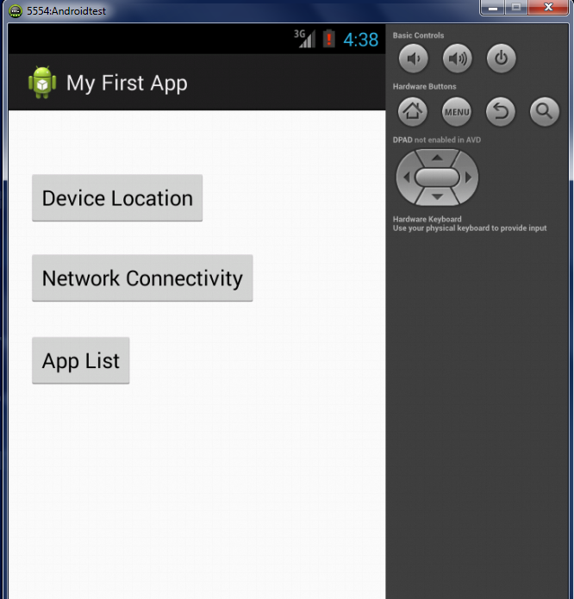

Clicking on “Device Location” will find the co-ordinates of the device and write it to the text file ‘Location_finder.txt’.

**Screenshot 2 : DisplayCoordinates screen**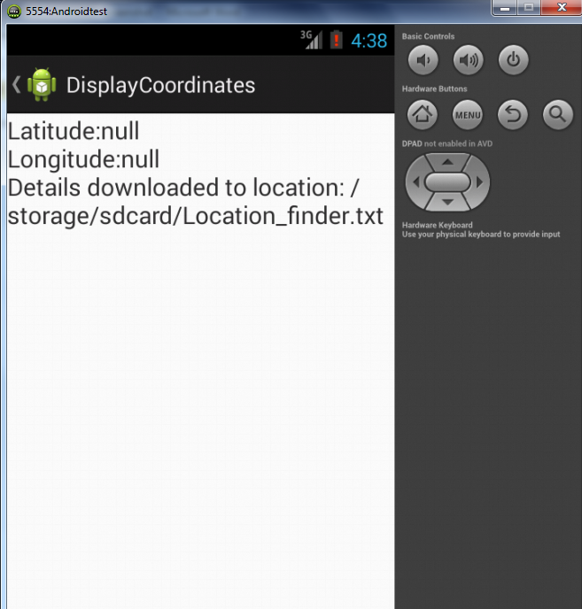

**NETWORK CONNECTIVITY:**

The network connectivity of the android device is displayed on clicking the Network Connectivity button. The following code segment finds out what is the connectivity of the device. Ethernet, Mobile and Wifi are coded here.

**public** **static** **int** getConnectivityStatus(Context context) {

// Find the Internet Connectivity the android device is using

ConnectivityManager cm = (ConnectivityManager) context

.getSystemService(Context.CONNECTIVITY_SERVICE);

NetworkInfo activeNetwork = cm.getActiveNetworkInfo();

**if** (**null** != activeNetwork) {

**if** (activeNetwork.getType() == ConnectivityManager.TYPE_WIFI)

**return** TYPE_WIFI;

**if** (activeNetwork.getType() == ConnectivityManager.TYPE_MOBILE)

**return** TYPE_MOBILE;

**if** (activeNetwork.getType() == ConnectivityManager.TYPE_ETHERNET)

**return** TYPE_ETHER;

}

**return** TYPE_NOT_CONNECTED;

}

Following is the screenshot when mobile connectivity was tested.

**Screenshot 4 : Network connectivity of the device**

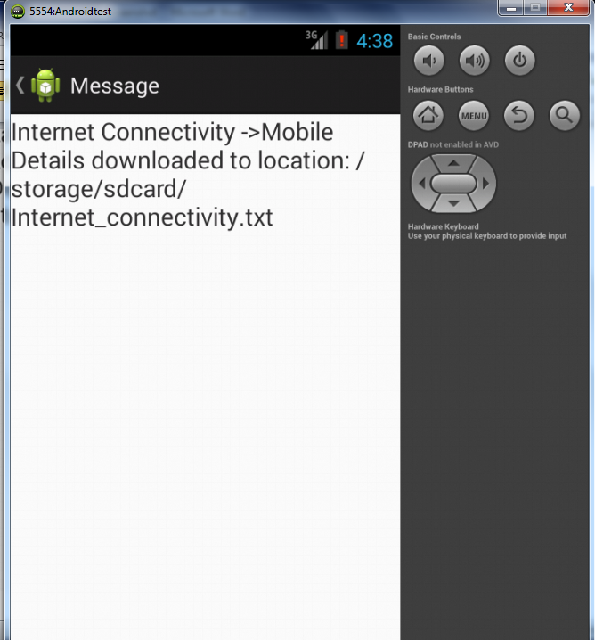

**INSTALLED APPS:**

The list of all apps installed (both system and user downloaded) will be written to the text file ‘Application_List.txt’.

The control goes from the main program MainActivity.java to the class DisplayMessageActivity in DisplayMessageActivity.java.

**Screenshot 3 : Application List page**

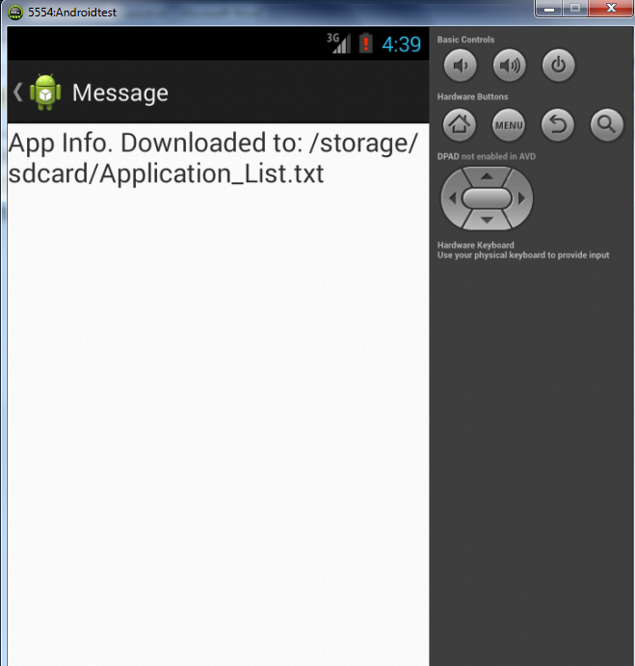

**Manifest File Permissions:**

The following code segment was added to the ‘AndroidManifest.xml’ to gain access to the information related to the connection manager and Location manager.

<uses-permission android:name=*"android.permission.WRITE_EXTERNAL_STORAGE"* />

    <uses-permission android:name=*"android.permission.ACCESS_NETWORK_STATE"* />

    <uses-permission android:name=*"android.permission.ACCESS_FINE_LOCATION"* />

    <uses-permission android:name=*"android.permission.ACCESS_COARSE_LOCATION"* />

    <uses-permission android:name=*"android.permission.INTERNET"* />