**Predicting 'Audience Rating' Project Documentation**

**1. Project Overview**

* **Project Title:** Predicting 'Audience Rating'
* **Objective:** Build a machine learning model to predict the 'audience_rating' from the given dataset.
* **Scope:**
  + Develop a pipeline for data preprocessing and model training.
  + Demonstrate the pipeline's functionality in a Google Colab or Jupyter notebook.
  + Validate the model’s performance and evaluate its accuracy.
* **Key Outcomes:**
  + A validated machine learning model capable of predicting audience ratings.
  + Insights into the factors influencing audience ratings.

**2. Dataset Description**

* **Dataset Source:** Provided dataset (**Rotten_Tomatoes_Movies3.csv)**
* **Target Variable:** audience_rating
* **Features:**
  + Movie-related attributes (e.g., genres, cast, director).
  + Audience-specific metrics (e.g., reviews, demographic information).
  + Additional attributes (e.g., runtime, box office collections).
* **Data Characteristics:**
  + Total records:
  + 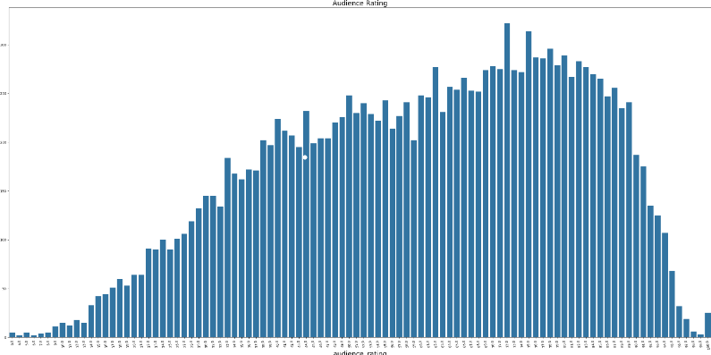Key insights:

**3. Problem Statement**

* Develop a machine learning pipeline to predict the audience_rating based on the given features.
* Ensure the model’s predictions are accurate and reliable for real-world applications.

**4. Methodology**

**Pipeline Steps:**

1. **Data Loading:** Import the dataset into the notebook and examine its structure.
2. **Data Preprocessing**:
   * Handle missing values using imputation techniques.
   * Encode categorical features using one-hot encoding or label encoding.
   * Normalize numerical features for consistent scaling.
3. **Exploratory Data Analysis (EDA):**
   * Visualize distributions and relationships between features and audience_rating.
   * Identify correlations and outliers.
4. **Feature Engineering:**
   * Select relevant features based on correlation and importance.
   * Perform dimensionality reduction if necessary.
5. **Model Training:**
   * Train multiple regression models (e.g., Random Forest, Gradient Boosting).
6. **Model Validation:**
   * Evaluate using metrics like Mean Squared Error (MSE), R-squared, and MAE.
7. **Hyperparameter Tuning:**
   * Optimize the model for improved accuracy and performance.

**5. Implementation**

* **Tools and Libraries:**
  + Python
  + Pandas, NumPy, Matplotlib, Seaborn for data handling and visualization.
  + Scikit-learn for preprocessing, model building, and evaluation.
* **Steps:**
  + Import the required libraries and load the dataset.
  + Perform data cleaning and preprocessing.
  + Visualize key trends using Seaborn and Matplotlib.
  + Implement the machine learning pipeline.
  + Validate and optimize the model.

**6. Results**

* **Model Evaluation Metrics:**

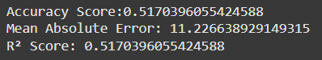

* **Best Model:** Gradient Boosting Regressor**.**

**7. Challenges and Solutions**

* **Handling Missing Data:**
  + **Challenge:** Missing values in critical columns.
  + **Solution:** Used mean/mode imputation for numerical and categorical variables.
* **Feature Selection:**
  + **Challenge:** High dimensionality of features.
  + **Solution:** Correlation analysis and feature importance rankings.
* **Overfitting:**
  + **Challenge:** Complex models overfitting the training data.
  + **Solution:** Applied regularization and cross-validation.

**8. Future Scope**

* **Model Enhancement:**
  + Explore deep learning methods for further accuracy improvements.
  + Incorporate external data sources for additional insights**.**
* **Real-World Application:**
  + Deploy the model as a web-based tool for predicting audience ratings.
  + Use the insights to recommend movies to target audiences.

**9. Conclusion**

* Successfully developed a machine learning pipeline to predict audience_rating.
* Demonstrated the pipeline in a notebook, ensuring clarity and reproducibility.
* Validated the model with appropriate metrics and achieved satisfactory accuracy.
* This model provides a foundation for real-world applications in movie analytics and recommendation systems.
* The performance of three regression models was evaluated, with the **Gradient Boosting Regressor** achieving the highest score of **0.5170**, indicating it best captured the patterns in the data.
* The **Support Vector Regressor** followed with a score of **0.4886**, slightly outperforming the **Random Forest Regressor**, which scored **0.4747**.
* This suggests that Gradient Boosting provided the most accurate predictions, while the Random Forest model showed the lowest performance.
* Overall, Gradient Boosting appears to be the most effective model for this dataset, though there may be opportunities to enhance performance further through hyperparameter tuning or additional techniques.