**Week-2 Assignment mlflow UI**

[Submitted by: Janany VB]

**Installing mlflow and required libraries**

**Loading Dataset and Perform basic EDA**

**Splitting the Dataset and building Classification model**

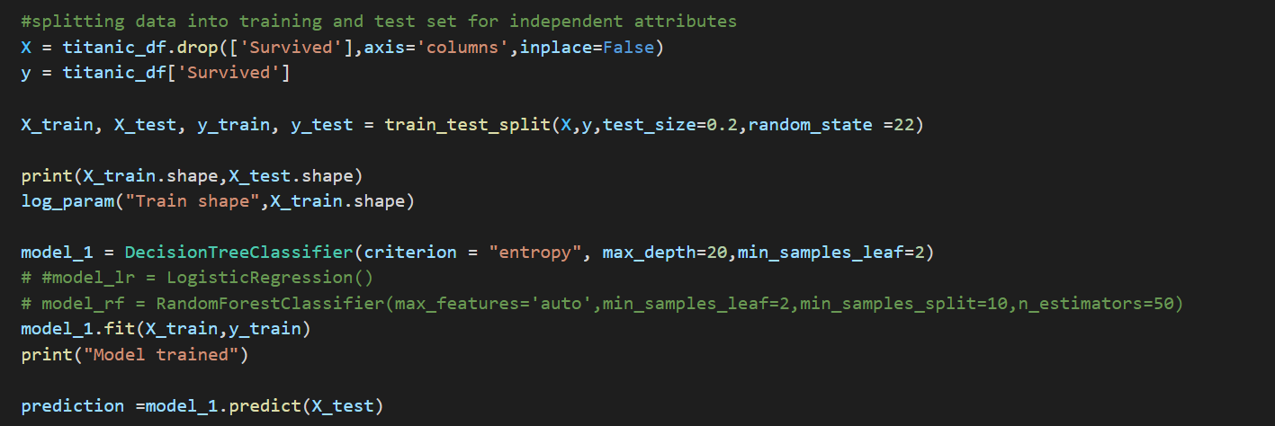

**Logging the Parameters and Metrics**

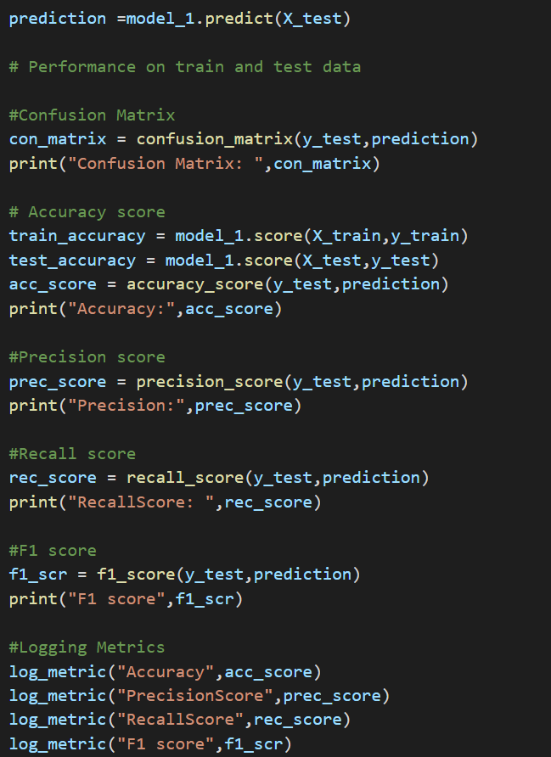

**Tracking the logged parameters in mlflow ui**

**Changing few parameters like train size and max_depth in DecisionTree model and tracking the changes in mlflow ui**

**Generating a model using Logistic Regression and tracking parameters**

**Generating a model using RandomForest Classifier and tracking parameters**

**

*Observation: Decision Tree classifier model performs better than other compared models for this data set.*

Thank you.