Testing different genomic selection scenarios in a small cattle population by simulation

J. Obšteter*, J. Jenko†, J. M. Hickey† & G. Gorjanc†

* Department of Animal Science, Agricultural Institute of Slovenia, Hacquetova ulica 17, 1000 Ljubljana, Slovenia
† The Roslin Institute and Royal (Dick) School of Veterinary Studies, The University of Edinburgh, Easter Bush, Midlothian, EH259RG, United Kingdom
cd
Jana Obšteter, Agricultural Institute of Slovenia, Department of Animal Science, Hacquetova ulica 17, 1000 Ljubljana, Slovenia
+386 1 280 51 34
jana.obsteter@kis.si (Corresponding Author)
Introduction (4000 characters words and spaces)
Genetic gain depends on four factors, namely accuracy, intensity, genetic variance for the trait and generation interval. With the exception of genetic variance, genomic selection (GS) can influence remaining three parameters. Choosing the parents based on their genomic breeding values (gEBVs) allows for an earlier selection compared to the conventional scenario, where the parents are chosen based on classical breeding values (EBVs) obtained after progeny testing. Genomic selection (GS) hence reduced the generation interval that together with a higher accuracy of early selection decisions increases the genetic gain (Schaeffer, 2006). However, the genomic prediction requires a large reference population. Consequently small cattle population encounter difficulties with implementation due to lacking financial resources (support?) and a small number of progeny tested reference bulls. The latter diminishes the gain in accuracy of genomic prediction compared with parent average estimates what in turn decreases the advantages of using genomic information (Thomasen et al,. 2014). Alternatively small cattle populations can participate in international associations for a joint genomic prediction with international reference population or they can include cows in the reference population. However, an information of a cow in the reference is not equal to the information of a progeny tested bull, therefore a larger number of cows has to be included to achieve desired accuracies (de Roos, 2011).

As mentioned, genomic selection can also reduce the generation interval. The degree of reduction depends on the strategy of using the genomic information in a breeding program: in which selection paths to use the genomic information and to what extent. Previous studies mainly tested the scenarios in which the genomic information is used either for a pre-selection of young bulls for progeny testing (so called GS-PS) or for the selection of genomically tested young bulls directly (so called turbo scheme) against the conventional scenario with progeny tested sires without the use of genomic information (Pryce et al., 2010; Lillehammer et al., 2011; de Roos et al., 2011). The studies observed that we can increase the genetic gain up to 30% by using genomic information for a pre-selection step and up to 195% by using genomic information directly for selection of young bulls and dams as parents (M=100%!!!, realistic – 40% → up to 108%).

Further on, Thomasen et al., 2014, deterministically explored hybrid schemes that simultaneously use both progeny tested and young genomically tested bulls which changes the generation to an intermediate degree. The study explored how varying the proportion of bull dams and cows mated with young / progeny tested sires affects annual monetary genetic gain (AMGG). They concluded that even in small populations, the genomic scenario was economically and genetically superior to the conventional scenario that uses progeny testes sires. However, with low reliabilities the hybrid scheme brought the higher AMGG whereas with high reliabilities the turbo scheme was the most superior (Thomasen et al., 2014).

In addition to maximising the genetic gain, breeding scheme have to manage genetic variation to assure long-term success and sustainability of selection (population). Balancing short- and long-term success of selection is crucial in breeding programs. While short-term success depends only on the genetic gain in the next (few) generation, long-term success enables increase of genetic gain after many generations of selection. Efficiency (of selection) measures how successful a specific scheme is in achieveing both goals. The latter can be measured by efficiency of converting genetic variance into genetic gain (Gorjanc et al., 2017).
The studies also focused onto how the use of genomic information affects inbreeding and obtained contradictory results. Some studies concluded that genomic selection results in a lower rate of inbreeding due to more accurate estimation of Mendelian sampling term – this results in lower co-selection of siblings that reduces inbreeding rate per generation. Although reducing the generation interval may increase annual genetic gain, managing inbreeding rate per generation in more important for avoiding inbreeding depression.

Problem and the aim
Although genomic selection is a well established technology globally, small population still struggle with the adoption of the technology. Contrary to other parameters of genomic selection, little work was done exploring how the use of genomic information in a breeding program affects genetic gain. Additionally, studies tend to overlook the long-term success of selection by not computing a common measure of genetic gain and genetic variance, stated here as the efficiency. LONG TERM, DETERMIISTIC; DISCRETE GENERATION, LARGE POPULATION. This study aimed to explore different strategies of the use of genomic information in order to determine the most efficient one in terms of genetic gain and genetic variance.
But the studies lack a common measure of genetic gain and genetic variance which provides insight into long-term success and sustainability of selection.

Material and Methods
First we developed a simulator of a realistic cattle population under selection which included all selection steps and allowed for the user to define all the selection parameters. We compared five sire selection scenarios in which we varied the criterion for the selection of bull and cow sires. Additionally we tested three sire use strategies with varying the number of bulls chosen each selection cycle and years kept in use. All tested scenarios were compared based on the achieved genetic gain, change (loss?) of genetic variance and efficiency of selection.

Simulator of a cattle breeding program
We have created a simulator of a realistic cattle populations under selection. The simulator was written as a Python wrapper around AlphaSim (Faux et al., 2016) and blupf90 (Misztal et al., 2002) software. The simulator enabled for the user to set all the selection parameters: the percentage of animals selected at each stage in each selection path, age at selection, selection criterion for each selection path, number of offspring per parent, years in use and number of selection cycles. The simulation was a continuous process resulting in overlapping generation. In each selection cycle three steps were performed: estimation of EBVs, selection of parents and mating. Breeding values were estimated as described below.
All the parameters in this study were set to mirror the Slovenian Brows Swiss population participating in milk recording consisting of ~30,000 active individuals - ~10,000 of which cows - with 8640 animals born each year, 8550 from cows and 90 from bull dams. Selection was performed based on single trait EBVs.

Genome consisted of ten chromosomes that included 20,000 SNPs from which 10,000 SNPs were chosen at QTNs for a polygenic trait with heritability of 0.25. The effects of the QTNs for each chromosome were drawn from a normal distribution.

Initially we simulated 20 generations of burn-in population. In the first 20 generations random mating was implemented. This was followed by 20 generations of conventional selection to achieve a population structure resembling a cattle population under selection. The last 20 generations implemented different testing scenarios that differed in the use of genomic information in the male selection paths only.

Estimation of breeding values
Breeding values were estimated using pedigree or single-step BLUP depending on whether the scenario used genomic information. We assumed a initial reference population of ~11,000 cows and 100 progeny tested sires for the genomic prediction. The reference population was updated each selection cycle by removing the oldest generation of cows from the reference and adding an equivalently large sample of cows from the currently active cow population to the reference. Each year all the bulls from the contracted mating were genotyped and added to the reference population.

Selection of females
Out of newborn females 1% was removed in their first year reflecting stillbirths and deaths occuring soon after birth. 90% of these female calves were inseminated in the second year and became cows in the third year. 20% of cows was removed progressing to a subsequent lactation and after the fourth lactation all cows were culled. This totaled to 10,653 cows active at a given moment from which 8550 were chosen to produce new generation of animals. All cows were screened for the trait and had their BV estimated. After the second completed lactation and estimation of BV, 43 cows with highest EBVs were chosen as bull dams. Bull dams were kept in use for three lactations, therefore completing five lactations in total. From 129 bull dams 90 were chosen each year for contracted mated with sires of sires to produce new generation of selection candidates.

Selection of sires
Sires were selected either based on progeny testing or genomic testing. Young bulls for progeny testing were pre-selected either based on the EBVs (which equal PA since they have no information) (CONV) or based on their gEBVs (GS-PS).

Each year we obtained 45 male offspring from contracted matings. The candidates either entered the progeny testing or genomic testing. Young bulls for progeny testing were pre-selected either based on the performance test and EBVs (which equal PA since they have no information) or based on their gEBVs (GS-PS).
a) performance testing - progeny testing: 60% (n=27) of male calves from contracted mating were randomly chosen for performance testing. The random choice reflects the realistic situation where the availability of male calves depends also on unpredictable human factors (where not all the best male calves are available for performance testing). In the second year 8/27 bulls were chosen for progeny testing. The non-chosen bulls were used in natural service as cow sires. After five years 4/8 progeny tested bulls were chosen as proven bulls.
b) genomic testing - progeny testing: all male calves from contracted mating were genomically tested in their first year. In the second year 8/45 bulls were chosen for progeny testing. The non-chosen bulls were used in natural service as cow sires. After five years 4/8 progeny tested bulls were chosen as proven bulls.
c) genomic testing: all male calves from contracted mating were genomically tested in their first year. In the second year 5/45 bulls were chosen as young sires. The non-chosen bulls were used in natural service as cow sires.

Tested scenarios
We tested five sire selection scenarios: one conventional and four genomic scenarios. The tested scenarios different in the criterion for the selection of sires only.
Table
PT | Sires of dams and sires of sires are progeny tested bulls (preselected for progeny testing based on their EBVs (PAs)).
GS-PS (preselection) | Sires of dams and sires of sires are progeny tested bulls (preselected for progeny testing based on their gEBVs).
GS-CS (cow sires) | Sires for the insemination of cows are young genomically tested bulls, sires for bull dams are GS-PT sires.
GS-BS (bull dam sires) | Sires for the insemination of bull dams are young genomically tested bulls, sires for cows are GS-PT sires.
GS | All sires are young genomically tested sires.

Sire use strategy
All five sire selection scenarios were tested within three sire use strategies. The original strategy reflected the situation in the simulated Slovenian Brown Swiss population where every year they selection five bulls and keep them in use for five years (SU 5/5). In the next strategy we increased the intensity of selection for which we selected only one bull per year and kept him in use for five years (SU1/5). We also created a strategy in which we reduced the generation interval even further by selecting five bulls each year and replacing them all in the next year, i.e. kept them in use for only one year (SU5/1).

Metrics of comparison
The scenarios were compared in terms of genetic gain per year (expressed with mean zero and in units of genetic standard deviation in the first generation of comparison) and efficiency averaged across 20 replicates. We defined the efficiency of selection as a regression of the achieved genetic gain on the amount of reduction of the genic standard deviation. We used the genic rather than the genetic standard deviation due to large fluctuations in the latter. When computing efficiency, both genetic gain and the genic standard deviation were standardised by the genic standard deviation in the first generation of comparison. Therefore, this efficiency metric indicates the potential genetic gain in units of genic standard deviation when all variation is converted into gain or lost due to drift. Results are presented as the mean of ten replicates for each scenario on a per generation or cumulative basis.

Results and Discussion
Genetic Gain

The results for the genetic gain is showed in Table 1. The numbers reflect the comparison of genetic gain in the last generation of comparison (generation 60). All the numbers are relative to the conventional scenario of the SU 5/5 strategy. As expected, the use genomic information increases the genetic gain in all sire use strategies. This is due to higher accuracy for selection of young unphenotyped animals and reduction in generation interval. It is interesting that in this particular population we can substantially increase the genetic gain (up to 44%) by using genomic information for pre-selection of male calves for progeny testing only – although the generation interval is not reduced. The increase is due to a higher accuracy of the pre-selection step, since gEBV are more accurate than PA. When we used gEBVs for immediate selection of sires of dams (Genomic B), we observed a reduction of 5% in generation interval and between 53 and 65% in genetic gain. Similarly, when we used genomic information for immediate selection of sires of sires (Genomic C) – while sires of dams remained progeny tested bulls – we reduced generation interval by 9% and increased the genetic gain between 61 and 69%. Lastly, the completely genomic scenario that used genomically tested bulls exclusively resulted in the highest reduction in generation interval (15%) and higher genetic gain with increase between 88 and 120%.

Increasing the intensity of selection and reducing the generation interval even further increased genetic gain. However, by comparing the three sire use strategies we observed, that (intensity 5 / 27 = 1.2664; 1/27 = 1.9962). although we implemented a severely intensive selection by selecting one bull only (increased the intensity of selection by 57%) in SU 1/5 strategy, we only observe up to 27% increase in genetic gain. In the SU 5/1 strategy the generation interval was reduced up to 39% compared to the corresponding scenarios in SU 5/5, the genetic gain was increased only up to 35%.

Table 1: Genetic gain of tested sire use strategies and sire selection scenarios averaged across 20 replicates. The genetic gain is expressed relative to the genetic gain of the conventional scenario in SU5/5 strategy.
 |  | Sire use strategies
 |  | SU5/5 | SU1/5 | SU5/1
Sire selection  scenario | Conventional | 100% | 122% | 101%
Sire selection  scenario | GS_PS | 136% | 144% | 133%
Sire selection  scenario | Genomic B | 153% | 162% | 165%
Sire selection  scenario | Genomic C | 160% | 161% | 169%
Sire selection  scenario | Genomic D | 188% | 208% | 220%

Genomic A = genomic information used for selection of young bulls for progeny testing, genomic B / C / D = genomically tested bulls used respectively as sires of dams / as sires of sires / as sires of dams and sires of sires. Sire use strategies: SU 5/5 = five bulls selected each year and used for five years, SU 1/5 = one bull selected each year and used for five years, SU 5/1 = five bulls selected each year and used for one year.

Genic variance

Here we report the results for genic variance due to large fluctuations of the genetic variation over the generations. The evolution of the genic variance for the tested scenarios is shown in Figure X. We notice that the strategy SU1/5 looses in general looses the most genic variance which is a consequence of the high selection pressure for sire selection in this strategy. Also, completely genomic scenario (Genomic D) looses the most genic variance in all sire use strategies. We attribute this to a faster turn-over of the generations.

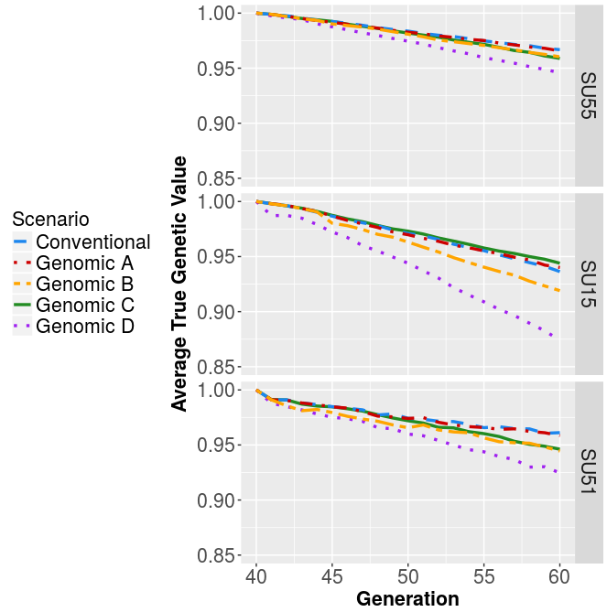
Figure: Genic variance for the five tested sire selection scenarios within the three sire use strategies averages across 20 replicates. Genomic A = genomic information used for selection of young bulls for progeny testing, genomic B / C / D = genomically tested bulls used respectively as sires of dams / as sires of sires / as sires of dams and sires of sires. Sire use strategies: SU 5/5 = five bulls selected each year and used for five years, SU 1/5 = one bull selected each year and used for five years, SU 5/1 = five bulls selected each year and used for one year.

Selection efficiencies

First we compared the selection efficiency between the five scenarios in the SU 5/5 strategy (Figure 1a). First we observe that the efficiencies do not follow the pattern of genetic gain. The differences between the scenarios are small and the efficiencies range between 71 and 100 (efficiency of e.g. 71 means that when we burn all the genetic variance we will reach genetic gain of 71 units). The conventional scenario was the least efficient one and the most comprehensive scenario was not the most efficient one. Only some of the differences were significant, i.e. between Genomic A, Genomic B and Genomic C with Conventional scenario with p-values of 0.00, 0.008 and 0.000, respectively. Additional significant differences were between Genomic C and D (p-value = 0.026) and between Genomic A and D (p-value = 0.048). Although not all differences are significant, the conventional scenario was the least efficient in 10 / 20 replicates and in other 10 / 20 it was the second least efficient. Completely genomic scenario was the most efficient only in 2 / 20 replicates.

The most efficient in SU 5/5 were genomic scenarios A and C, which were the most efficient in 7 / 20 and 6 / 20 replicates, respectively. We attribute that to a greater spread of sires EBV

Next we compared selection efficiency between the sire use strategies. Increasing the intensity of selection increased the differences between the scenarios (SU 1/5) which ranged from 39 to 68. The efficiencies were overall reduced compared to the SU 5/5 strategy which is due to a larger loss in genetic variance caused by selecting only bull per year (up to 7% larger loss in genic SD). The genomic scenario became the least efficient one due to the largest loss in genetic variability. We fixed this problem by selecting five bulls again in the SU 5/1 strategy. The plot of efficiencies in this strategy (Figure 1c) resembles more the one of the original SU 5/5 strategy (Figure 1a) since the differences between the scenarios are reduced. However, the efficiency is still reduced – ranged from 60 to 72 – due to larger loss in genetic variance (up to ). We attribute this to a 0.1 unit drop in accuracy compared to SU 5/5 strategy, which we believe is due to a larger genetic distance between the training and the testing population.

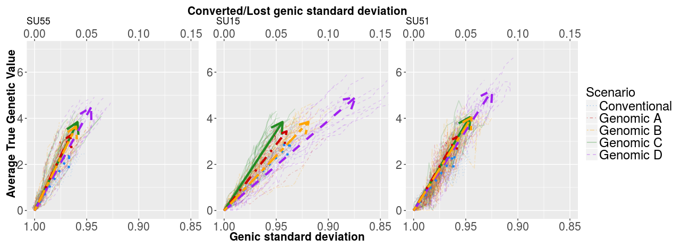

Figure: Change of genetic mean and genic standard deviation over the 20 years of selection

by sire selection scenario within sire use strategies averaged across ten replicates.

Arrows point the direction of change. Sire selection strategies: conventional = only progeny tested bulls (no genomic information), genomic A = genomic information used for selection of young bulls for progeny testing, genomic B / C / D = genomically tested bulls used respectively as sires of dams / as sires of sires / as sires of dams and sires of sires. Sire use strategies: SU 5/5 = five bulls selected each year and used for five years, SU 1/5 = one bull selected each year and used for five years, SU 5/1 = five bulls selected each year and used for one year.

Accuracy

