Interdisciplinary doctoral study program of Biosciences
Methodology of economic and social sciences in biosciences

Assignment: statistical analysis of a data on a private forest landowner dataset from two regions of the southeastern United States supplying wood for pellets exported to the EU.

Jana Obšteter, obsteter.jana@gmail.com

The subject of this research is a dataset obtained by surveying forest landowner from two regions of the southeastern United States supplying wood for pellets exported to the EU. The recorded variables included the information about the owner (age, sex, income), about their property (forest acreage, when did they obtain the land), about the importance of several factors for keeping the land (on the scale from not important to very important), the forest activites conducted in the last five years (1 for yes and 0 for no), activites plannes for the next five years (on the scale from very unlikely to very likely) and agreement with several statements regarding woody biomass.

Before the analysis all the 0 values for forest acreage, state and age were set to missing (NA). Also, values of 7 and 9 in the columns of dichotomous variables were set to missing.

1. First we inspected the distribution of forest acreage and age of owners. The “year of birth” variable was created by subtracting owners age from the year of the survey (2017).
Variable | Mean | Standard deviation | Minimum | Maximum
FOREARE [acres] | 541.0 | 2205.0 | 4.0 | 35,000.0
Year of birth | 1969 | 11.3 | 1918 | 1994
Table 1: The mean of forested acres owned by the pwners (FORAREA) and their year of birth.

2. Next we ran a regression of the forested acred by owners (FORAREA) onto the year in which they first acquired the forest area (FIRSTOWN).

For the ease of interpretation FIRSTOWN variable was transformed into »years owned« variables by substracting the FIRSTOWN from the year of the survey, i.e. 2017. We observed a positive (negative) regression coefficient for the »years owned« (FIRSTOWN) variable. This means that the more years they own the forest, the more forest they have (or the later they acquired the forest the less forest they have). The regression showed that for each additional year of ownership the owned area increased for 15.6 acres. The coefficient of “years owned” / FIRSTOWN is statistically significant with p-value of 0.000.

 | Estimate | Std. Error | t-value | Pr(>|t|)
Intercept | 31578.916 | 8152.476 | 3.874 | 0.000126
YEARSOWNED | 15.613 | 4.103 | 3.805 | 0.000164
Table 2: The output of a linear regression model of forest acreage onto “years owned”.
The R² of the model is 0.0356 – this mean that only ~3% of the variation in the dependent variable could be explained with the variation in the independent variable. The adjusted R², which also account for the complexity of the model, is even lower – i.e. 0.0332.

3. Next we ran a model:
FORARE ~ gen2 + KPBEAU + KPINV + KPHEIR + KPTIM + FTRAD + AGE + INCOME (model1)

; where gen2 - RESPONDENT IS 2ND GENERATION OF THEIR FAMILY TO OWN FORESTLAND, KPBEAU – importance of beauty/scenery for keeping the land, KPINV - importance of land investment for keeping the land, KPHEIR - importance of passing the land to heirs for keeping the land, KPTIM - importance of timber production for keeping the land, FTRAD – likelyhood od cutting / removing trees for sale of traditional wood products in the next five years, AGE – age of the owners, INCOME – income class.

a) The F-value of the model was 3.88 which tells us that the model as a whole is statistically significant (p=0.000). However, there is only one independent variable that reaches statistical significance – FTRAD (Table 3). This variable represents how likely the owners are to cut /and or remove trees for sale of traditional wood products in the next five years (1 – very unlikely, 5 – very likely). The coefficient for FTRAD is 203.3, which means the owners who are one degree more likely to cut / remove trees for sale of tradition wood products own on average 203.3 more acres of forest. Additionally, R² of the model is only 0.087 – that means that only 8.7% of variance in the forest acreage is explained by variation in all nine independent variables. The adjusted R² is 0.065 and is lower than R² due to many independent variables included in the model.
Variable | Coefficient | p-value
Distance | -0.00048 | 0.999
gen2 | 437.5 | 0.113
KPBEAU | 83.6 | 0.316
KPINV | 72.3 | 0.424
KPHEIR | -64.0 | 0.381
KPTIM | 10.4 | 0.221
FTRAD | 203.3 | 0.000***
AGE | 11.25 | 0.278
INCOME | 150.5 | 0.013*
Table 3: Regression coefficients and p-values of a regression model of forest acreage onto the listed independent variables.

b) Test for multicolinearity
We have computed the variance inflation factors for all independent variables (VIF).

Variable | VIF
Distance | 1.080
gen2 | 1.026
Beauty | 1.071
KPINV | 1.124
KPHEIR | 1.077
KPTIM | 1.186
FTRAD | 1.068
AGE | 1.050
INCOME | 1.071
Table 4: Variance inflation factors for the independent variables in the model1.

We see that all VIFs are around 0 with the highest one being for KPTIM and KPINV, i.e. 1.186 and 1.124, respectively (Table 4). However, none of these values suggest multicollinearity between the explanatory variables.

We also inspected the correlation between all pairs of independent variables (Figure 1). The correlation coefficients (Pearson) are shown in Figure 1 below. We observed that there are no correlations higher that 0.32 in absolute values between the pairs of variables. The highest correlation was between KPINV and KPTIM, that is the importance of timber products and land investment as factors for keeping the forest.
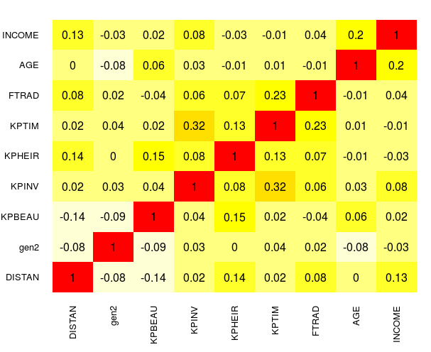
Figure 1: Pearson’s correlation coefficients for the independent variables in the model1.

Due to a slightly inflated VIF we removed KPINV from the models and observed the parameters of the reduced model. We observed no changes in the sign and significance of the regression coefficients and no major changes in R² (declines from 0.087 in the full model to 0.085 the reduced model). Therefore we conclude we do not have multicollinerality problems in our model.

c) Next we reran the regression with only significant variables. This model therefore included only FTRAD and INCOME as independent variables. The coefficients are shown in Table 5.

 | Estimate | Pr(>|t|)
FTRAD | 209.64 | 3.81e-05 ***
INCOME | 163.39 | 0.0039 **
Table 5: Regression coefficients and p-values of a regression model of forest acreage onto the listed independent variables.

The model is significant - F value of the model is 13.37 and the corresponding p-value is 0.000. The regression coefficients change slighty: from 203.3 to 209.6 for FTRAD and from 150.5 to 163.4 for INCOME. The exaplanatory power of the model decreses from original R² of 0.087 to 0.065 in this reduced model. However, the adjusted R² does not decline much – from 0.065 to 0.060. This suggests that the excluded variables contribute only a minor part to the explanatory power of the model.

4. In the last part we wanted to explore what factors influence whether a forest owner performed disease control in their own forest during the last five years. We also wanted to know whether those factors coincide with the factors influencing future disease control.

We ran a logistic regression model with the logit link and with disease control (DISEAS) in the past five years as a dependent variable.

model_log_full: DISEAS ~ AGE + YEARSOWNED + KPNAT + KPHEIR + KPTIM + KPBEAU + Q9CURR + Q9FUT + INVAS + BRUSH + INSECT + LEFT + PLAN + INCOME

The following independent variables were included in the model:
- age of the forest owner – this was included since older owners could be more experienced and aware of the importance of disease control – perhaps they have already had a bad experience
- years the owned the forest (YEARSOWNED) – the variable was included for a reason similar to age. It could be that owners that own the forest for longer have gained experience in forest managementprimeren
- importance of beauty / scenery for keeping the forest (KPBEAU) – it could be that owners that value the scenery of the forest more would be more willing to keep if healthy
- importance of nature protection and biological diversity for keeping the forest (KPNAT) – it could be that owners that appreciate biodiversity and want to protect nature would pay more attention to disease control since diseases can destroy trees as well as natural habitats and decrease diversity
- importance of passing the land to heirs to for keeping the forest (KPHEIR)– it could be assumed that owners wishing to pass down the land wish to keep it suitable for next generation use
- importance of producing timber product for keeping the forest (KPTIM) – it could be assumed that owners who want to use timber for further production want a lot of healthy wood
- whether (1/0) increasing current financial value of the land is important to the owner (Q9CURR) – diseases decrease the financial value of the forest
- whether (1/0) having future source of income is important to the owner (Q9FUT) – diseases could destroy the forest hence deplete the source of income
- whether (1/0) the owner has removed invasive plants during the past five years (INVAS) – it could be assumed that owners who remove invasive plants are more aware of the importance of forest health
- whether the owner has performed insect control in the past five years (INSECT) - it could be assumed that owners who perform insect control are more aware of the importance of forest health
- whether the owner has removed brush in the last five years (BRUSH) – it could be assumed that owners who remove brush pay special attention to the forest and are not concerned only with intensive timber production – are more dedicated to keeping the forest healthy
- in case the trees were cut /removed, did the owners left them in the woods where cut (LEFT) – it could be assumed that owners who leave the trees where cut are less concerned with the spread of diseases
- whether the owner has a written management plan for the forest (PLAN) – we could assume that owners with a management plan would manage the diseases better
- the income of the forest owner – it could be that higher income allow for a better diseases controlled

We first computed descriptive statistics of the independent variables. Here we are showing descriptive statistics for numerical (Table 6), categorical (Table 7 & 8) and binary variables separately (Table 9).
 | Mean | Median | Max | Min | Variance | SD
AGE | 48.25 | 47 | 99 | 23 | 128.74 | 11.35
YEARSOWNED | 30.21 | 27 | 262 | 0 | 745.2 | 27.3
Table 6: Descriptive statistics as the mean, median, maxima and minimum value, variance and standard deviation (SD) of numerical independent variables in the model_log.

 | Classes
 | Not important | Of little importance | Moderately important | Important | Very important | Median | Mode
KPBEAU | 0.03 | 0.07 | 0.17 | 0.26 | 0.41 | 4 | 5
KPHEIR | 0.05 | 0.06 | 0.15 | 0.27 | 0.39 | 4 | 5
KPNAT | 0.03 | 0.04 | 0.19 | 0.29 | 0.41 | 4 | 5
KPTIM | 0.06 | 0.07 | 0.15 | 0.26 | 0.41 | 4 | 5
Q9CURR | 0.02 | 0.08 | 0.17 | 0.27 | 0.41 | 4 | 5
Q9FUT | 0.05 | 0.07 | 0.19 | 0.27 | 0.38 | 4 | 5
Table 7: Descriptive statistics as the proportion of answers in classes “not important” to “very important”, the median and mode class of categorical independent variables in the model_log.

 | 1 | 2 | 3 | 4 | 5 | 6 | 7
INCOME | 0.05 | 0.18 | 0.14 | 0.13 | 0.07 | 0.22 | 0.15
Table 8: Descriptive statistics as the proportion of answers in income classes of categorical independent variables in the model_log. 1: < 30,000$, 2: 30,000 – 60,000$, 3: 60,000 – 90,000$, 4: 90,000 – 120,000$, 5: 120,000 – 150,000$, 6: > 150,000$, 7: prefer not to answer

 | Yes | No
INVAS | 0.23 | 0.77
BRUSH | 0.39 | 0.61
INSECT | 0.14 | 0.86
LEFT | 0.36 | 0.63
PLAN | 0.47 | 0.49
Table 9: Descriptive statistics as the the proportion of answers in yes (1) and no (0) of binary independent variables in the model_log.
Next we ran the regression model (model_log) and obtained the following coefficients and corresponding p-values from Wald’s test (Table 10). The variables that reach statistical significance are BRUSH and INSECT – indicating whether the owner removes the brushes and performed insect control in the past five years. These are all actions that improve the health of the forest and so is the disease control. We see that the exp(β) for the BRUSH is 4.16 which mean that the owners who removed brush are 3.17 more likely to have also performed disease control. Similarly, the owners who performed insect control are 32.3 more likely to have also performed the disease control in the last five years.

 | Coefficient | Exp coefficients | Wald’s p-value | VIF
AGE | -0.025 | 0.975 | 0.261 | 1.205
YEARSOWNED | -0.001 | 0.999 | 0.945 | 1.322
KPNAT | -0.381 | 0.683 | 0.291 | 2.906
KPHEIR | 0.124 | 1.132 | 0.604 | 1.339
KPTIM | 0.313 | 1.367 | 0.325 | 1.669
KPBEAU | 0.086 | 1.090 | 0.825 | 3.201
Q9CURR | -0.173 | 0.841 | 0.540 | 1.233
Q9FUT | 0.361 | 1.434 | 0.218 | 1.850
INVAS | -0.012 | 0.988 | 0.982 | 1.316
BRUSH | 1.426 | 4.161 | 0.017* | 1.426
INSECT | 3.503 | 33.221 | 0.000*** | 1.337
LEFT | 0.807 | 2.241 | 0.119 | 1.217
PLAN | -0.887 | 0.412 | 0.092 | 1.258
INCOME | 0.011 | 1.011 | 0.936 | 1.184
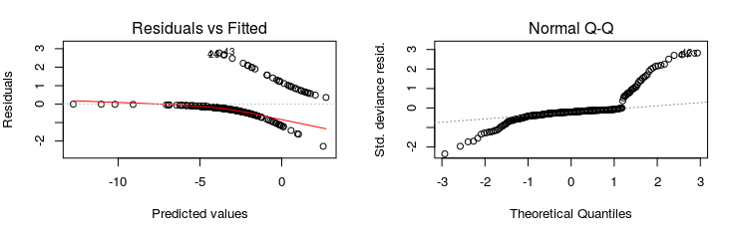
Table 10: The regression coefficients, expontents of regression coefficients, Wald’s p-values and variance inflation factors (VIF) for the independent variable in the model_log.
Figure 2: Quality plots for logistic regression of model_log.

We inspected R-provided plots of model fit. We see non-randomised errors in the residual vs. Fitted plot and a strong pattern indicating there is a class variable influencing the dependent variable. Also the Q-Q plot does not display a diagonal line – points fall of the corners – this indicated we have more extreme values in our data then

We ran likelihood ratio test for the logistic model as a whole and obtained a χ² of 154.7 with corresponding p-value of 0.000. This means the model as a whole is significant as compared to the null model. We also performed the so called Hosmer and Lemeshow goodness of fit test commonly used to evaluate the fit of logistic regression models. The Chi-square value from the test was 4.545 (on 10 degrees of freedom) and the corresponding p-value was 0.805. Since the test tests for the fitting NOT fitting the data, we therefore lack evidence that our model does not fit the data well. We also inspected the pseudo R² for the model. Here am I reporting the McFadden R² which is 0.551. The inrepretation of pseudo R² could be interpreted in the relative performance of the full model compared to the null model and can not be interpreted in the same way as in linear regression (the proportion of variance in the dependent variable explained).

We also tested for multicollinearity of the independent variables. We did so by first computing the VIFs of the independent variables (Table 10). By inspecting the VIF we see that no VIF exceeds value of 5. However, two of the variables – KPBEAU and KPNAT – have higher VIF that the other variables, i.e. 3.2 and 2.9 respectively.. We also inspected the correlation coefficients of all the independent variables (Figure 3).
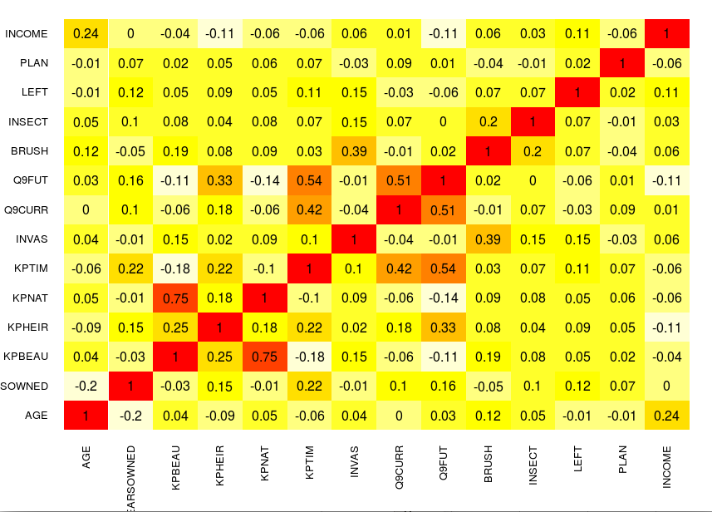
Figure 3: Pearson’s correlation coefficients for the independent variables in the model_log.

We observe a high correlation of 0.54 between variables KPTIM – the importance of the forest for timber production – and Q9FUT – the importance of having a future source of income. Also there is a high correlation of 0.54 of Q9FUT qith Q9CURR – the importance of increasing current financial value of the land. Additionaly a correlation of 0.42 was observed between Q9CURR and KPTIM. A moderate correlation was observed between Q9FUT and KPHEIR (the imprortnace of keeping the forest for passing it down to heirs), i.e. 0.33, between INVAS and BRUSH (0.39), between KPBEAU and KPHEIR (0.25), between INCOME and AGE (0.24), between KPHEIR and KPTIM and between KPTIM and YEARSOWNED.

Therefore we decided to remove Q9FUT and KPBEAU from the analysis and rerun the model:

model_log_reduced: DISEAS ~ AGE + YEARSOWNED + KPNAT + KPHEIR + KPTIM + Q9CURR + INVAS + BRUSH + INSECT + LEFT + PLAN + INCOME

We ran the likelihood-ratio test for the entire model and obtained the Chi-square value of 152.22 with corresponding p-value of 0.000. This means the model as a whole (compared to the null one) is significant. The Hoslem and Lemeshow goodness of fit test remains non-significant (Chi-squared = 2.450 p-value = 0.962), meaning that we lack evidence that the model does not fit the data.

The significance of the variables did not change in this reduced model, neither did the sign of the coefficients. The only significant variables remained BRUSH and INSECT – but their coefficients changed slightly. In this model a owner is 3.3 and 30.5 times more likely to have performed disease control if they have removed brushes or performed insect control, respectively.

Pseduo R2 – McFarrad R2 – decreased from 0.551 to 0.542. We wanted to know whether this difference between the full and this reduced model is significant. For this reason we performed a test for the significance of the difference in pseduo R2.. We did so by setting the reduced model as a null model – since the test always tests the performance of the full model against the null model this allowed us to compare the model performances. The McFadden pseudo R2 for the full again the null (reduced) model was 0.0196 and the LRT yielded a Chi-square of 2.52 with p-value of 0.284 – this means that the models are not significantly different from eachother and that we can not say that the full models has a higher R² and fits the data better.

However, we again inspected the VIFs of the model. We observe that the highest VIF in this model is 1.133 meaning that the VIFs are reduced compared to the full model.

Variable | Coefficient | exp(Coefficient) | p-value | VIF
AGE | -0.023 | 0.978 | 0.312 | 1.177
YEARSOWNED | 0.000 | 1.000 | 0.958 | 1.284
KPNAT | -0.318 | 0.727 | 0.162 | 1.182
KPHEIR | 0.246 | 1.280 | 0.281 | 1.201
KPTIM | 0.458 | 1.581 | 0.109 | 1.315
Q9CURR | -0.076 | 0.926 | 0.767 | 1.142
INVAS | -0.059 | 0.943 | 0.914 | 1.251
BRUSH | 1.462 | 4.313 | 0.012* | 1.364
INSECT | 3.452 | 31.553 | 0.000*** | 1.301
LEFT | 0.666 | 1.947 | 0.182 | 1.152
PLAN | -0.862 | 0.422 | 0.099 | 1.262
INCOME | 0.001 | 1.001 | 0.993 | 1.147
Table 10: The regression coefficients, expontents of regression coefficients, Wald’s p-values and variance inflation factors (VIF) for the independent variable in the model_log_reduced.

Lastly, we wanted to compare whether the same factors affect owners future intention for disease control. We ran a linear model with the likelihood that the owners will perform disease control in the future (FTREE) as a dependent variable:

model_lm: FTREE ~ AGE + YEARSOWNED + KPNAT + KPHEIR + KPTIM + Q9CURR + INVAS + BRUSH + INSECT + LEFT + PLAN + INCOME

The F-value of the regression was 3.82 with p-value 0.000 - hence the model is significant. The R² of the model was 0.137 and the adjusted R² was 0.102 which means that 13.7% of the variance in the dependent variable is explained by the variation in the independent variables. We observed that all the significant factors are the same as in logistic regression for past disease control (Table 11). Here the factors that reach significance are insect control, written management plan and the fact that owners leave cut wood at the site. All the factors have positive effect - that owners who have a written management plan, leave cut trees at the site and are one unit more likely to perform insect control are 0.78, 0.47 and 0.86 units more likely to perform disease control in the future. Also the VIFs in this model are not inflated with the highest VIF being 1.36 for KPTIM (Table 11).

Variable | Coefficient | P-value | VIF
AGE | 0.006 | 0.504 | 1.131
YEARSOWNED | 0.00152 | 0.7164 | 1.149
KPNAT | 0.0409 | 0.6824 | 1.097
KPHEIR | 0.00283 | 0.975 | 1.152
KPTIM | 0.0771 | 0.442 | 1.359
Q9CURR | -0.0449 | 0.680 | 1.261
INVAS | 0.149 | 0.555 | 1.249
BRUSH | 0.259 | 0.255 | 1.292
INSECT | 0.860 | 0.0025** | 1.093
LEFT | 0.474 | 0.0237* | 1.077
PLAN | 0.779 | 0.0002*** | 1.133
INCOME | 0.0103 | 0.849 | 1.103
Table 11: The regression coefficients, p-values and variance inflation factors (VIF) for the independent variable in the model_lm.

However, the model quality plots still suggest there is an underlying cause influencing the dependent variable (Figure 4). On the residual vs. fitted plot we see that a categorical variable in influencing the dependent variables since there is a pattern of six lines in the plot. The residuals are not distributed randomly. The Q-Q plot looks more promising now with the shape resembling a diagonal line a bit more then in the logistic regression.
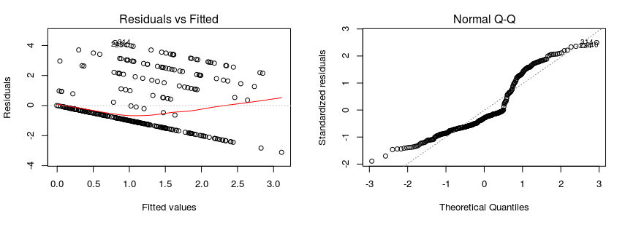
Figure 4: Quality plots for logistic regression of model_lm.

This exploratory research explored the factors that affect the past and future disease control by the forest owners. We observed that the factors that significantly affect the past and future disease control are not the all the same. A common significant factor was insect control which means that owners who have performed insect control in the past five years are more likely to have been performing disease control in the past five years as well as they are more likely to perform it in the next five years. As an important and highly significant factor for the future use disease control is whether the owners have a written management plan. One could assume that disease control is part of the plan and so the owners are more prone to performing it. We could also assume that the owners with a written management plan are more committed to and conscious about forest management.

The results show that logistic regression for the past disease control represents a good fit to the data. Contrary linear model for the future disease control does not have much explanatory power and the plots reveal there is still a categorical variables strongly affecting future disease control. Although this study represents a good base for future analysis of disease control, an expert knowledge about other influential factors in needed to improve the models.

