Genomic selection for any dairy breeding program via optimised investment in phenotyping and genotyping
Jana Obšteter^{1*}, Janez Jenko², John M. Hickey³, and Gregor Gorjanc^{3,4}
¹Department of Animal Science, Agricultural Institute of Slovenia, Hacquetova ulica 17, 1000 Ljubljana, Slovenia
²Geno Breeding and A.I. Association, Storhamargata 44, 2317 Hamar, Norway
³The Roslin Institute and Royal (Dick) School of Veterinary Studies, University of Edinburgh, Easter Bush, Midlothian, EH259RG, United Kingdom
⁴Biotechnical Faculty, University of Ljubljana, Jamnikarjeva 101, 1000 Ljubljana, Slovenia

*Jana Obšteter, Agricultural Institute of Slovenia, Department of Animal Science, Hacquetova ulica 17, 1000 Ljubljana, Slovenia

E-mail addresses:
J. O.: jana.obsteter@kis.si
J. J.: janez.jenko@geno.no
J. M. H.: john.hickey@roslin.ed.ac.uk
G. G.: gregor.gorjanc@roslin.ed.ac.uk

Abstract
Background: This paper evaluates the potential of maximizing genetic gain in dairy cattle breeding programs by optimizing allocation of resources into phenotyping and genotyping. Traditionally, dairy breeding programs have been optimized for maximal genetic gain based on phenotyping schemes. Genomic selection increased genetic gain compared to the traditional breeding programmes but have also increased the level of investment. Some breeding programmes are struggling with this investment. Here we evaluate the optimal level of investment in phenotyping and genotyping to enable genomic selection for any dairy breeding programme.
Results: We have simulated a number of equal costs scenarios where we have varied the number of repeated dairy phenotype records from X to Y per lactation and used the saved resources for genotyping. We have tested these scenarios in settings with or without initial training population for genomic selection. The results show that ???
Conclusions: This study shows that breeding programmes should optimise allocation of resources into phenotyping and genotyping efforts to maximise return on investment. This conclusion implies that most, if not all, dairy breeding programmes can implement genomic selection without increasing the level of investment.

Background
This paper evaluates the potential of maximizing genetic gain in dairy cattle breeding programs by optimizing allocation of resources into phenotyping and genotyping. All breeding programs strive to maximize genetic gain, which is a function of selection intensity, accuracy of selection, genetic variation and generation interval. The introduction of genomic selection (Meuwissen et al., 2001; Schaeffer, 2006) doubled the rate of genetic gain in dairy cattle (Wiggans et al., 2017)(Wiggans et al., 2017), which was collectively achieved by the reduced generation interval, increased selection intensity, and increased accuracy of selection for young animals. As shown in previous work, genomic selection increases genetic gain compared to conventional selection, despite lower accuracy of selection. This suggests that the effect of shorter generation interval dominates over the effect of lower accuracy (Schaeffer, 2006; Obšteter et al., 2019). While the generation interval can only be manipulated with age at which we select the animals, the accuracy of selection can be manipulated with more parameters, such as the method of estimation and the amount of data collected. The two measures are intertwined, since we require sufficient accuracy to make selection decisions. Hence, finding a balance between the two is crucial for an efficient selection. Genomic selection effectively decreases the accuracy of sires selection, however, it still increases the genetic gain due to reduced generation interval. Further more, if some parameters may increase genetic gain more than the others, should we (allocate the funds accordingly and) invest more time and resources into changing the more influential parameters?
The accuracy of pedigree-based estimates of breeding values increases with increasing heritability and increasing number of phenotype records per animal or its closest relatives (e.g., (Mrode, 2005)Mrode, 2005). For example, assume a female-expressed trait with the heritability of 0.25, a population with 100 bulls mated with 10,000 cows to generate 10,000 daughters and resources to record 10,000 phenotypes. In this setting ten phenotype records per cow enables recording 1,000 daughters and obtaining the expected accuracy of estimated breeding value of 0.50 for a daughter and 0.XX for a bull. If we decrease the number of phenotype records per daughter to 5, 2 or 1 and correspondingly increase the number of daughters, the accuracy respectively increases to 0.XX, 0.XX or 0.XX for daughters and respectively increases to 0.XX, 0.XX or 0.XX for bulls. This example shows that replicated phenotype records have diminishing returns and that there is a scope for optimising return on investment. However, repeated records enable the estimation of individual’s permanent effect due to non-additive genetic effects or individual specific environmental effects. Repeated records also enable prompt management.
The accuracy of genome-based estimates of breeding values also increases with increasing heritability and increasing number of phenotype records per genotyped animal, but also with increasing training population of phenotyped and genotyped animals, number of effective genome segments and genetic distance between training and prediction individuals (Daetwyler et al. 2008; Goddard, 2009; , Habier et al., 2010; Clark et al, 2011; Goddard et al., 2011). Following the previous example, assume 10,000 effective genome segments and resources to collect 10,000 phenotypes. Recording 1,000 cows ten times increases the heritability of the phenotype to 0.60 and results in the expected accuracy of genomic breeding value of 0.25 for a non-phenotyped animal. On the other hand, genomic prediction with 10,000 cows in the training population, each phenotyped once (the heritability of reference phenotypes is 0.25), results in the expected accuracy of 0.45. This example again shows that replicated phenotype records have diminishing returns and that there is a scope for optimising return on investment also with genomic breeding programmes. However, this example did not exploit all the available information – for example the single-step genomic evaluation increases the accuracy by combining all phenotypic, pedigree, and genomic information ( Gray et al., 2015; Gray et al., 2012; Gao et al., 2012).

The accuracy of genomic evaluation and prediction depends on the linkage disequilibrium between markers and causal loci between training and prediction animals. Recombination, selection, mutation, migration and drift change linkage disequilibrium, which decreases the accuracy of genomic prediction across generations (Meuwissen et al., 2001; Calus, 2010) if the training population is not updated. While the accuracy of genomic prediction decays slower than with pedigree prediction (Habier et al., 2010; Wolc et al., 2011), we still observe a substantial decrease. To prevent the drop in the accuracy, marker effects must be continually re-estimated and the training population must be continually updated with new animals.

In dairy breeding programs, the most extensively recorded phenotypes are milk production traits. There are different milk recording methods that differ in the responsibility for recording, sampling scheme, recording frequency, sampling frequency and the number of milkings per day (ICAR, 2017). The sampling methods vary in the authorisation to record, number of milkings per day, the amount of sample collected, and in applied corrections. The recording interval ranges from daily recording to recording every nine weeks, which translates to between 5 and 44 recordings per lactation. The prices of milk control differ between recoding systems, countries, and their regions. Some organizations require payment of a participation fee plus the price per sample, while others include the fee in the sample price or cover the costs in other ways.
Since milk recording is an example of repeated phenotyping, which is known to have diminished returns, we aimed to evaluate the optimal allocation of resources into milk recording and genotyping. To this end we have compared traditional phenotypic dairy breeding programme and designed equal-cost genomic breeding programmes by reducing the number of milk records per cow per lactation. We compared these strategies in a small cattle breeding programme as this is a challenging case to make genomic selection work.

As already mentioned, the estimation of breeding values requires financial resources for the collection of data. Breeding programs have to assure continuous cash inflow, since the data has to be updated to maintain high accuracy of prediction. While the funding for phenotyping is usually secured in breeding programs, the funding for genotyping is not yet well established to initiate and / or regularly update the training population for genomic prediction. Internal reallocation of resources seems like (the only) viable option. However, breeding programs constitute of many crucial actions, many of them can not be manipulated with or omitted. Since increasing the number of phenotypic records increases the accuracy in a diminishing manner, repeated measurements of the phenotype identifies as a plausible candidate for a reduction and financial reallocation.

The results show that reallocating a part of resources from phenotyping to genotyping increases genetic gain regardless the availability of the initial training population and the price of genotyping. The genetic gain also increases with increasing the investment into genotyping, despite reducing phenotyping. ?

Methods
The study aimed to investigate the effect of different allocation of resources into phenotyping and genotyping with a simulation of a small cattle breeding programme. The simulation mimicked a real dairy cattle population of ~30,000 animals with ~10,500 cows. We simulated a milk production trait with heritability of 0.25 and repeatability of 0.50. Breeding values were estimated with a pedigree or single-step genomic repeatability model with additive genetic, permanent environment, and herd-year random effects. We evaluated 36 genomic scenarios against a baseline conventional scenario, all with equal costs, but varying extent of phenotyping and genotyping. The baseline scenario was a conventional scenario with progeny testing and 11 phenotype records per lactation, while genomic scenarios reduced phenotyping and reallocated the saved resources to genotyping. The genomic scenarios differed in i) whether an initial training population was available; ii) the ratio of the price of phenotype ($P) vs the price of genotype ($G); and iii) the number of phenotype records per cow per lactation. All tested scenarios were compared based on their genetic gain and accuracy of selection.

Simulation of the base population, phenotype and historical breeding
The simulation mimicked a real dairy cattle population of ~30,000 animals with ~10,500 cows. This mimics a small breeding programme where introduction of effective genomic selection is challenging. We use it as a challenging case study to test optimising allocation of resources into phenotyping and genotyping. The detailed parameters of the simulation are described in Obšteter et al. (2019). In summary, in the breeding programme we selected 3,849 out of 4,320 new-born females as dams of dams and 139 as dams of sires during their second, third and fourth lactation. Further, in the conventional scenario, we produced 45 male calves from elite matings and out of these we chose 8 for progeny testing of which 4 were eventually selected as AI bulls. In the genomic scenarios we varied the number of genomically tested male calves and selected the best 5 as AI bulls solely on their genomic estimate of breeding value.

The breeding programme aimed to improve dairy performance, which was a single polygenic trait..? For this we used a coalescent process to simulate whole genome comprised of 10 cattle-like chromosomes, each with 10⁸ base pairs, 1000 randomly chosen causal loci and 2000 randomly chosen marker loci. The causal loci were assigned normally distributed effects and constituted animal’s breeding value (a_{i}) for dairy performance (y_{ijkl}). The trait was additionally influenced by animals’ permanent environment (p_{i}), herd (h_{j}), herd-year (hy_{jk}), herd-test-day (htd_{jkl}), and residual environment (e_{ijkl}) effects:
y_{ijkl} = a_{i} + p_{i} + h_{j} + hy_{jk} + htd_{jkl} + e_{ijkl}.
We sampled the permanent environment effects from a normal distribution with zero mean and variance equal to the additive genetic variance (σ²_{A)}. We sampled herd, herd-year and herd-test-day effects each from a normal distribution with zero mean and variance 1/3 σ²_{A}. Finally, we sampled residual environment effects from a normal distribution with zero mean and variance σ²_{A}. This sampling scheme gave a trait with heritability 0.25 and repeatability of 0.50. With the simulated genome and phenotype architecture we have initiated the dairy cattle breeding programme with corresponding groups of animals as described above and ran it for 20 years of a conventional selection with progeny-testing based on 11 cow phenotype records per lactation. We made all selection decisions based on pedigree-based estimates of breeding values. The 20 years represented historical breeding and provided a starting point for evaluating future breeding scenarios, which we ran for additional 20 years.

Estimation of breeding values
We estimated breeding values with a pedigree or single-step genomic repeatability model with permanent environment and herd year as random effects. We did not fit the herd-test day effect as data structure of this small population did not enable its accurate estimation . We estimated the breeding values once per year with blupf90 (Misztal et al., 2002, p. 90)(Misztal et al, 2002) with default settings. The phenotypic records accumulated through the years and were not removed from the estimation. Regarding pedigree, we included all active, phenotyped or genotyped animals and additional three generations of their ancestors.

Scenarios
We evaluated 36 genomic scenarios against a baseline conventional scenario, all with equal costs, but varying extent of phenotyping and genotyping. The baseline scenario was the conventional scenario with progeny testing and 11 phenotype records per lactation, corresponding to the standard ICAR recording interval of 4 weeks (ICAR, 2017). We assumed that this scenario represented the total amount of resources available in the breeding programme. We then created genomic scenarios that distributed the total resources between phenotyping and genotyping, we reduced phenotyping and reallocated the saved resources to genotyping.
In the genomic scenarios, we varied the price of genotype ($G) relative to the price of phenotyping ($P). With this, we wanted to include different system each with a specific pricing scheme. The price of one genotype was compared to the price of one-lactation screening with 11 phenotype records (recording every four weeks). We considered three ratios of $G:$P i. e. 1:1, 2:1, and 1:2. The ratios were created by inspecting the milk recording pricing systems of some of the world’s largest breeding or private organizations. The pricing of every additional milk recording decreased, hence the first recording was the most expensive and the price of each subsequent control was 95% of the preceding control.
Tukaj sedaj nanizaj kako so se scenariji razlikovali in nato pojdi skozi vsako tocko v locenem odstavku – sedaj imas pomesano kot da se ti mudi povedati vse na enkrat
- Najprej je pomembna cena, ker ti pove logiko studije – opisi (ze imas doli)
- Nato povej kako si spreminjala nP in nG na podlagi the cen
- Nato ali imamo ali nimamo reference in kako si handlala to
The genomic scenarios differed in i) whether an initial training population was available or not. When we assumed that initial training population was available a training population of all active cows (10,653) was assumed. This mimicked the existence of international training populations. In the case of non-existing initial training population, only females were genotyped until the training population reached a size of 2000. Once reaching this goal, the animals were genotyped as specified in Table 1. ii) the ratio of the price of genotyping ($G) vs the price of phenotyping ($P). iii) the number of phenotype records per cow per lactation. Scenarios followed the official ICAR standard recording intervals for milk recording. The baseline conventional scenario recorded 11 phenotypic values per cow per lactation, corresponding to the standard ICAR recording interval of 4 weeks. Genomic scenarios implemented reduced phenotyping following ICAR standards of 9, 8, and 5 recordings per lactation, corresponding to recording interval of 5, 6, and 9 weeks. Additionally, we created three non-standard recording systems collecting 10, 2 and 1 phenotypic values per lactation. This created different scenarios, since the reduction in phenotyping dictated the funds available for genotyping. We named the scenarios as “C” / “G” for conventional or genomic selection followed by the number of phenotype recordings.

The extent of genotyping in genomic scenarios therefore corresponded to the reduction in the number of phenotypic records and the ratio of the price of phenotyping and genotyping ($P:$G). The obtained funds were distributed for genotyping females and males in ratio 7:1. The genotyped females were selected from the first parity cows and their genotypes were used for updating the reference population. The males for genotyping were selected from the newborn male calves, prioritizing the offspring of elite matings and selecting the rest based on their parent average, and their genotypes were used to predict the gEBV for selection decisions. If the funds allocated to genotyping females exceeded the number of available first parity cows, all first parity cows were genotyped and funds were not reallocated to male genotyping. In the training population, the genotypes of cows and progeny tested bulls accumulated and none were removed up to 25,000 animals. After reaching this number, only the latest (25,000 minus male candidates) females were included into the training population.
Since the selection intensity in the dams of dams selection path is very low and the dams of sires are selected after the collection of their own phenotypes, we assumed that the female genotypes are mostly used to update the training population, whereas the male genotypes were used for selection.

Table 1. The number of genotyped males (M) and females (F) per year by scenario and relative cost of phenotype to genotype ($P:$G).
Relative costs | Scenario
Relative costs | G10 | G9 | G8 | G5 | G2 | G1
$P:$G = 1:2 | 160 F  22 M | 350 F  50 M | 590 F  85 M | 1610 F  235 M | 3230 F  465 M | 3850 F  565 M
$P:$G = 1:1 | 310 F  45 M | 700 F  100 M | 1180 F  165 M | 3230 F  465 M | 3850 F  925 M | 3850 F  1125 M
$P:$G = 2:1 | 620 F  90 M | 1400 F  295 M | 2360 F  335 M | 3850 F  925 M | 3850 F  1845 M | 3850 F  2245 M

The number of genotyped female (F) and male (M) animals by the ratio of the phenotyping versus genotyping ($P:$G) price and by scenario.

Analysis of scenarios
All tested scenarios had equal costs and we compared them based on their genetic gain and accuracy of selection that showed return for the same level of investment. Genetic gain was measured as an average true breeding value per year of birth and standardized zero mean and unit standard genetic deviation in the first year of comparison. Accuracy of breeding values was measured as a correlation between the true and estimated breeding values. We repeated simulation of the base population and each scenario 10 times and summarised results across the replicates.

Results
The results compare the impact of alternative allocation of financial resources between phenotyping and genotyping in terms of genetic gain and prediction accuracy. Additionally, the results compare the impact of an existing or non-existing training population for genomic prediction. Despite reduced phenotyping, genomic scenarios with an existing initial training population increased the genetic gain of the baseline conventional scenario by up to 143%. Genetic gain increased with increasing investment into genotyping, hence more animals genotyped. Compared to the baseline, implementing genomic selection also increased the accuracy for un-phenotyped selection male and female candidates, and dams. Removing the initial training population did not change the overall trend for genetic gain or prediction accuracy. Although it resulted in slightly smaller genetic gain due to a delay in the implementation of genomic selection, it still increased the genetic gain of the baseline by up to 134%.

Genetic gain with an initial training population

Table S1. The impact of scenario and price of genotyping on genetic gain with initial training population.
Scenario | Ratio of price of phenotyping ($P) and price of genotyping ($G)
Scenario | $P:$G = 1:2 | $P:$G = 1:1 | $P:$G = 2:1
C11 | 3.01_{0.22}^{a,A} | 3.01_{0.22}^{a,A} | 3.09_{0.22}^{a,A}
G10 | 5.43_{0.20}^{b, A} | 5.41_{0.29}^{b, A} | 6.50_{0.20}^{b, B}
G9 | 5.58_{0.26}^{b, A} | 6.30_{0.17}^{c, B} | 7.02_{0.24}^{c, C}
G8 | 6.35_{0.25}^{c, A} | 6.62_{0.25}^{d, B} | 7.02_{0.17}^{c, C}
G5 | 6.78_{0.21}^{d, A} | 7.07_{0.20}^{e, B} | 7.26_{0.19}^{c, B}
G2 | 7.13_{0.29}^{e, A} | 7.33_{0.26}^{e, A} | 7.28_{0.17}^{c, A}
G1 | 7.11_{0.16}^{e,A} | 7.27_{0.28}^{e, A} | 7.24_{0.22}^{c,A}
Genetic gain of the conventional and genomic scenarios by the ratio of the phenotyping versus genotyping ($P:$G) price when initial training population is available. TP = training population, scenarios are named “C” / “G” for conventional / genomic, followed by the number of phenotype recordings per lactation. Subscript numbers indicate standard deviation across simulation replicates. Lower-case letters denote statistically significant differences between scenarios within the same $P:$G and upper-case letters between different $P:$G within the same scenario.

With the same amount of differently (alternately?) distributed financial resources, genomic scenarios with an initial training population available increased the genetic gain of baseline conventional scenario between 79% and 143%, despite reduced phenotyping. In general, genetic gain increased with increasing investment in genotyping and more animals genotyped. This is shown in Figure 1 and Table S1, that present the genetic gain of different scenarios by the ratio between the price of phenotyping and genotyping when an initial training population is available. When the price of phenotyping equaled the price of genotyping ($P:$G = 1:1), the genomic scenarios increased the genetic gain of the baseline between 79% and 143%. By removing one phenotype recording, hence collecting 10 phenotype records per lactation (G10), we saved funds to genotype 355 animals, 45 of those male candidates. Compared to the baseline, this increased the intensity of male selection from 0.73 to 1.65 and increased the genetic gain by 79% (from 3.01 to 5.41). Removing two or three phenotype recordings, i.e. collecting nine or eight phenotype values per lactation (G9, G8), enabled the genotyping of 800 or 1345 animals per year, of those 100 or 165 male candidates. This increased the intensity of male selection to 2.02 or 2.20, and genetic gain by 109% or 120% (from 3.01 to 6.30 or 6.62). The highest genetic gain between 135% and 143% increase (between 7.07 and 7.33) was achieved when collecting five, two, or one phenotype values per lactation. This saved funds for genotyping all (3850) or close to all (3230) females and between 465 and 1125 male candidates per year, resulting in the intensity of male selection between 2.63 and 2.93.

We observed a similar trend for genetic gain when genotyping was half or twice the price of phenotyping. Changing the price of genotyping had the largest effect in the scenario with the smallest amount of genotyping (G10). In this scenario, when genotyping was twice or half the price of phenotyping, we genotyped 182 or 710 animals, 22 or 90 of those were male candidates, and increased genetic gain of the baseline for 80% (from 3.01 to 5.43) or 116% (from 3.01 to 6.50). When we maximized the investment into genotyping (G1), we genotyped all females at all three price ratios and between 565 and 2245 male candidates. Correspondingly we achieved a comparable increase in genetic gain, between 136% and 143% (from 3.01 to 7.11 or to 7.24) of the baseline, regardless the price of genotyping and different intensities of male selection.
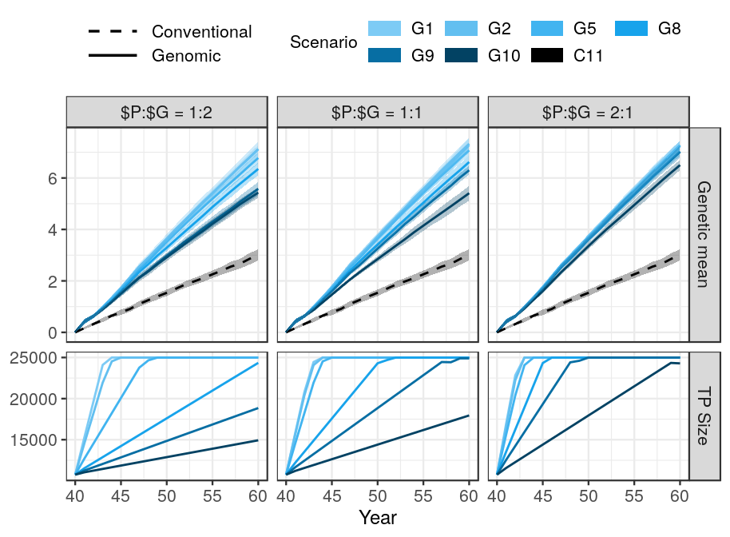

Figure 1 The impact of scenario and price of genotyping on genetic gain and training population growth.

Genetic gain and size of the training population for genomic prediction of the scenarios by the ratio between the price of phenotyping and the price of genotyping ($P:$G). An initial training population of all active cows and progeny tested sires was available. All scenarios had equal amount of financial resources differently split between phenotyping and genotyping. The genetic gain of the conventional scenario does not depend on the $P:$G, hence it is the same in all three $P:$G ratios. TP = training population, scenarios are named “C” / “G” for conventional / genomic, followed by the number of phenotype recordings per lactation.

Accuracy of the scenarios with initial training population

Table S2 Selection accuracy by scenario, price of genotyping, and availability of initial training population.
 | The ratio between the price of phenotyping ($P) and the price of genotyping ($G)
Scenario | $P:$G = 1:2 |  | $P:$G = 1:1 |  | $P:$G = 2:1
Scenario | With initial TP | Without initial TP | With initial TP | Without initial TP | With initial TP | Without initial TP
Male candidates
C11 | 0.37_{0.04}ª | 0.37_{0.04}ª | 0.37_{0.04}ª | 0.37_{0.04}ª | 0.37_{0.04}ª | 0.37_{0.04}ª
G10 | 0.89_{0.03}^{b} | 0.81_{0.03}^{b *} | 0.90_{0.02}^{b} | 0.84_{0.01}^{b *} | 0.91_{0.01}^{b} | 0.87_{0.01}^{b *}
G9 | 0.90_{0.03}^{b} | 0.85_{0.02}^{c *} | 0.91_{0.02}^{b} | 0.87_{0.01}^{bc *} | 0.91_{0.01}^{b} | 0.90_{0.01}^{bc *}
G8 | 0.91_{0.01}^{b} | 0.86_{0.01}^{cd *} | 0.91_{0.01}^{b} | 0.89_{0.01}^{c *} | 0.91_{0.01}^{b} | 0.90_{0.01}^{bc}
G5 | 0.91_{0.01}^{b} | 0.90_{0.01}^{d} | 0.91_{0.00}^{b} | 0.91_{0.01}^{c} | 0.91_{0.01}^{b} | 0.91_{0.01}^{c}
G2 | 0.91_{0.01}^{b} | 0.90_{0.01}^{d} | 0.91_{0.00}^{b} | 0.90_{0.01}^{c} | 0.90_{0.01}^{b} | 0.90_{0.01}^{bc}
G1 | 0.89_{0.01}^{b} | 0.89_{0.01}^{cd} | 0.90_{0.01}^{b} | 0.89_{0.01}^{c} | 0.89_{0.01}^{b} | 0.89_{0.01}^{bc}
Female candidates
C11 | 0.45_{0.02}ª | 0.45_{0.02}ª | 0.45_{0.02}ª | 0.45_{0.02}ª | 0.45_{0.02}ª | 0.45_{0.02}ª
G10 | 0.48_{0.01}^{ab} | 0.46_{0.02}^{ab *} | 0.48_{0.01}^{ab} | 0.47_{0.02}^{ab} | 0.51_{0.01}^{b} | 0.49_{0.01}^{b *}
G9 | 0.49_{0.02}^{b} | 0.47_{0.02}^{ab *} | 0.50_{0.01}^{b} | 0.49_{0.02}^{bc} | 0.52_{0.01}^{b} | 0.52_{0.01}^{bc}
G8 | 0.51_{0.01}^{b} | 0.49_{0.02}^{bc *} | 0.51_{0.01}^{b} | 0.52_{0.01}^{cd} | 0.54_{0.01}^{bc} | 0.53_{0.01}^{cd}
G5 | 0.51_{0.01}^{bc} | 0.52_{0.01}^{cd} | 0.55_{0.01}^{c} | 0.55_{0.01}^{de} | 0.57_{0.01}^{c} | 0.57_{0.01}^{d}
G2 | 0.55_{0.01}^{cd} | 0.55_{0.01}^{d} | 0.57_{0.01}^{c} | 0.56_{0.02}^{e} | 0.57_{0.01}^{c} | 0.57_{0.01}^{d}
G1 | 0.56_{0.01}^{d} | 0.55_{0.01}^{d} | 0.56_{0.01}^{c} | 0.56_{0.01}^{e} | 0.56_{0.01}^{c} | 0.56_{0.01}^{d}
Mothers
C11 | 0.48_{0.03}ª | 0.48_{0.03}ª | 0.48_{0.03}ª | 0.48_{0.03}ª | 0.48_{0.03}ª | 0.48_{0.03}ª
G10 | 0.56_{0.02}^{b} | 0.53_{0.01}^{b *} | 0.59_{0.02}^{b} | 0.56_{0.01}^{b *} | 0.63_{0.01}^{b} | 0.61_{0.01}^{b *}
G9 | 0.59_{0.03}^{bc} | 0.57_{0.02}^{bc *} | 0.63_{0.02}^{c} | 0.62_{0.02}^{c} | 0.70_{0.01}^{c} | 0.68_{0.02}^{c *}
G8 | 0.62_{0.02}^{c} | 0.60_{0.02}^{c *} | 0.67_{0.02}^{c} | 0.66_{0.01}^{d} | 0.74_{0.02}^{d} | 0.73_{0.02}^{d}
G5 | 0.70_{0.02}^{d} | 0.69_{0.02}^{d} | 0.77_{0.01}^{d} | 0.76_{0.01}^{e} | 0.79_{0.02}^{e} | 0.78_{0.02}^{e}
G2 | 0.76_{0.02}^{e} | 0.76_{0.01}^{e} | 0.79_{0.02}^{d} | 0.77_{0.02}^{e *} | 0.78_{0.01}^{e} | 0.77_{0.01}^{de}
G1 | 0.77_{0.02}^{e} | 0.76_{0.01}^{e} | 0.77_{0.02}^{d} | 0.76_{0.02}^{e} | 0.77_{0.01}^{de} | 0.76_{0.02}^{de}
Fathers
C11 | 0.86_{0.05}ª | 0.86_{0.05}ª | 0.86_{0.05}ª | 0.86_{0.05}ª | 0.86_{0.05}ª | 0.86_{0.05}ª
G10 | 0.75_{0.04}^{b} | 0.67_{0.08}^{bc *} | 0.75_{0.03}^{b} | 0.68_{0.05}^{cde *} | 0.73_{0.05}^{b} | 0.67_{0.06}^{b *}
G9 | 0.76_{0.04}^{b} | 0.70_{0.05}^{b *} | 0.72_{0.06}^{bc} | 0.72_{0.05}^{bc} | 0.69_{0.05}^{c} | 0.71_{0.05}^{b}
G8 | 0.76_{0.03}^{b} | 0.71_{0.05}^{b *} | 0.69_{0.05}^{cd} | 0.74_{0.05}^{b *} | 0.68_{0.06}^{c} | 0.70_{0.07}^{b}
G5 | 0.68_{0.07}^{c} | 0.68_{0.05}^{bc} | 0.67_{0.08}^{de} | 0.69_{0.05}^{cd} | 0.69_{0.04}^{c} | 0.69_{0.03}^{b}
G2 | 0.67_{0.05}^{c} | 0.65_{0.06}^{c} | 0.67_{0.05}^{de} | 0.64_{0.07}^{e} | 0.67_{0.04}^{c} | 0.69_{0.05}^{b}
G1 | 0.66_{0.06}^{c} | 0.67_{0.04}^{bc} | 0.63_{0.05}^{e} | 0.67_{0.03}^{de} | 0.67_{0.04}^{c} | 0.69_{0.05}^{b}
Average prediction accuracy of the scenarios by the ratio between the price of phenotyping and the price of genotyping ($P:$G) with or without an initial training population. TP = training population, scenarios are named “C” / “G” for conventional / genomic, followed by the number of phenotype recordings per lactation. Subscript numbers indicate standard deviation across simulation replicates. Lower-case letters denote statistically significant differences between scenarios within the same $P:$G and TP availability. Stars denote whether removing an initial TP significantly reduces prediction accuracy for a specific animal group within the same scenario and $P:$G.

In comparison to the baseline conventional scenario, genomic scenarios with the same total investments split between genotyping and phenotyping increased selection accuracy for young un-phenotyped male candidates, female candidates, and dams, and decreased selection accuracy for sires. Additionally, increasing investment in genotyping increased or did not affect the selection accuracy, except for sires. This is shown in Figure 2 and Table S2, that present the accuracy of selection for male candidates, female candidates, sires, and dams when the price of genotyping equals the prices of phenotyping and when an initial training population is available. In Figure 2, the accuracies of conventional scenario are shown as disconnected points. Selection of sires in conventional selection is a two stage process, hence we are showing the accuracy at pre-selection for progeny testing and at selection for proven sires.

Selection accuracy for the young genomically tested male candidates was between 0.90 and 0.91, and was not affected by the amount of phenotyping and genotyping. Compared to the first stage of male selection in the conventional scheme, i. e. of young un-phenotyped male candidates for progeny testing, genomic testing increased the accuracy for 0.53 - 0.54. However, compared to the accuracy in the second stage of male selection in the conventional scenario, i. e. when selecting proven sires for wide-spread use, genomic testing resulted in a 0.03 - 0.04 lower accuracy.

For female candidates, the selection accuracy increased with increasing genotyping, despite reducing phenotyping. The highest selection accuracy for female candidates, between 0.55 and 0.57, was achieved with investment in five, two or one phenotype per lactation (G5, G2 or G1), and the remaining into genotyping. Compared to the conventional testing in the baseline scenario, the genomic testing increased the accuracy between 0.03 and 0.11.

For dams, we observed the same trend as for female candidates, where selection accuracy increased with increasing investment in genotyping. Similarly, the highest accuracy for dams, between 0.77 and 0.79, was achieved by collecting five, two or one phenotype (G5, G2 or G1), and investing the rest in genotyping. Compared to the baseline conventional testing, genomic testing increased the accuracy for dams between 0.11 and 0.29.

In contrast, the accuracy for sires decreased with less phenotyping and more genotyping. The lowest accuracy for sires, 0.63, was observed in the scenario that invested the most into genotyping (G1) and the highest, 0.75, in the scenario that invested the most into phenotyping (G10). Compared to the conventional progeny testing, the genomic testing decreased the accuracy for proven sires between 0.11 and 0.23.

ALI moram tu napisati, kaj se zgodi, ko spremenimo ceno genotipa? Neke razlike so, ampak zelo na posamezni ravni.

Due to a small number of sires their accuracy varied considerably and the results implied a softer trend of decreasing accuracy with decreased phenotyping. The accuracy for sires decreased with reduced phenotyping, despite increased genotyping. This is a consequence of us trying to rank (distinguish between) sires (animals) in the tail of the distribution, where details matter – and every additional phenotype helps to correctly differentiate between sires. However, since this is the accuracy after the selection has been made, it is not of great interest for the breeders.

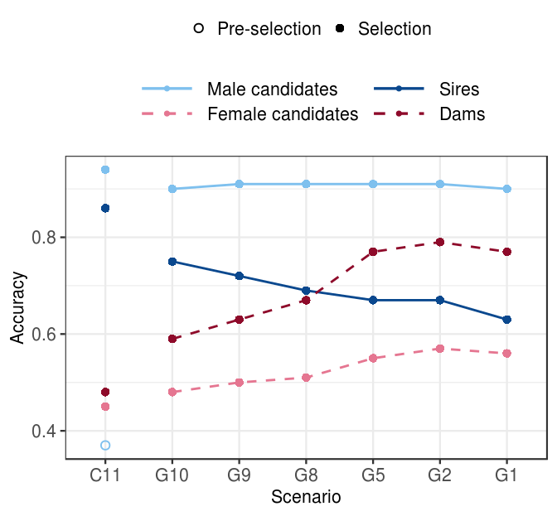
Figure 2 The impact of scenario on the prediction accuracy. The accuracy of young and proven males and females by scenario, when the price of genotype equals the price of phenotype and an initial training population is available. Conventional selection implements two-stage selection for males, hence we are showing the accuracy of the pre-selection stage for progeny testing (empty point), as well as the accuracy of selection for proven sires (solid point). Scenarios are named “C” / “G” for conventional / genomic, followed by the number of phenotype recordings per lactation.

Genetic gain and selection accuracy without an initial training population
Table S1 MERGE and put in the supplementary
 | Ratio of price of genotyping ($G) and price of phenotyping ($P)
Scenario | $G:$P = 2:1 | $G:$P = 1:1 | $G:$P = 1:2
C11 | 3.01_{0.22}^{a,A} | 3.01_{0.22}^{a,A} | 3.01_{0.22}^{a,A}
G10 | 3.93_{0.22}^{b, A} | 4.54_{0.14}^{b, B} | 5.61_{0.25}^{b, C}
G9 | 4.64_{0.18}^{c, A} | 5.75_{0.28}^{c, B} | 6.52_{0.17}^{c, C}
G8 | 5.61_{0.28}^{d, A} | 6.24_{0.19}^{d B} | 6.70_{0.25}^{cd, C}
G5 | 6.43_{0.21}^{e, A} | 6.90_{0.22}^{e, B} | 7.05_{0.27}^{de, B}
G2 | 6.81_{0.28}^{f, A} | 6.96_{0.17}^{e, A} | 7.00_{0.30d}^{e, A}
G1 | 6.78_{0.29}^{f,A} | 6.92_{0.26}^{e, A} | 7.01_{0.23}^{e,A}

Genetic gain
When an initial training population was not available, optimizing investment in phenotyping and genotyping increased the genetic gain of the baseline between 31% and 134%. However, all corresponding scenarios achieved between 2.4% and 28% smaller genetic gain than when an initial training population was available. This is shown in Figure 3, that shows the genetic gain, the growth of the training population and selection accuracy by scenario without an initial training population when the genotype and phenotype are equally priced, and Table S1 and Table S2, that compare the genetic gain and selection accuracies of all scenarios. The observed trends were in line with what we observed with a ~10K initial training population, i. e. increasing genotyping increased genetic gain despite reduced phenotyping, and changing the price of genotype did not change the overall trend.

Option 1: One price ratio at a time – just as above with genetic gain with initial TP
When genotype and phenotype were equally priced, genomic selection increased the genetic gain of the baseline scenario between 51% and 131%. Compared to when an initial training population was available, the genetic gain in the corresponding scenarios was reduced between 4.9% and 16.1%, with the largest reduction in the scenario that removed only one phenotype recording (G10) and invested the least into genotyping. However, the scenarios without an initial training population implemented genomic selection with a delay, since they first had to accumulate 2000 genotyped females. In this scenario we genotyped 355 animal per year, which required six years to build a training population and implement genomic selection. Increasing the investment into genotyping alleviated the effect of lacking (removing) an initial training population. Scenario with maximum investment into genotyping, G1, therefore achieved only 4.9% smaller genetic gain than with an initial training population available, which was 229% of the baseline.

When genotype was twice the price of phenotype, the genomic selection increased the genetic gain of the baseline between 31% and 126%, which represented between 4.7% and 28% reduction compared to scenarios with initial training population. When genotype was half the prices of phenotype, by optimizing the investment we managed to increase genetic gain between 86% and 133%, which was between 3.1% and 14% less than when we had an initial training population available.

Option2: Just point out the differences – all three price ratios at once
The lower genetic gain partly stems from a delay in the implementation of genomic selection, since the scenarios first had to accumulate 2000 genotyped females.. Removing the initial training population had the largest impact in the scenario with the smallest investment in genotyping (G10). In this scenario we genotyped between 182 and 710 animals per year, depending on the genotyping price, which required three to eleven years to build a training population and implement genomic selection. This reduced genetic gain between 14% and 28% compared to when an initial training population was available. However, this scenario still increased the genetic gain of the baseline scenario between 31% and 86%.
Increasing the investment into genotyping alleviated the effect of lacking (removing) an initial training population. Scenarios with maximum investment into genotyping, G1, achieved only between 3.1% and 4.9% smaller genetic gain than with an initial training population available. Depending on the genotype price, these scenarios increased the genetic gain of the baseline scenario between 125% and 133%.

Accuracy
Removing the initial training population decreased the accuracy of male candidates in low-genotyping scenarios, but did not affect the accuracy of female candidates and dams. This is shown in Figure 3, that shows the prediction accuracy without an initial training population when genotype and phenotype are equally priced, and Table S2, that compares the accuracies with or without an initial training population. Selection accuracy for male candidates increased with larger investment into genotyping, which is in contrast with what we observed with an initial training tpopulation, where the accuracy persisted high. At phenotype and genotype equally priced, the accuracy for male candidates was significantly decreased to 0.87 only when we recorded 10 phenotypes per lactation and invested the rest into genotyping. For female candidates and dams the accuracies followed the trends of when we had an initial training population, where increasing genotyping increased the accuracy. For female candidates the accuracy ranged between 0.47 and 0.56, and for dams and between 0.56 and 0.76. Regarding sires, the accuracy ranged between 0.64 and 0.74 with no clear trend of either increasing or decreasing accuracy.

Zopet – ali moram napisati, kaj se zgodi, ko spremenimo ceno genotipa? Nekaj sprememb je, vendar generalni trend ostaja enak.

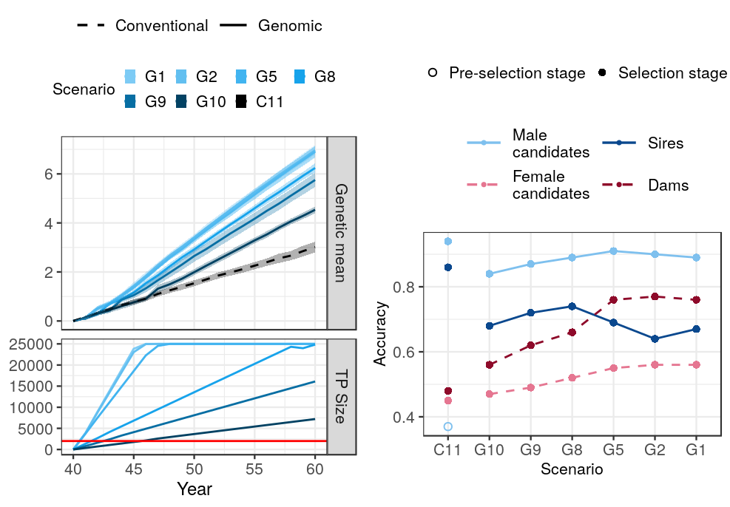
Figure 3 The impact of scenario on genetic gain and training population growth.
Genetic gain of the conventional and genomic scenarios and size of the training population for genomic prediction when the price of genotype equals the price of phenotype by scenario. An initial training population was not available and had to be established. The genetic gain of the conventional scenario does not depend on the $G:$P. The horizontal line marks the 2000 female training population limit for the implementation of genomic selection. TP = training population, scenarios are named “C” / “G” for conventional / genomic, followed by the number of phenotype recordings per lactation.

Discussion

1 Genetic gain
- reference yes: this mirrors the existence of international reference populations,
- genetic gein increases with increased genotyping (despite reduced phenotyping, regardless genotype price and existence of initial training population) – why?
  - compared to the baseline: reduced generation interval, higher accuracy of male candidates, higher intensity
  - among the genomic scenarios: accuracy does not increase with increasing genotyping, hence has to be the increasing intensity of selection
  - reducing phenotyping does not reduce accuracy enough to contradict the benefits
  - no reference: gain shoots up when we start with genomic selection of males
- genetic gain reaches a plateau – accuracies are 0.9 for selection candidates (can not improve more), all females are genotyped in the top XX scenarios (no room for improvement), intensity is high
- same maximum genetic gain achievable for all $G:$P ratios – largest relative difference between the price ratio in the scenarios that remove only one or two phenotypes

2 Accuracy
- general: accuracy does not drop despite reduced phenotyping → because more animals genotyped
- accuracy for male candidates persists high –
  - why is it high regardless the amount of genotyping and price ratio?
- the accuracy for the dams and female candidates:
  - higher than conventional – more animals genotyped, higher connectedness
  - increases with genotyping. This could be explained with first a growing reference population and secondly, more females genotyped and included in the gEBV prediction, higher connectedness
- WHY IS ACCURACY FOR FEMALE CANDIDATES THAT MUCH LOWER THAT THE MALE CANDIDATES? MALE CANDIdaTES are all GENOTYPED, FEMALE NOT
  - when all females (cows) genotyped, the accuracy closer to the one of male candidates (also all genotyped)
- accuracy for sires – inconsistent, slight increase – why?
- Without initial reference – the accuracy decreases when minimal genotyping for males candidates
  - small reference population + “low” heritability of the phenotype (only 1 recording)
  - once it hits XX, accuracies high → XX animals for update enough to keep the accuracy high
- Compare to theoretical accuracies

3 Recommendations for the Yes/No reference – for breeding organizations

4 Limitations and remarks
- limitations: 25K limit
- genotypes could be used also for parentage verification
- Genomic data also for management – monogenic diseases, caseins, inbreding / mating control
- phenotypes also for management → but it we cut the last one – the cows are already almost through the lactation, keep the recordings in the critical period
- future work: selective phenotyping?

5 Implications
All phenotyped animals should be genotyped to increase the value of phenotype investments (a phenotype itself is useful for 1-3 generations with the pedigree model, but many more generations with the marker model – can we make some simple calculations to show this – based on Daetwyler formulas? Also, can we show the value for a farmer if he is investing in multiple dairy records vs genotype – something that uses h2 and accuracy for selection and e2 for the level of variation that management can address?
Phenotypes are important, but investments should be balanced and most phenotyped animals should be genotyped to make better use of the phenotype investment.

Conclusions

TODO

Acknoweldgement
The authors acknowledge support from the BBSRC to The Roslin Institute (BBS/E/D/30002275) and The University of Edinburgh’s Data-Driven Innovation Chancellor’s fellowship.

References
Habier, D., Tetens, J., Seefried, F.-R., Lichtner, P., Thaller, G., 2010. The impact of genetic relationship information on genomic breeding values in German Holstein cattle. Genetics Selection Evolution 42, 5. https://doi.org/10.1186/1297-9686-42-5
Misztal, I., Tsuruta, S., Strabel, T., Auvray, B., Druet, T., Lee, D.H., 2002. BLUPF90 and related programs (BGF90), in: Proc. 7th World Congress on Genetics Applied to Livestock Production. Presented at the WCGALP, Montpellier, France, pp. 1–2.
Mrode, R.A., 2005. Linear Models for the Prediction of Animal Breeding Values, Second edition. ed. CABI, Wallingford, UK ; Cambridge, MA.
Wiggans, G.R., Cole, J.B., Hubbard, S.M., Sonstegard, T.S., 2017. Genomic Selection in Dairy Cattle: The USDA Experience. Annu. Rev. Anim. Biosci. 5, 309–327. https://doi.org/10.1146/annurev-animal-021815-111422
Wolc, A., Arango, J., Settar, P., Fulton, J.E., O’Sullivan, N.P., Preisinger, R., Habier, D., Fernando, R., Garrick, D.J., Dekkers, J.C., 2011. Persistence of accuracy of genomic estimated breeding values over generations in layer chickens. Genetics Selection Evolution 43, 23. https://doi.org/10.1186/1297-9686-43-23

Genetics Selection Evolution requires references to be formatted in Vancouver referencing style. Example reference style:
- Article within a journal
Smith JJ. The world of science. Am J Sci. 1999;36:234-5.
- Article within a journal (no page numbers)
Rohrmann S, Overvad K, Bueno-de-Mesquita HB, Jakobsen MU, Egeberg R, Tjønneland A, et al. Meat consumption and mortality - results from the European Prospective Investigation into Cancer and Nutrition. BMC Medicine. 2013;11:63.
- Article within a journal by DOI
Slifka MK, Whitton JL. Clinical implications of dysregulated cytokine production. Dig J Mol Med. 2000; doi:10.1007/s801090000086.

- Book chapter, or an article within a book
Wyllie AH, Kerr JFR, Currie AR. Cell death: the significance of apoptosis. In: Bourne GH, Danielli JF, Jeon KW, editors. International review of cytology. London: Academic; 1980. p. 251-306.
- OnlineFirst chapter in a series (without a volume designation but with a DOI)
Saito Y, Hyuga H. Rate equation approaches to amplification of enantiomeric excess and chiral symmetry breaking. Top Curr Chem. 2007. doi:10.1007/128_2006_108.
- Complete book, authored
Blenkinsopp A, Paxton P. Symptoms in the pharmacy: a guide to the management of common illness. 3rd ed. Oxford: Blackwell Science; 1998.
- Online document
Doe J. Title of subordinate document. In: The dictionary of substances and their effects. Royal Society of Chemistry. 1999. http://www.rsc.org/dose/title of subordinate document. Accessed 15 Jan 1999.
- Software
R: a language and environment for statistical computing. R Foundation for Statistical Computing, Vienna; 2012. OpenURL
- Proceeding of a congress
Van Eenennaam AL, Kinghorn BP. Use of mate selection software to manage lethal recessive conditions in livestock populations. In: Proceedings of the 10th World Congress on Genetics Applied to Livestock Production: 17–22 August 2014; Vancouver. https://asas.org/docs/default-source/wcgalp-posters/408_paper_9819_manuscript_1027_0.pdf?sfvrsn=2. Accessed 27 Feb 2015.
- Thesis
Park SDE. Trypanotolerance in West African cattle and the population genetic effects of selection. PhD thesis, University of Dublin. 2002.
- FAO paper report
Koziner AB, Shtakelberg ER. Animal genetic resources of the USSR. Rome: FAO and UNEP; 1989.
- Institutional document
Iversen A, Hermansen Ø. Cost development in farming of Norwegian Salmon. Tromso: Nofima Report; 2017. p. 46.

Figures
(only titles and legends should be included in main text; for more information on preparing figures, please see here https://gsejournal.biomedcentral.com/submission-guidelines/preparing-your-manuscript#preparing+figures)
Figure 1 Title.
Legend
Figure 2 Title.
Legend

Tables
Tables should be numbered and cited in the text in sequence using Arabic numerals (i.e. Table 1, Table 2 etc.).
Tables less than one A4 or Letter page in length can be placed in the appropriate location within the manuscript.
Tables larger than one A4 or Letter page in length can be placed at the end of the document text file. Please cite and indicate where the table should appear at the relevant location in the text file so that the table can be added in the correct place during production.
Larger datasets, or tables too wide for A4 or Letter landscape page can be uploaded as additional files. Please see [below] for more information.
Tabular data provided as additional files can be uploaded as an Excel spreadsheet (.xls ) or comma separated values (.csv). Please use the standard file extensions.
Table titles (max 15 words) should be included above the table, and legends (max 300 words) should be included underneath the table.
Tables should not be embedded as figures or spreadsheet files, but should be formatted using ‘Table object’ function in your word processing program.
Color and shading may not be used. Parts of the table can be highlighted using superscript, numbering, lettering, symbols or bold text, the meaning of which should be explained in a table legend.
Commas should not be used to indicate numerical values.
Table 1 Title
Column 1 | Column 2 | Column 3 | Column 4 | Column 5
Line 1
Line 2
Legend for Table under the table
Table 2 Title
Legend for Table under the table

Additional files
(only the format, title and legend of additional files should be provided in the main text; for more information on preparing additional files, please see here https://gsejournal.biomedcentral.com/submission-guidelines/preparing-your-manuscript#preparing+additional+files)
Additional file 1 Table S1
Format:
Title:
Description:
Additional file 2 Figure S1
Format:
Title:
Description:

