Comparison of different genomic selection scenarios in a small cattle population by simulation

J. Obšteter*, J. Jenko*,†, J. M. Hickey† & G. Gorjanc‡,†

* Department of Animal Science, Agricultural Institute of Slovenia, Hacquetova ulica 17, 1000 Ljubljana, Slovenia
‡ Biotechnical Faculty, University of Ljubljana, Jamnikarjeva 101, 1000 Ljubljana, Slovenia
† The Roslin Institute and Royal (Dick) School of Veterinary Studies, University of Edinburgh, Easter Bush, Midlothian, EH259RG, United Kingdom

Jana Obšteter, Agricultural Institute of Slovenia, Department of Animal Science, Hacquetova ulica 17, 1000 Ljubljana, Slovenia
+386 1 280 51 34
jana.obsteter@kis.si (Corresponding Author)

Introduction
This paper compares genetic gain, inbreeding, and efficiency of converting genetic variation into gain under different genomic selection scenarios in a small cattle population by simulation. Genomic selection has profoundly changed dairy breeding programs (Schaeffer, 2006; Garcia-Ruiz et al., 2016; Wiggans et al., 2017). Integration of genome-wide marker data into the traditional breeding programs has doubled the rate of genetic progress through a combination of decreased generation interval, increased selection accuracy for young animals, reduced costs of testing, and identification of recessive lethal alleles (Garcia-Ruiz et al., 2016; Wiggans et al., 2017). However, effective implementation of genomic selection requires a sizeable training population of genotyped and phenotyped animals, which is a limiting issue for small populations (Ducrocq et al., 2018).
The latter diminishes the gain in accuracy of genomic prediction compared to parent average (PA) estimates what in turn decreases the advantage of using genomic information (the advantage of genomic over conventional selection) (Thomasen et al., 2014). Alternatively small cattle populations can participate in international associations for a joint genomic prediction with international reference population or they can include cows in the reference population. However, an information of a cow in the reference is not equal to the information of a PT bull, therefore a larger number of cows has to be included to achieve desired accuracies (de Roos, 2011).
As mentioned, genomic selection also reduces the generation interval. The degree of reduction depends on the strategy of using the genomic information in a breeding program: in which selection paths to use the genomic information and to what extent. Previous studies mainly tested scenarios in which the genomic information was used either for a pre-selection of young bulls for progeny testing (so called GS-PS) or for the selection of genomically tested young bulls directly (so called turbo scheme) against the conventional scenario with progeny tested sires without the use of genomic information (de Roos et al., 2011; Lillehammer et al., 2011; Pryce et al., 2010). The studies observed that we can increase the genetic gain up to 30% by using genomic information for a pre-selection step and up to 195% by using genomic information directly for selection of young bulls and dams as parents (195% where markers explain 100% of the variance - M=100%!!!, realistic markers explain around 40% of the variance → here the gain is increased up to 108%).
Further on, Thomasen et al., 2014, deterministically explored hybrid schemes that simultaneously used both progeny tested and young genomically tested bulls which changes the generation interval to an intermediate degree. The study varied the proportion of bull dams and cows mated with young / progeny tested sires and inspected the resulting annual monetary genetic gain (AMGG). They concluded that even in small populations, the genomic scenario was economically and genetically superior to the conventional scenario that uses progeny testes sires. However, with low reliabilities the hybrid scheme brought the higher AMGG whereas with high reliabilities the turbo scheme was the most superior (Thomasen et al., 2014).
In addition to maximizing the genetic gain, breeding schemes have to manage genetic variation to assure sustainability of selection. The aim is to balance short- and long-term success of selection. While short-term success depends only on the genetic gain in the next (few) generation, long-term success enables increase of genetic gain after many generations of selection. Studies exploring how the use of genomic information affects inbreeding obtained contradictory results. While some studies observed a decrease in inbreeding rate per year with the use of genomic information (Lillehammer et al., 2011; Pryce et al., 2010), others observed an increase (de Roos et al., 2011). The potential of genomic selection for decreasing rate of inbreeding lies in a more accurate estimation of Mendelian sampling term – this results in a lower co-selection of siblings that reduces inbreeding rate per generation. However, although some studies showed reducing the generation interval may increase inbreeding rate per year, managing inbreeding rate per generation is more important for avoiding inbreeding depression (Daetwyler et al., 2007). Therefore, a combined measure of genetic gain and genetic variability is needed to assure long-term competitiveness of selection. Efficiency of converting genetic variance into genetic gain measures how successful a specific scheme is in achieving both goals (Gorjanc and Hickey, 2018).
Although genomic selection is a well-established technology globally, small populations still struggle with the adoption. Contrary to other parameters of genomic selection, less work was done exploring how the use of genomic information in a breeding program affects genetic gain. Although privous studies explored the genetic gain and / or inbreeding, questions remain about the optimal use of genomic information in small realistic cattle populations with overlapping generation that allow for a long-term success of selection. Also, studies mainly explored the use of genomic information for a pre-selection step or in a turbo scheme, but less work was done regarding intermediate strategies. This study aimed to explore different strategies of the use of genomic information in small realistic cattle populations in order to determine a strategy that allows for a sustainable yet competitive selection.

Material and Methods
First we developed a simulator of a realistic cattle population under selection which included all selection steps and allowed for the user to define all the selection parameters. We compared five scenarios of truncation selection in which we varied the criterion for the selection of sires for insemination of bull dams and cows. Additionally we tested three sire use strategies with varying number of bulls chosen each selection cycle and years kept in use. In contrast to these truncation selection scenarios we tested five OCS scenarios with varying target degrees between genetic gain and group coancestry. All tested scenarios were compared in terms of genetic gain, selection accuracy, genetic variance, generation interval, effective population size and efficiency of converting genetic variation into gain.

Cattle breeding program simulator
We developed a simulator of a realistic cattle breeding program (scheme?). The simulator was written as a Python wrapper around AlphaSim (Faux et al., 2016) and blupf90 (Misztal et al., 2002) software. The simulator enabled for the user to set all the selection parameters: the percentage of animals selected at each stage in each selection path, age at selection, selection criterion for each selection path, number of offspring per parent, years in use and number of selection cycles. The simulation was a continuous process resulting in overlapping generation. In each selection cycle three steps were performed: estimation of EBVs, selection of parents and mating. Breeding values were estimated as described below. Selection was performed based on single trait BVs.

Simulated population
The simulated population mirrored Slovenian Brown Swiss population in milk recording consisting of ~30,000 active individuals, ~10,000 of which cows. Genome included 10⁸ base pairs arranged in ten chromosomes. We created two SNP-chips, each including 20,000 distinct SNPs, from which one was used for selection and the other for the monitoring of inbreeding. From the segregating sites 10,000 were chosen as QTNs for a single polygenic trait with heritability of 0.25. None of the QTNs were included on the SNP-chips. The effects of the QTNs for each chromosome were drawn from a normal distribution. In total 60 generations were simulated with 8640 animals born each selection cycle. First 20 generations represented the burn-in population in which random mating was implemented. This was followed by 20 generations of conventional selection using PT bulls to achieve a population structure resembling a cattle population under selection. The last 20 generations implemented testing scenarios that differed in the use of genomic information in the male selection paths and strategy of sire selection and use.

Selection of females
The selection of females was either random (heifers) or based on EBVs (cows). Out of newborn females 1% was removed in their first year reflecting stillbirths and deaths occurring soon after birth. Out of these female calves 90% were inseminated in the second year and became cows in the third year. In each subsequent lactation we removed 20% of the cows and after the fourth lactation all cows were culled. This totalled to 10,653 active cows that were all screened for the trait and had their EBV estimated. In each generation 8550 cows with highest EBVs were chosen for mating. After the second completed lactation and estimation of EBVs, 43 cows with the highest EBVs were chosen as bull dams. Bull dams were kept in use for three lactations, completing five lactations in total. From 129 bull dams 90 were chosen each year for contracted mated to produce new generation of selection candidates.

Selection of sires
Sires were selected based on progeny or genomic testing. Each year we obtained 45 male offspring from contracted matings. Sires were selected based on three overall strategies: a) progeny testing with pre-selection based on PAs (PT); b) progeny testing with pre-selection based on gEBVs (GS-PS); c) genomic testing (GS).
In the PT strategy, 8/27 were chosen for progeny testing based on their PAs in their second year. In their sixth year 4/8 bulls were selected after obtaining progeny testing results. In the GS-PS strategy all 45 male candidates were genomically tested in their first year and 8/45 were chosen for progeny testing in their second year based on their gEBVs. In their sixth year 4/8 bulls were selected after obtaining progeny testing results. In the GS strategy all 45 male candidates were genomically tested in their first year and in their second year 5/45 were chosen as young sires based on their gEBVs.

The chosen candidates entered either progeny testing or genomic testing. Young bulls for progeny testing were pre-selected either based on the performance test and EBVs (which equal PA since they have no information) (PT) or based on their gEBVs (GS-PS).
a) performance testing - progeny testing: 60% (n=27) of male calves from contracted mating were randomly chosen for performance testing. The random choice reflects the realistic situation where the availability of male calves depends also on unpredictable human factors (where not all the best male calves are available for performance testing). In the second year 8/27 bulls were chosen for progeny testing. The non-chosen bulls were used in natural service as cow sires. After five years 4/8 progeny tested bulls were chosen as proven bulls.
b) genomic testing - progeny testing: all male calves from contracted mating were genomically tested in their first year. In the second year 8/45 bulls were chosen for progeny testing. The non-chosen bulls were used in natural service as cow sires. After five years 4/8 progeny tested bulls were chosen as proven bulls.
c) genomic testing: all male calves from contracted mating were genomically tested in their first year. In the second year 5/45 bulls were chosen as young sires. The non-chosen bulls were used in natural service as cow sires.

Testing scenarios
We created five testing scenarios of truncation selection by using different categories of sires (PT, GS-PS, GS) for insemination of cows and bull dams. Using genomically tested sires for insemination of cows or bull dams reduces generation interval in the corresponding selection path. This allowed us to test the effect of varying degree of reduction in generation interval on selected metrics. The tested scenarios included one conventional scenario without the use of genomic information and four genomic scenarios. i) PT scenario used PT sires exclusively for insemination of all cows and bull dams. ii) Similarly, GS-PS scenarios used GS-PS sires exclusively for insemination of all females. iii) GS-C used young genomically tested sires for insemination of cow population and GS-PS sires for insemination of bull dams. iv) Contrary, in GS-BD we used GS sires for the insemination of bull dams and GS-PS for insemination of cows. v) GS scenarios, also referred to elsewhere as “turbo”, used exclusively young GS sires for insemination of all females.

Sire use strategy
We next created three sire selection-use strategies by varying the number of selected sires per years and years they were kept in use. All five truncation selection scenarios were tested within the three strategies. i) In the first strategy, every year we selected five sires and keep them in use for five years (SU 5/5). This strategy reflects the situation in the simulated Slovenian Brown Swiss population. ii) In the second years we increased the intensity of selection. Every year we selected only one sire per year and kept him in use for five years (SU 1/5). iii) In the third strategy we performed a faster turn-over of the sires. Every year we selected five sires and replaced them all in the next year, i.e. kept them in use for only one year (SU 5/1).

Optimum contribution selection
In addition to different settings of truncation selection, we created an optimum contribution selection (OCS) scenario in which sire contributions only were optimized (Woolliams et al., 2015). Contributions were optimized with heuristic evolutionary algorithm implemented in AlphaMate software (Gorjanc et al., 2018). In contrast to truncation selection scenarios, we did not fix the number of sires selected and years kept in use in the OCS scenario. Also, male contributions were not equalized nor limited. Dams were selected as described above with equalized contributions (one offspring per dam). The OCS scenarios implemented genomic testing. All 45 male offspring from contracted matings were genotyped and added to the sire candidate pool along with already selected sires from the last five years. This sire candidate pool was subjected to AlphaMate for optimization along with selected dams for the next generation. The kinship was accounted for with H matrix constructed according to Legarra et al., 2009. The H relationship matrix was computed based on a set of reference animals for gEBV estimation and current dams (cows and bull dams?). The selected sires from the optimization were randomly mated to chosen dams according to optimized contributions. The goal of optimization were trigonometric degrees between genetic gain and group coancestry with smaller degrees prioritizing maximizing genetic gain over minimizing group coancestry. The simulation was ran in 20 replicates for each of the following target degrees: 15, 30, 45, 60 and 75.

Estimation of breeding values
Breeding values were estimated using pedigree or single-step BLUP depending on whether the genomic information was available. In genomic scenarios we assumed a initial reference population of ~11,000 cows and 100 progeny tested sires for the genomic prediction. The reference population was updated each selection cycle by removing the oldest generation of cows and adding an equivalently large sample of cows from the currently active cow population to the reference. Each year all the male offspring of contracted mating were genotyped and added to the reference population.

Rate of inbreeding
We computed the rate of inbreeding per year based on either pedigree or molecular information for all the tested scenario. The pedigree inbreeding was computed with AlphaRelate (AlphaSuite) following the procedure described in XXX. The pedigree rate of inbreeding (ΔF_{Ped}) was derived according to 1 - Ft = t * (1 – ΔF_{Ped})t from regression of log (1 – F) over generations of comparison (Pérez-Enciso, 1995). The corresponding effective population size (N_{e,ped}) was computed as 1 / (2 * ΔF_{Ped}). Molecular rate of inbreeding was computed based on a direct link of heterozygosity with inbreeding, i.e. Het_{t} = Het_{o}(1 – F) as described in Meuwissen et al., 2018. We computed heterozygosity separately for causal, marker and neutral loci. Analogous to regression for F_{ped} we regressed log(Het) over generations of comparison. Accordingly we then computed rate of inbreeding on causal loci (ΔF_{QTN}), marker loci (ΔF_{M}) and neutral loci (ΔF_{N}). Corresponding effective population sizes, namely Ne_{QTN}, Ne_{M} and Ne_{N}, were again computed as 1 / (2 * ΔF_{QTN} / ΔF_{M} / ΔF_{N}).

Metrics of comparison
The scenarios were compared in terms of genetic gain, efficiency and inbreeding averaged across 20 replicates. Genetic gain was expressed with mean zero and in units of genetic standard deviation in the first generation of comparison. Selection accuracy was computed as the correlation between true and estimated breeding values. We defined the efficiency as a regression of the achieved genetic gain on the amount of reduction of the genic standard deviation. We used genic variance because we believe it provides a better measure of genetic variability since it allows us to exclude the effect of linkage disequilibrium. When computing efficiency, both genetic gain and the genic standard deviation were standardized by the genic standard deviation in the first generation of comparison. Therefore, this efficiency metric indicates the potential genetic gain in units of genic standard deviation when all variation is converted into gain or lost due to drift. Results are presented as the mean of 20 replicates for each scenario on a per generation or cumulative basis.

Results
The results compare different sire selection and usage strategies in terms of genetic gain, selection accuracy, generation interval, genetic variance, effective population size and efficiency of converting genetic variation into gain. Earlier use of genomically tested young sires in a breeding program and their faster turnover from year to year increased genetic gain, as expected from changes in selection accuracy and generation interval, but also decreased genetic variance. However, the efficiency of converting genetic variation into gain increased with the simultaneous use of genomically and progeny tested sires. Compared to truncation selection scenarios, optimising sire contributions increased genetic gain even further with the lowest target degrees of optimization achieving the highest genetic gain. In contrast, increasing degrees of optimization increased efficiency of converting genetic variation into gain. Scenarios with the highest optimization degrees also increased efficiency of the truncation selection scenarios.
Genetic gain
Genetic gain increased with an earlier use of genomically tested young sires in a breeding program and their faster turnover from year to year. This is shown in Table 1, which presents genetic gain by breeding program and sire use strategy expressed as the percentage change to the baseline scenario that had genetic gain of 2.5 genetic standard deviations. Introducing genomic selection of young bulls for progeny testing increased genetic gain by 37% compared to the baseline scenario. Genomic selection of young bulls for a direct insemination of cows or bull dams respectively increased genetic gain by 63% or 69%, and by 95% when applied jointly for cows and bull dams. Reducing the use of 5 selected sires per year from 5 years to 1 year significantly decreased generation interval (Table S2) and further increased genetic gain, between 11% and 144% compared to the baseline scenario. Reducing the number of selected sires per year from 5 to 1 and using that sire for 5 years also increased genetic gain, between 22% and 126% compared to the baseline scenario, but not compared to the strategy where the use of 5 selected sires per year was reduced from 5 years to 1 year. The exception was the genomic selection of bulls for insemination of cows where the extreme strategy of selecting 1 sire per year and using it for 5 years had higher genetic gain than the strategy of selecting 5 sires per year and using them for 1 year. These genetic gains were a direct function of realized generation intervals (Table S1) and accuracies of selection (Table S2).
Table 1: Genetic gain by breeding program and sire selection-use strategy expressed as the percentage change to the baseline scenario that had the genetic gain of 2.5 genetic standard deviations
 | Sire selection and use strategy
Breeding program | 5 sires/year, use 5 years | 5 sires/year, use 1 year | 1 sire/year, use 5 years
PT | / ^{a, A} | 11₉^{a, AB} | 22₁₁^{a, B}
GS-PS | 37₁₂^{b, A} | 59₁₃^{b, B} | 54₁₃^{b, B}
GS-C | 63₁₄^{c, A} | 87₁₉^{c, B} | 94₂₁^{c, B}
GS-BD | 69₁₅^{c, A} | 84₁₈^{c, B} | 82₂₀^{c, B}
GS | 95₁₇^{d, A} | 144₂₇^{d, B} | 126₂₇^{d, C}
PT = conventional progeny testing; GS-PS = genomic selection of young bulls for progeny testing, GS-C = genomic selection of young bulls for insemination of cows; GS-BD = genomic selection of young bulls for insemination of bull-dams; GS = genomic selection of young bulls for insemination of cows and bull dams. Lower-case letters denote statistically significant differences between breeding programs and upper-case letters between sire selection-use strategies.

#ABSOLUTE TABLE
 | Sire selection and use strategy
Breeding program | 5 sires/year, use 5 years | 5 sires/year, use 1 year | 1 sire/year, use 5 years
PT | 2.5_{0.22} ^{a, A} | 2.75_{0.19}^{a, B} | 3.03₁₁^{a, C}
GS-PS | 3.41_{0.14}^{b, A} | 3.96_{0.17}^{b, B} | 3.84₁₃^{b, B}
GS-C | 4.05_{0.15c}^{, A} | 4.65_{0.21}^{c, B} | 4.82₂₁^{c, B}
GS-BD | 4.20_{0.19}^{c, A} | 4.56_{0.25}^{c, B} | 4.51₂₀^{d, B}
GS | 4.84_{0.26}^{d, A} | 6.04_{0.27}^{d, B} | 5.60₂₇^{e, C}

Table S1: Generation interval by breeding program, sire selection-use strategy and path of selection expressed as the percentage change to the baseline scenario that had the generation intervals of 9.0 years for the sire of sires path and 7.0 years for the sire of dams path
 | Sire selection and use
Breeding program | 5 sires/year, use 5 years |  | 5 sires/year, use 1 year |  | 1 sire/year, use 5 years
 | Sire of sires | Sire of dams | Sire of sires | Sire of dams | Sire of sires | Sire of dams
PT | /^{a,A} | /^{a,A} | -21_{0.5}^{a,B} | -18_{0.7}^{a,B} | 2_{1.1}^{a,C} | 9_{0.8}^{a,C}
GS-PS | 0_{0.8}^{a,A} | 0_{0.9}^{a,A} | -21_{0.5}^{a,B} | -18_{0.6}^{a,B} | 2_{1.1}^{a,C} | 9_{0.8}^{a,C}
GS-C | 0_{0.75}^{a,A} | -42_{0.7}^{b,A} | -21_{0.5}^{a,B} | -64_{0.3}^{b,B} | 2_{1.1}^{a,C} | -42_{0.4}^{b,A}
GS-BD | -58_{0.6}^{b,A} | -1_{0.9}^{c,A} | -58_{0.6}^{b,A} | -19_{0.6}^{c,B} | -58_{0.6}^{b,A} | 8_{0.8}^{c,C}
GS | -53_{0.7}^{c,A} | -44_{0.4}^{d,A} | -74_{0.5}^{c,B} | -67_{0.2}^{d,B} | -53_{0.9}^{c,A} | -44_{0.4}^{d,A}
PT = conventional progeny testing; GS-PS = genomic selection of young bulls for progeny testing, GS-C = genomic selection of young bulls for insemination of cows; GS-BD = genomic selection of young bulls for insemination of bull-dams; GS = genomic selection of young bulls for insemination of cows and bull dams. Lower-case letters denote statistically significant differences between breeding programs and upper-case letters between sire selection-use strategies.

#ABSOLUTE TABLE
 | Sire selection and use
Breeding program | 5 sires/year, use 5 years |  | 5 sires/year, use 1 year |  | 1 sire/year, use 5 years
 | Sire of sires | Sire of dams | Sire of sires | Sire of dams | Sire of sires | Sire of dams
PT | 9.0_{0.06}^{ab,A} | 7.0_{0.05}^{a,A} | 7.1_{0.00}^{a,B} | 5.8_{0.02}^{a,B} | 9.1_{0.07}^{a,C} | 7.7_{0.00}^{a,C}
GS-PS | 9.0_{0.06}^{a,A} | 7.0_{0.05}^{a,A} | 7.1_{0.00}^{a,B} | 5.8_{0.00}^{a,B} | 9.1_{0.07}^{a,C} | 7.7_{0.02}^{a,C}
GS-C | 9.0_{0.05}^{b,A} | 4.1_{0.04}^{b,A} | 7.1_{0.00}^{a,B} | 2.5_{0.00}^{b,B} | 9.1_{0.06}^{a,C} | 4.1_{0.00}^{b,A}
GS-BD | 3.8_{0.05}^{c,A} | 7.0_{0.05}^{c,A} | 3.8_{0.05}^{b,A} | 5.7_{0.00}^{c,B} | 3.8_{0.04}^{b,A} | 7.6_{0.00}^{c,C}
GS | 4.2_{0.05}^{d,A} | 3.9_{0.05}^{d,A} | 2.3_{0.05}^{c,B} | 2.3_{0.00}^{d,B} | 4.2_{0.07}^{c,A} | 3.9_{0.00}^{d,C}

Table S2: Accuracy of selection by breeding program, animal category and sire selection-use strategy.
 | Sire selection and use strategy
Breeding program | 5 sires/year, use 5 years | 5 sires/year, use 1 year | 1 sire/year, use 5 years
PT
young bulls | 0.31_{0.18} | 0.23_{0.20} | 0.30_{0.19}
Sires / bulls | 0.88_{0.10} | 0.87_{0.10} | 0.82_{0.17}
heifers | 0.35_{0.05} | 0.32_{0.06} | 0.36_{0.06}
GS-PS
young bulls (gen) | 0.80_{0.11} | 0.78_{0.12} | 0.80_{0.11}
Sires / bulls | 0.82_{0.16} | 0.83_{0.15} | 0.78_{0.20}
heifers | 0.47_{0.04} | 0.44_{0.05} | 0.46_{0.06}
GS-C
young bulls (gen) | 0.81_{0.11} | 0.80_{0.11} | 0.82_{0.12}
Sires / bulls – for BD | 0.89_{0.09} | 0.90_{0.08} | 0.87_{0.13}
heifers | 0.44_{0.05} | 0.41_{0.05} | 0.46_{0.07}
GS-BD
young bulls | 0.77_{0.11} | 0.78_{0.12} | 0.77_{0.11}
Sires / bulls | 0.84_{0.14} | 0.82_{0.16} | 0.80_{0.17}
heifers | 0.51_{0.06} | 0.46_{0.06} | 0.49_{0.06}
GS
young bulls | 0.79_{0.12} | 0.75_{0.11} | 0.80_{0.12}
heifers | 0.48_{0.05} | 0.43_{0.06} | 0.49_{0.07}
PT = conventional progeny testing; GS-PS = genomic selection of young bulls for progeny testing, GS-C = genomic selection of young bulls for insemination of cows; GS-BD = genomic selection of young bulls for insemination of bull-dams; GS = genomic selection of young bulls for insemination of cows and bull dams.

Figure S1: (Standardized) parent average and Mendelian sampling term of selected bulls by breeding program and sire selection-use strategy averaged over 20 generations.

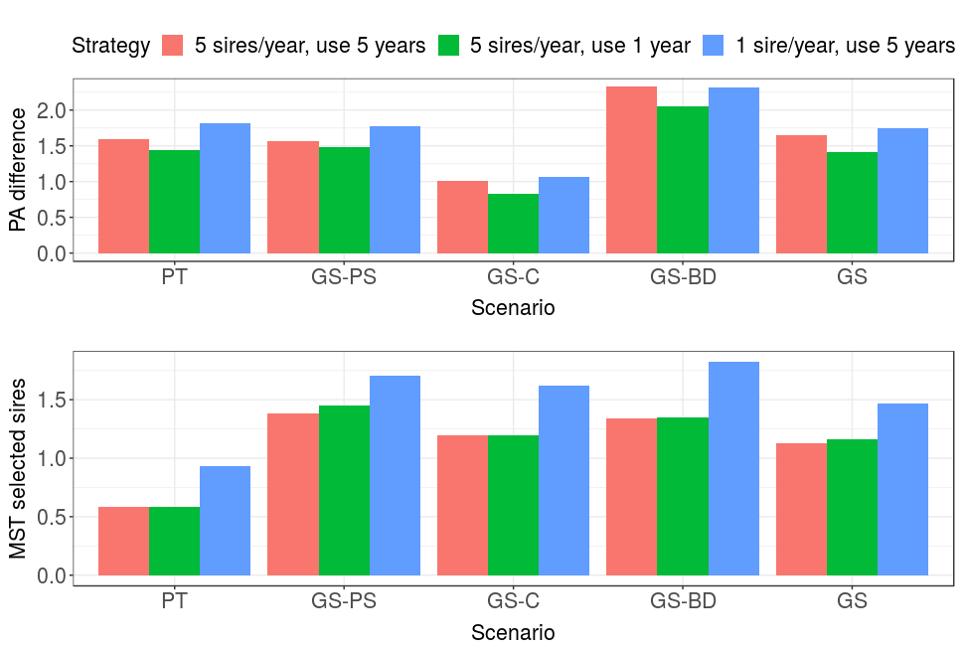
PT = conventional progeny testing; GS-PS = genomic selection of young bulls for progeny testing, GS-C = genomic selection of young bulls for insemination of cows; GS-BD = genomic selection of young bulls for insemination of bull-dams; GS = genomic selection of young bulls for insemination of cows and bull dams. PA difference = difference between parent average of the selected sires and the population; MST selected sires = Mendelian sampling term of the selected sires.

Genetic and genic standard deviation
Earlier use of genomically tested young sires in a breeding program, their faster turn-over and higher intensity of selection decreased genetic variation. This is shown in Figure 1, which presents genic and genetic standard deviation by breeding program and sire selection-use strategy expressed as the percentage change to the baseline scenarios that had at the final generation genic standard deviation of 0.97 and genetic standard deviation of 0.94. Genomic selection of young bulls for progeny test did not significantly decrease genic standard deviation. Genomic selection of young bulls for insemination of cows or bulls dams reduced genic standard deviation between 1.3% and 2.5%. Reducing the number of years sires were used from 5 to 1 further reduced genic standard deviation, though with the same pattern as with the 5 year use. The reduction was between 0.9% and 5.0% compared to the baseline scenario. Increasing selection intensity - by selecting only one sire per year instead of 5 - reduced genic standard deviation even further. Reduction was now between 3.0 and 10.3%. We observed a similar trend in the reduction of genetic standard deviation as for genic standard deviation. The reductions were however overall larger and had higher variation between simulation replicates.
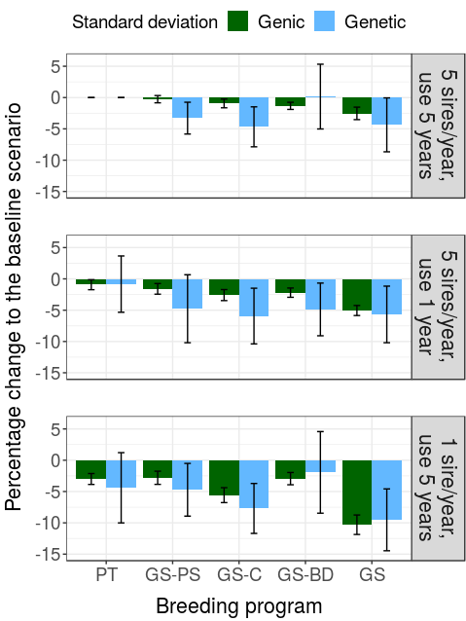
Figure 3: Genic and genetic standard deviation by breeding program and sire selection-use strategy expressed as percentage change to the baseline scenario that had at the final generation genic standard deviation of 0.97 and genetic standard deviation of 0.94. PT = conventional progeny testing; GS-PS = genomic selection of young bulls for progeny testing, GS-C = genomic selection of young bulls for insemination of cows; GS-BD = genomic selection of young bulls for insemination of bull-dams; GS = genomic selection of young bulls for insemination of cows and bull dams
#ABSOLUTE

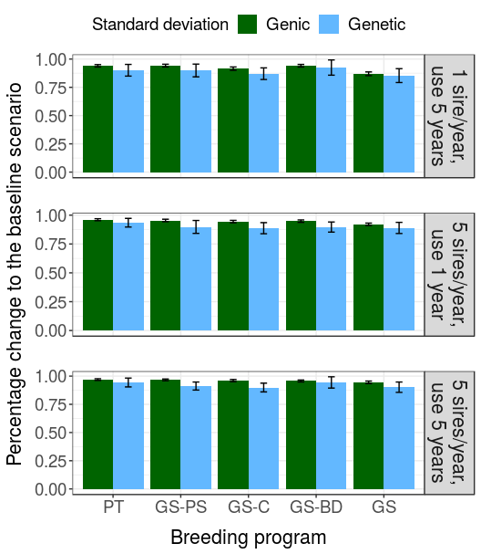

Effective population size
An earlier use of young genomically tested sires and increased selection intensity decreased effective population size. This is shown in Table 2, which presents effective population size at causal loci by breeding program and sire use strategy expressed as the percentage change to the baseline scenario that had effective population size of 172. Genomic selection of young bulls for progeny testing did not significantly change the effective population size. Inseminating cows with young genomically tested sires decreased effective population size by 23% and inseminating bull dams with them by 29%. The largest decrease of 45% was observed when both cows and bull dams were inseminated with young genomically tested sires. Reducing the years the sires are kept in use from 5 to 1 did not significantly change effective population size, except when both cows and bull dams were inseminated with young genomically tested sires (-59% compared to the baseline scenario). In contrast, reducing the number of sires selected per year from 5 to 1 and using that sire for 5 years decreased effective population size for all scenarios. The decrease ranged from 40% (when genomic selection was applied to selection of young sires for progeny testing) to 76% (when both cows and bull dams were inseminated with one young genomically tested sire). Most of the 76% decrease was due to the insemination of cows. These results were qualitatively the same as results for the effective population sizes at marker loci used for genomic selection or at neutral loci (results not shown).
Table 2: Effective population size at causal loci by breeding program and sire selection-use strategy expressed as the percentage change to the baseline scenario that had the effective population size of 172.
 | Sire selection and use strategy
Breeding program | 5 sires/year, use 5 years | 5 sires/year, use 1 year | 1 sire/year, use 5 years
PT | / ^{a, A} | 9₂₁^{a, A} | -42₁₂^{a, B}
GS-PS | -6₁₆^{a, A} | -13₂₁^{b, A} | -40₁₁^{a, B}
GS-C | -23₁₂^{b, A} | -26₁₇^{c, A} | -61₈^{b, B}
GS-BD | -29₁₂^{b, A} | -33₁₁^{c, AB} | -43₁₆^{a, B}
GS | -45₁₂^{c, A} | -56₁₀^{d, B} | -76₇^{c, C}
PT = conventional progeny testing; GS-PS = genomic selection of young bulls for progeny testing, GS-C = genomic selection of young bulls for insemination of cows; GS-BD = genomic selection of young bulls for insemination of bull-dams; GS = genomic selection of young bulls for insemination of cows and bull dams. Lower-case letters denote statistically significant differences between breeding programs and upper-case letters between sire selection-use strategies.

#ABSOLUTE TABLE
 | Sire selection and use strategy
Breeding program | 5 sires/year, use 5 years | 5 sires/year, use 1 year | 1 sire/year, use 5 years
PT | 172₄₈ ^{a, A} | 184₅₇^{a, A} | 96₂₀^{a, B}
GS-PS | 159₄₃^{a, A} | 146₄₀^{b, A} | 99₂₀^{a, B}
GS-C | 29₂₉^{b, A} | 124₃₂^{bc, A} | 64₁₁^{b, B}
GS-BD | 119₂₇^{b, A} | 113₂₄^{c, AB} | 93₂₄^{a, B}
GS | 90₁₄^{c, A} | 72₁₀^{d, A} | 38₆^{b, B}

Efficiency of converting genetic variation into gain
The largest efficiency of converting genetic variation into gain was achieved with the simultaneous use of genomically and progeny tested sires over several years. This is shown in Table 3, which presents the efficiency of converting genetic variation into gain by breeding program and sire selection-use strategy expressed as percentage change to the baseline scenario that has the efficiency of 77. This value indicates the genetic gain of 77 standard deviations when all genic variance will be exhausted. This calculation is based on the linear regression of achieved genetic gain on lost genic variance over the 20 years of selection, which we graphically represent in Figure 2 to complement the Table 3. Compared to the baseline scenario, the introduction of genomic selection increased the efficiency. The highest increase, 33%, was achieved by genomic selection of young bulls for progeny testing. Genomic selection of young bulls for the insemination of cows or bull dams increased the efficiency respectively by 30% or 25%. Genomic selection of young bulls for the insemination of cows and bull dams did not significantly increase the efficiency compared to the baseline scenario. Reducing the use of sires from 5 years to 1 year increased the efficiency up to 16% compared to the baseline scenario - with the exception of the conventional progeny testing, where we observed 18% decrease. The hybrid breeding programs using both genomic and progeny testing again had the highest efficiency (between 9 and 16%), while full genomic scheme had the same efficiency as the baseline scenario. However, comparing the use of sires for 5 years versus 1 year by breeding program showed that the efficiencies were smaller with 1 year use of sires. Reducing the number of selected sires per year to 1 and using it for 5 years reduced efficiencies across all breeding programs.
Table 3: Efficiency of converting genetic variation into gain by breeding program and sire selection-use strategy expressed as the percentage change to the baseline scenario that had the efficiency of 77.
 | Sire selection and use
Breeding program | 5 sires/year, use 5 years | 5 sires/year, use 1 year | 1 sire/year, use 5 years
PT | / ^{a, A} | -18₁₂^{a, B} | -35₁₂^{ab, C}
GS-PS | 33₂₅^{b, A} | 12₂₃^{b, B} | -14₁₇^{cd, C}
GS-C | 30₂₂^{b, A} | 9₂₀^{b, B} | -28₁₁^{ac, C}
GS-BD | 25₂₅^{bc, A} | 16₁₆^{b, A} | -2₂₅^{d, B}
GS | 12₂₀^{ac, A} | 2₂₂^{b, A} | -43₁₂^{b, B}
PT = conventional progeny testing; GS-PS = genomic selection of young bulls for progeny testing, GS-C = genomic selection of young bulls for insemination of cows; GS-BD = genomic selection of young bulls for insemination of bull-dams; GS = genomic selection of young bulls for insemination of cows and bull dams. Lower-case letters denote statistically significant differences between breeding programs and upper-case letters between sire selection-use strategies.
#ABSOLUTE TABLE
 | Sire selection and use
Breeding program | 5 sires/year, use 5 years | 5 sires/year, use 1 year | 1 sire/year, use 5 years
PT | 77₁₇^{a, A} | 61₉^{a, B} | 48₉^{ab, C}
GS-PS | 100₂₁^{b, A} | 84₁₇^{b, B} | 64₁₀^{cd, C}
GS-C | 98₂₀^{b, A} | 81₁₂^{b, B} | 54₁₀^{ac, C}
GS-BD | 93₁₉^{bc, A} | 87₁₅^{b, A} | 72₁₅^{d, B}
GS | 84₁₁^{ac, A} | 75₁₁^{b, A} | 42₅^{b, B}
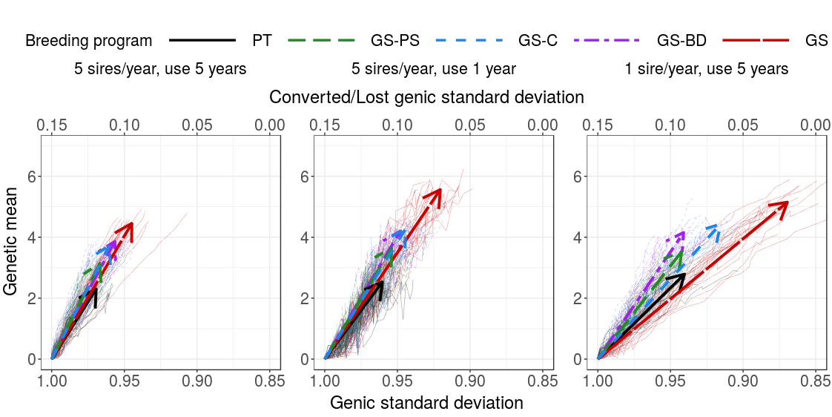Figure 2: Change of genetic mean and genic standard deviation over the 20 years of selection by breeding program and sire selection-use strategy. Thin lines represent individual replicates, while thick lines represent average linear regression with arrows pointing the direction of change. PT = conventional progeny testing; GS-PS = genomic selection of young bulls for progeny testing, GS-C = genomic selection of young bulls for insemination of cows; GS-BD = genomic selection of young bulls for insemination of bull-dams; GS = genomic selection of young bulls for insemination of cows and bull dams.
Optimized breeding program
Optimization of sire contributions at lower degrees increased genetic gain of the fixed scenarios and optimisation at lower degrees increased conversion efficiency. This is shown in Table 4, which presents the genetic gain, selection accuracy, generation interval, genic variance, rate of group coancestry, effective population size and efficiency of converting genetic variation into gain by breeding program expressed as percentage change to the baseline scenario, and Figure 4, which shows conversion efficiency only. Optimization of sire selection with target degree 30 delivered the highest genetic gain, i.e. 172% of the baseline scenario. However, this scenario lost 12.4% more genic variance than the baseline scenario and 39% lower conversion efficiency. OCS₁₅ and OCS₄₅ had genetic gain comparable to the one of the SU 5/1 GS scenario – and while OCS₁₅ lost more genic variance and had lower efficiency, OCS₄₅ was comparable to SU 5/1 GS in all measures. OCS₁₅ and OCS₃₀ also decreased effective population size of the fixed scenarios. On the other hand, OCS₆₀ reached genetic gain of the SU 5/5 GS scenario with a smaller loss of genic standard deviation(-2.5% vs. -0.6%) and higher efficiency (12% vs. 70%). OCS₇₅ similarly reached the genetic gain of the SU 5/5 PT scenario, but at the same time lost lesabss genic standard deviation, increased effective population size by 69%, and had 117% higher efficiency.
The number of sires and their offspring were freely set by optimization. The average number of fathers in the OCS₁₅ scenarios was 3.3 (SD = 3.9), 4.4 in OCS₃₀ (SD = 1.2), 9.6 in OCS₄₅ (SD = 2.0), 49 in OCS₆₀ (SD = 32) and 153 (SD = 51) in OCS₇₅. The average year the sires were kept is use was 1.77 in OCS₁₅ (SD = 0.41), 1.48 in OCS₃₀ (SD = 0.09), 1.61 in OCS₄₅ (SD = 0.06), 3.04 in OCS₆₀ (SD = 0.34) and 4.90 in OCS₇₅ (SD = 0.07).

Table 4: Comparison of fixed and optimized breeding programs expressed as the percentage change to the baseline scenario that had the genetic gain of 2.5 genetic standard deviations, sire selection accuracy of 0.88, sire-sire generation interval of 9.0 years, sire-dam generation interval of 7.0, genic standard deviation of 0.97, rate of group coancestry of 0.0031, effective population size of 172 and efficiency of 77.
Breeding program | Genetic gain | Sire selection accuracy | Generation interval  (sire-sire) | Generation interval  (sire-dam) | Genic standard deviation | Rate of group coancestry | Effective population size | Conversion efficiency
Fixed breeding program
5 sires/year, use 5 years, PT | /ª |  | /ª | /ª | /^{ab} | /^{ab} | /ª | /ª
5 sires/year, use 5 year, GS | 95₁₇^{b} |  | -53_{0.7}^{b} | -44_{0.4}^{b} | -2.5_{1.0}^{c} | 91₄₅^{ac} | -45₁₂^{b} | 12₂₀ª
5 sire/year, use 1 years, GS | 144₂₇^{c} |  | -74_{0.5}^{c} | -67_{0.2}^{c} | -5.0_{0.8}^{d} | 140₅₆^{c} | -56₁₀^{bc} | 2₂₂ª
Optimised breeding program
OCS_{15°} | 129₄₁^{c} |  | -66_{2.5}^{d} | -59_{3.2}^{d} | -15.5_{3.7}^{e} | 463₁₄₉^{d} | -81₅^{d} | -55₁₁^{b}
OCS_{30°} | 172₃₂^{d} |  | -69_{1.3}^{e} | -62_{1.8}^{e} | -12.4_{2.5}^{f} | 397₂₀₈^{d} | -77₉de | -39₁₆^{b}
OCS_{45°} | 153₂₉^{cd} |  | -69_{0.8}^{e} | -62_{1.0}^{e} | -5.6_{1.1}^{d} | 181₅₇^{c} | -63₇^{ce} | -3₁₆ª
OCS_{60°} | 92₂₁^{b} |  | -64_{1.2}^{f} | -56_{1.1}^{f} | -0.6_{0.7}ª | 20₂₈^{ab} | -12₁₉ª | 70₃₄^{c}
OCS_{75°} | 22₁₁ª |  | -53_{1.0}^{b} | -43_{0.9g} | 1.3_{0.6}^{b} | -37₁₅^{b} | 69₄₄^{f} | 117₅₃^{d}
PT = conventional progeny testing; GS = genomic selection of young bulls for insemination of cows and bull dams; OCS_{X°} = optimal contribution selection of young and proven bulls for insemination of cows and bull dams with target degrees of X°. Lower-case letters denote statistically significant differences between breeding programs.
#ABSOLUTE TABLE
Breeding program | Genetic gain | Sire selection accuracy | No Sires | Years in use | Generation interval  (sire-sire) | Generation interval  (sire-dam) | Genic standard deviation | Rate of group coancestry | Effective population size | Conversion efficiency
Fixed breeding program
5 sires/year, use 5 years, PT | 2.5_{0.22}ª | 0.88_{0.10} | 5 | 5 | 9.0_{0.06}ª | 7.0_{0.05}ª | 0.97_{0.01ab} | /^{ab} | /ª | /^{ab}
5 sires/year, use 5 year, GS | 4.84_{0.26}^{bd} | 0.80_{0.13} | 5 | 5 | 4.2_{0.05}^{b} | 3.9_{0.05}^{b} | 0 94_{0.01}^{c} | 91₄₅^{ac} | -45₁₂^{b} | 12₂₀ª
5 sire/year, use 1 years, GS | 6.04_{0.27}^{de} | 0.75_{0.11} | 5 | 1 | 2.3_{0.05}^{c} | 2.3_{0.00}^{c} | 0.92_{0.01}^{d} | 140₅₆^{c} | -56₁₀^{bc} | 2₂₂ª
Optimised breeding program
OCS_{15°} | 5.48_{1.51}^{bd} | 0.64_{0.09} | 3.3_{3.9} | 1.77_{0.41} | 3.0_{0.23}^{d} | 2.9_{0.22}^{d} | 0.82_{0.03}^{e} | 454₁₅₈^{d} | -81₅^{d} | -55₁₁^{b}
OCS_{30°} | 6.44_{1.19}^{e} | 0.75_{0.04} | 4.4_{1.2} | 1.48_{0.09} | 2.8_{0.12}^{e} | 2.7_{0.12}^{e} | 0.85_{0.0.2}^{f} | 406₂₀₉^{d} | -77₉^{cd} | -43₂₁^{b}
OCS_{45°} | 5.75_{1.62}^{de} | 0.77_{0.02} | 9.6_{2.0} | 1.61_{0.06} | 2.8_{0.07}^{e} | 2.7_{0.07}^{e} | 0.92_{0.02}^{d} | 166₅₆^{c} | -61₈^{bcd} | -5₂₀ª
OCS_{60°} | 4.57_{0.94}^{c} | 0.81_{0.02} | 49₃₂ | 3.04_{0.34} | 3.3_{0.10}^{f} | 3.1_{0.07}^{f} | 0.97_{0.01}ª | 17₃₃^{ab} | -5₄₂ª | 67₃₂^{c}
OCS_{75°} | 3.03_{0.17}ª | 0.82_{0.01} | 153₅₁ | 4.90_{0.07} | 4.2_{0.08}^{b} | 4.0_{0.06}^{g} | 0.98_{0.00}^{b} | -371₅^{b} | 69₄₄e | 117₅₃^{d}

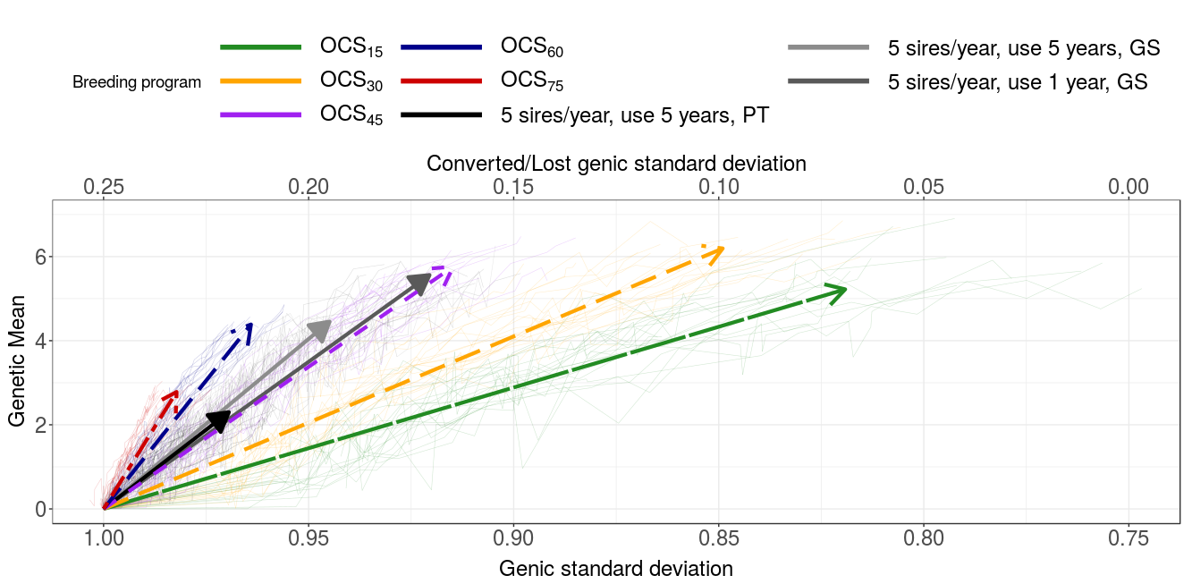Figure 4: Change of genetic mean and genic standard deviation over the 20 years of selection by fixed or optimised breeding program. Thin lines represent individual replicates, while thick lines represent average linear regression with arrows pointing the direction of change. PT = conventional progeny testing; GS-PS = genomic selection of young bulls for progeny testing, GS-C = genomic selection of young bulls for insemination of cows; GS-BD = genomic selection of young bulls for insemination of bull-dams; GS = genomic selection of young bulls for insemination of cows and bull dams.

Discussion

Genetic gain
As expected, the use of genomic information increased the genetic gain in all sire use strategies. This is due to a higher accuracy for selection of young unphenotyped animals and reduction in generation interval. We showed that by using gEBVs for the pre-selection step, we can substantially increase genetic gain without reducing generation interval (GS-PS scenario) - since gEBV (r = 0.80) are more accurate than PA (r = 0.31). By using genomically tested sires directly we also reduce the generation interval, which additionally increases the genetic gain despite the lower accuracy of sire selection. Thomasen et al., 2014, pointed out, that the benefit of genomic selection in small populations is undermined due to a small increase in the selection accuracy for young animals caused by a weak reference population (i.e. gEBVs not much more accurate than PAs). However, our results suggest that with a cow based reference population we can achieve an opposite result. Since in small populations the number of offspring in progeny testing is not as large, the accuracy of conventional EBVs for progeny tested bulls does not reach the accuracy of the large populations. With an adequate cow reference population we can reach relatively high accuracies of genomic prediction comparable to the accuracies of the progeny tested bulls (0.79 vs 0.83 in our case).
Within genomic scenarios, genetic gain increased with reduction in generation interval. These results suggest than we can alleviate the effect of the lower accuracy of genomic prediction with an earlier selection of sires, since the effect of the latter prevails. Generation interval for sires may seem long (Table S1) – the reason for this is a large standard deviation of sires’ true BV within a generation. The genetic value of some sires is significantly above others in their generation – therefore they can also compete with the sires in subsequent generations. Hence the offspring of these exceptional sires are selected even in the last year of the sire use, which prolongs generation interval. We also showed there is no significant difference in genetic gain when using genomic selection for sires used on unselected (reduced sires of dams generation interval) or selected female population (reduced sire of sires generation interval). This suggests that the amount of reduction in generation interval prevails over the path in which we use the genomic information (selection path is irrelevant and that genetic gain depends only on the amount of reduction). OR When using genomically tested sires for insemination of unselected females, the majority of the population is offspring of these young sires. On the other hand, when using young genomically tested sires on selected females only, the extent of their use is much smaller, but the impact is higher since they produce new male candidates. The completely genomic scenario used genomic selection for all sires – therefore all sires were selected at a lower accuracy. However, since generation interval was reduced in both sires of dams and sires of sires paths, the genetic gain increased the most. Our results for genetic gain are in concordance with previous studies that observed a higher genetic gain with the use of genomic information for a pre-selection for PT or for selection of young sires (“turbo” scheme) (Pryce et al., 2010; Lillehammer et al., 2011; de Roos et al., 2011; Thomasen et al., 2014).
A faster turn-over of sires reduced generation interval in both, sires of sires and sires of dams selection paths, which increased the genetic gain. Increasing intensity of selection also increased genetic gain, yet not to the same degree. Since in the latter we introduced an unrealistic condition of selecting only one sire, this strategy lost much more of genic variance that enables genetic progress.

Effective population size
We observed a discordance in Ne computed based on pedigree or molecular information with the former exceeding the latter up to 219% (results not shown). Our results are in concordance with previous findings that pedigree estimation tends to underestimated the true inbreeding in the population. While pedigree information measures identity by descend, the identity on molecular markers measures identity by state (Meuwissen et al., 2018). Therefore rate of inbreeding derived from pedigree information reflects population history and is affected by mating decisions and rate of coancestry derived from genomic information - and the corresponding effective population size - reflect situation under random mating (Cervantes et al., 2011). Regarding genomic data, the inbreeding estimated from QTN loci did not exceed inbreeding estimated from neutral or marker loci (results now shown). This is most likely a consequence of simulating a highly polygenic trait controlled by 1000 QTNs per chromosome.
The results suggest we can increase genetic gain and retain effective population size by using genomic selection for pre-selection of sires for progeny testing. All other strategies decrease effective population size despite increasing genetic gain even further.
While increasing the intensity of selection significantly decreases Ne, no such effect is observed for a faster turn-over of animals. Generation interval in this strategy was significantly reduced, which according to previous studies increases inbreeding (reviewed in Boichard et al., 2015). Previous studies also report that a larger number of sires counterbalances the effect of reduces effective number of bulls per generation caused by reduced generation interval. Considering we do not observe a decrease in the effective population size in SU 5/1 strategy, XXX pojasnilo
In addition to different breeding strategies, inbreeding rate can be reduced by applying inbreeding control. In the fixed scenarios we did not perform any form of inbreeding control, except for limiting the number of offspring per bull to a realistic viable number of semen doses. In order to efficiently bound the rate of inbreeding, we should apply inbreeding control on the same basis as used for estimation of breeding values (Sonesson et al., 2012). Therefore, while for PT and GS-PS scenarios a pedigree based inbreeding control would suffice, the genomic scenarios would required control based on genomic relationship.

Efficiency
We observed that efficiencies do not follow the pattern of genetic gain and that the hybrid scenarios achieved the highest conversion efficiency. The two extreme scenario – conventional and genomic – were the least efficient in all sire use strategies. We can attribute the low efficiency of the conventional scenario to its small genetic gain caused by long generation intervals although the scenario retains the most genic variance. In contrast, the low efficiency of the completely genomic scenario - despite its high genetic gain - is caused by a relatively large loss of genic standard deviation. The reason for the loss lies in the reduced accuracy of sire selection since genomic testing (mean r = 0.78) is less accurate than progeny testing (mean r = 0.86) (Table S1).
We showed that by using progeny and genomically tested sires simultaneously, we can achieve the highest conversion efficiency. Although not all differences were significant, the most efficient scenario in all three sires use strategies was one of the hybrid scenario. The hybrid scenarios do not reach the genetic gain of the genomic scenario neither do they maintain the genic variance of the conventional scenario, but they reach a balance that allows for a long-term genetic gain and sustainable selection. We explain the success of these scenarios by a greater spread of the true BVs of the PT sires due to a higher accuracy of their EBVs. Hence hybrid schemes lose less genetic (genic) variance relative to their genetic gain resulting in higher efficiencies. In the SU 5/5 and SU 5/1 strategy using genomic selection for pre-selection appeared to be the most efficient strategy. Using gEBVs at pre-selection step allows us to identify the effect of Mendelian sampling term that is crucial for providing long-term genetic gain. Increasing intensity (SU 1/5 strategy) resulted in a different pattern in the efficiencies of scenarios. While the GS remained the least efficient - due to a relatively large loss of genic standard deviation - we observed a large drop in the efficiency of the GS-C scenario when compared to SU 5/5. This corresponds to a large increase in the loss of genic variance. In GS-C scenarios the vast majority of the female population – with the exception of bull dams – is inseminated with genomically tested sire(s). [Tukaj ne znam pojasnit, zakaj GS-C izgubi veliko več genske variance v primerjavi z ostalimi scenariji kot pa V SU 5/5 in SU 5/1. Je res, da večino populacije (vse krave) osemenimo z enim genomsko testiranih bikom, katerega točnost je nižja (od PT) → pri čemer bi nižja točnost lahko pomenila večjo co-sib selection → vendar pa so ti biki genomsko testirani, kar pomeni ravno obratno – da najbrž izvajamo več izbire med družinami. Če bi bilo temu tako, bi lahko zapisali (to sem imela napisano prej, samo sem ugotovila, da najbrž ne drži): These results therefore suggest that in SU 1/5 strategy the effect of inseminating nearly entire population with a sire of lower accuracy is enhanced due to increased intensity. The effect of erroneously chosen sire is reflected throughout the population and results in a larger loss of genic variance. This effect is not as substantial in the GS-BD strategy since the bottle neck of selecting one sire for the majority of inseminations is made with larger accuracy (PT bulls)].
Increasing the intensity of selection (SU 1/5) and performing a faster turnover of the animals (SU 5/1) have different consequences on short and long-term success of selection (genetic gain). Although both these strategies increase genetic gain, increasing the intensity also causes a larger loss in genic variance and a severe drop in Ne. This significantly reduces conversion efficiencies of the scenarios, which is in concordance with a study of (Gorjanc et al., 2018) that observed decreased efficiency with a small number of parents. On the other hand, a faster turn-over of sires achieves the highest genetic gain, does not reduce efficiencies of the scenarios with the highest genetic gain (reduces efficiencies to a medium degree in only 3 / 5 scenarios) and retains the Ne. This suggests that a faster strategy could benefit breeding schemes and allow for a sustainable selection with high genetic gain.
Although the genomic scenarios lost more genic variance, the loss is still relatively small. The largest loss of genic standard deviation was 0.13 (absolutna vrednost 0.87) and was observed for GS scenario in the SU 1/5 strategy. This small loss could be explained by genomic selection increasing the frequency of rare alleles up to 0.5 will increase gen(et)ic variance in the population (Weller et al., 2017).

OCS
Optimization of sires contributions increased genetic gain even further with the highest gain achieved al low degrees of optimisation. OCS increases genetic gain due to two reasons: firstly, the optimization algorithm optimizes the selection of sires for the largest gain at a specified value of group coancestry; and secondly, selection at low optimization degrees also had increased intensity of sire selection and performed a faster turn-over of animals. The OCS scenarios with the largest gain used between 3 and 10 bulls per year and kept them in use for only 1.5 – 1.8 years.
Optimization at lower target degrees (15 and 30) had lower efficiency that fixed scenarios (Table 4) - despite higher genetic gain - due to a larger loss in genic variance. This is perhaps unexpected since OCS controls group coancestry and aims to maximize genetic gain for specifies value of group coancestry. On the other hand, lower degrees put more weight on genetic gain compared to lowering group coancestry. The larger loss in genic variance is a result of a low number of sires in OCS₁₅ scenario (mean = 3.3) and OCS₃₀ (mean = 4.4), since the sires were selected by optimization without any limitations for the number of sires and number of offspring per sire. For example, the average number of sires in the truncation scenarios in SU 5/5 strategies was ~50 (proven, young, natural service bulls) with limited number of offspring. This number of sires is comparable to OCS6₀ (mean = 49) that reaches the genetic gain of SU 5/5 GS scenario.
It is interesting, that the largest genetic gain is not reached at the highest optimisation degree, but rather at target degree 30°. We assume this is due to a smaller loss in genetic variability that allows for a continuous and long-term progress.
If we compare fixed and OCS scenarios with similar genetic gain, we observe different pattern at low and high optimization degrees. Optimization with high target degrees (60, 75) can improve effective population size and conversion efficiency of the corresponding fixed scenarios with a similar genetic gain. Such examples are SU 5/5 PT - OCS₇₅ and SU 5/5 GS – OCS₆₀ paired scenarios, where the OCS scenario has a higher effective population size and considerably higher conversion efficiency at the same genetic gain. On the other hand, optimisation at larger degrees (15 and 30) increases genetic gain, but does not retain the genic variance, effective population size and conversion efficiency of the corresponding fixed scenarios. For example, OCS₁₅ reaches a similar genetic gain than SU 5/1 GS scenario, but decreases genetic variability.

Conclusion
TODO

References
(Schaeffer, 2006)
(García-Ruiz et al., 2016)
(Wiggans et al., 2017)
(Thomasen et al., 2014)
(de Roos, 2011)
(Pryce et al., 2010)
(Lillehammer et al., 2011)
(De Roos, 2011)
(Daetwyler et al., 2007)
(Gorjanc and Hickey, 2018)
(Faux et al., 2016)
(Misztal et al., 2002)
(Pérez-Enciso, 1995)
(de Roos et al., 2011)
(Meuwissen et al., 2018)
(Boichard et al., 2015)

Boichard, D., Ducrocq, V., Fritz, S., 2015. Sustainable dairy cattle selection in the genomic era. J. Anim. Breed. Genet. 132, 135–143. https://doi.org/10.1111/jbg.12150
Cervantes, I., Goyache, F., Molina, A., Valera, M., Gutiérrez, J.P., 2011. Estimation of effective population size from the rate of coancestry in pedigreed populations. J. Anim. Breed. Genet. 128, 56–63. https://doi.org/10.1111/j.1439-0388.2010.00881.x
Daetwyler, H.D., Villanueva, B., Bijma, P., Woolliams, J.A., 2007. Inbreeding in genome-wide selection. J. Anim. Breed. Genet. 124, 369–376.
de Roos, A.P.W., 2011. Genomic selection in dairy cattle (PhD Thesis). Wageningen University, Wageningen, The Netherlands.
De Roos, A.P.W., 2011. Recent trends in genomic selection in dairy cattle, in: 62nd Annual Meeting of the EAAP. Presented at the EAAP, Wageningen Academic Publishers, Stavanger, Norway, p. Contribution 01-7, 4.
de Roos, A.P.W., Schrooten, C., Veerkamp, R.F., van Arendonk, J. a. M., 2011. Effects of genomic selection on genetic improvement, inbreeding, and merit of young versus proven bulls. J. Dairy Sci. 94, 1559–1567. https://doi.org/10.3168/jds.2010-3354
Ducrocq, V., Laloe, D., Swaminathan, M., Rognon, X., Tixier-Boichard, M., Zerjal, T., 2018. Genomics for Ruminants in Developing Countries: From Principles to Practice. Front. Genet. 9. https://doi.org/10.3389/fgene.2018.00251
Faux, A.-M., Gorjanc, G., Gaynor, R.C., Battagin, M., Edwards, S.M., Wilson, D.L., Hearne, S.J., Gonen, S., Hickey, J.M., 2016. AlphaSim: Software for Breeding Program Simulation. Plant Genome 9. https://doi.org/10.3835/plantgenome2016.02.0013
García-Ruiz, A., Cole, J.B., VanRaden, P.M., Wiggans, G.R., Ruiz-López, F.J., Tassell, C.P.V., 2016. Changes in genetic selection differentials and generation intervals in US Holstein dairy cattle as a result of genomic selection. Proc. Natl. Acad. Sci. 113, E3995–E4004. https://doi.org/10.1073/pnas.1519061113
Gorjanc, G., Gaynor, R.C., Hickey, J.M., 2018. Optimal cross selection for long-term genetic gain in two-part programs with rapid recurrent genomic selection. Theor. Appl. Genet. 131, 1953–1966. https://doi.org/10.1007/s00122-018-3125-3
Gorjanc, G., Hickey, J.M., 2018. AlphaMate: a program for optimizing selection, maintenance of diversity and mate allocation in breeding programs. Bioinformatics 34, 3408–3411. https://doi.org/10.1093/bioinformatics/bty375
Lillehammer, M., Meuwissen, T.H.E., Sonesson, A.K., 2011. A comparison of dairy cattle breeding designs that use genomic selection. J. Dairy Sci. 94, 493–500. https://doi.org/10.3168/jds.2010-3518
Meuwissen, T.H.E., Sonesson, A.K., Wooliams, J.A., 2018. Genomic management of inbreeding in breeding schemes. Presented at the World Congress on Genetics Applied to Livestock Production, Auckland, New Zealand.
Misztal, I., Tsuruta, S., Strabel, T., Auvray, B., Druet, T., Lee, D.H., 2002. BLUPF90 and related programs (BGF90), in: Proc. 7th World Congress on Genetics Applied to Livestock Production. Presented at the WCGALP, Montpellier, France, pp. 1–2.
Pérez-Enciso, M., 1995. Use of the uncertain relationship matrix to compute effective population size. J. Anim. Breed. Genet. 112, 327–332. https://doi.org/10.1111/j.1439-0388.1995.tb00574.x
Pryce, J.E., Goddard, M.E., Raadsma, H.W., Hayes, B.J., 2010. Deterministic models of breeding scheme designs that incorporate genomic selection. J. Dairy Sci. 93, 5455–5466. https://doi.org/10.3168/jds.2010-3256
Schaeffer, L.R., 2006. Strategy for applying genome-wide selection in dairy cattle. J. Anim. Breed. Genet. 123, 218–223. https://doi.org/10.1111/j.1439-0388.2006.00595.x
Sonesson, A.K., Woolliams, J.A., Meuwissen, T.H., 2012. Genomic selection requires genomic control of inbreeding. Genet. Sel. Evol. 44, 1–10. https://doi.org/10.1186/1297-9686-44-27
Thomasen, J.R., Egger-Danner, C., Willam, A., Guldbrandtsen, B., Lund, M.S., Sørensen, A.C., 2014. Genomic selection strategies in a small dairy cattle population evaluated for genetic gain and profit. J. Dairy Sci. 97, 458–470. https://doi.org/10.3168/jds.2013-6599
Weller, J.I., Ezra, E., Ron, M., 2017. Invited review: A perspective on the future of genomic selection in dairy cattle. J. Dairy Sci. 100, 8633–8644. https://doi.org/10.3168/jds.2017-12879
Wiggans, G.R., Cole, J.B., Hubbard, S.M., Sonstegard, T.S., 2017. Genomic Selection in Dairy Cattle: The USDA Experience. Annu. Rev. Anim. Biosci. 5, 309–327. https://doi.org/10.1146/annurev-animal-021815-111422
Woolliams, J.A., Berg, P., Dagnachew, B.S., Meuwissen, T.H.E., 2015. Genetic contributions and their optimization. J. Anim. Breed. Genet. 132, 89–99. https://doi.org/10.1111/jbg.12148

