Efficient use of genomic information for sustainable genetic improvement in small cattle population
Obšteter

Breeding programs aim to maximize genetic gain, but also have to maintain genetic variation. Genomic selection has been proven to increase genetic gain, but small cattle populations still struggle with its implementation. We simulated a small dairy cattle population and tested different genomic scenarios implementing either truncation or optimum contribution selection to asses their short- and long-term selection gain. We observed that both can be increased with the simultaneous use of conventional and genomic approach and optimization of male contributions. Our results will be of help to breeding organization in small cattle populations deciding upon which selection strategy to adopt.
Efficient use of genomic information for sustainable genetic improvement in small cattle population

J. Obšteter*, J. Jenko*,†, J. M. Hickey‡ & G. Gorjanc†,#

*Department of Animal Science, Agricultural Institute of Slovenia, Hacquetova ulica 17, 1000 Ljubljana, Slovenia
†Geno Breeding and A.I. Association, Storhamargata 44, 2317 Hamar, Norway
‡The Roslin Institute and Royal (Dick) School of Veterinary Studies, University of Edinburgh, Easter Bush, Midlothian, EH259RG, United Kingdom
#Biotechnical Faculty, University of Ljubljana, Jamnikarjeva 101, 1000 Ljubljana, Slovenia

Jana Obšteter, Agricultural Institute of Slovenia, Department of Animal Science, Hacquetova ulica 17, 1000 Ljubljana, Slovenia
+386 1 280 51 34
jana.obsteter@kis.si (Corresponding Author)

ABSTRACT
This paper compares genetic gain, genetic variation, and the efficiency of converting variation into gain under different genomic selection scenarios implementing truncation or optimum contribution selection in a small dairy population by simulation. Breeding programs have to maximize genetic gain but also ensure sustainability by maintaining genetic variation. Numerous studies showed that genomic selection increases genetic gain. Although genomic selection is a well-established method, small populations still struggle with choosing the most secure strategy to adopt the technology.
We developed a simulator of a dairy population. The simulated population mimicked the Slovenian Brown Swiss population of ~30,000 animals of which ~10,500 are cows. We created different truncation selection scenarios by varying i) the method of sire selection and their use on cows or bull dams, and ii) selection intensity and the number of years a sire is in use. Furthermore, we created different optimum contribution selection scenarios with dynamic optimization of sire selection and their usage. We compared the scenarios in terms of genetic gain, selection accuracy, generation interval, genetic and genic variance, the rate of coancestry, effective population size, and the efficiency of converting genetic variation into genetic gain.
The results show that early use of genomically tested bulls increased genetic gain compared to progeny testing as expected from changes in selection accuracy and generation interval. A faster turnover of bulls from year to year and higher intensity increased the genetic gain even further, but increased the loss of genetic variation. While maximizing intensity resulted in the lowest efficiency, a faster turn-over of sires decreased the conversion efficiency to an intermediate degree. The largest efficiency of converting genetic variation into gain was achieved with the simultaneous use of genomically and progeny tested bulls that were used over several years. Compared to truncation selection optimizing sire selection and their usage increased the efficiency of converting genetic variation into genetic gain by either achieving comparable genetic gain for a smaller loss of genetic variation or achieving higher genetic gain for a comparable loss of genetic variation. Our results will be of help to breeding organization in small cattle populations trying to implement genomic selection in a way to secure a short-term genetic gain as well as insure the maintenance of genetic variation and allow for a sustainable selection.
Key words: small cattle population, genomic selection, long term genetic gain, optimum contribution selection

Introduction
This paper compares genetic gain, genetic variation, and the efficiency of converting variation into gain under different genomic selection scenarios in a small dairy cattle population by simulation. Genomic selection has profoundly changed dairy cattle breeding programs (Schaeffer, 2006; Garcia-Ruiz et al., 2016; Wiggans et al., 2017). It has doubled the rate of genetic gain through decreased generation interval, increased selection accuracy for young animals, increased selection intensity, and identification and managment of recessive lethal alleles (Cole, 2015; Garcia-Ruiz et al., 2016; Wiggans et al., 2017). These changes enable large and small populations to achieve significant genetic gains. The prerequisite for this is a sizeable training population of genotyped and phenotyped animals, which is an issue for small populations (Thomasen et al., 2014; Jenko et al., 2017; Ducrocq et al., 2018). This problem can be partly addressed with international training populations that assemble data from multiple countries (Jorjani, 2012; Liu, 2013; Vandenplas et al., 2017). An effective implementation also requires an optimal use of genomic selection for different groups of animals, which is an as yet to be fully answered question, but see Thomasen et al. (2014). Further, small populations under selection are prone to genetic drift and related genetic variation issues, which can deteriorate with intense and rapid genomic selection (Falconer and Mackay, 1996; Gorjanc et al., 2018). An additional consequence of the limited number of individuals and resources in small cattle populations is lower intensity of selection, compares to the large populations, due to a smaller number of tested individuals.
Breeding programs aim to maximize genetic gain. Previous studies compared the conventional progeny testing with genomic pre-selection prior to progeny testing or direct genomic selection for widespread use without progeny testing (de Roos et al., 2011; Lillehammer et al., 2011; Pryce et al., 2010). These studies reported up to 30% increase in genetic gain with the genomic pre-selection and up to 195% increase in genetic gain with the direct genomic selection. Thomasen et al. (2014) deterministically evaluated hybrid schemes that use both progeny and young genomically tested bulls for the insemination of cows and bull dams in populations of different size. They concluded that genomic selection gives higher genetic gain than conventional progeny testing irrespective of population size, but that the hybrid schemes maximise annual monetary genetic gain when a population is small and accuracy of genomic selection is low.
Breeding programs also have to maintain genetic variation to ensure long-term sustainability. They achieve this by balancing short- and long-term success. This is especially important for small populations, since they have to stay competitive in the international market to justify their existence. While short-term success depends on the genetic gain in the next few generations, long-term success depends on the short-term genetic gain to stay competitive in the short term and maintenance of sufficient genetic variation to ensure a stable rate of genetic gain over a long-term period (Woolliams et al., 2015). Studies exploring the effect of genomic selection on genetic variation have had contradictory results. For example, Lillehammer et al. (2011) and Pryce et al. (2010) reported a decrease in the rate of coancestry per year, while de Roos et al. (2011) reported that the rate of coancestry depends on the proportion of genetic variation captured with genome-wide markers and a breeding program design. Genomic selection has the potential to decrease the rate of coancestry due to a more accurate estimation of Mendelian sampling terms for young animals. This enables differentiation of sibs and avoidance of their co-selection and in turn reduces the rate of coancestry (Daetwyler et al., 2007). Balancing short- and long-term success can be further enhanced with the optimum contribution selection (Woolliams et al., 2015).
Although genomic selection is a well-established method, small populations still struggle with choosing the most secure strategy to adopt genomic selection. The right strategy should ensure short- and long-term success as well as being economically and logistically (i.e., the number of animals) viable. To address some of these issues this study evaluates different genomic breeding program designs for a small dairy population with a focus on selection and usage of bulls and how this affects changes in genetic gain and genetic variation.
Material and Methods
We compared different breeding program designs in a small dairy cattle population with a newly developed simulator. Altogether we compared twenty-two scenarios. In fifteen scenarios we used truncation selection with five different selection criteria to choose sires for the insemination of bull dams and cows. Additionally, we tested each of the sire selection criterion scenarios within three sire usage scenarios that varied the number of sires and the period of their usage. To maximise genetic gain for a given loss in genetic variation we compared the truncation selection scenarios with seven optimum contribution selection scenarios where we varied balance between genetic gain and maintenance of genetic variation. We compared all the scenarios in terms of genetic gain, selection accuracy, generation interval, genic variance, effective population size, and efficiency of converting genetic variation into gain.

Simulation
We developed a simulator of a realistic dairy population. The simulator is a Python wrapper around the simulation program AlphaSim (Faux et al., 2016), the genetic evaluation program blupf90 (Misztal et al., 2002), and the optimum contribution selection program AlphaMate (Gorjanc and Hickey, 2018). The simulator is driven by a set of parameters describing a dairy breeding program, including the percentage of animals selected at each stage and in each selection path, age at selection, selection criterion (pedigree or genomic), the number of progeny per sire, years in use, and the number of selection cycles. These parameters allow the simulation of relevant dairy breeding programs. In each year the simulator generates phenotypic data, estimates breeding values, culls, selects and mates animals, and generates progeny - including their pedigree and genotypic data.

Population
The simulated population mimicked the Slovenian Brown Swiss population of ~30,000 animals of which ~10,500 are cows. The simulation started with a coalescent process to generate a cattle-like whole-genome sequence for ten chromosomes (Faux et al., 2016; Villa-Angulo et al., 2009). We randomly sampled segregating sequence variants to construct a set of 10,0000 causal variants (1,000 per chromosome) and two distinct sets of 20,000 marker variants (2,000 per chromosome). We used the two sets of marker variants to create two SNP arrays, one was used for genomic selection and the other for monitoring “neutral” diversity. We sampled the effects of causal variants from a normal distribution with a variance that gave a trait with the heritability of 0.25 in the base population. We randomly allocated base population animals to different categories to initiate a dairy breeding program. We have then run a conventional breeding program with selection on phenotype based estimated breeding values for 20 years, followed by a further 20 years of different scenarios described below.
We generated 4,320 female calves every year of which we removed a random 2% due to stillbirths and early deaths, and a further 9% due to other losses, for example, reproductive issues. The remaining heifers were inseminated in the second year and became cows in the third year. In each subsequent lactation we culled 20% of the cows at random and all remaining cows after the fourth lactation. This scheme totalled to about 10,500 active cows per year. After the first lactation, we assigned 43 cows with the highest estimated breeding values as bull dams. We kept bull dams in use for five lactations, which gave us 129 active bull dams per year. Every year we inseminated the best 90 bull dams with relevant sires to generate elite male selection candidates.
We selected sires based on genomic or progeny tests. Every year 45 elite male calves were tested following one of three scenarios: a) progeny test with a pre-selection based on pedigree prediction (PT), b) progeny test with a pre-selection based on genomic test (GT-PT) or c) genomic test (GT). With the PT scenario, 8 out of 27 calves were chosen for progeny test based on pedigree prediction in their second year, while the remaining 19 calves were used in natural service. With the GT-PT scenario 8 out of 45 calves were chosen for progeny test based on genomic test. With the PT and GT-PT scenario 5 out of 8 progeny tested bulls were selected as elite sires based on estimated breeding value in their sixth year. With the GT scenario 5 out of 45 genomically tested calves were directly selected as elite sires and were used for insemination from their second year onwards. Unselected genomically tested calves in all genomic scenarios were used as natural service sires.

Breeding value estimation
We estimated breeding values with the pedigree model (Henderson, 1984) or the single-step genomic model (Legarra et al., 2009) using the blupf90 program with default options (Misztal et al., 2002). In genomic breeding scenarios we assumed an initial reference population of about 11,000 genotyped and phenotyped cows and 100 genotyped and progeny tested sires. This mimicked the availability of international genomic evaluation in Brown Swiss (Jorjani, 2012). We updated the reference population each year by removing the oldest generation of about 2000 cows and adding approximately the same number of newly genotyped cows and elite male selection candidates. Variance components were assumed known and set to simulated values.

Breeding scenarios
We created different truncation selection scenarios by varying i) the method of sire selection and their use on cows or bull dams, and ii) selection intensity and the number of years a sire is in use. Furthermore, we created different optimum contribution selection scenarios with dynamic optimization of sire selection and their usage.
Truncation selection. The scenarios that varied the selection of sires in combination with their use on cows or bull dams were: i) PT scenario used PT sires for the insemination of cows and bull dams, ii) GT-PT scenario used GT-PT sires for the insemination of cows and bull dams, iii) GT-C scenario used GT sires for the insemination of cows and GT-PT sires for the insemination of bull dams, iv) GT-BD scenario used GT sires for the insemination of bull dams and GT-PT sires for the insemination of cows, and v) GT scenario used GT sires for the insemination of both cows and bull dams. The GT-C and GT-BD scenarios are also referred to as the hybrid scenarios.
The scenarios that varied selection intensity and the number of years a sire is in use were: i) select five sires every year and keep them in use for five years (5 sires/year, use 5 years), ii) reduce generation interval by using five sires for one year only (5 sires/year, use 1 year) and iii) maximise selection intensity by selecting only one sire and use it for five years (1 sire/year, use 5 years).
Optimum contribution selection. We have dynamically optimized sire selection and usage with optimum contribution selection (Woolliams et al., 2015) using the AlphaMate program (Gorjanc and Hickey, 2018). Every year we have added the 45 genotyped elite male calves to the pool of bulls selected in the previous generation with a limit of 5 years for bull usage. We then optimized their contributions while fixing female (heifers’ and cows’) contributions to one progeny per female. After optimization we randomly paired the optimized male contributions with the fixed female contributions. Inputs for optimum contribution selection were estimated breeding values and a coancestry matrix (Woolliams et al., 2015) for reference animals from the genomic single-step model (Legarra et al., 2009). We optimized male contributions with different emphasis on genetic gain versus group coancestry using the target degrees of the angle between the truncation selection solution and an optimum contribution solution (Kinghorn, 2011). For example, target degrees of 0 would maximise genetic gain by selecting only one male, while target degrees of 90 would solely minimise group coancestry. We ran simulations with the target degrees of 15, 30, 45, 50, 55, 60, and 75.
Analysis
We compared the scenarios in terms of genetic gain, selection accuracy, generation interval, genetic and genic variance, the rate of coancestry, effective population size, and the efficiency of converting genetic variation into genetic gain. Genetic gain was expressed as a deviation from average genetic merit of the individuals in the first generationof comparison in the units of genetic standard deviation. Selection accuracy was computed as the Pearson correlation between the true and estimated breeding values. Generation interval was computed as the average age of the parents at the birth of their selected offspring. Genetic variance measured variance of true breeding values. Genic variance measured variance of true breeding values under the assumption of no linkage between causal loci. The rate of coancestry per year was calculated from pedigree or genomic information. The pedigree coancestry was computed following Wright (1922) from which the rate of coancestry (ΔC_{P}) was estimated by regressing log(C_{P,t}) on the year of birth (Pérez-Enciso, 1995). The genomic coancestry was computed based on the direct link with heterozygosity, Het_{t} = Het_{o}(1 – C_{t}) (Falconer and Mackay, 1996). We computed heterozygosity separately for causal, marker, and neutral loci. We regressed log(C_{t}) on the year of birth to estimate the rate of coancestry for causal loci (ΔC_{Q}), marker loci (ΔC_{M}), and neutral loci (ΔC_{N}). Effective population size (N_{e}) was estimated for every measure of the rate of coancestry as 1/(2ΔC). Finally, the efficiency of converting genetic variation into genetic gain was computed as a regression of the achieved genetic gain on the loss of genic standard deviation (Gorjanc et al., 2018). This metric quantifies the genetic gain achieved in units of genic standard deviation when all variation is converted into gain or lost due to drift. Results are presented as the mean of 20 replicates for each scenario on a per year or cumulative basis. The progeny testing breeding program with 5 bulls selected per year and used for 5 years was chosen as the baseline breeding program.

Results
The results compare different breeding scenarios for a small dairy cattle population in terms of genetic gain, selection accuracy, generation interval, genetic variation, and the efficiency of converting genetic variation into genetic gain. As expected from the changes in selection accuracy and generation interval the early use of genomically tested bulls increased genetic gain compared to progeny testing. A faster turnover of bulls from year to year and higher intensity increased the genetic gain even further, but increased the loss of genetic variation. Efficiency of converting genetic variation into gain increased with the simultaneous use of genomically and progeny tested sires. Maximizing intensity resulted in the lowest effective population size and the lowest conversion efficiency. A faster turn-over of sires decreased the conversion efficiency to an intermediate degree. Compared to truncation selection optimizing sire selection and their usage increased the efficiency of converting genetic variation into genetic gain by either achieving comparable genetic gain for a smaller loss of genetic variation or achieving higher genetic gain for a comparable loss of genetic variation.

Genetic gain
Genetic gain increased with early use of genomically tested bulls, due to their faster turnover from year to year and increased intensity of selection. This is shown in Table 1, which presents genetic gain by breeding program and by sire selection and their usage. Genomic pre-selection for progeny testing increased genetic gain by 37% compared to the baseline breeding program. Genomic selection of sires for a direct insemination of cows or bull dams increased genetic gain respectively by 63% or 69%, and by 95% when applied jointly for cows and bull dams. Reducing the use of the selected sires from 5 years to 1 year further increased genetic gain, between 11% and 144% compared to the baseline breeding program. Reducing the number of selected sires per year from 5 to 1 and using that sire for 5 years also increased genetic gain, between 22% and 126% compared to the baseline breeding program, but not compared to the scenario where 5 selected sires per year were used for 1 year. These genetic gains were a direct function of realized generation intervals (Table S1) and selection accuracies (Table S2).

Genetic and genic standard deviation
Early use of genomically tested bulls, their faster turn-over and higher intensity of selection decreased genetic variation. This is shown in Figure 1, which presents genic and genetic standard deviation by breeding program and by sire selection and their usage expressed as the percentage change to the baseline scenarios that had in the final generation genic standard deviation of 0.97 and genetic standard deviation of 0.94. Genomic pre-selection for progeny test did not significantly decrease genic standard deviation. Genomic selection of bulls for a direct insemination of cows or bull dams reduced genic standard deviation between 1.3% and 2.5%. Reducing the number of years sires were used from 5 to 1 further reduced genic standard deviation, between 0.9% and 5.0% compared to the baseline breeding program. Increasing selection intensity, by selecting only 1 sire per year instead of 5, reduced genic standard deviation even further, between 3.0 and 10.3%. We observed a similar trend in the reduction of genetic standard deviation as for genic standard deviation, but the reductions were overall larger and had higher variation between simulation replicates.

Effective population size
Early use of genomically tested bulls and increased selection intensity decreased effective population size. This is shown in Table 2, which presents effective population size at causal loci by breeding program and sire usage scenario. Genomic pre-selection for progeny testing did not significantly change the effective population size. Inseminating cows, bull dams or both with young genomically tested bulls decreased effective population size respectively by 23%, 29%, and 45%. Reducing the years the sires are kept in use from 5 to 1 did not significantly change effective population size, except when both cows and bull dams were inseminated with genomically tested bulls (-59% compared to the baseline breeding program). In contrast, reducing the number of bulls selected per year from 5 to 1 and using that sire for 5 years decreased effective population size for all scenarios. The decrease ranged from 40% (with genomic pre-selection for progeny testing) to 76% (when both cows and bull dams were inseminated with one genomically tested sire). These results were qualitatively the same as results for the effective population sizes at marker loci used for genomic selection or at neutral loci (results not shown).

Efficiency of converting genetic variation into gain
The greatest efficiency of converting genetic variation into gain was achieved with the simultaneous use of genomically and progeny tested bulls that were used over several years. This is shown in Table 3, which presents the efficiency of converting genetic variation into gain by breeding program and by sire selection and their usage. The efficiency indicates long-term genetic gain in standard deviation units when all genic variance will be exhausted. This calculation is based on the linear regression of achieved genetic gain on lost genic variance over the 20 years of selection, which we graphically represent in Figure 2 to complement the Table 3. Compared to the baseline breeding program, the introduction of genomic selection increased the efficiency. The highest increase, 33%, was achieved with the genomic pre-selection for progeny testing. Genomic selection of bulls for the insemination of cows or bull dams increased the efficiency respectively by 30% or 25%. Genomic selection of young bulls for the insemination of cows and bull dams jointly did not significantly increase the efficiency compared to the baseline breeding program. Reducing the usage of sires from 5 years to 1 year decreased the efficiency, except for the two scenarios with the highest genetic gain, i.e. when using genomically tested young bulls for the insemination of bull dams or all females. Reducing the number of selected sires per year to 1 and using it for 5 years reduced efficiency furthermore.

Optimum contribution selection
Optimization of male contributions increased the efficiency of converting genetic variation into genetic gain compared to truncation selection. This is shown in Table 4 and Figure 3, which compare breeding programs that use either truncation selection or optimum contribution selection. Optimization increased the efficiency of converting genetic variation into genetic gain with the increased emphasis on maintenance of genetic variation. Therefore, there was always an optimum contribution selection scenario that either achieved comparable genetic gain as a truncation selection scenario, but with a smaller loss in genetic variation, or achieved larger genetic gain than a truncation selection scenario with a comparable loss in genetic variation. For example, optimum contribution selection with the target degrees of 75 achieved 22% higher genetic gain with a comparable rate of coancestry as the truncation selection scenario that used 5 progeny tested bulls for 5 years, which taken together resulted in 117% higher conversion efficiency. Similarly, optimum contribution selection with the target degrees of 55 and 60 degrees achieved comparable genetic gain of the truncation selection scenario that used 5 genomically tested sires for 5 years on all females, but had slightly smaller rates of coancestry, which taken together increased conversion efficiency by respectively 42 and 58%. On the other hand, optimum contribution selection with the target degrees of 50 achieved a 58% higher genetic gain with a comparable rate of coancestry as the truncation selection scenario that used 5 genomically tested sires for 5 years. Further, optimum contribution selection with the target degrees of 15, 45, and 50 degrees had comparable genetic gain as the truncation selection scenario that used 5 genomically tested sires for 1 year on all females. While optimization at 15 degrees lost more genic variance and had 57% lower conversion efficiency, optimization at 45 degrees was comparable to the truncation scenario in all measures, and optimization at 50 degrees had a 16% higher conversion efficiency. Increasing the emphasis on maintenance of genetic variation increased the number of selected bulls and their usage over time. The average number of used bulls ranged from an average of 3.3 bulls in optimization with the target degrees of 15 to an average of 153 bulls in optimization with the target degrees of 75. In general, the years of sire usage also increased with increasing target degrees.
Discussion
Selection dynamics in small populations differs from that of large populations. Small populations can not perform very intensive selection due to limited resources that allow for testing of only limited number of individuals. Further on, due to limited number of animals and progeny per bull, small populations struggle with the accuracy of progeny and genomic testing. And last, limited accuracy and limited number of available animals could potentially affect genetic variation of the population. Despite all this, small populations have to find a way to deliver both short- and long-term genetic gain to stay competitive with larger populations and to justify domestic selection. The results show that we can increase genetic gain in small dairy cattle populations by implementing the genomic selection of sires, a faster turn-over of sires, and increasing the intensity of sire selection. However, these strategies also increase the loss of genetic variation, though this loss has to be assessed against the larger genetic gains. For this reason, we evaluated the efficiency of converting genetic variation into genetic gain and the results show that in small dairy populations the efficiency can be improved by the simultaneous use of genomically and progeny tested sires. Optimization of male contributions can further increase the efficiency of converting genetic variation into genetic gain. Specifically, it can increase the genetic gain of the truncation selection with a comparable loss of genetic variation or it can reduce the loss of genetic variation with a comparable genetic gain. To address these main findings, we divided discussion into three parts: i) genetic gain of the scenarios with truncation selection; ii) loss of genetic variation with truncation selection, and iii) comparison of truncation and optimum contribution selection. I) first we discuss how does different application of truncation selection affect genetic gain in small populations and how this compares to the large populations; ii) how do different scenarios of limited number of bulls affect the genetic variability in small populations; c) whether OCS can be used to improve short- and long-term genetic gain in small (AND LARGE?) populations

Genetic gain with truncation selection
As expected, genomic selection increased the genetic gain in all sire selection and usage scenarios. This was due to a higher selection accuracy for young non-phenotyped animals and reduced generation interval (Schaeffer, 2006). Using genomic prediction as the pre-selection step increased genetic gain between 37% and 59% in different scenarios of sire selection and their usage without reducing generation interval. We observed a larger increased in genetic gain with genomic pre-selection than studies simulating larger populations (Pryce et al., 2010) or larger progeny groups (Lillehammer et al., 2011). In small populations additional benefit of genomic pre-selection can come from the fact that progeny testing is not as accurate as in large populations due to smaller progeny groups and can therefore results in a larger sib co-selection that in turn hinders genetic gain. Genomic testing more accurately estimates Mendelian sampling term of the candidates and lowers co-selection of sibs. Reducing the generation interval by using young genomically tested bulls directly on cows and bull dams further increased genetic gain between up to 144% when we used 5 sires per year and up to 126% when we maximized intensity and used only 1 sire per year. These results are largely in concordance with Pryce et al. (2010), Lillehammer et al. (2011) and de Roos et al. (2011), although these studies simulated approximately 10x higher selection intensity, that is typical of large cattle populations. Thomasen et al. (2014) argued that the benefit of genomic selection in small dairy populations is undermined by a limited selection accuracy for young non-phenotyped animals caused by a small reference population. While a small reference population will invariably lead to inaccurate genomic predictions, again, it should be pointed out that the number of progeny per tested bull is commonly limited in small dairy populations, which also limits the accuracy of progeny testing. In this study we achieved comparable accuracies of about 0.8 with the limited progeny test and genomic prediction based on a reference population of about 11,000 cows and 100 progeny tested sires, that was updated each year as described before. Recent drops in prices for genome-wide genotyping should enable small dairy populations to build such reference populations. A comparable level of accuracy can be also achieved with international reference populations (Jorjani, 2012; Špehar et al., 2013) or a combination of national and international reference populations (Vandenplas and Gengler, 2015; Vandenplas et al., 2017; Vandenplas et al., 2018). When this level of accuracy is combined with a reduced generation interval due to rapid genomic selection small populations can achieve substantially larger genetic gains than with progeny testing even in small dairy populations. Finally, increasing the selection intensity to the unrealistic use of just one bull further increased genetic gain, but with a considerable loss in genetic variation that started to limit genetic gain within the simulated 20 years. Increasing the intensity to selecting only one bull comes closer to the intensity of selection in large populations, although selecting only one bull has additional consequences on genetic variation.
Loss of genetic variation with truncation selection
The results show that small populations can increase genetic gain without increasing the loss of genetic variation in small dairy populations by using genomic pre-selection of bulls for progeny testing. All other genomic selection scenarios increased the loss of genetic variation compared to a conventional scenario with progeny testing, although the accuracies of progeny and genomic tests were comparable and that we selected the same number of sires per year. We observed this with genic and genetic variance as well as effective population size, as measured with pedigree and neutral, marker or causal loci. While losses of genic and genetic variance in the simulated period of 20 years do not seem substantial (at most 0.13 genic standard deviation), the changes of effective population size were substantial – from about 175 with the conventional scenarios to about 80 with the completely genomic scenarios. The differences in effective population size indicate long-term sustainability of the different breeding scenarios.
Our results for the rate of inbreeding are not in concordance with what was observed in simulations of large populations (Pryce et al., 2010) or of higher intensity of selection (Lillehammer et al., 2011) that observed a lower rate of inbreeding with genomic selection. However, lower intensity of selection in small populations stems from fewer tested animals, and not more selected, which means a smaller genetic pool to choose from. Our results are in concordance with Doekes et al. (2018). They attribute the higher rates of inbreeding with genomic selection to the fact, that the animals with a higher relatedness to the reference population have more accurate gEBVs and are therefore more frequently selected.
Another explanation for a larger loss of genetic variability with genomic selection is that shortening generation interval with genomic selection of bulls for direct use increases the turnover of germplasm from year to year, which increases genetic gain per unit of time, but also increases the loss of genetic variation per unit of time (Boichard et al., 2015; Gaynor et al., 2016; Gorjanc et al., 2018). An additional explanation would be that rapid genomic selection increases a genetic distance between the reference and prediction population, which is known to decrease accuracy of genomic selection (Clark et al., 2012; Gaynor et al., 2016; Gorjanc et al., 2018). We have not observed this to be the case in this study - genomic selection accuracy did not differ substantially between the different genomic scenarios. It seems that the yearly update of reference population sustained a constant level of accuracy.
To compare the simultaneous change in genetic gain and loss in genetic variation we compared different scenarios with the efficiency of converting genetic variation into genetic gain. We measured this with a linear regression of the achieved genetic gain on the lost genic standard deviation (Gorjanc et al., 2018). We found that in small cattle populations genomic pre-selection for progeny test and hybrid scenarios achieved the highest conversion efficiencies. The two extremes – conventional and complete genomic scenarios – were the least efficient. The conventional scenario had low efficiency due to a small genetic gain (caused by long generation intervals) although it retained most of genic variance. The low conversion efficiency of the conventional scenarios could be specific to small populations, since the accuracy of progeny testing is smaller than in large populations, as mentioned before. The completely genomic scenario had low efficiency despite a large genetic gain (caused by short generation intervals) as it lost the most of genic variance.
Increasing the turnover of the sires and increasing selection intensity have different consequences on short and long-term success of selection. Although both of these scenarios increase genetic gain, increasing the intensity also increases the loss of genetic variation and in turn reduces conversion efficiency. Increased turn-over of sires from 5 to 1 year in this study achieved higher genetic gain than reducing the number of sires from 5 to 1, because it did not impact genetic variation so severely.
Comparison of truncation and optimum contribution selection
Optimization of male contributions with optimum contribution selection increased the conversion efficiency of all truncation selection scenarios. Dynamic optimization of male contributions involved all active males - the young calves with genomic prediction and bulls selected in previous years – either young bulls with genomic prediction or bulls with progeny test. Optimum contribution selection with genomic information has been tested before (e.g. Clark et al., 2013) with the conclusion that there is not much scope for optimization with genomic relationships unless there are very large full-sib families. Here we use optimal contribution selection to optimize selection and usage of genomically and progeny tested bulls across generations and observe substantial differences over 20 years. We achieved this by optimizing male contributions with a range of emphasis on genetic gain versus maintenance of genetic variation. In this we followed the multi-objective approach of Kinghorn (2011), where the emphasis is measured with the angle between truncation selection solution and targeted optimum contribution selection solution.
For every truncation selection scenario, we found an optimum contribution selection scenario that had higher conversion efficiency. This higher efficiency was either achieved with the same genetic gain but smaller loss of genetic variation than truncation selection or with a higher genetic gain and the same loss of genetic variation as truncation selection. This improvement was achieved by optimized selection and usage of bulls. For example, the average number of sires with the truncation selection of 5 progeny tested sires that were used for 5 years was about 55 (this includes young, natural service and proven bulls). Here the bulls of the same age and the same status had a approximately the same number of progeny. This scenario achieved genetic gain of 2.50 genetic standard deviations, generation interval for sire-sire and sire-dam paths of 9.0 and 7.0 years, effective population size of 172 and conversion efficiency of 77. A comparable number of sires (49) was used with the optimization targeting 60 degrees, which involved mostly young bulls (3 years in use). Their variable (optimized) usage delivered genetic gain of 4.77 genetic standard deviations, generation interval for sire-sire and sire-dam paths of 3.3 and 3.1 years, effective population size of 144 and conversion efficiency of 126. The highest genetic gain was achieved with the targeted degrees between 30 and 50. These targets drive optimization to achieve every year between 87% and 65% of maximum possible genetic gain with truncation selection and between 50% and 77% minimum possible group coancestry (Kinghorn, 2011; Gorjanc and Hickey, 2018). Further on, although the optimization could choose progeny or genomically tested bulls, we observe that it chose mostly young genomically tested bulls. This is seen also from the years the bulls were kept in use with a maximum years in use 4.9 when optimizing at 75 target degrees. This is in contrast with truncation selection scenarios, where the highest conversion efficiency was achieved with simultaneous use of progeny and young genomically tested bulls.
Conclusion
This paper evaluated different designs of breeding programs in a small dairy cattle population implementing truncation genomic selection to evaluate its short- and long-term success. Furthermore, we explored whether optimum contribution selection can outperform the truncation selection. We concluded that genomic selection increases short-term genetic gain, but can also improve long-term genetic gain when used in combination with conventional selection. We also showed that optimum contribution selection improves conversion efficiency at a comparable genetic gain or achieves higher genetic gain at a similar conversion efficiency. Despite limited resource, small populations have to find a way to stay competitive in the international marker to justify domestic selection, although it is extremely important for maintenance of local agriculture. Our results will be of help to breeding organization in small cattle populations for which the implementation genomic selection, in a way to secure a short-term genetic gain as well as ensure the maintenance of genetic variation and allow for a sustainable selection, is difficult.

ACKNOWLEDGMENTS
The authors acknowledge T. Perpar (Agricultural Institute of Slovenia), M. Rigler (Chamber of Agriculture and Forestry of Slovenia), and K. Potočnik (Biotechnical Faculty, University of Ljubljana) for their help on obtaining the parameters of the national breeding scheme. We thank Andres Legarra (INRA) and Ivan Pocrnic (University of Georgia) for their advice on preparing the H-matrix. The first author also thanks the EAAP for the scholarship that enabled the attendance of the 2018 annual meeting and presentation of our preliminary results.
APPENDIX

Table S1: Generation interval by breeding program, sire selection and usage scenario, and the path of selection.
 | Sire selection and usage
Breeding program | 5 sires/year, use 5 years |  | 5 sires/year, use 1 year |  | 1 sire/year, use 5 years
 | Sire of sires | Sire of dams | Sire of sires | Sire of dams | Sire of sires | Sire of dams
PT | 9.0_{0.06}^{ab,A} | 7.0_{0.05}^{a,A} | 7.1_{0.00}^{a,B} | 5.8_{0.02}^{a,B} | 9.1_{0.07}^{a,C} | 7.7_{0.00}^{a,C}
GT-PT | 9.0_{0.06}^{a,A} | 7.0_{0.05}^{a,A} | 7.1_{0.00}^{a,B} | 5.8_{0.00}^{a,B} | 9.1_{0.07}^{a,C} | 7.7_{0.02}^{a,C}
GT-C | 9.0_{0.05}^{b,A} | 4.1_{0.04}^{b,A} | 7.1_{0.00}^{a,B} | 2.5_{0.00}^{b,B} | 9.1_{0.06}^{a,C} | 4.1_{0.00}^{b,A}
GT-BD | 3.8_{0.05}^{c,A} | 7.0_{0.05}^{c,A} | 3.8_{0.05}^{b,A} | 5.7_{0.00}^{c,B} | 3.8_{0.04}^{b,A} | 7.6_{0.00}^{c,C}
GT | 4.2_{0.05}^{d,A} | 3.9_{0.05}^{d,A} | 2.3_{0.05}^{c,B} | 2.3_{0.00}^{d,B} | 4.2_{0.07}^{c,A} | 3.9_{0.00}^{d,C}
PT = conventional progeny testing; GT-PT = genomic pre-selection of bulls for progeny testing, GT-C = genomic selection of bulls for the insemination of cows; GT-BD = genomic selection of bulls for the insemination of bull-dams; GT = genomic selection of bulls for the insemination of cows and bull dams. Subscript numbers indicate standard deviation across simulation replicates. Lower-case letters denote statistically significant differences between breeding programs and upper-case letters between sire selection and usage scenarios.

Table S2: Accuracy of selection by breeding program, animal category and sire selection-use scenario.
 | Sire selection and usage
Breeding program | 5 sires/year, use 5 years | 5 sires/year, use 1 year | 1 sire/year, use 5 years
PT
young bulls | 0.31_{0.18} | 0.23_{0.20} | 0.30_{0.19}
sires | 0.88_{0.10} | 0.87_{0.10} | 0.82_{0.17}
heifers | 0.35_{0.05} | 0.32_{0.06} | 0.36_{0.06}
GT-PT
young bulls (gen) | 0.80_{0.11} | 0.78_{0.12} | 0.80_{0.11}
sires | 0.82_{0.16} | 0.83_{0.15} | 0.78_{0.20}
heifers | 0.47_{0.04} | 0.44_{0.05} | 0.46_{0.06}
GT-C
young bulls (gen) | 0.81_{0.11} | 0.80_{0.11} | 0.82_{0.12}
sires | 0.89_{0.09} | 0.90_{0.08} | 0.87_{0.13}
heifers | 0.44_{0.05} | 0.41_{0.05} | 0.46_{0.07}
GT-BD
young bulls | 0.77_{0.11} | 0.78_{0.12} | 0.77_{0.11}
sires | 0.84_{0.14} | 0.82_{0.16} | 0.80_{0.17}
heifers | 0.51_{0.06} | 0.46_{0.06} | 0.49_{0.06}
GT
young bulls | 0.79_{0.12} | 0.75_{0.11} | 0.80_{0.12}
heifers | 0.48_{0.05} | 0.43_{0.06} | 0.49_{0.07}
PT = conventional progeny testing; GT-PT = genomic pre-selection of bulls for progeny testing, GT-C = genomic selection of bulls for the insemination of cows; GT-BD = genomic selection of bulls for the insemination of bull-dams; GT = genomic selection of bulls for the insemination of cows and bull dams. Subscript numbers indicate standard deviation across simulation replicates.
References
Boichard, D., V. Ducrocq, and S. Fritz. 2015. Sustainable dairy cattle selection in the genomic era. J. Anim. Breed. Genet. 132:135–143. https://doi.org/10.1111/jbg.12150
Clark S. A., J. M. Hickey, H. D. Daetwyler, and J. H. van der Werf. 2012. The importance of information on relatives for the prediction of genomic breeding values and the implications for the makeup of reference data sets in livestock breeding schemes. Genetics, selection, evolution : GSE, 44: 4. doi:10.1186/1297-9686-44-4
Clark S. A., B. P. Kinghorn, J. M. Hickey and J. H. van der Werf. 2013. The effect of genomic information on optimal contribution selection in livestock breeding programs. Genetics Selection Evolution. 45:44. https://doi.org/10.1186/1297-9686-45-44
Email author
Cole J.B. 2015. A simple strategy for managing many recessive disorders in a dairy cattle breeding program. Genet. Sel. Evol. 47:94. https://doi.org/10.1186/s12711-015-0174-9
Daetwyler, H.D., B. Villanueva, P. Bijma, and J. A. Woolliams. 2007. Inbreeding in genome-wide selection. J. Anim. Breed. Genet. 124:369–376.
de Roos, A. P. W., C. Schrooten, R. F. Veerkamp, and J. A. M. van Arendonk. 2011. Effects of genomic selection on genetic improvement, inbreeding, and merit of young versus proven bulls. J. Dairy Sci. 94:1559–1567. https://doi.org/10.3168/jds.2010-3354
Doekes H.P., R. F. Veerkamp, P. Bijma, S. J. Hiemstra, and J. J. Windig, J.J. 2018. Trends in genome-wide and region-specific genetic diversity in the Dutch-Flemish Holstein–Friesian breeding program from 1986 to 2015. Genet. Sel. Evol. 50:15. https://doi.org/10.1186/s12711-018-0385-y
Ducrocq, V., D. Laloe, M. Swaminathan, X. Rognon, M. Tixier-Boichard, and T. Zerjal. 2018. Genomics for Ruminants in Developing Countries: From Principles to Practice. Front. Genet. 9:251. https://doi.org/10.3389/fgene.2018.00251
Falconer, D.S. and T. F. C. Mackay. 1996. Introduction to Quantitative Genetics. 4th ed. Longmans Green, Harlow, Essex, UK.
Faux, A.-M., G. Gorjanc, R. C. Gaynor, M. Battagin, S. M. Edwards, D. L. Wilson, S. J. Hearne, S. Gonen, and J. M. Hickey. 2016. AlphaSim: Software for Breeding Program Simulation. Plant Genome 9:1-14. https://doi.org/10.3835/plantgenome2016.02.0013
García-Ruiz, A., J. B. Cole, P. M. VanRaden, G. R. Wiggans, F. J. Ruiz-López, and C. P. V. Tassell. 2016. Changes in genetic selection differentials and generation intervals in US Holstein dairy cattle as a result of genomic selection. Proc. Natl. Acad. Sci. 113:e3995–e4004. https://doi.org/10.1073/pnas.1519061113
Gaynor, C. R., G. Gorjanc, A. Bentley, E. Ober, P. Howell, R. Jackson, I. Mackay, Ian and J. M. Hickey. 2016. A Two-Part Strategy for Using Genomic Selection to Develop Inbred Lines. Crop Science. 56:2372–2386. doi: 10.2135/cropsci2016.09.0742
Gorjanc, G., R. C. Gaynor, and J. M. Hickey. 2018. Optimal cross selection for long-term genetic gain in two-part programs with rapid recurrent genomic selection. Theor. Appl. Genet. 131:1953–1966. https://doi.org/10.1007/s00122-018-3125-3
Gorjanc, G. and J. M. Hickey. 2018. AlphaMate: a program for optimizing selection, maintenance of diversity and mate allocation in breeding programs. Bioinformatics 34, 3408–3411. https://doi.org/10.1093/bioinformatics/bty375
Henderson, C. R. 1984. Applications of Linear Models in Animal Breeding. University of Guelph, Ontario, Canada.
Jenko, J., G. R. Wiggans, T. A. Cooper, S. A. E. Eaglen, W. G. de L. Luff, M. Bichard, R. Pong-Wong, and J. A. Woolliams. 2017. Cow genotyping strategies for genomic selection in a small dairy cattle population. J. Dairy Sci. 100:439–452. https://doi.org/10.3168/jds.2016-11479

Jorjani, H. 2012. Genomic evaluation of BSW populations, InterGenomics: Results and Deliverables. Interbull Bull. 43:5-8.
Kinghorn, B. P. 2011. An algorithm for efficient constrained mate selection. Genet. Sel. Evol. 43:4. https://doi.org/10.1186/1297-9686-43-4
Legarra, A., I. Aguilar, and I. Misztal. 2009. A relationship matrix including full pedigree and genomic information. J. Dairy Sci. 92:4656–4663. https://doi.org/10.3168/jds.2009-2061
Lillehammer, M., T. H. E. Meuwissen, and A. K. Sonesson. 2011. A comparison of dairy cattle breeding designs that use genomic selection. J. Dairy Sci. 94:493–500. https://doi.org/10.3168/jds.2010-3518
Misztal, I., S. Tsuruta, T. Strabel, B. Auvray, T. Druet, and D. H. Lee. 2002. BLUPF90 and related programs (BGF90). Pages 1-2 in Proc. 7th World Congress on Genetics Applied to Livestock Production, Montpellier, France. Australian Egg Corporation, Hurstville, NSW, Australia.
Pérez-Enciso, M. 1995. Use of the uncertain relationship matrix to compute effective population size. J. Anim. Breed. Genet. 112:327–332. https://doi.org/10.1111/j.1439-0388.1995.tb00574.x
Pryce, J.E., M. E. Goddard, H. W. Raadsma, and B. J. Hayes. 2010. Deterministic models of breeding scheme designs that incorporate genomic selection. J. Dairy Sci. 93:5455–5466. https://doi.org/10.3168/jds.2010-3256
Schaeffer, L.R. 2006. Strategy for applying genome-wide selection in dairy cattle. J. Anim. Breed. Genet. 123:218–223. https://doi.org/10.1111/j.1439-0388.2006.00595.x
Špehar M., K. Potočnik, G. Gorjanc. 2013. Accuracy of genomic prediction for milk production traits with different approaches in a small population of Slovenian Brown bulls. Livest. Sci. 157:421–426. https://doi.org/10.1016/j.livsci.2013.08.008
Thomasen, J.R., C. Egger-Danner, A. Willam, B. Guldbrandtsen, M. S. Lund, M.S., and A. C. Sørensen. 2014. Genomic selection strategies in a small dairy cattle population evaluated for genetic gain and profit. J. Dairy Sci. 97:458–470. https://doi.org/10.3168/jds.2013-6599
Vandenplas J. and N. Gengler. 2015. Strategies for comparing and combining different genetic and genomic evaluations: A review. Livestock Science. 181:121-130. https://doi.org/10.1016/j.livsci.2015.09.012.
Vandenplas J, M. Spehar, K. Potocnik, N. Gengler and G. Gorjanc. 2017. National single-step genomic method that integrates multi-national genomic information. J Dairy Sci. 100:465-478. doi: 10.3168/jds.2016-11733.
Vandenplas J, M. P. L. Calus and G. Gorjanc. 2018. Genomic Prediction Using Individual-Level Data and Summary Statistics from Multiple Populations. Genetics. 210:53-69. doi: 10.1534/genetics.118.301109.
Wiggans, G.R., J. B. Cole, S. M. Hubbard, and T. S. Sonstegard. 2017. Genomic Selection in Dairy Cattle: The USDA Experience. Annu. Rev. Anim. Biosci. 5:309–327. https://doi.org/10.1146/annurev-animal-021815-111422
Woolliams, J.A., P. Berg, B. S. Dagnachew, and T. H. E. Meuwissen. 2015. Genetic contributions and their optimization. J. Anim. Breed. Genet. 132:89–99. https://doi.org/10.1111/jbg.12148
Wright, S. 1922. Coefficients of Inbreeding and Relationship. Am. Nat. 56:330–338.
Table 1: Genetic gain in genetic standard deviation units by breeding program and by sire selection and their usage.
 | Sire selection and usage
Breeding program | 5 sires/year, use 5 years | 5 sires/year, use 1 year | 1 sire/year, use 5 years
PT | 2.50_{0.22}^{a, A} | 2.75_{0.19}^{a, B} | 3.03_{0.11}^{a, C}
GT-PT | 3.41_{0.14}^{b, A} | 3.96_{0.17}^{b, B} | 3.84_{0.13}^{b, B}
GT-C | 4.05_{0.15c}^{, A} | 4.65_{0.21}^{c, B} | 4.82_{0.21}^{c, B}
GT-BD | 4.20_{0.19}^{c, A} | 4.56_{0.25}^{c, B} | 4.51_{0.20}^{d, B}
GT | 4.84_{0.26}^{d, A} | 6.04_{0.27}^{d, B} | 5.60_{0.27}^{e, C}
PT = conventional progeny testing; GT-PT = genomic pre-selection of bulls for progeny testing, GT-C = genomic selection of bulls for the insemination of cows; GT-BD = genomic selection of bulls for the insemination of bull-dams; GT = genomic selection of bulls for the insemination of cows and bull dams. Subscript numbers indicate standard deviation across simulation replicates. Lower-case letters denote statistically significant differences between breeding programs and upper-case letters between sire selection and usage scenarios.
Table 2: Effective population size at causal loci by breeding program and by sire selection and their usage.
 | Sire selection and their usage
Breeding program | 5 sires/year, use 5 years | 5 sires/year, use 1 year | 1 sire/year, use 5 years
PT | 172₄₈^{a, A} | 184₅₇^{a, A} | 96₂₀^{a, B}
GT-PT | 159₄₃^{a, A} | 146₄₀^{b, A} | 99₂₀^{a, B}
GT-C | 129₂₉^{b, A} | 124₃₂^{bc, A} | 64₁₁^{b, B}
GT-BD | 119₂₇^{b, A} | 113₂₄^{c, AB} | 93₂₄^{a, B}
GT | 90₁₄^{c, A} | 72₁₀^{d, A} | 38 ₆^{b, B}
PT = conventional progeny testing; GT-PT = genomic pre-selection of bulls for progeny testing, GT-C = genomic selection of bulls for the insemination of cows; GT-BD = genomic selection of bulls for the insemination of bull-dams; GT = genomic selection of bulls for the insemination of cows and bull dams. Subscript numbers indicate standard deviation across simulation replicates. Lower-case letters denote statistically significant differences between breeding programs and upper-case letters between sire selection and usage scenarios.
Table 3: Efficiency of converting genetic variation into gain by breeding program and by sire selection and their usage.
 | Sire selection and their usage
Breeding program | 5 sires/year, use 5 years | 5 sires/year, use 1 year | 1 sire/year, use 5 years
PT | 77₁₇^{a, A} | 61 ₉^{a, B} | 48 ₉^{ab, C}
GT-PT | 100₂₁^{b, A} | 84₁₇^{b, B} | 64₁₀^{cd, C}
GT-C | 98₂₀^{b, A} | 81₁₂^{b, B} | 54₁₀^{ac, C}
GT-BD | 93₁₉^{bc, A} | 87₁₅^{b, A} | 72₁₅^{d, B}
GT | 84₁₁^{ac, A} | 75₁₁^{b, A} | 42 ₅^{b, B}
PT = conventional progeny testing; GT-PT = genomic pre-selection of bulls for progeny testing, GT-C = genomic selection of bulls for the insemination of cows; GT-BD = genomic selection of bulls for the insemination of bull-dams; GT = genomic selection of bulls for the insemination of cows and bull dams. Subscript numbers indicate standard deviation across simulation replicates. Lower-case letters denote statistically significant differences between breeding programs and upper-case letters between sire selection and usage scenarios.
Table 4: Comparison of breeding programs that use truncation or optimum contribution selection.
Breeding program | Genetic gain | Sire selection accuracy | No. sires | Years in use | Generation interval  (sire-sire) | Generation interval  (sire-dam) | Genic standard deviation | Rate of coancestry | Effective population size | Conversion efficiency
Truncation selection
5 sires/year, use 5 years, PT | 2.50_{0.22}ª | 0.88_{0.10}ª | 55_{0.0}ª | 2.7_{0.0}ª | 9.0_{0.06}ª | 7.0_{0.05}ª | 0.97_{0.01}ª | 0.003_{0.001}ª | 172₄₈ª | 77₁₇ª
5 sires/year, use 5 years, GT | 4.84_{0.26}^{b} | 0.79_{0.12}^{b} | 56_{0.1}ª | 2.1_{0..0}^{b} | 4.2_{0.05}^{b} | 3.9_{0.05}^{b} | 0.94_{0.01}^{b} | 0.006_{0.001}^{b} | 90₁₄^{bc} | 84₁₁ª
5 sires/year, use 1 year, GT | 6.04_{0.27}^{c} | 0.75_{0.11}^{c} | 36_{0.0}^{b} | 1.3_{0.0}^{c} | 2.3_{0.05}^{c} | 2.3_{0.00}^{c} | 0.92_{0.01}^{cd} | 0.007_{0.001}^{c} | 72₁₀^{bd} | 75₁₁ª
Optimum contribution selection
OCS_{45°} | 6.26_{0.39}^{c} | 0.77_{0.02}^{bc} | 9.6_{0.6}^{c} | 1.6_{0.06}^{d} | 2.8_{0.07}^{d} | 2.7_{0.07}^{d} | 0.91_{0.01}^{c} | 0.008_{0.001}^{d} | 61₁₀^{d} | 72 ₈ª
OCS_{50°} | 6.10_{0.23}^{c} | 0.79_{0.02}^{abc} | 14.3_{0.9}^{c} | 1.7_{0.05}^{d} | 2.9_{0.07}^{e} | 2.8_{0.05}^{e} | 0.93_{0.01}^{d} | 0.007_{0.001}^{bc} | 75₉^{bcd} | 87₁₁ª
OCS_{55°} | 5.27_{0.28}^{d} | 0.79_{0.02}^{abc} | 25.1_{4.7}^{d} | 2.1_{0.17}^{b} | 3.0_{0.07}^{f} | 2.9_{0.06}^{f} | 0.95_{0.01}^{be} | 0.005_{0.001}^{e} | 113₂₂^{ce} | 115₂₄^{b}
OCS_{60°} | 4.77_{0.25}^{b} | 0.81_{0.02}^{abc} | 49.0_{8.9}^{e} | 3.0_{0.34}^{e} | 3.3_{0.10}^{g} | 3.1_{0.07}^{g} | 0.96_{0.01}^{ae} | 0.004_{0.001}^{ae} | 144₂₄e | 126₁₇^{b}
OCS_{75°} | 3.03_{0.17}^{e} | 0.82_{0.01}^{abc} | 153.0_{9.1}^{f} | 4.9_{0.07}^{f} | 4.2_{0.08}^{b} | 4.0_{0.06}^{h} | 0.98_{0.00}^{f} | 0.002_{0.001}^{f} | 276₄₃^{f} | 162₃₇^{c}
PT = conventional progeny testing; GT = genomic selection of bulls for the insemination of cows and bull dams; OCS_{X°} = optimum contribution selection of bulls for the insemination of cows and bull dams with the target degrees of X°. Subscript numbers indicate standard deviation across simulation replicates. Lower-case letters denote statistically significant differences between breeding programs.

Obšteter, 1
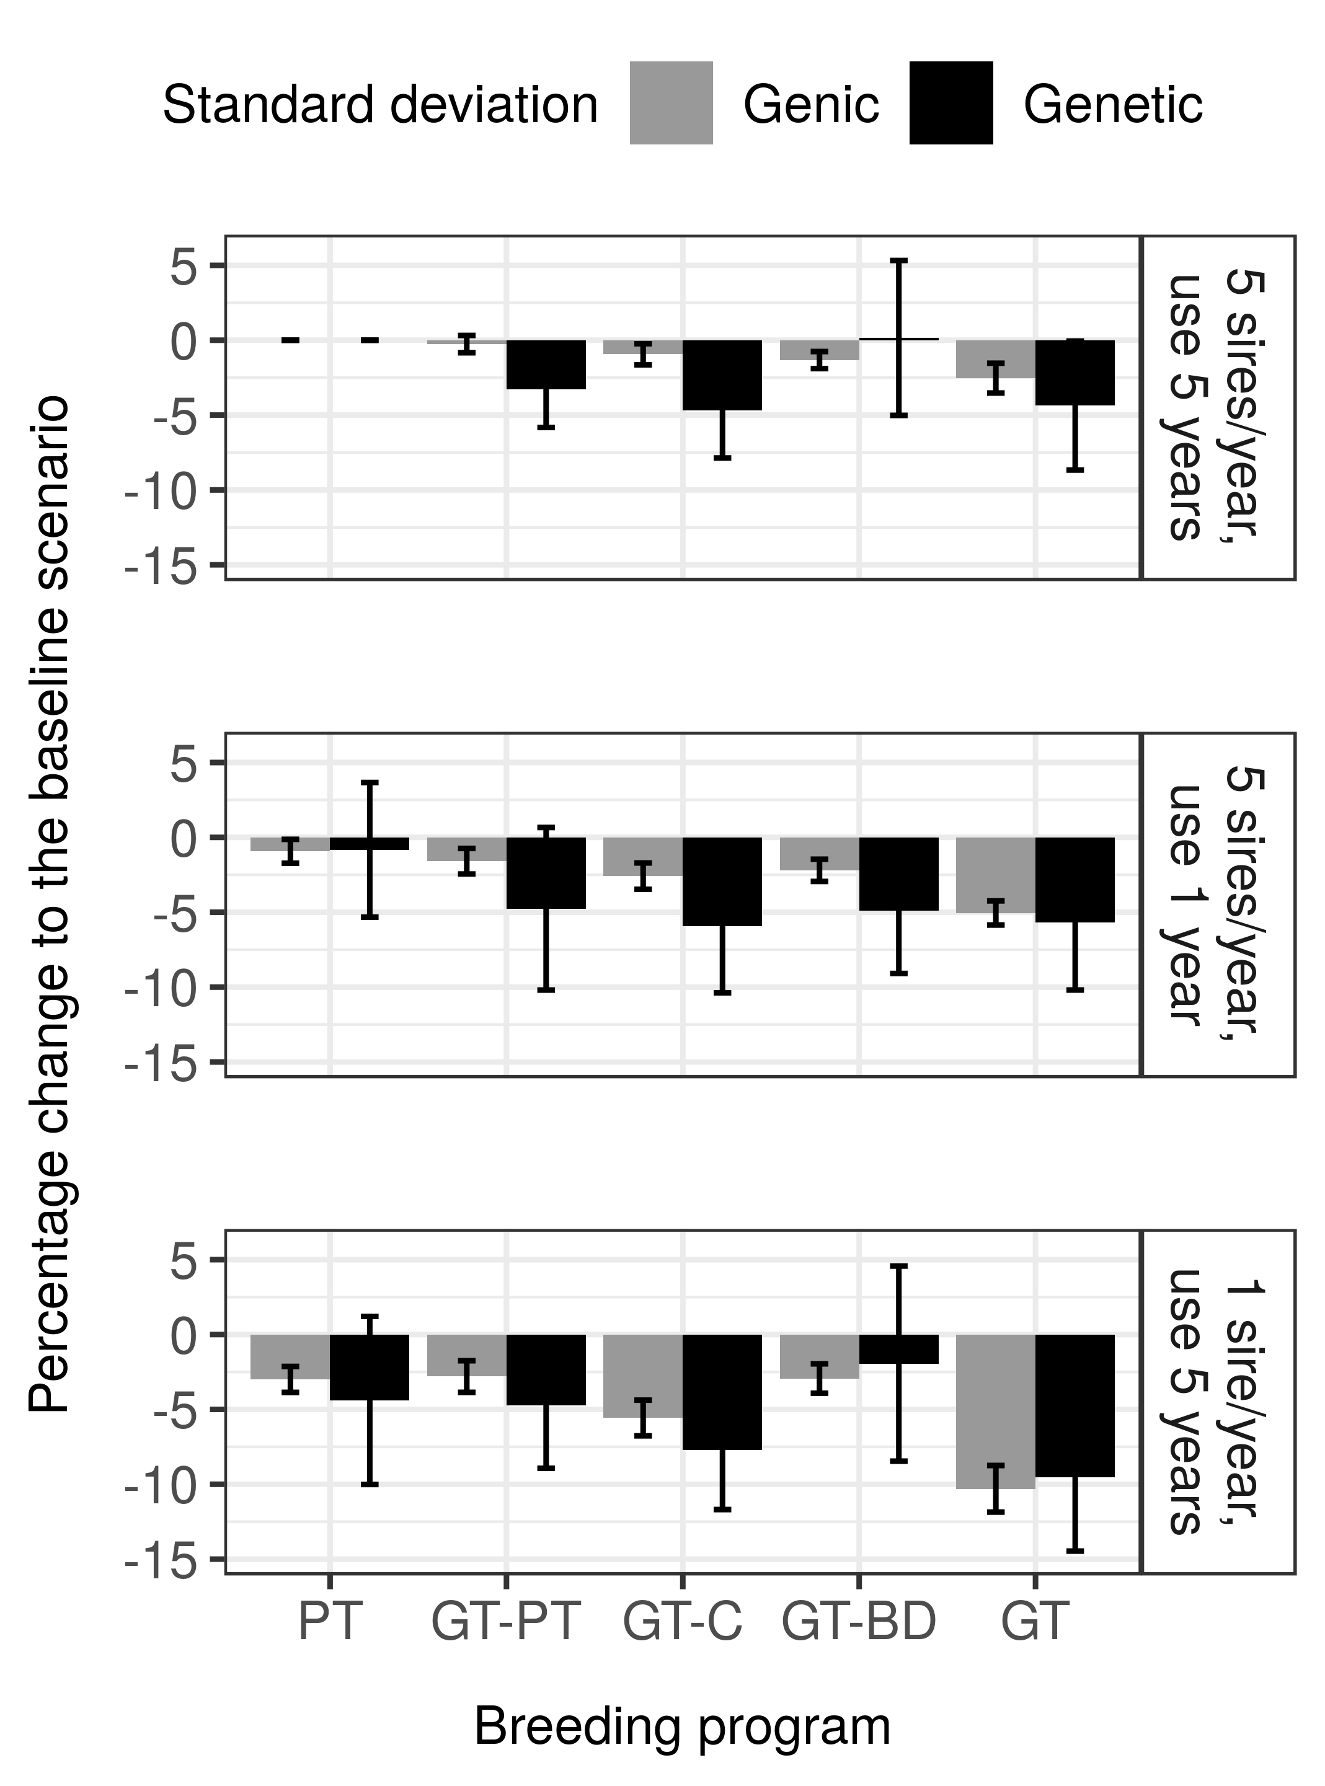
Figure 1: Genic and genetic standard deviation by breeding program and by sire selection and their usage scenario expressed as percentage change to the baseline scenario that had in the final generation genic standard deviation of 0.97 and genetic standard deviation of 0.94. PT = conventional progeny testing; GT-PT = genomic pre-selection of bulls for progeny testing, GT-C = genomic selection of bulls for the insemination of cows; GT-BD = genomic selection of bulls for the insemination of bull-dams; GT = genomic selection of bulls for the insemination of cows and bull dams.
Obšteter, 2
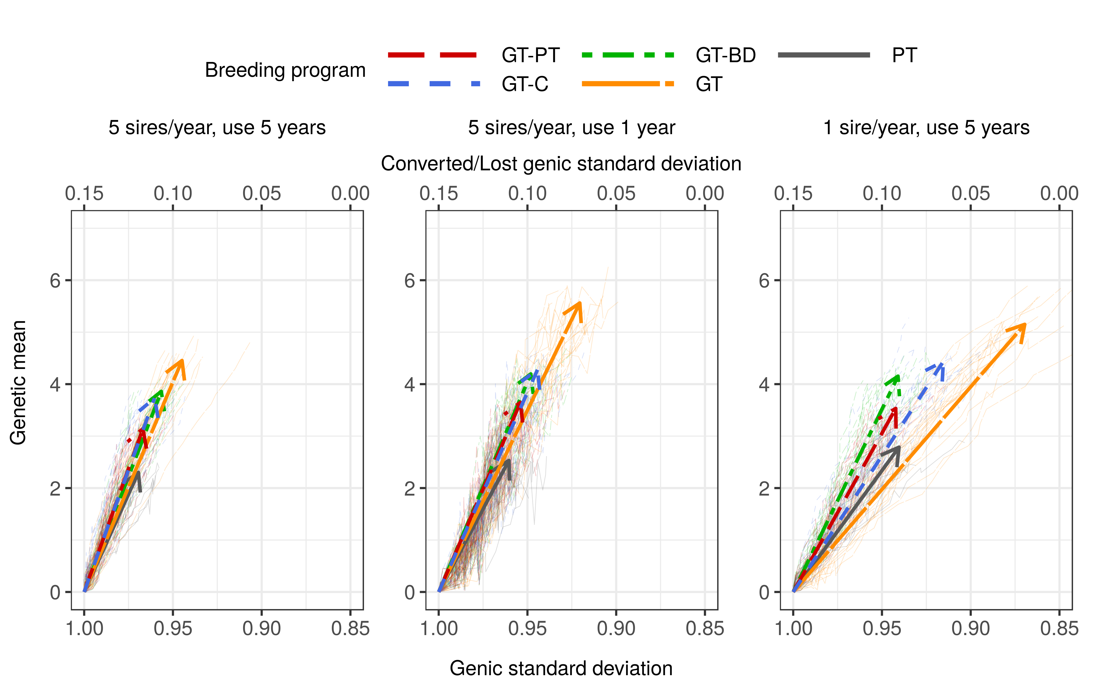
Figure 2: Change of genetic mean and genic standard deviation over the 20 years of selection by breeding program and by sire selection and their usage. Thin lines represent individual replicates, while thick lines represent average linear regression with arrows pointing in the direction of change. PT = conventional progeny testing; GT-PT = genomic pre-selection of bulls for progeny testing, GT-C = genomic selection of bulls for the insemination of cows; GT-BD = genomic selection of bulls for the insemination of bull-dams; GT = genomic selection of bulls for the insemination of cows and bull dams.
Obšteter, 3
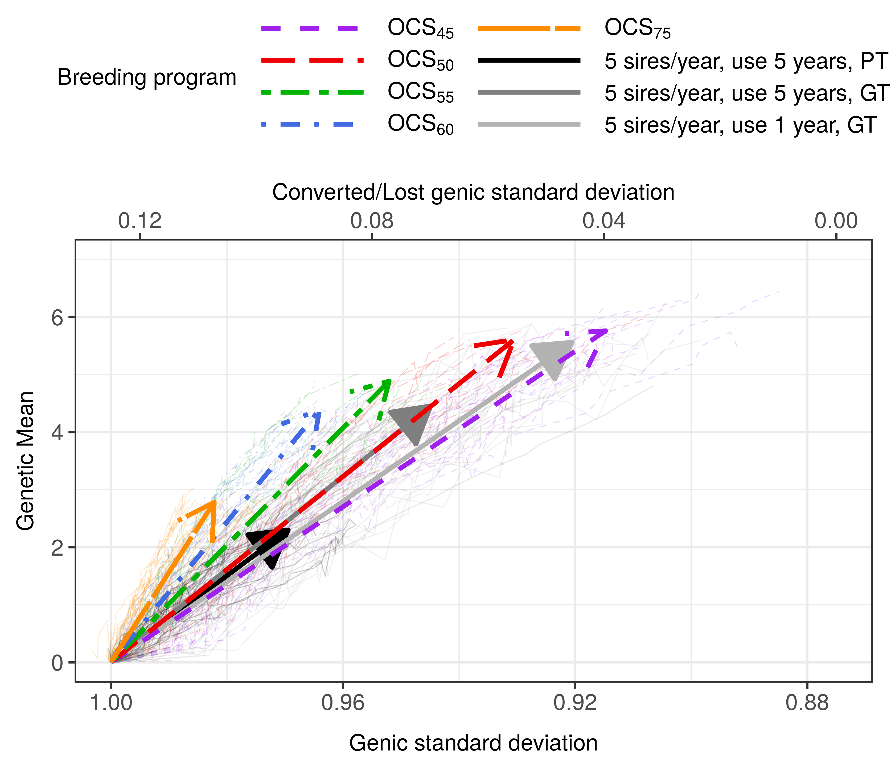

Figure 3: Change of genetic mean and genic standard deviation over the 20 years of selection for fixed or optimized breeding programs. Thin lines represent individual replicates, while thick lines represent average linear regression with arrows pointing in the direction of change. PT = conventional progeny testing; GT = genomic selection of bulls for the insemination of cows and bull dams; OCS_{X°} = optimum contribution selection of bulls for the insemination of cows and bull dams with the target degrees of X°.

