Testing different genomic selection scenarios in a small cattle population by simulation

J. Obšteter*, J. Jenko†, J. M. Hickey† & G. Gorjanc†

* Department of Animal Science, Agricultural Institute of Slovenia, Hacquetova ulica 17, 1000 Ljubljana, Slovenia
† The Roslin Institute and Royal (Dick) School of Veterinary Studies, The University of Edinburgh, Easter Bush, Midlothian, EH259RG, United Kingdom
cd
Jana Obšteter, Agricultural Institute of Slovenia, Department of Animal Science, Hacquetova ulica 17, 1000 Ljubljana, Slovenia
+386 1 280 51 34
jana.obsteter@kis.si (Corresponding Author)
Introduction (4000 characters words and spaces)
Genetic gain depends on four factors, namely accuracy, intensity, genetic variance for the trait and generation interval. With the exception of genetic variance, genomic selection (GS) can influence remaining three parameters. Choosing the parents (animals) based on their genomic breeding values (gEBVs) allows for an earlier selection compared to the conventional selection, where the parents (animals) are chosen based on conventional breeding values (EBVs) obtained after progeny testing (PT). GS hence reduced the generation interval that along with a higher accuracy of early selection decisions increases the genetic gain (Schaeffer, 2006). However, the genomic prediction requires a large reference population. Consequently small cattle populations encounter difficulties with implementation of GS due to lacking financial resources (support?) and a small number of PT reference bulls. The latter diminishes the gain in accuracy of genomic prediction compared to parent average (PA) estimates what in turn decreases the advantage of using genomic information (the advantage of genomic over conventional selection) (Thomasen et al,. 2014). Alternatively small cattle populations can participate in international associations for a joint genomic prediction with international reference population or they can include cows in the reference population. However, an information of a cow in the reference is not equal to the information of a PT bull, therefore a larger number of cows has to be included to achieve desired accuracies (de Roos, 2011).

As mentioned, GS can also reduce the generation interval. The degree of reduction depends on the strategy of using the genomic information in a breeding program: in which selection paths to use the genomic information and to what extent. Previous studies mainly tested the scenarios in which the genomic information is used either for a pre-selection of young bulls for progeny testing (so called GS-PS) or for the selection of genomically tested young bulls directly (so called turbo scheme) against the conventional scenario with progeny tested sires without the use of genomic information (Pryce et al., 2010; Lillehammer et al., 2011; de Roos et al., 2011). The studies observed that we can increase the genetic gain up to 30% by using genomic information for a pre-selection step and up to 195% by using genomic information directly for selection of young bulls and dams as parents (M=100%!!!, realistic – 40% → up to 108%).

Further on, Thomasen et al., 2014, deterministically explored hybrid schemes that simultaneously use both progeny tested and young genomically tested bulls which changes the generation interval to an intermediate degree. The study varied the proportion of bull dams and cows mated with young / progeny tested sires and inspected the resulting annual monetary genetic gain (AMGG). They concluded that even in small populations, the genomic scenario was economically and genetically superior to the conventional scenario that uses progeny testes sires. However, with low reliabilities the hybrid scheme brought the higher AMGG whereas with high reliabilities the turbo scheme was the most superior (Thomasen et al., 2014).

In addition to maximising the genetic gain, breeding schemes have to manage genetic variation to assure sustainability of selection. The aim is therefore to balance short- and long-term success of selection. While short-term success depends only on the genetic gain in the next (few) generation, long-term success enables increase of genetic gain after many generations of selection.

Some studies also focused onto how the use of genomic information affects inbreeding and obtained contradictory results. While some studies observed a decrease in inbreeding rate per year with the use of genomic information (Pryce et al., 2010; Lillehammer et al., 2011), the others observed and increase (de Roos et al., 2011). Although reducing the generation interval may increase annual inbreeding rate, managing inbreeding rate per generation is more important for avoiding inbreeding depression (Daetwyler et al., 2007). The reason for a lower rate of inbreeding with GS lies in a more accurate estimation of Mendelian sampling term – this results in lower co selection of siblings that reduces inbreeding rate per generation.

However, a combine measure of genetic gain and genetic variability is needed to assure long-term competitiveness of selection. Efficiency of converting genetic variance into genetic gain measures how successful a specific scheme is in achieving both goals (Gorjanc et al., 2017).

Although GS is a well established technology globally, small population still struggle with the adoption of the technology. Contrary to other parameters of GS, less work was done exploring how the use of genomic information in a breeding program affects genetic gain. Although the existed studies explored the genetic gain and / or inbreeding, questions remain about the optimal use of genomic information in small realistic cattle populations with overlapping generation that allow for a long-term success of selection. (LONG TERM, DETERMIISTIC; DISCRETE GENERATION, LARGE POPULATION). Also, studies mainly explored the use of genomic information for a pre-selection step or in a turbo scheme, but less work was done regarding the intermediate strategies. This study aimed to explore different strategies of the use of genomic information in small realistic cattle populations in order to determine the best one in terms of efficiency (the most efficient one).

Material and Methods
First we developed a simulator of a realistic cattle population under selection which included all selection steps and allowed for the user to define all the selection parameters. We compared five sire selection scenarios in which we varied the criterion for the selection of sires for insemination of bull dams and cows. Additionally we tested three sire use strategies with varying number of bulls chosen each selection cycle and years kept in use. All tested scenarios were compared based on the achieved genetic gain, change (loss?) of genetic variance and efficiency of selection.

Simulator of a cattle breeding program
We developed a simulator of a realistic cattle populations under selection. The simulator was written as a Python wrapper around AlphaSim (Faux et al., 2016) and blupf90 (Misztal et al., 2002) software. The simulator enabled for the user to set all the selection parameters: the percentage of animals selected at each stage in each selection path, age at selection, selection criterion for each selection path, number of offspring per parent, years in use and number of selection cycles. The simulation was a continuous process resulting in overlapping generation. In each selection cycle three steps were performed: estimation of EBVs, selection of parents and mating. Breeding values were estimated as described below. Selection was performed based on single trait BVs.

Simulated population
Genome consisted of ten chromosomes that included 20,000 SNPs from which 10,000 SNPs were chosen at QTNs for a polygenic trait with heritability of 0.25. The effects of the QTNs for each chromosome were drawn from a normal distribution. The simulated population mirrored Slovenian Brown-Swiss population participating in milk recording consisting of ~30,000 active individuals, ~10,000 of which cows. In total 60 generations were simulated with 8640 animals born each selection cycle. First 20 generations represented the burn-in population in which random mating was implemented. This was followed by 20 generations of conventional selection using PT bulls to achieve a population structure resembling a cattle population under selection. The last 20 generations implemented testing scenarios that differed in the use of genomic information in the male selection paths only.

Selection of females
Out of newborn females 1% was removed in their first year reflecting stillbirths and deaths occurring soon after birth. Out of these female calves 90% were inseminated in the second year and became cows in the third year. In each subsequent lactation we removed 20% of the cows and after the fourth lactation all cows were culled. This totaled to 10,653 active cows that were all screened for the trait and had their EBV estimated. In each generation 8550 cows with highest EBVs were chosen for mating. After the second completed lactation and estimation of EBVs, 43 cows with highest EBVs were chosen as bull dams. Bull dams were kept in use for three lactations, completing five lactations in total. From 129 bull dams 90 were chosen each year for contracted mated with sires of sires to produce new generation of selection candidates.

Selection of sires
Each year we obtained 45 male offspring from contracted matings. Sires were selected based on three overall strategies: a) progeny testing with pre-selection based on PAs (PT); b) progeny testing with pre-selection based on gEBVs (GS-PS); c) young genomically tested sires selected based on gEBVs (GS).

In the PT strategy, 27 out of 45 male candidates were randomly chosen for performance testing in their first year. In their second year 8/27 were chosen for progeny testing based on their PAs. In the sixth year 4/8 bulls were selected after obtaining progeny testing results. In the GS-PS strategy all 45 male candidates were genomically tested in their first year and 8/45 were chosen for progeny testing in their second year based on their gEBVs. In the sixth year 4/8 bulls were selected after obtaining progeny testing results. In the GS strategy all 45 male candidates were genomically tested in their first year and in their second year 5/45 were chosen as young sires based on their gEBVs.

The chosen candidates entered either progeny testing or genomic testing. Young bulls for progeny testing were pre-selected either based on the performance test and EBVs (which equal PA since they have no information) (PT) or based on their gEBVs (GS-PS).
a) performance testing - progeny testing: 60% (n=27) of male calves from contracted mating were randomly chosen for performance testing. The random choice reflects the realistic situation where the availability of male calves depends also on unpredictable human factors (where not all the best male calves are available for performance testing). In the second year 8/27 bulls were chosen for progeny testing. The non-chosen bulls were used in natural service as cow sires. After five years 4/8 progeny tested bulls were chosen as proven bulls.
b) genomic testing - progeny testing: all male calves from contracted mating were genomically tested in their first year. In the second year 8/45 bulls were chosen for progeny testing. The non-chosen bulls were used in natural service as cow sires. After five years 4/8 progeny tested bulls were chosen as proven bulls.
c) genomic testing: all male calves from contracted mating were genomically tested in their first year. In the second year 5/45 bulls were chosen as young sires. The non-chosen bulls were used in natural service as cow sires.

Tested scenarios
We created five testing scenarios by using different categories of sires (PT, GS-PS, GS) for insemination of cows and bull dams. The tested scenario included one conventional scenario without the use of genomic information and four genomic scenarios. PT scenario used PT sires exclusively for insemination of all cows and bull dams. Similarly, GS-PS scenarios used GS-PS sires exclusively for insemination of all females. Next we created two hybrid scenarios that used GS-PS and GS sires simultaneously. GS-C used young genomically tested sires for insemination of cow population and GS-PS sires for insemination of bull dams. Contrary, in GS-BD we used GS sires for the insemination of bull dams and GS-PS for insemination of cows. GS scenarios, also referred to as “turbo”, used exclusively young genomically tested bulls for insemination of all females.

Table 1: The five tested scenarios differing in sire category used for insemination of cows and bull dams.
PT | All females are inseminated with progeny tested bulls (preselected for progeny testing based on their EBVs (PAs)).
GS-PS | All females are inseminated with progeny tested bulls (preselected for progeny testing based on their gEBVs).
GS-C | Cows are inseminated with young genomically tested bulls and bull dams with progeny tested sires pre-selected based on their gEBVs.
GS-BD | Bull dams are inseminated with young genomically tested bulls and cows with progeny tested sires pre-selected based on their gEBVs.
GS | All females are inseminated with young genomically tested sires.
EBV = estimated breeding value, gEBV = genomic breeding value, PA = parent average

Sire use strategy
All five scenarios were tested within three sire use strategies. The original strategy reflected the situation in the simulated Slovenian Brown Swiss population where every year they select five bulls and keep them in use for five years (SU 5/5). In the next strategy we increased the intensity of selection for which we selected only one bull per year and kept him in use for five years (SU1/5). We also created a strategy in which we reduced the generation interval even further by selecting five bulls each year and replacing them all in the next year, i.e. kept them in use for only one year (SU5/1).

Estimation of breeding values
Breeding values were estimated using pedigree or single-step BLUP depending on whether the genomic information was available. In genomic scenarios we assumed a initial reference population of ~11,000 cows and 100 progeny tested sires for the genomic prediction. The reference population was updated each selection cycle by removing the oldest generation of cows and adding an equivalently large sample of cows from the currently active cow population to the reference. Each year all the male offspring of contracted mating were genotyped and added to the reference population.

Metrics of comparison
The scenarios were compared in terms of genetic gain per year (expressed with mean zero and in units of genetic standard deviation in the first generation of comparison) and efficiency averaged across 20 replicates. We defined the efficiency of selection as a regression of the achieved genetic gain on the amount of reduction of the genic standard deviation. We used the genic rather than the genetic standard deviation due to large fluctuations in the latter. When computing efficiency, both genetic gain and the genic standard deviation were standardised by the genic standard deviation in the first generation of comparison. Therefore, this efficiency metric indicates the potential genetic gain in units of genic standard deviation when all variation is converted into gain or lost due to drift. Results are presented as the mean of twenty replicates for each scenario on a per generation or cumulative basis.

Results and Discussion
Genetic Gain
The results for the genetic gain in the last generation of simulation / comparison (generation 60) of all scenarios within all three sire use strategies is shown in Table 2. The values for genetic gain are expressed relative to the genetic gain of PT scenario of the SU 5/5 strategy. As expected, the use of genomic information increases the genetic gain in all sire use strategies. This is due to higher accuracy for selection of young unphenotyped animals and reduction in generation interval. It is interesting that in this particular population we can substantially increase the genetic gain (up to 44%) by using genomic information for pre-selection of male calves for progeny testing only (GS-PS) – although the generation interval is not reduced. The reason for this lies in higher accuracy of the pre-selection step, since gEBV (mean r = 0.76) are more accurate than PA (mean r = 0.27). When we used GS sires for insemination of cow population (GS-C), we observed a reduction in generation interval in the sires of dams path up to 56% and between 53 and 65% increase in genetic gain. Similarly, when we used GS sires for insemination of bull dam population (GS-BD) – while cow population was inseminated with GS-PS bulls – we reduced generation interval up to 56% in the sires of sires selection path (56% in SU5/5, 46% in SU1/5 and 53% in SU5/1) and increased the genetic gain between 61 and 69%. This reveals that using young genomically tested bulls for insemination of bull dams and consequently as sires of sires results in a higher genetic gain than using them for insemination of cows (sires of dams). Lastly, the scenario that used exclusively GS sires resulted in the highest reduction in generation interval - up to 67% and 60% in the sire of sires and sires of dams selection path, respectively - and highest increase in genetic gain (between 88 and 120%). These results are in concordance with previous studies that observed a higher genetic gain with the use of genomic information for a pre-selection for PT or for selection of young sires (“turbo” scheme) (Pryce et al., 2010; Lillehammer et al., 2011; de Roos et al., 2011; Thomasen et al., 2014).

Changing the strategy of sire use affected genetic gain as well. Increasing the intensity of selection (SU15) and reducing the generation interval even further (SU51) both increased genetic gain. However, although we implemented a severely intensive selection by selecting one bull only in SU 1/5 strategy (increased the intensity of selection by 57%) (intensity 5 / 27 = 1.2664; 1/27 = 1.9962), we only observe up to 22% increase in genetic gain. In the SU 5/1 strategy, where the generation interval was reduced up to 41% compared to the corresponding scenarios in SU 5/5, the genetic gain was increased up to 32%.

Table 2: Genetic gain of tested sire use strategies and sire selection scenarios averaged across 20 replicates. The genetic gain is expressed relative to the genetic gain of the conventional scenario in SU5/5 strategy.
 |  | Sire use strategies
 |  | SU5/5 | SU1/5 | SU5/1
Sire selection  scenario | PT | 100% | 122% | 101%
Sire selection  scenario | GS-PS | 136% | 144% | 133%
Sire selection  scenario | GS-C | 153% | 162% | 165%
Sire selection  scenario | GS-BD | 160% | 161% | 169%
Sire selection  scenario | GS | 188% | 208% | 220%
PT = conventional scenario without use of genomic information; GS-PS = genomic information used for pre-selection of young bulls for progeny testing, GS-C / GS-BD / GS = genomically tested bulls used respectively for insemination of cows / bull dams / cows and bull dams. Sire use strategies: SU 5/5 = five bulls selected each year and used for five years, SU 1/5 = one bull selected each year and used for five years, SU 5/1 = five bulls selected each year and used for one year.

Genic variance
Here we report the results for genic variance due to large fluctuations of the genetic variation over the generations. The evolution of the genic variance for the tested scenarios is shown in Figure X. We notice that the strategy SU1/5 looses in general looses the most genic variance which is a consequence of the high selection pressure for sire selection in this strategy. Also, completely genomic scenario (Genomic D) looses the most genic variance in all sire use strategies. We attribute this to a faster turn-over of the generations.
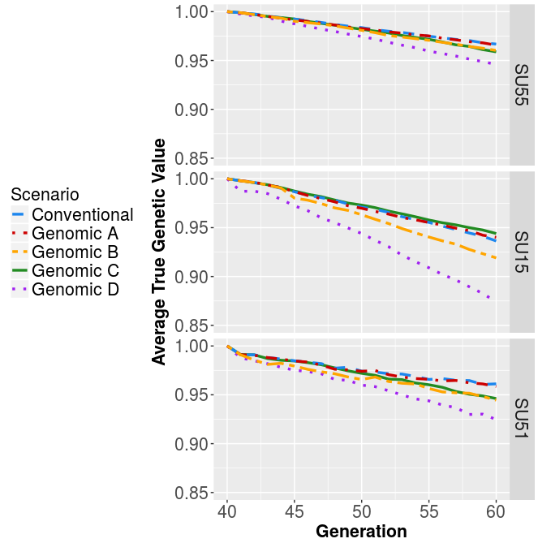
Figure: Genic variance for the five tested sire selection scenarios within the three sire use strategies averages across 20 replicates. Genomic A = genomic information used for selection of young bulls for progeny testing, genomic B / C / D = genomically tested bulls used respectively as sires of dams / as sires of sires / as sires of dams and sires of sires. Sire use strategies: SU 5/5 = five bulls selected each year and used for five years, SU 1/5 = one bull selected each year and used for five years, SU 5/1 = five bulls selected each year and used for one year.

Selection efficiencies
Selection efficiencies for five scenarios tested within three sire use strategies are shown in Figure 1. First we compared the efficiencies of the scenarios in the SU 5/5 strategy (Figure 1a). We observed that efficiencies do not follow the pattern of genetic gain. The efficiencies range between 71 and 100 with small differences between the scenarios (efficiency of e.g. 71 means that when we burn all the genic variance we will reach genetic gain of 71 units). The PT scenario was the least efficient one and the most comprehensive genomic scenario (GS) was not the most efficient one. Only some of the differences were significant, i.e. between GS-PS, GS-C and GS-BD with PT scenario with p-values of 0.00, 0.008 and 0.000, respectively. Additional significant differences were between GS-BD and GS scenario (p-value = 0.026) and between GS-PS and GS (p-value = 0.048). Although not all differences were significant, the PT scenario was the least efficient in 10 / 20 replicates and in other 10 / 20 it was the second least efficient. GS scenario was the most efficient only in 2 / 20 replicates. The most efficient in SU 5/5 were genomic scenarios GS-S and GS-BD, which were the most efficient in 7 / 20 and 6 / 20 replicates, respectively. We attribute that to a greater spread of sires EBV

The results suggest that schemes that use progeny tested and young genomically tested bulls simultaneously are the most efficient one and therefore most appropriate for a long-term sustainability of selection (genetic gain?) – although they do not bring the highest genetic gain. We explain this by a greater spread of the true BVs of the PT sires due to a higher accuracy of their EBVs. Hence this hybrid schemes loose less genetic (genic) variance resulting in higher efficiencies.

Next we compared selection efficiency between the sire use strategies. Increasing the intensity of selection increased the differences between efficiencies of the scenarios (SU 1/5) which ranged from 39 to 68. The efficiencies were overall reduced compared to the SU 5/5 strategy which is due to a larger loss in genetic variance caused by selecting only bull per year (up to 8% larger loss in genic SD, SU55 – 0.95, SU1/5 – 0.87). The genomic scenario became the least efficient due to the largest loss in genic variance. We fixed this problem by selecting five bulls again in the SU 5/1 strategy. The plot of efficiencies in the SU5/1 strategy (Figure 1c) resembles more the one of the original SU 5/5 strategy (Figure 1a) since the differences between the scenarios are again decreased. However, the efficiency is still reduced – ranges from 60 to 72 – due to larger loss in genetic variance (up to ). We attribute this to a 0.1 unit drop in accuracy compared to SU 5/5 strategy, which we believe is due to a larger genetic distance between the training and the testing population. This together suggests that increasing the intensity of selection and reducing the generation interval even further has different consequences on short and long-term success of selection (genetic gain). Although both these strategies increase genetic gain they also loose more genic variance and decrease the efficiencies.
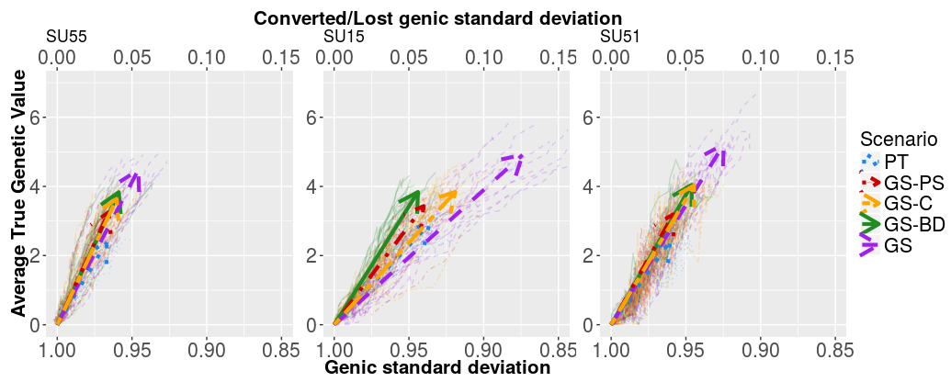
Figure 1: Change of genetic mean and genic standard deviation over the 20 years of selection
by sire selection scenario within sire use strategies averaged across 20 replicates.
Arrows point the direction of change. Sire selection strategies: conventional = only progeny tested bulls (no genomic information), PT = conventional scenario without use of genomic information; GS-PS = genomic information used for pre-selection of young bulls for progeny testing, GS-C / GS-BD / GS = genomically tested bulls used respectively for insemination of cows / bull dams / cows and bull dams. Sire use strategies: SU 5/5 = five bulls selected each year and used for five years, SU 1/5 = one bull selected each year and used for five years, SU 5/1 = five bulls selected each year and used for one year.

Conclusion
In summary, applying different strategies of the use of genomic information and sires has different effect on short- and long-term selection success. While a more comprehensive use of genomic information, increased intensity of selection and an additional reduction in generation interval all increase genetic gain, all these strategies also result in a higher loss of genic variation and consequently reduced efficiencies. The optimal strategy for a specific small cattle population therefore depend on their risk preferences and selection goals.

