Optimal investment in phenotyping and genotyping in dairy breeding

Jana Obšteter^{1*}, Janez Jenko², John M. Hickey³, and Gregor Gorjanc^{3,4}

¹Department of Animal Science, Agricultural Institute of Slovenia, Hacquetova ulica 17, 1000 Ljubljana, Slovenia
²Geno Breeding and A.I. Association, Storhamargata 44, 2317 Hamar, Norway
³The Roslin Institute and Royal (Dick) School of Veterinary Studies, University of Edinburgh, Easter Bush, Midlothian, EH259RG, United Kingdom
⁴Biotechnical Faculty, University of Ljubljana, Jamnikarjeva 101, 1000 Ljubljana, Slovenia

*Jana Obšteter, Agricultural Institute of Slovenia, Department of Animal Science, Hacquetova ulica 17, 1000 Ljubljana, Slovenia

E-mail addresses:
J. O.: jana.obsteter@kis.si
J. J.: janez.jenko@geno.no
J. M. H.: john.hickey@roslin.ed.ac.uk
G. G.: gregor.gorjanc@roslin.ed.ac.uk

Abstract
Background: the context and purpose of the study
Results: the main findings
Conclusions: a brief summary and potential implications

Background
This paper evaluates the potential of maximizing genetic gain in dairy cattle breeding programs by optimizing allocation of limited financial resources for phenotyping and genotyping. All breeding programs strive to maximize the genetic gain, which is a function of selection intensity, accuracy of selection, genetic variation and generation interval. The introduction of genomic selection [1, 2] (Meuwissen et al., 2001; Schaeffer, 2006) doubled the rate of genetic gain in dairy cattle [3](Wiggans et al., 2017), primarily by reducing the generation interval, increasing selection intensity, and increasing the accuracy of selection for young animals. As shown in previous work, genomic selection increases genetic gain compared to conventional selection, despite lower accuracy of selection. This suggests that the effect of shorter generation interval dominates over the effect of lower accuracy [2, 4](Schaeffer, 2006; Obšteter et al., 2019). While the generation interval can only be manipulated with age at which we select the animals, the accuracy of selection can be manipulated with more parameters, such as the method of estimation and the amount of data collected. The two measures are intertwined, since we require sufficient accuracy to make selection decisions. Hence, finding a balance between the two is crucial for an efficient selection. Further more, if some parameters may increase genetic gain more than the others, should we (allocate the funds accordingly and) invest more time and resources into changing the more influential parameters?

Accuracy of pedigree-based evaluation
The accuracy of pedigree-based breeding values for a given trait increases with increasing heritability and the number of phenotype records per animal (e.g., [5]Mrode, 2005). Replicated phenotype records also enable the estimation of individual’s permanent effect due to non-additive genetic or individual specific environmental effects. For example, assume a female-expressed trait with heritability of 0.25 and repeatability of 0.35, and accuracy of sire EBVs of 0.95. If we record one phenotype value per cow, the accuracy of its EBV is 0.50, while the accuracy of the parent average for the un-phenotyped cow would be 0.54. If we increase the number of phenotype values per cow to 2, 5, or 11, the accuracy of its EBV increases respectively to 0.61, 0.72, or 0.78, and the accuracy of parent average increases respectively to 0.56, 0.60, or 0.62. For a bull with 100 daughters these increases are marginal, since with one phenotypic value per cow the accuracy of its EBV is already 0.97. Collecting 5 or 11 records per cow increases the accuracy to 0.98.

Accuracy of genome-based evaluation
The accuracy of genomic breeding values for a given trait and a population structure increases primarily with increasing size of a training population of phenotyped and genotyped animals, heritability of the training phenotypes, and the number of effective genome segments (M_{e}) ([6–8]Daetwyler et al. 2008; Goddard, 2009; Goddard et al., 2011).

According to Daetwyler et al. (2008) [6] formula, the accuracy of genomic prediction depends only on the heritability, the number of animals in the training population, and M_{e}. Following the previous example, assume the M_{e} of 10,000. With 10,000 cows phenotyped once, the hleritability of our reference phenotypes is 0.25 and with a training population of 10,000 cows, we achieve the accuracy of 0.45 for un-phenotyped animals. On the other hand, the accuracy of genomic prediction with 1,000 cows in the training population, each phenotyped 10 times (the heritability of reference phenotypes is 0.60) is 0.24. As demonstrated, increasing the number of phenotypic records increases the accuracy in a diminishing manner, which shows a scope for optimization.

However, genomic prediction does not exploit all the available information, since it does not use the phenotypes of the un-genotyped animals. Combining all phenotypic, pedigree, and genomic information through a single-step genomic BLUP (ssGBLUP) increases the accuracy for un-genotyped as well as genotyped animals even further ([9–11] Gray et al., 2015; Gray et al., 2012; Gao et al., 2012).

Drop in accuracy without updating training population
The accuracy of genomic prediction depends on the persistence of linkage disequilibrium (LD) among markers and causal loci between training and prediction animals. Recombination, selection, mutation, migration and drift change LD, which decreases the accuracy of prediction across generations ([12]Calus, 2010), when the training population is not updated. While the accuracy of genomic prediction decays slower than of pedigree prediction ([13, 14]Habier et al., 2010; Wolc et al., 2011), we still observe a substantial decrease. To prevent the drop in the accuracy, marker effects must be continually re-estimated and the training population must be continually updated with new animals.

Milk recording
In dairy breeding programs, the most extensively recorded phenotypes are milk production traits. There are different milk recording methods that differ in the responsibility for recording, sampling scheme, recording frequency, sampling frequency and the number of milkings per day ([15]ICAR, 2017). The sampling methods vary in the number of milkings per day, the amount of sample collected, and in applied corrections. The recording interval ranges from daily recording to recording every nine weeks, which translates to between 5 and 44 recordings per lactation. The prices of milk control differ between recoding systems, countries, and their regions. Some organizations require payment of a participation fee plus the price per sample, while others include the fee in the sample price or do not require the fee at all.

Investment in data recording to support selection decisions
As already mentioned, the estimation of breeding values requires financial resources for the collection of data. Breeding programs have to assure continuous cash inflow, since the data has to be updated to maintain high accuracy of prediction. While the funding for phenotyping is usually secured in breeding programs, the funding for genotyping is not yet well established to initiate and / or regularly update the training population for genomic prediction. Internal reallocation of resources seems like (the only) viable option. However, breeding programs constitute of many crucial actions, many of them can not be manipulated with or omitted. Since increasing the number of phenotypic records increases the accuracy in a diminishing manner, repeated measurements of the phenotype identifies as a plausible candidate for a reduction and financial reallocation.

Aim
The aim of this paper was to evaluate the potential of maximizing genetic gain in dairy cattle breeding programs by optimizing allocation of resources for phenotyping and genotyping.

Methods
The study aimed to investigate the effect of different allocation of financial resources between phenotyping and genotyping in a simulated breeding program. The simulation mimicked a real dairy cattle population of ~30,000 animals with ~10,500 cows. We simulated a milk production trait with heritability of 0.25 and repeatability of 0.5. Breeding values were estimated with a pedigree or single-step genomic repeatability model with permanent environment and herd year as random effects. We evaluated 36 genomic scenarios against a baseline conventional scenario, all with equal amount of financial resources, but varying extent of phenotyping and genotyping. The baseline scenario was a conventional scenario with progeny testing and 11 recordings of phenotype per lactation, while genomic scenarios implemented reduced phenotyping and reallocated the corresponding saved resources to genotyping. The genomic scenarios differed in i) whether an initial training population was available; ii) the ratio of the price of phenotyping ($P) vs the price of genotyping ($G); iii) the number of phenotype records per cow per lactation. All tested scenarios were compared based on their genetic gain and accuracy of selection.

Simulation of the base population, phenotype and historical breeding.
The simulation mimicked a real dairy cattle population of ~30,000 animals with ~10,500 cows. The detailed parameters of the simulation are described in [4]Obšteter et al. (2019). In summary, we selected 3849 out of 4320 newborn females as dams of dams and 139 as dams of sires during their second, third and fourth lactation. In the conventional scenarios, 8 out of 45 selection candidates were chosen for progeny testing and 4 were chosen as AI bulls. In the genomic scenarios, 5 out of all tested male calves, the number depending on the scenario, were chosen as AI bulls. In all scenarios, 22 non-selected selection candidates were used in natural service.

We used a coalescent process to simulate whole genome comprised of 10 cattle-like chromosomes, each with 10⁸ base pairs, 1000 randomly chosen causal loci and 2000 randomly chosen marker loci. The causal loci were assigned normally distributed effects and constituted animal’s breeding value (a_{i}) for a milk production trait (y_{ijkl}) with heritability 0.25, which was additionally influenced by animals’ permanent environment (p_{i}), herd (h_{j}), herd-year (hy_{jk}), herd-test-day (htd_{jkl}), and residual (e_{ijkl}) effects:
y_{ijkl} = a_{i} + p_{i} + h_{j} + hy_{jk} + htd_{jkl} + e_{ijkl}.
Permanent environment effects were sampled from a normal distribution with zero mean and variance σ_{A}, herd, herd-year and herd-test-day effects were each sampled from a normal distribution with zero mean and variance 1/3 σ_{A}, while residual effects were sampled from a normal distribution with zero mean and variance σ_{A}. This resulted in a trait repeatability of 0.5. With the simulated genome and phenotype architecture we have initiated a dairy cattle breeding program with corresponding groups of animals and ran 20 years of a conventional selection with progeny-testing and collecting 11 phenotype records per lactation. All selection decisions were based on pedigree-based estimates of breeding values. The 20 years have represented historical breeding and provided a starting point for evaluating future breeding scenarios, which were run for additional 20 years.

Estimation of breeding values.
Breeding values were estimated with a pedigree or single-step genomic repeatability model with permanent environment and herd year as random effects. Breeding values were estimated once per year with blupf90 [16](Misztal et al, 2002) and its default settings for matrix construction. The phenotypic records accumulated through the years and were not removed from the estimation. Regarding pedigree, we included all active, phenotyped or genotyped animals and additional three generations of their ancestors.

Scenarios
We evaluated 36 genomic scenarios against a baseline conventional scenario, all with equal amount of financial resources, but varying extent of phenotyping and genotyping. The baseline scenario was a conventional scenario with progeny testing and 11 recordings of phenotype per lactation, corresponding to the standard ICAR recording interval of 4 weeks (ICAR, 2017). The total financial resources available equaled to the cost of phenotyping in the baseline scenario. In contrast, we created genomic scenarios that divided the total resources between phenotyping and genotyping. In the genomic scenarios we reduced phenotyping and reallocated the corresponding saved resources to genotyping. The genomic scenarios differed in i) whether an initial training population was available. In the former case, a training population of all active cows (10,653) was assumed. This mimicked the existence of international training populations. In the case of non-existing initial training population, only females were genotyped until the training population reached a size of 2000. Once reaching this goal, the animals were genotyped as specified in Table 1. ii) the ratio of the price of genotyping ($G) vs the price of phenotyping ($P). The price of one genotype was compared to the price of one-lactation recording with 11 recordings (recording every four weeks). We considered three ratios of $G:$P i. e. 1:1, 2:1, and 1:2. The ratios were created by inspecting the milk recording pricing systems of some of the world’s largest breeding or private organizations. The pricing of every additional milk recording decreased, hence the first recording was the most expensive and the price of each subsequent control was 95% of the preceding control. iii) the number of phenotype records per cow per lactation. Scenarios followed the official ICAR standard recording intervals for milk recording. The baseline conventional scenario recorded 11 phenotypic values per cow per lactation, corresponding to the standard ICAR recording interval of 4 weeks. Genomic scenarios implemented reduced phenotyping following ICAR standards of 9, 8, and 5 recordings per lactation, corresponding to recording interval of 5, 6, and 9 weeks. Additionally, we created three non-standard recording systems collecting 10, 2 and 1 phenotypic values per lactation. This created different scenarios, since the reduction in phenotyping dictated the funds available for genotyping. We named the scenarios as “C” / “G” for conventional or genomic selection followed by the number of phenotype recordings.

The extent of genotyping in genomic scenarios therefore corresponded to the reduction in the number of phenotypic records and the ratio of the price of phenotyping and genotyping ($P:$G). The obtained funds were distributed for genotyping females and males in ratio 7:1. The genotyped females were selected from the first parity cows and their genotypes were used for updating the reference population. The males for genotyping were selected from the newborn male calves, prioritizing the offspring of elite matings and selecting the rest based on their parent average, and their genotypes were used to predict the gEBV for selection decisions. If the funds allocated to genotyping females exceeded the number of available first parity cows, all first parity cows were genotyped and funds were not reallocated to male genotyping. In the training population, the genotypes of cows and progeny tested bulls accumulated and none were removed up to 25,000 animals. After reaching this number, only the latest females were included into the training population and the oldest genotyped animals were removed from the training population.
Since the selection intensity in the dams of dams selection path is very low and the dams of sires are selected after the collection of their own phenotypes, it was reasonable so assume that the female genotypes are mostly used to update the training population, whereas the male genotypes are used for predicting the gEBV and selecting the best individuals.

Table 1. The number of genotyped animals per year by scenario and by (phenotype vs.) genotype price.
Price ratio | Scenario
Price ratio | G10 | G9 | G8 | G5 | G2 | G1
$P:$G = 1:2 | 160 F  22 M | 350 F  50 M | 590 F  85 M | 1610 F  235 M | 3230 F  465 M | 3850 F  565 M
$P:$G = 1:1 | 310 F  45 M | 700 F  100 M | 1180 F  165 M | 3230 F  465 M | 3850 F  925 M | 3850 F  1125 M
$P:$G = 2:1 | 620 F  90 M | 1400 F  295 M | 2360 F  335 M | 3850 F  925 M | 3850 F  1845 M | 3850 F  2245 M
The number of genotyped female (F) and male (M) animals by the ratio of the phenotyping versus genotyping ($P:$G) price and by scenario.

Analysis of scenarios
All tested scenarios were assumed to have an equal amount of financial resources and were compared based on their genetic gain and accuracy of selection. Genetic gain was measured as an average true breeding value of individuals born in a certain year. It was standardized to reflect the deviation from the average true breeding value of the individuals in the first year of comparison in the units of genetic standard deviation. Accuracy of breeding values was measured as a correlation between the true and estimated breeding values. We repeated simulation of the base population and each scenario 10 times.

Results
The results compare the impact of alternative allocation of financial resources between phenotyping and genotyping in terms of the genetic gain and prediction accuracy. Additionally, we tested the impact of an existing or non-existing training population for genomic prediction. Despite reduced phenotyping, genomic scenarios with an existing initial training population increased the genetic gain of the baseline conventional scenario by 143%. Genetic gain increased with increasing the investment into genotyping, hence more animals genotyped. Compared to the baseline, implementing genomic selection also increased the accuracy for un-phenotyped selection candidates. Removing the initial training population did not change the overall trends for genetic gain or prediction accuracy. However, although it resulted in slightly smaller genetic gain due to a delay in the implementation of genomic selection, it still increased the genetic gain of the baseline up to 133%.

Genetic gain with an initial training population

Table S1. The impact of scenario and price of genotyping on genetic gain with initial training population.
Scenario | Ratio of price of phenotyping ($P) and price of genotyping ($G)
Scenario | $P:$G = 1:2 | $P:$G = 1:1 | $P:$G = 2:1
C11 | 3.01_{0.22}^{a,A} | 3.01_{0.22}^{a,A} | 3.09_{0.22}^{a,A}
G10 | 5.43_{0.20}^{b, A} | 5.41_{0.29}^{b, A} | 6.50_{0.20}^{b, B}
G9 | 5.58_{0.26}^{b, A} | 6.30_{0.17}^{c, B} | 7.02_{0.24}^{c, C}
G8 | 6.35_{0.25}^{c, A} | 6.62_{0.25}^{d, B} | 7.02_{0.17}^{c, C}
G5 | 6.78_{0.21}^{d, A} | 7.07_{0.20}^{e, B} | 7.26_{0.19}^{c, B}
G2 | 7.13_{0.29}^{e, A} | 7.33_{0.26}^{e, A} | 7.28_{0.17}^{c, A}
G1 | 7.11_{0.16}^{e,A} | 7.27_{0.28}^{e, A} | 7.24_{0.22}^{c,A}
Genetic gain of the conventional and genomic scenarios by the ratio of the phenotyping versus genotyping ($P:$G) price when initial training population is available. TP = training population, scenarios are named “C” / “G” for conventional / genomic, followed by the number of phenotype recordings per lactation. Subscript numbers indicate standard deviation across simulation replicates. Lower-case letters denote statistically significant differences between scenarios within the same $P:$G and upper-case letters between different $P:$G within the same scenario.

With the same amount of differently distributed financial resources, genomic scenarios with an initial training population available increased the genetic gain of baseline (conventional) scenario between 79% and 143%, despite reduced phenotyping. In general, genetic gain increased with increasing number of genotyped animals, hence more funds reallocated from phenotyping to genotyping. This is shown in Figure 1 and Table S1, that present the genetic gain of different scenarios by the ratio between the price of genotyping and phenotyping, when an initial training population is available. When the price of phenotyping equaled the price of genotyping ($P:$G = 1:1), the genomic scenarios increased the genetic gain of the baseline between 79% and 143%. By removing one phenotype recording, hence collecting 10 phenotype records per lactation (G10), we saved funds to genotype 355 animals, 45 of those male candidates. Compared to the baseline, this increased the intensity of male selection from 0.73 to 1.65 and increased the genetic gain by 79% (from 3.01 to 5.41). Removing two or three phenotype recordings, i.e. collecting nine or eight phenotype values per lactation (G9, G8), enabled the genotyping of 800 or 1345 animals per year, of those 100 or 165 male candidates. This increased the intensity of male selection to 2.02 or 2.2 and genetic gain by 109% or 120% (from 3.01 to 6.30 or 6.62). The highest genetic gain between 135% and 143% increase (between 7.07 and 7.33) was achieved when collecting five, two or one phenotype values per lactation. This saved funds for genotyping all (3850) or close to all (3230) females and between 465 and 1125 male candidates per year, resulting in the intensity of male selection between 2.63 and 2.93.

We observed a similar trend for genetic gain when the genotype was half or twice the price of phenotype. Changing the price of the genotype had the largest effect on scenarios with the smallest amount of genotyping (G10). In this scenario, when genotype was twice or half the price of phenotype, we genotyped 182 or 710 animals, 22 or 90 of those were male candidates, and increased genetic gain for 80% (from 3.01 to 5.43) or 116% (from 3.01 to 6.50). When we maximized the investment into genotyping (G1), we genotyped all females at all three price ratios and between 565 and 2245 male candidates. Correspondingly we achieved a comparable maximum increase in genetic gain between 136% and 143% (from 3.01 to 7.11 or to 7.24), regardless the price of genotyping and different intensities of male selection.

Figure 1 The impact of scenario and price of genotyping on genetic gain and training population growth.
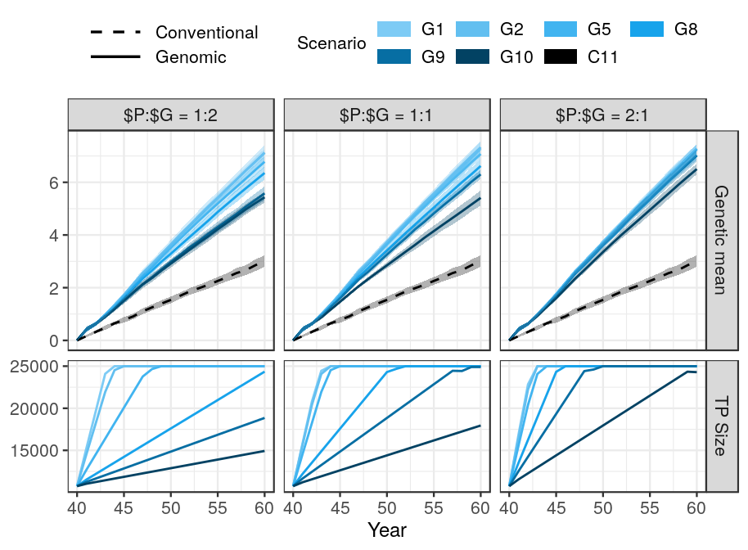
Legend: Genetic gain of the scenarios and size of the training population for genomic prediction by by the ratio between the price of phenotyping and the price of genotyping ($P:$G). An initial training population of all active cows and progeny tested sires was available. All scenarios had equal amount of financial resources differently split between phenotyping and genotyping. The genetic gain of the conventional scenario does not depend on the $P:$G, hence it is the same in all three $P:$G ratios. TP = training population, scenarios are named “C” / “G” for conventional / genomic, followed by the number of phenotype recordings per lactation.

Accuracy of the scenarios with initial training population

Table S2 Selection accuracy by scenario, price of genotyping, and availability of initial training population.
 | The ratio between the price of phenotyping ($P) and the price of genotyping ($G)
Scenario | $P:$G = 1:2 |  | $P:$G = 1:1 |  | $P:$G = 2:1
Scenario | With initial TP | Without initial TP | With initial TP | Without initial TP | With initial TP | Without initial TP
Male candidates
C11 | 0.37_{0.04}ª | 0.37_{0.04}ª | 0.37_{0.04}ª | 0.37_{0.04}ª | 0.37_{0.04}ª | 0.37_{0.04}ª
G10 | 0.89_{0.03}^{b} | 0.81_{0.03}^{b *} | 0.90_{0.02}^{b} | 0.84_{0.01}^{b *} | 0.91_{0.01}^{b} | 0.87_{0.01}^{b *}
G9 | 0.90_{0.03}^{b} | 0.85_{0.02}^{c *} | 0.91_{0.02}^{b} | 0.87_{0.01}^{bc *} | 0.91_{0.01}^{b} | 0.90_{0.01}^{bc *}
G8 | 0.91_{0.01}^{b} | 0.86_{0.01}^{cd *} | 0.91_{0.01}^{b} | 0.89_{0.01}^{c *} | 0.91_{0.01}^{b} | 0.90_{0.01}^{bc}
G5 | 0.91_{0.01}^{b} | 0.90_{0.01}^{d} | 0.91_{0.00}^{b} | 0.91_{0.01}^{c} | 0.91_{0.01}^{b} | 0.91_{0.01}^{c}
G2 | 0.91_{0.01}^{b} | 0.90_{0.01}^{d} | 0.91_{0.00}^{b} | 0.90_{0.01}^{c} | 0.90_{0.01}^{b} | 0.90_{0.01}^{bc}
G1 | 0.89_{0.01}^{b} | 0.89_{0.01}^{cd} | 0.90_{0.01}^{b} | 0.89_{0.01}^{c} | 0.89_{0.01}^{b} | 0.89_{0.01}^{bc}
Female candidates
C11 | 0.45_{0.02}ª | 0.45_{0.02}ª | 0.45_{0.02}ª | 0.45_{0.02}ª | 0.45_{0.02}ª | 0.45_{0.02}ª
G10 | 0.48_{0.01}^{ab} | 0.46_{0.02}^{ab *} | 0.48_{0.01}^{ab} | 0.47_{0.02}^{ab} | 0.51_{0.01}^{b} | 0.49_{0.01}^{b *}
G9 | 0.49_{0.02}^{b} | 0.47_{0.02}^{ab *} | 0.50_{0.01}^{b} | 0.49_{0.02}^{bc} | 0.52_{0.01}^{b} | 0.52_{0.01}^{bc}
G8 | 0.51_{0.01}^{b} | 0.49_{0.02}^{bc *} | 0.51_{0.01}^{b} | 0.52_{0.01}^{cd} | 0.54_{0.01}^{bc} | 0.53_{0.01}^{cd}
G5 | 0.51_{0.01}^{bc} | 0.52_{0.01}^{cd} | 0.55_{0.01}^{c} | 0.55_{0.01}^{de} | 0.57_{0.01}^{c} | 0.57_{0.01}^{d}
G2 | 0.55_{0.01}^{cd} | 0.55_{0.01}^{d} | 0.57_{0.01}^{c} | 0.56_{0.02}^{e} | 0.57_{0.01}^{c} | 0.57_{0.01}^{d}
G1 | 0.56_{0.01}^{d} | 0.55_{0.01}^{d} | 0.56_{0.01}^{c} | 0.56_{0.01}^{e} | 0.56_{0.01}^{c} | 0.56_{0.01}^{d}
Mothers
C11 | 0.48_{0.03}ª | 0.48_{0.03}ª | 0.48_{0.03}ª | 0.48_{0.03}ª | 0.48_{0.03}ª | 0.48_{0.03}ª
G10 | 0.56_{0.02}^{b} | 0.53_{0.01}^{b *} | 0.59_{0.02}^{b} | 0.56_{0.01}^{b *} | 0.63_{0.01}^{b} | 0.61_{0.01}^{b *}
G9 | 0.59_{0.03}^{bc} | 0.57_{0.02}^{bc *} | 0.63_{0.02}^{c} | 0.62_{0.02}^{c} | 0.70_{0.01}^{c} | 0.68_{0.02}^{c *}
G8 | 0.62_{0.02}^{c} | 0.60_{0.02}^{c *} | 0.67_{0.02}^{c} | 0.66_{0.01}^{d} | 0.74_{0.02}^{d} | 0.73_{0.02}^{d}
G5 | 0.70_{0.02}^{d} | 0.69_{0.02}^{d} | 0.77_{0.01}^{d} | 0.76_{0.01}^{e} | 0.79_{0.02}^{e} | 0.78_{0.02}^{e}
G2 | 0.76_{0.02}^{e} | 0.76_{0.01}^{e} | 0.79_{0.02}^{d} | 0.77_{0.02}^{e *} | 0.78_{0.01}^{e} | 0.77_{0.01}^{de}
G1 | 0.77_{0.02}^{e} | 0.76_{0.01}^{e} | 0.77_{0.02}^{d} | 0.76_{0.02}^{e} | 0.77_{0.01}^{de} | 0.76_{0.02}^{de}
Fathers
C11 | 0.86_{0.05}ª | 0.86_{0.05}ª | 0.86_{0.05}ª | 0.86_{0.05}ª | 0.86_{0.05}ª | 0.86_{0.05}ª
G10 | 0.75_{0.04}^{b} | 0.67_{0.08}^{bc *} | 0.75_{0.03}^{b} | 0.68_{0.05}^{cde *} | 0.73_{0.05}^{b} | 0.67_{0.06}^{b *}
G9 | 0.76_{0.04}^{b} | 0.70_{0.05}^{b *} | 0.72_{0.06}^{bc} | 0.72_{0.05}^{bc} | 0.69_{0.05}^{c} | 0.71_{0.05}^{b}
G8 | 0.76_{0.03}^{b} | 0.71_{0.05}^{b *} | 0.69_{0.05}^{cd} | 0.74_{0.05}^{b *} | 0.68_{0.06}^{c} | 0.70_{0.07}^{b}
G5 | 0.68_{0.07}^{c} | 0.68_{0.05}^{bc} | 0.67_{0.08}^{de} | 0.69_{0.05}^{cd} | 0.69_{0.04}^{c} | 0.69_{0.03}^{b}
G2 | 0.67_{0.05}^{c} | 0.65_{0.06}^{c} | 0.67_{0.05}^{de} | 0.64_{0.07}^{e} | 0.67_{0.04}^{c} | 0.69_{0.05}^{b}
G1 | 0.66_{0.06}^{c} | 0.67_{0.04}^{bc} | 0.63_{0.05}^{e} | 0.67_{0.03}^{de} | 0.67_{0.04}^{c} | 0.69_{0.05}^{b}
Average accuracy of predictions for different scenarios by the ratio between the price of phenotyping and the price of genotyping ($P:$G) with or without an initial training population. TP = training population, scenarios are named “C” / “G” for conventional / genomic, followed by the number of phenotype recordings per lactation. Subscript numbers indicate standard deviation across simulation replicates. Lower-case letters denote statistically significant differences between scenarios within the same $P:$G and TP availability. Stars denote whether removing an initial TP significantly reduces prediction accuracy for a specific animal group within the same scenario and $P:$G.

In comparison to baseline conventional scenario, genomic selection with the same total investments split between genotyping and phenotyping increased selection accuracy for male candidates, female candidates, and dams. However, the selection accuracy decreased for sires. This is shown in Figure 2 and Table S2, that present the accuracy of selection for male candidates, female candidates, sires, and dams when (the price of genotyping equals the prices of phenotyping and when) an initial training population is available. In Figure 2, the accuracies of conventional scenario are shown as disconnected points, since the accuracies are not directly comparable. The age of the male candidates and sires (age 6 - 10 years) does not correspond to the age of the sires in the genomic scenarios (age 2 - 6 years).Also, male selection in conventional selection is a two stage process, hence we are showing the accuracy at selection for progeny testing and for proven sires.

The largest increase in accuracy with genomic testing was observed for male candidates, when compared to the first stage of male selection in the conventional scheme, i. e. of young un-phenotyped male candidates for progeny testing with accuracy of 0.37. Selection accuracy for the genomically tested male candidates was between 0.90 and 0.91, and was not affected by the number of phenotypes and genotypes. When the initial training population was not present the prediction accuracy increased with less phenotyping and more genotyping. However, compared to the accuracy in the second stage of male selection in the conventional scenario, i. e. when selecting sires for wide-spread use, genomic testing resulted in a 0.3 – 0.4 lower accuracy

The second highest increase in selection accuracy was observed for female candidates. Here, selection accuracy increased with increasing genotyping, despite reducing phenotyping regardless if the initial training population was present or not. The presence of training population increased the accuracy of predictions only slightly. The highest selection accuracy for female candidates, between 0.55 and 0.57, was achieved with investment in five, two or one phenotype per lactation (G5, G2 or G1) and the remaining into genotyping. The third highest increase in selection accuracy was observed for dams. Here, we observed the same trend as for female candidates of selection accuracy increasing with increasing investment in genotyping. Similarly, the highest accuracy for dams, between 0.77 and 0.79, was achieved by collecting five, two or one phenotype (G5, G2 or G1), and investing the rest in genotyping. In contrast, compared to conventional progeny testing, the genomic testing decreased the accuracy for proven sires. Additionally, the accuracy for sires decreased with less phenotyping and more genotyping. When the initial testing population was not present there was no clear trend observed.

Due to a small number of sires their accuracy varied considerably and the results implied a softer trend of decreasing accuracy with decreased phenotyping. The accuracy for sires decreased with reduced phenotyping, despite increased genotyping. This is a consequence of us trying to rank (distinguish between) sires (animals) in the tail of the distribution, where details matter – and every additional phenotype helps to correctly differentiate between sires. However, since this is the accuracy after the selection has been made, it is not of great interest for the breeders.

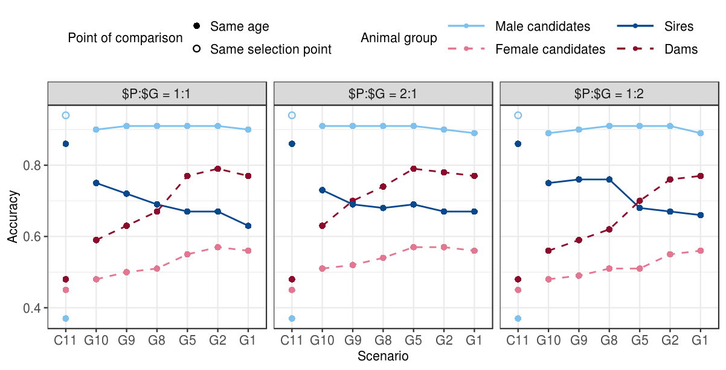Figure 2 The impact of scenario (and the genotype price) on the prediction accuracy. The accuracy of young and proven males and females when (the price of genotype equals the price of phenotype) by scenario, when an initial training population is available. Conventional selection implements two-stage selection for males, hence we are showing two accuracies for male candidates, with the solid point representing the accuracy of selection for progeny testing and the empty point selection of proven sires. Scenarios are named “C” / “G” for conventional / genomic, followed by the number of phenotype recordings per lactation. The accuracies of the conventional scenario are shown as disconnected points, since it does not directly compare to the genomic scenarios due to a different age of selecting sires.

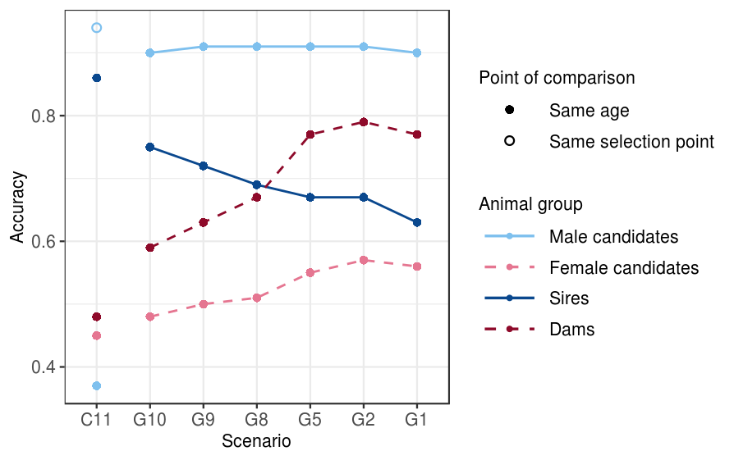

Genetic gain and selection accuracy without an initial training population
Table S1 MERGE and put in the supplementary
 | Ratio of price of genotyping ($G) and price of phenotyping ($P)
Scenario | $G:$P = 2:1 | $G:$P = 1:1 | $G:$P = 1:2
C11 | 3.01_{0.22}^{a,A} | 3.01_{0.22}^{a,A} | 3.01_{0.22}^{a,A}
G10 | 3.93_{0.22}^{b, A} | 4.54_{0.14}^{b, B} | 5.61_{0.25}^{b, C}
G9 | 4.64_{0.18}^{c, A} | 5.75_{0.28}^{c, B} | 6.52_{0.17}^{c, C}
G8 | 5.61_{0.28}^{d, A} | 6.24_{0.19}^{d B} | 6.70_{0.25}^{cd, C}
G5 | 6.43_{0.21}^{e, A} | 6.90_{0.22}^{e, B} | 7.05_{0.27}^{de, B}
G2 | 6.81_{0.28}^{f, A} | 6.96_{0.17}^{e, A} | 7.00_{0.30d}^{e, A}
G1 | 6.78_{0.29}^{f,A} | 6.92_{0.26}^{e, A} | 7.01_{0.23}^{e,A}

When an initial training population was not available, the increase in genetic gain by optimizing investment in phenotyping and genotyping was between 31% and 134%. Figure 3 shows the genetic gain and the growth of the training population by scenario without initial training population when the genotype and phenotype are equally priced. The observed trends were in line with those from ~10K initial training population, i.e. increasing genotyping increased genetic gain despite reduced phenotyping while changing the prices did not change the overall trend. However, the scenarios without an initial training population implemented genomic selection with a delay, since they first had to accumulate 2000 genotyped females. Consequently, all corresponding scenarios achieved between 4.6% and 28% smaller genetic gain than when an initial training population was available. The largest difference was in the scenario that removed only one phenotype recording (G10) and therefore invested the smallest amount of funds into genotyping. Depending on the genotype price there were between 182 and 710 animals genotyped per year in this phenotyping scenario. Because of the low number of genotyped animals there were three to eleven years required to build a training population and implement genomic selection. and achieved between 15% and 28% smaller genetic gain compared to when an initial training population was available. However, this scenario still increased the genetic gain of the baseline scenario between 26% and 77%. Further on, we again achieved a comparable maximum genetic gain, between 6.81 and 7.01 (126% and 133% of the baseline, regardless the price of the genotype.

In general, removing the initial training population did not decrease the prediction accuracy for any of the animal groups. This is shown in Figure 2 and Table S2, that compare the prediction accuracy with and without an initial training population by scenario when genotype and phenotype are equally priced. We observed a highly comparable trend for female candidates and dams when we had an initial training population or when we had to initiate it, and the vast majority of differences were non-significant The accuracy of all females therefore increased with increasing genotyping despite reduced phenotyping and regardless genotype price. Regarding male candidates, removing the initial training population resulted in a significant decrease in the accuracy for male candidates in the low-genotyping scenarios. The lowest accuracy for male candidates was observed when we genotyped minimal number of animals (G10), i.e. between 0.81 and 0.86, depending on the genotype price.

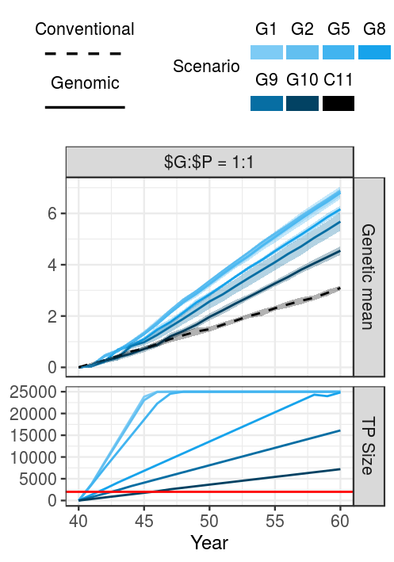
Figure 3 The impact of scenario on genetic gain and training population growth.
Genetic gain of the conventional and genomic scenarios and size of the training population for genomic prediction when the price of genotype equals the price of phenotype by scenario. An initial training population was not available and had to be established. The genetic gain of the conventional scenario does not depend on the $G:$P. The horizontal line marks the 2000 female training population limit for the implementation of genomic selection. TP = training population, scenarios are named “C” / “G” for conventional / genomic, followed by the number of phenotype recordings per lactation.

Possible: price for deltaG

Discussion
1 Genetic gain
- reference yes: this mirrors the existence of international reference populations,
- genetic gein increases with increased genotyping (despite reduced phenotyping, regardless genotype price and existence of initial training population) – why?
  - compared to the baseline: reduced generation interval, higher accuracy of male candidates, higher intensity
  - among the genomic scenarios: accuracy does not increase with increasing genotyping, hence has to be the increasing intensity of selection
  - reducing phenotyping does not reduce accuracy enough to contradict the benefits
  - no reference: gain shoots up when we start with genomic selection of males
- genetic gain reaches a plateau – accuracies are 0.9 for selection candidates (can not improve more), all females are genotyped in the top XX scenarios (no room for improvement), intensity is high
- same maximum genetic gain achievable for all $G:$P ratios – largest relative difference between the price ratio in the scenarios that remove only one or two phenotypes

2 Accuracy
- general: accuracy does not drop despite reduced phenotyping → because more animals genotyped
- accuracy for male candidates persists high –
  - why is it high regardless the amount of genotyping and price ratio?
- the accuracy for the dams and female candidates:
  - higher than conventional – more animals genotyped, higher connectedness
  - increases with genotyping. This could be explained with first a growing reference population and secondly, more females genotyped and included in the gEBV prediction, higher connectedness
- WHY IS ACCURACY FOR FEMALE CANDIDATES THAT MUCH LOWER THAT THE MALE CANDIDATES? MALE CANDIdaTES are all GENOTYPED, FEMALE NOT
  - when all females (cows) genotyped, the accuracy closer to the one of male candidates (also all genotyped)
- accuracy for sires – inconsistent, slight increase – why?
- Without initial reference – the accuracy decreases when minimal genotyping for males candidates
  - small reference population + “low” heritability of the phenotype (only 1 recording)
  - once it hits XX, accuracies high → XX animals for update enough to keep the accuracy high
- Compare to theoretical accuracies

3 Recommendations for the Yes/No reference – for breeding organizations

4 Limitations and remarks
- limitations: 25K limit
- genotypes could be used also for parentage verification
- Genomic data also for management – monogenic diseases, caseins, inbreding / mating control
- phenotypes also for management → but it we cut the last one – the cows are already almost through the lactation, keep the recordings in the critical period
- future work: selective phenotyping?

Conclusions

List of abbreviations

Declarations
Ethics approval and consent to participate
Consent for publication
Availability of data and materials

References
[1] Meuwissen THE, Hayes BJ, Goddard ME. Prediction of Total Genetic Value Using Genome-Wide Dense Marker Maps. Genetics 2001; 157: 1819–1829.
[2] Schaeffer LR. Strategy for applying genome-wide selection in dairy cattle. J Anim Breed Genet 2006; 123: 218–223.
[3] Wiggans GR, Cole JB, Hubbard SM, et al. Genomic Selection in Dairy Cattle: The USDA Experience. Annu Rev Anim Biosci 2017; 5: 309–327.
[4] Obšteter J, Jenko J, Hickey JM, et al. Efficient use of genomic information for sustainable genetic improvement in small cattle populations. J Dairy Sci; 0. Epub ahead of print 30 August 2019. DOI: 10.3168/jds.2019-16853.
[5] Mrode RA. Linear Models for the Prediction of Animal Breeding Values. Second edition. Wallingford, UK ; Cambridge, MA: CABI, 2005.
[6] Daetwyler HD, Villanueva B, Woolliams JA. Accuracy of Predicting the Genetic Risk of Disease Using a Genome-Wide Approach. PLoS ONE 2008; 3: e3395.
[7] Goddard M. Genomic selection: prediction of accuracy and maximisation of long term response. Genetica 2009; 136: 245–257.
[8] Goddard M e., Hayes B j., Meuwissen T h. e. Using the genomic relationship matrix to predict the accuracy of genomic selection. J Anim Breed Genet 2011; 128: 409–421.
[9] Lourenco DAL, Fragomeni BO, Tsuruta S, et al. Accuracy of estimated breeding values with genomic information on males, females, or both: an example on broiler chicken. Genet Sel Evol 2015; 47: 56.
[10] Gray KA, Cassady JP, Huang Y, et al. Effectiveness of genomic prediction on milk flow traits in dairy cattle. Genet Sel Evol GSE 2012; 44: 24.
[11] Gao H, Christensen OF, Madsen P, et al. Comparison on genomic predictions using three GBLUP methods and two single-step blending methods in the Nordic Holstein population. Genet Sel Evol 2012; 44: 8.
[12] Calus MPL. Genomic breeding value prediction: methods and procedures*. animal 2010; 4: 157–164.
[13] Habier D, Tetens J, Seefried F-R, et al. The impact of genetic relationship information on genomic breeding values in German Holstein cattle. Genet Sel Evol 2010; 42: 5.
[14] Wolc A, Arango J, Settar P, et al. Persistence of accuracy of genomic estimated breeding values over generations in layer chickens. Genet Sel Evol 2011; 43: 23.
[15] ICAR. International Committee for Animal Recording. 2017. Section 2 – Guidelines for Dairy Cattle Milk Recording. Rome: ICAR.
[16] Misztal I, Tsuruta S, Strabel T, et al. BLUPF90 and related programs (BGF90). In: Proc. 7th World Congress on Genetics Applied to Livestock Production. Montpellier, France, 2002, pp. 1–2.
Genetics Selection Evolution requires references to be formatted in Vancouver referencing style. Example reference style:
- Article within a journal
Smith JJ. The world of science. Am J Sci. 1999;36:234-5.
- Article within a journal (no page numbers)
Rohrmann S, Overvad K, Bueno-de-Mesquita HB, Jakobsen MU, Egeberg R, Tjønneland A, et al. Meat consumption and mortality - results from the European Prospective Investigation into Cancer and Nutrition. BMC Medicine. 2013;11:63.
- Article within a journal by DOI
Slifka MK, Whitton JL. Clinical implications of dysregulated cytokine production. Dig J Mol Med. 2000; doi:10.1007/s801090000086.

- Book chapter, or an article within a book
Wyllie AH, Kerr JFR, Currie AR. Cell death: the significance of apoptosis. In: Bourne GH, Danielli JF, Jeon KW, editors. International review of cytology. London: Academic; 1980. p. 251-306.
- OnlineFirst chapter in a series (without a volume designation but with a DOI)
Saito Y, Hyuga H. Rate equation approaches to amplification of enantiomeric excess and chiral symmetry breaking. Top Curr Chem. 2007. doi:10.1007/128_2006_108.
- Complete book, authored
Blenkinsopp A, Paxton P. Symptoms in the pharmacy: a guide to the management of common illness. 3rd ed. Oxford: Blackwell Science; 1998.
- Online document
Doe J. Title of subordinate document. In: The dictionary of substances and their effects. Royal Society of Chemistry. 1999. http://www.rsc.org/dose/title of subordinate document. Accessed 15 Jan 1999.
- Software
R: a language and environment for statistical computing. R Foundation for Statistical Computing, Vienna; 2012. OpenURL
- Proceeding of a congress
Van Eenennaam AL, Kinghorn BP. Use of mate selection software to manage lethal recessive conditions in livestock populations. In: Proceedings of the 10th World Congress on Genetics Applied to Livestock Production: 17–22 August 2014; Vancouver. https://asas.org/docs/default-source/wcgalp-posters/408_paper_9819_manuscript_1027_0.pdf?sfvrsn=2. Accessed 27 Feb 2015.
- Thesis
Park SDE. Trypanotolerance in West African cattle and the population genetic effects of selection. PhD thesis, University of Dublin. 2002.
- FAO paper report
Koziner AB, Shtakelberg ER. Animal genetic resources of the USSR. Rome: FAO and UNEP; 1989.
- Institutional document
Iversen A, Hermansen Ø. Cost development in farming of Norwegian Salmon. Tromso: Nofima Report; 2017. p. 46.

Figures (only titles and legends should be included in main text; for more information on preparing figures, please see here https://gsejournal.biomedcentral.com/submission-guidelines/preparing-your-manuscript#preparing+figures)
Figure 1 Title.
Legend
Figure 2 Title.
Legend

Tables
Tables should be numbered and cited in the text in sequence using Arabic numerals (i.e. Table 1, Table 2 etc.).
Tables less than one A4 or Letter page in length can be placed in the appropriate location within the manuscript.
Tables larger than one A4 or Letter page in length can be placed at the end of the document text file. Please cite and indicate where the table should appear at the relevant location in the text file so that the table can be added in the correct place during production.
Larger datasets, or tables too wide for A4 or Letter landscape page can be uploaded as additional files. Please see [below] for more information.
Tabular data provided as additional files can be uploaded as an Excel spreadsheet (.xls ) or comma separated values (.csv). Please use the standard file extensions.
Table titles (max 15 words) should be included above the table, and legends (max 300 words) should be included underneath the table.
Tables should not be embedded as figures or spreadsheet files, but should be formatted using ‘Table object’ function in your word processing program.
Color and shading may not be used. Parts of the table can be highlighted using superscript, numbering, lettering, symbols or bold text, the meaning of which should be explained in a table legend.
Commas should not be used to indicate numerical values.
Table 1 Title
Column 1 | Column 2 | Column 3 | Column 4 | Column 5
Line 1
Line 2
Legend for Table under the table
Table 2 Title
Legend for Table under the table

Additional files
(only the format, title and legend of additional files should be provided in the main text; for more information on preparing additional files, please see here https://gsejournal.biomedcentral.com/submission-guidelines/preparing-your-manuscript#preparing+additional+files)
Additional file 1 Table S1
Format:
Title:
Description:
Additional file 2 Figure S1
Format:
Title:
Description:

