Exploratory analysis and simple Orange workflows
Jana Obšteter
jana.obsteter@kis.si

Problem. Milk coagulation is one of the most important steps in cheese making and is influenced by genetic and environmental factors. It is becoming increasingly important to improve milk coagulation properties due to increased cheese consumption and market demands. Amongst most important factors affecting milk coagulation are the breed of cattle (genetics) and the milk protein content. Coagulation enzymes work directly on milk proteins, therefore a higher milk protein percentage is associated with better coagulation. At the Agricultural Institute of Slovenia we have started to record milk coagulation properties in October 2017 with the aim to select for them. Therefore, first, an exploratory analysis has to be performed to determine whether the data is measured and processed correctly and to define the main influences on the coagulation. We also want to inspect whether our results confirm the results of the previous studies exploring milk coagulation properties in other populations.

Material. The data includes 8 features relating to properties of milk or animals. Milk sample ID was a meta feature and served for identification purposes. The target features, i.e. two milk coagulation properties being coagulation time (RCT) and the firmness of the cheese curd (a30), both continuous, were obtained by infrared spectrometry in a milk laboratory in Ptuj. A shorter RCT and higher a30 indicate a better coagulation. Other features include additional milk or animal properties with prior evidence for affecting milk coagulation: fat, protein and lactose milk content [%], which were also obtain in the milk laboratory, milk yield [kg] and breed of the animal. All features were measured on 12,706 milk samples belonging to 12,672 Slovenian animals. The samples were collected from three breeds with 5750, 5345 and 1611 milk samples belonging to Holstein, Simmental and Brown Swiss animals, respectively.

Methods. The data was loaded into Orange and only records with milk yield different from 0 were selected for further analysis. Milk yield of 0 indicates a problem with the sample collection or the analysis. In the next step three visualisation methods were used: i) box plot to explore the differences in coagulation properties between breeds; ii) scatter plot to explore the relationships of milk coagulation properties with milk yield and milk content - the significance between different marginal groups was further inspected in a box plot; and iii) mosaic display to explore the differences in frequencies of different classes of milk coagulation properties in different breeds according to sample protein content (Figure 1).
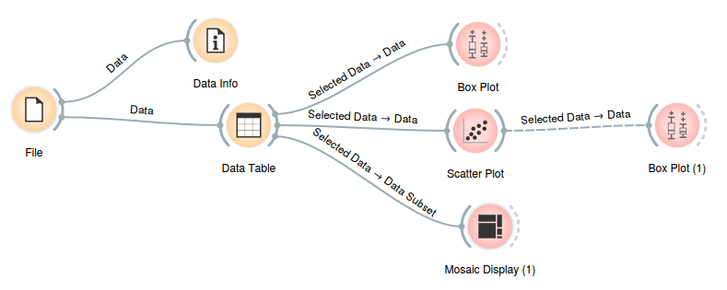
Figure 1: Workflow of the exploratory analysis on milk coagulation properties in Slovenian cattle population.

Results and discussion.
First, the box plot showed significant differences between both milk coagulation properties (RCT and a30) in different breeds (p = 0.000, results not shown). Our results are in concordance with previous studies that showed that the milk of Brown Swiss has better coagulation properties than Simmental and that the milk of Holstein breed has the poorest coagulation properties.

Next, we used scatter plot to inspect the relationship of milk coagulation properties with milk yield and milk yield. Here I am showing the results for inspecting the relationship between RCT and milk yield. The regression line revealed a weak trend of increasing RCT (declining coagulation properties) with increasing milk yield. Since the regression showed a weak trend and a poor correlation (r = 0.009) we chose data point 0 to 20 kg and 20 to 40 kg milk yield as the two groups and inspected the differences in a box plot (Figure 2). This showed significant differences in RCT between the two groups. This is in concordance with previous results that showed a higher milk yield is associated with poorer coagulation, mainly due to lower milk fat and protein content.

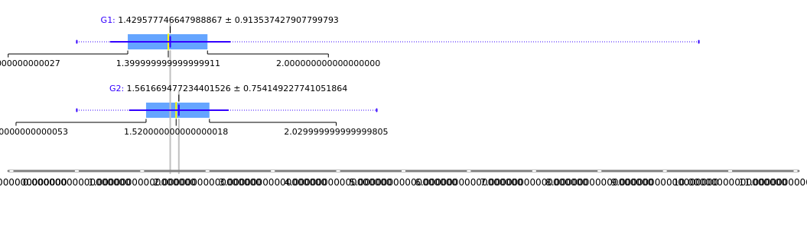
Figure 2: A comparison of rennet coagulation time between the groups of samples with milk yield 0 – 20 kg (G1) and 20 – 40 kg (G2).
Next, we created a mosaic display to inspect the differences in RCT between breeds according to the protein content of milk samples (Figure 3). The comparison revealed that the most represented RCT class in Brown Swiss is the lowest RCT, i.e. best coagulation, class. The frequency decreases towards the class with the highest RCT, i.e. poorest coagulation. The same situation is observed for Simmental breed, although the differences are smaller. In contrast, the most Holstein samples are in the class with the highest RCT, i.e. worse coagulation. This is in concordance with the results that the coagulation properties decrease from Brown Swiss to Holstein. Next, the highest protein content class is over-represented in the lowest RCT class. Similarly, the lowest protein class is over-represented in the highest RCT class. This was expected since proteins are directly responsible for milk coagulation therefore more proteins enable more extensive coagulation. We also see that there are no major difference between protein content in different RCT classes between breeds, although we have observed poorest RCT in Holstein. This suggest there are factors other than the protein content influencing and worsening coagulation in Holstein.
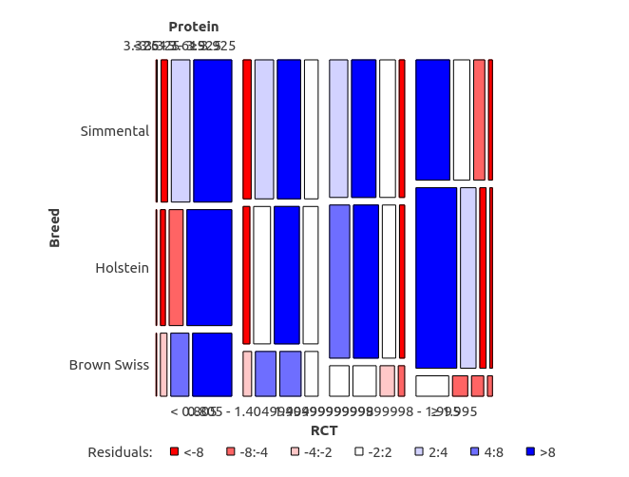

Figure 3: Mosaic display of classes of RCT within the three breeds coloured by the milk protein content.

The results support the work of previous studies and indicate that data was collected and processed correctly. Similar analysis has to be performed for the other coagulation property, a30. If the results do not reveal any unexpected trends or any illogical scope of the data, we can start using this values for selection purposes.

