Comparison of different genomic selection scenarios in a small cattle population by simulation

J. Obšteter*, J. Jenko*,†, J. M. Hickey† & G. Gorjanc‡,†

* Department of Animal Science, Agricultural Institute of Slovenia, Hacquetova ulica 17, 1000 Ljubljana, Slovenia
‡ Biotechnical Faculty, University of Ljubljana, Jamnikarjeva 101, 1000 Ljubljana, Slovenia
† The Roslin Institute and Royal (Dick) School of Veterinary Studies, University of Edinburgh, Easter Bush, Midlothian, EH259RG, United Kingdom

Jana Obšteter, Agricultural Institute of Slovenia, Department of Animal Science, Hacquetova ulica 17, 1000 Ljubljana, Slovenia
+386 1 280 51 34
jana.obsteter@kis.si (Corresponding Author)

Introduction
This paper compares genetic gain, genetic variation and the efficiency of converting variation into gain under different genomic selection scenarios in a small cattle population by simulation. Genomic selection has profoundly changed dairy breeding programs (Schaeffer, 2006; Garcia-Ruiz et al., 2016; Wiggans et al., 2017). It has doubled the rate of genetic gain through decreased generation interval, increased selection accuracy for young animals, reduced costs of testing and therefore increased selection intensity, and identification of recessive lethal alleles (Garcia-Ruiz et al., 2016; Wiggans et al., 2017). These changes enable large and small populations to achieve significant genetic gains; in fact they potentially enable small populations to catch up with large populations. This requires a sizeable training population of genotyped and phenotyped animals, which is an issue for small populations (Thomasen et al., 2014; Ducrocq et al., 2018). This problem can be partly addressed with international training populations (Jorjani, 2012; Liu, 2013; Vandenplas et al., 2017). An effective implementation also requires an optimal use of genomic selection for different groups of animals, which has not been thoroughly addressed, but see Thomasen et al. (2014). Further, small populations under selection are prone to genetic drift and related genetic variation issues, which can detoriate with intense and rapid genomic selection.
Previous studies compared the conventional progeny testing with genomic pre-selection for progeny testing or direct genomic selection for widespread use (de Roos et al., 2011; Lillehammer et al., 2011; Pryce et al., 2010). These studies reported up to 30% increase in genetic gain with the genomic pre-selection and up to 195% increase in genetic gain with the direct genomic selection. Thomasen et al. (2014) deterministically evaluated hybrid schemes that use both progeny and young genomically tested bulls for the insemination of cows and bull dams. They concluded that genomic selection gives higher genetic gain than conventional progeny testing irrespective of population size, but that the hybrid schemes maximise annual monetary genetic gain when accuracy of genomic selection is low.
Breeding programs also have to maintain genetic variation to ensure sustainability. The aim is to balance short- and long-term success of a breeding program. While the short-term success depends on the genetic gain in the next few generations, the long-term success depends on the short-term genetic gain to stay competitive and sufficient genetic variation that ensures stable rate of genetic gain over a long-term period (Woolliams et al., 2015). Studies exploring the effect of genomic selection on genetic variation obtained contradictory results. For example, Lillehammer et al. (2011) and Pryce et al. (2010) reported a decrease in the rate of coancestry per year, while de Roos et al. (2011) reported that the rate of coancestry depends on the proportion of genetic variation captured with genome-wide markers and breeding program design. In general genomic selection has a potential to decrease the rate of coancestry due to a more accurate estimation of Mendelian sampling terms for young animals. This enables differentiation of sibs and avoidance of their co-selection and in turn reduces the rate of coancestry (Daetwyler et al., 2007). Balancing short- and long-term success can be further enhanced with the optimal contribution selection (Woolliams et al., 2015).
Although genomic selection is a well-established method, small populations still struggle with choosing the most secure strategy to gradually adopt genomic selection. The right strategy should ensure short- and long-term success and be viable in terms of funds and number of animals. To address some of these issues this study evaluates different genomic breeding program designs for a small realistic cattle population with a focus on selection and usage of bulls and how this affects changes in genetic gain and genetic variation.
Material and Methods
We compared different breeding program designs with a newly developed simulator of a realistic cattle breeding program. We compared five scenarios with truncation selection that varied in selection criterion of sires for the insemination of bull dams and cows. Additionally, we tested each of the sire selection criterion scenarios within three sire usage scenarios that varied the number of selected sires and the period of their usage. To maximise genetic gain for a given loss in genetic variation we compared the truncation selection scenarios with the optimal contribution selection with varied balance between genetic gain and genetic variation. We compared all the scenarios in terms of genetic gain, selection accuracy, generation interval, genic variance, effective population size and efficiency of converting genetic variation into gain.

Cattle breeding program simulator
We developed a simulator of a realistic dairy cattle breeding program. The simulator is a Python wrapper around the simulation program AlphaSim (Faux et al., 2016), the genetic evaluation program blupf90 (Misztal et al., 2002) and the optimal contribution selection program AlphaMate (Gorjanc and Hickey, 2018). The simulator is driven by a set of parameters describing a cattle breeding program, including the percentage of animals selected at each stage and in each selection path, age at selection, selection criterion (pedigree or genomic), the number of progeny per sire, years in use and the number of selection cycles. These parameters allow the simulation of relevant dairy breeding programs. In each year the simulator generates phenotypic data, estimates breeding values, culls, selects and mates animals and generates progeny, including their pedigree and genotypic data.
Simulated population
The simulated population mimicked the Slovenian Brown Swiss population of ~30,000 animals of which ~10,500 are cows. The simulation started with a coalescent process to generate a cattle-like whole-genome sequence for ten chromosomes (Faux et al., 2016; Villa-Angulo et al., 2009). We randomly sampled segregating sequence variants to construct a set of 10,0000 causal variants (1,000 per chromosome) and two distinct sets of 20,000 marker variants (2,000 per chromosome). We used the two sets of marker variants to create two SNP arrays, one was used for genomic selection and the other for monitoring “neutral” diversity. We sampled the effects of causal variants from a normal distribution with a variance that gave a trait with the heritability of 0.25 in the base population. We randomly allocated base population animals to different categories to initiate a dairy breeding program. We have then ran a conventional breeding program with selection on phenotype based estimated breeding values for 20 years, followed by a further 20 years of different scenarios described below.
We generated 4,320 female calves every year of which we removed a random 2% due to stillbirths and early deaths and a further 9% due to other losses, for example, reproductive issues. The remaining heifers were inseminated in the second year and became cows in the third year. In each subsequent lactation we culled 20% of the cows at random and all remaining cows after the fourth lactation. This scheme totalled to about 10,500 active cows per year. After the second lactation, we assigned 43 cows with the highest estimated breeding values as bull dams. We kept bull dams in use for five lactations, which gave us 129 active bull dams per year. Every year we inseminated the best 90 bull dams with relevant sires to generate elite male selection candidates.
We selected sires based on genomic or progeny tests. Every year 45 elite male calves were tested following one of three scenarios: a) progeny test with a pre-selection based on pedigree prediction (PT), b) progeny test with a pre-selection based on genomic test (GT-PT) or c) genomic test (GT). With the PT scenario, 8 out of 27 calves were chosen for progeny test based on pedigree prediction in their second year, while the remaining 19 calves were used in natural service. With the GT-PT scenario 8 out of 45 calves were chosen for progeny test based on genomic test. With the PT and GT-PT scenario 5 out of 8 progeny tested bulls were selected as sires based on estimated breeding value in their sixth year. With the GT scenario 5 out of 45 genomically tested calves were directly selected as sires and were used for insemination from their second year onwards. Unselected genomically tested calves in all genomic scenarios were used as natural service sires.

Breeding scenarios
We created different breeding scenarios by varying the selection of sires in combination with their use on cows or bull dams, varying selection intensity and the number of years a sire is in use, and finally by dynamically optimizing sire selection and usage with optimal contribution selection.
The scenarios that varied the selection of sires in combination with their use on cows or bull dams were: i) PT scenario used PT sires for the insemination of cows and bull dams, ii) GT-PT scenario used GT-PT sires for the insemination of cows and bull dams, iii) GT-C scenario used GT sires for the insemination of cows and GT-PT sires for the insemination of bull dams, iv) GT-BD scenario used GT sires for the insemination of bull dams and GT-PT sires for the insemination of cows, and v) GT scenario used GT sires for the insemination of cows and bull dams.
The scenarios that varied selection intensity and the number of years a sire is in use were: i) select five sires every year and keep them in use for five years (5 sires/year, use 5 years), ii) reduce generation interval by using the five sires for one year only (5 sires/year, use 1 year) and iii) maximise selection intensity by selecting only one sire and use it for five years (1 sire/year, use 5 years).
By combining variable selection and variable sire usage scenarios we evaluated 15 scenarios. We have also evaluated the effect of dynamically optimizing sire selection and usage with optimal contribution selection as described below.
Breeding value estimation
We estimated breeding values with the pedigree model (Henderson, 1984) or the single-step genomic model (Legarra et al., 2009) using the blupf90 program with default options (Misztal et al., 2002). In genomic breeding scenarios we assumed an initial reference population of about 11,000 genotyped and phenotyped cows and 100 genotyped and progeny tested sires. This mimicked the availability of international genomic evaluation in Brown Swiss (Jorjani, 2012). We updated the reference population each year by removing the oldest generation of about 2000 cows and adding an equivalent number of newly genotyped cows and elite male selection candidates. Variance components were assumed known and set to simulated values.
Optimal contribution selection
We have dynamically optimized sire selection and usage with optimal contribution selection (Woolliams et al., 2015) using the AlphaMate program (Gorjanc and Hickey, 2018). Every year we have added the 45 genotyped elite male calves to the pool of bulls selected in the last five years. We have then optimized their contributions while fixing female (heifers’ and cows’) contributions to one progeny per female. After optimization we randomly paired optimized male contributions with fixed female contributions. Inputs for optimal contribution selection were estimated breeding values and a coancestry matrix (Woolliams et al., 2015) for the currently active animals for animals(heifers, cows, male candidates and bulls) from the genomic single-step model (Legarra et al., 2009). We optimized male contributions with different emphasis on genetic gain versus group coancestry using the target degrees of the angle between the truncation selection solution and an optimal contribution solution (Kinghorn, 2011). For example, target degrees of 0 would maximise genetic gain by selecting only one male, while target degrees of 90 would solely minimise group coancestry. We ran simulations with the target degrees of 15, 30, 45, 50, 55, 60 and 75.

Analysis

We compared the scenarios in terms of genetic gain, selection accuracy, generation interval, genetic and genic variance, the rate of coancestry, effective population size and the efficiency of converting genetic variation into genetic gain. Genetic gain was expressed as a deviation from the first generation of comparison in the units of genetic standard deviation. Selection accuracy was computed as the Pearson correlation between the true and estimated breeding values. Generation interval was computed as the average age of the parents at the birth of their selected offspring. Genetic variance measured variance of true breeding values. Genic variance measured variance of true breeding values under the assumption of no linkage between causal loci. The rate of coancestry per year was calculated from pedigree or genomic information. The pedigree coancestry was computed following Wright (1922) from which the rate of coancestry (ΔC_{P}) was estimated by regressing log(C_{P,t}) on the year of birth (Pérez-Enciso, 1995). The genomic coancestry was computed based on the direct link with heterozygosity, Het_{t} = Het_{o}(1 – C_{t}) (Falconer and Mackay, 1996). We computed heterozygosity separately for causal, marker and neutral loci. We regressed log(C_{t}) on the year of birth to estimate the rate of coancestry for causal loci (ΔC_{Q}), marker loci (ΔC_{M}) and neutral loci (ΔC_{N}). Effective population size (N_{e}) was estimated for every measure of the rate of coancestry as 1/(2ΔC). Finally, the efficiency of converting genetic variation into genetic gain was computed as a regression of the achieved genetic gain on the loss of genic standard deviation (Gorjanc et al., 2018). This metric indicates the potential genetic gain in units of genic standard deviation when all variation is converted into gain or lost due to drift. Results are presented as the mean of 20 replicates for each scenario on a per year or cumulative basis. The progeny testing breeding program with 5 bulls selected per year and used for 5 years was chosen as the baseline breeding program.

Results
The results compare different breeding scenarios in terms of genetic gain, selection accuracy, generation interval, genetic variation, and the efficiency of converting genetic variation into gain. Early use of genomically tested bulls increased genetic gain compared to progeny testing as expected from changes in selection accuracy and generation interval. A faster turnover of bulls from year to year and higher intensity increased the genetic gain even further, but decreased genic variance. Efficiency of converting genetic variation into gain was increased with simultaneous use of genomically and progeny tested sires increased. Maximizing intensity resulted in the lowest effective population size and the lowest conversion efficiency. On the other hand, a faster turn-over of sires maintained the effective population size and decreased conversion efficiency to an intermediate degree. Compared to truncation selection optimizing sire selection and usage increased short- and long-term genetic gain.
Genetic gain
Genetic gain increased with an early use of genomically tested bulls, their faster turnover from year to year and increased intensity of selection. This is shown in Table 1, which presents genetic gain by breeding program and sire selection and usage scenarios. Genomic pre-selection for progeny testing increased genetic gain by 37% compared to the baseline breeding program. Genomic selection of sires for a direct insemination of cows or bull dams respectively increased genetic gain by 63% or 69%, and by 95% when applied jointly for cows and bull dams. Reducing the use of the selected sires per year from 5 years to 1 year further increased genetic gain, between 11% and 144% compared to the baseline breeding program. Reducing the number of selected sires per year from 5 to 1 and using that sire for 5 years also increased genetic gain, between 22% and 126% compared to the baseline breeding program, but not compared to the scenario where 5 selected sires per year were used for 1 year. These genetic gains were a direct function of realized generation intervals (Table S1) and selection accuracies (Table S2).
Table 1: Genetic gain in genetic standard deviation units by breeding program and sire selection and usage scenario.
 | Sire selection and usage
Breeding program | 5 sires/year, use 5 years | 5 sires/year, use 1 year | 1 sire/year, use 5 years
PT | 2.50_{0.22}^{a, A} | 2.75_{0.19}^{a, B} | 3.03_{0.11}^{a, C}
GT-PT | 3.41_{0.14}^{b, A} | 3.96_{0.17}^{b, B} | 3.84_{0.13}^{b, B}
GT-C | 4.05_{0.15c}^{, A} | 4.65_{0.21}^{c, B} | 4.82_{0.21}^{c, B}
GT-BD | 4.20_{0.19}^{c, A} | 4.56_{0.25}^{c, B} | 4.51_{0.20}^{d, B}
GT | 4.84_{0.26}^{d, A} | 6.04_{0.27}^{d, B} | 5.60_{0.27}^{e, C}
PT = conventional progeny testing; GT-PT = genomic pre-selection of bulls for progeny testing, GT-C = genomic selection of bulls for the insemination of cows; GT-BD = genomic selection of bulls for the insemination of bull-dams; GT = genomic selection of bulls for the insemination of cows and bull dams. Subscript numbers indicate standard deviation across simulation replicates. Lower-case letters denote statistically significant differences between breeding programs and upper-case letters between sire selection and usage scenarios.

Table S1: Generation interval by breeding program, sire selection and usage scenario, and the path of selection.
 | Sire selection and usage
Breeding program | 5 sires/year, use 5 years |  | 5 sires/year, use 1 year |  | 1 sire/year, use 5 years
 | Sire of sires | Sire of dams | Sire of sires | Sire of dams | Sire of sires | Sire of dams
PT | 9.0_{0.06}^{ab,A} | 7.0_{0.05}^{a,A} | 7.1_{0.00}^{a,B} | 5.8_{0.02}^{a,B} | 9.1_{0.07}^{a,C} | 7.7_{0.00}^{a,C}
GT-PT | 9.0_{0.06}^{a,A} | 7.0_{0.05}^{a,A} | 7.1_{0.00}^{a,B} | 5.8_{0.00}^{a,B} | 9.1_{0.07}^{a,C} | 7.7_{0.02}^{a,C}
GT-C | 9.0_{0.05}^{b,A} | 4.1_{0.04}^{b,A} | 7.1_{0.00}^{a,B} | 2.5_{0.00}^{b,B} | 9.1_{0.06}^{a,C} | 4.1_{0.00}^{b,A}
GT-BD | 3.8_{0.05}^{c,A} | 7.0_{0.05}^{c,A} | 3.8_{0.05}^{b,A} | 5.7_{0.00}^{c,B} | 3.8_{0.04}^{b,A} | 7.6_{0.00}^{c,C}
GT | 4.2_{0.05}^{d,A} | 3.9_{0.05}^{d,A} | 2.3_{0.05}^{c,B} | 2.3_{0.00}^{d,B} | 4.2_{0.07}^{c,A} | 3.9_{0.00}^{d,C}
PT = conventional progeny testing; GT-PT = genomic pre-selection of bulls for progeny testing, GT-C = genomic selection of bulls for the insemination of cows; GT-BD = genomic selection of bulls for the insemination of bull-dams; GT = genomic selection of bulls for the insemination of cows and bull dams. Subscript numbers indicate standard deviation across simulation replicates. Lower-case letters denote statistically significant differences between breeding programs and upper-case letters between sire selection and usage scenarios.

Table S2: Accuracy of selection by breeding program, animal category and sire selection-use scenario.
 | Sire selection and usage
Breeding program | 5 sires/year, use 5 years | 5 sires/year, use 1 year | 1 sire/year, use 5 years
PT
young bulls | 0.31_{0.18} | 0.23_{0.20} | 0.30_{0.19}
sires | 0.88_{0.10} | 0.87_{0.10} | 0.82_{0.17}
heifers | 0.35_{0.05} | 0.32_{0.06} | 0.36_{0.06}
GT-PT
young bulls (gen) | 0.80_{0.11} | 0.78_{0.12} | 0.80_{0.11}
sires | 0.82_{0.16} | 0.83_{0.15} | 0.78_{0.20}
heifers | 0.47_{0.04} | 0.44_{0.05} | 0.46_{0.06}
GT-C
young bulls (gen) | 0.81_{0.11} | 0.80_{0.11} | 0.82_{0.12}
sires | 0.89_{0.09} | 0.90_{0.08} | 0.87_{0.13}
heifers | 0.44_{0.05} | 0.41_{0.05} | 0.46_{0.07}
GT-BD
young bulls | 0.77_{0.11} | 0.78_{0.12} | 0.77_{0.11}
sires | 0.84_{0.14} | 0.82_{0.16} | 0.80_{0.17}
heifers | 0.51_{0.06} | 0.46_{0.06} | 0.49_{0.06}
GT
young bulls | 0.79_{0.12} | 0.75_{0.11} | 0.80_{0.12}
heifers | 0.48_{0.05} | 0.43_{0.06} | 0.49_{0.07}
PT = conventional progeny testing; GT-PT = genomic pre-selection of bulls for progeny testing, GT-C = genomic selection of bulls for the insemination of cows; GT-BD = genomic selection of bulls for the insemination of bull-dams; GT = genomic selection of bulls for the insemination of cows and bull dams. Subscript numbers indicate standard deviation across simulation replicates.
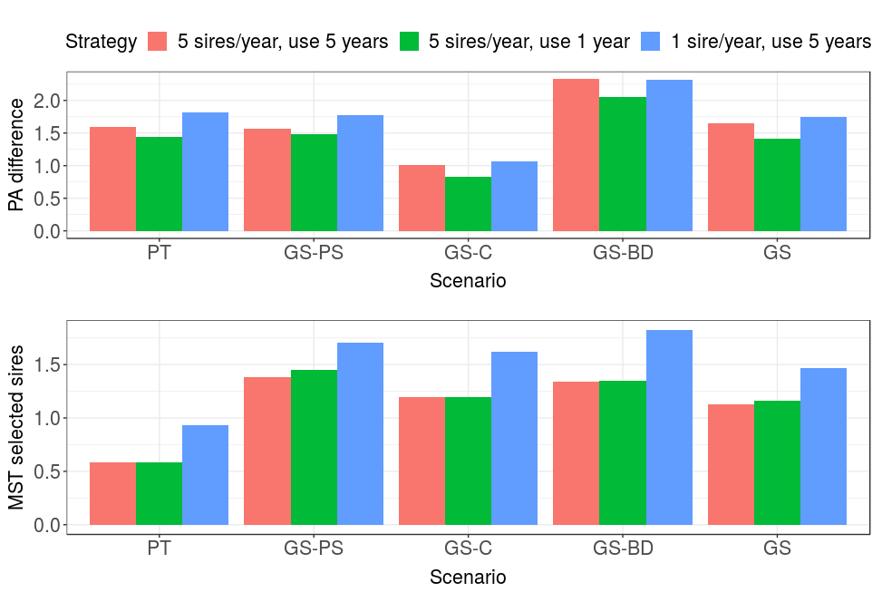
Figure S1: (Standardized) parent average and Mendelian sampling term of selected bulls by breeding program and sire selection and usage scenario. PT = conventional progeny testing; GT-PT = genomic pre-selection of bulls for progeny testing, GT-C = genomic selection of bulls for the insemination of cows; GT-BD = genomic selection of bulls for the insemination of bull-dams; GT = genomic selection of bulls for the insemination of cows and bull dams. Lower-case letters denote statistically significant differences between breeding programs and upper-case letters between sire selection and usage scenarios. PA difference = difference between parent average of the selected sires and the population; MST selected sires = Mendelian sampling term of the selected sires.

Genetic and genic standard deviation
Early use of genomically tested bulls, their faster turn-over and higher intensity of selection decreased genetic variation. This is shown in Figure 1, which presents genic and genetic standard deviation by breeding program and sire selection and usage scenarios. Genomic pre-selection for progeny test did not significantly decrease genic standard deviation. Genomic selection of bulls for a direct insemination of cows or bulls dams reduced genic standard deviation between 1.3% and 2.5%. Reducing the number of years sires were used from 5 to 1 further reduced genic standard deviation, between 0.9% and 5.0% compared to the baseline breeding program. Increasing selection intensity, by selecting only 1 sire per year instead of 5, reduced genic standard deviation even further, between 3.0 and 10.3%. We observed a similar trend in the reduction of genetic standard deviation as for genic standard deviation, but the reductions were overall larger and had higher variation between simulation replicates.
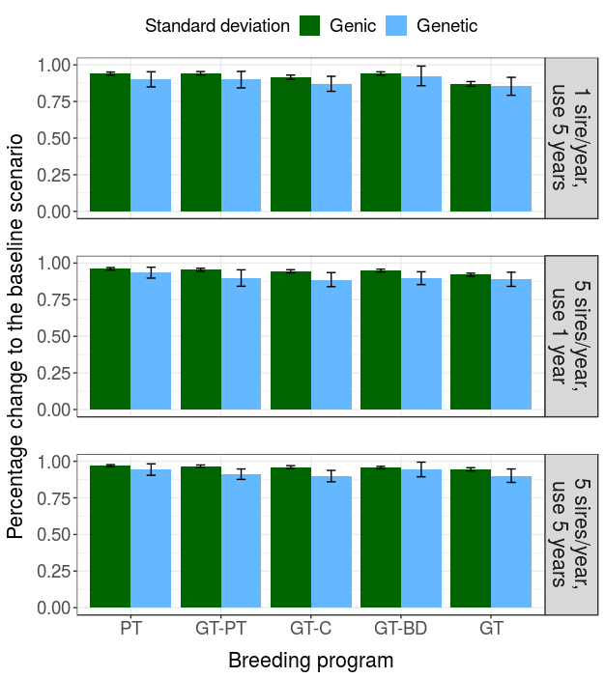
Figure 1: Genic and genetic standard deviation by breeding program and sire selection and usage scenario. PT = conventional progeny testing; GT-PT = genomic pre-selection of bulls for progeny testing, GT-C = genomic selection of bulls for the insemination of cows; GT-BD = genomic selection of bulls for the insemination of bull-dams; GT = genomic selection of bulls for the insemination of cows and bull dams.

Effective population size
Early use of genomically tested bulls and increased selection intensity decreased effective population size. This is shown in Table 2, which presents effective population size at causal loci by breeding program and sire usage scenario. Genomic pre-selection for progeny testing did not significantly change the effective population size. Inseminating cows, bull dams or both with young genomically tested bulls decreased effective population size respectively by 23%, 29%, and 45%. Reducing the years the sires are kept in use from 5 to 1 did not significantly change effective population size, except when both cows and bull dams were inseminated with genomically tested bulls (-59% compared to the baseline breeding program). In contrast, reducing the number of bulls selected per year from 5 to 1 and using that sire for 5 years decreased effective population size for all scenarios. The decrease ranged from 40% (with genomic pre-selection for progeny testing) to 76% (when both cows and bull dams were inseminated with one genomically tested sire). These results were qualitatively the same as results for the effective population sizes at marker loci used for genomic selection or at neutral loci (results not shown).
Table 2: Effective population size at causal loci by breeding program and sire selection and usage scenario.
 | Sire selection and usage
Breeding program | 5 sires/year, use 5 years | 5 sires/year, use 1 year | 1 sire/year, use 5 years
PT | 172₄₈^{a, A} | 184₅₇^{a, A} | 96₂₀^{a, B}
GT-PT | 159₄₃^{a, A} | 146₄₀^{b, A} | 99₂₀^{a, B}
GT-C | 129₂₉^{b, A} | 124₃₂^{bc, A} | 64₁₁^{b, B}
GT-BD | 119₂₇^{b, A} | 113₂₄^{c, AB} | 93₂₄^{a, B}
GT | 90₁₄^{c, A} | 72₁₀^{d, A} | 38 ₆^{b, B}
PT = conventional progeny testing; GT-PT = genomic pre-selection of bulls for progeny testing, GT-C = genomic selection of bulls for the insemination of cows; GT-BD = genomic selection of bulls for the insemination of bull-dams; GT = genomic selection of bulls for the insemination of cows and bull dams. Subscript numbers indicate standard deviation across simulation replicates. Lower-case letters denote statistically significant differences between breeding programs and upper-case letters between sire selection and usage scenarios.

Efficiency of converting genetic variation into gain
The largest efficiency of converting genetic variation into gain was achieved with the simultaneous use of genomically and progeny tested bulls that were used over several years. This is shown in Table 3, which presents the efficiency of converting genetic variation into gain by breeding program and sire selection and usage scenario. The efficiency indicates long-term genetic gain in standard deviation units when all genic variance will be exhausted. This calculation is based on the linear regression of achieved genetic gain on lost genic variance over the 20 years of selection, which we graphically represent in Figure 2 to complement the Table 3. Compared to the baseline breeding program, the introduction of genomic selection increased the efficiency. The highest increase, 33%, was achieved with the genomic pre-selection for progeny testing. Genomic selection of bulls for the insemination of cows or bull dams increased the efficiency respectively by 30% or 25%. Genomic selection of young bulls for the insemination of cows and bull dams jointly did not significantly increase the efficiency compared to the baseline breeding program. Reducing the usage of sires from 5 years to 1 year decreased the efficiency, except for the two scenarios with the highest genetic gain, i.e. when using genomically tested young bulls for the insemination of bull dams or all females. Reducing the number of selected sires per year to 1 and using it for 5 years reduced efficiency further still.
Table 3: Efficiency of converting genetic variation into gain by breeding program and sire selection and usage scenario.
 | Sire selection and usage
Breeding program | 5 sires/year, use 5 years | 5 sires/year, use 1 year | 1 sire/year, use 5 years
PT | 77₁₇^{a, A} | 61 ₉^{a, B} | 48 ₉^{ab, C}
GT-PT | 100₂₁^{b, A} | 84₁₇^{b, B} | 64₁₀^{cd, C}
GT-C | 98₂₀^{b, A} | 81₁₂^{b, B} | 54₁₀^{ac, C}
GT-BD | 93₁₉^{bc, A} | 87₁₅^{b, A} | 72₁₅^{d, B}
GT | 84₁₁^{ac, A} | 75₁₁^{b, A} | 42 ₅^{b, B}
PT = conventional progeny testing; GT-PT = genomic pre-selection of bulls for progeny testing, GT-C = genomic selection of bulls for the insemination of cows; GT-BD = genomic selection of bulls for the insemination of bull-dams; GT = genomic selection of bulls for the insemination of cows and bull dams. Subscript numbers indicate standard deviation across simulation replicates. Lower-case letters denote statistically significant differences between breeding programs and upper-case letters between sire selection and usage scenarios.
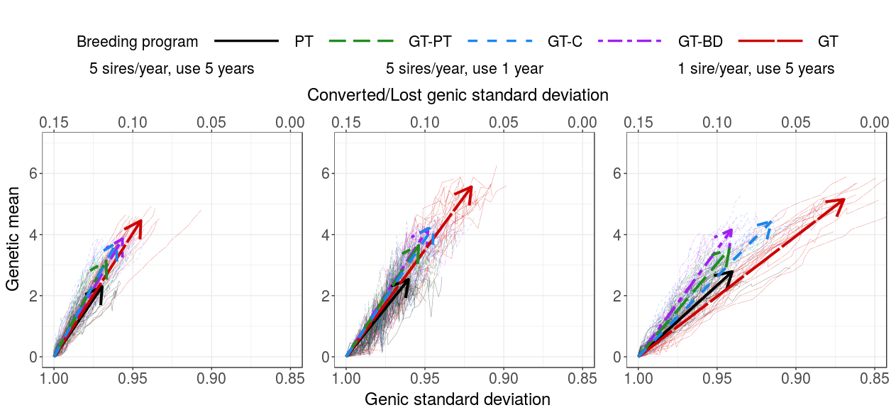
Figure 2: Change of genetic mean and genic standard deviation over the 20 years of selection by breeding program and sire selection and usage scenario. Thin lines represent individual replicates, while thick lines represent average linear regression with arrows pointing in the direction of change. PT = conventional progeny testing; GT-PT = genomic pre-selection of bulls for progeny testing, GT-C = genomic selection of bulls for the insemination of cows; GT-BD = genomic selection of bulls for the insemination of bull-dams; GT = genomic selection of bulls for the insemination of cows and bull dams.

Optimized breeding program
Optimization of male contributions at lower degrees increased genetic gain of the scenarios with truncation selection and optimization at higher degrees increased conversion efficiency. This is shown in Table 4 and Figure 3 that summarise outcomes of fixed and optimised breeding programs. Optimization of sire selection and usage with target degree 30 delivered the highest genetic gain, i.e. 172% of the baseline breeding program. However, this breeding program lost 12.4% more genic variance than the baseline breeding program and had 39% lower conversion efficiency. Optimization at 15 and 45 target degrees had genetic gain comparable to when using 5 genomically for 1 year on all females (SU 5/1 GT) – and while optimization at 15 degrees lost more genic variance and had lower efficiency, optimization at 45 degrees was comparable to SU 5/1 GT in all measures. Optimization at 15 and 30 degrees also decreased effective population size of the scenarios with truncation selection. On the other hand, optimization at 60 target degrees reached genetic gain as if using 5 genomically tested sires for 5 years on all females (SU 5/5 GT) with a smaller loss of genic standard deviation (-2.5% vs. -0.6%) and higher efficiency (12% vs. 70%). Optimization at 75 degrees similarly reached the genetic gain of using 5 progeny tested sires for 5 years on all females, but at the same time lost less genic standard deviation, increased effective population size by 69%, and had 117% higher efficiency.
The number of sires and their offspring were freely set by optimization. The average number of fathers in the OCS₁₅ scenarios was 3.3 (SD = 3.9), 4.4 (SD = 1.2) in OCS₃₀, 9.6 (SD = 2.0) in OCS₄₅ , 49 (SD = 32) in OCS₆₀ and 153 (SD = 51) in OCS₇₅. The average year the sires were kept is use was 1.77 (SD = 0.41) in OCS₁₅, 1.48 (SD = 0.09) in OCS₃₀, 1.61 (SD = 0.06) in OCS₄₅, 3.04 (SD = 0.34) in OCS₆₀ and 4.90 (SD = 0.07) in OCS₇₅.

Table 4: Comparison of fixed and optimized breeding programs
Breeding program | Genetic gain | Sire selection accuracy | No Sires | Years in use | Generation interval  (sire-sire) | Generation interval  (sire-dam) | Genic standard deviation | Rate of group coancestry | Effective population size | Conversion efficiency
Fixed breeding program
5 sires/year, use 5 years, PT | 2.5_{0.22}ª | 0.88_{0.10} | 5 | 5 | 9.0_{0.06}ª | 7.0_{0.05}ª | 0.97_{0.01}^{ab} | 0.003_{0.0009} ª | 172₄₈ ª | 77₁₇ª
5 sires/year, use 5 year, GT | 4.84_{0.26}^{b} | 0.80_{0.13} | 5 | 5 | 4.2_{0.05}^{b} | 3.9_{0.05}^{b} | 0 94_{0.01}^{c} | 0.006_{0.001}^{bc} | 90₁₄^{b} | 84₁₁ª
5 sire/year, use 1 years, GT | 6.04_{0.27}^{cd} | 0.75_{0.11} | 5 | 1 | 2.3_{0.05}^{c} | 2.3_{0.00}^{c} | 0.92_{0.01}^{d} | 0.007_{0.001}^{bd} | 72₁₀^{bc} | 75₁₁ª
Optimised breeding program
OCS_{15°} | 5.48_{1.51}^{c} | 0.64_{0.09} | 3.3_{3.9} | 1.77_{0.41} | 3.0_{0.23}^{d} | 2.9_{0.22}^{d} | 0.82_{0.03}^{e} | 0.017_{0.005}^{e} | 32₉^{d} | 33₅^{b}
OCS_{30°} | 6.44_{1.19}^{e} | 0.75_{0.04} | 4.4_{1.2} | 1.48_{0.09} | 2.8_{0.12}^{e} | 2.7_{0.12}^{e} | 0.85_{0.0.2}^{f} | 0.014_{0.004}^{f} | 37₁₁de | 45₇^{b}
OCS_{45°} | 5.75_{1.62}^{d} | 0.77_{0.02} | 9.6_{2.0} | 1.61_{0.06} | 2.8_{0.07}^{e} | 2.7_{0.07}^{e} | 0.92_{0.02}^{d} | 0.008_{0.001}^{d} | 61₁₀^{ce} | 72₈ª
OCS_{60°} | 4.57_{0.94}^{b} | 0.81_{0.02} | 49₃₂ | 3.04_{0.34} | 3.3_{0.10}^{f} | 3.1_{0.07}^{f} | 0.97_{0.01}ª | 0.004_{0.0006}^{ac} | 144₂₄^{f} | 126₁₇^{c}
OCS_{75°} | 3.03_{0.17}^{f} | 0.82_{0.01} | 153₅₁ | 4.90_{0.07} | 4.2_{0.08}^{b} | 4.0_{0.06}^{g} | 0.98_{0.00}^{b} | 0.002_{0.0003}ª | 276₄₃^{g} | 162₃₇^{d}

PT = conventional progeny testing; GT = genomic selection of bulls for the insemination of cows and bull dams; OCS_{X°} = optimal contribution selection of bulls for the insemination of cows and bull dams with target degrees of X°. Subscript numbers indicate standard deviation across simulation replicates. Lower-case letters denote statistically significant differences between breeding programs.
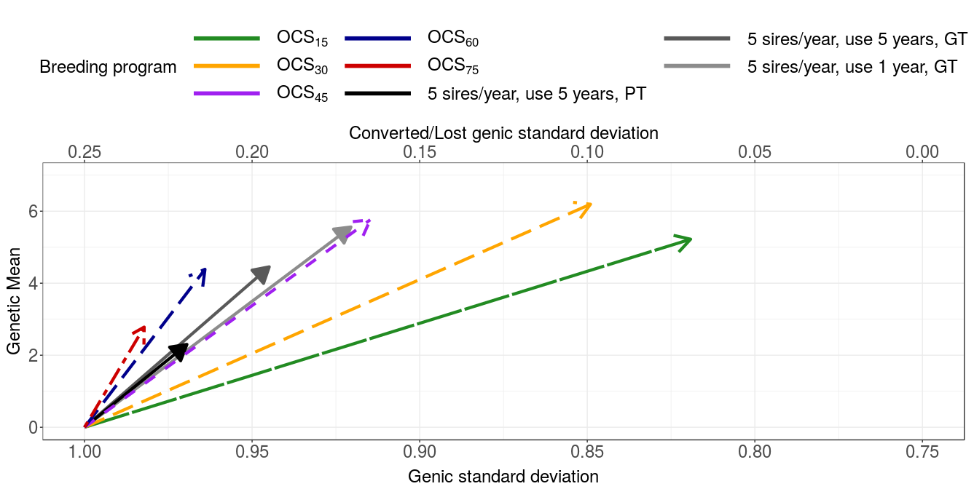
Figure 3: Change of genetic mean and genic standard deviation over the 20 years of selection for fixed or optimized breeding programs. Thin lines represent individual replicates, while thick lines represent average linear regression with arrows pointing in the direction of change. PT = conventional progeny testing; GT-PT = genomic selection of bulls for progeny testing, GT-C = genomic selection of bulls for the insemination of cows; GT-BD = genomic selection of bulls for the insemination of bull-dams; GT = genomic selection of bulls for the insemination of cows and bull dams.

Discussion

Genetic gain
As expected, the use of genomic information increased the genetic gain in all sire use strategies. This is due to a higher accuracy for selection of young unphenotyped animals and reduction in generation interval. We showed that by using gEBVs for the pre-selection step, we can substantially increase genetic gain without reducing generation interval (GT-PT scenario) - since gEBV (r = 0.80) are more accurate than PA (r = 0.31). By using genomically tested sires directly we also reduce the generation interval, which additionally increases the genetic gain despite the lower accuracy of sire selection. Thomasen et al., 2014, pointed out, that the benefit of genomic selection in small populations is undermined due to a small increase in the selection accuracy for young animals caused by a weak reference population (i.e. gEBVs not much more accurate than PAs). However, our results suggest that with a cow based reference population we can achieve an opposite result. Since in small populations the number of offspring in progeny testing is not as large, the accuracy of conventional EBVs for progeny tested bulls does not reach the accuracy of the large populations. With an adequate cow reference population we can reach relatively high accuracies of genomic prediction comparable to the accuracies of the progeny tested bulls (0.79 vs 0.83 in our case).
Within genomic scenarios, genetic gain increased with reduction in generation interval. These results suggest than we can alleviate the effect of the lower accuracy of genomic prediction with an earlier selection of sires, since the effect of the latter prevails. Generation interval for sires may seem long (Table S1) – the reason for this is a large standard deviation of sires’ true BV within a generation. The genetic value of some sires is significantly above others in their generation – therefore they can also compete with the sires in subsequent generations. Hence the offspring of these exceptional sires are selected even in the last year of the sire use, which prolongs generation interval. We also showed there is no significant difference in genetic gain when using genomic selection for sires used on unselected (reduced sires of dams generation interval) or selected female population (reduced sire of sires generation interval). This suggests that the amount of reduction in generation interval prevails over the path in which we use the genomic information (selection path is irrelevant and that genetic gain depends only on the amount of reduction). OR When using genomically tested sires for insemination of unselected females, the majority of the population is offspring of these young sires. On the other hand, when using young genomically tested sires on selected females only, the extent of their use is much smaller, but the impact is higher since they produce new male candidates. The completely genomic scenario used genomic selection for all sires – therefore all sires were selected at a lower accuracy. However, since generation interval was reduced in both sires of dams and sires of sires paths, the genetic gain increased the most. Our results for genetic gain are in concordance with previous studies that observed a higher genetic gain with the use of genomic information for a pre-selection for PT or for selection of young sires (“turbo” scheme) (Pryce et al., 2010; Lillehammer et al., 2011; de Roos et al., 2011; Thomasen et al., 2014).
A faster turn-over of sires reduced generation interval in both, sires of sires and sires of dams selection paths, which increased the genetic gain. Increasing intensity of selection also increased genetic gain, yet not to the same degree. Since in the latter we introduced an unrealistic condition of selecting only one sire, this scenario lost much more of genic variance that enables genetic progress.efficiently bound the rate of inbreeding, we should apply inbreeding control on the same basis as used for estimation of breeding values (Sonesson et al., 2012). Therefore, while for PT and GT-PT scenarios a pedigree based inbreeding control would suffice, the genomic scenarios would required control based on genomic relationship.

Effective population size
We observed a discordance in Ne computed based on pedigree or molecular information with the former exceeding the latter up to 219% (results not shown). Our results are in concordance with previous findinGT that pedigree estimation tends to underestimated the true inbreeding in the population. While pedigree information measures identity by descend, the identity on molecular markers measures identity by state (Meuwissen et al., 2018). Therefore rate of inbreeding derived from pedigree information reflects population history and is affected by mating decisions and rate of coancestry derived from genomic information - and the corresponding effective population size - reflect situation under random mating (Cervantes et al., 2011). Regarding genomic data, the inbreeding estimated from QTN loci did not exceed inbreeding estimated from neutral or marker loci (results now shown). This is most likely a consequence of simulating a highly polygenic trait controlled by 1000 QTNs per chromosome.
The results suggest we can increase genetic gain and retain effective population size by using genomic selection for pre-selection of sires for progeny testing. All other strategies decrease effective population size despite increasing genetic gain even further.
While increasing the intensity of selection significantly decreases Ne, no such effect is observed for a faster turn-over of animals. Generation interval in this scenario was significantly reduced, which according to previous studies increases inbreeding (reviewed in Boichard et al., 2015). Previous studies also report that a larger number of sires counterbalances the effect of reduces effective number of bulls per generation caused by reduced generation interval. Considering we do not observe a decrease in the effective population size in SU 5/1 scenario, XXX pojasnilo
In addition to different breeding strategies, inbreeding rate can be reduced by applying inbreeding control. In the fixed scenarios we did not perform any form of inbreeding control, except for limiting the number of offspring per bull to a realistic viable number of semen doses. In order to efficiently bound the rate of inbreeding, we should apply inbreeding control on the same basis as used for estimation of breeding values (Sonesson et al., 2012). Therefore, while for PT and GT-PT scenarios a pedigree based inbreeding control would suffice, the genomic scenarios would required control based on genomic relationship.

Efficiency
We observed that efficiencies do not follow the pattern of genetic gain and that the hybrid scenarios achieved the highest conversion efficiency. The two extreme scenario – conventional and genomic – were the least efficient in all sire use strategies. We can attribute the low efficiency of the conventional scenario to its small genetic gain caused by long generation intervals although the scenario retains the most genic variance. In contrast, the low efficiency of the completely genomic scenario - despite its high genetic gain - is caused by a relatively large loss of genic standard deviation. The reason for the loss lies in the reduced accuracy of sire selection since genomic testing (mean r = 0.78) is less accurate than progeny testing (mean r = 0.86) (Table S1).
We showed that by using progeny and genomically tested sires simultaneously, we can achieve the highest conversion efficiency. Although not all differences were significant, the most efficient scenario in all three sires use strategies was one of the hybrid scenario. The hybrid scenarios do not reach the genetic gain of the genomic scenario neither do they maintain the genic variance of the conventional scenario, but they reach a balance that allows for a long-term genetic gain and sustainable selection. We explain the success of these scenarios by a greater spread of the true BVs of the PT sires due to a higher accuracy of their EBVs. Hence hybrid schemes lose less genetic (genic) variance relative to their genetic gain resulting in higher efficiencies. In the SU 5/5 and SU 5/1 scenario using genomic selection for pre-selection appeared to be the most efficient scenario. Using gEBVs at pre-selection step allows us to identify the effect of Mendelian sampling term that is crucial for providing long-term genetic gain. Increasing intensity (SU 1/5 scenario) resulted in a different pattern in the efficiencies of scenarios. While the GT remained the least efficient - due to a relatively large loss of genic standard deviation - we observed a large drop in the efficiency of the GT-C scenario when compared to SU 5/5. This corresponds to a large increase in the loss of genic variance. In GT-C scenarios the vast majority of the female population – with the exception of bull dams – is inseminated with genomically tested sire(s). [Tukaj ne znam pojasnit, zakaj GT-C izgubi veliko več genske variance v primerjavi z ostalimi scenariji kot pa V SU 5/5 in SU 5/1. Je res, da večino populacije (vse krave) osemenimo z enim genomsko testiranih bikom, katerega točnost je nižja (od PT) → pri čemer bi nižja točnost lahko pomenila večjo co-sib selection → vendar pa so ti biki genomsko testirani, kar pomeni ravno obratno – da najbrž izvajamo več izbire med družinami. Če bi bilo temu tako, bi lahko zapisali (to sem imela napisano prej, samo sem ugotovila, da najbrž ne drži): These results therefore suggest that in SU 1/5 scenario the effect of inseminating nearly entire population with a sire of lower accuracy is enhanced due to increased intensity. The effect of erroneously chosen sire is reflected throughout the population and results in a larger loss of genic variance. This effect is not as substantial in the GT-BD scenario since the bottle neck of selecting one sire for the majority of inseminations is made with larger accuracy (PT bulls)].
Increasing the intensity of selection (SU 1/5) and performing a faster turnover of the animals (SU 5/1) have different consequences on short and long-term success of selection (genetic gain). Although both these strategies increase genetic gain, increasing the intensity also causes a larger loss in genic variance and a severe drop in Ne. This significantly reduces conversion efficiencies of the scenarios, which is in concordance with a study of (Gorjanc et al., 2018) that observed decreased efficiency with a small number of parents. On the other hand, a faster turn-over of sires achieves the highest genetic gain, does not reduce efficiencies of the scenarios with the highest genetic gain (reduces efficiencies to a medium degree in only 3 / 5 scenarios) and retains the Ne. This suggests that a faster scenario could benefit breeding schemes and allow for a sustainable selection with high genetic gain.
Although the genomic scenarios lost more genic variance, the loss is still relatively small. The largest loss of genic standard deviation was 0.13 (absolutna vrednost 0.87) and was observed for GT scenario in the SU 1/5 scenario. This small loss could be explained by genomic selection increasing the frequency of rare alleles up to 0.5 will increase gen(et)ic variance in the population (Weller et al., 2017).

OCS
Optimization of sires contributions increased genetic gain even further with the highest gain achieved al low degrees of optimization. OCS increases genetic gain due to two reasons: firstly, the optimization algorithm optimizes the selection of sires for the largest gain at a specified value of group coancestry; and secondly, selection at low optimization degrees also had increased intensity of sire selection and performed a faster turn-over of animals. The OCS scenarios with the largest gain used between 3 and 10 bulls per year and kept them in use for only 1.5 – 1.8 years.
Optimization at lower target degrees (15 and 30) had lower efficiency that fixed scenarios (Table 4) - despite higher genetic gain - due to a larger loss in genic variance. This is perhaps unexpected since OCS controls group coancestry and aims to maximize genetic gain for specifies value of group coancestry. On the other hand, lower degrees put more weight on genetic gain compared to lowering group coancestry. The larger loss in genic variance is a result of a low number of sires in OCS₁₅ scenario (mean = 3.3) and OCS₃₀ (mean = 4.4), since the sires were selected by optimization without any limitations for the number of sires and number of offspring per sire. For example, the average number of sires in the truncation scenarios in SU 5/5 strategies was ~50 (proven, young, natural service bulls) with limited number of offspring. This number of sires is comparable to OCS6₀ (mean = 49) that reaches the genetic gain of SU 5/5 GT scenario.
It is interesting, that the largest genetic gain is not reached at the highest optimization degree, but rather at target degree 30°. We assume this is due to a smaller loss in genetic variability that allows for a continuous and long-term progress.
If we compare fixed and OCS scenarios with similar genetic gain, we observe different pattern at low and high optimization degrees. Optimization with high target degrees (60, 75) can improvepostopoma effective population size and conversion efficiency of the corresponding fixed scenarios with a similar genetic gain. Such examples are SU 5/5 PT - OCS₇₅ and SU 5/5 GT – OCS₆₀ paired scenarios, where the OCS scenario has a higher effective population size and considerably higher conversion efficiency at the same genetic gain. On the other hand, optimization at larger degrees (15 and 30) increases genetic gain, but does not retain the genic variance, effective population size and conversion efficiency of the corresponding fixed scenarios. For example, OCS₁₅ reaches a similar genetic gain than SU 5/1 GT scenario, but decreases genetic variability.
Conclusion
TODO
References
Boichard, D., V. Ducrocq, and S. Fritz. 2015. Sustainable dairy cattle selection in the genomic era. J. Anim. Breed. Genet. 132:135–143. https://doi.org/10.1111/jbg.12150
Cervantes, I., F. Goyache, A. Molina, M. Valera, and J. P. Gutiérrez. 2011. Estimation of effective population size from the rate of coancestry in pedigreed populations. J. Anim. Breed. Genet. 128:56–63. https://doi.org/10.1111/j.1439-0388.2010.00881.x
Daetwyler, H.D., B. Villanueva, P. Bijma, and J. A. Woolliams. 2007. Inbreeding in genome-wide selection. J. Anim. Breed. Genet. 124:369–376.
de Roos, A. P. W. 2011. Genomic selection in dairy cattle (PhD Thesis). Wageningen University, Wageningen, The Netherlands.
de Roos, A. P. W., C. Schrooten, R. F. Veerkamp, and J. A. M. van Arendonk. 2011. Effects of genomic selection on genetic improvement, inbreeding, and merit of young versus proven bulls. J. Dairy Sci. 94:1559–1567. https://doi.org/10.3168/jds.2010-3354
Ducrocq, V., D. Laloe, M. Swaminathan, X. Rognon, M. Tixier-Boichard, and T. Zerjal. 2018. Genomics for Ruminants in Developing Countries: From Principles to Practice. Front. Genet. 9:251. https://doi.org/10.3389/fgene.2018.00251
Falconer, D.S. and T. F. C. Mackay. 1996. Introduction to Quantitative Genetics. 4th ed. Longmans Green, Harlow, Essex, UK.
Faux, A.-M., G. Gorjanc, R. C. Gaynor, M. Battagin, S. M. Edwards, D. L. Wilson, S. J. Hearne, S. Gonen, and J. M. Hickey. 2016. AlphaSim: Software for Breeding Program Simulation. Plant Genome 9:1-14. https://doi.org/10.3835/plantgenome2016.02.0013
García-Ruiz, A., J. B. Cole, P. M. VanRaden, G. R. Wiggans, F. J. Ruiz-López, and C. P. V. Tassell. 2016. Changes in genetic selection differentials and generation intervals in US Holstein dairy cattle as a result of genomic selection. Proc. Natl. Acad. Sci. 113:e3995–e4004. https://doi.org/10.1073/pnas.1519061113
Gorjanc, G., R. C. Gaynor, and J. M. Hickey. 2018. Optimal cross selection for long-term genetic gain in two-part programs with rapid recurrent genomic selection. Theor. Appl. Genet. 131:1953–1966. https://doi.org/10.1007/s00122-018-3125-3
Gorjanc, G. and J. M. Hickey. 2018. AlphaMate: a program for optimizing selection, maintenance of diversity and mate allocation in breeding programs. Bioinformatics 34, 3408–3411. https://doi.org/10.1093/bioinformatics/bty375
Henderson, C. R. 1984. Applications of Linear Models in Animal Breeding. University of Guelph, Ontario, Canada.
Jorjani, H. 2012. Genomic evaluation of BSW populations, InterGenomics: Results and Deliverables. Interbull Bull. 43:5-8.
Kinghorn, B. P. 2011. An algorithm for efficient constrained mate selection. Genet. Sel. Evol. 43:4. https://doi.org/10.1186/1297-9686-43-4
Legarra, A., I. Aguilar, and I. Misztal. 2009. A relationship matrix including full pedigree and genomic information. J. Dairy Sci. 92:4656–4663. https://doi.org/10.3168/jds.2009-2061
Lillehammer, M., T. H. E. Meuwissen, and A. K. Sonesson. 2011. A comparison of dairy cattle breeding designs that use genomic selection. J. Dairy Sci. 94:493–500. https://doi.org/10.3168/jds.2010-3518
Meuwissen, T.H.E., A. K. Sonesson, and J. A. Wooliams. 2018. Genomic management of inbreeding in breeding schemes. Presented at the World Congress on Genetics Applied to Livestock Production, Auckland, New Zealand.
Misztal, I., S. Tsuruta, T. Strabel, B. Auvray, T. Druet, and D. H. Lee. 2002. BLUPF90 and related programs (BGF90). Pages 1-2 in Proc. 7th World Congress on Genetics Applied to Livestock Production, Montpellier, France. Australian Egg Corporation, Hurstville, NSW, Australia.
Pérez-Enciso, M. 1995. Use of the uncertain relationship matrix to compute effective population size. J. Anim. Breed. Genet. 112:327–332. https://doi.org/10.1111/j.1439-0388.1995.tb00574.x
Pryce, J.E., M. E. Goddard, H. W. Raadsma, and B. J. Hayes. 2010. Deterministic models of breeding scheme designs that incorporate genomic selection. J. Dairy Sci. 93:5455–5466. https://doi.org/10.3168/jds.2010-3256
Schaeffer, L.R. 2006. Strategy for applying genome-wide selection in dairy cattle. J. Anim. Breed. Genet. 123:218–223. https://doi.org/10.1111/j.1439-0388.2006.00595.x
Sonesson, A.K., J. A. Woolliams, and T. H. E. Meuwissen. 2012. Genomic selection requires genomic control of inbreeding. Genet. Sel. Evol. 44:1–10. https://doi.org/10.1186/1297-9686-44-27
Thomasen, J.R., C. Egger-Danner, A. Willam, B. Guldbrandtsen, M. S. Lund, M.S., and A. C. Sørensen. 2014. Genomic selection strategies in a small dairy cattle population evaluated for genetic gain and profit. J. Dairy Sci. 97:458–470. https://doi.org/10.3168/jds.2013-6599
Weller, J.I., E. Ezra, and M. Ron, M. 2017. Invited review: A perspective on the future of genomic selection in dairy cattle. J. Dairy Sci. 100:8633–8644. https://doi.org/10.3168/jds.2017-12879
Wiggans, G.R., J. B. Cole, S. M. Hubbard, and T. S. Sonstegard. 2017. Genomic Selection in Dairy Cattle: The USDA Experience. Annu. Rev. Anim. Biosci. 5:309–327. https://doi.org/10.1146/annurev-animal-021815-111422
Woolliams, J.A., P. Berg, B. S. Dagnachew, and T. H. E. Meuwissen. 2015. Genetic contributions and their optimization. J. Anim. Breed. Genet. 132:89–99. https://doi.org/10.1111/jbg.12148
Wright, S. 1922. Coefficients of Inbreeding and Relationship. Am. Nat. 56:330–338.

