Short communication: Software implementing the partitioning genetic trend method and a demonstrative application

G. Gorjanc^{1,a}, J. Obsteter^{2,b}

¹The Roslin Institute and Royal (Dick) School of Veterinary Studies, University of Edinburgh, Easter Bush, Midlothian, EH259RG, United Kingdom
²Department of Animal Science, Agricultural Institute of Slovenia, Hacquetova ulica 17, 1000 Ljubljana, Slovenia

Corresponding author: . Email:

Short title: Should not exceed 50 characters [Arial 12 regular, style 'ANM main text']

Abstract [Arial 12 bold, style 'ANM heading 1']
The abstract should be in a single paragraph and should not exceed 400 words. There should be no references to tables, figures or bibliography [Arial 12 regular, style 'ANM main text'].

Keywords: genetic trend, partition, Mendelian sampling term, software

Implications [Arial 12 bold, style 'ANM heading 1']
Authors must write maximum 100 words explaining the implications of their work. Implications explain the expected importance or economic, environmental and/or social impact. This must be in simple English suitable for non science readers. The Implications will be peer-reviewed [Arial 12 regular, style 'ANM main text'].
Introduction

Animal breeding
Selection aims to genetically improve a target population of individuals for a selected trait or a set of traits. The individuals are selected on their breeding values, that capture the genetic components of their phenotypic values. The improvement is measured by a genetic trend, that is usually presented as an average breeding value of individuals or a group of individuals in a particular generation or year. While this provides information on how much we have improved the population, it does not inform us about the sources of genetic gain and their contributions.

The need for partition
For breeding programs to be competitive, they have to also strive to achieve high efficiency in terms of the balance between resources they spent and genetic gain they achieve, also termed the return on investment. Genetic gain is a cumulative measure of genetic gain contributed by different selection decision, selection paths, breeding locations etc. To achieve either economic or selective efficiency of a breeding program, we have to identify the sources of progress and how much they contribute to the final goal, e.g. genetic gain, and allocate the resources according to the contributions. The investment may be in terms of time, research, measurements, accuracy or financial funds.

Animal breeding is a competitive industry, where countries or breeding organizations compete in which one will have the animal with the highest merit, since this leads to dominating the international market. The aim is to use all types of sources as efficiently as possible.

Partition method
While the sources of progress (gain) are usually known, their corresponding contributions are not. The method described in García-Cortés et al., 2008, partitions genetic trend into contributions by identified sources / paths. The general idea is to partition the genetic trend into partial genetic trends according to several origins of Mendelian sampling term effect. These groups could be different countries of origin (Gorjanc et al,. 2011), different artificial insemination centres, or different selection paths (García-Cortés et al., 2008). This method has already been used to partition genetic trends for cattle (Gorjanc et al., 2011; Špehar et al., 2011; Gorjanc et al., 2012) and for pigs (Nagy et al., 2011; Škorput et al., 2015). The use and the results indicate the usefulness and the value of the method, for which no open-source software exists.

This paper presents the R package implementing the partitioning method described above and examples of its use.

Implementation
AlphaPart is implemented in R and is freely available from CRAN repository (URL). The package consists of the main function AlphaPart, that performs the partition of the additive genetic trend, and five (11) supplementary (auxiliary) functions for manipulating the input data as well as summarizing, visualizing, and storing the results. The inputs for the functions are either simple data frames or outputs of other functions of the package.

The package also includes a simulated dataset AlphaPart.ped. The dataset includes pedigree, path and trait information. The pedigree includes 48 individuals, 8 of those founders, assigned to two different locations. The two locations differ in genetic mean and genetic variance for the trait. The pedigree than includes two scenarios or traits: in the first scenario the selection is based only on location1 and in second scenarios, the selection is performed in both locations.

The main function of the package is AlphaPart, that partitions additive genetic values by paths. The function takes three main inputs: a pedigree data frame that includes the information on individuals, father, mother and year of birth; a vector with partition path information; and a vector with genetic values for the selected traits. The pedigree can be of two types, the first being “IPP” that includes information on individual, Parent 1 and Parent 2, and the second being the “IPG” that includes information for the individual, Parent 1 and one grandparent of parent 2. Function AlphaPart also allows for or requires recoding and sorting of the pedigree and enables a direct summation of partition by group. The functions performs a set of tests to insure the input data is in a suitable format. The main work is done by a C++ program AlphaPartDrop, that is internally compiled in the package. The program first computes parent averages for the individuals and Mendelian sampling term. In a recursive process it then “drops” the values through the pedigree and assigns the Mendelian sampling term accordingly (to the group / path). The output of the function is of AlphaPart class. We demonstrate the application of the function on AlphaPart.ped dataset.

> data(AlphaPart.ped)
>
> ##Partition additive genetic values
> part <- AlphaPart(x = AlphaPart.ped, colPath = “loc”, colAGV = c(“agv1”, “agv2”))

Function summary.AlphaPart summarizes an AlphaPart class object. The user has to specify the the name of column by which to summarize the data and the function to do it with (default is mean). It also allows for a summary of only a subset of the object. Here is a demonstration, how to summarize above obtained partition results by “location” variable.

> ## Sumarize by location variable
> sumPart <- summary(part, by = “loc”)

Function AlphaPartSubset is a supplementary function that enables the user to keep only partitions for specific paths. It can process either AlphaPart or summaryAlphaPart objects. Here we show how to keep partitions only for location 1.

> ## Subset AlphaPart object
> AlphaPartSubset (x = part, paths = “1”)
> ## Subset summaryAlphaPart object
> AlphaPartSubset (x = part, paths = “1”)

Function AlphaPartSum is a supplementary function that sums partitions of several paths. It accepts a summaryAlphaPart objects. The user specifies the paths to sum and whether to remove the original paths. Here is an example how to sum partitions of specific generations.

> ## Sumarize partition by generation
> sumPart <- summary(part, by = “gen”)
> ## Sum AlphaPart object
> AlphaPartSum (x = sumPart, map = list(c(“1”, “2”), c(“3”, “4”, “5”))

Function pedFixBirthYear imputes or fixed missing or erroneous birth year information. The input data is a pedigree with at least four columns – individual, father, mother and birth year. The user has to specify the generation interval in years. Other optional parameters define how the birth years are imputed. Here is an example of the application on a pedigree with missing data:

## Example pedigree with missing (unknown) birth year for some individuals
ped0 <- data.frame(id=c( 1, 2, 3, 4, 5, 6, 7, 8, 9, 10, 11, 12, 13, 14),
fid=c( 0, 0, 0, 1, 1, 1, 3, 3, 3, 5, 4, 0, 0, 12),
mid=c( 0, 0, 0, 2, 0, 2, 2, 2, 5, 0, 0, 0, 0, 13),
by =c(NA, 0, 1, NA, 3, 3, 3, 3, 4, 4, 5, NA, 6, 6) + 2000)

## First run - using information from children
ped1 <- pedFixBirthYear(x=ped0, interval=1)
## Second run - using information from parents
ped2 <- pedFixBirthYear(x=ped1, interval=1, down=TRUE)

Function pedSetBase sets the base population in the pedigree. The user had to specify which individuals to keep. This remove the records for unselected individuals as well their presence as parents.

> ## Remove the individuals in generation 1 from AlphaPart.ped
> pedSetBase (AlphaPart.ped, keep = AlphaPart.ped$Generation > 1)

The package also includes plot.summaryAlphaPart function for visualisation of summaryAlphaPart class, print functions to display partition and summary partition results as well as the plot; and savePlot and write.csv functions to save the created results.

Pig selection example
We will present the implementation of the AlphaPart R-package and its function on a pig selection example.

Selection in pigs is carried out in three levels. The nucleus performs breeding and selection based on a selection index. The next level in the reproduction, which served for expansion of the population and selection. Here the animals are selected based on one trait only, usually a performance trait. Due to a larger number of animals and a narrower selection criterion, the intensity of selection is higher than in the nucleus. The last level is the commercial level, that does not perform selection of animals.

We simulated a pig population with the corresponding structure with AlphaSimR package (). We simulated two traits, T1 and T2, with heritabilities of 0.1 and 0.25. The simulation ran for 40 generation, 20 of those burn-in and 20 selection. In burn-in we simulated only nucleus selection. In each of the 20 generation we selected 25 males and 500 females with the highest index EBV, which was the mean value of EBV for both traits. The selected parents were randomly crossed to produce 6000 individuals each year (12 offspring per cross).

In each of the following 20 generations we performed selection in nucleus as well as reproduction. In nucleus, we selected 25 males and 500 females with the highest selection index to produce 6000 offspring (12 offspring per cross). In the reproduction level we also selected on index EBV and implemented two different scenarios: i) every year (generation / cycle) we imported all males from nucleus (N = 25) and selected 15% females in the reproduction level (N = 750) as parents to produce 10,500 offspring each year (14 offspring per cross). ii) every year (generation / cycle) we imported 50% of the males from nucleus (N = 25) and selected the other 50% (N = 25) from the reproductive level. 15% of the females (N = 750) from the reproduction level were selected to produce 10,500 offspring each year (14 offspring per cross).

The aim was to determine the main source of genetic gain by gender and breeding level.

Program with 100% import of males in reproduction
In the first scenario we imported all males to reproduction, therefore we partitioned the genetic trend by program presented in Figure 1. Since all females originate from reproductive level and all males from nucleus, this partition is equivalent to partition by gender.
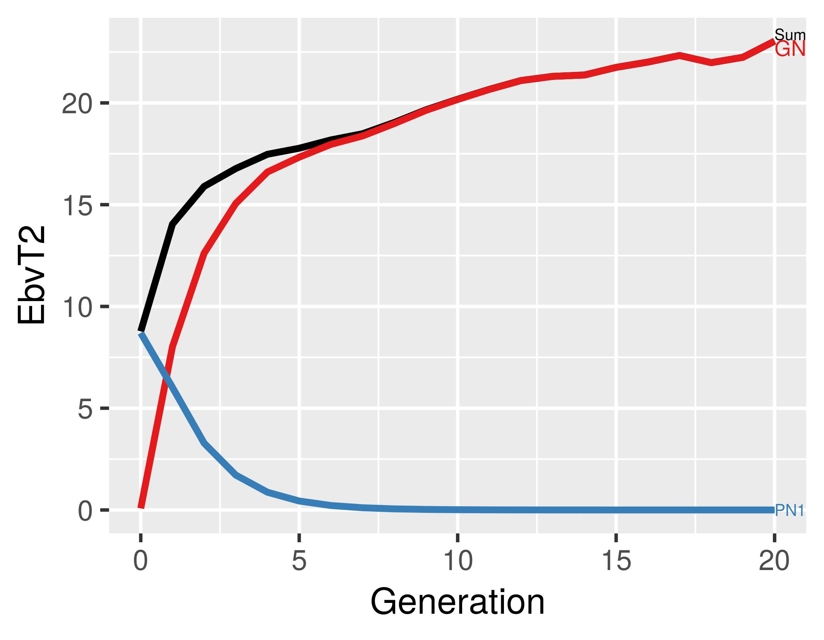
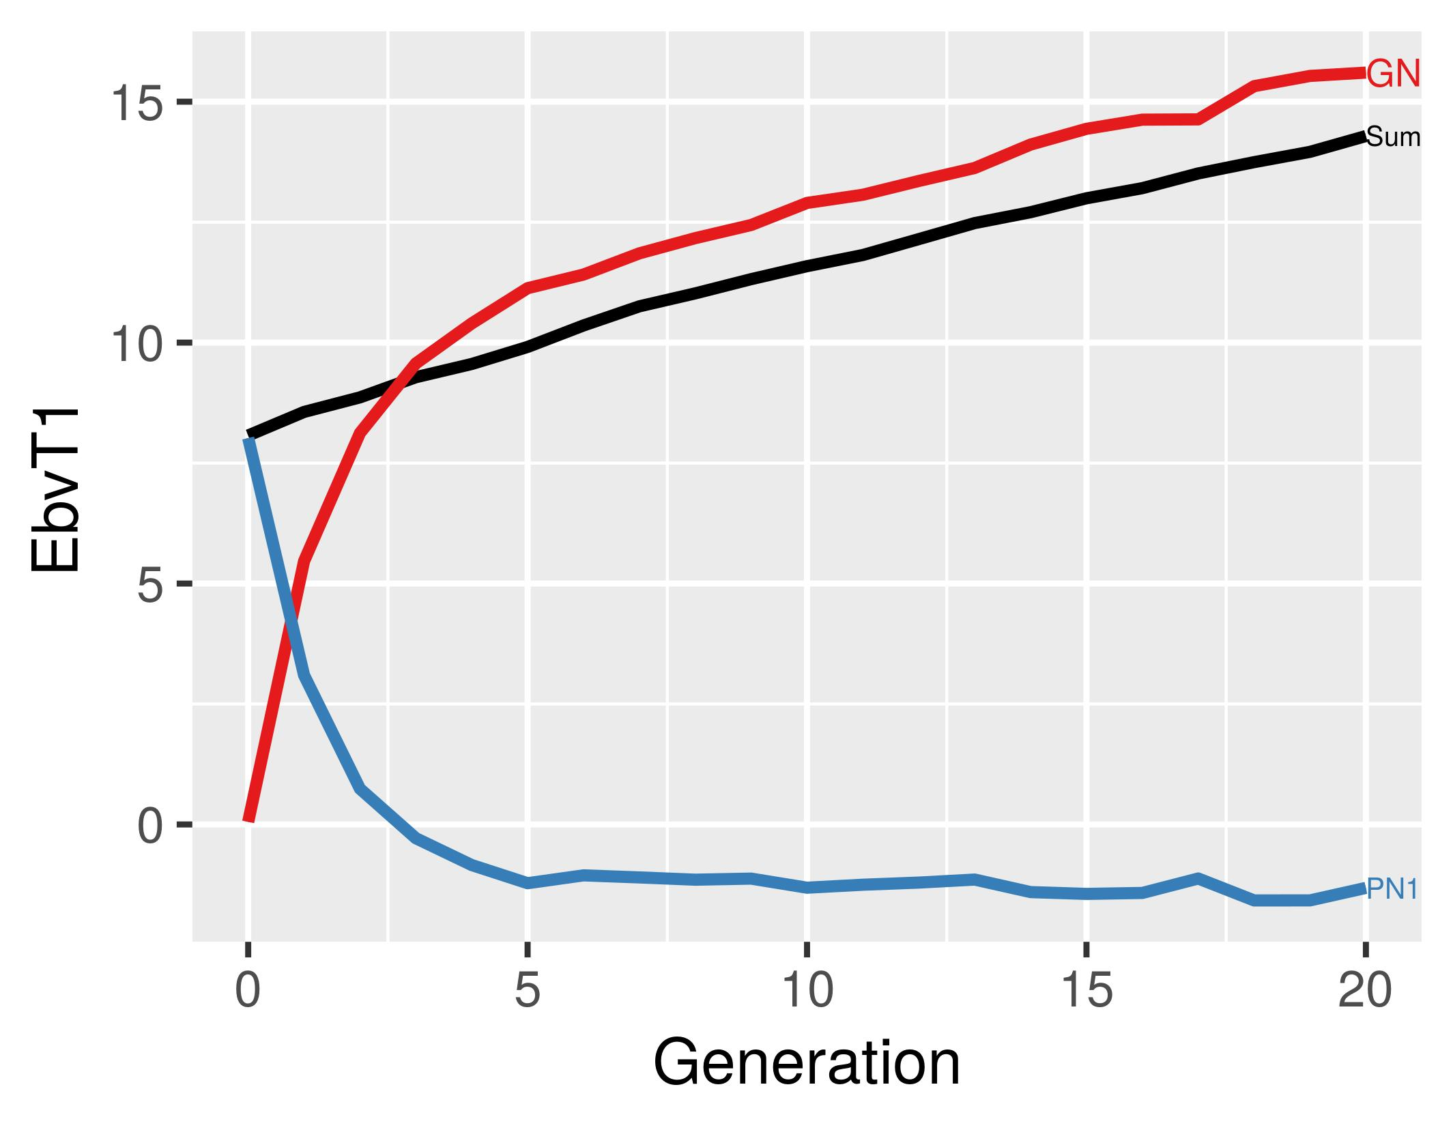

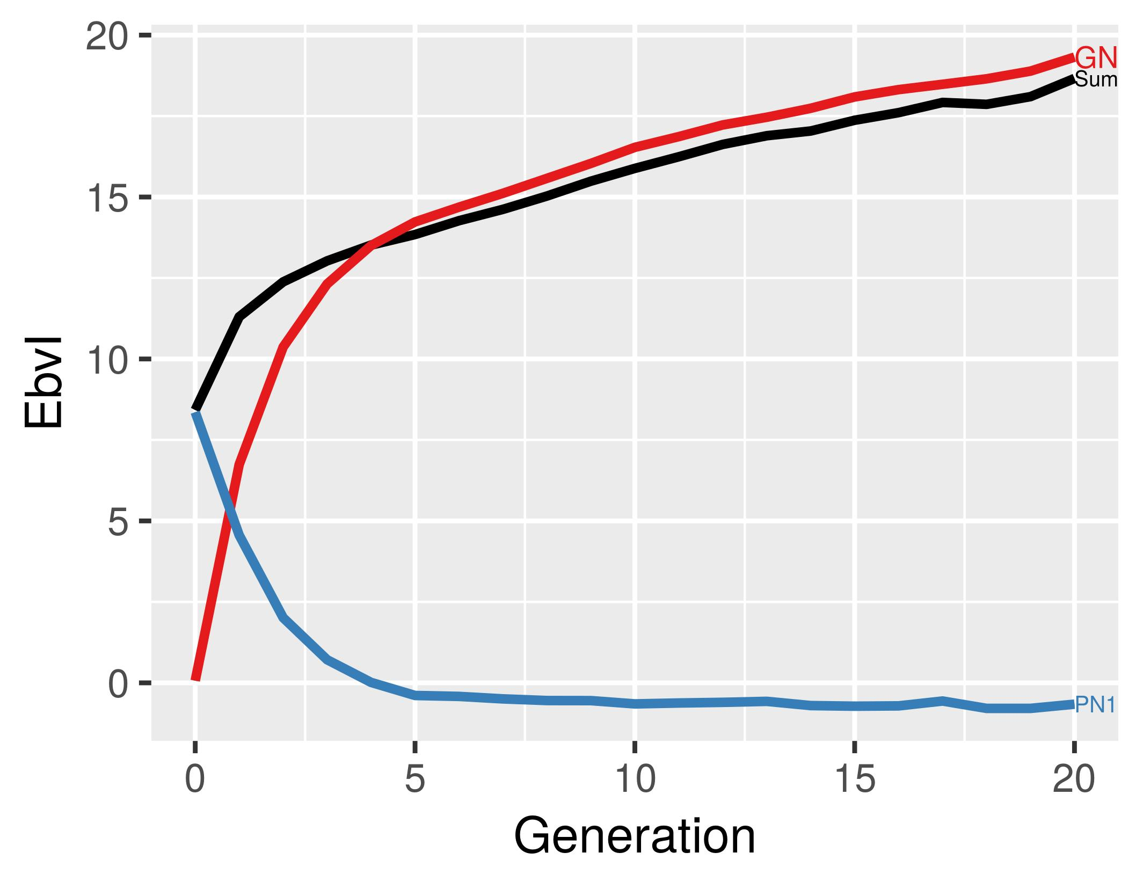
Since intensity of female selection is very low, 5000 out of 5220 are selected, the genetic trend for in females is zero (trait 1, index) or even slightly negative (trait 2). All genetic progress is contributed by males, where we perform intensive selection (100 selected out of 5280 tested).

Program with 50% import of males in reproduction
In the second scenario we imported only 50% of the males, therefore we had males from nucleus and males from reproduction level contributing to genetic gain. Therefore we partitioned the genetic trend by program-gender variable and the results are shown in Figure 2.
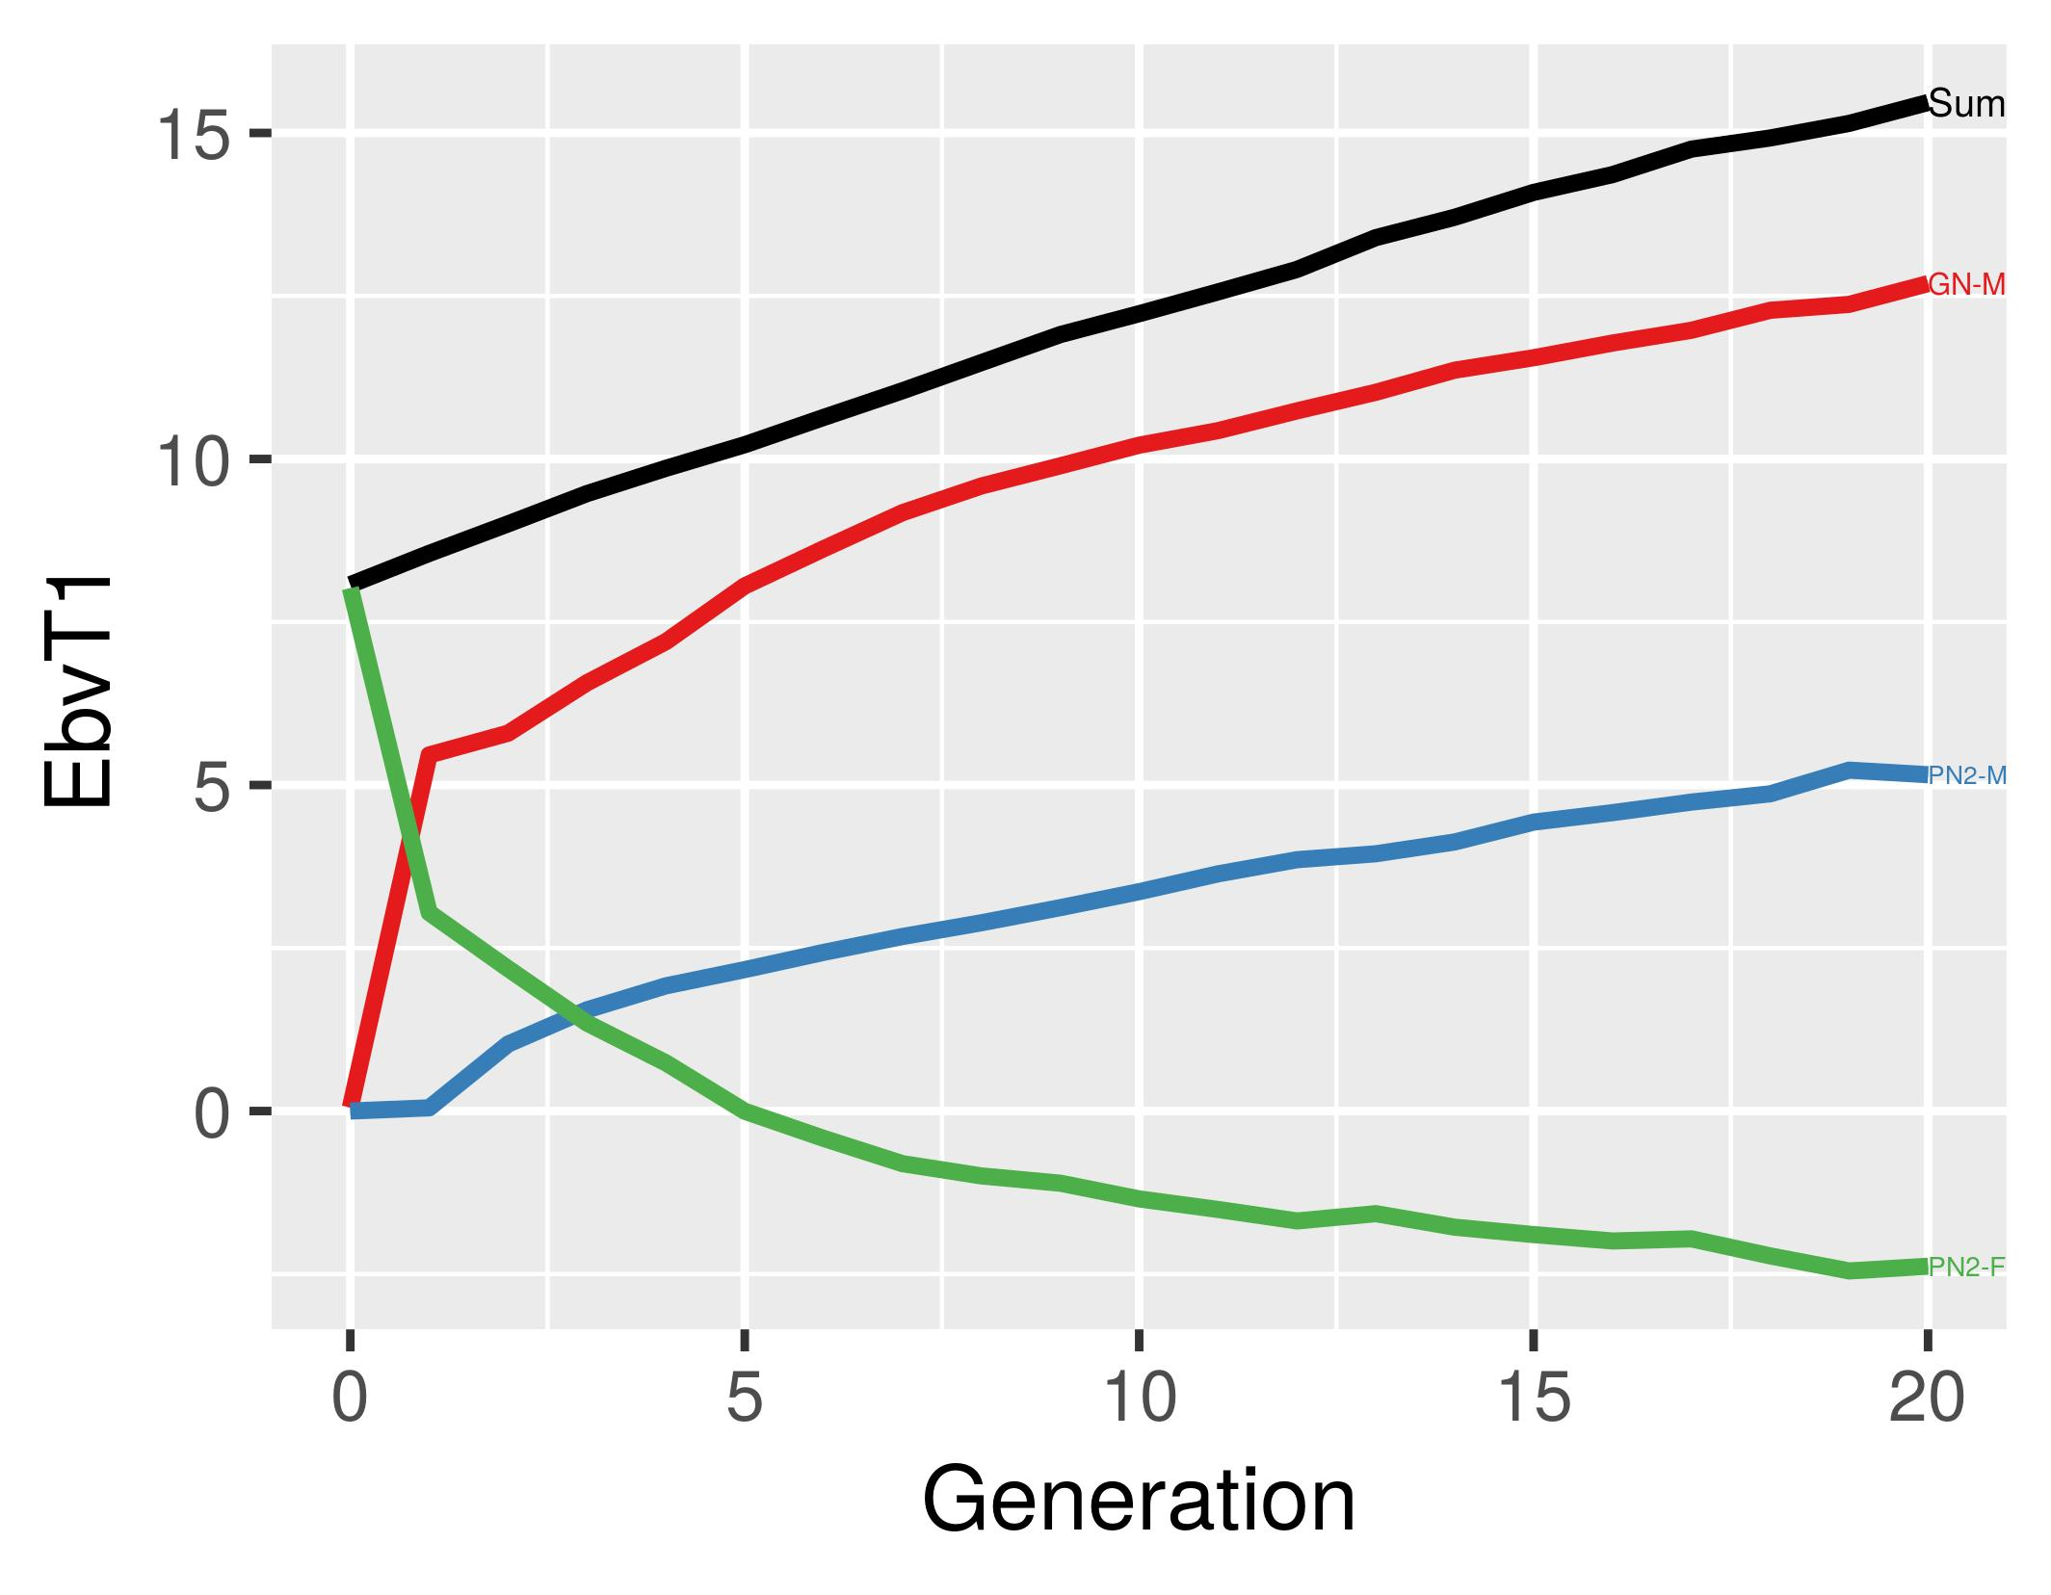
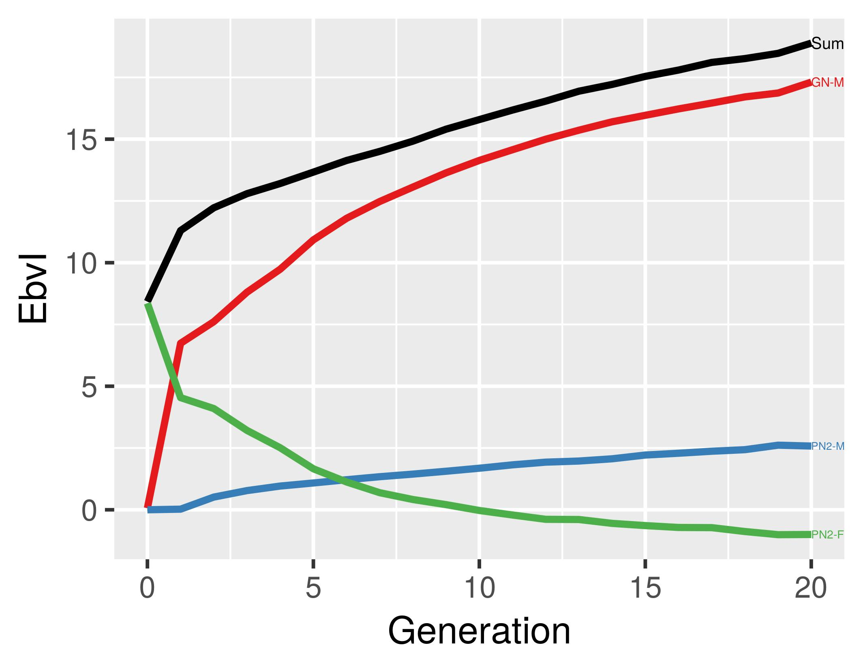

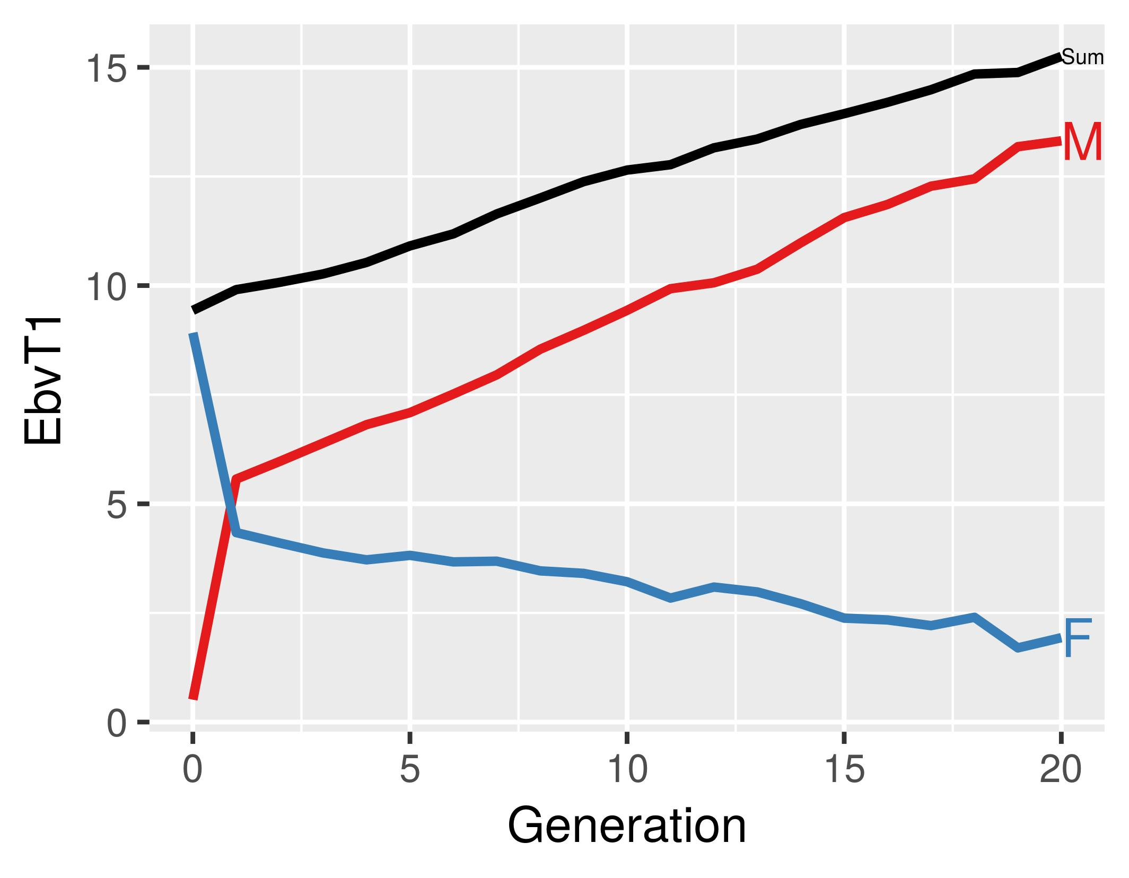
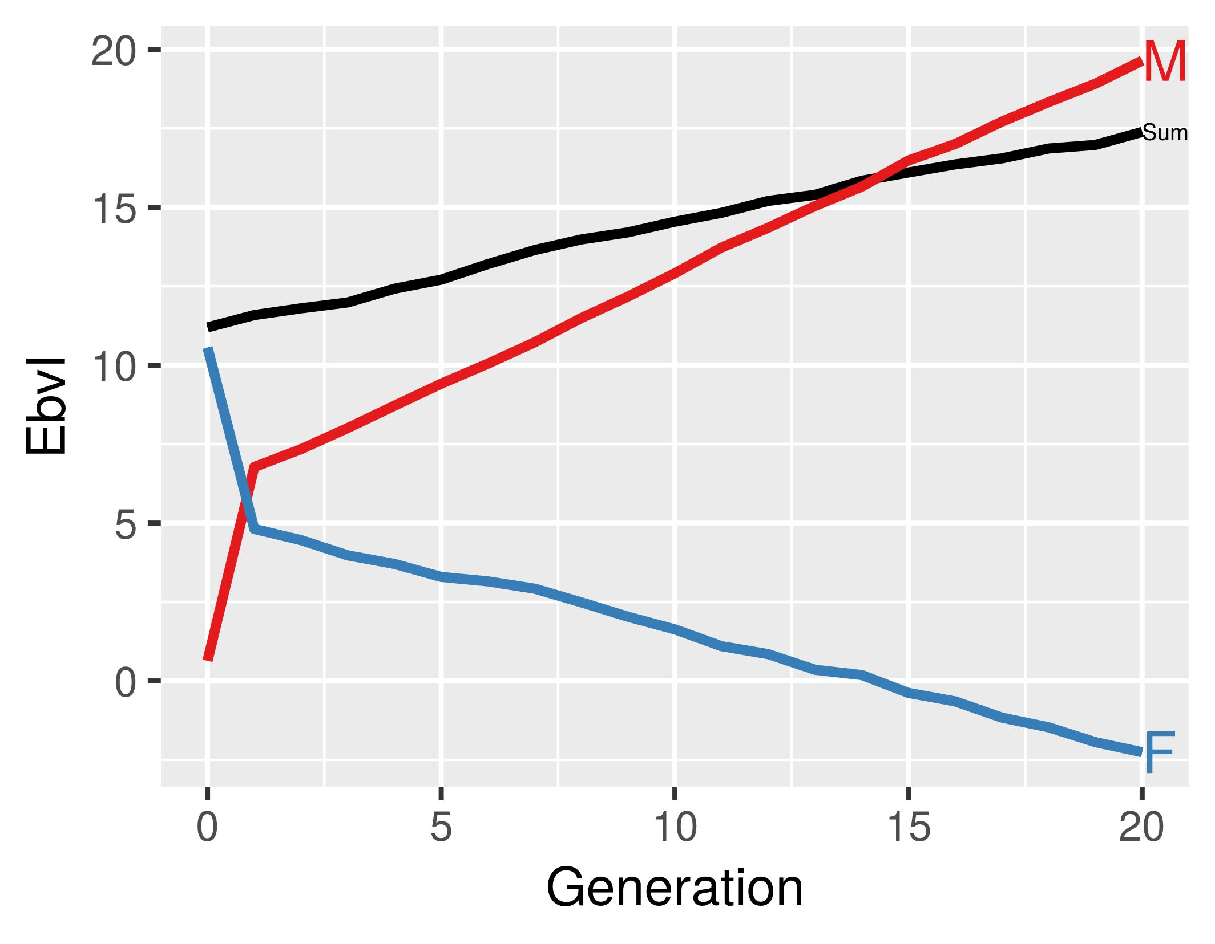
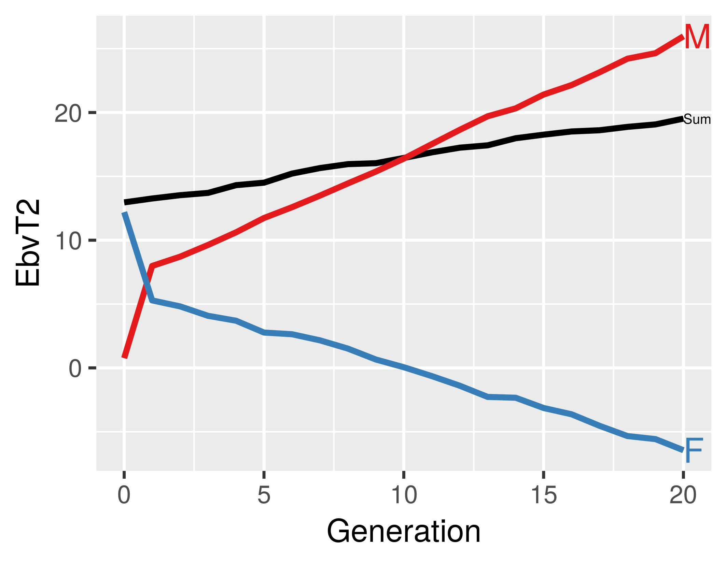

Acknowledgements [Arial 12 bold, style 'ANM heading 1']
Text [Arial 12 regular, style 'ANM main text'].

Declaration of interest [Arial 12 bold, style 'ANM heading 1']
Text [Arial 12 regular, style 'ANM main text'].

Ethics statement [Arial 12 bold, style 'ANM heading 1']
Text [Arial 12 regular, style 'ANM main text'].

Software and data repository resources [Arial 12 bold, style 'ANM heading 1']
Text [Arial 12 regular, style 'ANM main text']

References [Arial 12 bold, style 'ANM heading 1']
Author A and Author D Year. Chapter title. In book title (eds. AB Editor and CD Editor), pp. first page-last page numbers. Publisher name, place of publication (i.e. city, state (if applicable) and country).
Author A, Author B, Author CD and Author E Year. Title of article. Full Name of the Journal Volume number, first page-last page numbers.
Author A, Author N, Author CAB and Author M Year. Title of communication. Proceedings of the conference title, date of the conference (i.e. day month year), place of the conference (i.e. city, state (if applicable) and country), first page-last page numbers or poster/article number.
Author AB Year. Title of article. Full Name of the Journal Volume number, first page-last page numbers [Arial 11 regular, style 'ANM References].
Author C, Author B, Author AD and Author E Year. Title of book. Publisher name, place of publication (i.e. city, state (if applicable) and country).
Author C, Author B, Author AD and Author E Year. Title of communication. In Name of the meeting or symposium (eds A Author, BC Author and D Author), pp. first page-last page. Publisher name, place of publication (i.e. city, state (if applicable) and country).
Author M Year. Title of thesis. Type of thesis, University with English name, location of the University (i.e. city, state (if applicable) and country).
Author M, Author J, Author PE and Author D Year. Document title. Retrieved on date month year from full URL address of the web page.
Author M, Author N, Author AB and Author M Year. Title of paper. Paper presented at the nature of the event, date of the event (i.e. day month year), place of the event (i.e. city, state (if applicable) and country), pages (if applicable).
Table 1 [Arial 12 bold, style 'ANM heading 1'] Effect of x and y on z in w; tables should be sufficiently detailed for being understood without any reference to the text [Arial 12 italic, style 'ANM Table title]
Heading
[Arial 11 regular, style 'ANM Tab Spanner]
 | Heading¹ |  | Heading
Heading | ColH1² | ColH2 | ColH3 | ColH4 | ColH5 | RMSE | P-value
Row heading (units)
Row subheading
Row sub-subheading | Value | Value | Value | Value | Value | Value | Value
Row sub-subheading | Value | Value | Value | Value | Value | Value | Value
Row subheading
Row sub-subheading | Value | Value | Value | Value | Value | Value | Value
Row sub-subheading | Valuea | Valueab | Valuebc | Valuec | Value | Value | Value
Row heading3 | Value | Value | Value | Value | Value | Value | Value
Row heading | Value | Value | Value | Value | Value | Value | Value
Row heading | Value | Value | Value | Value | Value | Value | Value
ColH1 = Column heading 1; ColH2 = Column heading 2; ColH3 = Column heading 3; ColH4 = Column heading 4; ColH5 = Column heading 5
¹ Footnote explaining heading.
² Footnote explaining column heading 1.
3 Footnote explaining row heading.
a,b Values within a row with different superscripts differ significantly at P<0.05.
Figure captions [Arial 12 bold, style 'ANM heading 1']

Figure 1 [Arial 12 bold, style 'ANM heading 1'] All figure captions are listed on a separate sheet at the end of the manuscript and should be sufficiently detailed to allow figures to be understood without any reference to the text [Arial 12 regular, style 'ANM main text'].

Figure 2 [Arial 12 bold, style 'ANM heading 1'] This is the caption of figure 2 [Arial 12 regular, style 'ANM main text'].
Figures

Please check the following points before submitting your files:

- All figures are provided as separate files, not as part of the main text.

- All figure captions are listed on the same page at the end of the main text, not in the graphic file.

- Files are in the correct format.
Our preferred file format is EPS or TIFF.
MS Excel, MS PowerPoint, AI and layered PSD (up to version CS3) are permitted, provided that figures have been originally created in these formats and that all embedded images are at a suitable resolution.

- Bitmap image resolutions that are acceptable for publication are:
- for line figures (e.g. graphs) – 1200 dpi at maximum publication size (i.e. width of a double column: 175 mm);
- for figures with different shadings (e.g. bar charts) – 600 dpi at maximum publication size;
- for half tones (e.g. photographs) – 300 dpi at maximum publication size.
If any doubt, submit the source files that were used to create your figures.

- Images from the internet are unacceptable, as most of them have a resolution of only 72 dpi.

- Figures could be reduced to single-column width (83 mm). Lettering, symbols and line thickness on the original figure should be clear and large enough to be legible after reduction.

-Fonts should be consistent within and among figures. Fonts such as Arial, Symbol or Times are preferred. Avoid capital letters and bold type whenever possible.

-There are charges for colour figures that are reproduced in print and for offprints. The cost is available on the website at
http://animal-journal.eu/documents/Reprints_cost.pdf.
If figures are to be printed in colour, use CMYK (instead of RGB) colour mode preferably.

- All figures must be of the best possible quality. We cannot improve overall appearance and resolution.

Manuscript title
F. A. Author, S.-B. Author, T. Author and F. Author Jr

Supplementary material

Authors can include in the manuscript supplementary material in any type of text (full research paper, review paper, short communication, etc.).
This supplementary material could contain original modus operandi, tables or figures which are not necessary for understanding the text within the main body of the paper, mathematical models, references of publications which are used, for example, in a meta-analysis and which do not appear in the text, or pictures improving the understanding of the text.

-The manuscript must stand alone without the supplementary material for those readers who will be reading the hard copy only.

-Supplementary material will appear only in the electronic version. It will be peer-reviewed along with the rest of the manuscript, but will not be edited or typeset. It will be posted online as supplied.

-Authors are entirely responsible for its content and must check carefully the format and styles. It is subject to the same copyright requirements as primary material.

-Supplementary material should be submitted with the main manuscript in a separate file and identified as "Supplementary File – for Online Publication Only".
It should be mentioned in the main text as:
Supplementary Table S1, Supplementary Table S2, etc. for tables;
Supplementary Figure S1, Supplementary Figure S2, etc. for figures;
Supplementary Material S1, Supplementary Material S2, etc. for other material.
For example: “The list of references used for the meta-analysis is given in Supplementary Material S1”.

-The article title and the author list should be included at the top of the supplementary material.

