Short communication
AlphaPart: R implementation of the partitioning genetic trend method
J. Obsteter¹, J.M. Hickey², G. Gorjanc²
¹Department of Animal Science, Agricultural Institute of Slovenia, Hacquetova ulica 17, 1000 Ljubljana, Slovenia
²The Roslin Institute and Royal (Dick) School of Veterinary Studies, University of Edinburgh, Easter Bush, Midlothian, EH259RG, United Kingdom
Corresponding author: Jana Obsteter. Email: jana.obsteter@kis.si
Short title: AlphaPart: R package for partitioning genetic trends

Abstract
In this paper we present the AlphaPart R package for partitioning genetic trends and demonstrate its use with an intriguing pig breeding example of higher genetic trend for some traits in a multiplier compared to the nucleus. TODO Selection aims to genetically improve a target population of individuals for a selected trait or a set of traits. For breeding programmes to be competitive they have to improve genetic merit but also be efficient in terms of the balance between invested resources and achieved genetic gain. While the sources of genetic gain are usually known, their corresponding contributions are not. This paper presents the R package AlphaPart implementing the method for partitioning genetic trends and examples of its use. AlphaPart is available from the CRAN repository at http://CRAN.R-project.org/package=AlphaPart.
Keywords: genetic trend, partition, Mendelian sampling term, R package

Implications
In this paper we present the AlphaPart R package that implements the method for partitioning genetic trends for assessing driving sources of genetic change. We show how to use the package with a small number of R commands. We then demonstrate the package to identify sources of genetic trend in an intriguing pig breeding example with higher genetic trend for some traits in a multiplier compared to the nucleus. Specifically, we show that female selection in a large multiplier can increase genetic trend above the nucleus genetic trend for traits that are measured in the multiplier.
Introduction
In this paper we present the AlphaPart R package for partitioning genetic trends and demonstrate its use with an intriguing pig breeding example of higher genetic trend for some traits in a multiplier compared to the nucleus. Breeding programmes improve populations for a set of traits by identifying and reproducing genetically superior? individuals. The improvement of populations is commonly measured with a genetic trend by averaging estimated breeding values of individuals by their year of birth. While genetic trends provide information about the overall progress, they do not provide information about driving sources of the progress.
While the driving sources of the overall genetic gain are usually known, their contributions are hard to assess, particularly in complex breeding programmes with overlapping generations, multiple sources of information, multiple breeding stages, and variable reproduction rates. To this end García-Cortés et al. (2008) proposed a method that first partitions individual breeding values by “paths” and then summarizes the path specific contributions to the overall genetic trend. The “paths” represent potential driving sources, for example males and females, pedigree-tested and progeny-tested males etc. The first step is based on partitioning individual breeding value into parent average and Mendelian sampling term (Thompson, 1979) and assigning the Mendelian sampling terms to “paths” according to the aims of an analysis.
The partitioning method enables a clear analysis of driving sources of genetic merit and has been used in a number of cases. Gorjanc et al. (2011) estimated the contribution of different countries to genetic trends in global population of Brown-Swiss bulls evaluated with the Multiple Across Country Evaluation at the InterBull. Špehar et al. (2011) estimated the contribution of national selection and import in Croatian Simmental cattle. Gorjanc et al., (2012) estimated the contribution of different countries to genetic trends in global population of Holstein bulls evaluated with the Multiple Across Country Evaluation at the InterBull and projected the global contributions to four countries that used the global bulls in different ways. Finnaly, Škorput et al. (2015) estimated the contribution of national selection and import in two pig breeds in Croatia.
Recently a request has been made for our implementation of the partitioning method and we have prepared an open-source R package AlphaPart for sharing with the academic community. The aim of this paper is to present how to use of the R package AlphaPart and demonstrate its use in explaining an intriguing pig breeding example of higher genetic trend for some traits in a multiplier compared to nucleus.

Material and methods

AlphaPart
AlphaPart is implemented in R and is available from CRAN repository https://CRAN.R-project.org/package=AlphaPart. The package consists of the main function AlphaPart, that performs the partition of the additive genetic trend, and six (11) auxiliary functions for manipulating the input data as well as summarizing, visualizing, and storing the results. The inputs for the functions are either simple data frames or outputs of other functions of the package.
The package also includes a dataset AlphaPart.ped. The dataset holds pedigree (individual, father, mother), path, and breeding values. The pedigree includes eight individuals of two genders, assigned to two different countries, X and Y, and four generations.
The main function of the package is AlphaPart, that partitions additive genetic values into partial genetic trend of the specified groups (called paths). The function takes three main inputs: a pedigree data frame that includes the information on the individual, father, mother, and the year of birth; a vector with individual path information; and a vector with genetic values for the selected traits. The pedigree can be of two types, the first being “IPP”, which holds the information for the individual, parent 1 and parent 2, and the second being the “IPG”, which holds the information for the individual, parent 1 and one grandparent of parent 2. The function also enables sorting and recoding the pedigree when necessary, and performing a direct summation of partition by a chosen variable (groups). The main work is done by a C++ programme AlphaPartDrop, which is internally compiled in the package. The programme first calculates the parent average and Mendelian sampling term for all individuals. In a recursive process it then “drops” the values through the pedigree and assigns the Mendelian sampling term to the corresponding path of origin. The output of the function is of AlphaPart class. We demonstrate the application of the function on AlphaPart.ped dataset, where we partition the additive genetic values for the trait (“EBV”) into contributions by the two countries (“Country”).
> data(AlphaPart.ped)
> ##Partition additive genetic values by location
> part <- AlphaPart(x = AlphaPart.ped,
colPath = “Country”,
colAGV = “EBV”)
Function summary.AlphaPart summarizes an AlphaPart class object. The user has to specify the name of variable (group) by which to summarize the data and the function to do it with (default is mean). The summary.AlphaPart function also enables the summary of only a subset of the object. Below is a demonstration how to summarize above obtained partition results (“part”) by country.
> ## Sumarize by country variable
> sumPart <- summary(part, by = “Country”)
Function AlphaPartSubset is a auxiliary function that keeps only partitions for the specified paths. It accepts both AlphaPart and summaryAlphaPart objects. Here we show how to keep partitions only for country X.
> ## Subset AlphaPart object
> AlphaPartSubset (x = part, paths = “X”)
Function AlphaPartSum is a auxiliary function that sums the partitions of several paths. It accepts a summaryAlphaPart objects. The user specifies the paths to sum and whether to remove the original paths. Here is an example how to sum the partitions of specific generation.
> ## Sumarize partition by generation
> sumPart <- summary(part, by = “Generation”)
> ## Sum AlphaPart object
> AlphaPartSum(x = sumPart, map = list(c(1, 2), c(2, 3, 4))
Function pedFixBirthYear imputes or fixes missing or erroneous birth year information. The input data is a pedigree with at least four columns – individual, father, mother, and birth year. The user has to specify the generation interval in years. Other optional parameters define how to impute the birth years. Here is an example of the application on a pedigree with missing data:
## Example pedigree with missing birth years for some individuals
ped0 <- data.frame(id. = c( 1, 2, 3, 4, 5, 6, 7, 8, 9, 10),
fid = c( 0, 0, 0, 1, 1, 1, 3, 4, 0, 5),
mid = c( 0, 0, 0, 2, 0, 2, 2, 2, 5, 0),
by = c(NA, 0, 1, NA, 3, 3, 3, 3, 4, 4))
## First run - using information from children
ped1 <- pedFixBirthYear(x = ped0, interval = 1)
## Second run - using information from parents
ped2 <- pedFixBirthYear(x = ped1, interval = 1, down = TRUE)
Function pedSetBase sets the base population in the pedigree. The user has to specify which individuals to keep. The function then removes the records for unselected individuals as well their presence as parents.
> ## Remove the individuals in generation 1 from AlphaPart.ped
> pedSetBase(AlphaPart.ped, keep = AlphaPart.ped$Generation > 1)
The package also includes plot.summaryAlphaPart function for visualisation of summaryAlphaPart class, print functions to display partition and summary partition results as well as the plots; and savePlot and write.csv functions to save the created results.

Pig breeding example
We present the implementation of the AlphaPart R-package and its function on a pig selection example.
Selection in pigs is carried out in three tiers: nucleus, multiplier, and commercial tier. In the nucleus the animals are selected based on a set of traits combined in a selection index. The best parents enter the multiplier tier, which serves for expansion of the population and selection. Multiplier animals are selected based on one trait only, usually a performance trait. The last tier is the commercial level, that does not perform selection of animals.
The breeding companies often observe that animals in the multiplier have higher breeding values for a specific trait than nucleus animals. Hence, the aim was to explain this by partitioning the total genetic trend, determining the contributions of tier-gender groups, and identifying the sources of genetic gain in nucleus and multiplier tier.
We simulated a pig population with the corresponding structure with AlphaSimR package (Gaynor et al., 2019). We simulated two traits, T1 with heritability 0.25 and T2 with heritability 0.1. The simulation ran for 40 year, 20 of those burn-in and 20 evaluation. In the burn-in we simulated only nucleus and performed selection based on phenotypic values. Each year, we selected 25 nucleus males and 500 nucleus females with the highest index phenotypic value, which was the mean of phenotypic values for both traits. The selected parents were randomly crossed to produce 6000 individuals each year (12 offspring per cross). At the end of the burn-in we selected 25 nucleus males, 500 nucleus females, and 5000 multiplier females to enter the selection (evaluation?) years.
In each of the following 20 years we performed selection in the nucleus as well as the multiplier and selected animals based on their index EBVs, which were the mean of EBVs for both traits. In the nucleus, we selected 25 males and 500 females with the highest index EBVs to produce 6000 selection candidates (12 offspring per cross) for new nucleus parents. In the multiplier, we selected 15% females (N = 750) with the highest index EBVs and crossed them to: 1) nucleus males (N = 25) (Programme 100% import of fathers); or 2) equal proportion of top nucleus (N=25) and multiplier males (N=25) (Programme 50% import of fathers). The crosses in the multiplier produced 10,500 selection candidates (14 offspring per cross) for the new multiplier parents. The EBVs were estimated with pedigree-based BLUP implemented in blupf90 (Misztal et al., 2002). The prediction model included the mean as a fixed and animal as a random effect. We repeated the simulation of the burn-in and each scenario 10 times.
Next, we performed the partitioning of genetic trend with AlphaPart. We partitioned the true breeding values of the animals born in the 20 evaluation years by tier gender variable. The partitioned values were summarized by year to obtain a partial genetic trend for each of the contributing tier-gender groups.

Results
The results compare partition results of the two simulated pig breeding programmes with varying degree of local selection obtained with the newly developed AlphaPart package. The partition revealed, that nucleus animals contribute a vast majority to the genetic gain in both, nucleus and multiplier tiers for both traits. In both programmes multiplier tier achieved a higher genetic gain than nucleus for trait 1. When we performed only local selection of multiplier females and imported all fathers into multiplier, the superiority of the multiplier originated from additional contribution of nucleus males and multiplier females. When we performed local selection of multiplier females as well as males, and imported only half the fathers into multiplier, the mean of the multiplier was even higher above nucleus due to the additional gain stemming entirely from multiplier males and females.

Programme 1: 100% import of fathers into multiplier
In Programme 1, the multiplier achieved a higher genetic gain than nucleus for trait 1. The additional gain in the multiplier stemmed from the nucleus males and multiplier females. This is shown in Figure 1, that presents the total and partial genetic trends for trait 1 and 2 in nucleus and multiplier tier in Programme 1. The partition of true breeding values revealed, that the nucleus animals were the main origin of genetic gain for both traits in both tiers, with the nucleus males contributing the most. In nucleus, all the genetic gain was contributed by nucleus animals with males contributing 57% or 60% and females 43% or 40% to genetic gain for trait 1 or trait 2. Genetic gain for trait 1 in the last year was 4.2% higher in the multiplier than in the nucleus. Approximately half of this increase, 52% (2.2% of the difference in genetic gain), came from a larger contribution of nucleus males compared to the nucleus. The remaining part of the increase, 48% (2.0%), came from the multiplier females. The contribution of the latter to the total genetic gain varied across years and ranged between 1.3% and 8.9% (4.5% on average, 2% in the last generation). For trait 2, nucleus and multiplier achieved comparable genetic gains and no superiority of the multiplier was observed.
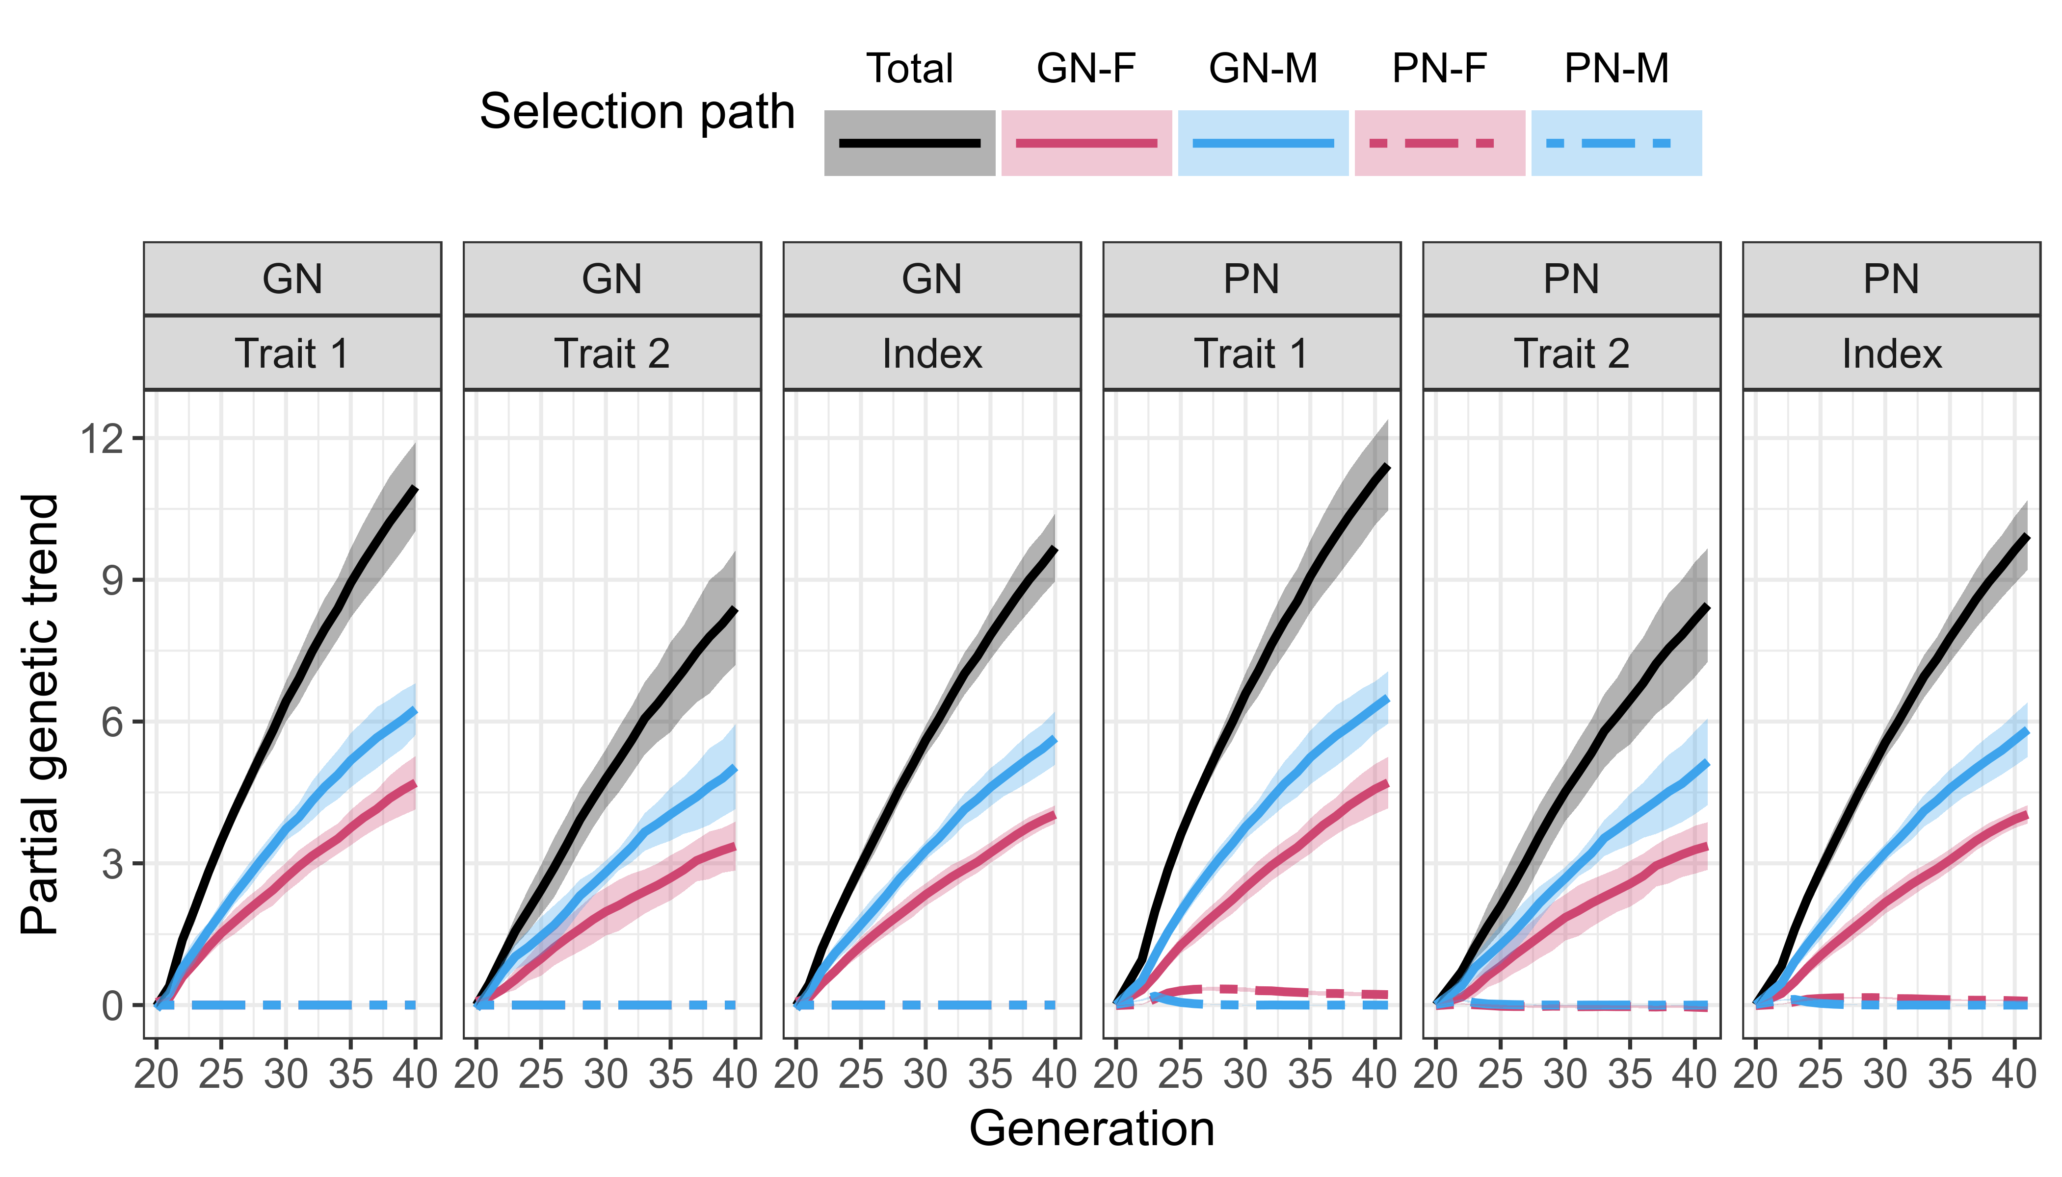
Figure 1: Total and partial genetic trends by tier and trait in Programme 1. GN = nucleus, PN = multiplier, GN-F = nucleus females, GN-M = nucleus males, PN-F = multiplier females, PN-M = multiplier males. Programme 1 uses only nucleus male in multiplier. Trait 1 with heritability 0f 0.25 is measured on all animals and trait 2 with heritability of 0.1 is measured only on nucleus animals.

Programme 2: 50% import of nucleus males in multiplier
Compared to Programme 1, local selection of multiplier fathers in Programme 2 further increased the genetic advantage of the multiplier tier, since both, multiplier females and males, contributed to the genetic gain for trait 1 in the multiplier. For trait 2, the genetic gain in the multiplier suffered from loosing the imported contribution from nucleus through paternal line. This is shown in Figure 2, that presents the total and partial genetic trends by trait and tier in Programme 2. Additionally, the distributions of true breeding value of nucleus and multiplier animals for the two traits and the index are presented in Figure 3. In the nucleus of Programme 2, the partition revealed similar trends than in Programme 1. Nucleus males contributed 56% or 62% and females 44% or 38% to the genetic gain for trait 1 or trait 2. Multiplier tier again achieved a higher genetic gain for trait 1 than nucleus, with an even larger difference than in Programme 1, i. e. 9%. This increase was in 58% (5.2%, 7.6% of the total genetic gain) attributable to the contribution of multiplier females and in 42% (3.8%, 5.8% of the total genetic) to multiplier males. The contributions of the multiplier animals to the total genetic gain for trait 1 varied across years and reached between 2% and 21% for multiplier females and between 6% and 28% for multiplier males (14.7% for both on average, 7.6% and 5.8% in the last year). Compared to the nucleus, the contribution of the nucleus animals was reduced (11% for males and 16% for females). For trait 2, the genetic gain was 13% higher in the nucleus than in multiplier, with the multiplier animals having a small negative contribution to the genetic trend (3% for each, males and females).
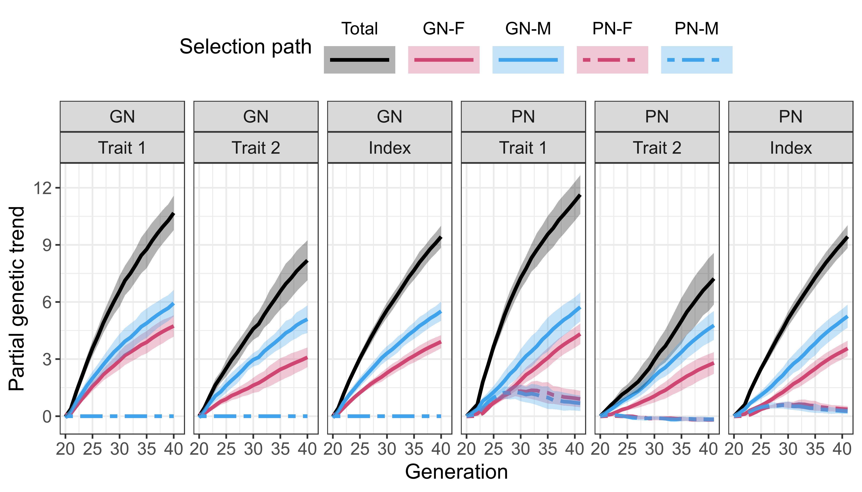
Figure 2: Total and partial genetic trends by tier and trait in Programme 2. GN = nucleus, PN = multiplier, GN-F = nucleus females, GN-M = nucleus males, PN-F = multiplier females, PN-M = multiplier males. Programme 2 uses nucleus and multiplier males in multiplier in equal proportion. Trait 1 with heritability 0f 0.25 is measured on all animals and trait 2 with heritability of 0.1 is measured only on nucleus animals.
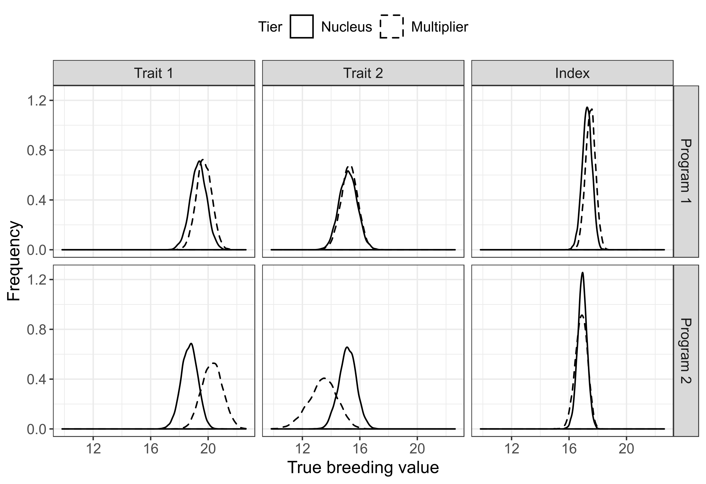
Figure 3: Distribution of true breeding values by traits and tiers in Programme 2 in the last year of comparison of the first repetition of the simulation. Programme 2 uses nucleus and multiplier males in multiplier in equal proportion. Trait 1 with heritability 0f 0.25 is measured on all animals and trait 2 with heritability of 0.1 is measured only on nucleus animals.

Discussion
In this paper we present AlphaPart R-package, which is the first software to implement the method for partitioning genetic trends. It works by dropping the Mendelian sampling terms through the pedigree and assigning them to the group of origin. The developed software is a valuable tool for deciphering the origins of genetic gain and corresponding contributions. The package enables easy handling of the data, since the input data for all functions is either a simple data frame or an output class of another package function. The package also allows for visualising and storing the results.
By partitioning the results of our simulated pig breeding programmes, we wanted to disentangle the phenomena of pig breeding companies observing multiplier animals that are genetically superior to nucleus animals. The partition first revealed, that nucleus animals are the main source of genetic progress for both traits in both tiers, since the genetic gain produced in the nucleus is also imported in the multiplier. Nucleus animals contributed the most, because they were measured for both traits and were also one generation ahead of the multiplier. We also observed that nucleus males contributed more than nucleus females, which can be explained by higher intensity of selection in the male selection path (i = 2.73 for males and I = 1.49 for females).
The partition further on revealed that the genetic gain in the multiplier depends on the amount of genetic gain we directly import from the nucleus into the multiplier, and on the contribution of the multiplier animals themselves, which is conditional on (/ controlled by) the accuracy of selection in the multiplier.
In both Programmes, we observed the multiplier outperforming the nucleus for trait 1, for which we had the power to select the genetically superior animals in the multiplier. Trait 1 had a medium heritability (0.25) and was also measured on all 10,500 multiplier animals. This enabled a more accurate selection of multiplier animals (r = 0.56 in nucleus and r = 0.55 in multiplier), which consequently contributed to the genetic gain. The partition revealed, that when we import all paternal genetic gain from nucleus into multiplier (Programme 1), the multiplier benefits from two sources. First, compared to the nucleus, the contribution of the nucleus males increases, since they also contribute through multiplier females they father. And second, the multiplier females themselves contribute to the genetic gain. In Programme 2, we implemented local selection of both, males and females in the multiplier and imported only half of the fathers in the multiplier. This resulted in the multiplier having an even higher advantage over nucleus for trait 1 than in Programme 1 due to both, multiplier males and females contributing to the genetic gain. In contrast, the contribution of the nucleus animals was reduced compared to the nucleus, which is the opposite of what we observed in Programme 1. The reason was, that nucleus males now fathered only half of the multiplier females, hence genetic gain of the latter was only partially attributed to nucleus males and partly to multiplier males. Consequently, the contribution of multiplier animals was higher than in Programme 1, since they also started contributing through their selected female and male offspring.
On the contrary, trait 2 had a lower heritability, 0.1, and was not measured in the multiplier. Hence the multiplier animals were selected only based on their parent average / breeding values for the multiplier animals effectively represented (captured) parent average (average accuracy = 0.30 in multiplier; and 0.50 in nucleus). Considering also, that we selected the animals based on an index, this gave us little power to to identify the multiplier animals that were genetically superior for trait 2. In Programme 1, this resulted in a null contribution of multiplier animal to the genetic trend for trait 2. Consequently, genetic gains in nucleus and multiplier were comparable, since all genetic gain was imported from nucleus. A similar result was observed in Programme 2, where multiplier females nor males contributed to genetic gain for trait 2. Here, that genetic gain for trait 2 was reduced in the multiplier compared to nucleus. This is different than in Programme 1, since less genetic gain was directly imported from the nucleus through paternal line.

Acknowledgements
The authors thank Ivan Pocrnic (University of Edinburgh, Roslin Institute) for advice on estimation of breeding values with blupf90 as well as Owen Powell (University of Edinburgh, Roslin Institute) and Chris Gaynor (University of Edinburgh, Roslin Institute) for the advice on troubleshooting the breeding scheme and breeding value estimation. G. Gorjanc and J. M. Hickey acknowledge support from the BBSRC funding to The Roslin Institute (BBS/E/D/30002275).

Software and data repository resources
AlphaPart is available from the CRAN repository at http://CRAN.R-project.org/package=AlphaPart.

References
García-Cortés, LA, Martínez-Ávila, JC, Toro, MA 2008. Partition of the genetic trend to validate multiple selection decisions. Animal 2, 821–824.
Gaynor RC, Gorjanc G, Wilson D, Money D, Hickey JM 2019. AlphaSimR Breeding Program Simulations. Version 0.11.0. http://CRAN.R-project.org/package=AlphaSimR
Gorjanc G, Potočnik K, García-Cortés LA, Jakobsen J and Dürr J 2011. Partitioning of international genetic trends by origin in Brown Swiss bulls. Interbull Bulletin 44, 81-86.
Gorjanc G, Hely FS, Amer PR 2012. Partitioning international genetic trends by origin in Holstein bulls. Paper presented at the ICAR conference, 28 May – 1 June 2012, Cork, Ireland.
Misztal I, Tsuruta S, Strabel T, Auvray B, Druet T and Lee DF 2002. BLUPF90 and related programs (BGF90). Proceedings from the 7th World Congress on Genetics Applied to Livestock Production, August 2002, Montpellier, France, 1-2.
Škorput D, Gorjanc G., Kasap A and Luković Z 2015. Partition of genetic trends by origin in Landrace and Large-White pigs. Animal 9, 1605–1609.
Špehar M, Ivkić Z, Bulić V, Barać Z, and Gorjanc G 2011. Partitioning of Genetic Trends by Origin in Croatian Simmental Cattle. Agriculturae Conspectus Scientificus 76, 301-304.
Thompson R 1979. Sire Evaluation. Biometrics 35, 339-353.
Figure captions

Figure 1 [Arial 12 bold, style 'ANM heading 1'] All figure captions are listed on a separate sheet at the end of the manuscript and should be sufficiently detailed to allow figures to be understood without any reference to the text [Arial 12 regular, style 'ANM main text'].

Figure 2 [Arial 12 bold, style 'ANM heading 1'] This is the caption of figure 2 [Arial 12 regular, style 'ANM main text'].
Figures

Please check the following points before submitting your files:

- All figures are provided as separate files, not as part of the main text.

- All figure captions are listed on the same page at the end of the main text, not in the graphic file.

- Files are in the correct format.
Our preferred file format is EPS or TIFF.
MS Excel, MS PowerPoint, AI and layered PSD (up to version CS3) are permitted, provided that figures have been originally created in these formats and that all embedded images are at a suitable resolution.

- Bitmap image resolutions that are acceptable for publication are:
- for line figures (e.g. graphs) – 1200 dpi at maximum publication size (i.e. width of a double column: 175 mm);
- for figures with different shadings (e.g. bar charts) – 600 dpi at maximum publication size;
- for half tones (e.g. photographs) – 300 dpi at maximum publication size.
If any doubt, submit the source files that were used to create your figures.

- Images from the internet are unacceptable, as most of them have a resolution of only 72 dpi.

- Figures could be reduced to single-column width (83 mm). Lettering, symbols and line thickness on the original figure should be clear and large enough to be legible after reduction.

-Fonts should be consistent within and among figures. Fonts such as Arial, Symbol or Times are preferred. Avoid capital letters and bold type whenever possible.

-There are charges for colour figures that are reproduced in print and for offprints. The cost is available on the website at
http://animal-journal.eu/documents/Reprints_cost.pdf.
If figures are to be printed in colour, use CMYK (instead of RGB) colour mode preferably.

- All figures must be of the best possible quality. We cannot improve overall appearance and resolution.

