Genomic selection for any dairy breeding program via optimised investment in phenotyping and genotyping
Jana Obšteter^{1*}, Janez Jenko², John M. Hickey³, and Gregor Gorjanc^{3,4}
¹Department of Animal Science, Agricultural Institute of Slovenia, Hacquetova ulica 17, 1000 Ljubljana, Slovenia
²Geno Breeding and A.I. Association, Storhamargata 44, 2317 Hamar, Norway
³The Roslin Institute and Royal (Dick) School of Veterinary Studies, University of Edinburgh, Easter Bush, Midlothian, EH259RG, United Kingdom
⁴Biotechnical Faculty, University of Ljubljana, Jamnikarjeva 101, 1000 Ljubljana, Slovenia

*Jana Obšteter, Agricultural Institute of Slovenia, Department of Animal Science, Hacquetova ulica 17, 1000 Ljubljana, Slovenia

E-mail addresses:
J. O.: jana.obsteter@kis.si
J. J.: janez.jenko@geno.no
J. M. H.: john.hickey@roslin.ed.ac.uk
G. G.: gregor.gorjanc@roslin.ed.ac.uk

Abstract
Background: This paper evaluates the potential of maximizing genetic gain in a dairy cattle breeding programmes by optimizing investment into phenotyping and genotyping. Conventional dairy breeding programmes focus on phenotyping selection candidates or their close relatives to increase selection accuracy, since this is the main driver of genetic gain and quality assurance for the producers. Genomic selection changed the relative importance of breeding actions and selection parametersand through this doubled genetic gain per year compared to the conventional selection. However, genomic selection requires a large initial investment, which limits the adoption of genomic selection for some breeding programmes. Here we evaluate the possibility of optimizing the investment in phenotyping and genotyping to enable genomic selection in a case study of small dairy population and provide suggestions for other dairy breeding programmes.
Results: We simulated a case study with a number of equal costs breeding scenarios. The baseline was a conventional dairy cattle scenario with 11 phenotype records per lactation. In genomic scenarios, we reduced phenotyping and used the saved resources for genotyping. We reduced phenotyping by varying the number of repeated dairy phenotype records from 10 to 1 per lactation. We tested these scenarios in settings with or without initial training population for genomic selection. The results show that reallocating a part of phenotyping resources to genotyping increases genetic gain compared to the conventional scenario regardless of the amount and relative cost of genotyping, and the presence of an initial training population. The genetic gain increases with increased investment in genotyping, despite reduced phenotyping.
Conclusions: This study shows that breeding programmes should optimise allocation of resources into phenotyping and genotyping to maximise return on investment. This conclusion implies that most, if not all, dairy breeding programmes can implement genomic selection without increasing the level of investment.

Background
This paper evaluates the potential of maximizing genetic gain in dairy cattle breeding programmes by optimizing allocation of resources into phenotyping and genotyping. All breeding programmes strive to maximize genetic gain, which is a function of selection intensity, accuracy of selection, genetic variation, and generation interval. However, breeding schemes differ in the relative importance of the parameters. The conventional breeding scheme has a long generation interval as well as lengthy and costly sire (progeny?) testing that does not allow for high selection intensity. Consequently, it funnels all the resources into phenotyping to increase the accuracy of sire selection, since this is the main driver of genetic gain. Genomic selection [1, 2] (Meuwissen et al., 2001; Schaeffer, 2006), on the other hand, achieves genetic gain mainly through substantially reduced generation interval, increased selection intensity, and increased accuracy of selection for young animals [2, 4](Schaeffer, 2006; Obšteter et al., 2019). Although due to earlier selection in genomic selection the accuracy of selection candidates is often lower than that of a progeny test, genomic selection doubles the rate of genetic gain per year in dairy cattle compared to the conventional progeny testing [3](Wiggans et al., 2017).
All breeding programmes operate with a certain amount of resources that they aim to allocate between breeding activities to achieve the maximum return on investment. Genomic selection is becoming a standard in livestock breeding, but sets different priorities than conventional selection. It requires a large initial investment in genotyping to establish a training population and further investments for yearly updates This can be challenging for phenotypically oriented breeding programmes, especially in the transition period, when they usually run both schemes simultaneously / the investments has not yet been reallocated. The breeding programs therefore need to evaluate their priorities, and reorganise the programmes to optimise the investment into increasing accuracy by phenotyping and reducing the generation interval by genotyping.
The accuracy of pedigree-based estimates of breeding values increases with increasing heritability and increasing number of phenotype records per animal or its closest relatives (e.g., [5]Mrode, 2005). To illustrate, assume a female-expressed trait with the heritability of 0.25, repeatability of 0.35, and progeny testing in a population with 100 sires each tested on 100 daughters. Collecting ten phenotype records per daughter allows for expected accuracy of sire selection of 0.98 and accuracy of parent average for non-phenotyped offspring of 0.66. If we decrease the number of phenotype records per daughter to 5, 2, or 1, the accuracy of sire selection respectively decreases to 0.97, 0.96, or 0.93, and the accuracy of parent average to 0.64, 0.59, or 0.56. This shows that replicated phenotype records have diminishing returns and that there is a scope for optimising return on investment.
The accuracy of genome-based estimates of breeding values also increases with increasing heritability and increasing number of phenotype records per genotyped animal, but also with increasing training population of phenotyped and genotyped animals, decreasing genetic distance between training and prediction individuals, and decreasing number of effective genome segments (Daetwyler et al. 2008; Goddard, 2009; Habier et al., 2010; Clark et al, 2011; Goddard et al., 2011). The latter partly dictates linkage disequilibrium between markers and causal loci between training and prediction animals, that further affects the accuracy of genomic evaluation and prediction. Recombination, selection, mutation, migration, and drift change linkage disequilibrium, which decreases the accuracy of genomic prediction across generations (Meuwissen et al., 2001; Calus, 2010) if the training population is not updated. While the accuracy of genomic prediction decays slower than with pedigree prediction (Habier et al., 2010; Wolc et al., 2011), we still observe a substantial decrease. To prevent the drop in the accuracy, marker effects must be continually re-estimated and the training population must be continually updated with new animals.
Following the previous example, assume 10,000 effective genome segments and a training population for genomic prediction of 10,000 cows. Recording ten phenotype values per cow increases the heritability of phenotype to 0.60 and results in the expected accuracy of genomic breeding value of 0.61 for a non-phenotyped animal. By reducing the number of phenotype records per cow to 5, 2, or 1, we reduce the phenotype heritability to 0.52, 0.37, or 0.25, and prediction accuracy to 0.59, 0.52, or 0.45. This example again shows that replicated phenotyping has diminishing returns and that there is a scope for optimising return on investment also with genomic breeding programmes. If we simultaneously increase the number of genotyped animals, to compensate for reduced genotyping, genomic prediction with 100,000 cows in the training population, each phenotyped once, results in the expected accuracy of 0.85 for non-phenotyped animals. For sire selection, these accuracies are still lower than in progeny testing. Despite this, the genomic selection this increases genetic gain.For example, if we assume 10,000 females each phenotyped ten times, 5% of males selected, and genetic standard deviation of 1 for the trait, the expected genetic gain in a conventional progeny testing with 100 sires and generation interval of 6 years is 0.32 units of genetic standard deviation per year. At the same intensity of male selection and same genetic standard deviation, but generation interval reduced to 2 years, genomic selection achieves genetic gain of 0.61 units genetic standard deviation per year. However, we can not predict the observed (actual) accuracies and genetic gain of complex breeding programmes with simple equations, but need to run a complex holistic simulation.
However, repeated records enable the estimation of individual’s permanent effect due to non-additive genetic effects or individual specific environmental effects. Repeated records also enable prompt management.
Pedigree-based nor genomic prediction exploit all the available information, since for some animals in the breeding programme we have only phenotype, genotype, or both types of information. Single-step combines all phenotypic, pedigree, and genomic information and in turn increases prediction accuracy even further (Gao et al., 2012, Gray et al., 2012; Lourenco et al., 2015).
Repeated phenotyping could be an internal financial reserve that enables any breeding programme to implement genomic selection. In dairy breeding programs, the most repeatedly and extensively recorded phenotypes are milk production traits. There are different milk recording methods that differ in the authorisation for recording, sampling scheme, recording frequency, sampling frequency, and the number of milkings per day (ICAR, 2017). The recording interval ranges from daily recording to recording every nine weeks, which translates to between 5 and 44 recordings per lactation. However, the prices of milk recording are not standardized and differ between recoding systems, countries, and their regions. Some organizations require payment of a participation fee plus the cost per sample, while others include the fee in the sample cost or cover the costs in other ways.
The aim of this study was to evaluate the potential of reallocating a part of phenotyping resources to genotyping to implement genomic selection. Since milk recording is an example of repeated phenotyping, which has diminished returns, we aimed to evaluate the optimal investment into milk recording and genotyping. To this end we have compared conventional progeny testing dairy breeding programme with equal-cost genomic breeding programmes that reduced the number of milk records per cow per lactation and invested the saved funds into genotyping. We compared these strategies in a small cattle breeding programme as this is a challenging case to implement genomic selection.
The results show that reallocating a part of phenotyping resources to genotyping increases genetic gain regardless of the cost and amount of genotyping, and the availability of initial training population. The genetic gain also increases with increasing investment into genotyping, despite reducing phenotyping.

As already mentioned, the estimation of breeding values requires financial resources for the collection of data. Breeding programs have to assure continuous cash inflow, since the data has to be updated to maintain high accuracy of prediction. While the funding for phenotyping is usually secured in breeding programs, the funding for genotyping is not yet well established to initiate and / or regularly update the training population for genomic prediction. Internal reallocation of resources seems like (the only) viable option. However, breeding programs constitute of many crucial actions, many of them can not be manipulated with or omitted. Since increasing the number of phenotypic records increases the accuracy in a diminishing manner, repeated measurements of the phenotype identifies as a plausible candidate for a reduction and financial reallocation.

Methods
The study aimed to investigate the effect of different allocation of resources into phenotyping and genotyping with a simulation of a case study - a small dairy breeding programme. The simulation mimicked a real dairy cattle population of ~30,000 animals analysed in our previous study [4]Obšteter et al. (2019). We evaluated 36 genomic scenarios against a baseline conventional scenario, all with equal costs, but varying extent of phenotyping and genotyping. The baseline scenario was a conventional scenario with progeny testing and 11 phenotype records per lactation, while genomic scenarios reduced phenotyping and invested saved resources to genotyping. The genomic scenarios differed in i) the number of phenotype records per cow per lactation; ii) the relative cost of phenotyping and genotyping; iii) the availability of an initial training population.All tested scenarios were compared based on their final genetic gain and accuracy of selection.

Simulation of the base population, phenotype and historical breeding
The simulation mimicked a small realistic dairy cattle breeding programme of ~30,000 animals with ~10,500 cows, where introduction of effective genomic selection is difficult. We use this population as a challenging case study to optimize allocation of resources into phenotyping and genotyping. The breeding programme aimed to improve dairy performance, which we simulated as a single polygenic trait. For this we used a coalescent process to simulate whole genome comprised of 10 cattle-like chromosomes, each with 10⁸ base pairs, 1,000 randomly chosen causal loci and 2,000 randomly chosen marker loci. We sampled the causal loci effects from a normal distribution and constituted animal’s breeding value (a_{i}) for dairy performance (y_{ijkl}). We assigned permanent environment (p_{i}), herd (h_{j}), herd-year (hy_{jk}), herd-test-day (htd_{jkl}), and residual environment (e_{ijkl}) effects to the trait:
y_{ijkl} = a_{i} + p_{i} + h_{j} + hy_{jk} + htd_{jkl} + e_{ijkl}.
We sampled the permanent environment effects from a normal distribution with zero mean and variance equal to the additive genetic variance (σ²_{A}). We sampled herd, herd-year, and herd-test-day effects each from a normal distribution with zero mean and variance 1/3 σ²_{A}. Finally, we sampled residual environment effects from a normal distribution with zero mean and variance σ²_{A}. This sampling scheme gave a trait with heritability 0.25 and repeatability of 0.50. With the simulated genome and phenotype architecture we have initiated the dairy cattle breeding programme and ran it for 20 years of a conventional selection with progeny-testing based on 11 cow phenotype records per lactation. The detailed parameters of the simulation are described in [4]Obšteter et al. (2019). In summary, in the breeding programme we selected 3,849 out of 4,320 new-born females as dams of dams and 139 as dams of sires during their second, third and fourth lactation. We generated 45 male calves from elite matings and out of these chose 8 for progeny testing of which 4 were eventually selected as AI bulls. We made all selection decisions based on pedigree-based estimates of breeding values. The 20 years represented historical breeding and provided a starting point for evaluating future breeding scenarios, which we ran for additional 20 years.

Scenarios
We evaluated 36 genomic scenarios against a baseline conventional scenario, all with equal costs, but varying extent of phenotyping and genotyping. The baseline scenario was the conventional scenario with progeny testing and 11 phenotype records per lactation (named C11), corresponding to the standard ICAR recording interval of 4 weeks (ICAR, 2017). The conventional scenario followed the breeding scheme from the 20 years of historical breeding. We assumed that this scenario represented the total amount of resources available for generating data. We then created genomic scenarios that distributed the total resources between phenotyping and genotyping - we reduced phenotyping and reallocated the saved resources to genotyping. In genomic scenarios, while selection of females followed the historical breeding scheme, in selection of males we varied the number of genomically tested male calves and selected the best 5 as AI bulls solely on their genomic estimate of breeding value. We evaluated the genomic scenarios under a range of factors: number of phenotype records per lactation, cost of genotyping, and the availability of an initial training population.
Genomic scenarios reduced phenotyping of the baseline scenario and varied the number of phenotype records per lactation between 10 and 1. The scenarios followed ICAR standards of 9, 8, and 5 records per lactation, corresponding to recording intervals of 5, 6, and 9 weeks. Additionally, we created three non-standard recording systems collecting 10, 2, and 1 records per lactation. We named the scenarios as “G” genomic selection followed by the number of records per lactation. The reduction in the number of phenotype records per lactation from the baseline and the relative cost of genotype dictated the funds available for genotyping and number of animals genotyped (Table 1).
Genomic scenarios next varied the cost of phenotyping ($P) relative to the cost of genotyping ($G). With this, we wanted to include different systems each with a specific cost scheme. The cost of one genotype was compared to the cost of one-lactation recording with 11 phenotype records (recording every four weeks). We considered three ratios of $P:$G, i. e. 2:1, 1:1, and 1:2. The ratios were created by inspecting the pricing systems of milk recording in some of the world’s largest breeding or private organizations. The pricing of every additional milk recording decreased, hence the first recording was the most expensive and the cost of each subsequent control was 95% of the preceding control. We distributed the available funds for genotyping females and males in ratio 7:1. We modelled this based on our previous study [4]Obšteter et al. (2019) and available genotyping resources (Table 1). If the funds allocated to genotyping females exceeded the cost of genotyping all first parity cows, we did not reallocate the excess funds to male genotyping. To maximise and sustain high accuracy of genomic prediction we genotyped first parity cows. To maximise the genetic gain we genotyped newborn male calves from elite matings and high parent average matings.
Lastly, we created scenarios with or without an initial training population for genomic prediction. In scenarios with initial training population available, we genotyped all active cows (10,653) and progeny tested sires (100) before the first evaluationWithout an available initial training population we yearly genotyped the designated number of first parity cows until the training population reached a size of 2000. Once we reached this goal, we genotyped both females and males as specified in Table 1.

Estimation of breeding values
We selected the animals based on their estimated breeding values that we estimated with a pedigree or single-step genomic (Legarra et al., 2009) repeatability model with breeding value, permanent environment, and herd-year as random effects. We did not fit the herd-test-day effect as data structure of this small population did not enable its accurate estimation. We estimated breeding values once a year with blupf90 (Misztal et al, 2002) with default settings. In the estimation we included all available phenotype records and pedigree records forall active, phenotyped or genotyped animals and additional three generations of their ancestor. However, we used at most 25,000 genotyped animals due to a maximum number of animals allowed in the non-commercial software version we used. . When we accumulated more than 25,000 genotyped animals, we removed the older animals in favour of the latest genotyped females and male selection candidates.
Table 1. The number of genotyped animals yearly by scenario and relative cost of phenotyping to genotyping.
Relative cost | Scenario
Relative cost | G10 | G9 | G8 | G5 | G2 | G1
$P:$G = 1:2 | 160 F  22 M | 350 F  50 M | 590 F  85 M | 1610 F  235 M | 3230 F  465 M | 3850 F  565 M
$P:$G = 1:1 | 310 F  45 M | 700 F  100 M | 1180 F  165 M | 3230 F  465 M | 3850 F  925 M | 3850 F  1125 M
$P:$G = 2:1 | 620 F  90 M | 1400 F  295 M | 2360 F  335 M | 3850 F  925 M | 3850 F  1845 M | 3850 F  2245 M

Scenarios are named “C” and “G” for conventional and genomic, followed by the number of phenotype records per lactation. The number of phenotype records and the relative cost of phenotyping to genotyping ($P:$G) dictated the number of genotyped animals. We genotyped females (F) and males (M) in 7:1 ratio.

Analysis of scenarios
All tested scenarios had equal costs and we compared them based on their final genetic gain and accuracy of selection that showed return for the same level of investment. We measured the genetic gain as an average true breeding value by year of birth and standardized it to have zero mean and unit standard genetic deviation in the first year of comparison. We measured the accuracy of breeding values as the correlation between true and estimated breeding values. We repeated simulation of the base population and each scenario 10 times and summarised results across the replicates.

Results
The results compare the impact of optimizing the investment into phenotyping and genotyping on genetic gain and prediction accuracy. Specifically, the results compare the impact of varying the number of phenotype records per lactation, relative cost of genotyping, and the availability of an initial training population for genomic prediction. Despite reduced phenotyping, genomic scenarios with an existing initial training population increased the genetic gain of the baseline conventional scenario by up to 143%. Genetic gain increased with increasing investment into genotyping, hence more animals genotyped. Compared to the baseline, implementing genomic selection also increased the accuracy for non-phenotyped selection male and female candidates, and dams. Removing the initial training population did not change the overall trend for genetic gain or prediction accuracy. Although it resulted in slightly smaller genetic gain due to a delay in the implementation of genomic selection, it still increased the genetic gain of the baseline by up to 134%.
Genetic gain with an initial training population
Table S1. Genetic gain by scenario and relative cost of phenotyping to genotyping with initial training population.
Scenario | Relative cost of phenotyping ($P) to genotyping ($G)
Scenario | $P:$G = 1:2 | $P:$G = 1:1 | $P:$G = 2:1
C11 | 3.01_{0.22}^{a,A} | 3.01_{0.22}^{a,A} | 3.09_{0.22}^{a,A}
G10 | 5.43_{0.20}^{b, A} | 5.41_{0.29}^{b, A} | 6.50_{0.20}^{b, B}
G9 | 5.58_{0.26}^{b, A} | 6.30_{0.17}^{c, B} | 7.02_{0.24}^{c, C}
G8 | 6.35_{0.25}^{c, A} | 6.62_{0.25}^{d, B} | 7.02_{0.17}^{c, C}
G5 | 6.78_{0.21}^{d, A} | 7.07_{0.20}^{e, B} | 7.26_{0.19}^{c, B}
G2 | 7.13_{0.29}^{e, A} | 7.33_{0.26}^{e, A} | 7.28_{0.17}^{c, A}
G1 | 7.11_{0.16}^{e,A} | 7.27_{0.28}^{e, A} | 7.24_{0.22}^{c,A}
Scenarios are named “C” and “G” for conventional and genomic, followed by the number of phenotype records per lactation. We assumed an initial training population (TP) of all active cows and progeny tested sires. The table presents the means and standard deviations (subscript) across ten replicates. Lower-case letters denote statistically significant differences between scenarios within the same $P:$G and upper-case letters between different $P:$G within the same scenario.
At equal cost, genomic scenarios with an initial training population available increased the genetic gain of baseline conventional scenario between 79% and 143%. In general, genetic gain increased with increasing investment in genotyping, despite reduced phenotyping. This is shown in Figure 1 and Table S1, that present the genetic gain of scenarios by the relative cost of phenotyping to genotyping when an initial training population is available. When the cost of phenotyping equalled the cost of genotyping ($P:$G = 1:1), the genomic scenarios increased the genetic gain of the baseline between 79% and 143%. By removing one phenotype record, hence collecting 10 phenotype records per lactation (G10), we saved funds to genotype 355 animals, 45 of those male candidates. Compared to the baseline, this increased the intensity of male selection from 0.73 to 1.65 and increased the genetic gain by 79% (from 3.01 to 5.41). Removing two or three phenotype records, i.e. collecting nine or eight phenotype values per lactation (G9, G8), enabled the genotyping of 800 or 1345 animals per year, of those 100 or 165 male candidates. This increased the intensity of male selection to 2.02 or 2.20, and genetic gain by 109% or 120% (from 3.01 to 6.30 or 6.62). We achieved the highest genetic gain, between 135% and 143% of the baseline (between 7.07 and 7.33), when we collected five, two, or one phenotype values per lactation. These three scenarios yearly genotyped between 3230 and 3850 (all) females and between 465 and 1125 male candidates per year, implementing the intensity of male selection between 2.63 and 2.93.
We observed a similar trend for genetic gain when genotyping cost was half or twice the cost of phenotyping. Changing the cost of genotyping had the largest effect in the scenario with the smallest amount of genotyping (G10). In this scenario, when genotyping was twice or half the cost of phenotyping, we yearly genotyped 182 or 710 animals, 22 or 90 of those male candidates, and increased genetic gain of the baseline for 80% (from 3.01 to 5.43) or 116% (from 3.01 to 6.50). When we maximized the investment into genotyping (G1), we genotyped all females at all three price ratios and between 565 and 2245 male candidates. Correspondingly, we achieved a comparable genetic gain, between 136% and 143% (from 3.01 to 7.11 or to 7.24) of the baseline, regardless of the cost of genotyping and different intensities of male selection.
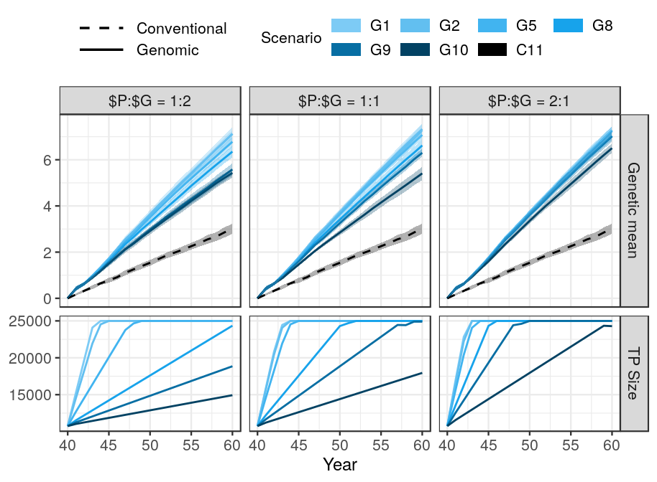Figure 1 Genetic gain and training population size by scenario and relative cost of genotyping with initial training population. Scenarios are named “C” and “G” for conventional and genomic, followed by the number of phenotype records per lactation. We assumed an initial training population (TP) of all active cows and progeny tested sires. The figure presents the means and standard deviations (coloured bands) across ten replicates. The genetic gain of the conventional scenario does not depend on the relative cost of phenotyping to genotyping ($P:$G), hence it is the same in all three ratios.

Accuracy with an initial training population
Table S2 Selection accuracy by scenario, relative cost of genotyping, and availability of initial training population.
 | Relative cost of phenotyping ($P) to genotyping ($G)
Scenario | $P:$G = 1:2 |  | $P:$G = 1:1 |  | $P:$G = 2:1
Scenario | With initial TP | Without initial TP | With initial TP | Without initial TP | With initial TP | Without initial TP
Male candidates
C11 | 0.37_{0.04}ª | 0.37_{0.04}ª | 0.37_{0.04}ª | 0.37_{0.04}ª | 0.37_{0.04}ª | 0.37_{0.04}ª
G10 | 0.89_{0.03}^{b} | 0.81_{0.03}^{b *} | 0.90_{0.02}^{b} | 0.84_{0.01}^{b *} | 0.91_{0.01}^{b} | 0.87_{0.01}^{b *}
G9 | 0.90_{0.03}^{b} | 0.85_{0.02}^{c *} | 0.91_{0.02}^{b} | 0.87_{0.01}^{bc *} | 0.91_{0.01}^{b} | 0.90_{0.01}^{bc *}
G8 | 0.91_{0.01}^{b} | 0.86_{0.01}^{cd *} | 0.91_{0.01}^{b} | 0.89_{0.01}^{c *} | 0.91_{0.01}^{b} | 0.90_{0.01}^{bc}
G5 | 0.91_{0.01}^{b} | 0.90_{0.01}^{d} | 0.91_{0.00}^{b} | 0.91_{0.01}^{c} | 0.91_{0.01}^{b} | 0.91_{0.01}^{c}
G2 | 0.91_{0.01}^{b} | 0.90_{0.01}^{d} | 0.91_{0.00}^{b} | 0.90_{0.01}^{c} | 0.90_{0.01}^{b} | 0.90_{0.01}^{bc}
G1 | 0.89_{0.01}^{b} | 0.89_{0.01}^{cd} | 0.90_{0.01}^{b} | 0.89_{0.01}^{c} | 0.89_{0.01}^{b} | 0.89_{0.01}^{bc}
Female candidates
C11 | 0.45_{0.02}ª | 0.45_{0.02}ª | 0.45_{0.02}ª | 0.45_{0.02}ª | 0.45_{0.02}ª | 0.45_{0.02}ª
G10 | 0.48_{0.01}^{ab} | 0.46_{0.02}^{ab *} | 0.48_{0.01}^{ab} | 0.47_{0.02}^{ab} | 0.51_{0.01}^{b} | 0.49_{0.01}^{b *}
G9 | 0.49_{0.02}^{b} | 0.47_{0.02}^{ab *} | 0.50_{0.01}^{b} | 0.49_{0.02}^{bc} | 0.52_{0.01}^{b} | 0.52_{0.01}^{bc}
G8 | 0.51_{0.01}^{b} | 0.49_{0.02}^{bc *} | 0.51_{0.01}^{b} | 0.52_{0.01}^{cd} | 0.54_{0.01}^{bc} | 0.53_{0.01}^{cd}
G5 | 0.51_{0.01}^{bc} | 0.52_{0.01}^{cd} | 0.55_{0.01}^{c} | 0.55_{0.01}^{de} | 0.57_{0.01}^{c} | 0.57_{0.01}^{d}
G2 | 0.55_{0.01}^{cd} | 0.55_{0.01}^{d} | 0.57_{0.01}^{c} | 0.56_{0.02}^{e} | 0.57_{0.01}^{c} | 0.57_{0.01}^{d}
G1 | 0.56_{0.01}^{d} | 0.55_{0.01}^{d} | 0.56_{0.01}^{c} | 0.56_{0.01}^{e} | 0.56_{0.01}^{c} | 0.56_{0.01}^{d}
Mothers
C11 | 0.48_{0.03}ª | 0.48_{0.03}ª | 0.48_{0.03}ª | 0.48_{0.03}ª | 0.48_{0.03}ª | 0.48_{0.03}ª
G10 | 0.56_{0.02}^{b} | 0.53_{0.01}^{b *} | 0.59_{0.02}^{b} | 0.56_{0.01}^{b *} | 0.63_{0.01}^{b} | 0.61_{0.01}^{b *}
G9 | 0.59_{0.03}^{bc} | 0.57_{0.02}^{bc *} | 0.63_{0.02}^{c} | 0.62_{0.02}^{c} | 0.70_{0.01}^{c} | 0.68_{0.02}^{c *}
G8 | 0.62_{0.02}^{c} | 0.60_{0.02}^{c *} | 0.67_{0.02}^{c} | 0.66_{0.01}^{d} | 0.74_{0.02}^{d} | 0.73_{0.02}^{d}
G5 | 0.70_{0.02}^{d} | 0.69_{0.02}^{d} | 0.77_{0.01}^{d} | 0.76_{0.01}^{e} | 0.79_{0.02}^{e} | 0.78_{0.02}^{e}
G2 | 0.76_{0.02}^{e} | 0.76_{0.01}^{e} | 0.79_{0.02}^{d} | 0.77_{0.02}^{e *} | 0.78_{0.01}^{e} | 0.77_{0.01}^{de}
G1 | 0.77_{0.02}^{e} | 0.76_{0.01}^{e} | 0.77_{0.02}^{d} | 0.76_{0.02}^{e} | 0.77_{0.01}^{de} | 0.76_{0.02}^{de}
Fathers
C11 | 0.86_{0.05}ª | 0.86_{0.05}ª | 0.86_{0.05}ª | 0.86_{0.05}ª | 0.86_{0.05}ª | 0.86_{0.05}ª
G10 | 0.75_{0.04}^{b} | 0.67_{0.08}^{bc *} | 0.75_{0.03}^{b} | 0.68_{0.05}^{cde *} | 0.73_{0.05}^{b} | 0.67_{0.06}^{b *}
G9 | 0.76_{0.04}^{b} | 0.70_{0.05}^{b *} | 0.72_{0.06}^{bc} | 0.72_{0.05}^{bc} | 0.69_{0.05}^{c} | 0.71_{0.05}^{b}
G8 | 0.76_{0.03}^{b} | 0.71_{0.05}^{b *} | 0.69_{0.05}^{cd} | 0.74_{0.05}^{b *} | 0.68_{0.06}^{c} | 0.70_{0.07}^{b}
G5 | 0.68_{0.07}^{c} | 0.68_{0.05}^{bc} | 0.67_{0.08}^{de} | 0.69_{0.05}^{cd} | 0.69_{0.04}^{c} | 0.69_{0.03}^{b}
G2 | 0.67_{0.05}^{c} | 0.65_{0.06}^{c} | 0.67_{0.05}^{de} | 0.64_{0.07}^{e} | 0.67_{0.04}^{c} | 0.69_{0.05}^{b}
G1 | 0.66_{0.06}^{c} | 0.67_{0.04}^{bc} | 0.63_{0.05}^{e} | 0.67_{0.03}^{de} | 0.67_{0.04}^{c} | 0.69_{0.05}^{b}
Scenarios are named “C” and “G” for conventional and genomic, followed by the number of phenotype records per lactation. We assumed an initial training population (TP) of all active cows and progeny tested sires. The table presents the means and standard deviations (subscript) across ten replicates. Lower-case letters denote statistically significant differences between scenarios within the same $P:$G and upper-case letters between different $P:$G within the same scenario. Stars denote whether removing an initial training population significantly reduced prediction accuracy for a n animal group within the same scenario and $P:$G.
Compared to the baseline conventional scenario, genomic scenarios with equal investment split between genotyping and phenotyping increased selection accuracy for young non-phenotyped male and female candidates, and dams, and decreased selection accuracy for sires. This is shown in Figure 2 and Table S2, that present the accuracy for male candidates, female candidates, sires, and dams when the phenotyping cost equals the genotyping cost and when an initial training population is available. In Figure 2, the accuracies of conventional scenario are shown as disconnected points. Also, since selection of sires in conventional selection is a two stage process, the figure presents the accuracy at pre-selection for progeny testing and at selection for proven sires.
Selection accuracy for young genomically tested male candidates ranged between 0.90 and 0.91, and did not depend on the amount of phenotyping and genotyping. Compared to the baseline, genomic testing increased the accuracy of non-phenotyped male candidates (first stage selection) for 0.53 – 0.54 but decreased the selection accuracy for proven sires (second stage) by 0.03 – 0.04. The selection accuracy for female candidates increased with increasing genotyping, despite reducing phenotyping. We observed the highest selection accuracy for female candidates, between 0.55 and 0.57, when we recorded five, two, or one phenotype values per lactation and invested the rest into genotyping. Compared to the conventional baseline scenario, the genomic scenarios increased the selection accuracy for female candidates between 0.03 and 0.11. The accuracy for dams followed the trend of female candidates, hence the accuracy increased with increasing investment in genotyping. Similarly, we observed the highest accuracy for dams, between 0.77 and 0.79, by collecting five, two, or one phenotype and investing the rest in genotyping. Genomic scenario also increased the accuracy for dams between 0.11 and 0.29 compared to the baseline. In contrast, the accuracy for sires decreased with increasing the investment into genotyping. We observed the lowest accuracy for sires, 0.63, when we invested the most into genotyping (G1), and the highest, 0.75, when we invested the most into phenotyping (G10). Compared to the conventional progeny testing, the genomic testing decreased the accuracy of proven sires between 0.11 and 0.23.
ALI moram tu napisati, kaj se zgodi, ko spremenimo ceno genotipa? Neke razlike so, ampak zelo na posamezni ravni.
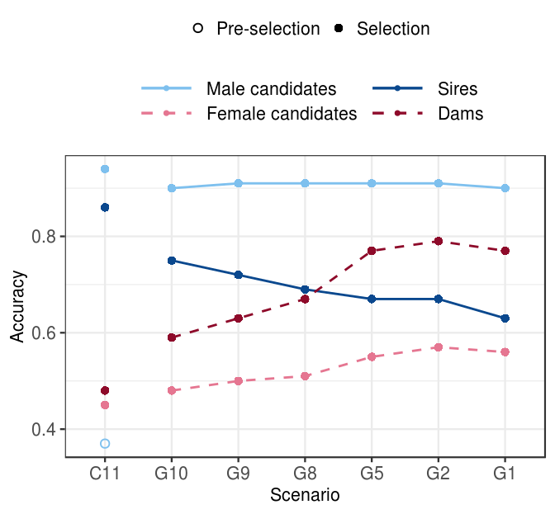
Figure 2 Accuracy by scenario with an initial training population when the cost of phenotype equals the cost of genotype. Scenarios are named “C” and “G” for conventional and genomic, followed by the number of phenotype records per lactation. We assumed an initial training population (TP) of all active cows and progeny tested sires. Conventional selection implemented two-stage selection for males, hence we present the accuracy of the pre-selection stage for progeny testing (empty point) and the accuracy of selection for proven sires (solid point).
Genetic gain and accuracy without an initial training population
MERGE WITH Table S1 and put in the supplementary
 | Relative cost of phenotyping ($P) to genotyping ($G)
Scenario | $P:$G = 1:2 | $P:$G = 1:1 | $P:$G = 2:1
C11 | 3.01_{0.22}^{a,A} | 3.01_{0.22}^{a,A} | 3.01_{0.22}^{a,A}
G10 | 3.93_{0.22}^{b, A} | 4.54_{0.14}^{b, B} | 5.61_{0.25}^{b, C}
G9 | 4.64_{0.18}^{c, A} | 5.75_{0.28}^{c, B} | 6.52_{0.17}^{c, C}
G8 | 5.61_{0.28}^{d, A} | 6.24_{0.19}^{d B} | 6.70_{0.25}^{cd, C}
G5 | 6.43_{0.21}^{e, A} | 6.90_{0.22}^{e, B} | 7.05_{0.27}^{de, B}
G2 | 6.81_{0.28}^{f, A} | 6.96_{0.17}^{e, A} | 7.00_{0.30d}^{e, A}
G1 | 6.78_{0.29}^{f,A} | 6.92_{0.26}^{e, A} | 7.01_{0.23}^{e,A}

Genetic gain
When an initial training population was not available, we increased the genetic gain of the baseline between 31% and 134% by optimizing investment in phenotyping and genotyping. However, all corresponding scenarios achieved between 2.4% and 28% smaller genetic gain than when an initial training population was available. This is shown in Figure 3, that shows the genetic gain, the growth of the training population, and accuracy by scenario without an initial training population when the phenotyping cost equals the genotyping cost, and Table S1 and Table S2, that compare the genetic gain and accuracies of all tested scenarios. The observed trends were in line with what we observed with an initial training population, i. e. increasing genotyping increased genetic gain despite reduced phenotyping, and changing the price of genotype did not change the overall trend.

Option 1: One price ratio at a time – just as above with genetic gain with initial TP
When the cost of phenotyping equalled the cost of genotyping, genomic selection increased the genetic gain of the baseline scenario between 51% and 131%. Removing the initial training population reduced genetic gain between 4.9% and 16.1% in the corresponding scenarios, with the largest reduction in the scenario that invested the least into genotyping (G10). However, the scenarios without an initial training population implemented genomic selection with a delay, since they first had to accumulate 2000 genotyped females. In this scenario we genotyped 355 animal per year, which required six years to build a training population and implement genomic selection. Increasing the investment into genotyping alleviated the effect of lacking (removing) an initial training population. Scenario with maximum investment into genotyping, G1, therefore achieved only 4.9% smaller genetic gain than when we had an initial training population, which was 229% of the baseline.
When the cost of phenotyping was twice the cost of genotyping, the genomic selection increased the genetic gain of the baseline between 31% and 126%, which represented between 4.7% and 28% reduction compared to scenarios with initial training population. When phenotype was half the cost of genotype, by optimizing the investment we managed to increase genetic gain of the baseline between 86% and 133%, which was between 3.1% and 14% less than when we had an initial training population available.

Option2: Just point out the differences – all three price ratios at once
The lower genetic gain partly stems from a delay in the implementation of genomic selection, since the scenarios first had to accumulate 2000 genotyped females.. Removing the initial training population had the largest impact in the scenario with the smallest investment in genotyping (G10). In this scenario we genotyped between 182 and 710 animals per year, depending on the relative cost of genotyping, which required three to eleven years to build a training population and implement genomic selection. This reduced genetic gain between 14% and 28% compared to when an initial training population was available. However, this scenario still increased the genetic gain of the baseline scenario between 31% and 86%.
Increasing the investment into genotyping alleviated the effect of lacking (removing) an initial training population. Scenarios with maximum investment into genotyping, G1, achieved only between 3.1% and 4.9% smaller genetic gain than with an initial training population available. Depending on the genotype price, these scenarios increased the genetic gain of the baseline scenario between 125% and 133%.
Accuracy
Removing the initial training population decreased the accuracy of male candidates in low-genotyping scenarios, but did not affect the accuracy of female candidates, dams, and sires. This is shown in Figure 3, that shows the accuracy without an initial training population when the cost of phenotyping equals the cost of genotyping, and Table S2, that compares the accuracies with or without an initial training population. Selection accuracy for male candidates increased with increasing the investment into genotyping, which is in contrast with what we observed when we initial training population available, where the accuracy persisted high. At an equal cost of phenotyping and genotyping, the accuracy for male candidates was significantly lower, 0.87, only when we invested the least into genotyping and recorded 10 phenotypes per lactation. For female candidates and dams the accuracies followed the trends of when we had an initial training population, where increasing genotyping increased the accuracy. For female candidates the accuracy ranged between 0.47 and 0.56, and for dams and between 0.56 and 0.76. Regarding sires, the accuracy ranged between 0.64 and 0.74 with no clear trend of either increasing or decreasing accuracy.

Zopet – ali moram napisati, kaj se zgodi, ko spremenimo ceno genotipa? Nekaj sprememb je, vendar generalni trend ostaja enak.

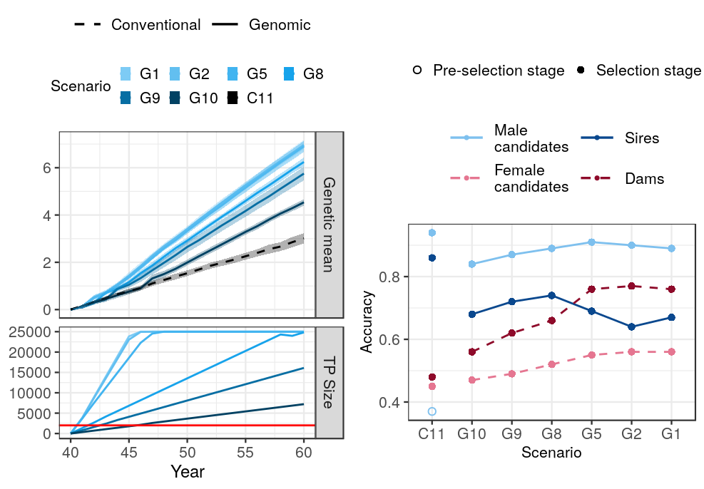
Figure 3 Genetic gain, training population size, and accuracy by scenario without initial training population at an equal cost of phenotyping and genotyping. Scenarios are named “C” and “G” for conventional and genomic, followed by the number of phenotype records per lactation. The figure presents the mean genetic with standard deviations (coloured bands) and mean accuracy across ten replicates. The genetic gain of the conventional scenario does not depend on the relative cost of phenotyping to genotyping ($P:$G), hence it is the same in all three ratios. Conventional selection implemented two-stage selection for males, hence we present the accuracy of the pre-selection stage for progeny testing (empty point) and the accuracy of selection for proven sires (solid point). TP = training population.

Discussion
- Since the selection intensity in the dams of dams selection path is very low and the dams of sires are selected after the collection of their own phenotypes, we assumed that the female genotypes are mostly used to update the training population, whereas the male genotypes were used for selection.

1 Genetic gain
- reference yes: this mirrors the existence of international reference populations,
- genetic gein increases with increased genotyping (despite reduced phenotyping, regardless genotype price and existence of initial training population) – why?
  - compared to the baseline: reduced generation interval, higher accuracy of male candidates, higher intensity
  - among the genomic scenarios: accuracy does not increase with increasing genotyping, hence has to be the increasing intensity of selection
  - reducing phenotyping does not reduce accuracy enough to contradict the benefits
  - no reference: gain shoots up when we start with genomic selection of males
- genetic gain reaches a plateau – accuracies are 0.9 for selection candidates (can not improve more), all females are genotyped in the top XX scenarios (no room for improvement), intensity is high
- same maximum genetic gain achievable for all $G:$P ratios – largest relative difference between the price ratio in the scenarios that remove only one or two phenotypes

2 Accuracy
- general: accuracy does not drop despite reduced phenotyping → because more animals genotyped
- accuracy for male candidates persists high –
  - why is it high regardless the amount of genotyping and price ratio?
- the accuracy for the dams and female candidates:
  - higher than conventional – more animals genotyped, higher connectedness
  - increases with genotyping. This could be explained with first a growing reference population and secondly, more females genotyped and included in the gEBV prediction, higher connectedness
- WHY IS ACCURACY FOR FEMALE CANDIDATES THAT MUCH LOWER THAT THE MALE CANDIDATES? MALE CANDIdaTES are all GENOTYPED, FEMALE NOT
  - when all females (cows) genotyped, the accuracy closer to the one of male candidates (also all genotyped)
- accuracy for sires – inconsistent, slight increase – why?
  - Due to a small number of sires their accuracy varied considerably and the results implied a softer trend of decreasing accuracy with decreased phenotyping. The accuracy for sires decreased with reduced phenotyping, despite increased genotyping. This is a consequence of us trying to rank (distinguish between) sires (animals) in the tail of the distribution, where details matter – and every additional phenotype helps to correctly differentiate between sires. However, since this is the accuracy after the selection has been made, it is not of great interest for the breeders.
- Without initial reference – the accuracy decreases when minimal genotyping for males candidates
  - small reference population + “low” heritability of the phenotype (only 1 recording)
  - once it hits XX, accuracies high → XX animals for update enough to keep the accuracy high
- Compare to theoretical accuracies

3 Recommendations for the Yes/No reference – for breeding organizations

4 Limitations and remarks
- limitations: 25K limit
- genotypes could be used also for parentage verification
- Genomic data also for management – monogenic diseases, caseins, inbreding / mating control
- phenotypes also for management → but it we cut the last one – the cows are already almost through the lactation, keep the recordings in the critical period
- future work: selective phenotyping?

5 Implications
All phenotyped animals should be genotyped to increase the value of phenotype investments (a phenotype itself is useful for 1-3 generations with the pedigree model, but many more generations with the marker model – can we make some simple calculations to show this – based on Daetwyler formulas? Also, can we show the value for a farmer if he is investing in multiple dairy records vs genotype – something that uses h2 and accuracy for selection and e2 for the level of variation that management can address?
Phenotypes are important, but investments should be balanced and most phenotyped animals should be genotyped to make better use of the phenotype investment.

Conclusions

TODO

Acknoweldgement
The authors acknowledge support from the BBSRC to The Roslin Institute (BBS/E/D/30002275) and The University of Edinburgh’s Data-Driven Innovation Chancellor’s fellowship.

References

[1] Meuwissen THE, Hayes BJ, Goddard ME. Prediction of Total Genetic Value Using Genome-Wide Dense Marker Maps. Genetics 2001; 157: 1819–1829.
[2] Schaeffer LR. Strategy for applying genome-wide selection in dairy cattle. J Anim Breed Genet 2006; 123: 218–223.
[3] Wiggans GR, Cole JB, Hubbard SM, et al. Genomic Selection in Dairy Cattle: The USDA Experience. Annu Rev Anim Biosci 2017; 5: 309–327.
[4] Obšteter J, Jenko J, Hickey JM, et al. Efficient use of genomic information for sustainable genetic improvement in small cattle populations. J Dairy Sci; 0. Epub ahead of print 30 August 2019. DOI: 10.3168/jds.2019-16853.
[5] Mrode RA. Linear Models for the Prediction of Animal Breeding Values. Second edition. Wallingford, UK ; Cambridge, MA: CABI, 2005.
[6] Daetwyler HD, Villanueva B, Woolliams JA. Accuracy of Predicting the Genetic Risk of Disease Using a Genome-Wide Approach. PLoS ONE 2008; 3: e3395.
[7] Goddard M. Genomic selection: prediction of accuracy and maximisation of long term response. Genetica 2009; 136: 245–257.
[8] Goddard M e., Hayes B j., Meuwissen T h. e. Using the genomic relationship matrix to predict the accuracy of genomic selection. J Anim Breed Genet 2011; 128: 409–421.
[9] Lourenco DAL, Fragomeni BO, Tsuruta S, et al. Accuracy of estimated breeding values with genomic information on males, females, or both: an example on broiler chicken. Genet Sel Evol 2015; 47: 56.
[10] Gray KA, Cassady JP, Huang Y, et al. Effectiveness of genomic prediction on milk flow traits in dairy cattle. Genet Sel Evol GSE 2012; 44: 24.
[11] Gao H, Christensen OF, Madsen P, et al. Comparison on genomic predictions using three GBLUP methods and two single-step blending methods in the Nordic Holstein population. Genet Sel Evol 2012; 44: 8.
[12] Calus MPL. Genomic breeding value prediction: methods and procedures*. animal 2010; 4: 157–164.
[13] Habier D, Tetens J, Seefried F-R, et al. The impact of genetic relationship information on genomic breeding values in German Holstein cattle. Genet Sel Evol 2010; 42: 5.
[14] Wolc A, Arango J, Settar P, et al. Persistence of accuracy of genomic estimated breeding values over generations in layer chickens. Genet Sel Evol 2011; 43: 23.
[15] ICAR. International Committee for Animal Recording. 2017. Section 2 – Guidelines for Dairy Cattle Milk Recording. Rome: ICAR.
[16] Misztal I, Tsuruta S, Strabel T, et al. BLUPF90 and related programs (BGF90). In: Proc. 7th World Congress on Genetics Applied to Livestock Production. Montpellier, France, 2002, pp. 1–2.
Genetics Selection Evolution requires references to be formatted in Vancouver referencing style. Example reference style:
- Article within a journal
Smith JJ. The world of science. Am J Sci. 1999;36:234-5.
- Article within a journal (no page numbers)
Rohrmann S, Overvad K, Bueno-de-Mesquita HB, Jakobsen MU, Egeberg R, Tjønneland A, et al. Meat consumption and mortality - results from the European Prospective Investigation into Cancer and Nutrition. BMC Medicine. 2013;11:63.
- Article within a journal by DOI
Slifka MK, Whitton JL. Clinical implications of dysregulated cytokine production. Dig J Mol Med. 2000; doi:10.1007/s801090000086.

- Book chapter, or an article within a book
Wyllie AH, Kerr JFR, Currie AR. Cell death: the significance of apoptosis. In: Bourne GH, Danielli JF, Jeon KW, editors. International review of cytology. London: Academic; 1980. p. 251-306.
- OnlineFirst chapter in a series (without a volume designation but with a DOI)
Saito Y, Hyuga H. Rate equation approaches to amplification of enantiomeric excess and chiral symmetry breaking. Top Curr Chem. 2007. doi:10.1007/128_2006_108.
- Complete book, authored
Blenkinsopp A, Paxton P. Symptoms in the pharmacy: a guide to the management of common illness. 3rd ed. Oxford: Blackwell Science; 1998.
- Online document
Doe J. Title of subordinate document. In: The dictionary of substances and their effects. Royal Society of Chemistry. 1999. http://www.rsc.org/dose/title of subordinate document. Accessed 15 Jan 1999.
- Software
R: a language and environment for statistical computing. R Foundation for Statistical Computing, Vienna; 2012. OpenURL
- Proceeding of a congress
Van Eenennaam AL, Kinghorn BP. Use of mate selection software to manage lethal recessive conditions in livestock populations. In: Proceedings of the 10th World Congress on Genetics Applied to Livestock Production: 17–22 August 2014; Vancouver. https://asas.org/docs/default-source/wcgalp-posters/408_paper_9819_manuscript_1027_0.pdf?sfvrsn=2. Accessed 27 Feb 2015.
- Thesis
Park SDE. Trypanotolerance in West African cattle and the population genetic effects of selection. PhD thesis, University of Dublin. 2002.
- FAO paper report
Koziner AB, Shtakelberg ER. Animal genetic resources of the USSR. Rome: FAO and UNEP; 1989.
- Institutional document
Iversen A, Hermansen Ø. Cost development in farming of Norwegian Salmon. Tromso: Nofima Report; 2017. p. 46.

Figures
(only titles and legends should be included in main text; for more information on preparing figures, please see here https://gsejournal.biomedcentral.com/submission-guidelines/preparing-your-manuscript#preparing+figures)
Figure 1 Title.
Legend
Figure 2 Title.
Legend

Tables
Tables should be numbered and cited in the text in sequence using Arabic numerals (i.e. Table 1, Table 2 etc.).
Tables less than one A4 or Letter page in length can be placed in the appropriate location within the manuscript.
Tables larger than one A4 or Letter page in length can be placed at the end of the document text file. Please cite and indicate where the table should appear at the relevant location in the text file so that the table can be added in the correct place during production.
Larger datasets, or tables too wide for A4 or Letter landscape page can be uploaded as additional files. Please see [below] for more information.
Tabular data provided as additional files can be uploaded as an Excel spreadsheet (.xls ) or comma separated values (.csv). Please use the standard file extensions.
Table titles (max 15 words) should be included above the table, and legends (max 300 words) should be included underneath the table.
Tables should not be embedded as figures or spreadsheet files, but should be formatted using ‘Table object’ function in your word processing program.
Color and shading may not be used. Parts of the table can be highlighted using superscript, numbering, lettering, symbols or bold text, the meaning of which should be explained in a table legend.
Commas should not be used to indicate numerical values.
Table 1 Title
Column 1 | Column 2 | Column 3 | Column 4 | Column 5
Line 1
Line 2
Legend for Table under the table
Table 2 Title
Legend for Table under the table

Additional files
(only the format, title and legend of additional files should be provided in the main text; for more information on preparing additional files, please see here https://gsejournal.biomedcentral.com/submission-guidelines/preparing-your-manuscript#preparing+additional+files)
Additional file 1 Table S1
Format:
Title:
Description:
Additional file 2 Figure S1
Format:
Title:
Description:

