Homework #5: Image Analytics
Jana Obšteter, jana.obsteter@kis.si
We have used different algorithms to predict classes of images. The images included three types of cells – animal, plant and fungi. The three cells have different characteristic: animal cells have a large nucleus and no cell wall, plant cells have cell walls, are tightly packed, have vacuoles and chlorophyll; and fungi cell are organised in a chain-like shape called hyphae. Each class was represented with 23 images.
The images were first cropped to 299x299 size and embedded using inception v3.

1. First we used hierarchical clustering to classify the types of cells. We determined the three-clusters threshold on the dendrogram and inspected the results. One of the clusters consisted from 21 plant cell images and one animal. Another cluster of 15 images consisted almost only from animal cells images, with the exception of one fungal and one plant cell. The third cluster consisted of 22 fungi cell images with additional four animal and one plant cell image.
The results show that classes of image cells have characteristics that are unique enough for the hierarchical clustering to be able to differentiate between them. Apparently the characteristics of fungal and plant cells are stronger than those of animal cells, since only one fungal and two plant cells were misclassified compared to the five misclassified animal cells. When inspecting the plant and fungal image that were classified as animal cells, we see a similarity in the shape and size of the cells – all the images in this cluster have a large number of small cells.
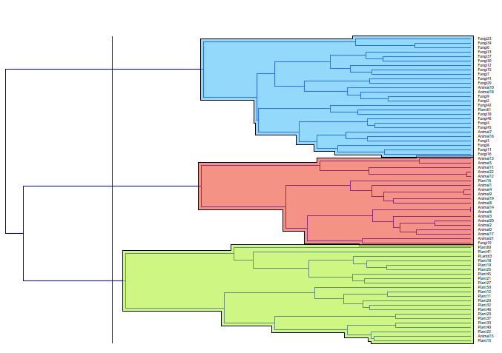
Fungal cluster (with 4 animal and 1 plant)
Animal cluster (with 1 animal and 1 plant)
Plant cluster (with 1 animal)
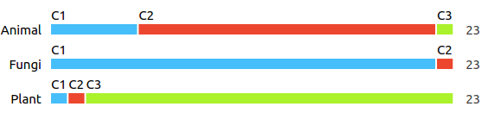
k-means performs slightly worse that the hierarchical clustering. Here the most misclassified images are those of fungal cells and the less those of plant cells.

2. Next, learning algorithms were applied to the subclasses of images and the success was inspected with 3-fold cross validation. The 3-fold cross-validation was used due to a smaller dataset. If we used 10xCV only 2 images would be used for predicting the class – therefore it could be only 0, 50% or 100%. Also, the chance of assigning the true class by chance are high.
Trees fail to classify the data since they are built for binary classification and therefore fail to classify additional class.
The kNN also fail in classifying the data since the data is multidimensional and computing the distance in hgiher dimensions is not a reliable tool.

