Reallocation of financial resources in a cattle breeding program

J. Obšteter*, J. Jenko*,†, J. M. Hickey‡ & G. Gorjanc‡,§

*Department of Animal Science, Agricultural Institute of Slovenia, Hacquetova ulica 17, 1000 Ljubljana, Slovenia
†Geno Breeding and A.I. Association, Storhamargata 44, 2317 Hamar, Norway
‡The Roslin Institute and Royal (Dick) School of Veterinary Studies, University of Edinburgh, Easter Bush, Midlothian, EH259RG, United Kingdom
§Biotechnical Faculty, University of Ljubljana, Jamnikarjeva 101, 1000 Ljubljana, Slovenia

Jana Obšteter, Agricultural Institute of Slovenia, Department of Animal Science, Hacquetova ulica 17, 1000 Ljubljana, Slovenia
+386 1 280 51 34
jana.obsteter@kis.si (Corresponding Author)

Introduction
This paper evaluates the potential of maximizing genetic gain in dairy cattle breeding programs by optimizing allocation of resources for phenotyping and genotyping. All breeding programs strive to maximize the genetic gain, which is a function of selection intensity, accuracy of selection, genetic variation and generation interval. The introduction of genomic selection (Meuwissen et al., 2001; Schaeffer, 2006) doubled the rate of genetic gain in dairy cattle (Wiggans et al., 2017), primarily by reducing the generation interval, increasing selection intensity, and increasing the accuracy of selection for young animals. As shown in previous work, genomic selection increases genetic gain compared to conventional selection, despite lower accuracy of selection, suggesting that the effect of reducing generation interval dominates over the effect of increasing accuracy (Schaeffer, 2006; Obšteter et al., 2019). While the generation interval can only be manipulated with age at which we select the animals, the accuracy of selection can be manipulated with more parameters, such as the method of estimation and the amount of data collected. The two measures are intertwined, since we require sufficient accuracy to make selection decisions. Hence, finding a balance between the two is crucial for an efficient selection. Further more, if some parameters may increase genetic gain more than the others, should we (allocate the funds accordingly and) invest more time and resources into changing the more influential parameters?

Accuracy of pedigree-based evaluation
The accuracy of pedigree-based breeding values for a given trait increases with increasing heritability and the number of phenotype records per animal (e.g., Mrode, 2005). Replicated phenotype records also enable the estimation of individual’s permanent effect due to non-additive genetic or individual specific environmental effects. For example, assume a female-expressed trait with heritability of 0.25 and repeatability of 0.35, and accuracy of sire EBVs of 0.95. If we record one phenotypic value per cow, the accuracy of its EBV is 0.50, while the accuracy of the parent average for the un-phenotyped cow would be 0.54. If we increase the number of recorded phenotypic values per cow to 2, 5, or 11, the accuracy of its EBV increases respectively to 0.61, 0.72, or 0.78, and the accuracy of parent average increases respectively to 0.56, 0.60, or 0.62. For a bull with 100 daughters these increases are marginal, since with one phenotypic value per cow the accuracy of its EBV is already 0.97. Collecting 5 or 11 records per cow increases the accuracy to 0.98.

Accuracy of genome-based evaluation
The accuracy of genomic breeding values for a given trait and a population structure increases primarily with increasing size of a training population of phenotyped and genotyped animals, heritability of the training phenotypes, and the number of effective genome segments (M_{e}) (Daetwyler et al. 2008; Goodard, 2009; Goddard et al., 2011).

According to Daetwyler et al. (2008) formula, the accuracy of genomic prediction depends only on the heritability, the number of animals in the training population, and M_{e}. Following the previous example, assume the M_{e} of 10,000. With 10,000 cows phenotyped once (only one phenotypic value per cow, the heritability of our reference phenotypes is 0.25 and with a training population of 10,000 cows, we achieve the accuracy of 0.45 for un-phenotyped animals. On the other hand, the accuracy of genomic prediction with 1,000 cows in the training population, each phenotyped 10 times (the heritability of reference phenotypes is 0.60) is be 0.24. As demonstrated, increasing the number of phenotypic records increases the accuracy in a diminishing manner, which shows a scope for optimization.

However, genomic prediction does not exploit all the available information, since it does not use the phenotypes of the un-genotyped animals. Combining all phenotypic, pedigree, and genomic information through a single-step genomic BLUP (ssGBLUP) increases the accuracy for un-genotyped as well as genotyped animals even further (Lourenco et al., 2015; Gray et al., 2012; Gao et al., 2012).

Drop in accuracy without updating training population
The accuracy of genomic prediction depends on the persistence of linkage disequilibrium (LD) among markers and causal loci between training and prediction animals. Recombination, selection, mutation and drift (and migration) change LD, which decreases the accuracy of prediction across generations (Calus, 2010), when the training population is not updated. While the accuracy of genomic prediction decays slower than of pedigree prediction (Habier et al., 2010; Wolc et al., 2011), we still observe a substantial decrease. To prevent the drop in the accuracy, marker effects must be continually re-estimated and the training population must be continually updated with new animals.

Milk recording
In dairy breeding programs, the most extensively recorded phenotypes are milk production traits. There are different milk recording methods that differ in the responsibility for recording, sampling scheme, recording frequency, sampling frequency and the number of milkings per day (ICAR, 2017). The sampling methods vary in the number of milkings per day, the amount of sample collected, and in applied corrections. The recording interval ranges from daily recording to recording every nine weeks, which translates to between 5 and 44 recordings per lactation. The prices of milk control differ between recoding systems, countries, and their regions. Some organizations require payment of a participation fee plus the price per sample, while others include the fee in the sample price or do not require the fee at all.

Investment in data recording to support selection decisions
As already mentioned, the estimation of breeding values requires financial resources for the collection of data. Breeding programs have to assure continuous cash inflow, since the data has to be updated to maintain high accuracy of prediction. While the funding for phenotyping is usually secured in breeding programs, the funding for genotyping is not yet well established to initiate and / or regularly update the training population for genomic prediction. Internal reallocation of resources seems like (the only) viable option. However, breeding programs constitute of many crucial actions, many of them can not be manipulated with or omitted. Since increasing the number of phenotypic records increases the accuracy in a diminishing manner, repeated measurements of the phenotype identifies as a plausible candidate for a reduction and financial reallocation.

Aim
The aim of this paper was to evaluate the potential of maximizing genetic gain in dairy cattle breeding programs by optimizing allocation of resources for phenotyping and genotyping.
SHORT SUMMARY OF RESULTS (BUT ONLY ONCE WE HAVE THEM)

Material and methods
The simulation mimicked a real dairy cattle population of ~30,000 animals with ~10,500 cows. We simulated a milk production trait with heritability 0.25 and repeatability of 0.5. Breeding values were estimated with a pedigree or single-step genomic repeatability model with permanent environment and herd year as random effects. We evaluated 36 genomic scenarios against a baseline conventional scenario, all with equal amount of financial resources, but varying extent of phenotyping and genotyping. The baseline scenario was a conventional scenario with progeny testing and 11 recordings of phenotype per lactation, while genomic scenarios implemented reduced phenotyping and reallocated the corresponding saved resources to genotyping. The genomic scenarios differed in i) whether an initial training population was already available; ii) the ratio of the price of genotyping ($G) vs the price of phenotyping ($P); iii) the number of phenotype records per cow per lactation. All tested scenarios were compared based on their genetic gain and accuracy of selection.

Simulation
Simulation of the base population, phenotype and historical breeding. The simulation mimicked a real dairy cattle population of ~30,000 animals with ~10,500 cows. The detailed parameters of the simulation are described in Obšteter et al. (2019). To summarize breeding structure, we selected 3849 out of 4320 newborn females as dams of dams and 139 as dams of sires during their second, third and fourth lactation. In the conventional scenarios, 8 out of 45 selection candidates were chosen for progeny testing and 4 were chosen as AI bulls. In the genomic scenarios, 5 out of all tested male calves, the number depending on the scenario, were chosen as AI bulls. In all scenarios, 22 non-selected selection candidates were used in natural service.

We used a coalescent process to simulate whole genome comprised of 10 cattle-like chromosomes, each with 10⁸ base pairs, 1000 randomly chosen causal loci and 2000 randomly chosen marker loci. The causal loci were assigned normally distributed effects and constituted animal’s breeding value (a_{i}) for a milk production trait (y_{ijkl}) with heritability 0.25, which was additionally influenced by animals’ permanent environment (p_{i}), herd (h_{j}), herd-year (hy_{jk}), herd-test-day (htd_{jkl}), and residual (e_{ijkl}) effects:
y_{ijkl} = a_{i} + p_{i} + h_{j} + hy_{jk} + htd_{jkl} + e_{ijkl}.
Permanent environment effects were sampled from a normal distribution with zero mean and variance σ_{A}, herd, herd-year and herd-test-day effects were each sampled from a normal distribution with zero mean and variance 1/3 σ_{A}, while residual effects were sampled from a normal distribution with zero mean and variance σ_{A}. This resulted in a trait repeatability of 0.5. With the simulated genome and phenotype architecture we have initiated a dairy cattle breeding program with corresponding groups of animals and ran 20 years of a conventional selection with progeny-testing and collecting 11 phenotype records per lactation. All selection decisions were based on pedigree-based estimates of breeding values. The 20 years have represented historical breeding and provided a starting point for evaluating future breeding scenarios, which were run for additional 20 years.
Estimation of breeding values. Breeding values were estimated with a pedigree or single-step genomic repeataPaper_draft_Phenotyping_2019-10-07_JObility model with permanent environment and herd year as random effects. Breeding values were estimated once per year with blupf90 (Misztal et al, 2002) and its default settings. The phenotypic records accumulated through the years and were not removed from the estimation.

Scenarios
We evaluated 36 genomic scenarios against a baseline conventional scenario, all with equal amount of financial resources, but varying extent of phenotyping and genotyping. The baseline scenario was a conventional scenario with progeny testing and 11 recordings of phenotype per lactation, corresponding to the standard ICAR recording interval of 4 weeks. The total financial resources available equaled to the cost of phenotyping in the baseline scenario. In contrast, we created genomic scenarios that divided the total resources between phenotyping and genotyping. In the genomic scenarios we reduced phenotyping and reallocated the corresponding saved resources to genotyping. The genomic scenarios differed in i) whether an initial training population was already available. In the former case, a reference population of all active cows (10,653) was assumed. In the case of non-existing initial training population, only females were genotyped until the training population reached a size of 2000. Once reaching this goal, the animals were genotyped as specified in Table 1. ii) the ratio of the price of genotyping ($G) vs the price of phenotyping ($P). The price of one genotype was compared to the price of one-lactation recording with 11 recordings (recording every four weeks). We considered three ratios of $G:$P i. e. 1:1, 2:1, and 1:2. The ratios were created by inspecting the milk recording pricing systems of some of the worlds largest breeding or private organizations. The pricing of every additional milk recording decreased, hence the first recording was the most expensive and the price of each subsequent control was 95% of the preceding control. iii) the number of phenotype records per cow per lactation. Scenarios followed the official ICAR standard recording intervals for milk recording. The baseline conventional scenario recorded 11 phenotypic values per cow per lactation, corresponding to the standard ICAR recording interval of 4 weeks. Genomic scenarios implemented reduced phenotyping following ICAR standards of 9, 8, and 5 recordings per lactation, corresponding to recording interval of 5, 6, and 9 weeks. Additionally, we created three non-standard recording systems collecting 10, 2 and 1 phenotypic values per lactation.

The extent of genotyping in genomic scenarios therefore corresponded to the reduction in the number of phenotypic records and the ratio of the price of phenotyping and genotyping ($G:$P). The obtained funds were distributed for genotyping females and males in ratio 7:1. The genotyped females were selected from the first parity cows and their genotypes were used for updating the reference population. The males for genotyping were selected from the newborn male calves, prioritizing the offspring of elite matings, and their genotypes were used to predict the gEBV for selection decisions. If the funds allocated to genotyping females exceeded the number of available first parity cows, all first parity cows were genotyped and funds were not reallocated to male genotyping. In the training population, the genotypes accumulated and none were removed up to 25,000 (minus selection candidates) animals. After reaching this number, only the (25,000 minus male selection candidates) latest females were included into the training population.
Since the selection intensity in the dams of dams selection path is very low and the dams of sires are selected after the collection of their own phenotypes, it was reasonable so assume that the female genotypes are mostly used to update the training population, whereas the male genotypes are used for predicting the gEBV and selecting the best individuals

 | Number of phenotypic records
 | 10 | 9 | 8 | 5 | 2 | 1
$G:$P = 2:1 | 160 F  22 M | 350 F  50 M | 590 F  85 M | 1610 F  235 M | 3230 F  465 M | 3850 F  565 M
$G:$P = 1:1 | 310 F  45 M | 700 F  100 M | 1180 F  165 M | 3230 F  465 M | 3850 F  925 M | 3850 F  1125 M
$G:$P = 1:2 | 620 F  90 M | 1400 F  295 M | 2360 F  335 M | 3850 F  925 M | 3850 F  1845 M | 3850 F  2245 M
Table XX: The number of genotyped female (F) and male (M) animals by the ratio of the genotyping versus phenotyping ($G:$P ) price and by number of phenotype records collected per lactation.

Analysis of scenarios
All tested scenarios were assumed to have an equal amount of financial resources and were compared based on their genetic gain and accuracy of selection. The genetic gain was measured in units of standard deviation and the accuracy was measured as a correlation between the true and estimated breeding values. We repeated simulation of the base population and each scenario 10 times.

RESULTS
SUMMARY OF THE RESULTS

Genetic gain with initial training population
With the same amount of financial resources, genomic scenarios with an existing initial training population and reduced phenotyping increased the genetic gain of conventional scenario with full phenotyping. In general, genetic gain increased with the increasing the number of genotyped animals, hence with reducing the number of phenotype records, and with lower price of genotyping. This is shown in Figure 1, that presents the genetic gain by the ratio between the price of genotyping and phenotyping and by number of phenotype recordings, when an initial training population is available. When the price of genotyping equaled the price of phenotyping ($G:$P = 1:1), the scenarios genotyped between 355 and 4975 animals per year and increased the genetic gain of the baseline between 174% and 248%. The highest genetic gain of 7.XX was achieved when collecting only one phenotype value per lactation and genotyping the maximum number of animals. This scenario genotyped all females (3950) and 1080 males per year, resulting in the intensity of male selection of 2.7. The lowest genetic gain was achieved by collecting 10 phenotype values and genotyping only 355 animals per year, 45 of those males, with intensity of male selection of 1.7.
The same trend was observed for when the price of genotype was twice or half the price of phenotyping with a difference in the range of scenarios. When the genotype was expensive, i. e. twice the price of phenotype, we genotyped between 182 and 4415 animals per year and increased the genetic gain of the baseline between 170% and 242%. When the genotyped was cheap, i. e. half the price of phenotyping, we genotyped between 710 and 6195 animals per year and increased the genetic gain of the baseline between 206% and 246%. We achieved a comparable maximum genetic gain iregardless of the ratios of the price of genotyping and the price of phenotying, despite different intensity of male selection. The intensity of male selection in the highest permorming scenarios was XX in the $G:$P = 1:1. However, in all three ratios the scenario with maximum genotyping genotyped all female animals (3450).

When genotyping is expensive, i.e twice the price of phenotyping, the genomic scenarios increased the genetic gain of the baseline scenario up to 243%. The highest genetic gain of 7.XX units was achieved by recording 1 phenotype value per lactation which genotyped all females and 565 males per year. The intensity of male selection in this scenario was 2.70. The lowest genetic gain of 4.XX amongst the genomic scenarios was achieved with the most abundant phenotyping, i. e. 10 recordings of phenotype per lactation. This scenarios genotyped 182 animals per year, 22 of those males, and had the intensity of male selection of 1.32. When the price of phenotyping equaled the price of genotyping, genomic scenarios increased the genetic gain up to 235% compared to the baseline. The highest genetic gain of 7.XX was not achieved with the largest amount of phenotyping nor genotyping, but by recording five phenotype values per lactation. This scenario genotyped 3695 animals per year, 465 of those males, resulting in the intensity of male selection of 2.66. The lowest genetic gain was again achieved by collecting 10 phenotype values per lactation, hence genotyping only 355 animals per year, 45 of those males (i = 1.71). When genotyping was cheap, i. e. half the price of phenotyping, all scenarios genotyped the most animals, hence the lowest genetic gain was as high as 6.XX, observed by collecting 10 phenotype records per lactation. The highest genetic gain of 7.XX was achieved by collecting 2 phenotype records per lactation and genotyping 5695 animals per year, 1845 of those male (i = 3.14).

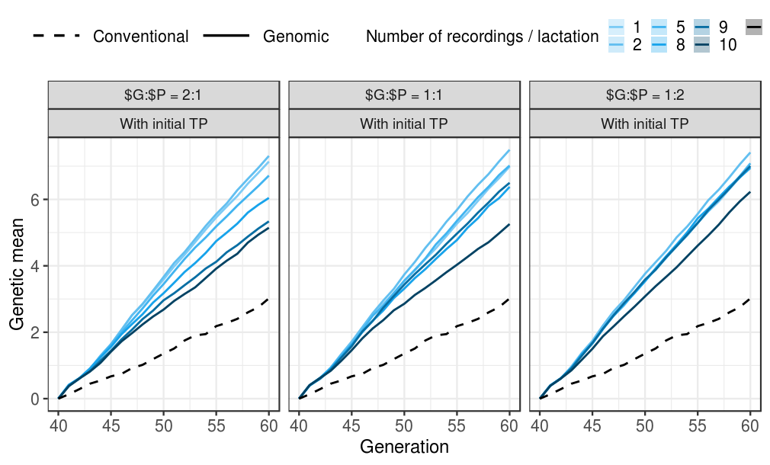Figure 1: Genetic gain of the conventional and genomic scenarios by the ratio of the genotyping versus phenotyping ($G:$P) price and by number of phenotype records collected per lactation. The genetic gain of the conventional scenario does not depend on the $G:$P, hence it is the same in all three G:$P ratios.

Accuracy of the scenarios with initial training population
Implementing genomic selection with reduced phenotyping increased selection accuracy for un-phenotyped selection candidates. However, decreasing the number of phenotypic records and increasing genotyping had different consequence on the accuracy of female or male and young or proved individuals. This is shown in Figure XXa, that shows the accuracy of breeding values when we have an existing initial training population and an equal price of genotype and phenotype by different animal groups and by number of phenotype recordings. When the price of genotype equaled the price of phenotype, the accuracy for un-phenotyped genomically tested male candidates persisted high irregardless of the amount of phenotyping or genotyping. The highest accuracy was achieved by collecting two phenotype records with the correlation of 0.90. Compared to the full-phenotyping conventional scheme, genomic scenarios increased the accuracy of unphenotyped male candidates for 0.5. The lowest accuracy in all three price ratios was observed when collecting only one phenotype record and maximizing the genotyping. This trend could be due to the following reason: when we genotyped a small number of animals, we genotyped only offspring from elite matings. These animals therefore had a higher accuracy, since the accuracy of their elite parents was higher. When we genotyped more animals, we included more male offspring of unselected parents, some came from natural service bulls, hence we observed a large drop in accuracy that became comparable to the accuracy of the female calves. Also, the correlation with a smaller number of animals can be biased.
The accuracy of the gEBVs for female candidates increased with decreasing number of phenotype records and increasing genotyping.

The highest accuracy for un-phenotyped female candidates was observed either by collecting one ($G:$P = 2:1, r = 0.55), two ($G:$P = 1:1, r = 0.57), or five ($G:$P = 1:2, r = 0.55) phenotype records per lactation. These were all the scenarios the genotyped all females. The lowest accuracy for un-phenotyped females in all three price ratios was observed when collecting ten phenotype records (r = 0.47 – 0.49).

The accuracy of mothers’ and fathers’ EBVs increased with increasing genotyping and decreasing the number of collected phenotype records. The lowest accuracy for mothers was therefore 0.67 and 0.64 when collecting 10 phenotype records. The highest accuracy for mothers was 0.89 when collecting two phenotype records and for fathers 0.65 when collecting five phenotype records per lactation.

This could be explained with first a growing reference population and secondly, more females genotyped and included in the gEBV prediction.
WHY IS ACCURACY FOR FEMALE CANDIDATES THAT MUCH LOWER THAT THE MALE CANDIDATES??? MALE CANDIADTES GENOTYPED!!! FEMALE NOT!

- - difference in accuracies for male candidates
- difference in accuracies for female candidates
- difference in accuracy for tested males / females
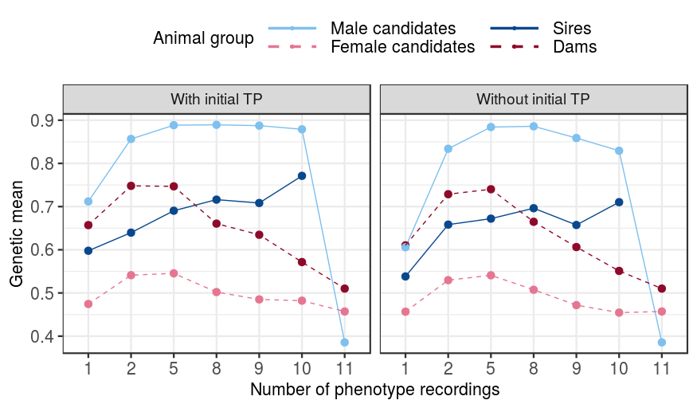

Scenarios without an initial training population
In the scenarios where an initial training population was not available, the genomic scenarios still increased the genetic gain of the conventional scenario from 122% to 211% after 20 years of selection. This is shown in Figure XX, that shows the genetic gain by the ratio between the price of genotyping and phenotyping, and by number of phenotype recordings without an initial reference population. The trend regarding genetic gain and accuracies followed the trend from the scenarios with an existing initial reference population. When the genotype is twice the price of phenotyping, we increase the genetic gain of the conventional scenario up to 197% with 5 phenotype recording (genetic gain is 5.XX). This gain is comparable to the genetic gain obtained in scenarios with an existing reference population. This scenario genotyped 1845 animal per year, hence required two year to collect 2000 cows in the training population and to start genotyping males. The lowest genetic gain of 3.XX in the $G:$P ratio 2:1 was reached with collecting 10 phenotype records per lactation. This scenario genotyped 182 animals per year, hence started with genomic selection of males only in year 11 of selection.

- how do the three PG ratios compares
- how does it compare with the reference yes scenario
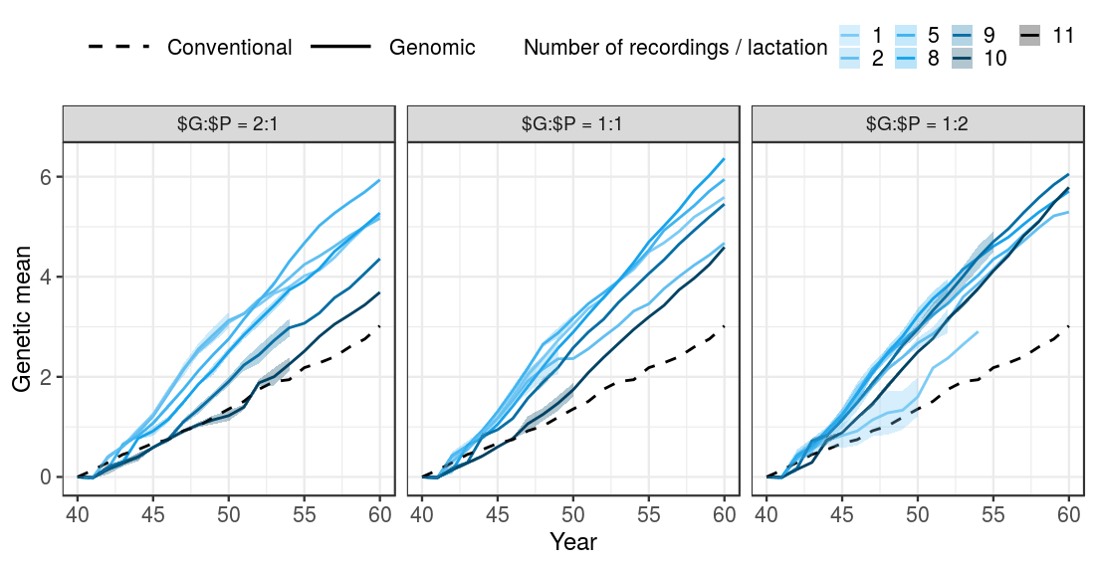
Possible: price for deltaG

DISCUSSION
Genetic gain and accuracy
- same genetic gain achievable for all $G:$P ratios
- why does the genetic gain start dropping again – the effect of the accuracy
- why does the accuracy of the males drop quicker
- why does the accuracy of the cows decreased
- no reference – compare the genetic gain and accuracy
  - gain shoots up when we start with genomic selection of males
- Recommendations for the Yes/No reference – for breeding organisations

Also:
- limitations: 25K limit
- genotypes could be used also for parentage verification
- Genomic data also for management
- phenotypes also for management

