- If not: what does it tell you about the data? How can you have excellent predictive models but clustering is not able to re-discover the two classes as subgroups in the data?

K-means clustering makes some assumptions about the shape and the distribution of the data. If the k-means fail to correctly assign the classes via clustering, it means, that the assumptions are broken i.e. data does not follow the assumed shape and distribution. However, some of the predictive model might still work well, since they do no make the same assumptions and are also able to learn from the data.
The first assumptions of the k-means is the assumption of the spherical clusters. If the clusters are non-spherical, i.e. in a disk, and near to each other, k-means will fail to correctly identify the clusters. However, if the clusters are non-spherical but far apart, the k-means might succeed.

Therefore, one possible explanation for this specific example is that the classes are not spherical. K-means tries to minimise sum of squared error (or the variance) within the clusters and maximise the one between the clusters. So if the distances within the classes are larger than the distances between the classes (variance within > variance between) the k-means clustering will fail in correctly assigning the classes. An examples is shown in the figure below. The logistic regression would work well in this situation, since the classes can be separated with a hyperplane. All the cases/ controls and above / below a certain threshold. The classes are not spherical – consequently k-means fails.
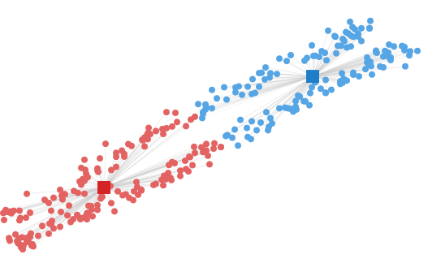
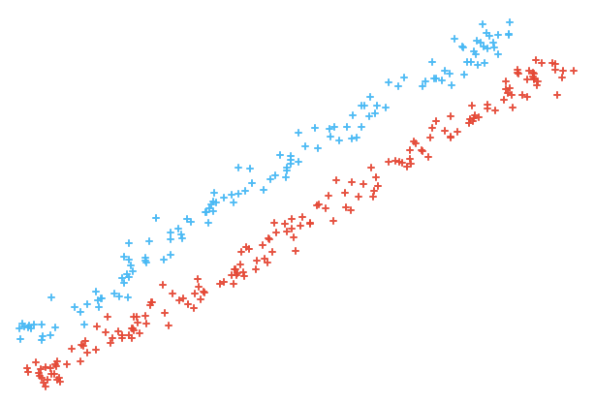
Further more, k-means clustering makes another assumptions of the roughly equal sizes of the clusters. If the classes have uneven number of instances, k-means might fail. An example of such is shown in the figure below. Again, logistic regression would perform well since the data can be separated with a hyperplane.
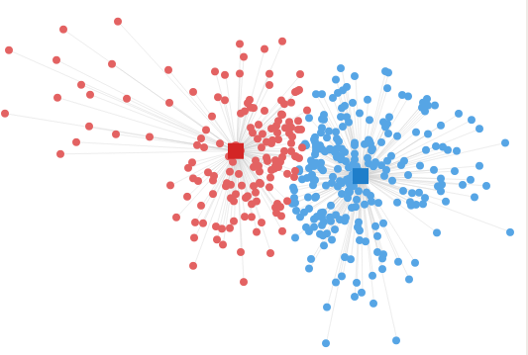
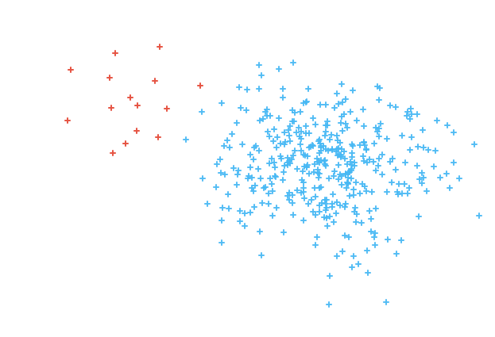
Moreover, k-means clustering is unable to cancel out the noise. All the attributes are equally important. If the data contains a lot of noise of uninformative attributes, k-means will perform poorly. This is where trees work well, since they can identify the most informative attribute to split the data through the learning process.

In higher dimensions the curse of dimensionality worsens the problems.
Supervised – can learn which features are more important (logistic regression gives higher probabilites, trees perform attribute selection) – find the most informative attributes.

