Matthews et al.

Aim and methods:
The aim of the paper was to determine the impact of selection within / from different subpopulations on the overall rate of industry genetic progress:
The domestic population included active cow population (10%, high level of GS, potential to breed AI) and passive (commercial herds) + foreign population (only sires). The used sires were progeny tested (domestic), GS (domestic) and foreign. The method of choice was recursive deterministic prediction, they used gene flow that accounted for lag in genetic progress. The programme was simulated over 10- or 20-year period.

They tested scenarios varying the: i) reliability of domestic GS bulls (0.3, 0.45, 0.6, 0.75); ii) (rate of) foreign genetic trend (0.08, 0.12, 0.14); iii) starting merit of foreign population; iv) fixed or responsive sire use (fixed - 1/3 PT, 1/3 GS, 1/3 foreign; responsive - according to genetic merit of the bull types). Additionally they tested the impact of increasing GS relative to PT use in scenarios with foreign trend set to 0.1 over a range or GS reliabilities. They created three splits for GS:PT contributions: i) 0.5 each; ii) 0.5 to 0.9 increasing GS by 0.08 each year; iii) 0.8:0.2. They created a further scenario where import was introduced to the population for the first time with varying degrees of foreign starting merit and foreign genetic trend.

Results:

- Foreign genetic trend has larger impact than GS reliability.
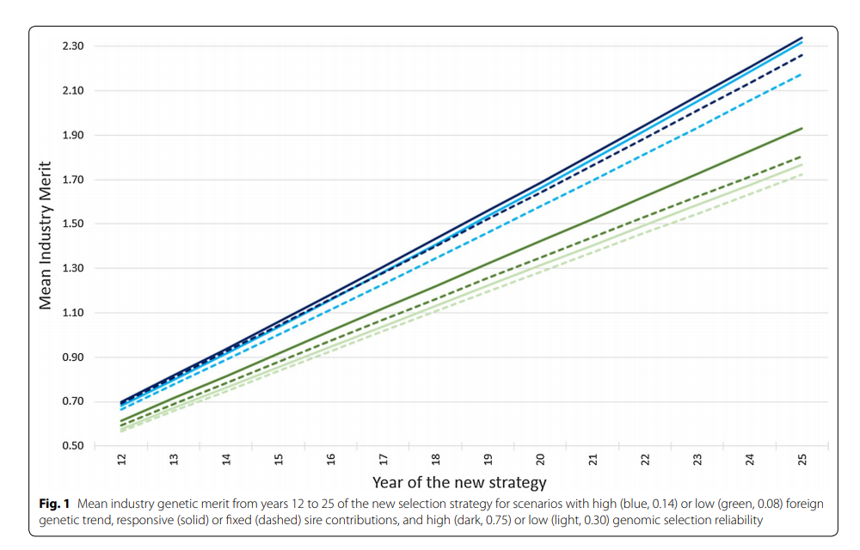
- Effect of responsive sire contributions depends on interaction of reliability and foreign genetic trend: low foreign trend: higher GS contribution as the GS reliability increases; high foreign trend – more foreign sires when GS reliability is low.
- Responsive vs. fixed sire contributions: responsive use delivers a higher genetic response (with the same reliability and foreign trend) in all but one scenario (where they are the same).
- Increasing foreign trend (above domestic) erodes the benefit of increasing domestic GS reliability, reduces difference in genetic progress between fixed / responsive sire use.
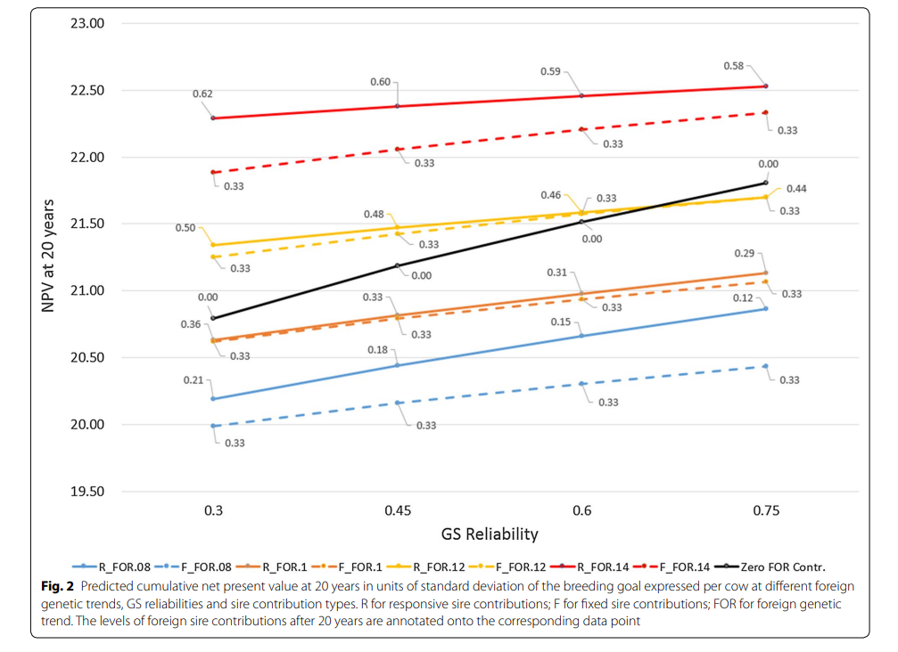
- Increasing GS reliability has the largest impact when foreign contributions is fixed to 0.
- High foreign trend – higher GS reliability moderately impacts foreign contributions; low foreign trend – larger reduction in foreign sire contributions with increase in GS reliability
- Higher foreign has trend bigger impact on foreign sire use than GS reliability – time lag until higher reliability. produce better candidates.
- Increasing GS over PT contributions – NPV (net profit value) increasing with increasing GS reliability – NPV increases steeper with higher GS contribution.
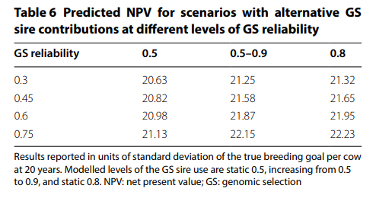
- Industry importing foreign semen for the first time: if foreign merit is high and foreign genetic trend is low – NPV still higher (after 20 years) than no import;
  - when starting foreign merit high – NPV increases with increasing foreign genetic trend;
  - when starting foreign merit is low and foreign genetic trend is low – worse than no import;
  - when foreign merit is low, but foreign genetic trend equal or higher than domestic – increased NPV (because low foreign merit still higher than domestic)

  - 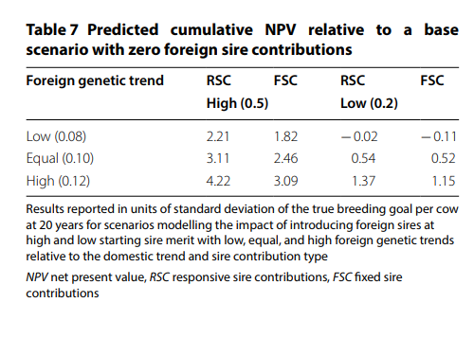

Discussion / Conclusion:
- there is substantial reductions in return on investments to increase GS reliability
- the value of increasing GS reliability when considered as cumulative NPV is surprisingly modest (0.9 to 3.4% depending on the parameters)
- impact of foreign semen was found to be a major driver
- investments to improve GS reliability will yield greater returns when the foreign genetic trend is lower than the domestic trend, which is most likely due to GxE

