Results

Table 1: Genetic gain in domestic / foreign population (foreign population – genomic selection throughout; domestic – with 10 or 0-year delay)
 | r² = 0.8 |  | r² = 0.9 |  | r² = 1.0
 | Domestic | Foreign | Domestic | Foreign | Domestic | Foreign
10-year delay
100% import
50% import
10% import
0-year delay
100% import
50% import
10% import

Figure 1: Partition of genetic gain in the domestic population with 10-year delay in implementing genomic selection.
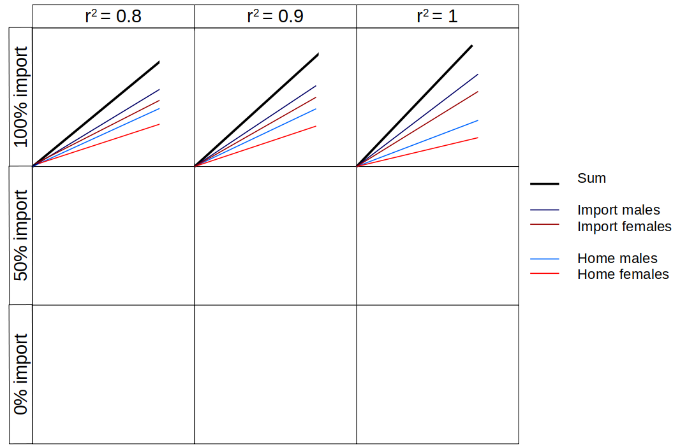

Figure 2: Partition of genetic gain in the domestic population with 0-year delay in implementing genomic selection.

IF POSSIBLE! - The same plots for variance partition. If not possible, then maybe a supplementary figure with variances.

Figure 3: Partition of genetic variance in the domestic population with 0-year delay in implementing genomic selection.
