**Discussion**

The estimation of breeding values requires stable investment for continuous collection of data. While breeding programmes usually have a secure funding for phenotyping, the funding for genotyping is not yet well established to initiate and regularly update the training population for genomic prediction. In this paper we propose implementing genomic selection by optimizing the investment into phenotyping of milk production traits and genotyping. We show that by reallocating a part of phenotyping resources to genotyping, we can substantially increase genetic gain regardless of the cost and amount of genotyping, and availability of initial training population. We also show that we can increase the genetic gain even further by increasing the investment into genotyping, despite simultaneously decreasing the amount of phenotyping. Similarly, although reduced phenotyping decreased the phenotype accuracy, genomic prediction maintained or increased the accuracy for non-phenotyped selection candidates. These results raised four discussion points 1) how optimizing investment in phenotyping and genotyping affects genetic gain with or without an initial training population; 2) how optimizing investment in phenotyping and genotyping affects accuracy with and without an initial training population; 3) limitations and remarks of the study; 4) implications for breeding programmes.

**1 Genetic gain**

**Implementing genomic selection by optimizing the investment in phenotyping and genotyping increases genetic gain compared to the conventional scenario despite reduced phenotyping, regardless the amount of genotyping (or better: even at minimum investment into genotyping).**

In this study we assumed that some small populations have access to an international training population, such as InterGenomics for Brown Swiss in Central Europe (Jorjani, 2012). We mimicked this by creating an initial 10K female training population. With the latter available, the genomic scenarios with reduced phenotyping achieved up to 147% genetic gain of the conventional scenario. The main driver of this increase was reduced generation interval in genomic scenarios. This can be seen as the scenarios that did not increase the intensity of sire selection (G10, $P:$G = 1:1) still increased the genetic gain by 79% compared to the conventional scenario. This is also in agreement with previous studies, that concluded that the genomic selection doubles the genetic gain compared to the conventional progeny-testing scheme despite reduced accuracy of selection (Wiggans et al., 2017; Obšteter et al., 2019).

Assisting this increase was also the fact, that although reduced phenotyping decreased the accuracy of the training population phenotype, it did not affect the selection accuracy in the same way. While the genomic prediction decreased the selection accuracy for sires only between 3% and 6%, it actually increased the selection accuracy for females between 7% and 27%. We discuss the reasons for this in more details below.

Finally, the majority of the tested genomic scenarios had a higher intensity of sire selection than the conventional scenario. A costly and lengthy procedure of progeny-testing limits the number of tested sires in the conventional schemes. Genomic selection significantly reduced the cost of testing male candidates (Schaeffer, 2006) and thus allowed for increased intensity of male selection.

**We further increased the genetic gain with increasing the investment into genotyping.** The main driving force of this increase was increasing the intensity of sire selection. This can be seen as increasing genotyping did not further reduce generation interval and did also not increase the accuracy of sire selection candidates (discussed in the next section). Increasing investment into genotyping resulted in more male candidates tested, but same number selected, which in turn intensified the selection. A minor drive of this increase was also the increasing selection accuracy of female candidates. The benefit of this was however diminished, since the intensity of selection in females was very low.

Although increasing investment into genotyping increased genetic gain, the increase was not proportional. Instead, **increasing genotyping had a diminishing return relationship with genetic gain,** **which reached a plateau**. Our results show that investing more than the resources of six phenotype records into genotyping did not significantly improve the genetic gain (the high‑genotyping scenarios G5, G2, and G1 had equal genetic gain). The first reason for this is, that the accuracy of sire selection in genomic scenario did not increase with increasing genotyping, but was high regardless. We discuss the reasons for this in more details below. Secondly, the intensity of male selection was high in all high‑genotyping scenarios. For example, reducing the number of records from two to one per lactation and investing the rest into genotyping increased the intensity of male selection only between 1.0% and 2.6%. Lastly, the high‑genotyping scenarios genotyped nearly all or all females. This resulted in the maximum size as well as the maximum yearly update of the training population.

Our results agree with previous studies showing that adding an additional female (non-repeated phenotype) to the training population has diminishing return relationship with accuracy and economic genetic gain (Grevenhof et al., 2012; Gonzalez-Recio et al., 2014). Gonzales-Recio et al. showed that the contribution of an additional female decreases with the number of females in the training population. That is, when the number of females in a training population is small, an additional record has a larger value for the genetic gain than when the female training population is large. Since our scenarios in question all started with a ~10K training population, additional revenue from enlarging the training population was small to begin with, but still decreased with increasing genotyping.

However, Gonzales-Recio et al. assumed each female was phenotyped only once, hence they used the term phenotypes and females interchangeably. In our study we distinguish between them, since as the scenarios increased the number of females in the training population, they decreased the number of (repeated) phenotypes (Figure S1). The top performing scenarios had a training population with the largest number of females but also the smallest number of (repeated) phenotypes. Hence we show that while genetic gain does increase with the number of non-repeated (unique? / females?) phenotypes in training population (although with diminishing return), adding repeated phenotypes does not have the same effect. However, since we ran a single step, the phenotypes of the non-genotyped animals also contributed to the estimation.

The Gonzales-Recio et al. paper also provides insight into what would happen at a different heritability of the phenotype. They showed that as the heritability increases, the contribution of an additional phenotype to the genetic gain decreases. This means less phenotypes (unique phenotypes / females) are needed to achieve the maximum gain and we would need to invest less into genotyping to achieve the maximum genetic gain. In contrast, at lower heritabilities we would need the invest even more to genotype more phenotyped females.

**Due to similar reasons, we achieved a comparable maximum genetic gain regardless the relative price of phenotyping to genotyping.** When collecting only one record per lactation, we saved enough funds to genotype all females at all three relative prices of phenotyping to genotyping. This resulted in a comparable number of females in the training population and high intensity of sire selection at all three price ratios. At maximum genotyping, changing the relative price of phenotyping from twice to half of genotyping increased the intensity of sire selection only by 0.44 (16%).

In this paper, we also considered a situation, when small populations **do not have access to a training population and have to initialize one themselves**. **These scenarios still increased the genetic gain compared to the conventional scenario, between 31% and 134%**, regardless the investment in genotyping. We did observe a decrease compared to the corresponding scenarios with an initial population available. The largest reduction was in the scenario that invested the least into genotyping, since this resulted in the smallest training population and the longest delay in the implementation of genomic selection for the sires. Prior to the latter, we did not observe any increase above the conventional scenario. However, we also did not observe any decrease below the conventional scenario, despite reduced phenotyping. This means that breeding programmes can accumulate genotypes to initiate a training population by reallocating a part of phenotyping resources to genotyping without harming the genetic gain in the accumulation (transition?) period.

In contrast, increasing the investment into genotyping compensated for starting without a training population. This agrees with the fact, that increasing the number of females in the training population has diminishing return. For example, Gonzales-Recio et al. showed, that for most traits the additional gain from increasing the number of females above 10,000 is negligible. Also, increasing genotyping shortened the delay in implementation of genomic selection. At maximum genotyping, the scenarios without an initial training population implemented the genomic selection after the first year (had only 1 year delay).

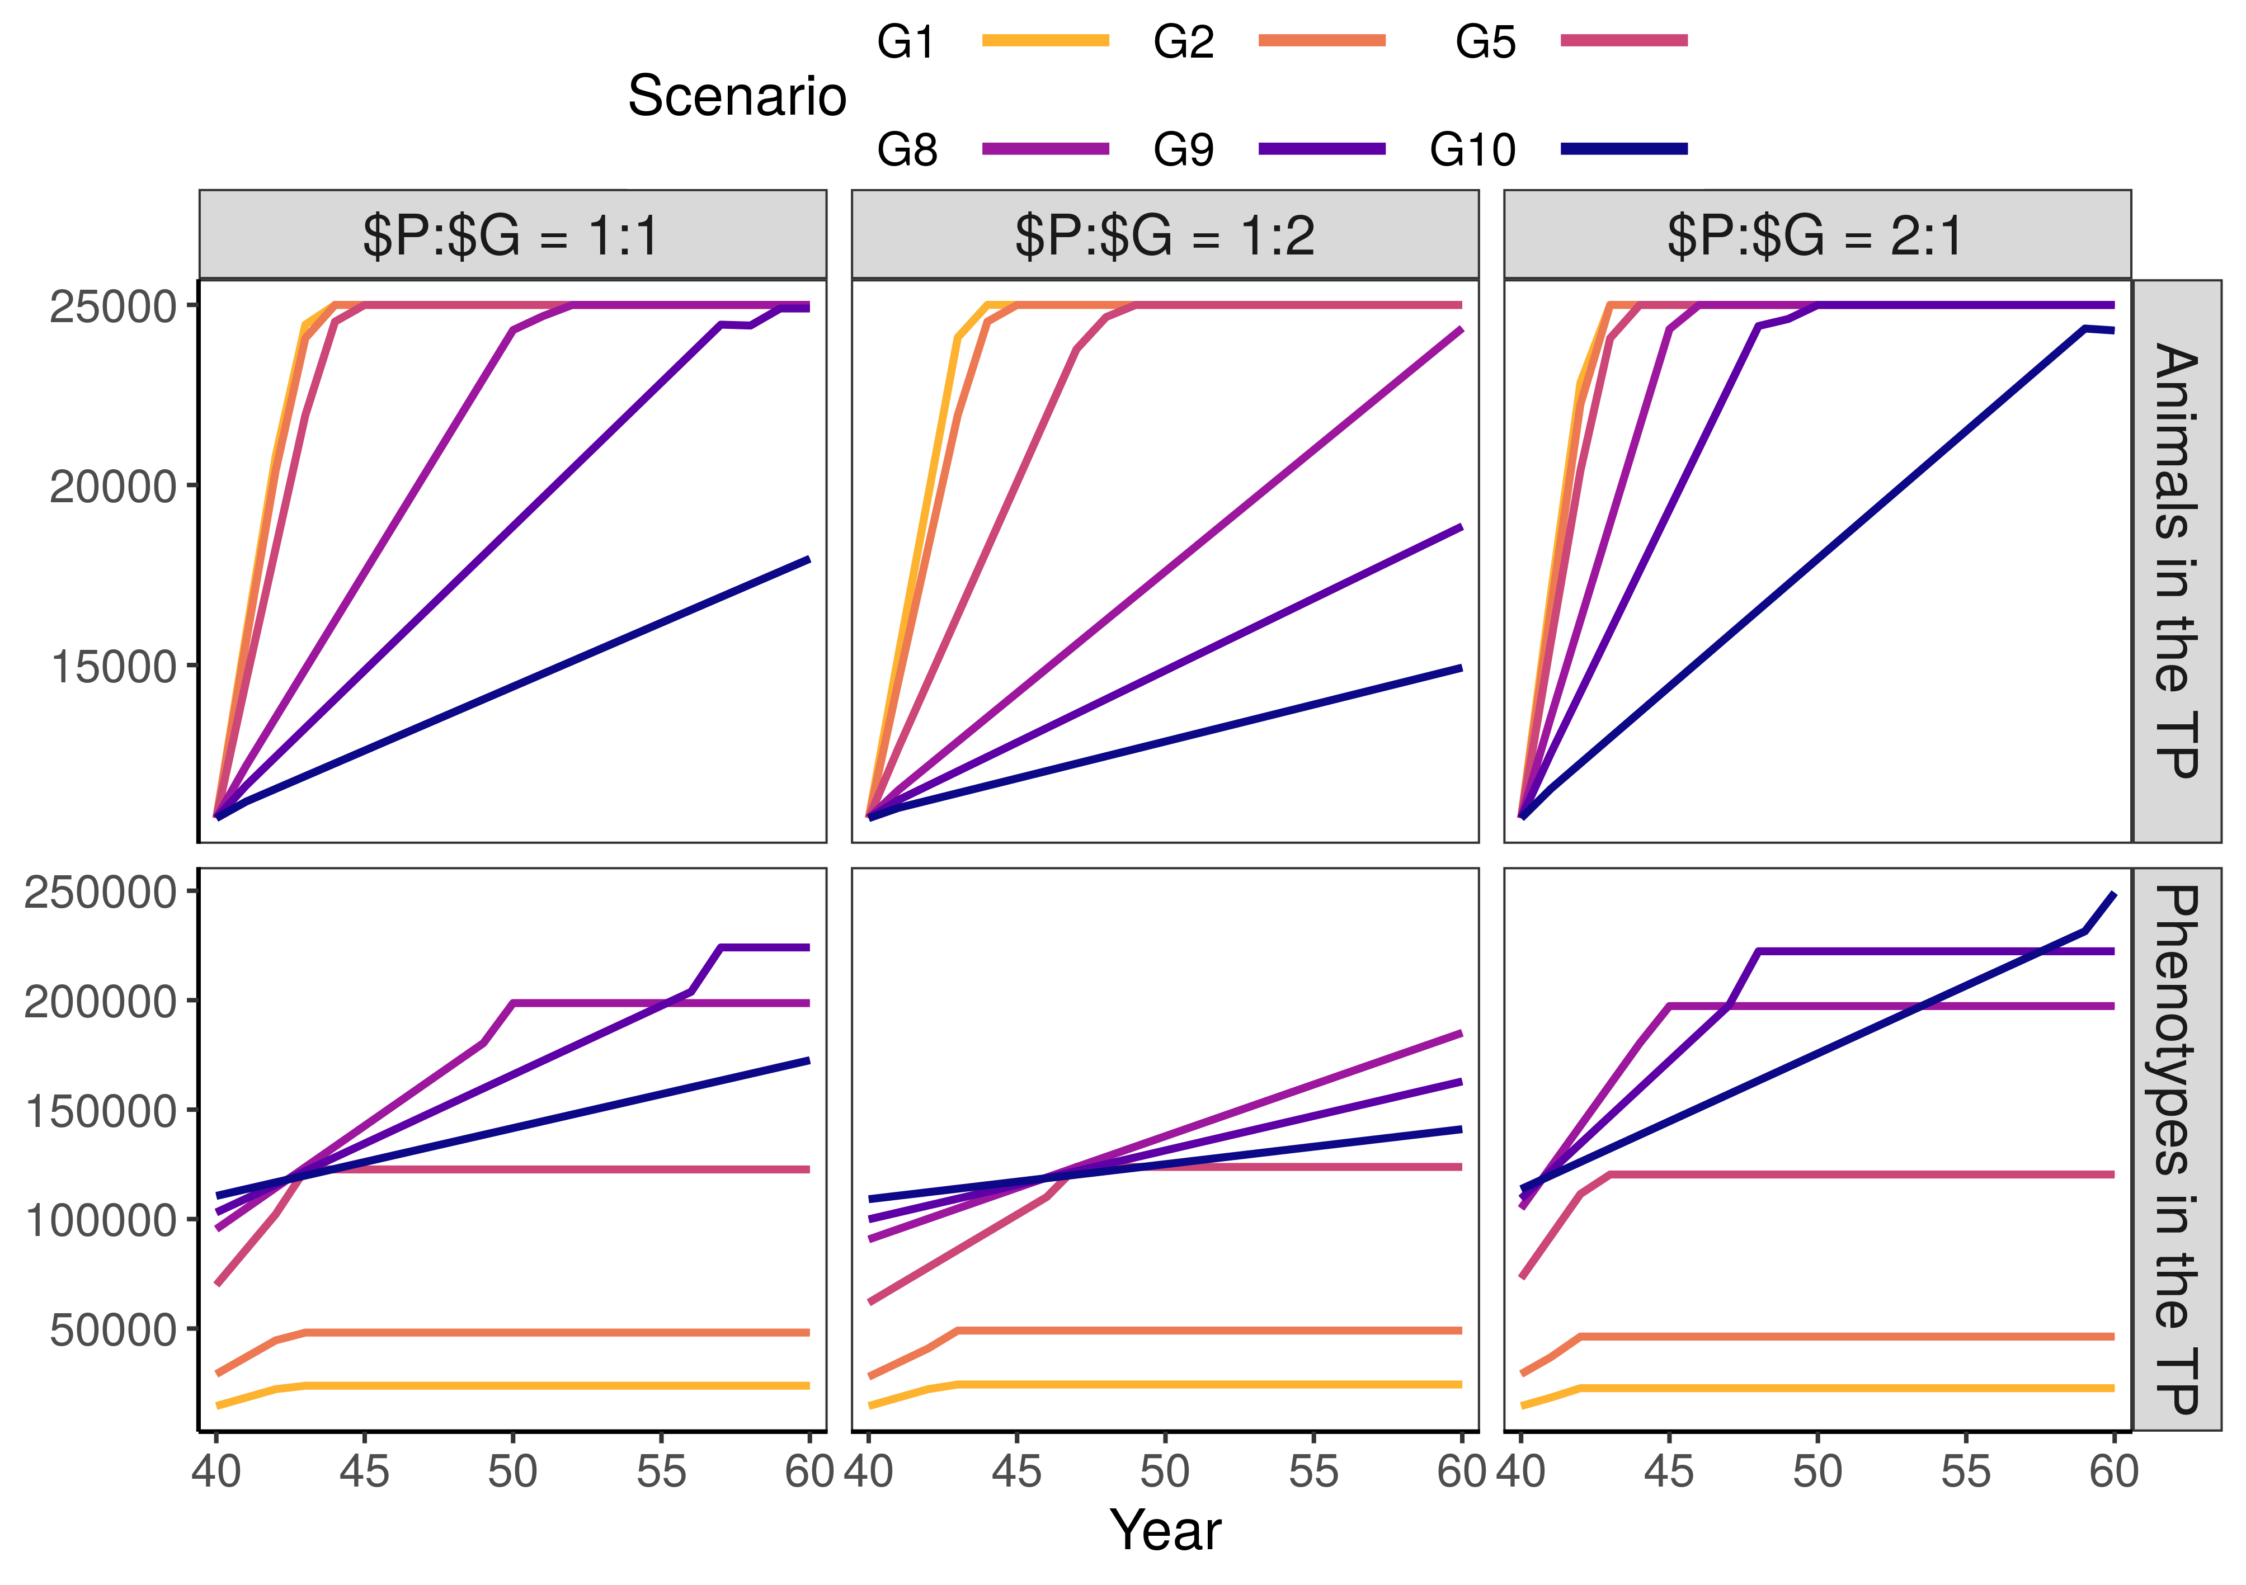**Figure S1:**The number of animals and phenotypes in the training population.

**General comments**

* **Too much repetition of results**
* **Lack of comparison with the other studies**
* **Some deep thinking is missing (this is the place where you can express your thoughts)**
* **Explain some things more in detail, eg. why did the accuracies for young females increase (higher parentage average because of their dam genotyping).**
* **Finish your ideas in writing. This will take time but will force you to think what you have written and if it is correct. This is a great paper and a great opportunity for you to excel.**