1. 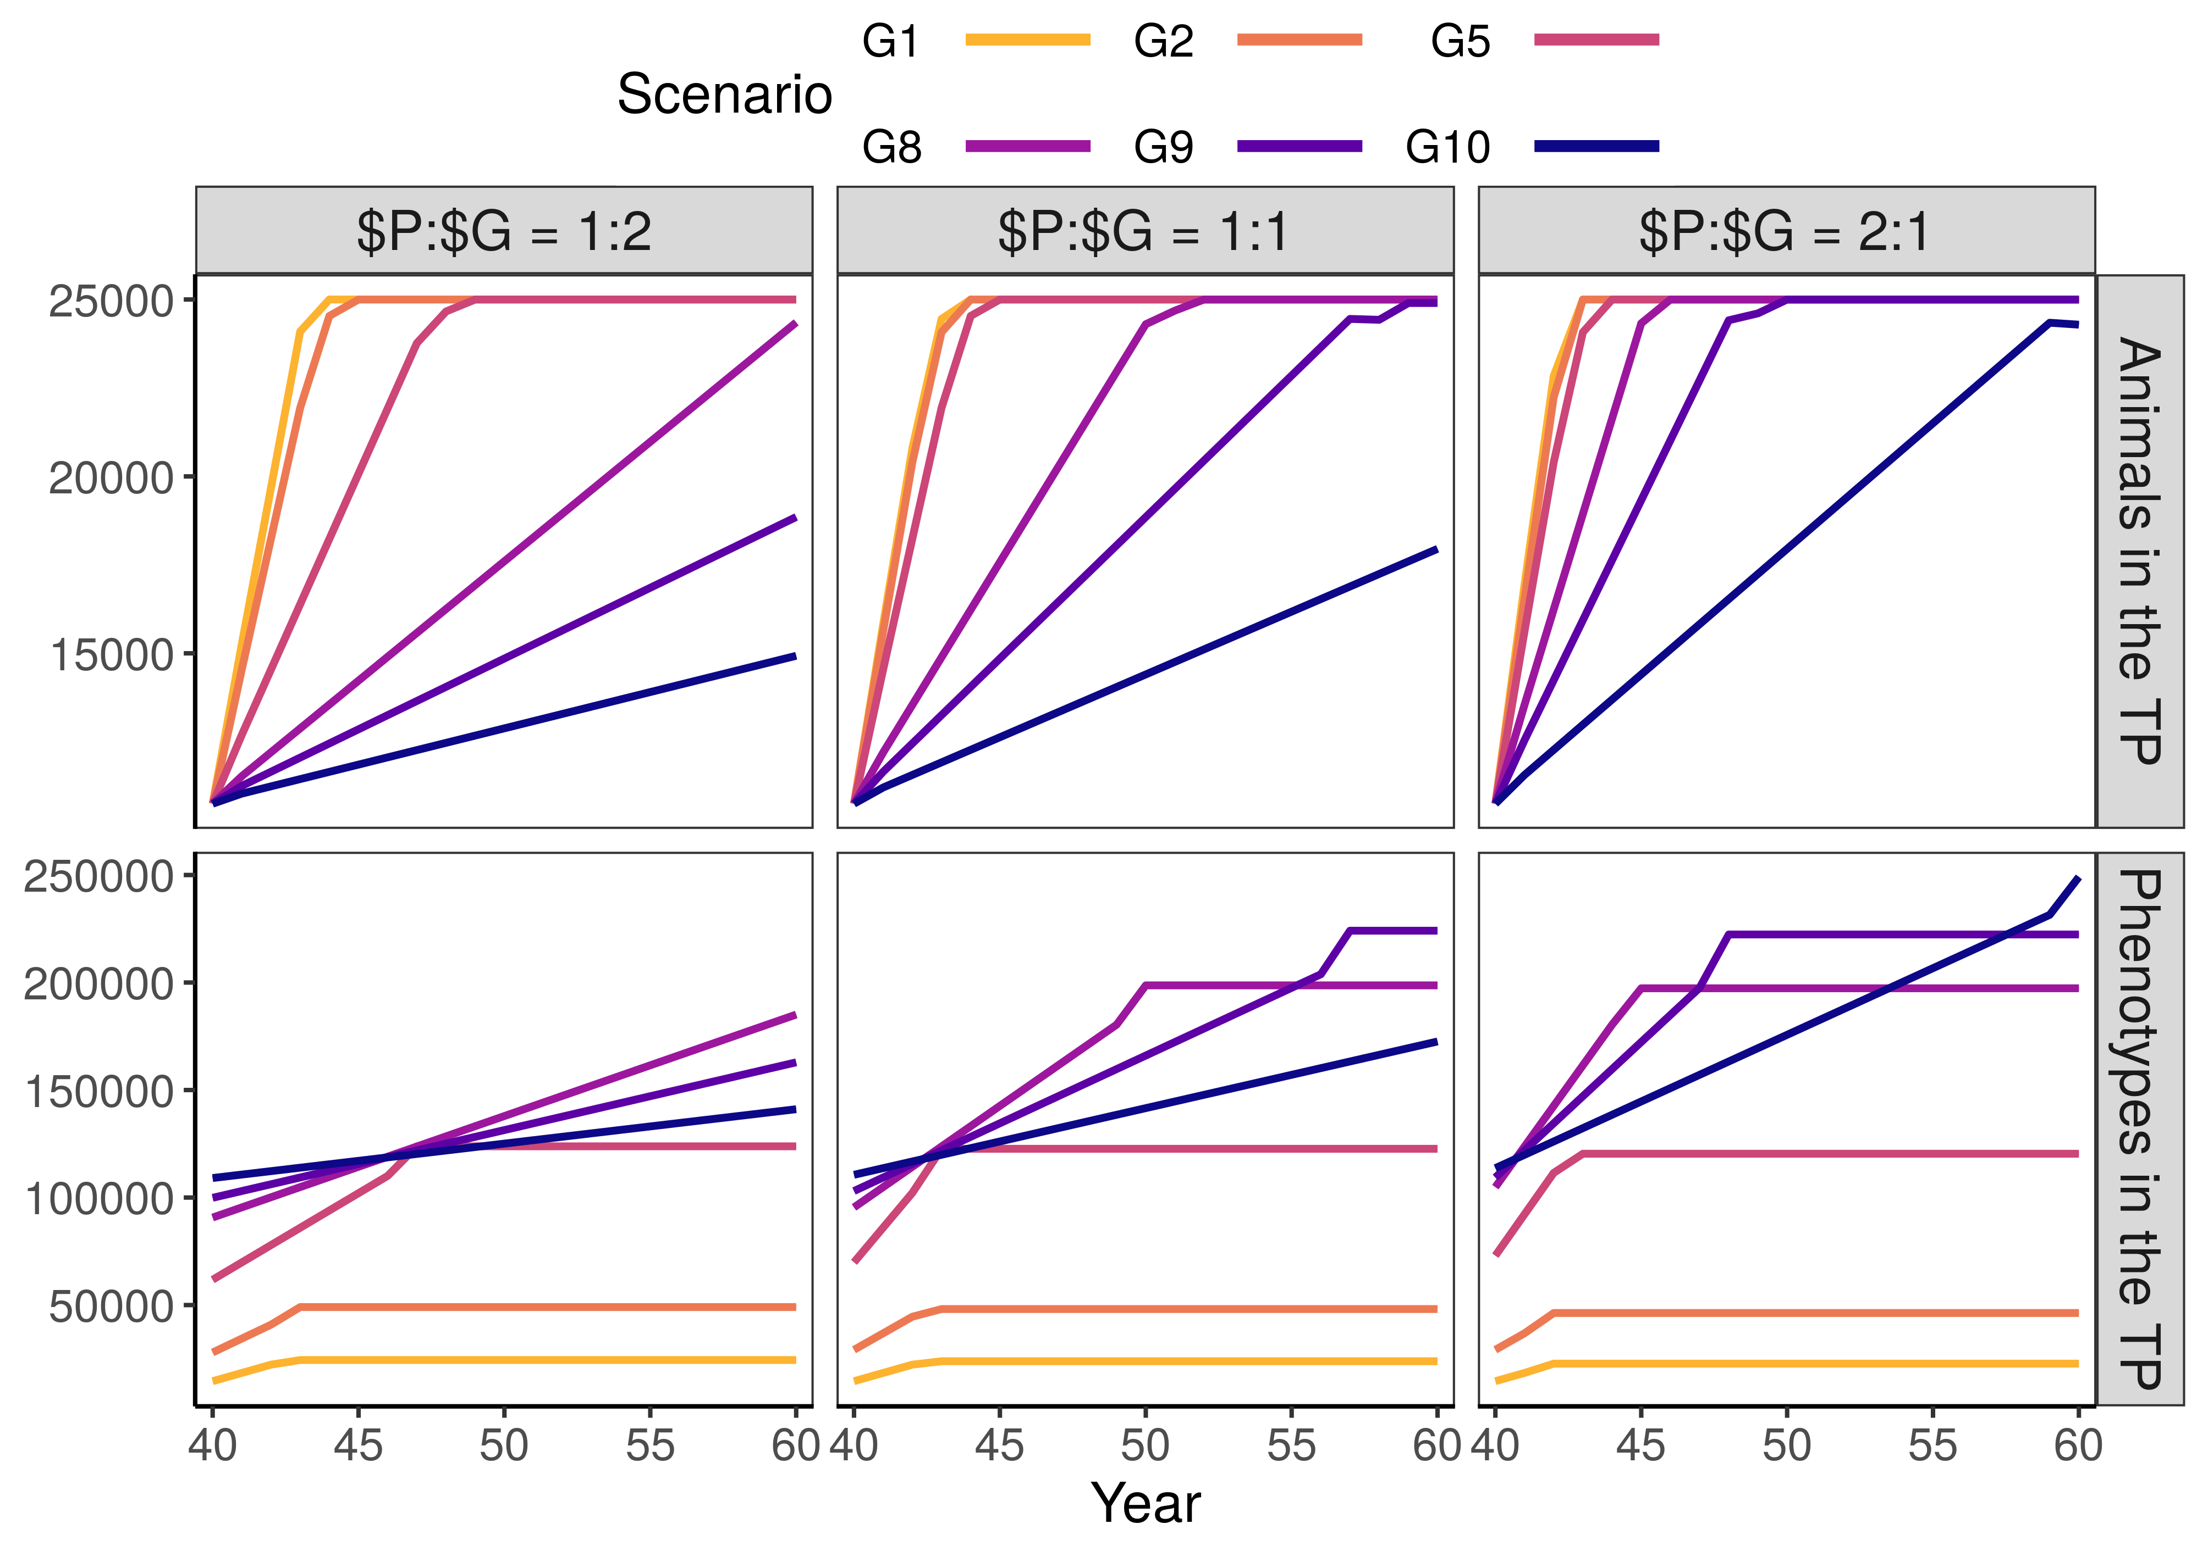**Figure S1 The number of animals and repeated phenotypes in the training population**. The figure presents the results for three relative costs of phenotyping to genotyping ($P:$G). In our simulation, scenarios traded repeated phenotype records for genotypes. Hence, the scenarios with the largest training population collected the least repeated records. These were also the scenarios that achieved the highest genetic gain.