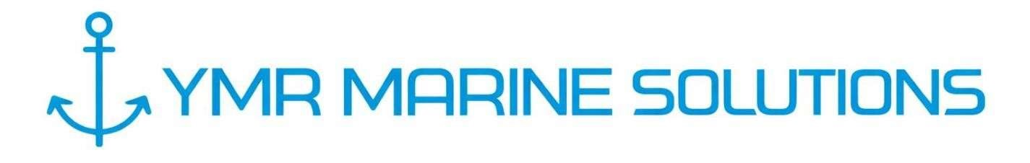

REGISTERED OFFICE ADDRESS: Runwal Elegante, A2605, Lokhandwala, Andheri West, Mumbai, Maharashtra- 400058 e-mail: ops@ymrmarine.com Phone: +919820482713 http://www.ymrmarine.com

{{DATE}}
{{PORT}}

To,
{{RECIPIENT_DESIGNATION}}
{{RECIPIENT_COMPANY}}
{{RECIPIENT_LOCATION}}

Dear Sir,
Sub: Request Permission to board {{VESSEL_NAME}} at {{BERTH_NO}}, to carry out {{SURVEY_TYPE}} survey on board.

We, the undersigned marine & cargo surveyors, have been appointed by the charterers of {{VESSEL_NAME}} to carry out {{SURVEY_TYPE}} survey on board.

In this regard we request you kindly give permission to board the vessel on her berthing to completion.

Details of surveyors.

- Mr. {{SURVEYOR_1_NAME}} / {{SURVEYOR_1_AGE}} yrs. / Aadhar No. {{SURVEYOR_1_AADHAR}}
- Mr. {{SURVEYOR_2_NAME}} / {{SURVEYOR_2_AGE}} Yrs. / Aadhar No. {{SURVEYOR_2_AADHAR}}
- Mr. {{SURVEYOR_3_NAME}} / {{SURVEYOR_3_AGE}} yrs. / Aadhar No. {{SURVEYOR_3_AADHAR}}
- Mr. {{SURVEYOR_4_NAME}} / {{SURVEYOR_4_AGE}} yrs. / Aadhar No. {{SURVEYOR_4_AADHAR}}

Thanks & Regards,

M/s. YMR MARINE SOLUTIONS LLP

