**Portfolio**

A portfolio’s meaning can be defined as a collection of financial assets and investment tools that are held by an individual, a financial institution or an investment firm. To develop a profitable portfolio, it is essential to become familiar with its fundamentals and the factors that influence it.

**What is a Portfolio?**

As per portfolio definition, it is a collection of a wide range of assets that are owned by investors. The said collection of financial assets may also be valuables ranging from gold, stocks, funds, derivatives, property, cash equivalents, bonds, etc. Individuals put their money in such assets to generate revenue while ensuring that the original equity of the asset or capital does not erode.

Depending on one’s know-how of the investment market, individuals may either manage their portfolio or seek the assistance of professional financial advisors for the same. As per financial experts, diversification is a vital concept in portfolio management.

## Types of Portfolio

Though there are several types of investment portfolios, investors make it a point to build one that matches their investment intent and risk capacity.Based on investment strategies, these following are some common types of portfolios –

1. Income portfolio:This type of portfolio emphasises more on securing a steady flow of income from investment avenues. In other words, it is not entirely focused on potential capital appreciation. For instance, income-driven investors may invest in stocks that generate regular dividends instead of those who show a track of price appreciation.

2. Growth portfolio:A growth-oriented portfolio mostly parks money into growth stocks of a company who are in their active growth stage. Typically, growth portfolios are subject to greater risks. This type of portfolio is known for presenting high risk and reward aspects.

3. Value portfolio:Such a portfolio puts money into cheap assets in valuation and focuses on securing bargains in the investment market. When the economy is struggling, and companies are barely surviving, value-oriented investors look for profitable companies whose shares are priced lower than their fair value. When the market revives, value portfolio holders generate substantial earnings.

**Factors that Affect Portfolio Allocation**

These following factors tend to influence an investor’s portfolio allocation to a great extent

1. Risk Tolerance

Investors’ risk appetite impacts how they are going to allocate their financial assets and investments into their portfolio. One can quickly gauge the risk tolerance level of an investor from the component of their portfolio.

For instance, conservative investors are often more inclined to build a portfolio that comprises large-cap value stock, investment-grade bonds, cash equivalents, market index funds, etc. Conversely, individuals with a high-risk appetite may include investments like small-cap and large-cap growth stock, high-yield bonds, gold, oil, real estate, etc. in their portfolio.

1. Time horizon :

The time-frame of putting money on a particular investment option is also quite crucial for building a profitable portfolio. As the general rule suggests, investors should modify their portfolio to achieve a conservative asset allocation mix as they approach nearer to their financial goals. It is followed to prevent accumulated earnings of their investment portfolio from eroding.

Typically, investors who are nearing their retirement are recommended to invest a more significant portion of their portfolio in less risky assets like – cash and bonds and the remainder in higher-yielding options. On the other hand, those who have just begun their career are suggested to invest the larger portion of their portfolio into high risk-reward investment options for the long haul. A longer time frame will help them to ride out the short-term market fluctuations and losses.

Other than this, investors’ financial goal is another important factor that influences the portfolio allocation. To elaborate, those with long-term goals are more likely to invest in long-term investment options like – equity funds , ULIPS , stocks, debt mutual funds. Alternatively, those with short-term goals tend to prefer liquid mutual funds, recurring deposits, government bonds, treasury bills and more.

**Need for Portfolio Management – In a Nutshell**

With the help of sound portfolio management, investors can build the best investment plan that matches their income, financial goals, age and risk capacity.

These pointers below highlight the underlying need for active portfolio management

* It helps to cushion investment-oriented risks and increases the scope of generating more profits.
* Helps to develop sound strategies and rebalance asset composition as per their current market condition so that investors can make the most of existing investment.
* It enables quick customisation based on immediate financial needs and market conditions.
* Helps understand which investments work best under which market situation and how to distribute resources into different asset classes.

The best way to build a sound investment portfolio is by determining its financial objective and rebalancing its components frequently. Subsequently, investors should focus more on diversifying their resources to attain the best possible rewards at manageable risks in all situations. In case individuals lack the farsightedness or market knowledge to manage a portfolio, they should seek a professional opinion.

**The Technology Portfolio**

One method for reviewing and beginning new projects is the use of a concept known as a Technology Portfolio. A technology portfolio is a compilation of information about a firm's investments in Information Technology. The information is organized to show how these investments support the firm's goals and to demonstrate the relationships among current and planned investments. The portfolio enhances the ability of key decision-makers to assess the probable impact of investments on a firm's overall Information Technology infrastructure.

The portfolio approach recognizes the maturing capabilities of the legal-sector Information Technology community. It also recognizes the continuous advance of technology and the need for firms to seek new initiatives in the context of their total operations, including their IT investments. The portfolio provides a process for coordinating new projects in the context of a business plan and with consideration of the larger IT portfolio.

The portfolio concept is grounded in the management principle that any significant investment requires careful stewardship to maximize its value and insulate it from threats to its integrity. This principle is well understood with respect to traditional investment categories - real property, commercial paper, and equity investments - all of which are commonly managed in portfolios. These portfolios allow decision-makers to view the range of investments as a whole but also consider discrete investments in context.

The need for an IT portfolio is less well understood with respect to IT investments but no less important. Agency IT investments involve significant taxpayer funds; are often mission-critical; and are increasingly interrelated in a digital, networked environment. IT investments can be leveraged with great effect if the portfolio is sufficiently flexible to adapt to changing business and service needs. Their value, on the other hand, can be undermined by rigid design, unsubstantiated claims about capabilities or performance, and neglect.

Portfolio-based IT management and oversight requires a sound business case to justify the investment of taxpayer funds in any new project. It requires an assessment of the impact of the proposed system on the existing IT infrastructure. It involves the disciplined use of preventative measures to mitigate risk, and it argues for the leveraging of private-sector expertise as needed. IT Portfolios, as defined herein, are reviewed to identify areas of duplication of effort or infrastructure and inconsistencies with the statewide direction. Portfolio-based oversight removes much of the burden of a paper-intensive reporting process while placing a premium on activities that help ensure success. To summarize, this concept provides three critical benefits:

* Reduce Technology Project Risk
* Introduce New Technology with Benefits
* Assure Critical Reviews of Technology

**Level of Risk**

Just as with insurance or investment portfolios a firm may establish its goal to maintain a risky or safe portfolio. A fairly standard breakdown of a Technology portfolio may include the following levels of investment.

* SAFE Items may include, Maintenance, Support Costs, Personnel Cost, Standard Equipment Replacement. Typically these are investments where the time and money is well understood and there is minimal risk of that time and money being wasted.
* RISK investments are typically characterized by some combination of Cost, Benefit, Risk, and Implementation.
* LOW RISK projects typically have 3 or 4 favorable characteristics. For example, High Benefit, Low Risk, Low Cost and easy implementation, would be 4 favorable characteristics.
* MODERATE RISK projects typically have 3 or 4 favorable characteristics. For example, High Benefit, Low Risk, Low Cost and easy implementation, would be 4 favorable characteristics.
* HIGH RISK projects typically have only 1 compelling favorable characteristics. For example, High Benefit, Low Risk, Low Cost and easy implementation, would be 4 favorable characteristics.

The percentage of projects that fall into each category and the exact definition of each category is a planning exercise for each firm to perform. Only they will know how risk-adverse they wish to be.

Why then take on any risk? Simply put, the technological advances in matter management, litigation support, and firm control are simply too advantageous to ignore. Failure to adopt new systems will put a firm at an inherent disadvantage.

By establishing a baseline Technology Portfolio a firm essentially performs a quick review of what is in progress and to what degree that firm is comfortable with Technology project risk. That baseline portfolio will fluctuate over time as additional projects are started or as projects reach the end of their "risk" stage and move into the "safe" stage. But by maintaining an eye on the overall portfolio key decision makers can see when the overall firm technology projects have strayed into uncomfortable levels and then take corrective actions.

**PROJECT**

<https://github.com/janapareddyjayadeep/Techncialportfolio>

**INDEX.HTML OUTPUT**

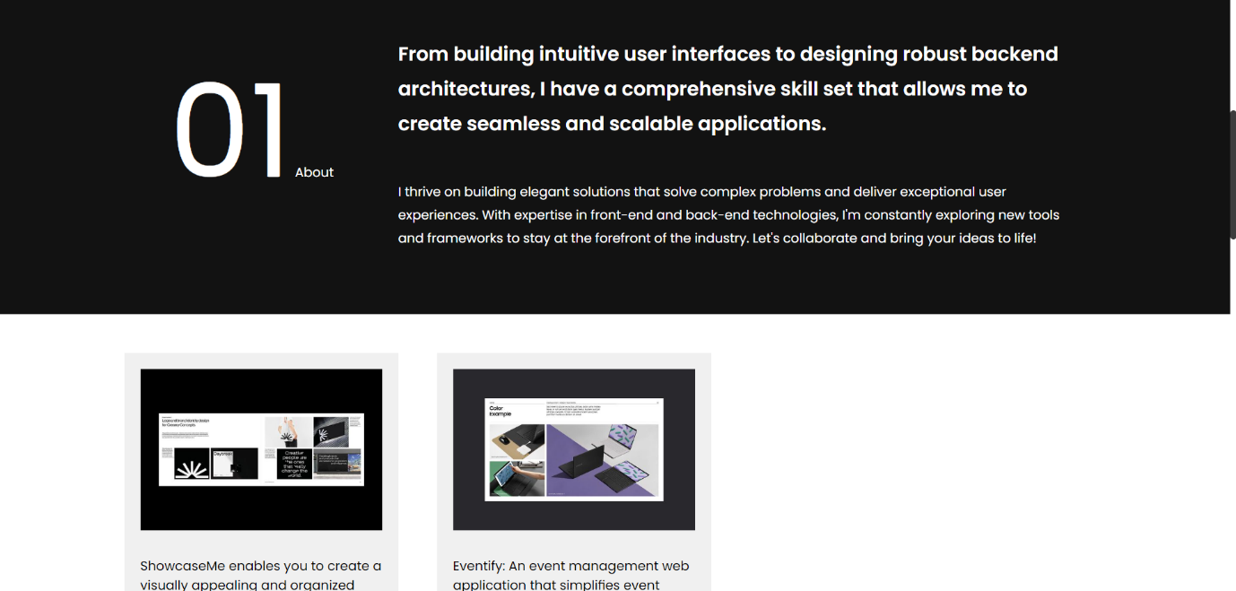 

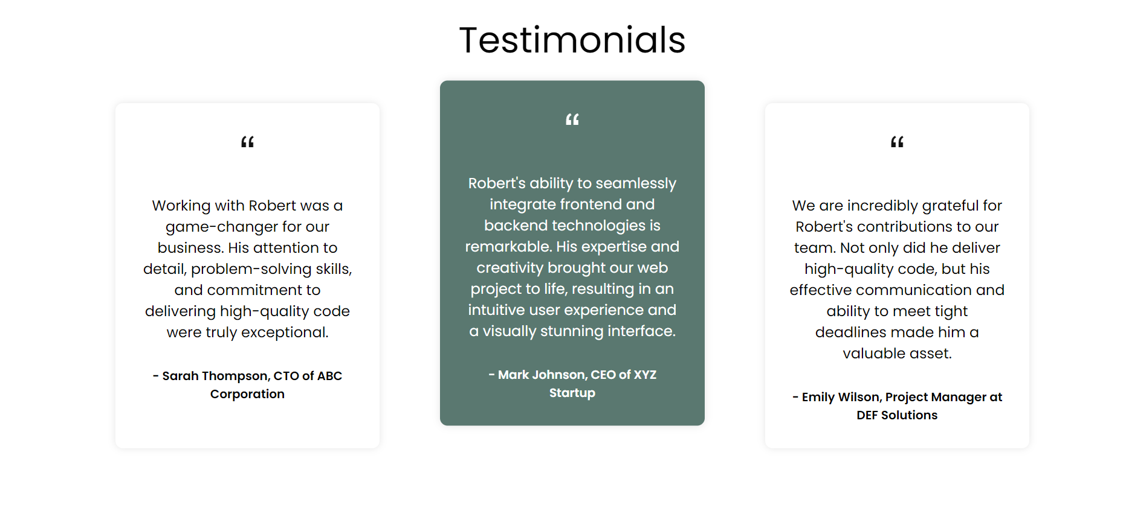

**PROJECTS.HTML OUTPUT**

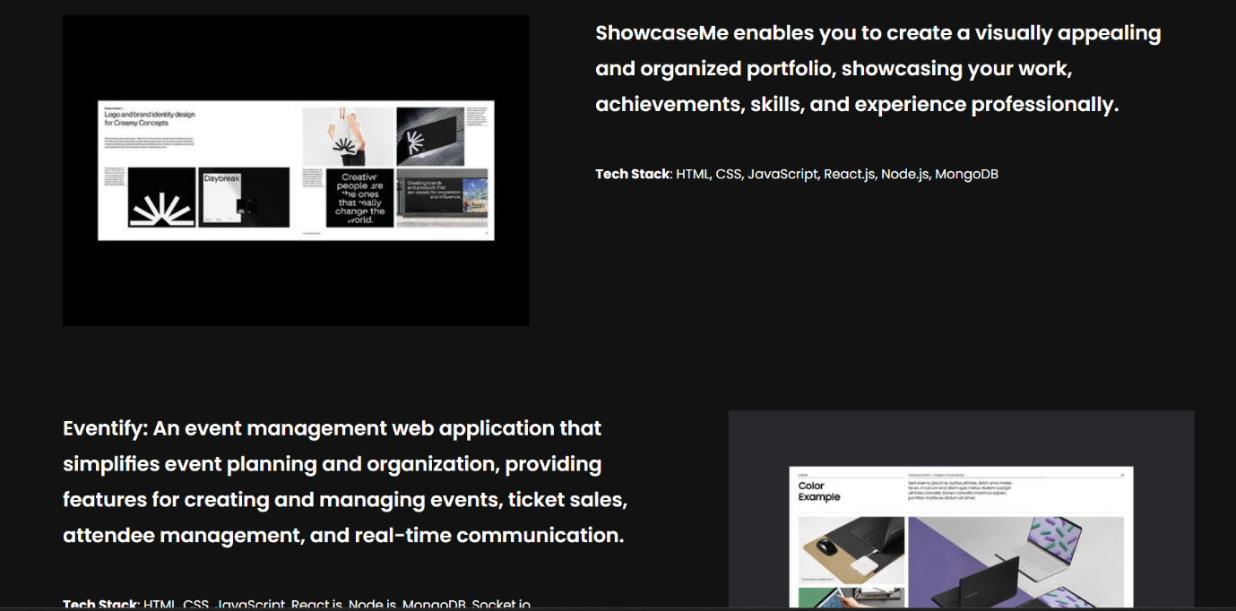

**SKILLS.HTML OUTPUT**

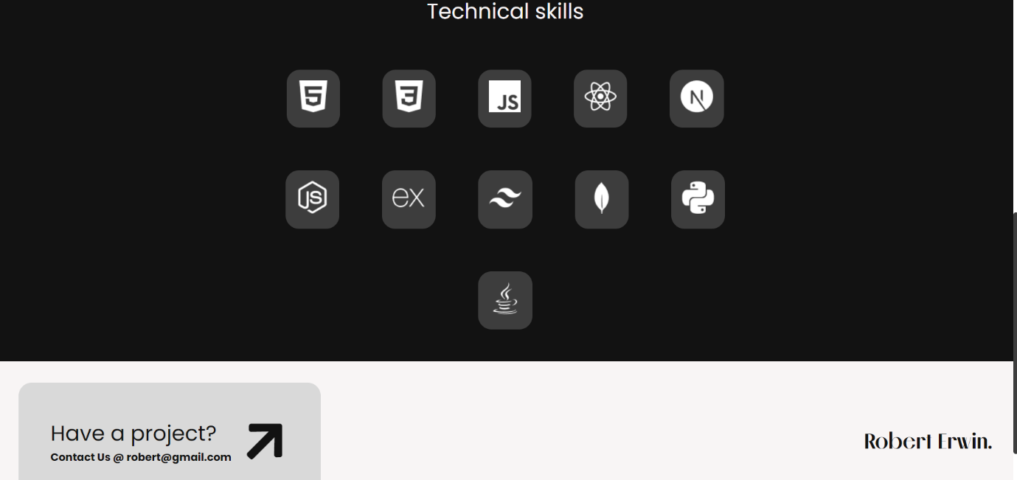

**THANK YOU**