# **WEEK 6: React**

## **Create new React Application**

### **Code:**

function App(){

  return(

    <h1>Welcome to first session of React</h1>

  );

}

export default App;

### **Output:**

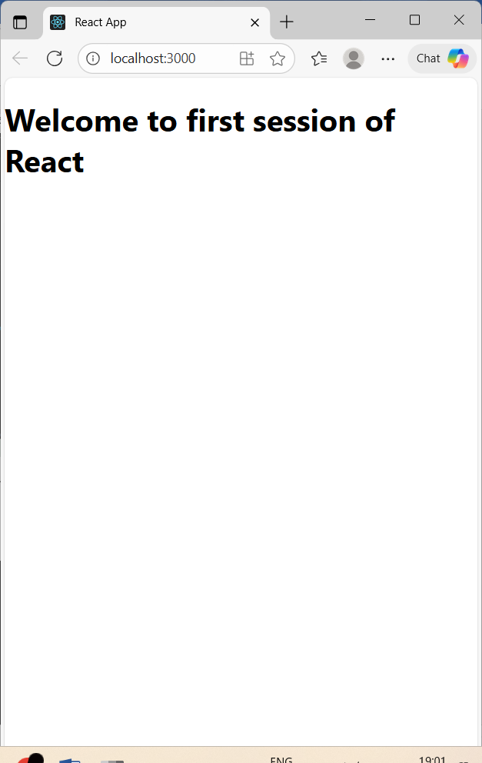

## **Components in React**

### **Code:**

**Components/Home.js**

import React, {Component} from 'react';

class Home extends Component {

  render() {

    return (

    <div>

      <h1>Welcome to Home Page of Student Management Portal</h1>

    </div>

    );

  }

}

export default Home;

**Components/About.js**

import React, { Component } from 'react';

class About extends Component {

  render() {

    return (

    <div>

      <h1>Welcome to About Page of Student Management Portal</h1>

    </div>

    );

  }

}

export default About;

**Contact.js**

import React, {Component} from 'react';

class Contact extends Component {

  render() {

    return (

    <div>

      <h1>Welcome to Contact Page of Student Management Portal</h1>

    </div>

    );

  }

}

export default Contact;

### **Output:**

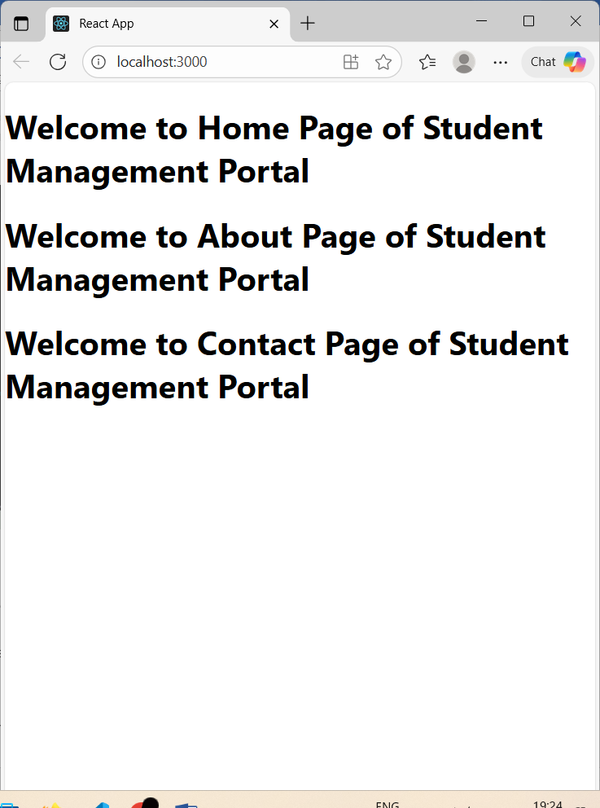

## **E-commerce Platform Search Function**

### **Code:**

**CalculateScore.js**

import '../Stylesheets/mystyle.css';

const percentToDecimal = (decimal) => {

    return (decimal.toFixed(2) + '%')

}

const calcScore = (total, goal) => {

    return percentToDecimal((total / goal))

}

export const CalculateScore = ({Name, School, total, goal }) => {

    return (

        <div className="formatstyle">

            <h1><font color="Brown">Student Details:</font></h1>

            <div className="Name">

                <b><span>Name: </span></b>

                <span>{Name}</span>

            </div>

            <div className="School">

                <b><span>School: </span></b>

                <span>{School}</span>

            </div>

            <div className="Total">

                <b><span>Total: </span></b>

                <span>{total}</span>

                <span> Marks</span>

            </div>

            <div className="Score">

                <b> Score: </b>

                <span>{calcScore(total, goal)}</span>

            </div>

        </div>

    );

}

**mystyle.css**

.Name{

    color: blue;

    text-align: center;

    font-size: 20px;

}

.School{

    color: green;

    text-align: center;

    font-size: 20px;

}

.Total{

    color: red;

    text-align: center;

    font-size: 20px;

}

.formatstyle{

    text-align: center;

    font-size: 20px;

}

.Score{

    color: purple;

    text-align: center;

    font-size: 30px;

}

### **Output:**

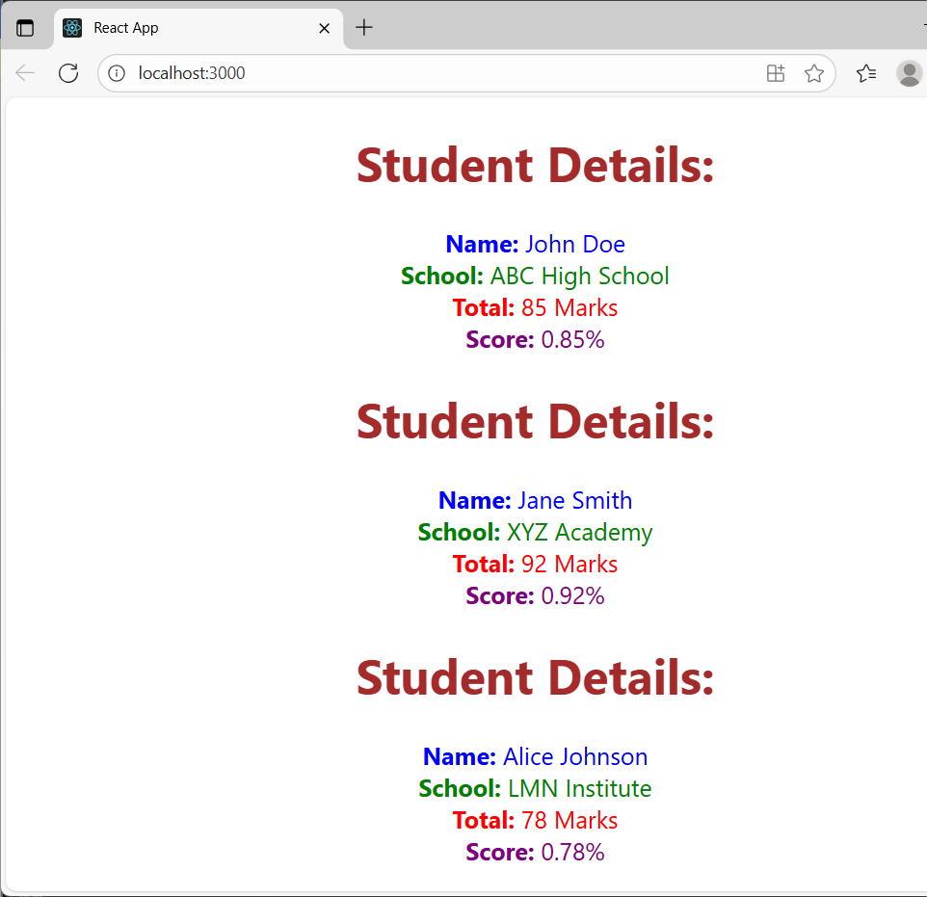

## **Blog app**

### **Code:**

**Post.js**

class Post{

    constructor(id, title, body){

        this.id = id;

        this.title = title;

        this.body = body;

    }

}

**Posts.js**

import React, { Component }from "react";

import Post from "./Post";

class Posts extends Component {

    constructor(props) {

        super(props);

        this.state = {

            posts: [],

            hasError: false,

        };

    }

    async loadPosts(){

        try {

            const response = await fetch("https://jsonplaceholder.typicode.com/posts");

            const data = await response.json();

            this.setState({ posts: data });

        }

        catch (error) {

            console.error("Error loading posts:", error);

            this.setState({ hasError: true });

        }

    }

    componentDidMount() {

        this.loadPosts();

    }

    render(){

        if (this.state.hasError) {

            return <h2>Something went wrong. Please try again later.</h2>;

        }

        return (

          <div>

            <h1>Blog Posts</h1>

            {this.state.posts.length === 0 ? (

              <p>Loading posts...</p>

            ) : (

              this.state.posts.map((post) => (

                <div key={post.id}>

                  <h3>{post.title}</h3>

                  <p>{post.body}</p>

                  <hr />

                </div>

              ))

            )}

          </div>

        );

    }

    componentDidCatch(error, info) {

        this.setState({ hasError: true });

        console.error("Error occurred:", error, info);

    }

}

export default Posts;

### **Output:**

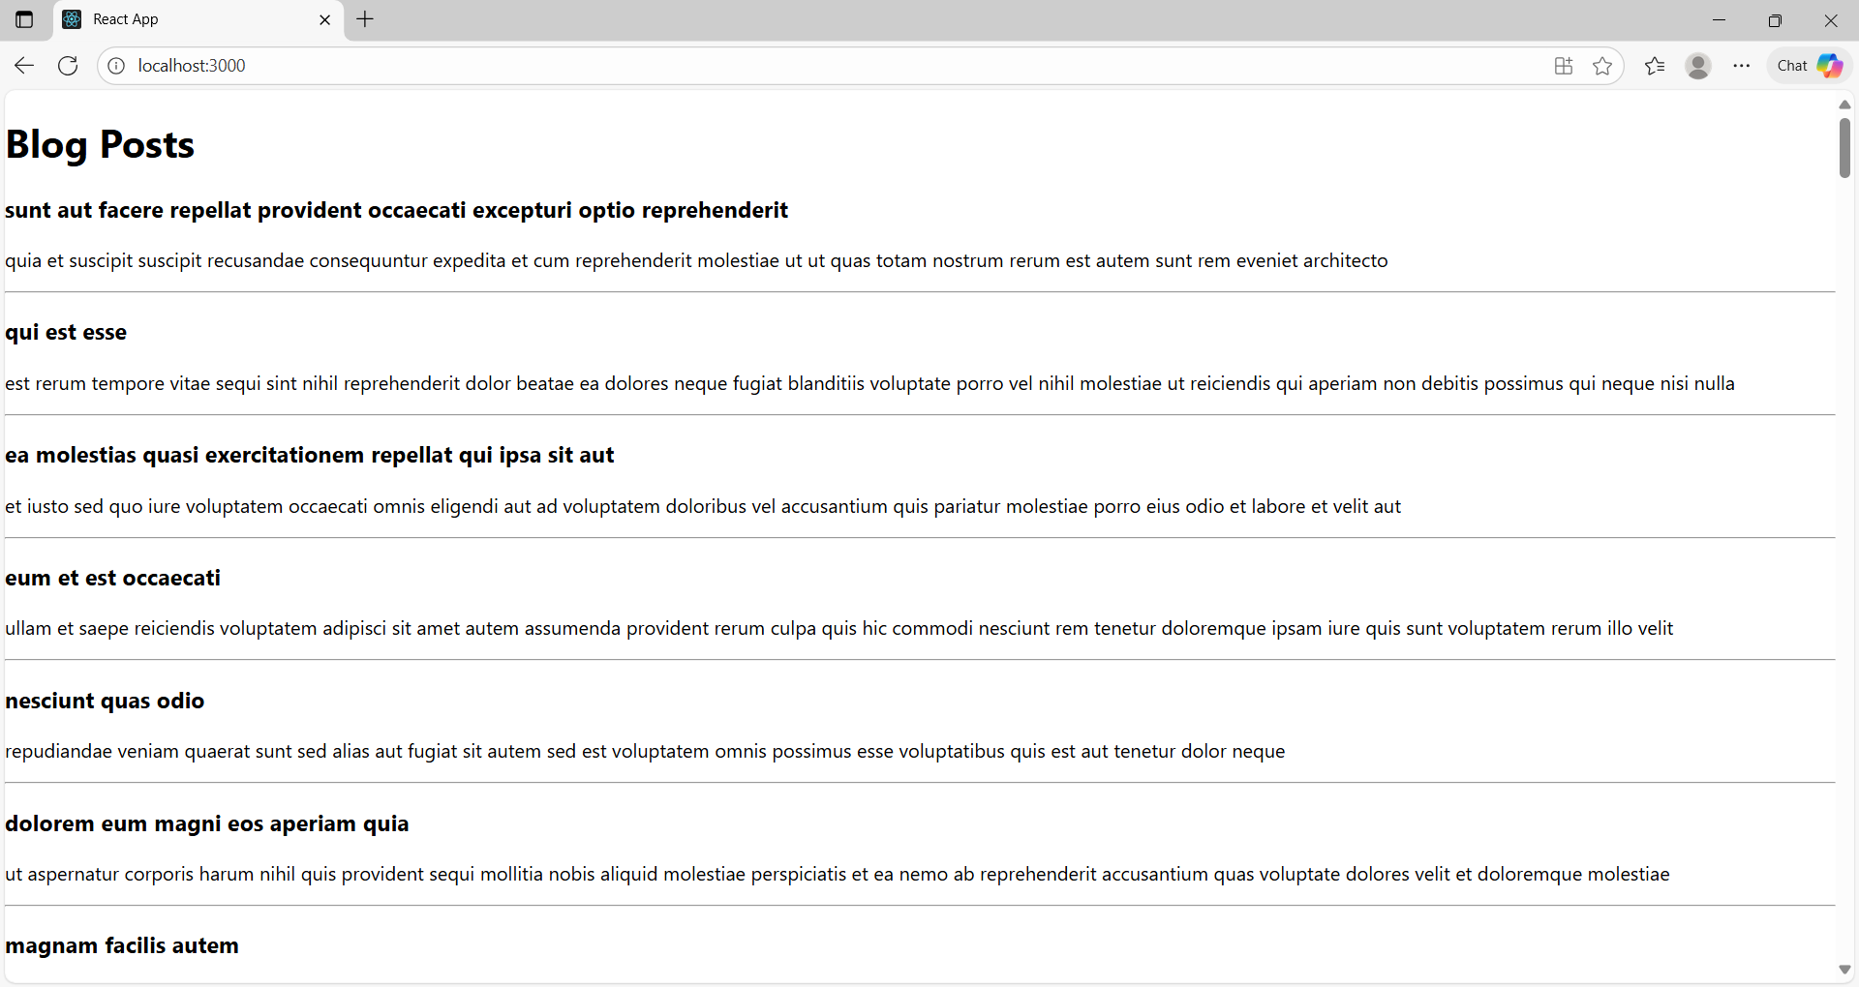

## **Cohort Dashboard**

### **Code:**

import React from "react";

import styles from "../Styles/CohortDetails.module.css";

const CohortDetails = ({name, status, startDate, coach, trainer }) => {

  return (

    <div className={styles.box}>

      <h3 style={{ color: status === "ongoing" ? "green" : "blue" }}>{name}</h3>

      <dl>

        <dt>Current Status:</dt>

        <dd>{status}</dd>

        <dt>Started On:</dt>

        <dd>{startDate}</dd>

        <dt>Coach:</dt>

        <dd>{coach}</dd>

        <dt>Trainer:</dt>

        <dd>{trainer}</dd>

      </dl>

    </div>

  );

};

**CSS:**

.box {

  width: 300px;

  display: inline-block;

  margin: 10px;

  padding: 10px 20px;

  border: 1px solid black;

  border-radius: 10px;

}

dt {

  font-weight: 500;

}

### **Output:**

