# **WEEK 7: React**

## **Cricket Players**

### **Code:**

**ListOfplayers.js**

import React from "react";

const ListofPlayers = () => {

  const players = [

    { name: "Mr. Jack", score: 50 },

    { name: "Mr. Michael", score: 70 },

    { name: "Mr. John", score: 40 },

    { name: "Mr. Ann", score: 61 },

    { name: "Mr. Elisabeth", score: 61 },

    { name: "Mr. Sachin", score: 95 },

    { name: "Mr. Dhoni", score: 100 },

    { name: "Mr. Virat", score: 84 },

    { name: "Mr. Jadeja", score: 64 },

    { name: "Mr. Raina", score: 75 },

    { name: "Mr. Rohit", score: 80 },

  ];

  const below70 = players.filter(p => p.score <= 70);

  return (

    <div style={{ padding: "20px" }}>

      <h2>List of Players</h2>

      <ul>

        {players.map((p, index) => (

          <li key={index}>

            • {p.name} {p.score}

          </li>

        ))}

      </ul>

      <h3>List of Players having Scores Less than 70</h3>

      <ul>

        {below70.map((p, index) => (

          <li key={index}>

            • {p.name} {p.score}

          </li>

        ))}

      </ul>

    </div>

  );

};

export default ListofPlayers;

**IndianPlayers.js**

import React from "react";

const IndianPlayers = () => {

  const players = [

    { name: "Sachin", pos: 1 },

    { name: "Dhoni", pos: 2 },

    { name: "Virat", pos: 3 },

    { name: "Rohit", pos: 4 },

    { name: "Yuvaraj", pos: 5 },

    { name: "Raina", pos: 6 },

  ];

  const oddPlayers = players.filter((_, index) => index % 2 === 0);

  const evenPlayers = players.filter((_, index) => index % 2 !== 0);

  const mergedPlayers = [

    "Mr. First Player",

    "Mr. Second Player",

    "Mr. Third Player",

    "Mr. Fourth Player",

    "Mr. Fifth Player",

    "Mr. Sixth Player"

  ];

  return (

    <div style={{ padding: "20px" }}>

      <h2>Odd Players</h2>

      <ul>

        {oddPlayers.map((p, index) => (

          <li key={index}>

            • {p.name} {p.pos}

          </li>

        ))}

      </ul>

      <h2>Even Players</h2>

      <ul>

        {evenPlayers.map((p, index) => (

          <li key={index}>

            • {p.name} {p.pos}

          </li>

        ))}

      </ul>

      <h2>List of Indian Players Merged:</h2>

      <ul>

        {mergedPlayers.map((p, index) => (

          <li key={index}>• {p}</li>

        ))}

      </ul>

    </div>

  );

};

export default IndianPlayers;

**App.js**

import React, { useState } from "react";

import ListofPlayers from "./Components/ListOfplayers";

import IndianPlayers from "./Components/IndianPlayers";

function App() {

   const [flag, setFlag] = useState(true);

  const toggleView = () => {

    setFlag(!flag);

  };

  return (

    <div style={{ marginTop: "30px" }}>

            <button

        onClick={toggleView}

        style={{

          marginBottom: "20px",

          padding: "10px 20px",

          backgroundColor: "#008CBA",

          color: "white",

          border: "none",

          borderRadius: "6px",

          cursor: "pointer",

          fontSize: "16px",

        }}

      >{flag ? "Indian Players" : "List of Players"}</button>

      {flag ? <ListofPlayers /> : <IndianPlayers />}

    </div>

  );

}

export default App;

### **Output:**

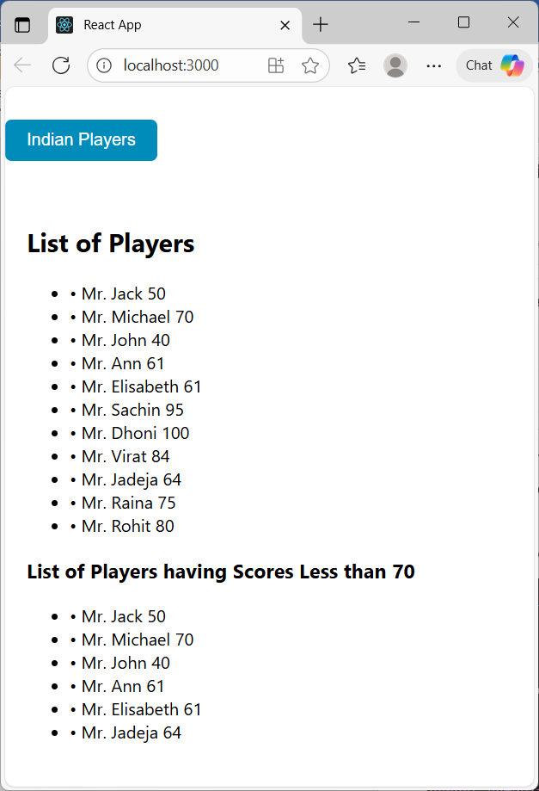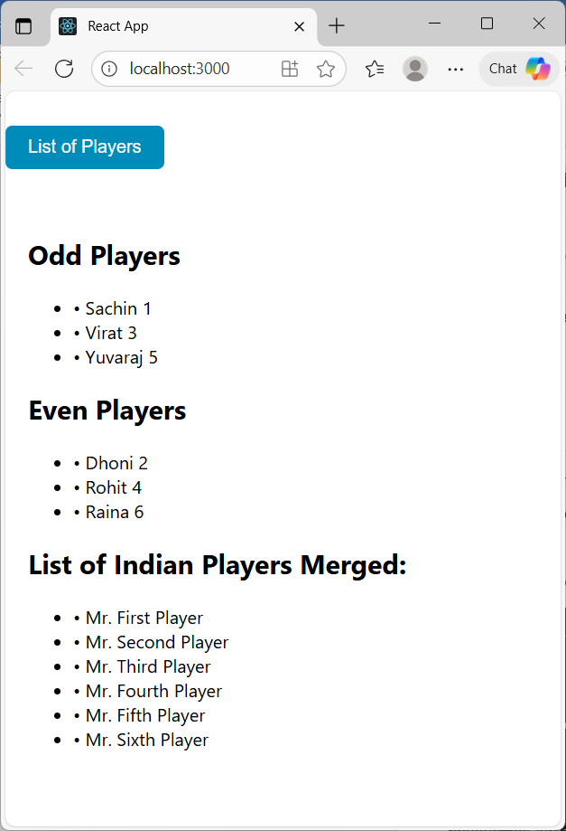

## **Office Space Rental**

### **Code:**

**Office.js**

import React from "react";

import '../StyleSheets/officeStyle.css';

import officeImg from '../Images/office.jpg';

export const Office = ({ office }) => {

  const rentClass = office.Rent <= 60000 ? 'textRed' : 'textGreen';

  return (

    <div className="officeCard">

      <h2>{office.Name}</h2>

      <img src={officeImg} alt="Office Space" className="officeImage" />

      <h3 className={rentClass}>Rent: Rs. {office.Rent}</h3>

      <h4>Address: {office.Address}</h4>

    </div>

  );

};

**OfficeList.js**

import React from "react";

import { Office } from "./Office";

const officeSpaces = [

  { Name: "DBS", Rent: 50000, Address: "Chennai" },

];

export const OfficeList = () => {

  return (

    <div>

      <h1>Office Spaces, at affordable range</h1>

      <div>

        {officeSpaces.map((office, index) => (

          <Office key={index} office={office} />

        ))}

      </div>

    </div>

  );

};

**officeStyle.css**

.officeCard {

  border: 1px solid black;

  border-radius: 8px;

  padding: 15px;

  margin: 10px;

  display: inline-block;

  width: 250px;

  text-align: left;

}

.officeImage {

  width: 100%;

  height: auto;

  border-radius: 5px;

}

export default Contact;

### **Output:**

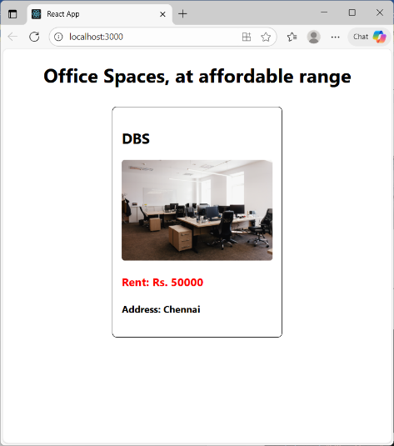

## **Events in React**

### **Code:**

**Counter.js**

import React, { Component } from "react";

import '../Stylesheets/eventStyles.css';

export class Counter extends Component {

  constructor(props) {

    super(props);

    this.state = {

      count: 0,

    };

    this.increment = this.increment.bind(this);

    this.sayHello = this.sayHello.bind(this);

    this.handleIncrement = this.handleIncrement.bind(this);

  }

  increment() {

    this.setState({ count: this.state.count + 1 });

  }

  sayHello() {

    console.log("Hello! This is a static message");

  }

  handleIncrement() {

    this.increment();

    this.sayHello();

  }

  decrement = () => {

    this.setState({ count: this.state.count - 1 });

  };

  sayWelcome() {

    alert(`Welcome`);

  }

  handleSyntheticEvent = (e) => {

    console.log("Synthetic event object:", e);

    alert("I was clicked");

  };

  render() {

    return (

      <div style={{ margin: "20px" }}>

        <h2>Counter: {this.state.count}</h2>

        <button onClick={this.handleIncrement}>Increment</button>

        <button onClick={this.decrement}>Decrement</button>

        <br /><br />

        <button onClick={() => this.sayWelcome()}>Welcome</button>

        <br /><br />

        <button onClick={this.handleSyntheticEvent}>Click Me</button>

      </div>

    );

  }

}

**CurrencyConverter.js**

import React, { Component } from "react";

export class CurrencyConvertor extends Component {

  constructor(props) {

    super(props);

    this.state = {

      rupees: "",

      euro: "",

    };

  }

  handleChange = (e) => {

    this.setState({ rupees: e.target.value });

  };

  handleSubmit = (e) => {

    e.preventDefault();

    const euro = (this.state.rupees / 90).toFixed(2); // Example conversion rate

    this.setState({ euro });

  };

  render() {

    return (

      <div style={{ margin: "20px" }}>

        <h2>Currency Convertor: INR to EURO</h2>

        <form onSubmit={this.handleSubmit}>

          <input

            type="number"

            value={this.state.rupees}

            onChange={this.handleChange}

            placeholder="Enter Rupees"

          />

          <button type="submit">Convert</button>

        </form>

        {this.state.euro && <h3>Euro: €{this.state.euro}</h3>}

      </div>

    );

  }

}

### **Output:**

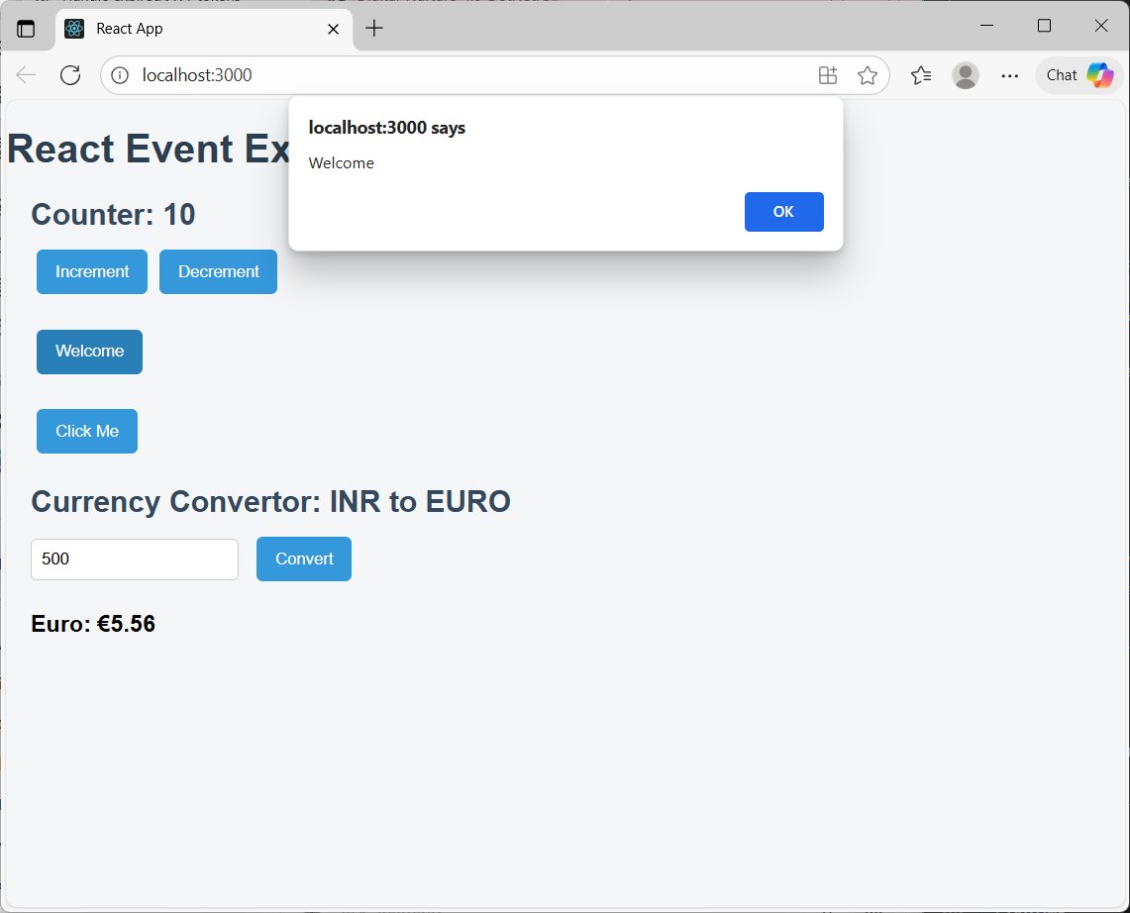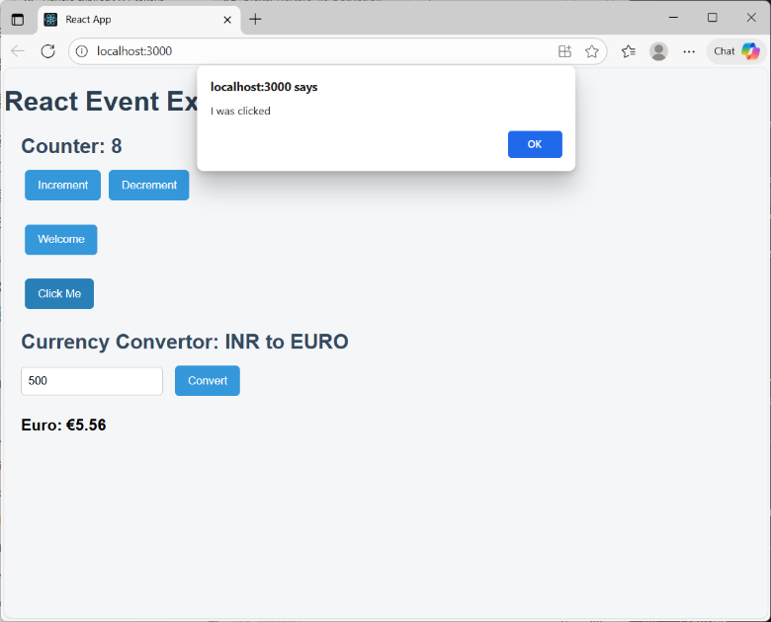

## **Ticket Booking**

### **Code:**

**Login.js**

export function LoginButton(props) {

  return (

    <button onClick={props.onClick} style={{ padding: "10px", margin: "5px" }}>

      Login

    </button>

  );

}

**Logout.js**

export function LogoutButton(props) {

  return (

    <button onClick={props.onClick} style={{ padding: "10px", margin: "5px" }}>

      Logout

    </button>

  );

}

**User.js**

export function UserGreeting() {

  return (

    <div>

      <h2>Welcome User!</h2>

      <p>You can now book your flight tickets.</p>

      <ul style={{ listStyleType: "none", padding: 0, margin: 0 }}>

        <li>Flight 101: Mumbai → Delhi [Book]</li>

        <li>Flight 202: Chennai → Bangalore [Book]</li>

        <li>Flight 303: Kolkata → Hyderabad [Book]</li>

      </ul>

    </div>

  );

}

**Guest.js**

export function GuestGreeting() {

  return (

    <div>

      <h2>Welcome Guest!</h2>

      <p>Please log in to book your flight tickets.</p>

      <ul style={{ listStyleType: "none", padding: 0, margin: 0 }}>

        <li>Flight 101: Mumbai → Delhi</li>

        <li>Flight 202: Chennai → Bangalore</li>

        <li>Flight 303: Kolkata → Hyderabad</li>

      </ul>

    </div>

  );

}

**Greet.js**

import { UserGreeting } from "./User";

import { GuestGreeting } from "./Guest";

export function Greeting(props) {

  const isLoggedIn = props.isLoggedIn;

  return isLoggedIn ? <UserGreeting /> : <GuestGreeting />;

}

**App.js**

import React, { useState } from "react";

import { LoginButton } from "./Components/Login";

import { LogoutButton } from "./Components/Logout";

import { Greeting } from "./Components/Greet";

import "./App.css";

function App() {

  const [isLoggedIn, setIsLoggedIn] = useState(false);

  const handleLogin = () => setIsLoggedIn(true);

  const handleLogout = () => setIsLoggedIn(false);

  return (

    <div style={{ textAlign: "center", marginTop: "50px" }}>

      <Greeting isLoggedIn={isLoggedIn} />

      {isLoggedIn ? (

        <LogoutButton onClick={handleLogout} />

      ) : (

        <LoginButton onClick={handleLogin} />

      )}

    </div>

  );

}

export default App;

### **Output:**

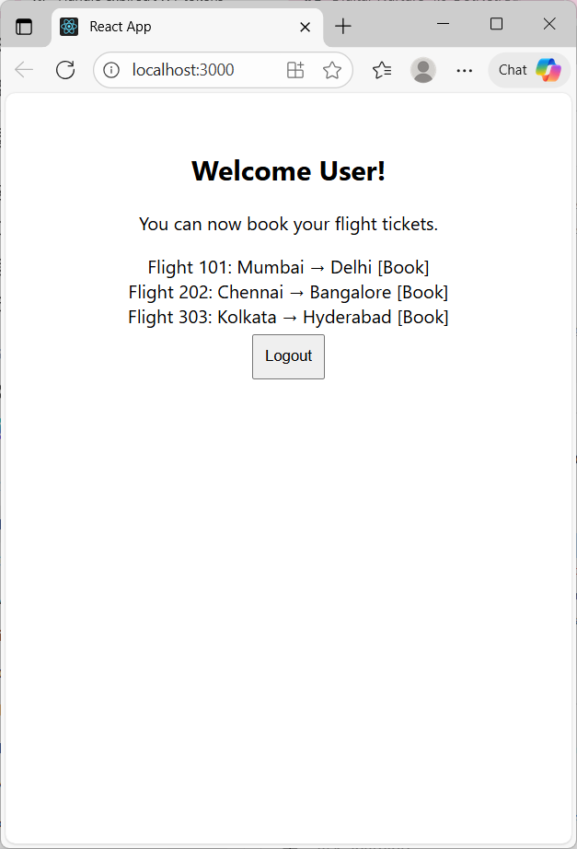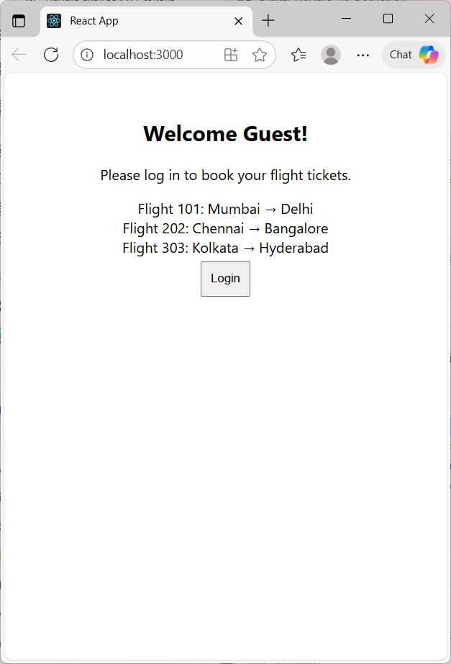

## **BloggerApp**

### **Code:**

**BlogDetails.js**

import styles from "./CardStyles.module.css";

export const blogs = [

  { id: 201, title: "React Hooks", content: "Learn about useState and useEffect" },

  { id: 202, title: "Angular 11", content: "Components and Modules" },

  { id: 203, title: "MongoDB", content: "Basics of NoSQL Database" },

];

export function BlogDetails() {

  return (

    <div className={styles.card}>

      <h1>Blog Details</h1>

      <ul style={{ listStyleType: "none", padding: 0 }}>

        {blogs.map((blog) => (

          <li key={blog.id}>

            <h3>{blog.title}</h3>

            <h4>{blog.content}</h4>

          </li>

        ))}

      </ul>

    </div>

  );

}

**BookDetails.js:**

import styles from "./CardStyles.module.css";

export const books = [

  { id: 101, bname: "Master React", price: 670 },

  { id: 102, bname: "Deep Dive into Angular 11", price: 800 },

  { id: 103, bname: "Mongo Essentials", price: 450 },

];

export function BookDetails() {

  return (

    <div className={styles.card}>

      <h1>Book Details</h1>

      <ul style={{ listStyleType: "none", padding: 0 }}>

        {books.map((book) => (

          <li key={book.id}>

            <h3>{book.bname}</h3>

            <h4>Price: Rs. {book.price}</h4>

          </li>

        ))}

      </ul>

    </div>

  );

}

**CourseDetails.js:**

import styles from "./CardStyles.module.css";

export const courses = [

  { id: 301, cname: "React Mastery", duration: "30 Days" },

  { id: 302, cname: "Node.js Bootcamp", duration: "25 Days" },

  { id: 303, cname: "Cloud Fundamentals", duration: "20 Days" },

];

export function CourseDetails() {

  return (

    <div className={styles.card}>

      <h1>Course Details</h1>

      <ul style={{ listStyleType: "none", padding: 0 }}>

        {courses.map((course) => (

          <li key={course.id}>

            <h3>{course.cname}</h3>

            <h4>Duration: {course.duration}</h4>

          </li>

        ))}

      </ul>

    </div>

  );

}

### **Output:**

