# **WEEK 8: GIT**

## **GIT Commands**

DELL@DESKTOP-5CVK56E MINGW64 ~

$ git version

git version 2.50.1.windows.1

DELL@DESKTOP-5CVK56E MINGW64 ~

$ git config --global user.name "user"

DELL@DESKTOP-5CVK56E MINGW64 ~

$ git config --global user.email "janapriya112005@gmail.com"

DELL@DESKTOP-5CVK56E MINGW64 ~

$ git config --global --list

user.name=user

user.email=janapriya112005@gmail.com

DELL@DESKTOP-5CVK56E MINGW64 ~

$ notepad

DELL@DESKTOP-5CVK56E MINGW64 ~

$ notepad.exe bash -profile

DELL@DESKTOP-5CVK56E MINGW64 ~

$ git config --global core.editor "notepad.exe"

DELL@DESKTOP-5CVK56E MINGW64 ~

$ git config --global -e

DELL@DESKTOP-5CVK56E MINGW64 ~

$ git init GitDemo

Reinitialized existing Git repository in C:/Users/DELL/GitDemo/.git/

DELL@DESKTOP-5CVK56E MINGW64 ~

$ cd GitDemo

DELL@DESKTOP-5CVK56E MINGW64 ~/GitDemo (master)

$ echo "Welcome to the Version Control" >> welcome.txt

DELL@DESKTOP-5CVK56E MINGW64 ~/GitDemo (master)

$ ls -al

total 21

drwxr-xr-x 1 DELL 197121 0 Aug 8 10:17 **.**/

drwxr-xr-x 1 DELL 197121 0 Aug 8 10:15 **..**/

drwxr-xr-x 1 DELL 197121 0 Aug 8 10:16 **.git**/

-rw-r--r-- 1 DELL 197121 31 Aug 8 10:17 welcome.txt

DELL@DESKTOP-5CVK56E MINGW64 ~/GitDemo (master)

$ cat welcome.txt

Welcome to the Version Control

DELL@DESKTOP-5CVK56E MINGW64 ~/GitDemo (master)

$ git status

On branch master

No commits yet

Untracked files:

(use "git add <file>..." to include in what will be committed)

welcome.txt

nothing added to commit but untracked files present (use "git add" to track)

DELL@DESKTOP-5CVK56E MINGW64 ~/GitDemo (master)

$ git add welcome.txt

warning: in the working copy of 'welcome.txt', LF will be replaced by CRLF the next time Git touches it

DELL@DESKTOP-5CVK56E MINGW64 ~/GitDemo (master)

$ git commit

Aborting commit due to empty commit message.

DELL@DESKTOP-5CVK56E MINGW64 ~/GitDemo (master)

$ git commit

[master (root-commit) 5019c13] commited

1 file changed, 1 insertion(+)

create mode 100644 welcome.txt

DELL@DESKTOP-5CVK56E MINGW64 ~/GitDemo (master)

$ git remote -v

DELL@DESKTOP-5CVK56E MINGW64 ~/GitDemo (master)

$ git remote add origin "https://github.com/janapriya-s/GitDemo.git"

DELL@DESKTOP-5CVK56E MINGW64 ~/GitDemo (master)

$ git push origin master

info: please complete authentication in your browser...

Enumerating objects: 3, done.

Counting objects: 100% (3/3), done.

Writing objects: 100% (3/3), 240 bytes | 80.00 KiB/s, done.

Total 3 (delta 0), reused 0 (delta 0), pack-reused 0 (from 0)

To https://github.com/janapriya-s/GitDemo.git

* [new branch] master -> master

DELL@DESKTOP-5CVK56E MINGW64 ~/GitDemo (master)

$ git pull origin master

From https://github.com/janapriya-s/GitDemo

* branch master -> FETCH_HEAD

Already up to date.

## **.gitignore**

DELL@DESKTOP-5CVK56E MINGW64 ~/GitDemo (master)

$ echo "Log data" > app.log

DELL@DESKTOP-5CVK56E MINGW64 ~/GitDemo (master)

$ mkdir log

DELL@DESKTOP-5CVK56E MINGW64 ~/GitDemo (master)

$ echo "Server Logs" > log/server.log

DELL@DESKTOP-5CVK56E MINGW64 ~/GitDemo (master)

$ touch .gitignore

DELL@DESKTOP-5CVK56E MINGW64 ~/GitDemo (master)

$ code .gitignore

DELL@DESKTOP-5CVK56E MINGW64 ~/GitDemo (master)

$ ls

app.log **log**/ welcome.txt

DELL@DESKTOP-5CVK56E MINGW64 ~/GitDemo (master)

$ notepad .gitignore

DELL@DESKTOP-5CVK56E MINGW64 ~/GitDemo (master)

$ git status

On branch master

Untracked files:

(use "git add <file>..." to include in what will be committed)

.gitignore

nothing added to commit but untracked files present (use "git add" to track)

DELL@DESKTOP-5CVK56E MINGW64 ~/GitDemo (master)

$ git add .gitignore

DELL@DESKTOP-5CVK56E MINGW64 ~/GitDemo (master)

$ git commit -m "Added .gitignore"

[master 09ad2cb] Added .gitignore

1 file changed, 2 insertions(+)

create mode 100644 .gitignore

DELL@DESKTOP-5CVK56E MINGW64 ~/GitDemo (master)

$ git add .

DELL@DESKTOP-5CVK56E MINGW64 ~/GitDemo (master)

$ git status

On branch master

nothing to commit, working tree clean

## **Git Branching and Merging**

DELL@DESKTOP-5CVK56E MINGW64 ~/GitDemo (master)

$ git branch GitNewBranch

DELL@DESKTOP-5CVK56E MINGW64 ~/GitDemo (master)

$ git branch -a

GitNewBranch

* master

remotes/origin/master

DELL@DESKTOP-5CVK56E MINGW64 ~/GitDemo (master)

$ git checkout GitNewBranch

Switched to branch 'GitNewBranch'

DELL@DESKTOP-5CVK56E MINGW64 ~/GitDemo (GitNewBranch)

$ echo "This is a file in GitNewBranch" > branchFile.txt

git add branchFile.txt

git commit -m "Added branchFile.txt in GitNewBranch"

warning: in the working copy of 'branchFile.txt', LF will be replaced by CRLF the next time Git touches it

On branch GitNewBranch

nothing to commit, working tree clean

DELL@DESKTOP-5CVK56E MINGW64 ~/GitDemo (GitNewBranch)

$ git status

On branch GitNewBranch

nothing to commit, working tree clean

DELL@DESKTOP-5CVK56E MINGW64 ~/GitDemo (GitNewBranch)

$ git checkout master

Switched to branch 'master'

DELL@DESKTOP-5CVK56E MINGW64 ~/GitDemo (master)

$ git diff GitNewBranch

DELL@DESKTOP-5CVK56E MINGW64 ~/GitDemo (master)

$ git difftool GitNewBranch

DELL@DESKTOP-5CVK56E MINGW64 ~/GitDemo (master)

$ git config --global diff.tool p4merge

DELL@DESKTOP-5CVK56E MINGW64 ~/GitDemo (master)

$ git config --global difftool.p4merge.cmd '"C:/Program Files/Perforce/p4merge.exe" "$LOCAL" "$REMOTE"'

DELL@DESKTOP-5CVK56E MINGW64 ~/GitDemo (master)

$ git config --global merge.tool p4merge git config --global mergetool.p4merge.cmd '"C:/Program Files/Perforce/p4merge.exe" "$BASE" "$LOCAL" "$REMOTE" "$MERGED"'

DELL@DESKTOP-5CVK56E MINGW64 ~/GitDemo (master)

$ git config --global mergetool.keepBackup false

DELL@DESKTOP-5CVK56E MINGW64 ~/GitDemo (master)

$ git difftool --tool=p4merge

DELL@DESKTOP-5CVK56E MINGW64 ~/GitDemo (master)

$ git config --global --get difftool.p4merge.cmd

"C:/Program Files/Perforce/p4merge.exe" "$LOCAL" "$REMOTE"

DELL@DESKTOP-5CVK56E MINGW64 ~/GitDemo (master)

$ git checkout GitNewBranch

Switched to branch 'GitNewBranch'

DELL@DESKTOP-5CVK56E MINGW64 ~/GitDemo (GitNewBranch)

$ vim branchFile.txt

DELL@DESKTOP-5CVK56E MINGW64 ~/GitDemo (GitNewBranch)

$ git add .

warning: in the working copy of 'branchFile.txt', LF will be replaced by CRLF the next time Git touches it

DELL@DESKTOP-5CVK56E MINGW64 ~/GitDemo (GitNewBranch)

$ git commit -m "Updated readme in GitNewBranch"

[GitNewBranch f377e6c] Updated readme in GitNewBranch

1 file changed, 1 insertion(+)

DELL@DESKTOP-5CVK56E MINGW64 ~/GitDemo (GitNewBranch)

$ git checkout master

Switched to branch 'master'

DELL@DESKTOP-5CVK56E MINGW64 ~/GitDemo (master)

$ git difftool master GitNewBranch

Viewing (1/1): 'branchFile.txt'

Launch 'p4merge' [Y/n]? y

DELL@DESKTOP-5CVK56E MINGW64 ~/GitDemo (master)

$ git merge GitNewBranch

Updating 954d0fd..f377e6c

Fast-forward

branchFile.txt | 1 +

1 file changed, 1 insertion(+)

DELL@DESKTOP-5CVK56E MINGW64 ~/GitDemo (master)

$ git log --oneline --graph --decorate

* f377e6c (**HEAD** -> **master**, **GitNewBranch**) Updated readme in GitNewBranch

* 954d0fd Added branchFile.txt

* 09ad2cb Added .gitignore

* 5019c13 (**origin/master**) commited

DELL@DESKTOP-5CVK56E MINGW64 ~/GitDemo (master)

$ git branch -d GitNewBranch

Deleted branch GitNewBranch (was f377e6c).

DELL@DESKTOP-5CVK56E MINGW64 ~/GitDemo (master)

$ git branch

* master

DELL@DESKTOP-5CVK56E MINGW64 ~/GitDemo (master)

$ git status

On branch master

nothing to commit, working tree clean

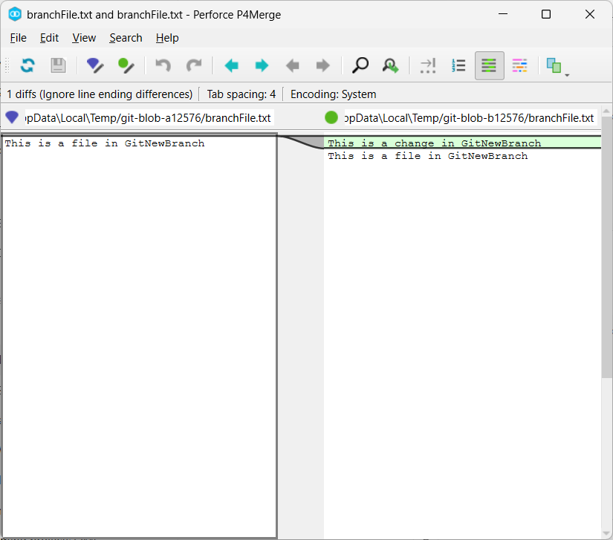

## **Git Conflict during Merge**

DELL@DESKTOP-5CVK56E MINGW64 ~/GitDemo (master)

$ git status

On branch master

nothing to commit, working tree clean

DELL@DESKTOP-5CVK56E MINGW64 ~/GitDemo (master)

$ git checkout -b GitWork

Switched to a new branch 'GitWork'

DELL@DESKTOP-5CVK56E MINGW64 ~/GitDemo (GitWork)

$ echo "<message>Hello from GitWork branch</message>" > hello.xml

DELL@DESKTOP-5CVK56E MINGW64 ~/GitDemo (GitWork)

$ git status

On branch GitWork

Untracked files:

(use "git add <file>..." to include in what will be committed)

hello.xml

nothing added to commit but untracked files present (use "git add" to track)

DELL@DESKTOP-5CVK56E MINGW64 ~/GitDemo (GitWork)

$ git add hello.xml

git commit -m "Added hello.xml in GitWork branch"

warning: in the working copy of 'hello.xml', LF will be replaced by CRLF the next time Git touches it

[GitWork 7dc270b] Added hello.xml in GitWork branch

1 file changed, 1 insertion(+)

create mode 100644 hello.xml

DELL@DESKTOP-5CVK56E MINGW64 ~/GitDemo (GitWork)

$ git checkout master

Switched to branch 'master'

DELL@DESKTOP-5CVK56E MINGW64 ~/GitDemo (master)

$ echo "<message>Hello from master branch</message>" > hello.xml

git add hello.xml

git commit -m "Added hello.xml in master branch"

warning: in the working copy of 'hello.xml', LF will be replaced by CRLF the next time Git touches it

[master e921b3e] Added hello.xml in master branch

1 file changed, 1 insertion(+)

create mode 100644 hello.xml

DELL@DESKTOP-5CVK56E MINGW64 ~/GitDemo (master)

$ git log --oneline --graph --decorate --all

* e921b3e (**HEAD** -> **master**) Added hello.xml in master branch

| * 7dc270b (**GitWork**) Added hello.xml in GitWork branch

|/

* f377e6c Updated readme in GitNewBranch

* 954d0fd Added branchFile.txt

* 09ad2cb Added .gitignore

* 5019c13 (**origin/master**) commited

DELL@DESKTOP-5CVK56E MINGW64 ~/GitDemo (master)

$ git diff master GitWork

**diff --git a/hello.xml b/hello.xml**

**index 82868a7..0bf4c19 100644**

**--- a/hello.xml**

**+++ b/hello.xml**

@@ -1 +1 @@

-<message>Hello from master branch</message>

+<message>Hello from GitWork branch</message>

DELL@DESKTOP-5CVK56E MINGW64 ~/GitDemo (master)

$ git difftool master GitWork

Viewing (1/1): 'hello.xml'

Launch 'p4merge' [Y/n]? Y

DELL@DESKTOP-5CVK56E MINGW64 ~/GitDemo (master)

$ git merge GitWork

Auto-merging hello.xml

CONFLICT (add/add): Merge conflict in hello.xml

Automatic merge failed; fix conflicts and then commit the result.

DELL@DESKTOP-5CVK56E MINGW64 ~/GitDemo (master|MERGING)

$ notepad hello.xml

DELL@DESKTOP-5CVK56E MINGW64 ~/GitDemo (master|MERGING)

$ git mergetool

Merging:

hello.xml

Normal merge conflict for 'hello.xml':

{local}: created file

{remote}: created file

DELL@DESKTOP-5CVK56E MINGW64 ~/GitDemo (master|MERGING)

$ git add hello.xml

DELL@DESKTOP-5CVK56E MINGW64 ~/GitDemo (master|MERGING)

$ git commit -m "Resolved merge conflict"

[master ff769a0] Resolved merge conflict

DELL@DESKTOP-5CVK56E MINGW64 ~/GitDemo (master)

$ echo "*.orig" >> .gitignore

echo "*.bak" >> .gitignore

git add .gitignore

git commit -m "Ignore merge backup files"

warning: in the working copy of '.gitignore', LF will be replaced by CRLF the next time Git touches it

[master 4f32fba] Ignore merge backup files

1 file changed, 2 insertions(+)

DELL@DESKTOP-5CVK56E MINGW64 ~/GitDemo (master)

$ git branch

GitWork

* master

DELL@DESKTOP-5CVK56E MINGW64 ~/GitDemo (master)

$ git branch -d GitWork

Deleted branch GitWork (was 7dc270b).

DELL@DESKTOP-5CVK56E MINGW64 ~/GitDemo (master)

$ git log --oneline --graph --decorate

* 4f32fba (**HEAD** -> **master**) Ignore merge backup files

* ff769a0 Resolved merge conflict

|\

| * 7dc270b Added hello.xml in GitWork branch

* | e921b3e Added hello.xml in master branch

|/

* f377e6c Updated readme in GitNewBranch

* 954d0fd Added branchFile.txt

* 09ad2cb Added .gitignore

* 5019c13 (**origin/master**) commited

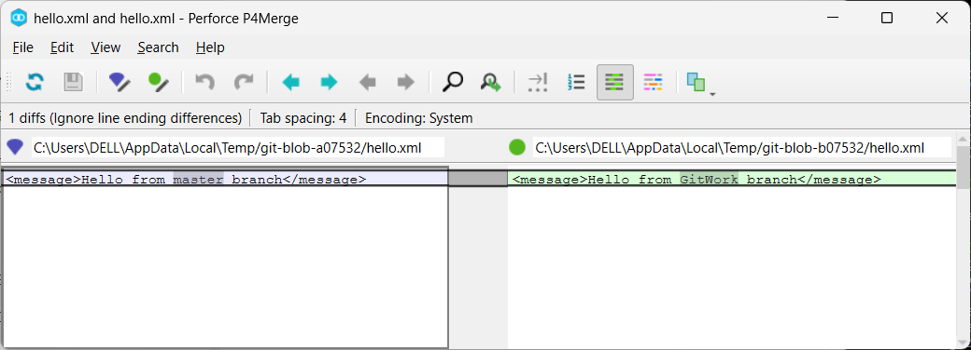

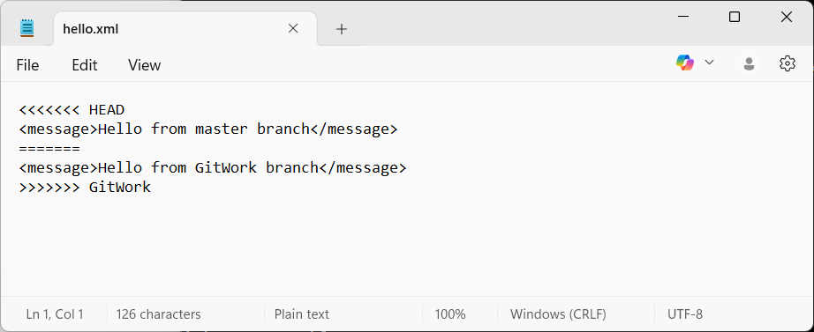

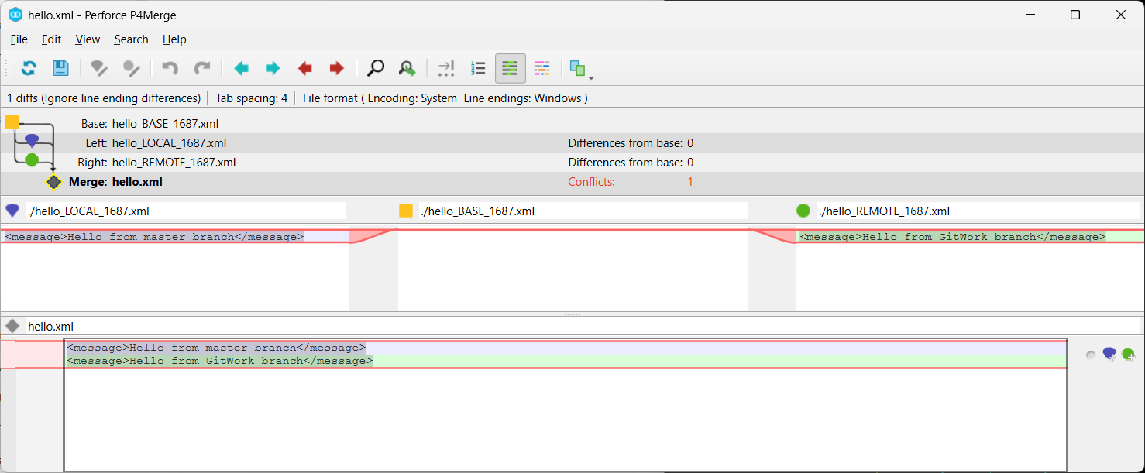

## **Clean up and Push back into remote git**

DELL@DESKTOP-5CVK56E MINGW64 ~/GitDemo (master)

$ git branch

* master

DELL@DESKTOP-5CVK56E MINGW64 ~/GitDemo (master)

$ git branch -r

origin/master

DELL@DESKTOP-5CVK56E MINGW64 ~/GitDemo (master)

$ git checkout master

Already on 'master'

DELL@DESKTOP-5CVK56E MINGW64 ~/GitDemo (master)

$ git pull origin master

From https://github.com/janapriya-s/GitDemo

* branch master -> FETCH_HEAD

Already up to date.

DELL@DESKTOP-5CVK56E MINGW64 ~/GitDemo (master)

$ git add .

DELL@DESKTOP-5CVK56E MINGW64 ~/GitDemo (master)

$ git commit -m "Completed Git-T03-HOL_002 changes"

On branch master

nothing to commit, working tree clean

DELL@DESKTOP-5CVK56E MINGW64 ~/GitDemo (master)

$ git push origin master

Enumerating objects: 22, done.

Counting objects: 100% (22/22), done.

Delta compression using up to 4 threads

Compressing objects: 100% (16/16), done.

Writing objects: 100% (21/21), 1.92 KiB | 394.00 KiB/s, done.

Total 21 (delta 5), reused 0 (delta 0), pack-reused 0 (from 0)

remote: Resolving deltas: 100% (5/5), done.

To https://github.com/janapriya-s/GitDemo.git

5019c13..4f32fba master -> master

DELL@DESKTOP-5CVK56E MINGW64 ~/GitDemo (master)

$ git log --oneline --graph --decorate

* 4f32fba (**HEAD** -> **master**, **origin/master**) Ignore merge backup files

* ff769a0 Resolved merge conflict

|\

| * 7dc270b Added hello.xml in GitWork branch

* | e921b3e Added hello.xml in master branch

|/

* f377e6c Updated readme in GitNewBranch

* 954d0fd Added branchFile.txt

* 09ad2cb Added .gitignore

* 5019c13 commited

DELL@DESKTOP-5CVK56E MINGW64 ~/GitDemo (master)

$ git remote -v

origin https://github.com/janapriya-s/GitDemo.git (fetch)

origin https://github.com/janapriya-s/GitDemo.git (push)