EXPERIMENT 14

Challenge–Response Authentication System
(Password Never Transmitted)
JANARDHAN VEMA
Roll No.: 2024UCS1538

1. Aim
To develop a small website that authenticates a user without sending the raw password to the server. The application stores a password-derived verifier, issues a signed one-time challenge, verifies an HMAC response, rejects replay attempts, and returns a session token only after successful authentication.

2. Problem Statement
In a conventional login form, a password is submitted to the server (normally protected by HTTPS). This experiment demonstrates a different authentication flow: the browser derives a verifier locally and proves knowledge of it by answering a fresh server challenge. The raw password is not included in the registration or login API payload.

3. Theory
A challenge–response protocol uses a fresh random value (nonce) so a previously captured response cannot simply be reused. During registration, the browser generates a random salt and derives a 256-bit verifier using PBKDF2-HMAC-SHA256. During login, the server creates a random challenge and signs the challenge payload with RSA-PSS/SHA-256. The browser verifies the signature, derives the verifier from the entered password and stored salt, and computes HMAC-SHA256 over the challenge. The server checks the response and marks the challenge as consumed. A valid response results in a session token; an invalid, expired, unknown, or reused challenge is rejected.

4. Algorithms and Parameters
- PBKDF2-HMAC-SHA256: 200,000 iterations; 16-byte random salt; 256-bit verifier.
- HMAC-SHA256: response = HMAC(verifier, challenge); compared using a constant-time comparison.
- Challenge/nonce: 32 random bytes, expires after 60 seconds, and is single-use.
- RSA-PSS with SHA-256: server signs the canonical payload username + challenge + expiry; browser verifies using the server public key.
- Session token: 32 random bytes encoded as Base64URL and returned only after successful verification.

5. Website Flow
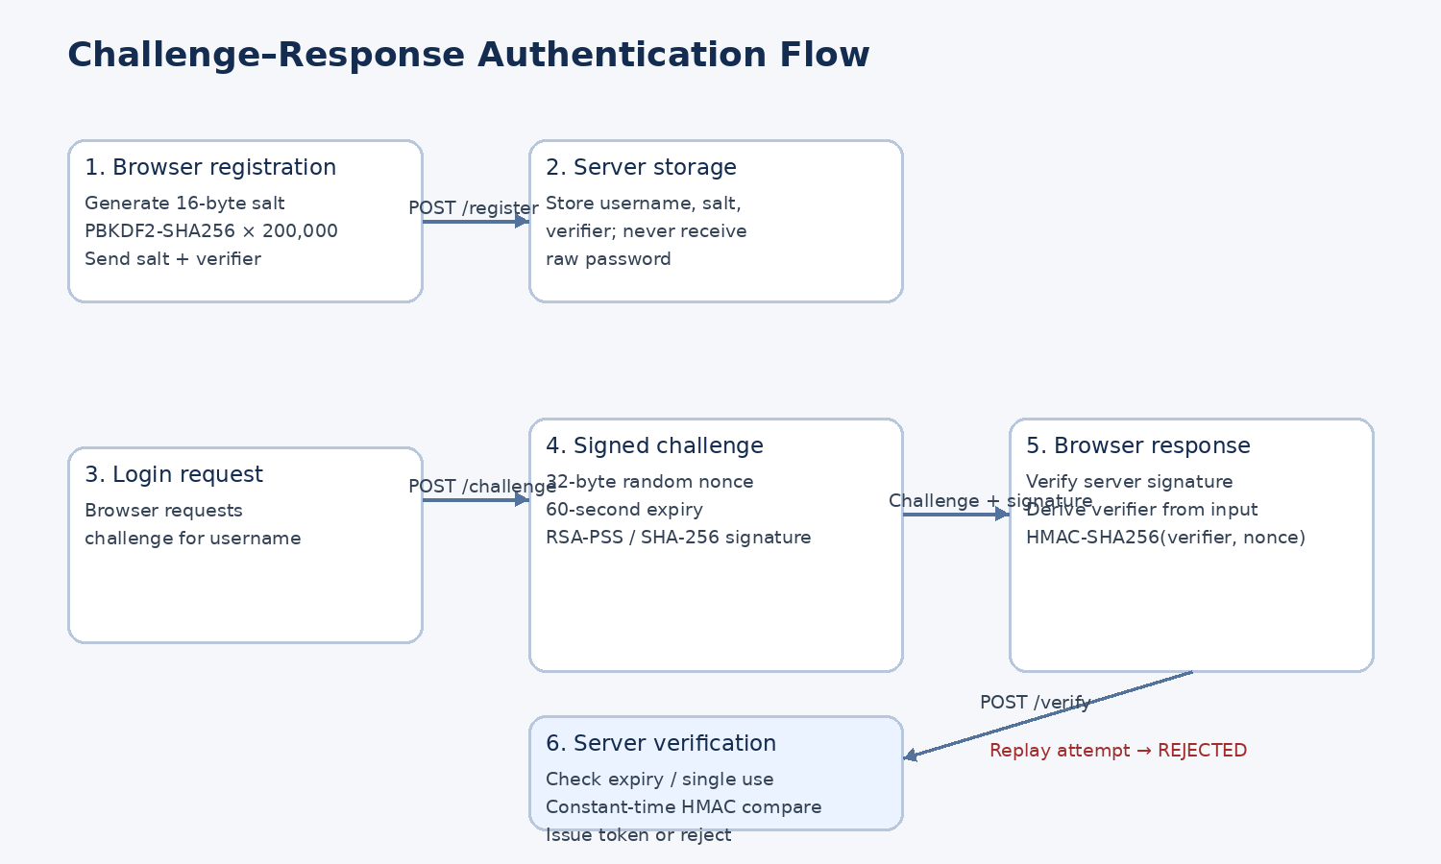
Figure 1. Registration and challenge–response login flow implemented by the JavaScript website.

6. Technology Stack
- Frontend: HTML5, CSS3 and JavaScript.
- Browser cryptography: Web Crypto API (PBKDF2, HMAC, RSA-PSS signature verification).
- Backend: Node.js and Express.js REST API.
- Server cryptography: Node.js crypto module (RSA key pair, RSA-PSS signature, HMAC-SHA256, secure random bytes, timing-safe comparison).
- Storage: JSON file for demonstration user records and JSON-lines audit log.
- Runtime: Node.js 18+ and npm; modern browser; localhost.

7. Website Interface
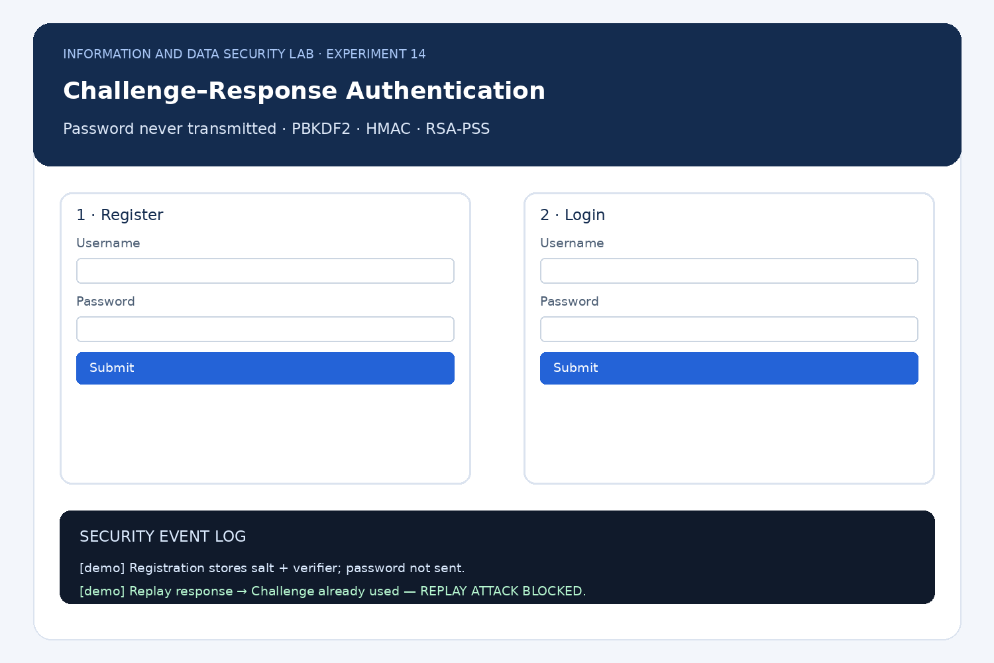
Figure 2. Illustrative interface layout for the registration, login, and security-event panels. This is a designed preview, not a screenshot from a live browser session.

8. Project File Structure
- server.js — Express server, REST endpoints, challenge store, signature creation, HMAC verification, replay checks and session-token creation.
- public/index.html — registration and login forms plus the event-log panel.
- public/style.css — responsive layout and form styling.
- public/app.js — browser PBKDF2/HMAC operations, signature verification, API calls and replay test.
- package.json — Node.js dependencies and start command.
- data/users.json — created at runtime; stores username, salt and verifier, not the raw password.
- data/audit.log — created at runtime; records registration, challenge issuance, success, failure and replay events.

9. API Endpoints
Method / Endpoint | Purpose | Expected result
GET /api/status | Check server status and TTL | online, 60 seconds
GET /api/public-key | Return RSA public key | Browser can verify server signature
POST /api/register | Store username, salt and verifier | 201 Registered; duplicate username rejected
POST /api/request-challenge | Issue signed challenge | Challenge, salt, expiry and signature returned
POST /api/verify | Check HMAC and consume nonce | Success + token or a clear rejection
GET /api/audit | Read recent demo events | Registration/login/replay events

10. How the Application Works
- Registration: the browser generates a 16-byte salt and derives a 256-bit PBKDF2 verifier from the password. It sends username, salt and verifier to POST /api/register. The password field is cleared after the request.
- Challenge request: after the user enters a username, the browser calls POST /api/request-challenge. The server creates a random challenge, challenge ID and expiry time, then signs a canonical payload with RSA-PSS.
- Server authentication: the browser fetches the public key and verifies the signature before using the challenge. If verification fails, login stops.
- Response creation: the browser derives the verifier from the entered password and returned salt, then computes HMAC-SHA256(verifier, challenge).
- Verification: the server looks up the challenge, rejects unknown or expired challenges, marks a valid challenge ID as consumed, and compares HMAC values in constant time.
- Success or failure: a correct response returns LOGIN SUCCESS and a random session token. A wrong password fails with HMAC mismatch. A reused challenge is rejected as a replay attempt.

11. Setup and Execution
- Install Node.js 18 or later from the official Node.js website.
- Extract the provided project ZIP and open a terminal in the extracted folder.
- Run: npm install
- Run: npm start
- Open http://localhost:3000 in a modern browser.
- Register a username and password (at least 8 characters).
- Log in with the same credentials and observe LOGIN SUCCESS.
- Click Replay last response. The server should respond: Challenge already used — REPLAY ATTACK BLOCKED.
- Try an incorrect password; the response should be LOGIN FAILED (HMAC mismatch).
- Click Refresh log to inspect recorded events.

12. Expected Output / Test Cases
Test | Expected UI/API result | Security property
Register new user | User registered; verifier stored | Raw password not sent
Correct password | LOGIN SUCCESS and session token | HMAC matches
Incorrect password | LOGIN FAILED (HMAC mismatch) | Authentication denied
Replay last response | Challenge already used — REPLAY ATTACK BLOCKED | Single-use nonce
Expired challenge | Challenge expired; request a new one | 60-second TTL
Unknown username | Unknown username. Register first. | Unknown accounts rejected
Note: challenge values, RSA signatures, session tokens and timestamps are random or time-dependent, so their exact values vary on each run.

13. Security Considerations and Limitations
- This is a classroom prototype, not a production authentication service.
- The server generates a new RSA key pair each time it starts; production needs safely persisted and managed keys.
- Challenges and session tokens are held in memory, so restart clears them; a production service needs persistent, atomic single-use challenge storage.
- JSON storage is used for simplicity. File permissions alone do not replace a database with access controls and backups.
- HTTPS is not configured; use this project on localhost only.
- The stored PBKDF2 verifier is sensitive. In this simplified design, theft of the verifier could allow impersonation. A production design should use a carefully reviewed protocol (for example, a suitable PAKE) and professional security review.
- Add rate limiting, lockout policy, secure session-cookie handling, CSRF protections where applicable, and operational logging before any real deployment.

14. Result and Conclusion
A JavaScript-based website has been designed to demonstrate password-derived verifier storage, signed server challenges, HMAC challenge–response authentication, single-use challenge enforcement, replay rejection, and session-token issuance. The frontend uses the browser Web Crypto API, while Node.js and Express provide the API and server-side cryptographic checks. The raw password is not sent to the server. The limitations above must be addressed before adapting the prototype for real users.

15. Source Code
The accompanying project ZIP contains the complete runnable source files. The main files are server.js, public/index.html, public/style.css and public/app.js. Keeping the implementation in separate files makes the report readable and the website easier to run and modify.

