Git local repository creation

First create the folder and add the git into it by using the command **git inti**

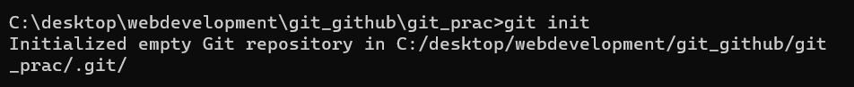

**git status** command is used to see the status of the repository or a particular file  
  
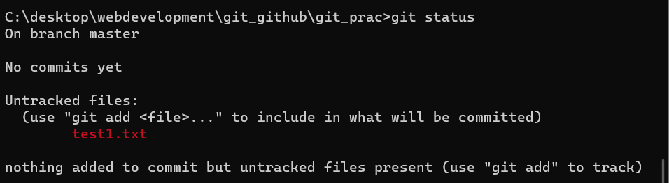

Next we need to add all the files in the working directory to the staging directory to keep track of their changes by git

We can do that by using **git add <filename>**



We can use the command <**git add .** >to add all the file in the working directiory into staging directory.

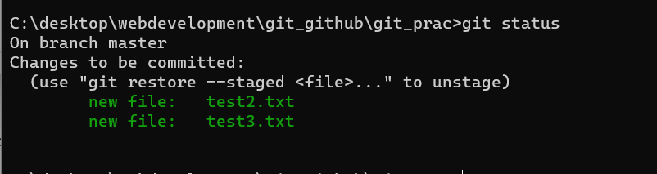

Now the all the files are added into the staging directory

**git status**  after adding it into the staging directory

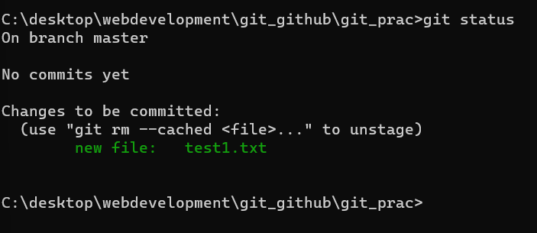

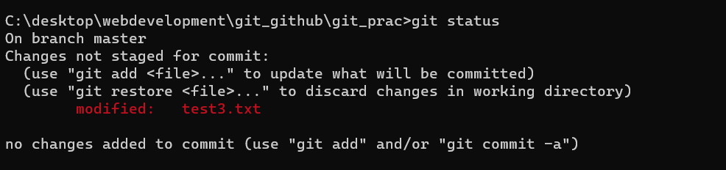

**Git status** showing the uncommited file

Now we have to commit the changes to make a save point at that situation/stage .For this we need to use cmd **git commit -m “Message ” (* as a best practice keep message in present tense *)**

**Eg git commit -m “First text commit”**



Now a check point will be formed at this point of time , in layman it will be version 1.

We can use  **git log**  command to see the commits we made

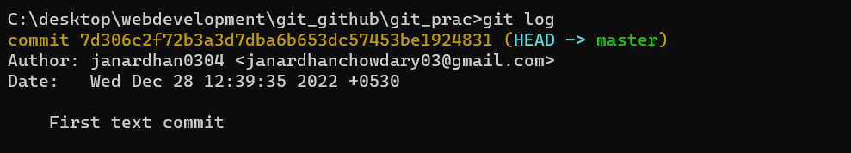

We will be shown the hash and the HEAD in the working version details and also the commit message

**git diff**  to check the changes in the repo

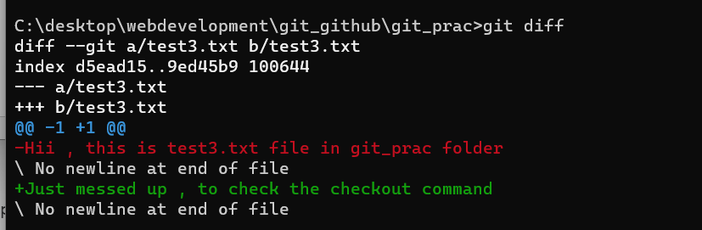

**git checkout <filename>**  is the command used to go back to the last version of our code.

Briefly here I have first commited the file test3.txt and then by mistake I have erased the text in it and entered some wrng data which I don’t need, so now I need to go back to the previous version.

I can do this by using checkpoint command



Now let us make the repository in our github that is to move local repository to github