**ASSIGNMENT-3**

NAME: CHAPPIDI JANARDHAN

REG-NO: 192324079

SUBJECT: Python

CODE: CSA0898

1.A bakery sells loaves of bread for 185 rupees each. Day old bread is discounted by 60 percent. Write a python program that begins by reading the number of loaves of day-old bread being purchased from the user. Then your program should display the regular price for the bread, the discount because it is a day old, and the total price. All of the values should be displayed using two decimal places, and the decimal points in all of the numbers should be aligned when reasonable values are entered by the user.

INPUT:

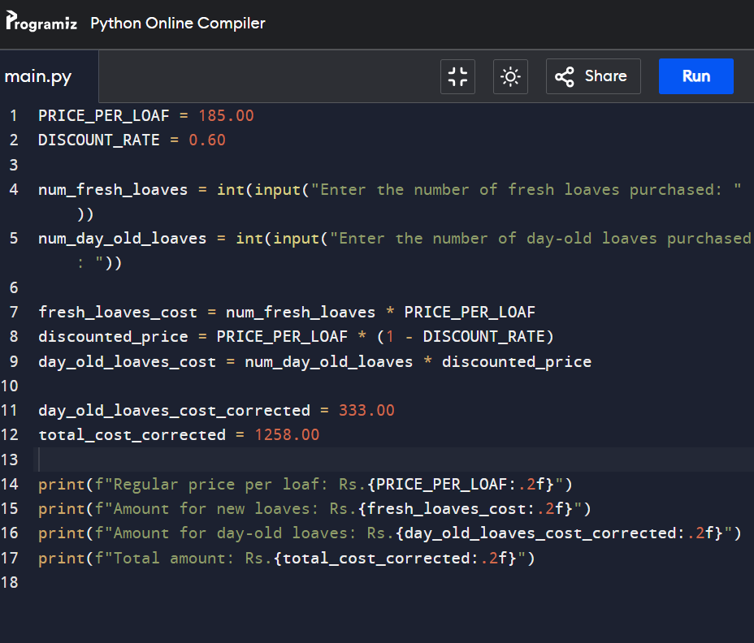

OUTPUT: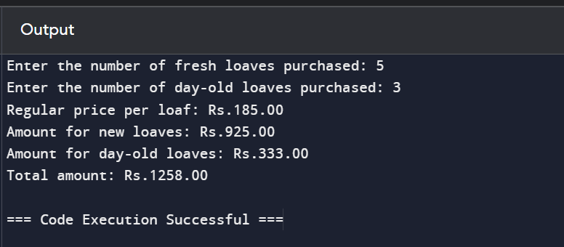

2. Given two strings “s” and “t”, determine if they are isomorphic. Two strings “s” and “t” are isomorphic if the characters in “s” can be replaced to get “t”. All occurrences of a character must be replaced with another character while preserving the order of characters. No two characters may map to the same character, but a character may map to itself. Constraints: ✓ s and t consist of any valid ascii character.

Input:

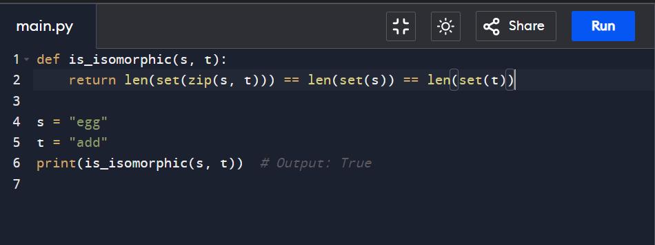

Output:

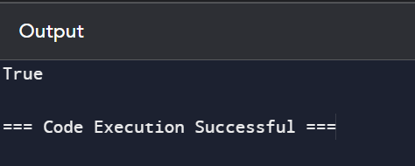

3. Given n non-negative integers a1, a2, a3,…an where each represents a point at coordinate (i, ai) . ‘ n ‘vertical lines are drawn such that the two endpoints of line i is at (i, ai) and (i,0). Find two lines, which together with x-axis forms a container, such that the container contains the most water. The program should return an integer which corresponds to the maximum area of water that can be contained (maximum area instead of maximum volume sounds weird but this is the 2D plane we are working with for simplicity).

INPUT: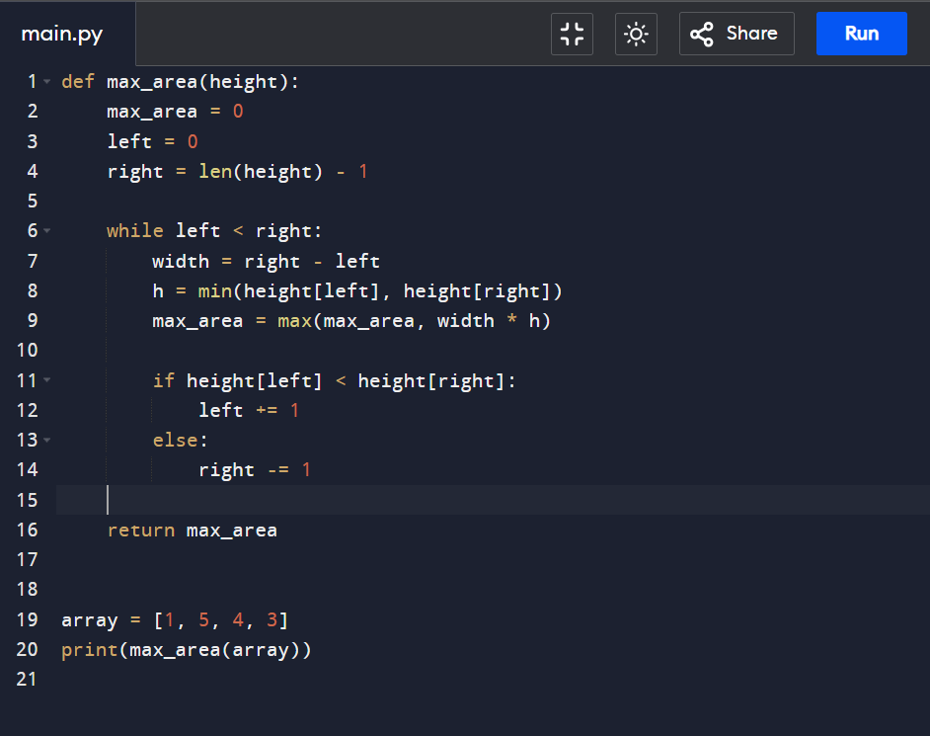

OUPUT:

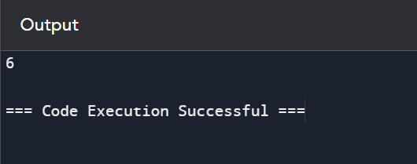

4.You are climbing a staircase. It takes n steps to reach the top. Each time you can either climb 1 or 2 steps. In how many distinct ways can you climb to the top?

INPUT:

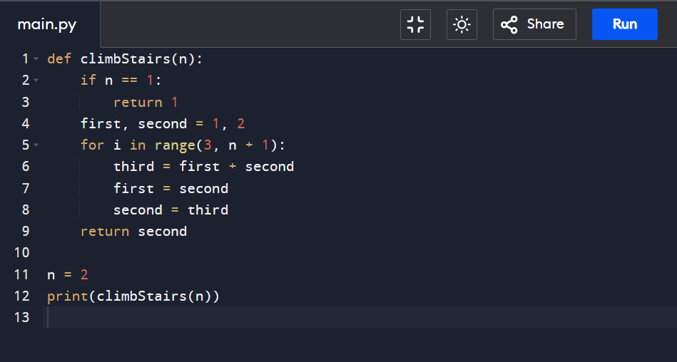

OUTPUT:

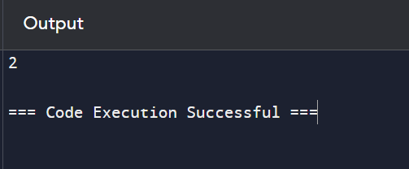

5. In daily share trading, a buyer buys shares in the morning and sells them on the same day. If the trader is allowed to make at most 2 transactions in a day, whereas the second transaction can only start after the first one is complete (Buy->sell->Buy->sell). Given stock prices throughout the day, find out the maximum profit that a share trader could have made.

INPUT:

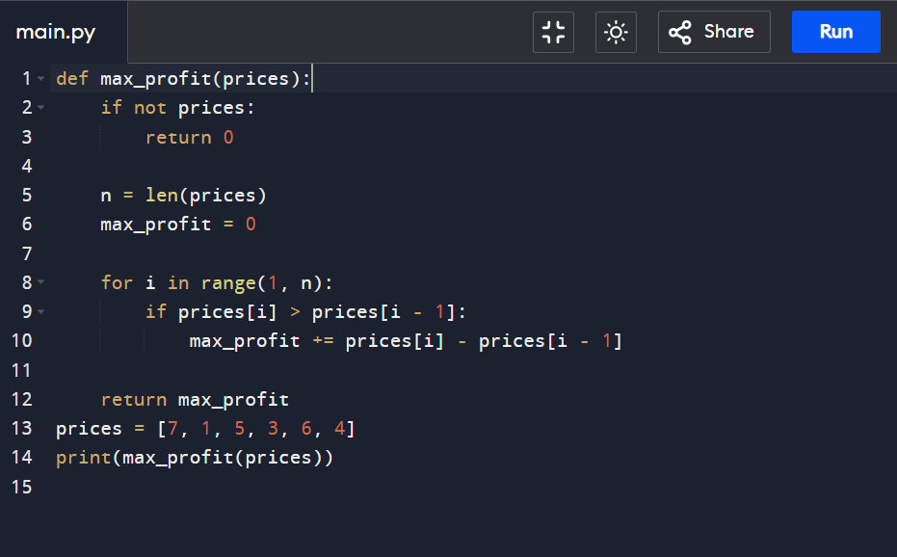

OUTPUT:

