Duck Warehouse
Architecture, Process Flows and Sequence Diagrams
Current implementation | 15 October 2026 | Warehouse UI + backend; store API only
This document describes the inspected code in the project folder. It separates the React client, Spring Boot modules, transaction boundary and MySQL data store. The diagrams describe current behavior; proposed improvements are listed on the final page.
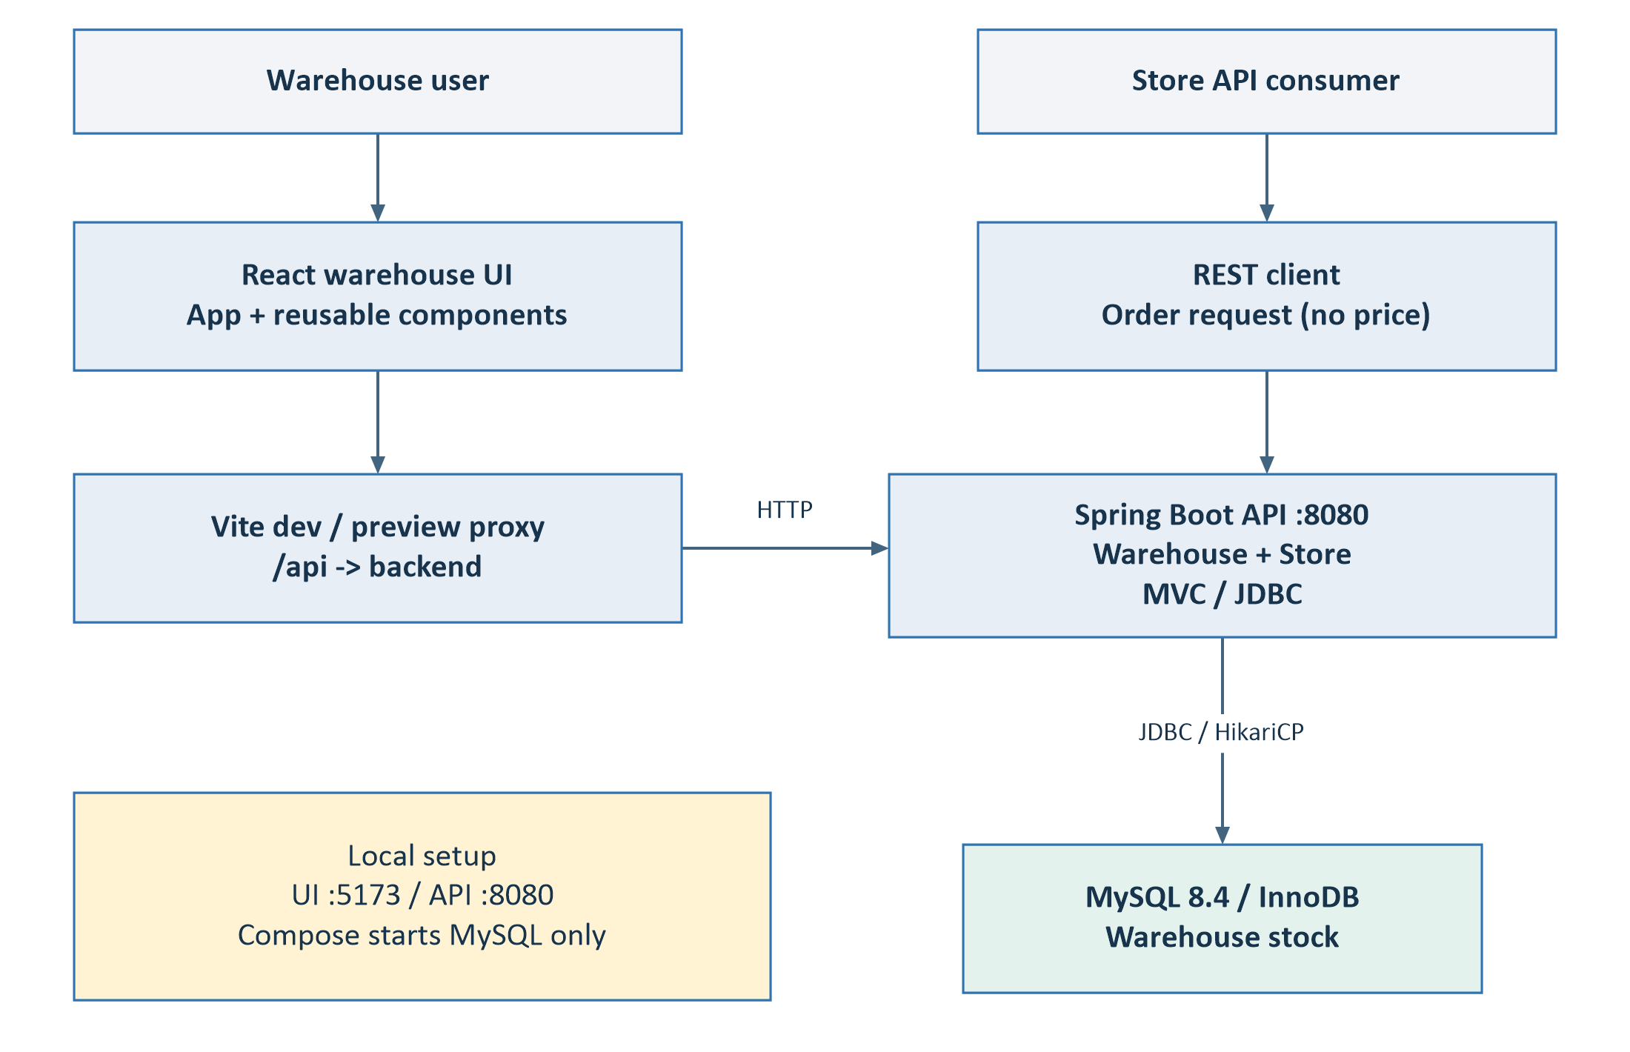
Figure 1. Local development context. Vite uses :5173 for development and :4173 for preview. Its proxy forwards /api to the backend; production static hosting requires its own API forwarding.
- Warehouse: create, list, edit and logically delete ducks through the UI.
- Store: one REST endpoint calculates packaging, protections, price and itemized adjustments. It does not persist orders or consume inventory.
Reading order: components and data (p2); warehouse flow and sequences (p3-7); store flow and sequence (p8-9); patterns (p10); decisions and source map (p11).

1. Backend components and data
Controllers adapt HTTP requests. Services coordinate operations; DuckRepository owns SQL. StoreService reuses warehouse data and delegates packaging and pricing to focused components.
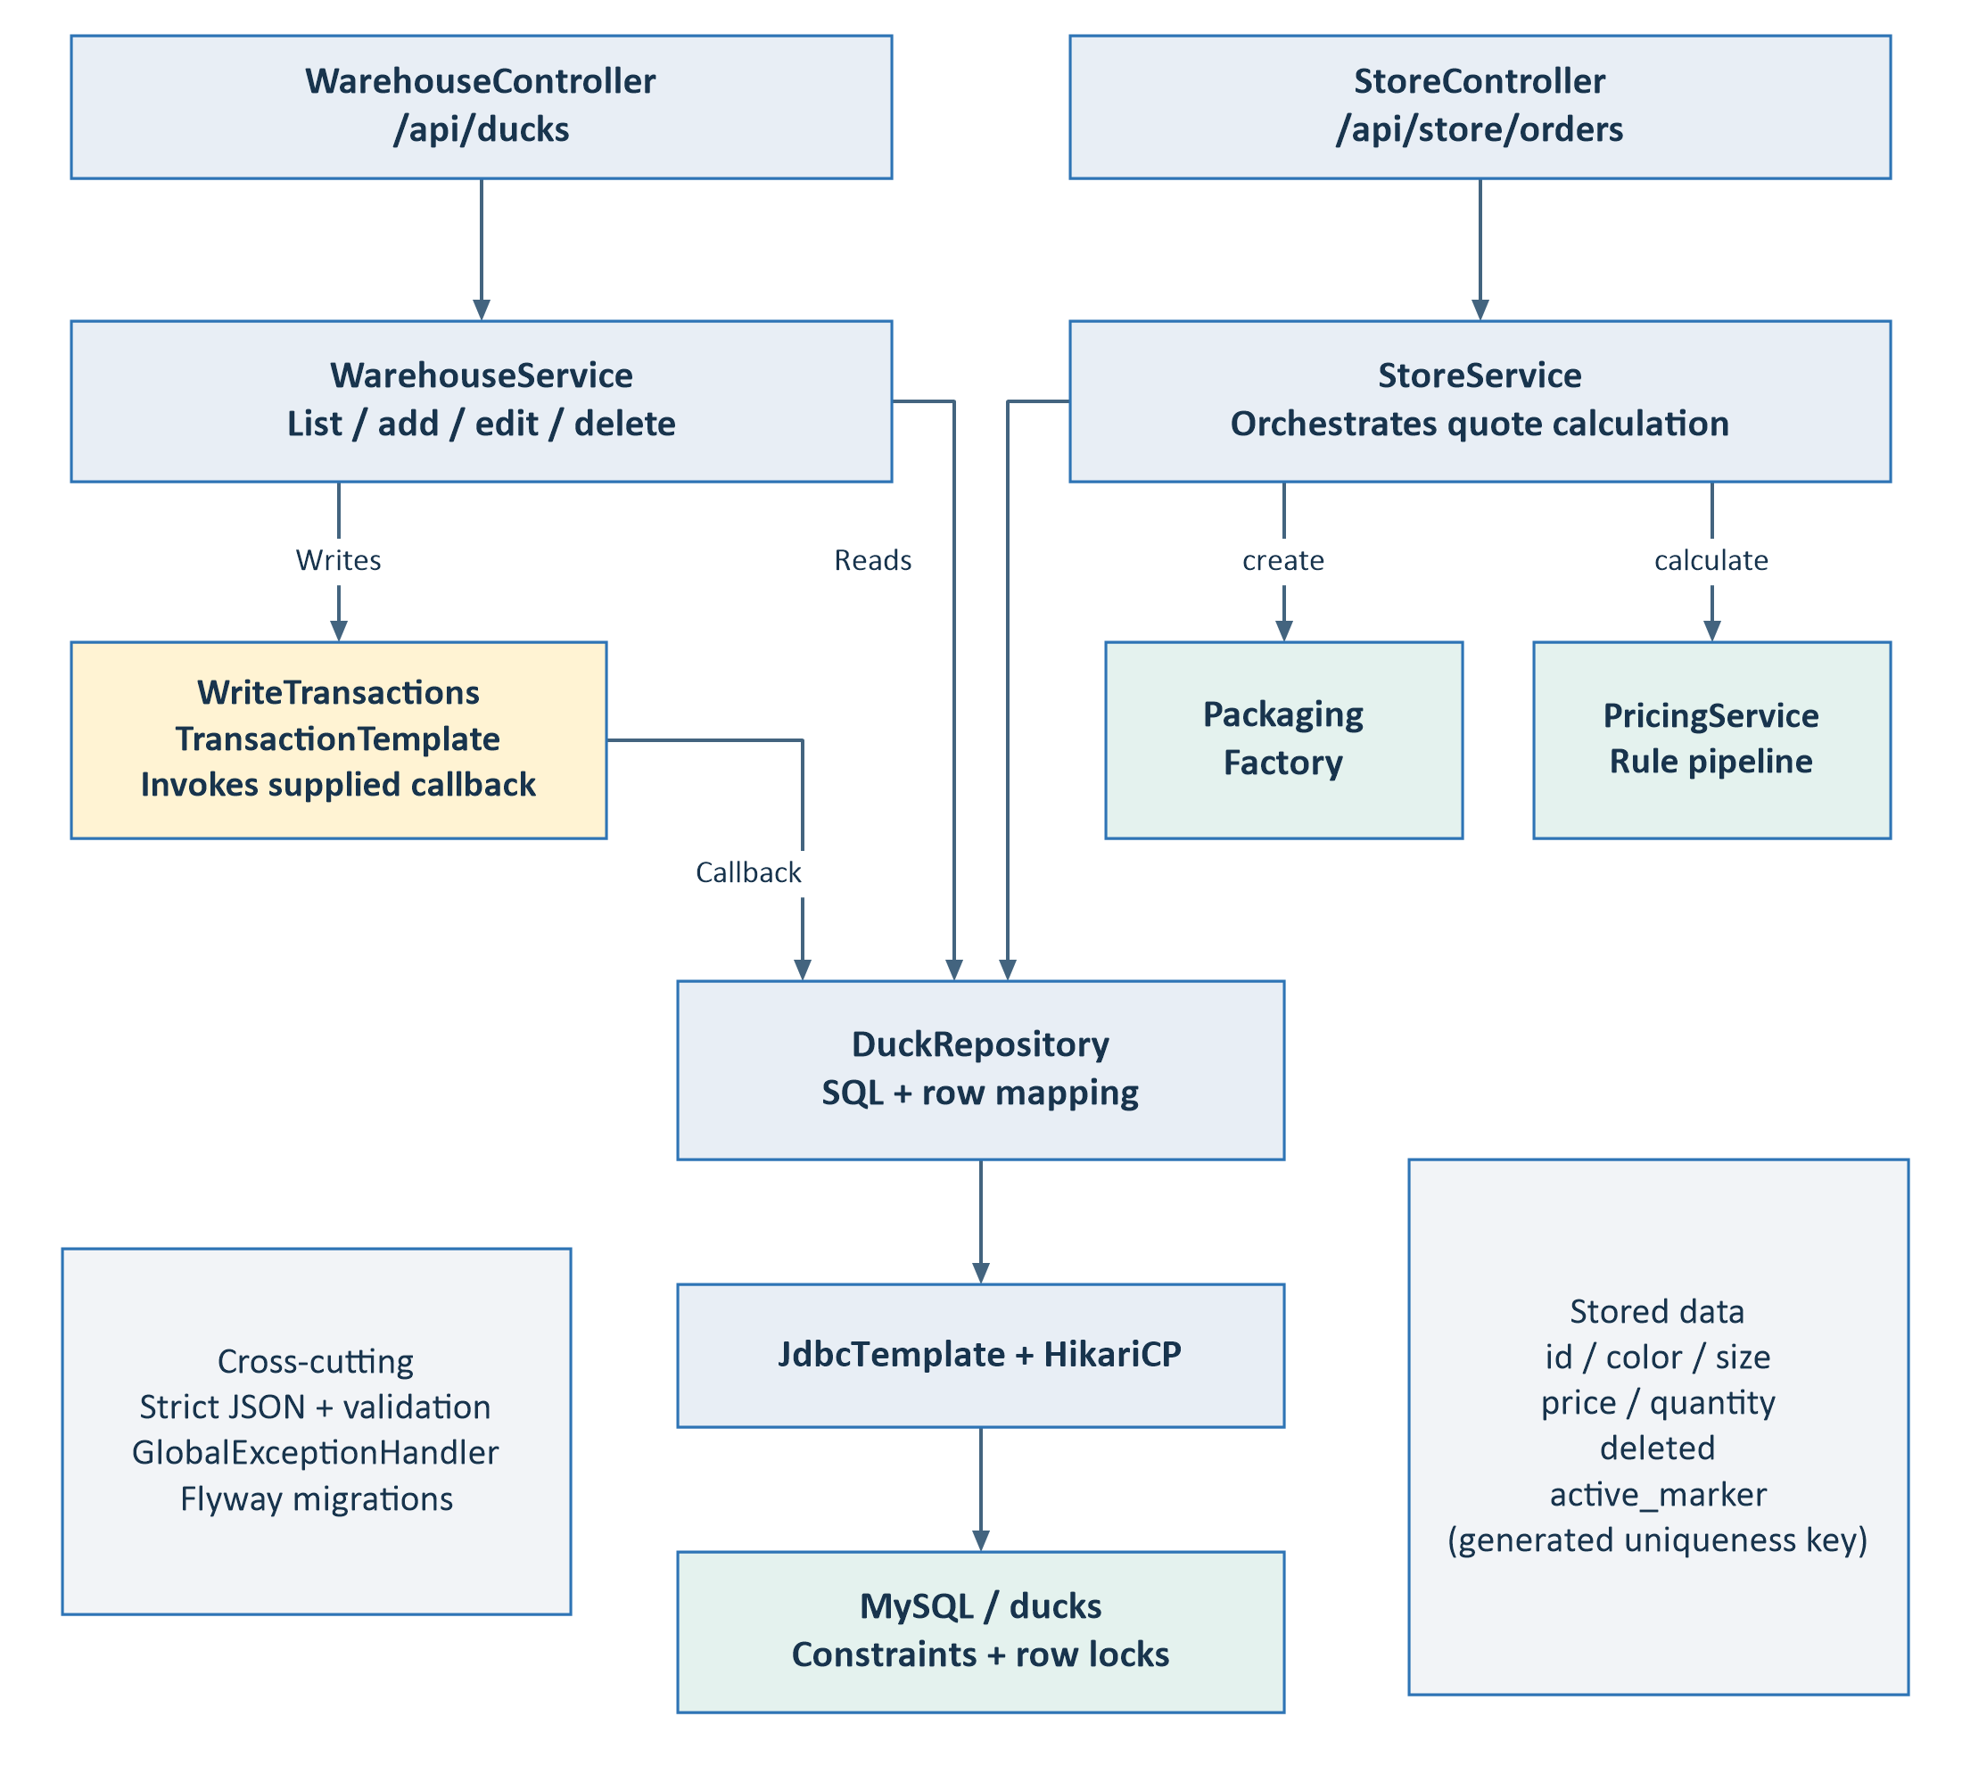
Figure 2. Dependencies in the current code. The transaction helper invokes a Supplier callback created by WarehouseService; business repository calls remain in that callback. Strict JSON, validation, exception mapping and migrations support both modules.
- The database stores id, color, size, price, quantity and deleted. A generated active_marker supports uniqueness for active variants while retaining deleted history.
Source: warehouse/ and store/ Java packages; config/JsonConfiguration.java; resources/db/migration/V1__create_ducks.sql. Canonical source roots are on p11.

2. Warehouse process flow
The listing is authoritative. Add and edit reuse DuckForm; deletion uses DeleteConfirmation. Every successful mutation is followed by a separate list refresh.
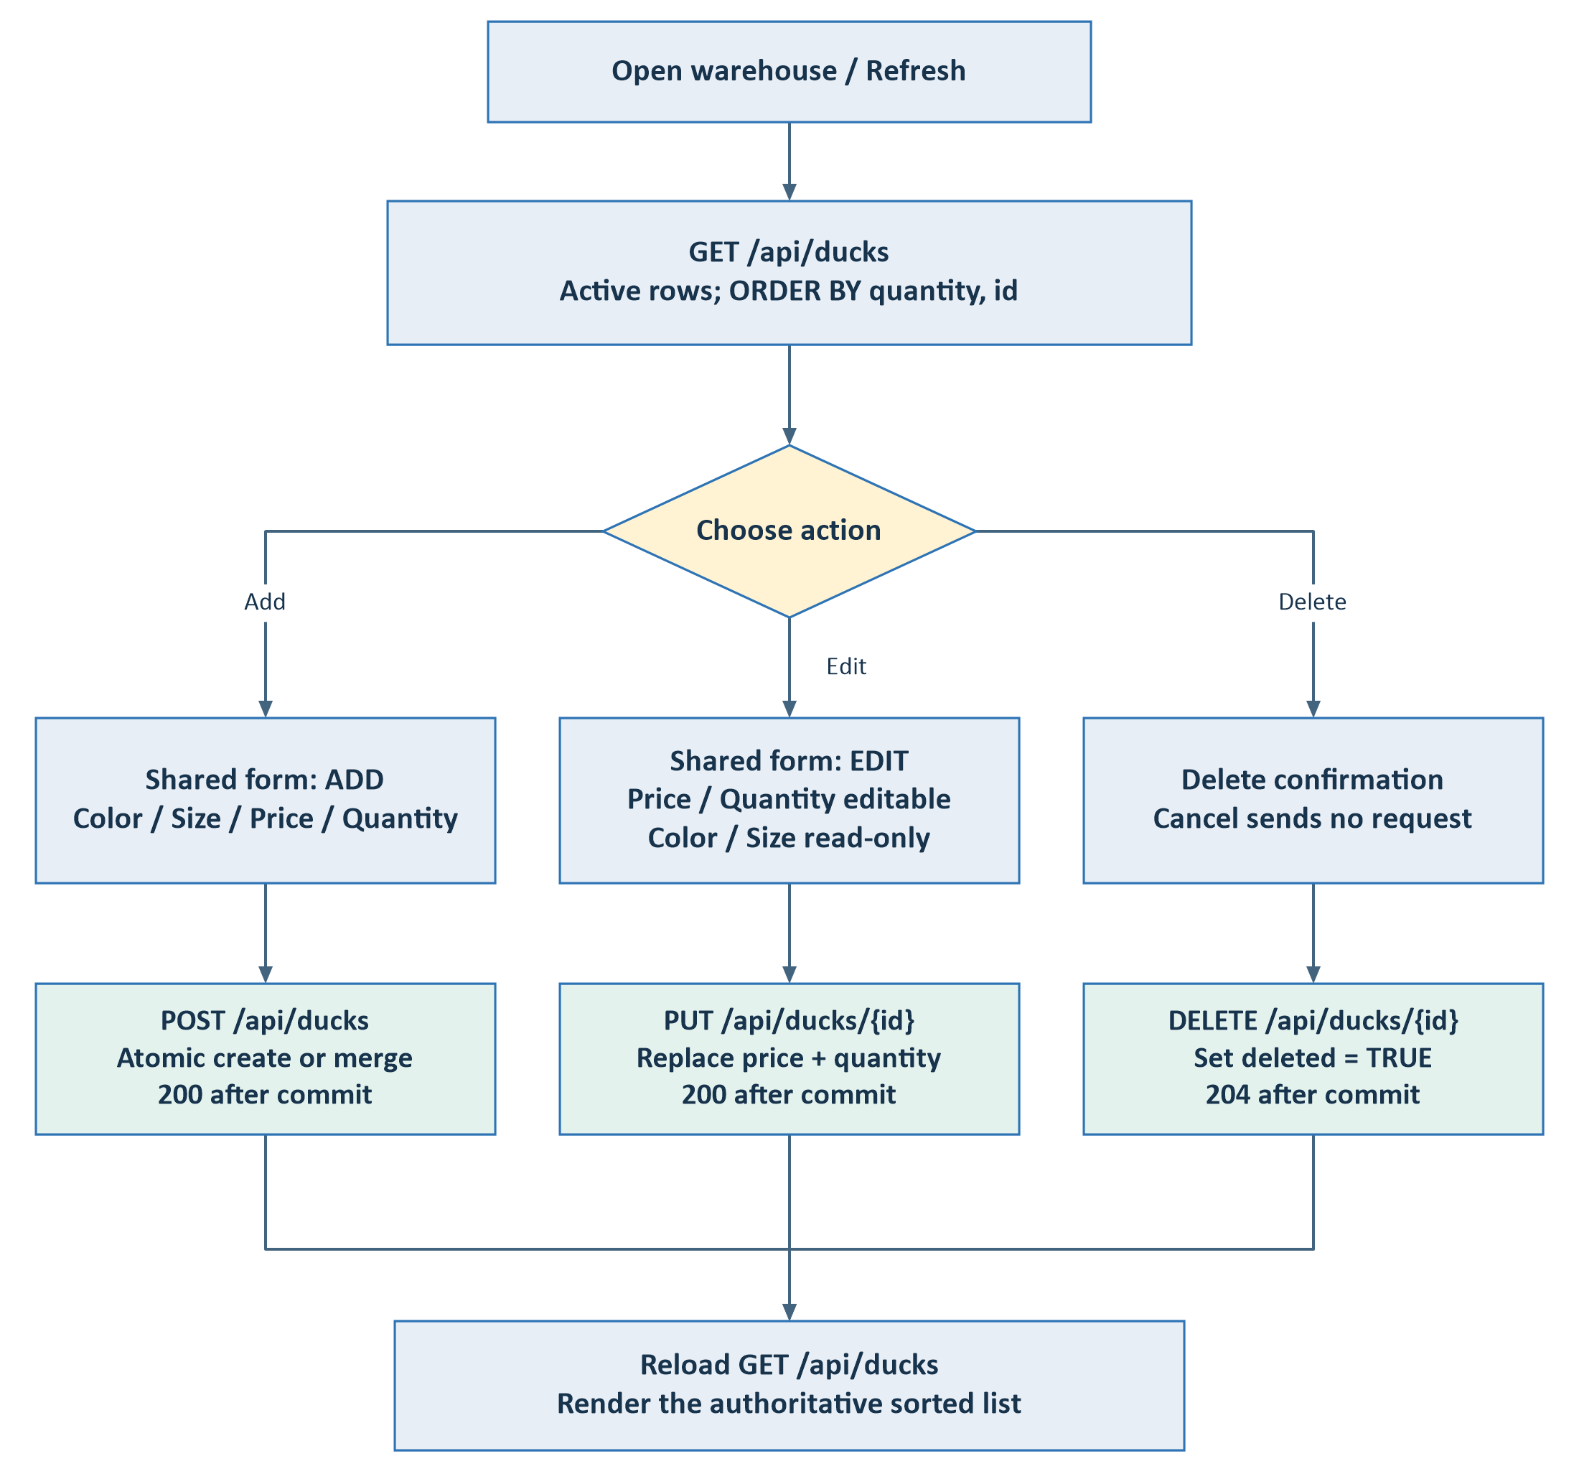
Figure 3. UI-to-API workflow. Edit opens the selected list row; the current UI does not fetch GET /api/ducks/{id} when opening its edit dialog. That endpoint is available in the backend.
Cancellation closes the dialog without a write. Client validation catches invalid form values; backend validation remains authoritative. A failed refresh retains the previous rows, marks them stale and disables mutation controls.
Source: App.jsx; components/DuckForm.jsx; components/DeleteConfirmation.jsx; hooks/useWarehouse.js; api/ducks.js.

3. Sequence: list and refresh
Initial loading, manual refresh and post-mutation refresh share this read path. There is no explicit WriteTransactions wrapper for listing.
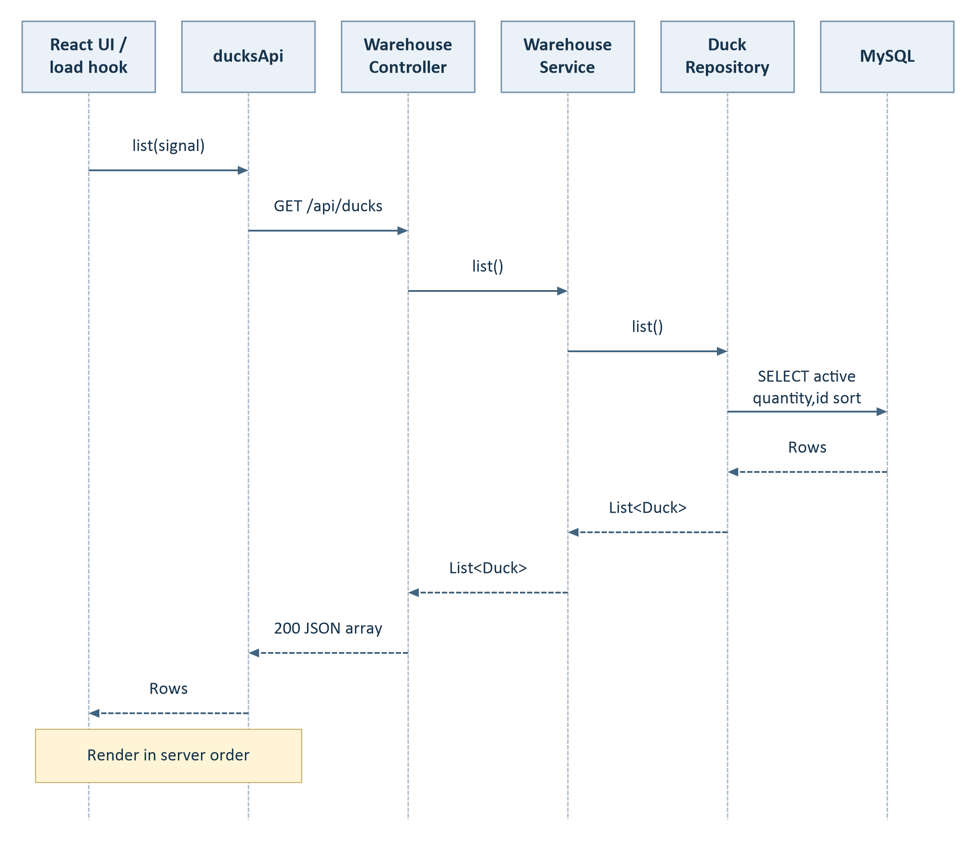
Figure 4. Solid arrows are calls; dashed arrows are returns. Lifelines represent logical participants. Validation and JSON serialization are framework behavior around the controller.
- SQL filters deleted=FALSE and orders by quantity ascending, then id.
- useWarehouse aborts a superseded list request and preserves the server's ordering.
Source: useWarehouse.js:11; ducks.js:36; WarehouseController.java:16; DuckRepository.java:21.

4. Sequence: add or merge stock
Creation and merging both return HTTP 200 after a successful commit.
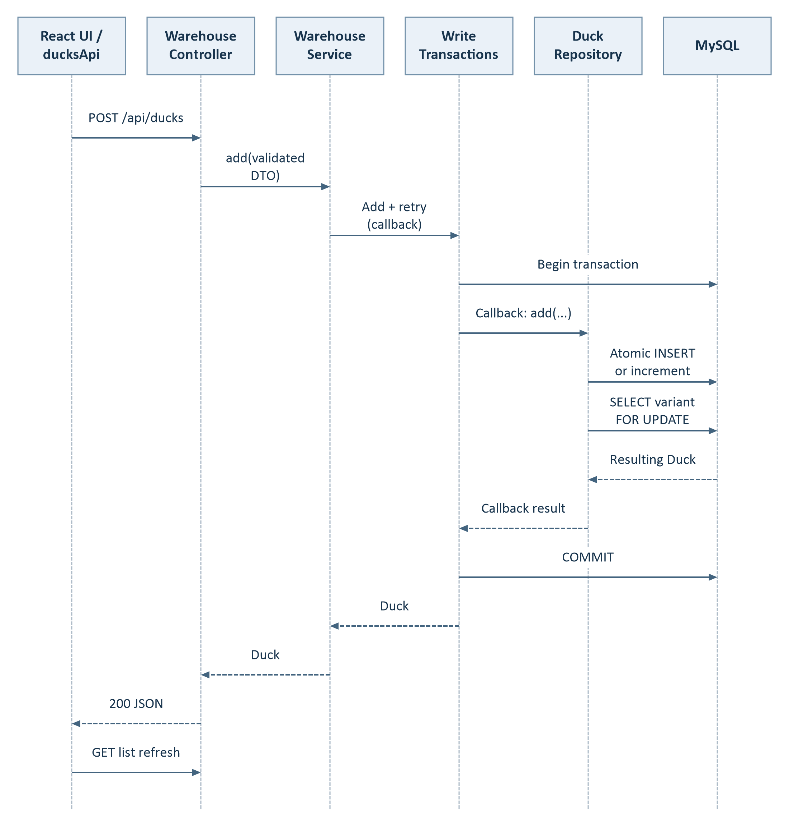
Figure 5. Begin/commit arrows represent Spring's transaction manager and JDBC, not SQL directly issued by WriteTransactions. Its callback contains the WarehouseService repository operation.
The helper retries only MySQL deadlock 1213, at most three fresh attempts. Unknown connection/commit outcomes are not automatically retried. Source: WarehouseService.java:20; WriteTransactions.java:18; DuckRepository.java:28.

5. Sequence: simultaneous matching adds
Illustration: an existing active row has id=42 and quantity=0. Request A adds 2 units and request B adds 3. This ordering shows A winning the row lock first.
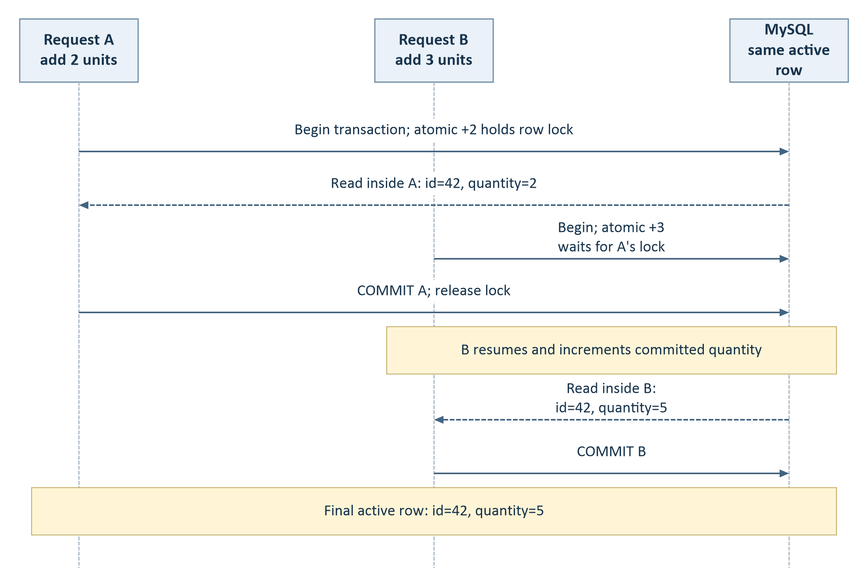
Figure 6. Final quantity is 5 if both transactions commit and no other write intervenes. Individual responses reflect each transaction's result; they do not both have to return 5. Either request may win first.
- The unique key is (color, size, price, active_marker). Active rows have marker 1; deleted history has NULL.
- When no active row exists, uniqueness plus the atomic upsert prevents duplicate active variants. The code does not perform a separate check-then-insert.
This illustrates the concurrency mechanism; it is not a load-test result. Source: V1__create_ducks.sql:8; DuckRepository.java:28; WarehouseIT.java:39.

6. Sequence: edit and logical delete
The two mutations share a transaction shape. The alt frame selects one update; it does not execute both.
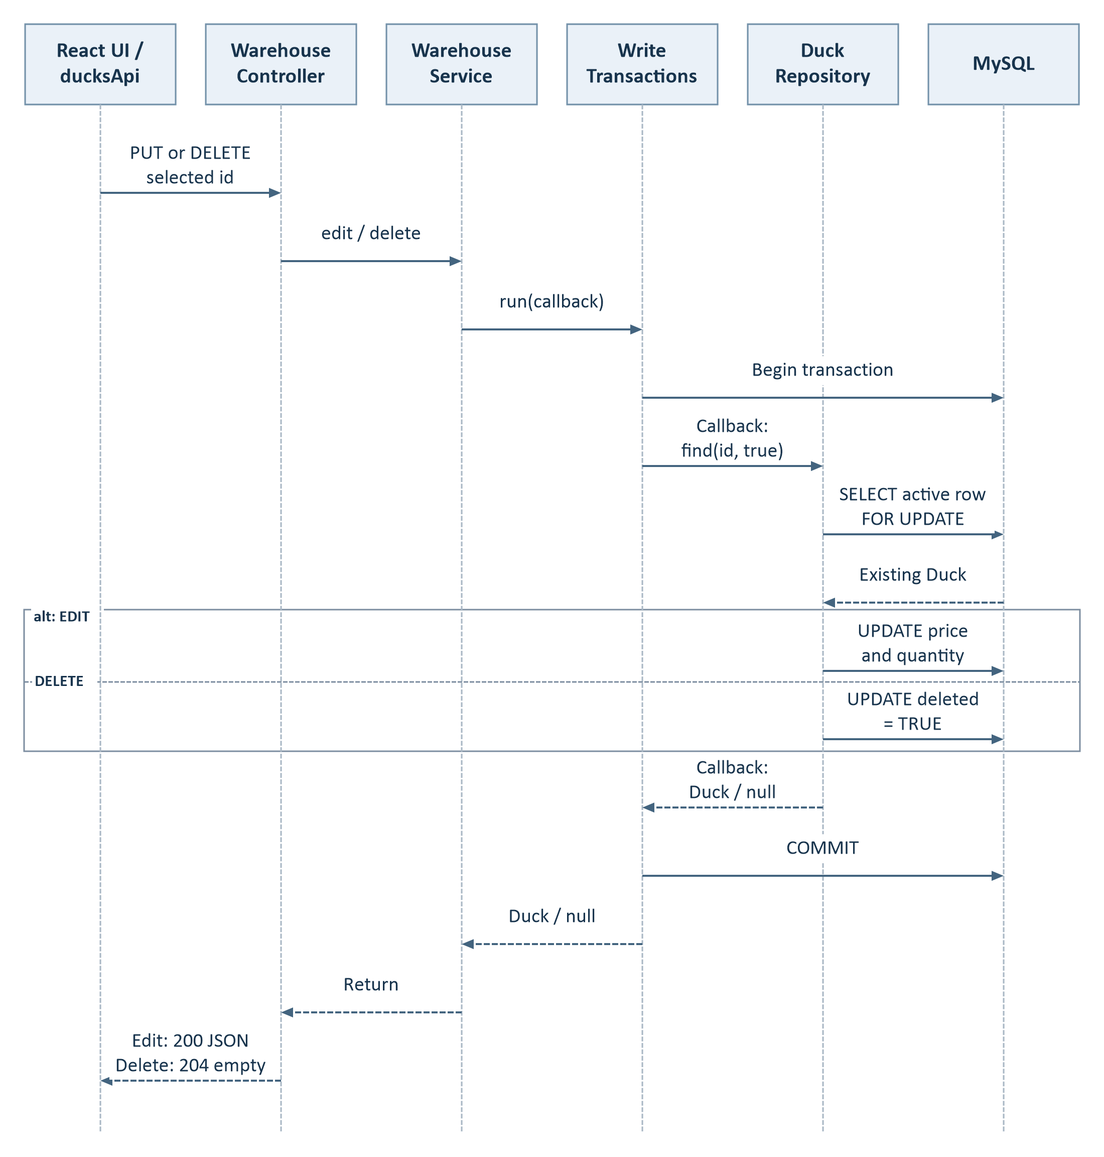
Figure 7. Edit builds the response from the existing color/size and submitted price/quantity; it performs no post-update SELECT. Delete returns 204 with an empty body. The UI reloads the list after either success.
Missing/deleted IDs return 404; an edit variant collision returns 409 with rollback. Out-of-range edit inputs return 400; add/merge quantity overflow returns 409. Delete requires UI confirmation; cancel sends no HTTP request. Source: WarehouseService.java:24; DuckRepository.java:25; App.jsx:61.

7. Store quote process flow
The request supplies color, size, positive integer quantity, destination country and shipping mode. Unit price comes from warehouse data.
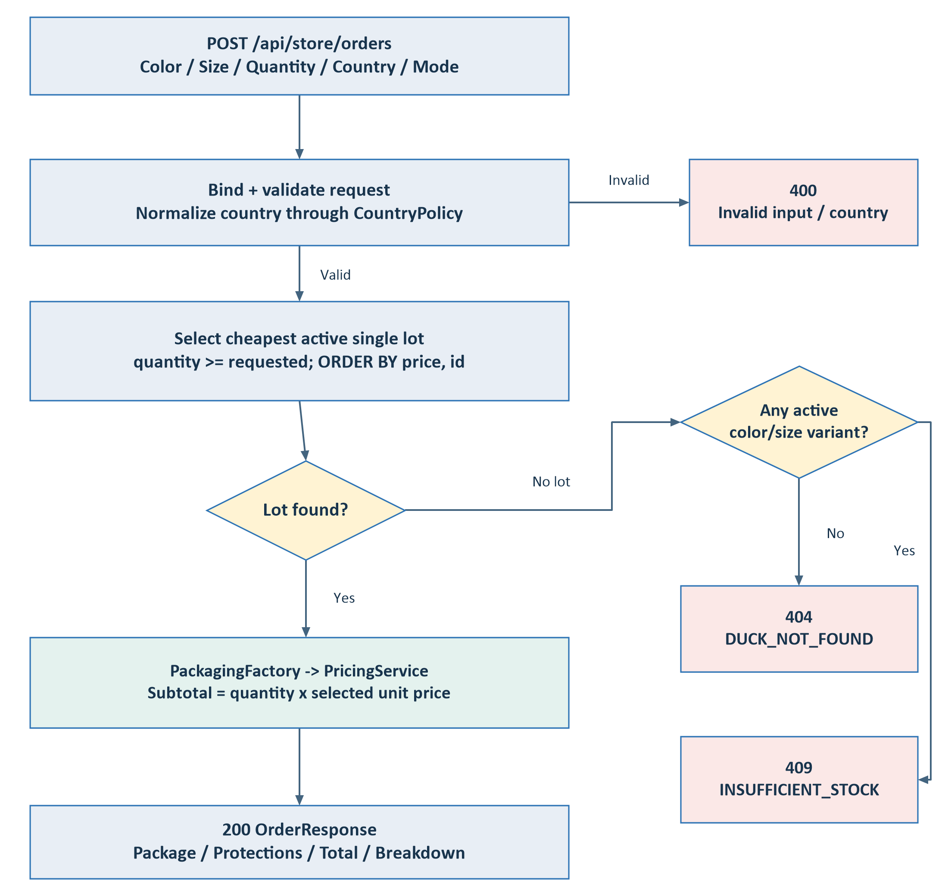
Figure 8. Price resolution chooses a single active lot with enough stock, ordered by price then id. Differently priced lots are not combined. Invalid JSON, fields, enums, extra price input or unsupported country format return 400.
The result is a snapshot quote. There is no order table, reservation, payment step or inventory decrement in this path.
Source: OrderRequest.java:8; StoreService.java:20; DuckRepository.java:45; CountryPolicy.java:27.

8. Sequence: calculate a store quote
This is the success path. The preceding flowchart shows validation and stock-selection alternatives.
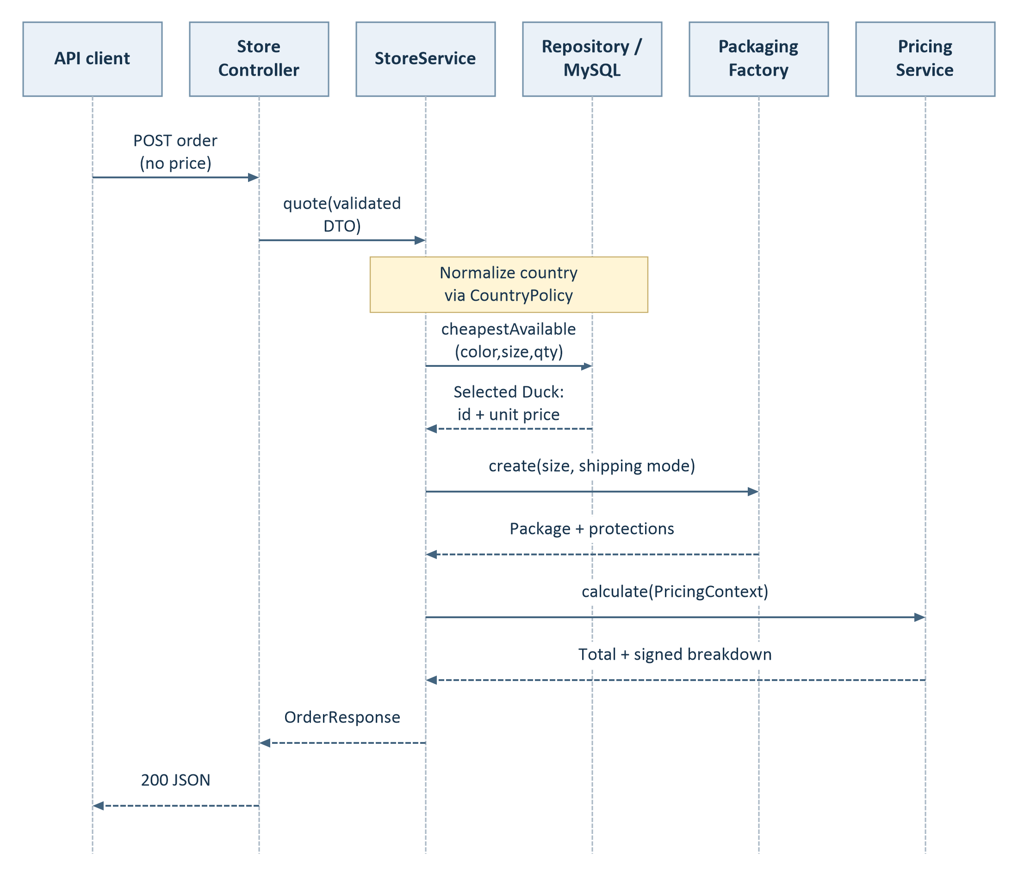
Figure 9. DuckRepository and MySQL are combined into one persistence lane for readability; they remain separate application and database components. Country normalization is a CountryPolicy call made by StoreService.
OrderResponse includes packageType, protectionTypes, totalToPay and breakdown, plus USD currency, selected warehouse ID/unit price, quantity and normalized country. Each breakdown line records code, description, basis, nullable ratePercent and signed amount.
Source: StoreController.java:12; StoreService.java:20; OrderResponse.java:6; PriceLine.java:6.

9. Packaging and pricing patterns
The implementation uses a packaging factory, shipping protection strategies and an ordered pricing-rule pipeline. The strategies are lambdas in an immutable map.
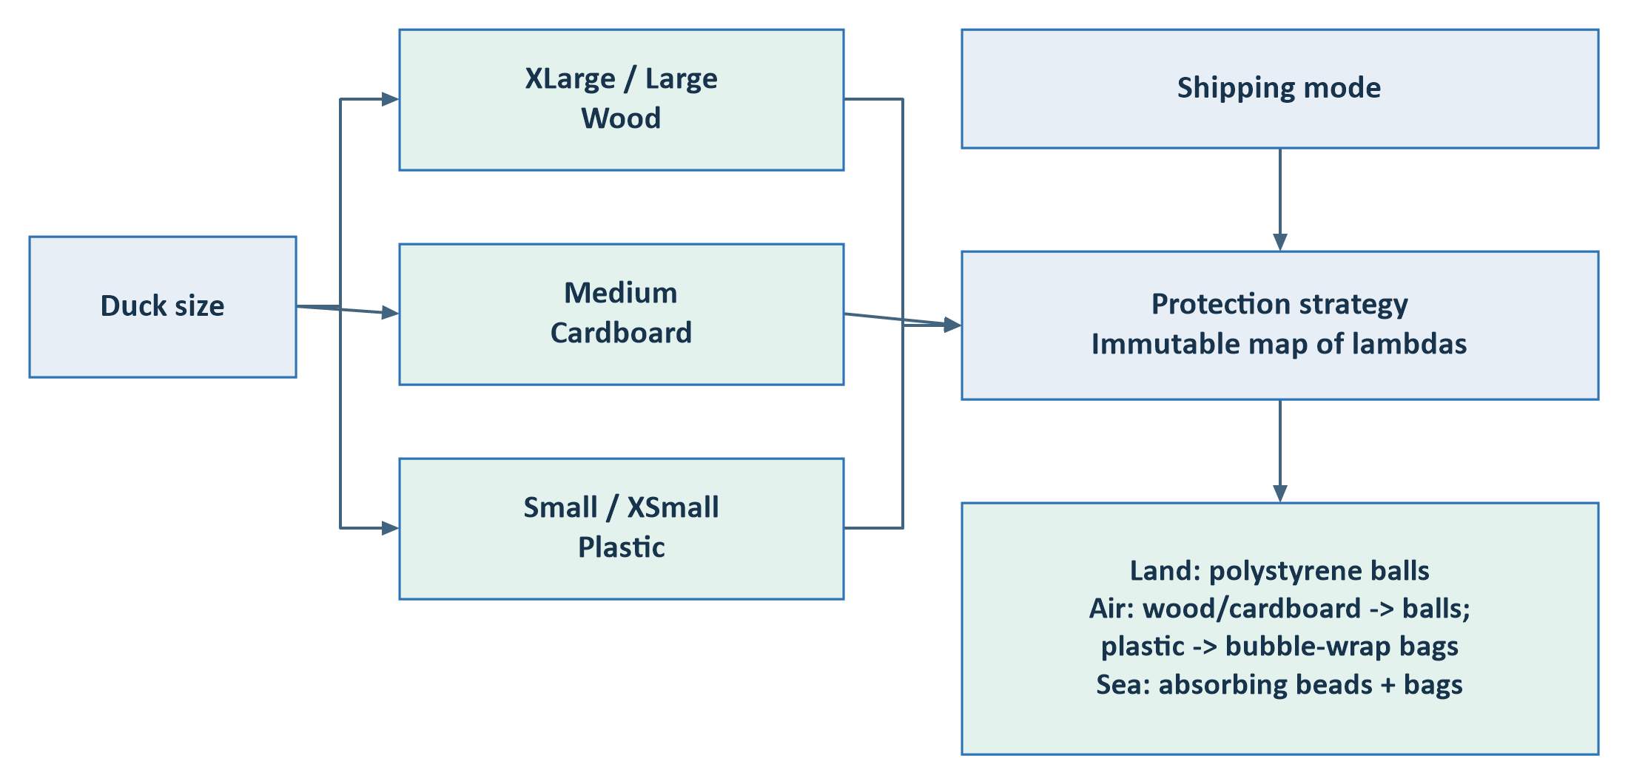
Figure 10. In the diagram, balls means polystyrene balls, bags means bubble-wrap bags and absorbing beads means moisture-absorbing beads.
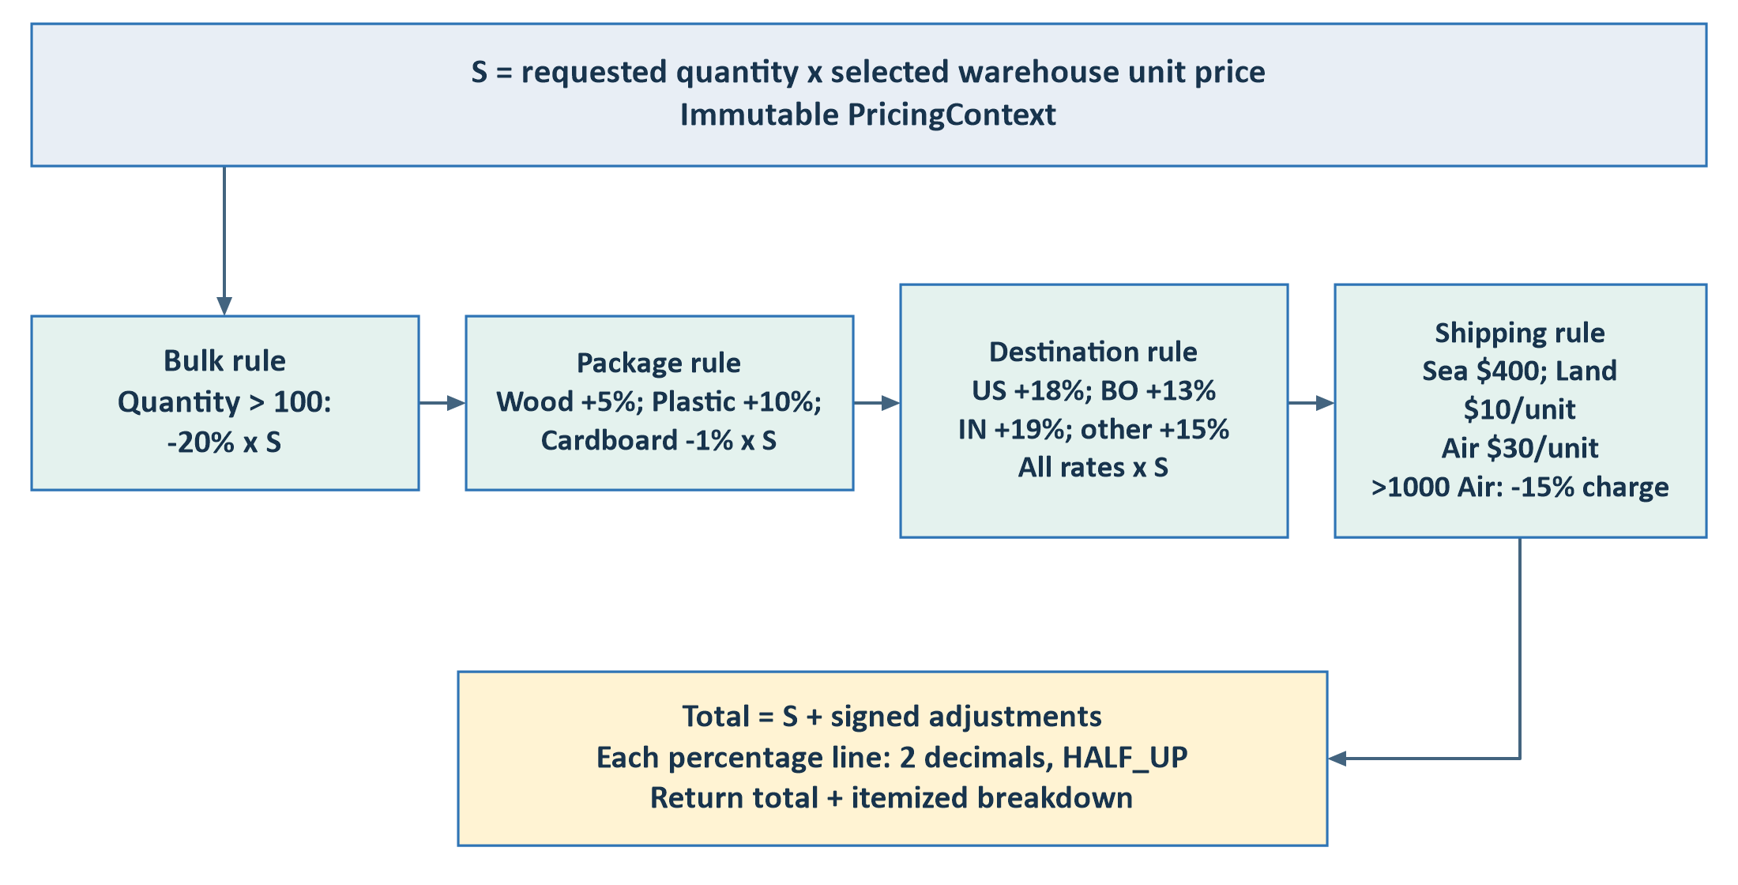
Figure 11. Percentages use the original subtotal S; they do not compound. The >100-unit discount starts at 101. The >1000-unit air discount starts at 1001 and applies only to the air charge. Java uses BigDecimal and HALF_UP rounding.
Source: PackagingFactory.java:11; PricingService.java:11; PricingRules.java:10.

10. Decisions, boundaries and source map

Current implementation decisions
- Money uses BigDecimal and MySQL DECIMAL(12,2), rather than the exercise's Double declaration. Java enums preserve the required JSON labels.
- The Java Duck record exposes five fields. The database contains deleted and enforces soft deletion; an explicit six-field persistence model would make entity conformance clearer.
- Edits replace absolute quantity and price, using last-write-wins behavior. Add/add merging is protected, but stale edits can overwrite intervening changes.
- Country input accepts ISO alpha-2 codes and documented aliases for USA, Bolivia and India. All percentage adjustments use the original subtotal.

Review items; not implemented by these diagrams
Handle transaction-acquisition wrappers consistently in GlobalExceptionHandler; clarify the entity/type contract; add rendered CRUD and successful store HTTP tests. Pagination, idempotency and measured capacity work belong to the separate scaling plan.

Code-to-diagram map
Diagrams | Primary source files
Context and components | vite.config.js; WarehouseController; WarehouseService; StoreController; StoreService; DuckRepository.
Warehouse UI flow | App.jsx; useWarehouse.js; DuckForm.jsx; DeleteConfirmation.jsx; ducks.js.
List / add / edit / delete | WarehouseService.java; WriteTransactions.java; DuckRepository.java.
Concurrent adds and data | V1__create_ducks.sql; DuckRepository.java; WarehouseIT.java.
Store flow and patterns | OrderRequest; StoreService; CountryPolicy; PackagingFactory; PricingService; PricingRules; OrderResponse.
Backend root: project/duck-warehouse-springboot/duck-warehouse-api/src/main/java/com/example/ducks/. Frontend root: project/duck-warehouse-react-ui/duck-warehouse-ui/src/. SQL migrations are under backend src/main/resources/db/migration/.
Prepared from source inspection. The previous review ran nine frontend helper/API tests successfully; live MySQL concurrency and full browser flows were not exercised. No application, database, WAR or JAR was changed to create this document.

