GitHub location: <https://github.com/janardhanckd/mproject/tree/master>

Project Git location: <https://github.com/janardhanckd/mproject.git>

POST Operation: http://localhost:9091/rewards/calculateRewards

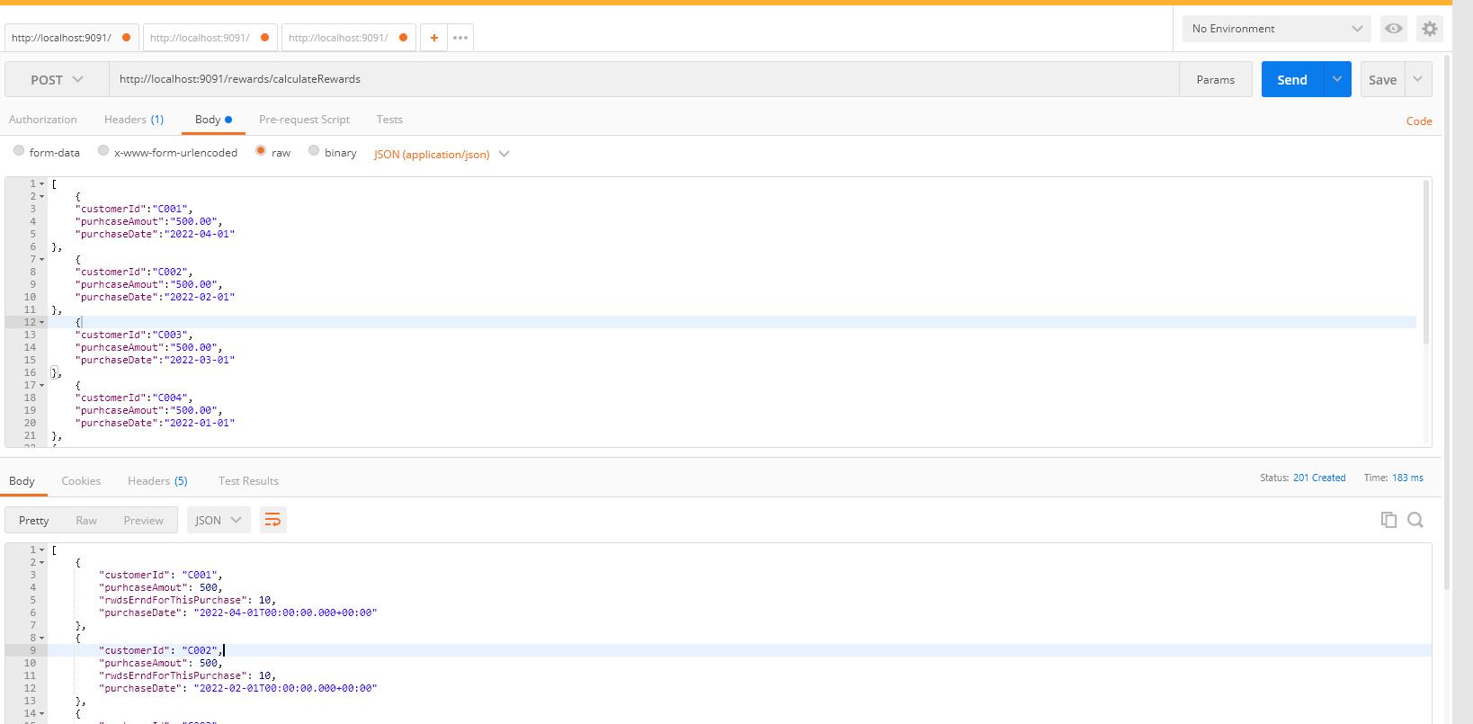

GET Operation for specific customer

http://localhost:9091/rewards/getCustomerDetails/C002

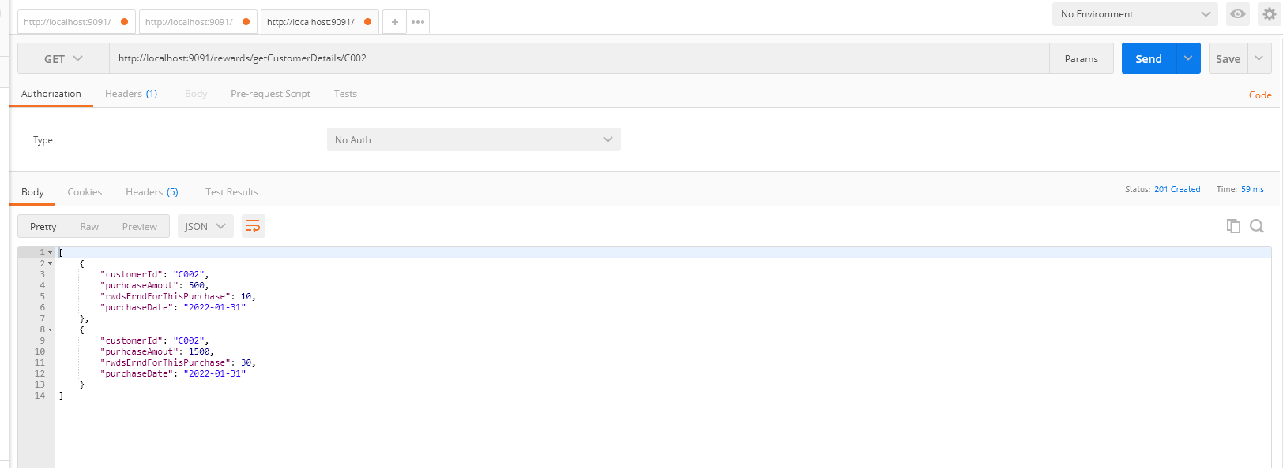

3. GET Operation

<http://localhost:9091/rewards/getQuarterlyRecords>

this will give you the Quarterly records

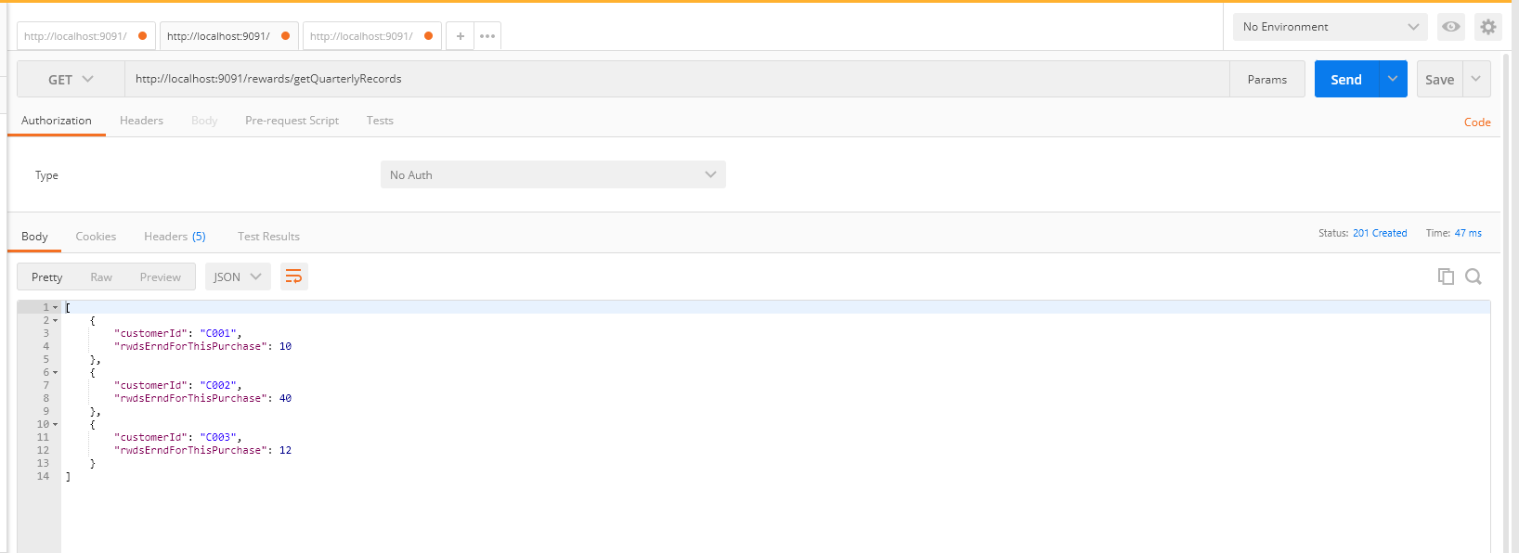

4. GET Operation

http://localhost:9091/rewards/getMonthlyRecords

this will give you the Quarterly records

