Pre-requisites To Install Kubernetes
Since we are dealing with VMs, we recommend the following settings for the VMs:-
Master:
- 2 GB RAM
- 2 Cores of CPU
Slave/ Node:
- 1 GB RAM
- 1 Core of CPU

Pre-Installation Steps On Both Master & Slave (To Install Kubernetes)
The following steps have to be executed on both the master and node machines. Let’s call the the master as ‘kmaster‘ and node as ‘knode‘.
First, login as ‘sudo’ user because the following set of commands need to be executed with ‘sudo’ permissions. Then, update your ‘apt-get’ repository.
$ sudo su
# apt-get update
Note: After logging-in as ‘sudo’ user, note that your shell symbol will change to ‘#’ from ‘$’.
Note: For this installation, we recommend a fresh Ubuntu 16.04 image since Kubernetes can take up a lot of resources. If your installation fails at any time, then execute all the steps mentioned from the very beginning in a fresh VM, because debugging would take longer.

Pre-requisites To Install Kubernetes
Since we are dealing with VMs, we recommend the following settings for the VMs:-
Master:
- 2 GB RAM
- 2 Cores of CPU
Slave/ Node:
- 1 GB RAM
- 1 Core of CPU
By this point of time, I have assumed you have 2 plain Ubuntu VMs imported onto your Oracle Virtual Box. So, I’l just get along with the installation process.

Pre-Installation Steps On Both Master & Slave (To Install Kubernetes)
The following steps have to be executed on both the master and node machines. Let’s call the the master as ‘kmaster‘ and node as ‘knode‘.
First, login as ‘sudo’ user because the following set of commands need to be executed with ‘sudo’ permissions. Then, update your ‘apt-get’ repository.
$ sudo su
# apt-get update
Note: After logging-in as ‘sudo’ user, note that your shell symbol will change to ‘#’ from ‘$’.

Turn Off Swap Space
Next, we have to turn off the swap space because Kubernetes will start throwing random errors otherwise. After that you need to open the ‘fstab’ file and comment out the line which has mention of swap partition.
# swapoff -a
# nano /etc/fstab

Then press ‘Ctrl+X’, then press ‘Y’ and then press ‘Enter’ to Save the file.

Update The Hostnames
To change the hostname of both machines, run the below command to open the file and subsequently rename the master machine to ‘kmaster’ and your node machine to ‘knode’.

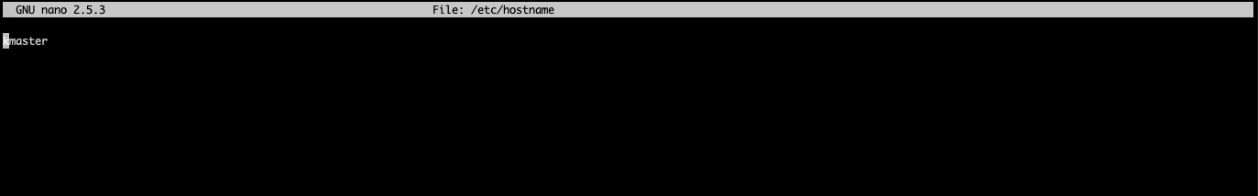

Then press ‘Ctrl+X’, then press ‘Y’ and then press ‘Enter’ to Save the file.

Update The Hosts File With IPs Of Master & Node
Run the following command on both machines to note the IP addresses of each.
# ifconfig
Make a note of the IP address from the output of the above command. The IP address which has to be copied should be under “enp0s8”, as shown in the screenshot below.

Now go to the ‘hosts’ file on both the master and node and add an entry specifying their respective IP addresses along with their names ‘kmaster’ and ‘knode’. This is used for referencing them in the cluster. It should look like the below screenshot on both the machines.
# nano /etc/hosts

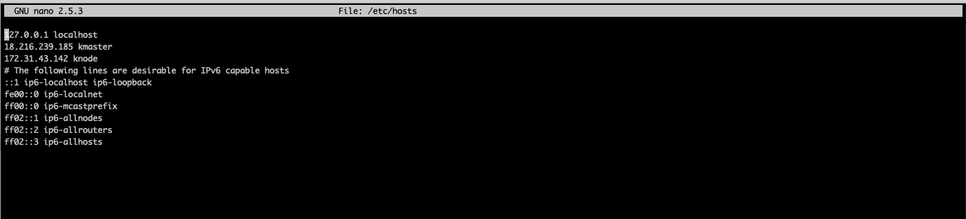

Setting Static IP Addresses
Next, we will make the IP addresses used above, static for the VMs. We can do that by modifying the network interfaces file. Run the following command to open the file:
# nano /etc/network/interfaces
Now enter the following lines in the file.
auto enp0s8
iface enp0s8 inet static
address <IP-Address-Of-VM>
It will look something like the below screenshot.
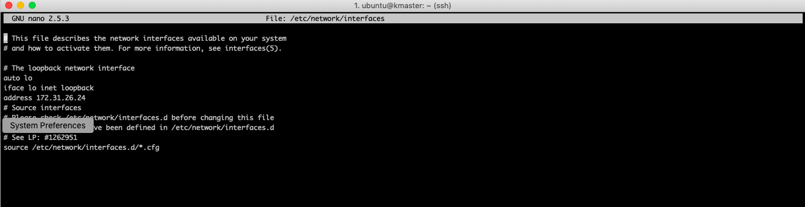

Then press ‘Ctrl+X’, then press ‘Y’ and then press ‘Enter’ to Save the file.
After this, restart your machine(s).

Install OpenSSH-Server
Now we have to install openshh-server. Run the following command:
# sudo apt-get install openssh-server

Install Docker
Now we have to install Docker because Docker images will be used for managing the containers in the cluster. Run the following commands:
# sudo su
# apt-get update
# apt-get install -y docker.io
Next we have to install these 3 essential components for setting up Kubernetes environment: kubeadm, kubectl, and kubelet.
Run the following commands before installing the Kubernetes environment.
# apt-get update && apt-get install -y apt-transport-https curl
# curl -s https://packages.cloud.google.com/apt/doc/apt-key.gpg | apt-key add -
# cat <<EOF >/etc/apt/sources.list.d/kubernetes.list
deb http://apt.kubernetes.io/ kubernetes-xenial main
EOF
# apt-get update

Install kubeadm, Kubelet And Kubectl
Now its time to install the 3 essential components. Kubelet is the lowest level component in Kubernetes. It’s responsible for what’s running on an individual machine. Kuebadm is used for administrating the Kubernetes cluster. Kubectl is used for controlling the configurations on various nodes inside the cluster.
# apt-get install -y kubelet kubeadm kubectl

Updating Kubernetes Configuration
Next, we will change the configuration file of Kubernetes. Run the following command:
# nano /etc/systemd/system/kubelet.service.d/10-kubeadm.conf
This will open a text editor, enter the following line after the last “Environment Variable”:
Environment=”cgroup-driver=systemd/cgroup-driver=cgroupfs”

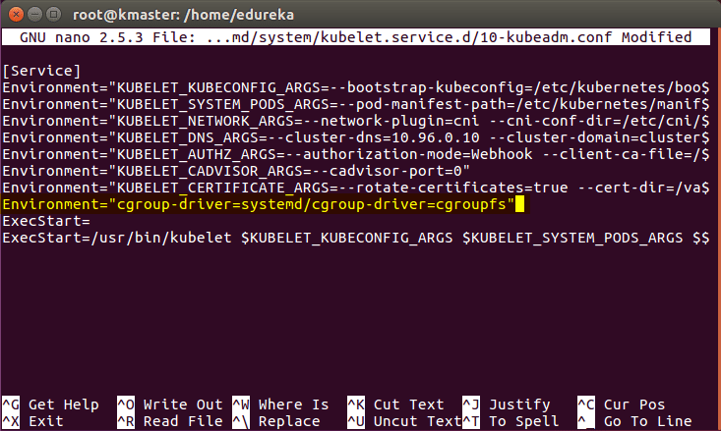

Now press Ctrl+X, then press Y, and then press Enter to Save.
Voila! You have successfully installed Kubernetes on both the machines now!
As of now, only the Kubernetes environment has been setup. But now, it is time to install Kubernetes completely, by moving onto the next 2 phases, where we will individually set the configurations in both machines.

Steps Only For Kubernetes Master VM (kmaster)
Note: These steps will only be executed on the master node (kmaster VM).
Step 1: We will now start our Kubernetes cluster from the master’s machine. Run the following command:
# kubeadm init --apiserver-advertise-address=<ip-address-of-kmaster-vm> --pod-network-cidr=192.168.0.0/16
- You will get the below output. The commands marked as (1), execute them as a non-root user. This will enable you to use kubectl from the CLI
- The command marked as (2) should also be saved for future. This will be used to join nodes to your cluster

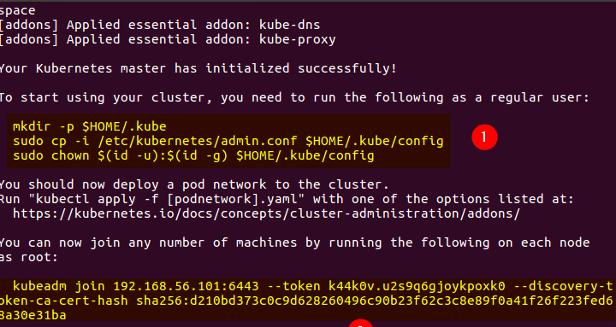

$ mkdir -p $HOME/.kube
$ sudo cp -i /etc/kubernetes/admin.conf $HOME/.kube/config
$ sudo chown $(id -u):$(id -g) $HOME/.kube/config

To verify, if kubectl is working or not, run the following command:
$ kubectl get pods -o wide --all-namespaces

