 

HYDRO STAGNATION RESCUE SYSTEM BASED ON INTERNET OF THINGS

## A PROJECT REPORT

*Submitted by*

# Mr. K. JANARTHANAN (952819106010)

# Mr. A. ESSAKI SURIYA (952819106008)

# Mr. A. MAHESH RAJ (952819106015)

# Mr. M. DURAIRAJA (952819106005)

***In partial fulfillment for the award of the degree of***

# BACHELOR OF ENGINEERING

***In***

## ELECTRONICS AND COMMUNICATION ENGINEERING SCAD COLLEGE OF ENGINEERING & TECHNOLOGY, TIRUNELVELI-627414

**ANNA UNIVERSITY: CHENNAI 600 025**

**MAY 2023**

ANNA UNIVERSITY: CHENNAI 600 025

# BONAFIDE CERTIFICATE

Certified that this project report titled **“HYDRO STAGNATION RESCUE SYSTEM BASED ON INTERNET OF THINGS**” is the bonafide work of **“Mr. K. JOHN SAMUEL RAJ, Mr. K. JANARTHANAN (952819106010), Mr. A. ESSAKI SURIYA (952819106008), Mr. A. MAHESH RAJ (952819106015)** and **Mr. M. DURAI RAJA (952817106005)”** who carried out the project work under my supervision.

**SIGNATURE**

Mr. EZHIL E. NITHILA, M.E, Ph.D.,

**HEAD OF THE DEPARTMENT**

DEPARTMENT OF ELECTRONICS & COMMUNICATION ENGINEERING SCAD COLLEGE OF ENGINEERING & TECHNOLOGY CHERANMAHADEVI-627414.

**SIGNATURE**

Mr. K. JOHN SAMUEL RAJ, M.E.,

**ASSISTANT PROFESSOR**

DEPARTMENT OF ELECTRONICS & COMMUNICATION ENGINEERING SCAD COLLEGE OF ENGINEERING & TECHNOLOGY CHERANMAHADEVI-627414.

Submitted for PROJECT VIVA-VOCE held on At SCAD College of Engineering & Technology, Cheranmahadevi.

**INTERNAL EXAMINER EXTERNAL EXAMINER**

## ACKNOWLEDGEMENT

First of all, we would like to thank the **ALMIGHTY** for giving us good health and knowledge throughout our project work. We would like to express thanks to our beloved **PARENTS** for the successful completion of our project.

We extend our thanks to our Founder **Dr. S. CLETUS BABU, M.A., M.Phil., Ph.D.,** who played a major role in our college learning life. We would like to thank **Dr. A. JUSTIN THIRAVIUM M.E, Ph.D.,** Principal, SCAD College of Engineering and Technology, Tirunelveli for giving us the opportunity to do this project.

We express our sincere thanks to our respected Head of the Department **Mrs. EZHIL E. NITHILA M.E, Ph.D.,** for his overwhelming support in all endeavors.

We express our sincere thanks to our Project Coordinator and Project Guide **Mr. K. JOHN SAMUEL RAJ M.E.,** Assistant Professor, ECE Department, SCAD College of Engineering and Technology, Tirunelveli for their full-hearted support and continuous guidance and inspiration. Also, we express our thanks to all the faculty members of our department.

## ABSTRACT

## As the technology is growing immensely in recent years, certain improvisations needs to be made. Drowning which typically involves a watery environment, it is serious concern for public health especially for young age and aged people. According to the world health organization estimation around 362,000(3.62 million) human life per year affected on drowning. Drowning is one of the leading causes of death globally for children and adult aged between 1 to 20 years. Because a few numbers of children and adults are don’t to want to know the swimming and don’t make the high priority for learn swimming on this days. Along with others involve victims that die from injury, intoxication, suffocation. So this are causes for happening lots of drowning accident into the water bodies like swimming pool, lake, well, river, ocean etc...

## To secure the value of the human life form drowning accidents into the water, we propose an intelligent system of “HYDRO STAGNATION RESCUE SYSTEM BASED ON IOT”. This system will identify that “is drowning object human or not?” By using the esp32 cam. The “AI thinker algorithm” make to identify on human face by using face detection or face recognition method. If the drowning object is human conformed by esp32 cam, it send the rescue message to rescue team to alert them and activate the basic rescue system operation in embedded system. This rescue system will connect with water out pump motor. This water out pump motor will reduce the water level in stagnation to increase little amount of the oxygen level in water.

## “Prevention is better than cure”. According to that we avoid alcoholic person entrance in hydro stagnation by using alcoholic sensor. The temperature level of stagnation would monitored by temperature sensor to avoid health issues like redness, itching, peeling, cold and cough. The ultrasonic sensor would monitor the water level of the stagnation. This system is very effective to use on swimming pool, small size wells and gardener.

|  |  |  |
| --- | --- | --- |
|  | **TABLE OF CONTENTS** |  |
| **CHAPTER NO.** | **TITLE** | **PAGE NO.** |
|  | LIST OF FIGURES | viii |
|  | LIST OF TABLES | x |
|  | LIST OF ABBREVIATION | xi |
| **1** | **INTRODUCTION** | **01** |
|  | **1.1 EMBEDDED SYSTEM** | **01** |
|  | 1.1.1 EXAMPLES OF EMBEDDED SYSTEM | 01 |
|  | 1.1.2 STRUCTURE OF EMBEDDED SYSTEM | 02 |
|  | 1.1.3 TYPES OF EMBEDDED SYSTEM | 03 |
|  | 1.1.4 CHARACTERISTICS OF EMBEDDED SYSTEM | 04 |
|  | 1.1.5 ADVANTAGES OF EMBEDDED SYSTEM | 04 |
|  | **1.2 ROLE OF EMBEDDED SYSTEMS IN THE IOT**  **TECHNOLOGY** | 04 |
|  | 1.2.1 CHARACTERISTICS OF IOT TECHNOLOGY | 05 |
|  | 1.2.2 ADVANTAGES OF IOT TECHNOLOGY | 06 |
| **2** | **LITERATURE SURVEY** | **07** |
| **3** | **SYSTEM ANALYSIS** | **11** |
|  | **3.1 ORIGIN OF PROPOSAL** | **11** |
|  | **3.2 PROBLEM STATEMENT** | **11** |
|  | **3.3 REASON FOR DROWNING ACCIDENTS** | **12** |
|  | **3.4 OBJECTIVE** | **13** |
|  | **3.5 REVIEW AND STATUS OF RESEARCH AND**  **DEVELOPMENT IN THE SUBJECT** | **13** |
|  | 3.5.1 INTERNATIONAL STATUS | **13** |
|  | 3.5.2 NATIONAL STATUS | **14** |
|  | **3.6 EXISTING SYSTEM** | **15** |
|  | 3.6.1 DRAWBACKS OF EXISTING SYSTEM | 15 |
|  | **3.7 PROPOSED SYSTEM** | **16** |
|  | **3.8 CIRCUIT DESCRIPTION** | **19** |
|  | 3.8.1 DISCRYPTION ABOUT METHOD OF WORKING | 21 |
|  | 3.8.2 ADVANTAGES | 22 |
|  | **3.9 HARDWARE REQUIREMENTS** | **22** |
|  | **3.10 SOFTWARE REQUIREMENTS** | **22** |
| **4** | **HARDWARE DESCRIPTION** | **23** |
|  | **4.1 ARDUINO UNO CONTROLLER** | **23** |
|  | 4.1.1 ARDUINO UNO ARCHITECTURE | 24 |
|  | 4.1.2 BOARD SPECIFICATIONS | 28 |
|  | 4.1.3 ADVANTAGES OF ARDIUNO UNO | 29 |
|  | **4.2 JSN-SR04T ULTRASONIC SENSOR** | **29** |
|  | 4.2.1 THEORY OF OPERATION | 30 |
|  | 4.2.2 FEATURES | 32 |
|  | 5.2.4 APPLICATIONS | 33 |
|  | **4.3 DS18B20 TEMPERATURE SENSOR** | **33** |
|  | 4.3.1 SPECIFICATION | 34 |
|  | 4.3.2 ADVANTAGE | 34 |
|  | 4.3.4 DISADVANTAGE | 35 |
|  | **4.4 MQ3 ALCOHOL SENSOR** | **35** |
|  | 4.4.1 SPECIFICATION | 36 |
|  | **4.5 ESP32 CAM** | **37** |
|  | 4.5.1 OPERATING PRINCIPLE | 38 |
|  | 4.5.2 WORKING PRINCIPLE | 38 |
|  | **4.6 LCD-LIQUID CRYSTAL DISPLAY** | **39** |
|  | 4.6.1 FEATURES | 41 |
| 5 | **SYSTEM TESTING & MAINTANANCE** | **42** |
|  | **5.1 SOFTWARE REQUIREMENT** | **42** |
|  | 5.1.1 ARDUINO IDE | 42 |
|  | **5.2 SYSTEM TESTING** | **43** |
|  | 7.1 APPLICATION BEHAVIOUR | 43 |
|  | 7.2 PERFORMANCE | 43 |
|  | 7.3 ROBUSTNESS | 43 |
|  | 7.4 ACCEPTANCE TESTING | 43 |
|  | **5.3 SYSTEM MAINTANANCE** | **45** |
| 6 | **CONCLUSION AND FUTURE RECOMMENDATIONS** | **46** |
| 7 | **APPENDIX** | **48** |
|  | **7.1 OUTPUT** | **48** |
|  | 7.1.1 OUTPUT OF RECORDING MODE | 49 |
|  | 7.1.2 OUTPUT OF READING MODE | 49 |
|  | 7.1.3 OUTPUT OF RESULT | 52 |

|  |  |  |
| --- | --- | --- |
|  | **LIST OF FIGURES** |  |
| **FIGURE NO.** | **FIGURE NAME** | **PAGE NO.** |
| 3.1 | Block Diagram of Hydro stagnation rescue system | 17 |
| 3.2 | Circuit Diagram of Hydro stagnation rescue system | 18 |
| 3.3 | Flow Chart of Hydro stagnation rescue system | 20 |
| 5.1 | Arduino Uno Controller | 24 |
| 5.2 | Arduino Uno Architecture | 25 |
| 5.3 | Arduino Uno PIN Diagram | 26 |
| 5.4 | JSN-SR04T Ultrasonic Sensor | 30 |
| 5.5 | Working of JSN-SR04T Ultrasonic Sensor | 31 |
| 5.6 | JSN-SR04T Ultrasonic Sensor Range Waveform | 32 |
| 5.7 | DS18B20 Temperature Sensor | 33 |
| 5.8 | Circuit Diagram of DS18B20 Temperature Sensor | 34 |
| 5.9 | MQ3 Alcohol Sensor | 35 |
| 5.10 | PIN Configuration of MQ3 Alcohol Sensor | 36 |
| 5.11 | ESP32 CAM | 37 |
| 5.12 | Representation of ESP32 CAM | 37 |
| 5.13 | LCD Display | 39 |
| 10.1 | Overall System Setup | 48 |
| 10.2 | Recording Mode | 49 |

|  |  |  |
| --- | --- | --- |
| 10.3 | Output of JSN-SR04T Ultrasonic Sensor | 49 |
| 10.4 | Output of DS18B20 Temperature Sensor | 50 |
| 10.5 | Output of MQ3 Alcohol Sensor | 51 |
| 10.6 | Final Output | 52 |
|  | **LIST OF TABLES** |  |
| **TABLE NO.** | **TABLE NAME** | **PAGE NO.** |
| 5.4 | Board Specification of Arduino Uno | 28 |
| 5.15 | PIN Description of LCD Display | 40 |
| 7.1 | Test Case | 44 |

|  |  |
| --- | --- |
|  | **LIST OF ABBREVATIONS** |
| **IoT** | Internet of Things |
| **RTOS** | Real Time Operation |
| **DSP** | Digital Signal Processing |
| **POS** | Point of Scale |
| **ADC** | Analog To Digital Conversion |
| **DAC** | Digital To Analog Conversion |
| **Wi-Fi** | Wireless Fidelity |
| **LCD** | Liquid Crystal Display |
| **USB** | Universal Signal Bus |
| **MQ** | Metal Oxidesemicord |
| **PWM** | Pulse Width Modulation |
| **UART** | Universal Asynchronous Reverse Transmitter |
| **LED** | Light Emitting Diode |
| **EEPROM** | Electrically Erasable Programmable Read Only Memory |
| **SRAM** | Static Random Access Memory |
| **ICSP** | In Circuit Serial Programming |
| **GUI** | Graphical User Interface |
| **ESP32** | Espressif System |

## CHAPTER 1

## INTRODUCTION

* 1. **EMBEDDED SYSTEM**

An embedded system is a combination of computer hardware and software designed for a specific function. Embedded systems may also function within a larger system. The systems can be programmable or have a fixed functionality. Industrial machines, consumer electronics, agricultural and processing industry devices, automobiles, medical equipment, cameras, digital watches, household appliances, airplanes, vending machines and toys, as well as mobile devices, are possible locations for an embedded system.

While embedded systems are computing systems, they can range from having no user interface (UI) -- for example, on devices designed to perform a single task -- to complex graphical user interfaces (GUIs), such as in mobile devices. User interfaces can include buttons, LEDs (light-emitting diodes) and touchscreen sensing. Some systems use remote user interfaces as well.

Markets and Markets, a business-to-business (B2B) research firm, predicted that the embedded market will be worth $116.2 billion by 2025. Chip manufacturers for embedded systems include many well-known technology companies, such as Apple, IBM, Intel and Texas Instruments. The expected growth is partially due to the continued investment in artificial intelligence (AI), mobile computing and the need for chips designed for high-level processing.

## EXAMPLES OF EMBEDDED SYSTEM

Embedded systems are used in a wide range of technologies across an array of industries. Some examples include:

**Smart Appliances:** Electrolux is a home appliance company offering fridges, ovens, washers, dryers and more. Founded in 1919, Electrolux products are designed to be sustainable by using sensor technology that prevents excessive energy use in dryers and fridges.

**Security system:** [JOSH.AI](https://www.josh.ai/) provides voice-controlled home automation that can connect to [a variety of devices](https://www.josh.ai/devices). The voice-based Josh OS can connect to smart devices like phones, watches, TVs and tablets. The options for home security range from doorbell cameras and door locks to ceiling and outdoor cameras. The Josh app lets users control their devices remotely.

**Health care:** By attaching [Propeller](https://www.propellerhealth.com/)’s sensor to an inhaler, users can learn more about what triggers asthma attacks while staying connected to friends, family and healthcare providers through an online app. According to its website, using digital data to assess asthma control has been shown to more accurately determine how many inhaler puffs were needed to control an attack, which in turn could influence usage guidelines and improve patient health.

Often, embedded systems are used in real-time operating environments and use a real-time operating system (RTOS) to communicate with the hardware. Near-real-time approaches are suitable at higher levels of chip capability, defined by designers who have increasingly decided the systems are generally fast enough and the tasks tolerant of slight variations in reaction. In these instances, stripped- down versions of the Linux operating system are commonly deployed, although other OSes have been pared down to run on embedded systems, including Embedded Java and Windows IoT (formerly Windows Embedded).

## STRUCTURE OF EMBEDDED SYSTEM

Embedded systems vary in complexity but, generally, consist of three main elements:

* **Hardware.** The hardware of embedded systems is based around microprocessors and microcontrollers. Microprocessors are very similar to microcontrollers and, typically, refer to a CPU (central processing unit) that is integrated with other basic computing components such as memory chips and digital signal processors ([DSPs](https://whatis.techtarget.com/definition/digital-signal-processing-DSP)). Microcontrollers have those components built into one chip.
* **Software and firmware.** Software for embedded systems can vary in complexity. However, industrial-grade microcontrollers and embedded IoT systems usually run very simple software that requires little memory.
* **Real-time operating system.** These are not always included in embedded systems, especially smaller-scale systems. RTOS define how the system works by supervising the software and setting rules during program execution.

In terms of hardware, a basic embedded system would consist of the following elements:

* **Sensors** convert physical sense data into an electrical signal.
* **Analog-to-digital (A-D) converters** change an analog electrical signal into a digital one.
* **Processor** process digital signals and store them in memory.
* **Digital-to-analog (D-A) converters** change the digital data from the processor into analog data.
* **Actuators** compare actual output to memory-stored output and choose the correct one.

## TYPES OF EMBEDDED SYSTEM

There are a few basic embedded system types, which differ in their functional requirements. They are:

* **Mobile embedded systems** are small-sized systems that are designed to be portable. Digital cameras are an example of this.
* **Networked embedded systems** are connected to a network to provide output to other systems. Examples include home security systems and point of sale (POS) systems.
* **Standalone embedded systems** are not reliant on a host system. Like any embedded system, they perform a specialized task. However, they do not necessarily belong to a host system, unlike other embedded systems. A calculator or MP3 player is an example of this.
* **Real-time embedded systems** give the required output in a defined time interval. They are often used in medical, industrial and military sectors because they are responsible for time-critical tasks. A traffic control system.

## CHARACTERISTICS OF EMBEDDED SYSTEM

The main characteristic of embedded systems is that they are task-specific. Additionally, embedded systems can include the following characteristics: Typically, consist of hardware, software and firmware; Can be embedded in a larger system to perform a specific function, as they are built for specialized tasks within the system, not various tasks; Can be either microprocessor-based or microcontroller-based -- both are integrated circuits that give the system compute power; Are often used for sensing and real-time computing in internet of things ([IoT](https://internetofthingsagenda.techtarget.com/definition/Internet-of-Things-IoT)) devices, which are devices that are internet-connected and do not require a user to operate; Can vary in complexity and in function, which affects the type of software, firmware and hardware they use; and are often required to perform their function under a time constraint to keep the larger system functioning properly.

## ADVANTAGES OF EMBEDDED SYSTEM

* They are convenient for mass production. This results in low price per piece.
* These systems are highly stable and reliable.
* Embedded systems are made for specific tasks.
* The embedded systems are very small in size, hence can be carried and loaded anywhere.
* These systems are fast. They also use less power.
* The embedded systems optimize the use or resources available.

### **ROLE OF EMBEDDED SYSTEMS IN THE IOT TECHNOLOGY**

* Internet of Things (IoT) is the connection of devices via the internet to exchange data. Today, it emerged as the most trending technology, as we can control the embedded devices from any location using **IoT technology**.
* Simply speaking, IoT involves a process in which the objects have sensors, processors, and actuators. The peripherals help in designing and developing hardware boards, software systems, web APIs, and protocols in creating a connected environment of embedded systems.
* The connected environment allows technologies to connect multiple devices, networks, and platforms. It creates a web of communication that helps in changing the way people interact digitally with the world. The connected embedded systems have the power to change how people demeanor with the environment, homes, and communities.
* However, designing an embedded system is challenging. Therefore, when designing embedded IoT systems, engineers require designing them for specific functions, keeping in mind particular aspects, such as lower power consumption, secured architecture, and reliable processors, among several others.

## CHARACTERISTICS OF IOT TECHNOLOGY:

The Internet of Things (IoT) technology is revolutionizing the way we interact with our environment and has the potential to revolutionize the way we live. Here are some of the characteristics of IoT technology.

* **Automation:** Automation is an important part of IoT technology, as it allows for the efficient control of devices and processes. This automation can be used to automate mundane tasks such as turning on lights, controlling temperature, and monitoring security systems.
* **Security:**  IoT devices are designed to be secure, using encryption and authentication to protect data and communication. This security helps to ensure that only authorized users can access the data, prevent malicious actors from gaining access, and enable secure data transmission.
* **Connectivity:** IoT devices can be connected and other networks via a variety of protocols, including Wi-Fi, Bluetooth, and cellular. This connectivity allows for the seamless transfer of data, allowing for the sharing of data between devices.
* **Scalability:** IoT devices are designed to be flexible and able to scale as needed. This scalability allows for the deployment of large numbers of devices, from a few to tens of thousands, and allows for the efficient management and control of these devices.
* **Intelligence:** These devices are intelligent since they combine algorithms and processing, software and hardware. Along with that, the ambient intelligence improves the capabilities of IoT devices. Due to this intelligence, they respond intelligently to situations ad assist IoT in fulfilling specified tasks.

## 1.2.2 ADVANTAGES OF IOT TECHNOLOGY:

## Increased Efficiency: IoT enables devices and systems to communicate with each other, share data, and work together seamlessly, leading to increased efficiency and productivity.

## Cost Savings: IoT can reduce costs through automation, predictive maintenance, and data-driven decision-making, resulting in more significant savings for businesses and individuals.

## Improved Quality of Life: IoT can improve people's lives by enabling better healthcare, safer living, and increased convenience, among other things.

## Enhanced Safety and Security: IoT devices can enhance safety and security by monitoring and detecting threats in real-time, preventing accidents and incidents before they occur.

## Greater Accessibility: IoT technology can make services and information more accessible to people who are geographically remote or have physical disabilities.

## Better Environmental Sustainability: IoT can promote environmental sustainability by reducing energy consumption, optimizing resource usage, and promoting eco-friendly practices.

## CHAPTER-2

## LITERATURE SURVEY

### **S. Karthik; Dhivya Priya E.L.; Gokul Anand K.R.; A. Sharmila 2020 “IoT Based Safety Enhanced Swimming Pool with Embedded Techniques to reduce drowning accidents”**

The prototype of the design has been successfully implemented which leads to the conclusion that such a system can help in keeping the driver awake at all times while driving and hence facilitate in avoidance of any traffic accidents involving driver’s alertness.

This paper begins with an overview of the importance of swimming pools as a popular recreational activity and the risks associated with them. The authors S. Karthik and A, Sharmila reviews the existing literature on drowning accidents in swimming pools and the different factors that contribute to them, including lack of supervision, inadequate fencing, and the absence of safety devices.

Next, the paper discusses the various technologies and techniques that have been proposed to enhance swimming pool safety, including Ultra sonic sensors and PIR sensor. The authors also describe the limitations of these technologies, such as their high cost and limited range of coverage.

It focuses on the use of IoT and embedded techniques to improve swimming pool safety. The authors discuss the potential benefits of using IoT, sensors and devices to monitor pool conditions and detect potential hazards, such as changes in water levels and the presence of Downer’s. They also describe how embedded systems can be used to automate safety procedures, such as turning off pool pumps when a Downer’s is detected.

The paper concludes with a summary of the different technologies and techniques that have been proposed to enhance swimming pool safety and a discussion of the potential benefits and limitations of the system proposed in the paper.

### **Gonçalo Simões; Carolina Dionísio; Gloria; Pedro Sebastião; Nuno Souto 2019”Smart System for Monitoring and Control of Swimming Pools”**

The paper introduces a new scheme for monitoring and controlling the quality of swimming pools through a low-cost system based on wireless sensor networks. The proposed system aims to reduce the need for human intervention in maintaining the swimming pool's quality and to provide resource savings for the users, both in financial and natural resources, contributing to a sustainable environment. The paper also presents a mobile application that allows users with administrator permissions to interact with the system and control some actions in the swimming pool, thereby stabilizing the required parameters for its good quality.

The literature survey of this paper highlights the importance of maintaining the quality of swimming pool water for the safety and health of swimmers. It emphasizes the need for proper disinfection and pH control of pool water to prevent the transmission of waterborne diseases and skin irritations. The literature survey also discusses the limitations of traditional methods of monitoring and controlling pool water quality, which require frequent manual measurements and can be time-consuming and costly.

The paper presents various studies that have proposed using wireless sensor networks and IoT-based systems for monitoring and controlling the quality of swimming pools. These systems use sensors to measure different parameters of pool water, such as pH, temperature, chlorine levels, and total dissolved solids. The literature survey also highlights the advantages of such systems, such as real-time monitoring, reduced maintenance costs, and improved energy efficiency.

The paper concludes by emphasizing the need for low-cost, easy-to-use systems for monitoring and controlling the quality of swimming pool water. It proposes a wireless sensor network-based system that is easy to install and use and offers significant cost savings for the users while promoting sustainability.

### **A. Sangeetha; R. Santhana Krishnan; G. Praveen Kumar; E. Golden Julie; R. Karthik Ganesh; Y. Harold Robinson 2023 “Smart Swimming Pool Management System (SSPMS) using IoT”**

The issue of pool safety and maintaining proper water quality has been a topic concern in a recent years. The literature survey highlights that a significance number drowning incidents occur globally, and most of them can be attributed to lack of swimming skills or negligence. The importance of maintaining the pH level of water within a certain range to prevent skin and eye irritation is also emphasized. Several previous studies have proposed various approaches to monitor and maintain pool quality. The proposed system in this article combines the use of sensors and advance technology to create an automatic monitoring system that can detect pH level water and track the condition of the swimmers. The system’s ability to update all observed status in the cloud using the internet is a unique features that can enhance pool management and safety. Overall, the literature survey emphasizes the important of pool safety and the proposed system can be effective solution to address the problem.

### **Pillalamarri Laxman;Anuj Jain 2021 “Intelligent Swimming-pool design with Embedded Drown Alerting, Preventing and Autonomous Rescue System”**

The paper propose a technological solution to the problem of fatal drowning accidents in a swimming pools. Despite the many benefits of swimming pool physical and mental fitness drowning incidents remains major threat globally. The paper highlights the highest prevalence of drowning accidents than reported by statistics and the need for multi-layer solution to prevent such accidents. The proposed solution combines various technology tools like proximity sensors, laser trip wire module, pull switches and drain monitor to detect t=any human body laying at the bottom of pool. The system also include alerting lights, buzzers, and an elevator assembly on top of the pool to prevent accidental falls of children or pets. The system is designed to give immediate rescue alert and causes power-on-self test to ensure safety. The prototype implementation of the system is satisfactory and provides promising results. The paper emphasizes the importance of proactive measures to ensure the safety of individuals and stresses the need for implementing such system on a larger scale to reduce fatal drowning accidents.

### **Aboli Kulkarni; Kshitij Lakhani; Shubham Lokhande 2016 “A sensor based low cost drowning detection system for human life safety”**

This paper present a system for addressing the problem of the drowning, which is the one of the leading causes of accidental deaths. The proposed system make the uses of three sensor to automatically detect drowning: a non- invasive oxygen saturation level sensor, respiration monitoring sensor and water sensor. These sensor are used to detect parameters such as blood oxygen saturation level, respiratory movements, and submersion of a person’s body under water. If any two of the above mentioned parameter detect drowning, the system detect it as a case of drowning. The approach is variable solution to device an innovative, portable, low cost and wearable system. Results obtained by performing tests on individual sensors and the entire system illustrate the effectiveness of the approach.

## CHAPTER 3

## SYSTEM ANALYSIS

## ORIGIN OF PROPOSAL:

Swimming is the best workout practice followed by many from the old days till now. Hydro stagnation accidents, characterized by the accumulation of still water in particular locations, have emerged as significant safety concern in various aquatic bodies like swimming pools, water storage tanks and other water environment. Often the beginners feel I difficult to breathe under water and cause of choking water, then as a loss of balance it causes drowning accidents. This research proposal lays the groundwork for a rigorous and comprehensive investigation into hydro stagnation accidents, and its result are expected to contribute of the field of water safety and IOT based system.

**3.2 PROBLEM STATEMENT:**

Accidents known as hydro stagnation, which occur when still water builds up in a variety of aquatic habitats such swimming pools, water storage tanks, and other water bodies, represent a serious risk to public safety. Drowning, waterborne illnesses, mosquito breeding, and other safety risks can ensue from these accidents. Despite the inherent dangers of hydro stagnation, there is a paucity of thorough knowledge regarding the origins, trends, and outcomes of these mishaps, particularly when it comes to emerging nations like India.

## Statistical data from various sources highlight the severity of the problem:

1. Drowning was the main cause of unintentional demise in India in 2019, accounting for 22.6% of all accidental deaths, according to the National Crime Records Bureau (NCRB) of India.

2. In accordance with estimates from the World Health Organization (WHO), over 320,000 drowning deaths occur each year, with over 90% of these deaths occurring in low- and middle-income countries. Drowning is the third highest cause of unintentional injury-related deaths globally.

3. According to a research by the Centers for Disease Control and Prevention (CDC) in the United States, drowning events involving children between the ages of 1-4 years most frequently occur in swimming pools.

Research studies have also highlighted the potential risks of hydro stagnation accidents, including the increased risk of drowning, spread of waterborne diseases, and breeding of disease-carrying mosquitoes.

These figures highlight the need for thorough investigation into the causes, trends, and effects of hydro stagnation accidents, particularly in developing nations like India where the issue is rife. Such study can aid in the creation of evidence-based treatments to improve water safety, avoid loss of life and health concerns related to hydro stagnation accidents, and help discover effective techniques for prevention and mitigation of hydro stagnation accidents.

* 1. **REASON FOR DROWNING ACCIDENTS:**
     + **Lack of safety regulations:** Many swimming pools in India do not have proper safety regulations in place, such as lifeguards, safety equipment, or safety instructions for swimmers.
     + **Poor maintenance:** Some swimming pools are not properly maintained, leading to unsafe conditions such as murky water, slippery surfaces, or malfunctioning pool equipment.
     + **Lack of swimming skills**: Many people in India do not know how to swim or have limited swimming skills, which increases the risk of accidents and drowning.
     + **Alcohol consumption:** Drinking alcohol before or during swimming can impair judgment and increase the risk of accidents and drowning.
  2. **OBJECTIVE:**
* To find the engrossed people in the swimming pool and sending alert message to rescue team
* To identify the temperature level of water in swimming pool.
* To find the drunken people in the swimming pool area.
* To find the level of water in the swimming pool.
  1. **REVIEW AND STATUS OF RESEARCH AND DEVELOPMENT IN THE SUBJECT:**

**3.5.1 INTERNATIONAL STATUS**

Unintentional injury death worldwide. Here are some statistics on swimming pool drowning accidents at an international level:

* Drowning is responsible for an estimated 236,000 deaths each year worldwide.
* Drowning is the 3rd leading cause of unintentional injury death worldwide, accounting for 7% of all injury-related deaths.
* There are approximately 42 Drowning every one hours, every day
* Children under the age of five are particularly vulnerable to drowning, with drowning being the leading cause of death for this age group.
* In high-income countries, drowning rates are highest among children aged 1-4 years, while in low- and middle-income countries, drowning rates are highest among children aged 5-14 years.
* According to WHO, 91% global drowning accidents occurs in middle and low developed countries.
* Swimming pools are a common location for drowning accidents, particularly for children. In the United States, for example, drowning is the leading cause of unintentional injury death for children aged 1-4 years, with most of these deaths occurring in swimming pools.

According to the World Health Organization, "drowning prevention requires a multi-sectorial approach involving government sectors beyond health, and partner organizations in civil society, including those working in education, transportation, environment, housing, urban planning, disaster risk reduction, and others.

* + 1. **NATIONAL STATUS**

Swimming pool accidents in India have been a growing concern in recent years, as more people are using public and private swimming pools for recreation and exercise. According to a report by the National Crime Records Bureau (NCRB), 1,562 people died due to drowning in swimming pools and other water bodies in India in 2018.

There are several factors that contribute to swimming pool accidents in India, including:

* The survey covered 224 077 children aged 1–14 years. Drowning deaths accounted for 7.2%, 12.5% and 5.8% of all deaths in 1–4, 5–9 and 10–14 years age groups, respectively.
* The adjusted incidence of drowning deaths was 14.3 (95% CI 14.0 to 14.7) per
* 100 000 children, with it being higher in urban (16.1, 95% CI 14.8 to 17.3) areas.
* Nearly half of the children drowned in a river (5.9, 95% CI 5.6 to 6.1) followed by in a pond (2.8, 95% CI 2.6 to 2.9). Drowning death incidence was the highest while playing (5.1, 95% CI 4.9 to 5.4) and bathing (4.0, 95% CI 3.8 to 4.2) with the former accounting for more deaths in 1–4 years age group. Sixty per cent of children were already dead when found. None of these deaths were reported to the civil registration system to obtain death certificate
* In the year 2018, there were 29,696 incidences of drowning, resulting in deaths of 30,187 people. Out of these, 258 deaths were caused by capsizing of boats, 19,939 deaths were caused by accidental fall into water bodies, while 9,990 cases were caused by unspecified causes.
* Drowning (7%) was the third major cause of all accidental deaths reported in India, after traffic accidents (43%) and sudden deaths (11%). Accidental fall into water bodies made up for 66% of the drowning deaths in 2018.
  1. **EXISTING SYSTEM**

The suggested method stops someone from drowning in a pool by activating the alarm and lifting the individual up using a plate. By setting a threshold value, an ultrasonic sensor may determine whether a person drowns in the water or at a higher, safer level. The PIR sensor is used to differentiate between the drowning items and determine if it is a person, an animal, or any other non-living thing.

## DRAWBACKS OF EXISTING SYSTEM

## Limited range: PIR and ultrasonic sensors have a limited range, which could result in missed detections if the person is too far away from the sensor.

## Dependence on line of sight: PIR and ultrasonic sensors depend on a clear line of sight, meaning that obstacles in the water, such as waves or debris, could interfere with the sensors and prevent accurate detection.

## False alarms: PIR sensors can detect movement from other sources, such as animals or waves, which could lead to false alarms and unnecessary alerts.

## Inability to detect non-moving targets: The previous system using PIR and ultrasonic sensors could only detect moving targets. Non-moving targets, such as a person who has already drowned or is unconscious, may not be detected.

## Limited accuracy: PIR and ultrasonic sensors may not be accurate in all weather and water conditions, such as heavy rain, fog, or murky water.

## PROPOSED SYSTEM

The proposed system to detect drowning persons in stagnant water is a life-saving 0technology that aims to reduce the number of drowning incidents around the world. This system uses the ESP32-CAM module with AI thinker and several sensors to detect drowning

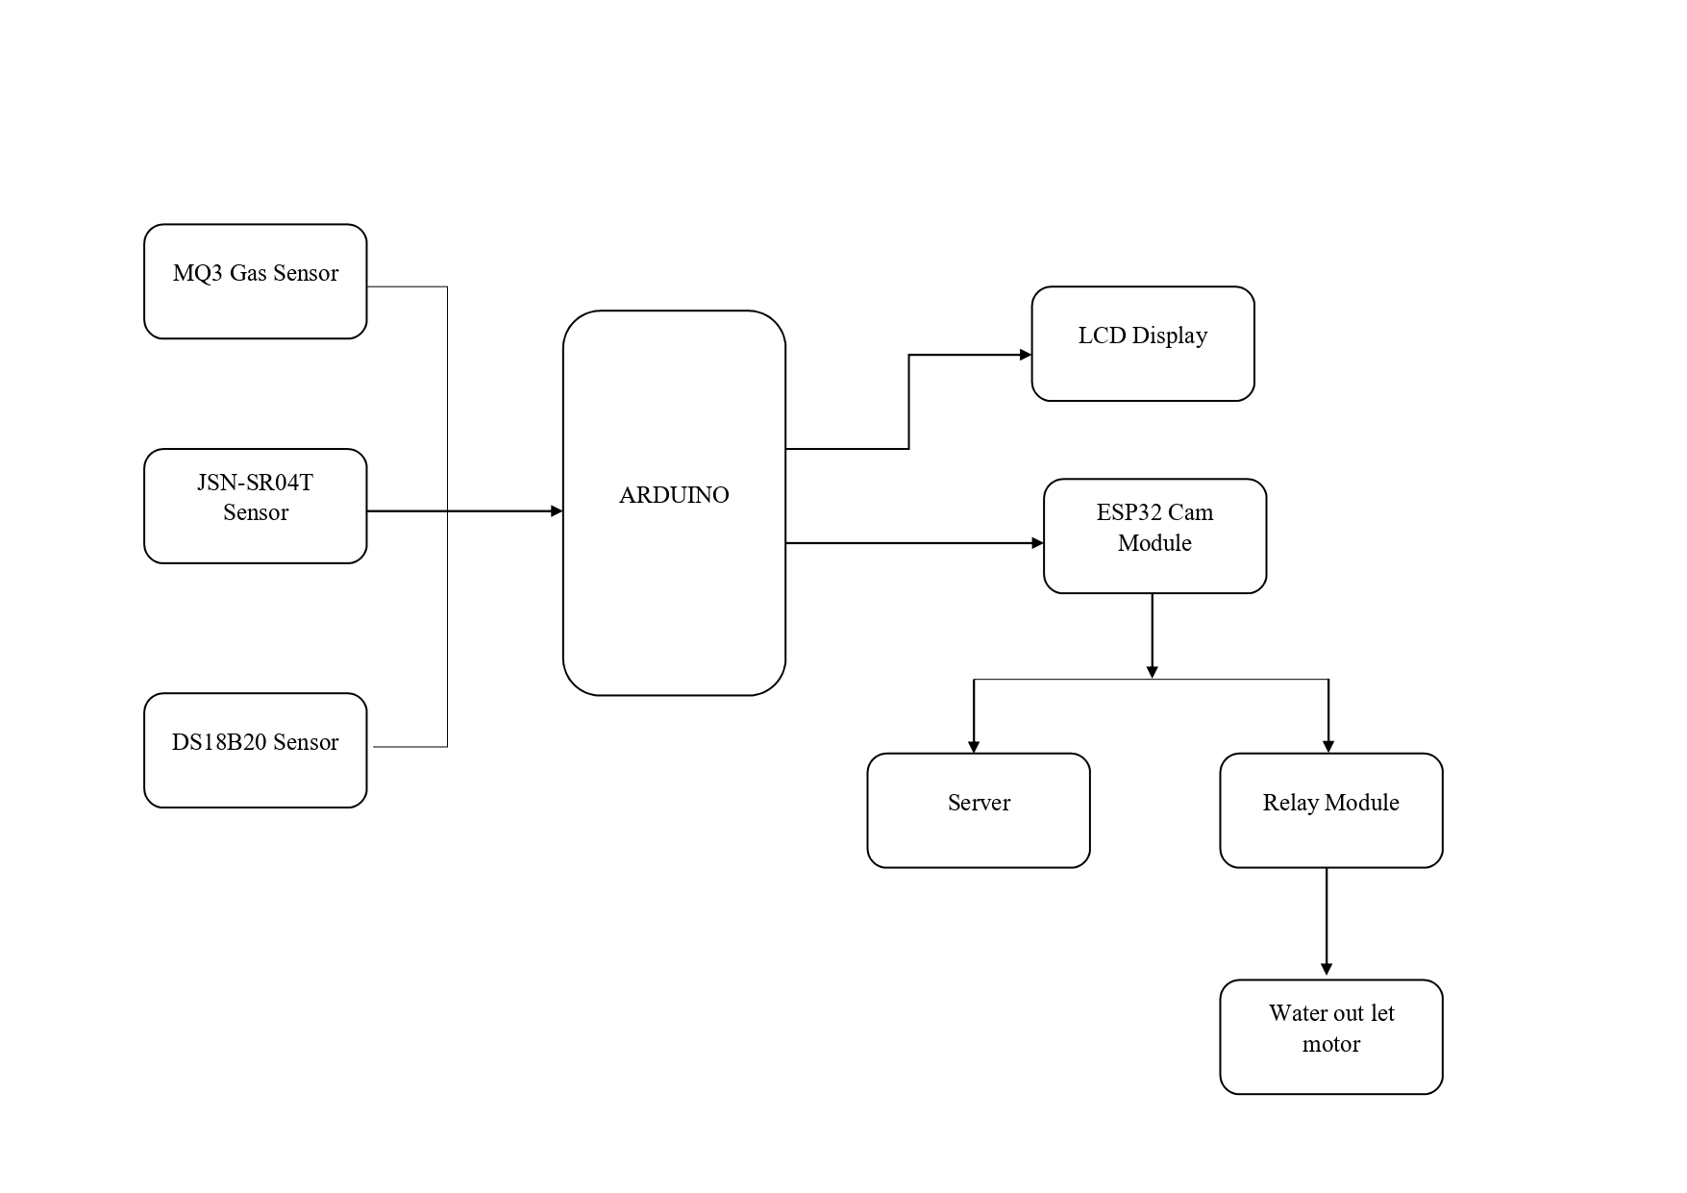

## Figure 3.1 Block Diagram of Hydro stagnation rescue system

person in stagnant water and alert rescue teams. Additionally, the system includes a water pump motor that helps to pump out water from the area where a person is drowning.

The ESP32-CAM module is a powerful microcontroller that includes a Wi-Fi module, a camera sensor, and a micro-SD card slot. The ESP32-CAM module will be used to capture images of the stagnant water body and analyse them using an image processing algorithm to detect the presence of a drowning person. The AI thinker module provides voice control functionality to the system, making it easy for people to interact with the system and alert the rescue team.

The proposed system also includes several sensors that measure temperature, water level, and alcohol content. The temperature sensor will monitor the temperature of the water body continuously. If the temperature rises above a certain threshold, an alert will be generated, notifying the rescue team. The water level sensor will monitor the height of the water level in the stagnant water body. If the water level rises above a certain level, an alert will be generated, notifying the rescue team. The alcohol sensor will detect the presence of an alcoholic person around the stagnant water body. If an alcoholic person is detected, an alert will be generated, notifying the rescue team.

Once a drowning person is detected, the water pump motor will turn on to pump out the water from the area where the person is drowning. The system will also send a rescue message to the rescue team.

**3.8 CIRCUIT DESCRIPTION**

In this circuit, Pin 8 of the Arduino is connected to the trigger pin of the HC-SR04 ultrasonic sensor, and pin 9 of the Arduino is connected to the echo pin of the HC-SR04 sensor. These pins are used to send a pulse and measure the time it takes for the pulse to bounce back, allowing you to calculate the distance between the sensor and an object.

Pin 7 of the Arduino is connected to the data pin of the temperature sensor, which provides temperature readings to the Arduino.

Pins 11, 10, 5, 4, 3, and 2 of the Arduino are connected to the enable, reset, and data pins of the relay module, respectively. These pins are used to control the relay module, which can switch on or off a high-powered circuit like a motor.

The power and ground pins of the ESP32 camera module are connected to the power and ground pins of the Arduino. This is done to power the camera module and ensure that it is properly grounded

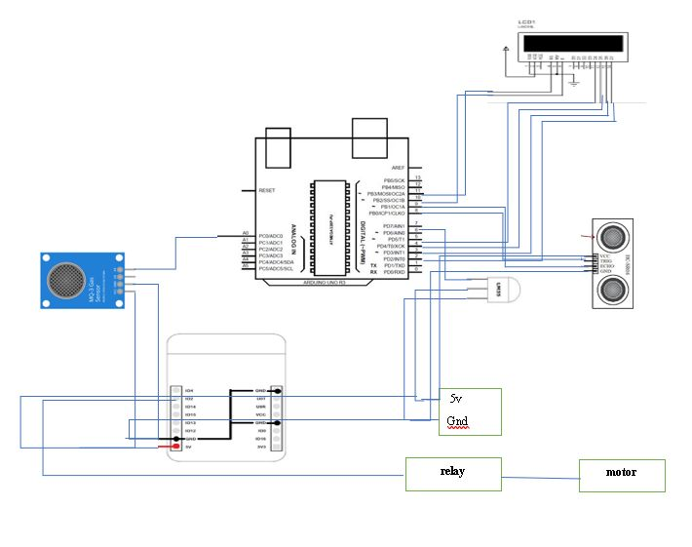Pin 2 of the ESP32 module is connected to the control pin of the relay module. This allows the Arduino to turn the relay on or off, which in turn controls the motor.

To summarize, the Arduino is used to read temperature data from a sensor, measure distances using an ultrasonic sensor, and control a motor using a relay module. The ESP32 camera module is also powered by the Arduino and is used to capture images or video as needed.

**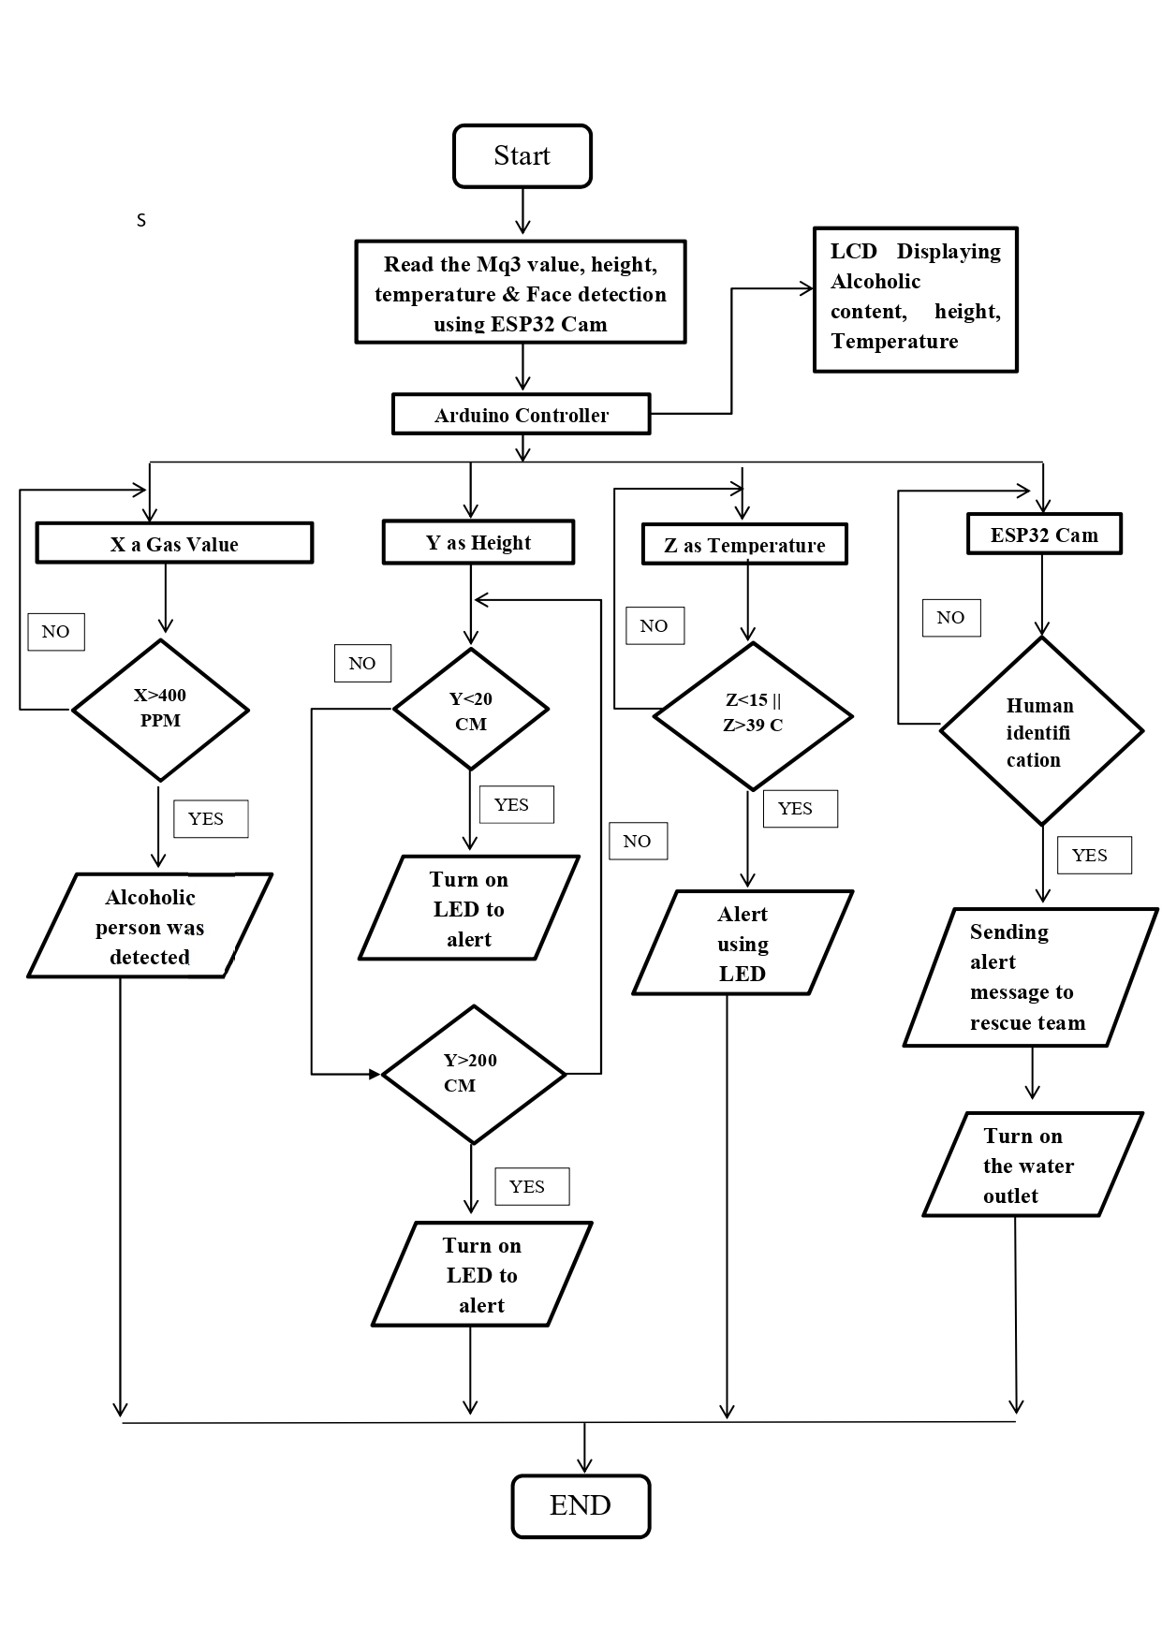**

## Figure 3.2 Flow Chart of Hydro stagnation rescue system

**3.8.1 DESCRIPTION ABOUT METHOD OF WORKING:**

**Step 1:** Installation of the system

The first step is to install the system in the vicinity of stagnant water bodies. The system includes the ESP32-CAM module, AI thinker module, water pump motor, and several sensors. The system needs to be installed at a location where it can capture images of the stagnant water body and monitor the temperature, water level, and alcohol content.

**Step 2:** Image processing

The ESP32-CAM module will capture images of the stagnant water body periodically. These images will be analysed using an image processing algorithm to detect the presence of a drowning person.

**Step 3:** Detection of a drowning person

If a drowning person is detected, the system will activate the water pump motor to pump out the water from the area where the person is drowning. The system will also send a rescue message to the rescue team, including the location of the drowning person.

**Step 4:** Continuous monitoring

The temperature sensor and the water level sensor will continuously monitor the temperature and height of the water level in the stagnant water body. If the temperature rises above a certain threshold or the water level rises above a certain level, an alert will be generated, notifying the rescue team.

**Step 5:** Detection of an alcoholic person

The alcohol sensor will continuously monitor the area around the stagnant water body for the presence of an alcoholic person. If an alcoholic person is detected, an alert will be generated, notifying the rescue team.

The proposed system has several benefits, including the ability to detect the presence of a drowning person even when there are no witnesses around. The system can also detect the presence of an alcoholic person around the stagnant water body, potentially preventing drowning incidents caused by impaired judgment and coordination. Another significant benefit of the proposed system is its ability to pump out water from the area where a person is drowning. This feature can potentially save lives by quickly removing water from the area and allowing the drowning person to breathe. Furthermore, the system can help prevent drowning incidents caused by flooding. The system can detect the rising water level and alert

## ADVANTAGES:

## Early Detection: By utilizing sensors such as the ESP32 cam and AI thinker, the system can detect the presence of a person in the stagnant water at an early stage. This allows for prompt action and increases the chances of successful rescue.

## Accurate Monitoring: The system incorporates temperature and water level sensors to provide accurate monitoring of the hydro parameters. This ensures that dangerous conditions, such as extremely cold water or high water levels, can be detected and appropriate measures can be taken.

## Alcoholic Person Detection: The inclusion of an alcoholic sensor adds an additional layer of safety by detecting the presence of individuals who may be under the influence of alcohol. This helps in preventing accidents and minimizing the risk of drowning.

## Real-time Alerts: The system is equipped with an alert mechanism that can quickly notify rescue teams or relevant authorities about a potential drowning situation. Real-time alerts enable swift response and increase the chances of saving lives.

## Enhanced Safety Measures: With its comprehensive approach, the system provides an added layer of safety by combining multiple sensors and technologies. This holistic approach improves the overall safety and reduces the risks associated with stagnant water bodies.

## 

**3.9 HARDWARE REQUIREMENTS:**

* ARDUINO UNO
* WATER PROOF ULTRASONIC SENSOR
* WATER PROOF TEMPERATUE SENSOR
* MQ3 SENSOR
* RELAY MODULE
* LCD DISPLAY

## 3.10 SOFTWARE REQUIREMENTS:

* ARDUINO

**CHAPTER 4**

## HARDWARE AND SOFTWARE DESCRIPTION

**4.1 ARDUINO UNO CONTROLLER**

**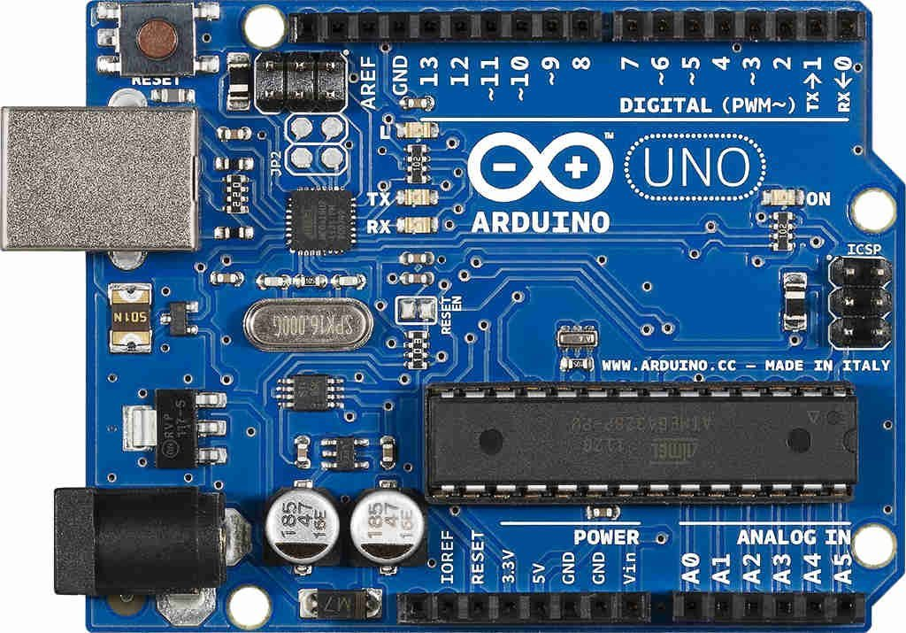**

**Figure 4.1 Arduino Uno Controller**

Arduino UNO is a microcontroller board based on the **ATmega328P**. It has 14 digital input/output pins (of which 6 can be used as PWM outputs), 6 analog inputs, a 16 MHz ceramic resonator, a USB connection, a power jack, an ICSP header and a reset button. It contains everything needed to support the microcontroller; simply connect it to a computer with a USB cable or power it with a AC-to-DC adapter or battery to get started. You can tinker with your UNO without worrying too much about doing something wrong, worst case scenario you can replace the chip for a few dollars and start over again.

The Arduino UNO is the best board to get started with electronics and coding. If this is your first experience tinkering with the platform, the UNO is the most robust board you can start playing with. The UNO is the most used and documented board of the whole Arduino family. The Arduino project started at the Interaction Design Institute Ivrea (IDII) in Ivrea, Italy. At that time, the students used a BASIC Stamp microcontroller, at a cost that was a considerable expense for many students. In 2003, Hernando Barragan created the development platform wiring as a Master's thesis project at IDII, under the supervision of Massimo Banzi and Casey Reas, who are known for work on the Processing language. The project goal was to create simple, low-cost tools for creating digital projects by non-engineers. The Wiring platform consisted of a printed circuit board (PCB) with an ATmega168 microcontroller, an IDE based on Processing, and library functions to easily program the microcontroller. In 2003, Massimo Banzi, with David Mellis, another IDII student, and David Cuartielles, added support for the cheaper ATmega8 microcontroller to Wiring. But instead of continuing the work on Wiring, they forked the project and renamed it Arduino. Early arduino boards used the FTDI USB-to-UART serial chip and an ATmega168.The Uno differed from all preceding boards by featuring the ATmega328P microcontroller and an ATmega16U2 (Atmega8U2 up to version R2) programmed as a USB-to-serial converter.

## ARDUINO UNO ARCHITECTURE

The Arduino UNO includes 6 analog pin inputs, 14 digital pins, a USB connector, a power jack, and an ICSP (In-Circuit Serial Programming) header. It is programmed based on IDE, which stands for Integrated Development Environment. It can run on both online and offline platforms.

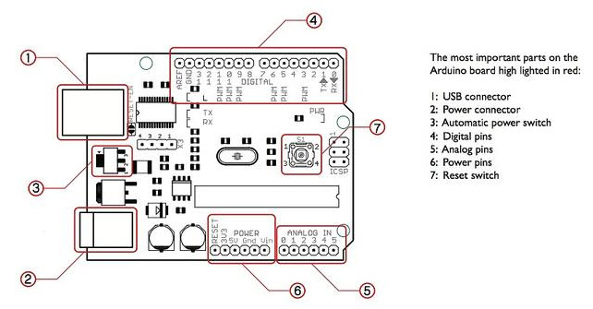

## Figure 4.2 Arduino Uno Architecture

## aian_0416.pngFigure 4.3 Arduino Uno Pin Diagram

**VIN:**This is the input voltage pin of the Arduino board used to provide input supply from an external power source.

**5V:**This pin of the Arduino board is used as a regulated power supply voltage and it is used to give supply to the board as well as onboard components.

**3.3V:** This pin of the board is used to provide a supply of 3.3V which is generated from a voltage regulator on the board

**GND:** This pin of the board is used to ground the Arduino board.

**Reset:** This pin of the board is used to reset the microcontroller. It is used to Resets the microcontroller.

**Analog Pins:**The pins A0 to A5 are used as an analog input and it is in the range of 0-5V.

**Digital Pins:**The pins 0 to 13 are used as a digital input or output for the Arduino board.

**Serial Pins:** These pins are also known as a UART pin. It is used for communication between the Arduino board and a computer or other devices. The transmitter pin number 1 and receiver pin number 0 is used to transmit and receive the data resp.

**External Interrupt Pins:** This pin of the Arduino board is used to produce the External interrupt and it is done by pin numbers 2 and 3.

**PWM Pins:** This pins of the board is used to convert the digital signal into an analog by varying the width of the Pulse. The pin numbers 3, 5, 6, 9, 10 and 11 are used as a PWM pin.

**SPI Pins:** This is the Serial Peripheral Interface pin, it is used to maintain SPI communication with the help of the SPI library. SPI pins include:

1. SS: Pin number 10 is used as a Slave Select
2. MOSI: Pin number 11 is used as a Master Out Slave In
3. MISO: Pin number 12 is used as a Master In Slave Out
4. SCK: Pin number 13 is used as a Serial Clock

**LED Pin:**  The board has an inbuilt LED using digital pin-13. The LED glows only when the digital pin becomes high.

**AREF Pin:** This is an analog reference pin of the Arduino board. It is used to provide a reference voltage from an external power supply.

## BOARD SPECIFICATIONS

|  |  |
| --- | --- |
| MICROCONTROLLER | ATmega328P |
| OPERATING VOLTAGE | 5V |
| INPUT VOLTAGE (RECOMMENDED) | 7-12V |
| IN OUT VOLTAGE (LIMIT) | 6-20V |
| DIGITAL I/O PINS | 14 (of which 6 provide PWM output) |
| PWM DIGITAL I/O PINS | 6 |
| ANALOG INPUT PINS | 6 |
| DC CURRENT PER I/O PIN | 20mA |
| DC CURRENT FOR 3.3V PIN | 50mA |
| FLASH MEMORY | 32KB |
| SRAM | 2 KB (ATmega328P) |
| EEPROM | 1 KB(ATmega328P) |
| CLOCK SPEED | 16 MHZ |
| LED\_BUILTIN | 13 |
| LENGTH | 68.6 mm |
| WIDTH | * 1. mm |
| WEIGHT |  |

**Figure 4.4 Board Specification of Arduino Uno**

## 4.1.3 ADVANTAGES OF ARDUINO UNO:

* Easy to Use. Arduino is super easy to learn.
* Inexpensive Hardware. Arduino boards are available at low cost.
* Active User Community.
* Cross Platform Support.
* Tons of Libraries.
* Lack of Multitasking.
* Not Optimized for Performance.
* Lack of Communications.

## JSN-SR04T ULTRASONIC SENSOR

* This ultrasonic sensor is very similar to the ultrasonic sensors which are found in cars. This Waterproof Ultrasonic Obstacle Sensor shows some important constructional advantages over the conventional sensors. It comes in two separate parts one being the transducer which is the sensing element and the other being the control board.
* **The module is capable of providing information of the objects between the distance ranges of 250 mm to 4500 mm.** The great advantage of using this Waterproof Ultrasonic Obstacle Sensor is you can put the sensing element far away from all the control circuitry.
* This Ultrasonic Distance Sensor is an industrial-grade sensor to measure distance. Interfacing with it is the same as another cheap ultrasonic sensor, but it offers **better performance and is compatible with harsher environments and is waterproof too!** It can be easily interfaced with Arduino and Sample codes and projects are available.
* There are many ultrasonic distance sensors on the market, but sometimes, this kind of sensor needs to work in vulnerable conditions. This Waterproof Ultrasonic Obstacle Sensor meets this requirement. It has a good performance and almost the same usage of an HC-SR04 module.

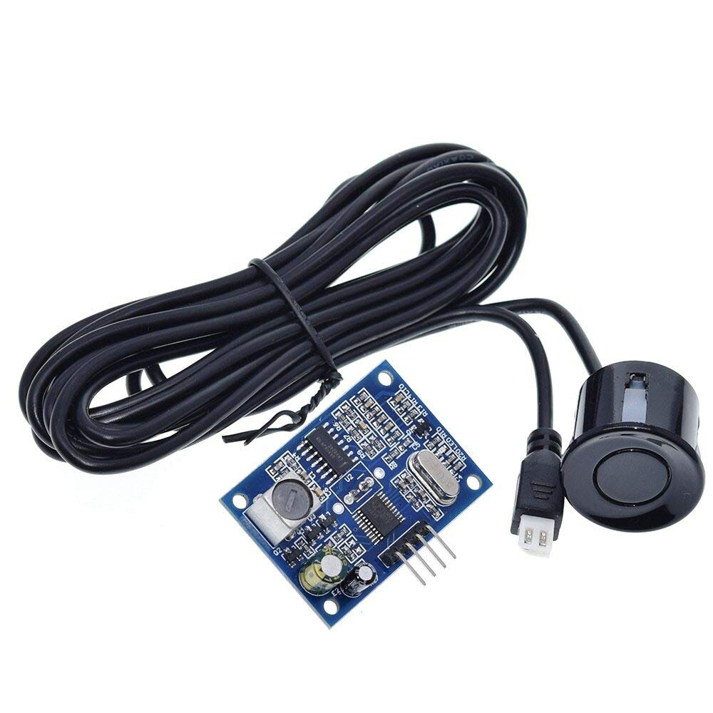

## Figure 4.5 JSN-SR04T Water Proof Ultrasonic Sensor

It is very easy to use, a control port with a 10US above high level can wait for high-level output at the receiving port. An output can drive the timer when this port is low can read the timer value, this time for the location of the time can be distance measurement. Constantly cycle tests that can achieve the measurement of the value of your mobile.

**4.2.1 THEORY OF OPERATION**

In operation, the sensor transmits pulses of ultrasonic sound and then listens to see if they get reflected back. If they do, then the time delay between transmission and reception is measured. This time delay can be used to compute the distance to the object that reflected the sound

* Turn on TRIG Pin to 5V for at least 10uS
* The module will then automatically send 8 40KHz tones and automatically detect when the signal return after reflecting back from the object
* Upon detecting the signal, a high-level signal is outputted through the IO Pin ECHO. By keeping track of the time duration between transmitting and receiving the signal, the distance can be calculated. Distance = (Time to Receive Reflected Signal \* speed of sound (340M/S)) /2

**Distance = Speed × Time**

In operation, the sensor transmits pulses of ultrasonic sound and then listens to see if they get reflected back. If they do, then the time delay between transmission and reception is measured. This time delay can be used to compute the distance to the object that reflected the sound.

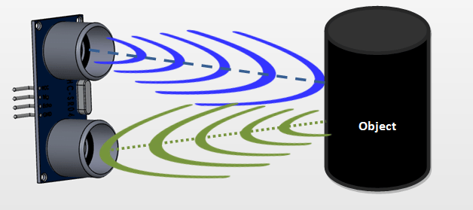

## Figure 4.6 Working of Water Proof Ultrasonic Sensor

The JSN-SR0T4 is a waterproof ultrasonic distance/range measurement sensor module with a non-contact range/distance of 25 cm to 450 cm and is very similar to the ultrasonic sensor found in a car bumper. It Operates from a nominal supply voltage of 4.5 V to 5.5 V DC. However, they typically operate at 5.0 VDC and require 30 mA of maximum current. The equivalent of JSNSR04T Waterproof ultrasonic is the HC-SR04 ultrasonic sensor. The alternatives of JSNSR04T are the IR sensor module, US transmitter-receiver module, IR sensor pair, and IR analog distance sensor. This article gives a brief description of how to use the JSNSR04Twaterproofultrasonicsensor.

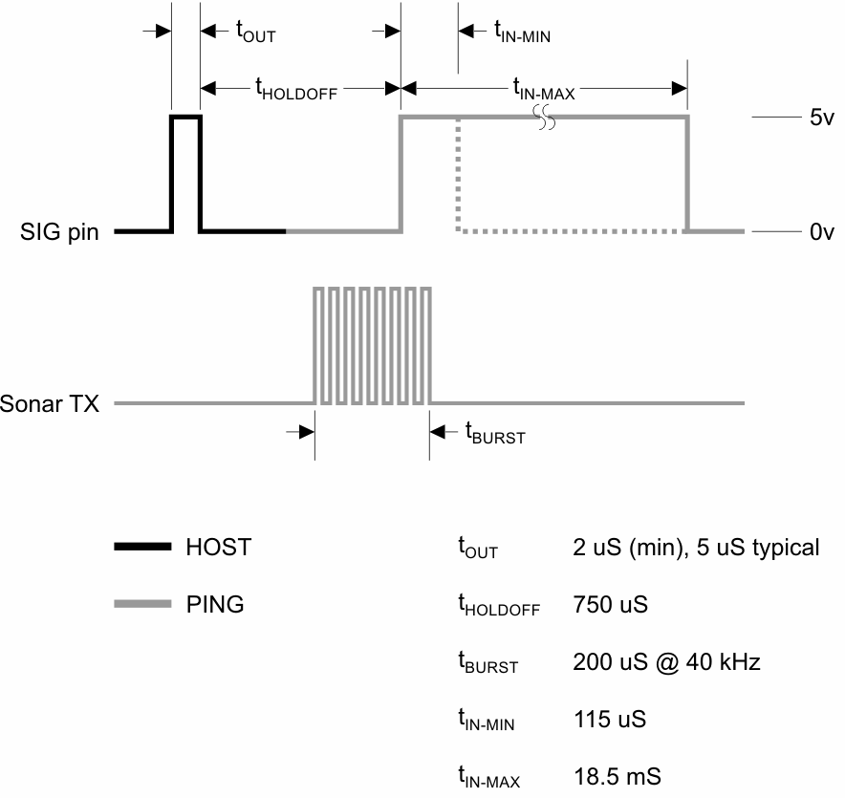

## Figure 4.7 Ultrasonic Sensor Range Waveform

**4.2.2 FEATURES**

## Operating voltage: DC3.0-5.5V.

## Static current: >8mA.

## Operating current: 30mA.

## Operating range: 20cm ~ 6m.

## Resolution: 1mm.

## Detecting Angle: < 75°

## Operating Temperature: -20 ~ 70°C.

## 4.2.3 APPLICATIONS:

* Car Alarm systems.
* Residential and commercial security systems.
* Automatic doors opening systems.

## DS18B20 TEMPERATURE SENSOR

* The DS18B20 waterproof temperature sensor is a pre-wired, one-meter-long, sealed, waterproof digital temperature sensor probe and it is manufactured by Dallas semiconductor and maxim integrated corporations in a waterproof version. It is easy to use, well-designed and handy to measure the temperature in any environmental conditions.
* This is a 1 Meter Long Waterproof, sealed and pre-wired digital temperature sensor probe based on DS18B20 sensor. It is very handy for when you need to measure something far away, or in wet conditions. Because they are digital, you don't get any signal degradation even over long distance.
* These 1-wire digital temperature sensors are fairly precise (±0.5°C over much of the range) and can give up to 12 bits of precision from the onboard digital-to-analog converter. They work great with any microcontroller using a single digital pin, and you can even connect multiple ones to the same pin, each one has a unique 64-bit ID burned in at the factory to differentiate them. Usable with 3.0-5.0V systems.

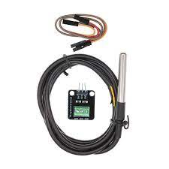

## Figure 4.8 DS18B20 Temperature Sensor

# 

# Figure 4.9 Circuit Diagram of DS18B20 Temperature Sensor

Measuring the temperature in difficult environments such as chemical storage, deep soils, and mines is not an easy task and most temperature sensors cannot withstand extreme heat and environmental conditions. So, the **DS18B20 waterproof temperature sensor** is used, which is waterproof and moisture-proof, and suitable in harsh and hazardous environments.

## 4.3.1 SPECIFICATIONS

* Operating Voltage: 3.0V –5.0V
* Detection range: 2cm – 30cm (Adjustable using potentiometer)
* Current Consumption: at 3.3V: ~23 mA, at 5.0V: ~43mA
* Active output level: Outputs Low logic level when obstacle is detected
* On board Obstacle Detection LED indicator

## 4.3.2 ADVANTAGES

* Very wide temperature range about -200oC to +2500oC
* Fast response time
* They are a simple construction
* Low initial cost
* Durable
* Easy to read has a clear screen and good scale
* Quick response for any temperature changes
* Precision accuracy in temperature measurement
* It is not easily broken good durability
* Good to be used temperature variation measurement with below 1 cm distance range

## 4.3.3 DISADVANTAGES

* Not as stable as RTD
* Recalibration is difficult
* More susceptible to RFI/EMI
* They are nonlinear
* It is used for only temperature measurement only
* They have a low output voltage
* Less sensitivity
* They require a reference for operation
* The stray voltage pick up is possible

## download (1).jpgMQ3 ALCOHOL SENSOR

**Figure 4.10 MQ3 Alcohol Sensor**

The MQ3 sensor is one of the most widely used in the MQ sensor series. It is a MOS (Metal Oxide Semiconductor) sensor. Metal oxide sensors are also known as **Chemiresistors** because sensing is based on the change in resistance of the sensing material when exposed to alcohol. The MQ3 sensor is one of the most widely used in the MQ sensor series. It is a MOS (Metal Oxide Semiconductor) sensor. Metal oxide sensors are also known as **Chemiresistors** because sensing is based on the change in resistance of the sensing material when exposed to alcohol.

The MQ3 alcohol sensor operates on 5V DC and consumes approximately 800mW. It can detect alcohol concentrations ranging from 25 to 500 ppm. The MQ3 is a heater-driven sensor. It is therefore covered with two layers of fine stainless steel mesh known as an “anti-explosion network”. It ensures that the heater element inside the sensor does not cause an explosion because we are sensing flammable gas (alcohol). It also protects the sensor and filters out suspended particles, allowing only gaseous elements to pass through the chamber.

## 4.4.1 SPECIFICATIONS

* Operating voltage 5V
* Load resistance 200 KΩ
* Heater resistance 33Ω ± 5%
* Heating consumption <800mw
* Sensing Resistance 1 MΩ – 8 MΩ
* Concentration Range 25 – 500 ppm
* Preheat Time Over 24 hour

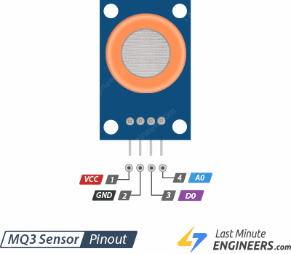

**Figure 4.11 PIN Configuration of MQ3 Sensor**

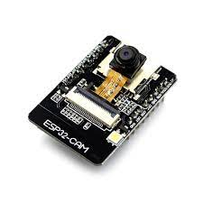**4.5 ESP32 CAM**

**Figure 4.12 ESP32 Cam**

The ESP32-CAM is a small size, low power consumption camera module based on ESP32. It comes with an OV2640 camera and provides onboard TF card slot. The ESP32-CAM can be widely used in intelligent IoT applications such as wireless video monitoring, Wi-Fi image upload, QR identification, and so on.

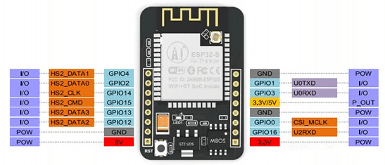

## Figure 4.13 Representation of ESP32 Cam

The ESP32-CAM board has built-in Wi-Fi and Bluetooth connectivity, allowing it to communicate with other devices or the internet. It can be programmed using the Arduino IDE or the ESP-IDF (Expressive IoT Development Framework), which is the official development framework for the ESP32.

The camera module on the ESP32-CAM board uses an OV2640 sensor that supports up to 1600x1200 resolution. It can capture images and video in various formats such as JPEG, BMP, and YUV. The micro SD card slot on the board can be used to store the images and videos captured by the camera.

The ESP32-CAM board can be used in a wide range of applications, including home automation, security systems, robotics, and industrial automation. It is capable of streaming live video over Wi-Fi, making it ideal for projects that require real-time monitoring of remote locations.

## 4.5.1 OPERATING PRINCIPLE

The operating principle of the ESP32-CAM involves several components working together. The ESP32 chip is the heart of the module, and it provides the processing power and Wi-Fi connectivity. The camera sensor captures images and sends them to the ESP32 chip for processing. The module also includes flash memory for storing images and other data.

The ESP32-CAM can be programmed using the Arduino IDE, which provides a simple and easy-to-use development environment. The Arduino code can control the camera module, capture images and video, and send them over the internet via Wi-Fi.

To use the ESP32-CAM, you need to connect it to a power source, such as a battery or USB cable. You also need to provide a micro SD card for storing images and other data.

**4.5.2 WORKING PRINCIPLE FOR FACE DETECTION:**

* Importing the necessary libraries: You need to include the appropriate libraries for face detection. Some popular libraries used in ESP32-based face detection include Open CV, Tensor Flow, and MTCNN.
* Setting up the camera: ESP32 typically uses a camera module to capture images for face detection. You need to initialize the camera and configure its settings such as resolution, brightness, and contrast.
* Preprocessing the images: Before you can perform face detection on an image, you need to preprocess it by converting it to grayscale or normalizing the pixel values.
* Loading the face detection model: You need to load a pre-trained face detection model that can detect human faces in an image. The model can be trained using various machine learning techniques such as Haar cascades, CNN, or MTCNN.
* Running the face detection algorithm: Once the model is loaded, you can run the face detection algorithm on the preprocessed image to detect the location of human faces in the image.
* Displaying the results: You can display the results of the face detection algorithm by drawing a rectangle around the detected face or highlighting the facial features.

**4.6 LCD – LIQUID CRYSTAL DISPLAY**

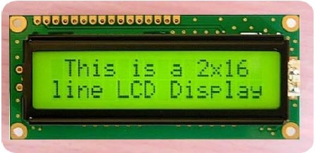

**Figure 4.14 LCD display**

Liquid Crystal Displays (LCDs) have materials, which combine the properties of both liquid and crystals. Rather than having a melting point, they have a temperature range within which the molecules are almost as mobile as they would be in a liquid, but are grouped together in an ordered form similar to a crystal. An LCD consists of two glass panels, with the liquid crystal material sand witched in between them. The inner surface of the glass plates is coated with transparent electrodes which define the character, symbols or patterns to be displayed polymeric layers are present in between the electrodes and the liquid crystal, which makes the liquid crystal molecules to maintain a defined orientation angle. One each polarizer is pasted outside the two glass panels. This polarizer would rotate the light rays passing through them to a definite angle, in a particular direction. When the LCD is in the off state, light rays are rotated by the two polarizer and the liquid crystal, such that the light rays come out of the LCD without any orientation, and hence the LCD appears transparent. When sufficient voltage is applied to the electrodes, the liquid crystal molecules would be aligned in a specific direction. The light rays passing through the LCD would be rotated by the polarizer, which would result in activating / highlighting the desired characters.

LCD display used in our project for title message and information message. Our project connects to a microcontroller unit data line connected to a ‘PORT 2’ and control lines connected to a P3.5, P3.6, P3.7.

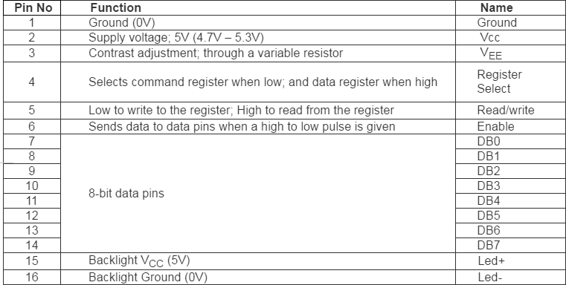

## Table 4.15 PIN Description of LCD Display

**4.6.1 FEATURES:**

* Operating Voltage is 4.7V to 5.3V
* Current consumption is 1mA without backlight
* Alphanumeric LCD display module, meaning can display alphabets and numbers
* Consists of two rows and each row can print 16 characters.
* Each character is built by a 5×8-pixel box
* Can work on both 8-bit and 4-bit mode
* It can also display any custom generated characters
* Available in Green and Blue Backlight.

## CHAPTER 5

## SYSTEM TESTING & MAINTANANCE

## 5.1 SOFTWARE REQUIREMENT

**5.1.1 ARDUINO IDE**

* Install the ESP32 core for Arduino IDE: To use the ESP32 in Arduino IDE, you first need to install the ESP32 core for Arduino IDE. Open the Arduino IDE and go to File > Preferences. In the Additional Boards Manager URLs field, enter the following URL: https://dl.espressif.com/dl/package\_esp32\_index.json. Then, go to Tools > Board > Boards Manager, search for "esp32" and install the ESP32 board package.
* Select the board: Once the ESP32 board package is installed, you can select the appropriate board by going to Tools > Board and selecting your ESP32 board.
* Select the serial port: Connect your ESP32 board to your computer using a USB cable and select the appropriate serial port by going to Tools > Port and selecting the correct port.
* Upload the sketch: You can now upload your Arduino sketch to the ESP32 board by clicking on the Upload button (the right-facing arrow icon) in the Arduino IDE toolbar.
* Verify the upload: After the upload is complete, you can verify that the sketch is running on the ESP32 board by opening the Serial Monitor (Tools > Serial Monitor) and selecting the correct serial port and baud rate. You should see output from your sketch in the Serial Monitor.

## 5.2 SYSTEM TESTING

System testing is an important phase without which a system cannot be released to users.

* + - Error detection and removal
    - Determine level of reliability
    - Done by independent quality assurance group (except for unit testing)

## APPLICATION BEHAVIOR

It is one of the embedded application testing. It checks whether the output is correct or not. Tests are made for applicable in real time application.

## PERFORMANCE

MQ3 sensor, Ultrasonic sensor, Temperature sensor and ESP32 Cam are deployed in this project collects the corresponding data and transmits those data to ARDUINO UNO which in turn displays those data in LCD screen and it also transmits those data to distant user using server within stipulated time.

## ROBUSTNESS

Tests are made for clarifying the error. Here, it checks whether the human is detected and collects the water parameter by the system or not and checks the clearness of the output.

## ACCEPTANCE TESTING

It is a test conducted to determine if the requirements of a specification contract to new data.

|  |  |  |  |  |  |  |
| --- | --- | --- | --- | --- | --- | --- |
| Test Objective - Test for determined result of each module | | | | | | |
| Prerequisite Tests: Nil | | Tested on | 05-03-2023 | | | |
| Tested by | K. JANARTHANAN  A. ESSAKI SURIYA  A. MAHESH RAJ  M. DURAIRAJA | | | |
| Test Environment  Hardware: ARDIUNO AND ESP32 CAM  Software: ARDIUNO IDE | | Estimated time | 40 Minutes | | | |
| Time taken | 25 Minutes | | | |
| No. | Action | Expected  Results | | Input | Result  Pass/Fail | Remarks |
| T1 | Checking the ESP32 Cam | It checks the face detection and updates the occurrence of theft detection to Arduino with browser. | |  | Pass |  |
| T2 | Checking the Ultrasonic sensor, Temperature Sensor and MQ3 Gas Sensor | It detects the Obstacles both front and sides of the Stagnation and send the data to the Arduino. | |  | Pass |  |
| T3 | Checking the information shared through Server | ESP32 Cam collects the data from stagnation and transmit it to distant user through Server. | |  | Pass |  |

## Table 5.1 Test Case

**5.3 SYSTEM MAINTENANCE**

## Regular inspections: The system should be regularly inspected to ensure that all components, including the ESP32 Cam, sensors, and other electronic components, are functioning properly. Any damaged or malfunctioning parts should be repaired or replaced as necessary.

## Cleaning: The system should be kept clean and free of debris and other obstructions that could interfere with the detection of humans in water. Regular cleaning can help prevent damage to the system and ensure accurate detection.

## Calibration: The sensors used in the system may require periodic calibration to ensure accurate detection of human presence in water. This may involve adjusting the sensitivity of the sensors or other parameters.

## Firmware updates: The firmware of the ESP32 Cam and other electronic components should be regularly updated to ensure that the system is functioning optimally and that any bugs or security vulnerabilities are addressed.

## Battery replacement: If the system is powered by a battery, the battery should be replaced periodically to ensure that the system has adequate power to function.

## Regular testing: The system should be regularly tested to ensure that it is functioning properly and accurately detecting humans in water. This may involve simulating different scenarios or testing the system in different types of water conditions.

## CHAPTER 6

**CONCLUSION AND FUTURE RECOMMENDATIONS**

**6.1 CONCLUSION**

## In conclusion, the proposed system to detect drowning persons in stagnant water is an innovative solution to reduce the number of drowning incidents worldwide. The system uses the ESP32-CAM module with AI thinker and several sensors to detect drowning persons in stagnant water and alert rescue teams. Additionally, the system includes a water pump motor that helps to pump out water from the area where a person is drowning.

## The proposed system has several benefits, including the ability to detect the presence of a drowning person even when there are no witnesses around. The system can also detect the presence of an alcoholic person around the stagnant water body, potentially preventing drowning incidents caused by impaired judgment and coordination.

## Moreover, the system can help prevent drowning incidents caused by flooding. The system can detect the rising water level and alert rescue teams, potentially saving lives by evacuating people from the area before the water level becomes dangerous.

## However, the proposed system has some limitations. Firstly, the system requires a reliable Wi-Fi connection to send alerts to the rescue team. If there is no Wi-Fi connection available, the system will not be able to send alerts. Secondly, the system's effectiveness may be limited in situations where the stagnant water body is too large or deep, making it challenging to detect drowning persons. Finally, the system's cost may be a limiting factor for some communities, making it difficult to implement in low-income areas.

## In conclusion, the proposed system is a life-saving technology that has the potential to reduce the number of drowning incidents worldwide. With continued research and development, the proposed system can become an effective and affordable solution to prevent drowning incidents and save lives.

## 6.2 FUTURE RECOMMENDATIONS

## Future works can focus on improving the system's accuracy and reliability in detecting drowning persons in stagnant water. For example, the system can use advanced image processing algorithms to detect subtle movements of drowning persons in the water, making it easier to detect them. Additionally, future works can focus on developing a mobile application that can be used to control the system remotely and receive alerts in real-time.

## CHAPTER 7

## APPENDIX

* 1. **OUTPUT:**

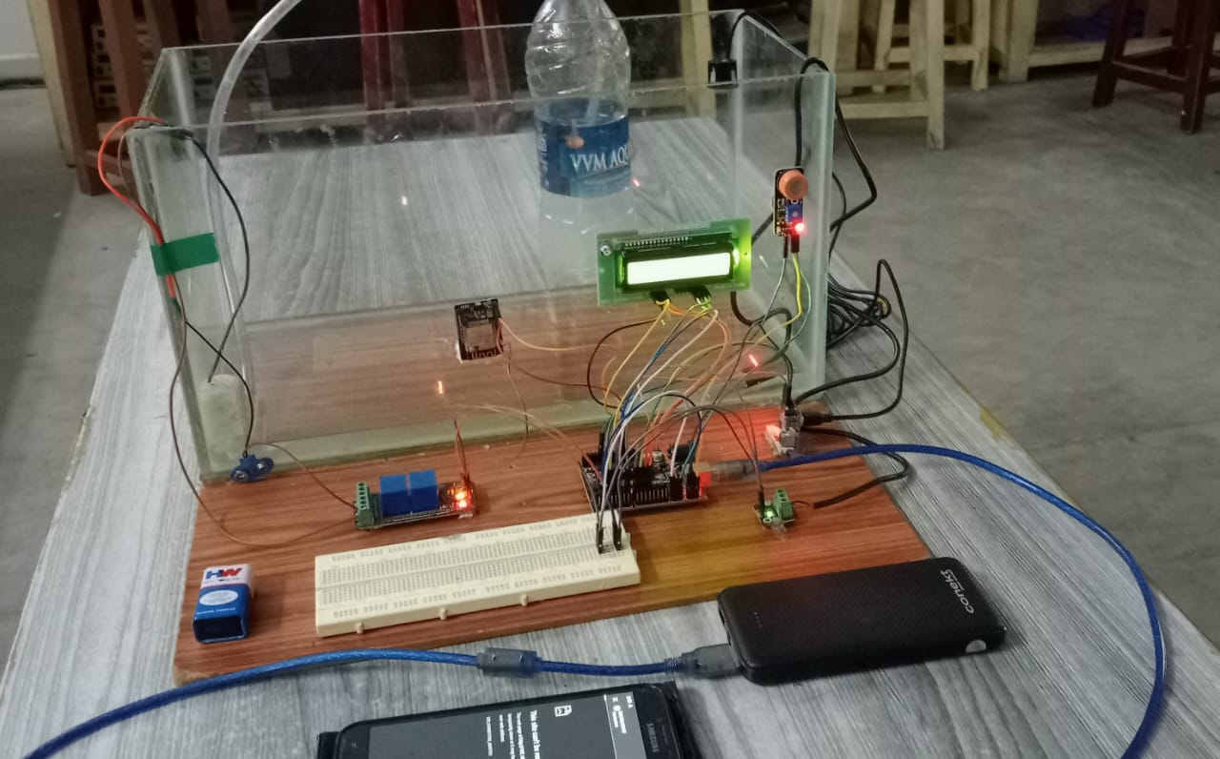

**Figure 10.1 Overall System setup**

Figure 10.1 shows that the overall system setup consists of Arduino Uno, Water proof temperature Sensors, water proof Ultrasonic Sensors, LCD Display, Relay module and Motor.

## OUTPUT OF RECORDING MODE

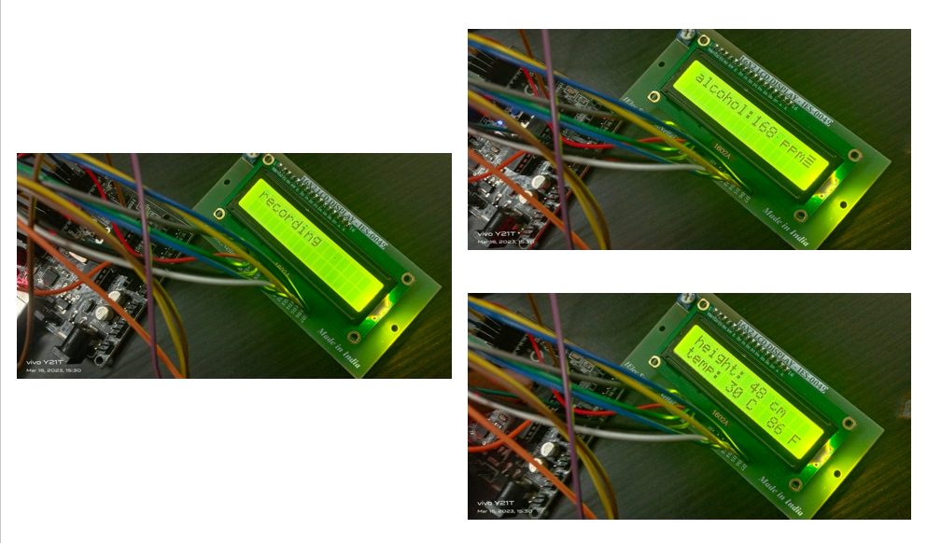

**Figure 7.2 Recording Mode**

## 7.1.2 OUTPUT OF READING MODE

****

**Figure 7.3 Output of JSN-SR04T Ultrasonic Sensor**

Figure 10.3 shows that the ultrasonic sensor doesn't sense any obstacles, the level of water in Stagnation. When it senses any obstacles, the Value of water level in stagnation will be show on the LCD display.

****

**Figure 7.4 Output of DS18B20 Temperature Sensor**

Figure 10.4 shows that the output of Water proof temperature sensors. When the right sensor senses current state of hydro stagnation in hot state, the LCD display shows right as 'HIGH Celsius ' and when the left sensor senses current state of hydro stagnation in cool state,, the LCD display shows left as 'LOW Celsius'.

****

**Figure 7.5 Output of MQ3 gas Sensor**

Figure 10.5 shows that the output of MQ3 gas sensors. When the right sensor senses detect the alcoholic person are entered into near the stagnation, the LCD display shows right as 'HIGH PPM ' and when the left sensor senses detect the un-alcoholic person are entered into near the stagnation, the LCD display shows left as 'LOW PPM'.

## OUTPUT OF RESULT

## 

**Figure 7.6 Final Output**

## Figure 10.6 shows that the output of detection a human, when someone drowning in the stagnation and alert the rescue team via server message.

## REFERENCES

1. S. Karthik, D. Priya E.L., G. Anand K.R. and A. Sharmila, "IoT Based Safety Enhanced Swimming Pool with Embedded Techniques to reduce drowning accidents," 2020 International Conference on Smart Electronics and Communication (ICOSEC), Trichy, India, 2020, pp. 843-847, doi: 10.1109/ICOSEC49089.2020.9215247.
2. R. Memon, S. Kulsoom Memon, A. A. Memon and T. Din Memon, "IoT Based Water Quality Monitoring System for Safe Drinking Water in Pakistan," 2020 3rd International Conference on Computing, Mathematics and Engineering Technologies (iCoMET), Sukkur, Pakistan, 2020, pp. 1-7, doi: 10.1109/iCoMET48670.2020.9074141.
3. H. Abdulwahid, "IoT Based Water Quality Monitoring System for Rural Areas," 2020 9th International Conference on Renewable Energy Research and Application (ICRERA), Glasgow, UK, 2020, pp. 279-282, doi: 10.1109/ICRERA49962.2020.9242798.
4. G. Simões, C. Dionísio, A. Glória, P. Sebastião and N. Souto, "Smart System for Monitoring and Control of Swimming Pools," 2019 IEEE 5th World Forum on Internet of Things (WF-IoT), Limerick, Ireland, 2019, pp. 829-832, doi: 10.1109/WF-IoT.2019.8767240.
5. P. Laxman and A. Jain, "Intelligent Swimming-pool design with Embedded Drown Alerting, Preventing and Autonomous Rescue System," 2021 Fourth International Conference on Computational Intelligence and Communication Technologies (CCICT), Sonepat, India, 2021, pp. 335-342, doi: 10.1109/CCICT53244.2021.00069.
6. Sangeetha, R. S. Krishnan, G. P. Kumar, E. G. Julie, R. K. Ganesh and Y. H. Robinson, "Smart Swimming Pool Management System (SSPMS) using IoT," 2023 International Conference on Innovative Data Communication Technologies and Application (ICIDCA), Uttarakhand, India, 2023, pp. 840-846, doi: 10.1109/ICIDCA56705.2023.10099729.
7. V. Pleština, V. Papić and H. Turić, "Swimming Pool Segmentation in Pre-processing for Tracking Water Polo Players," 2020 International Conference on Electrical, Communication, and Computer Engineering (ICECCE), Istanbul, Turkey, 2020, pp. 1-4, doi: 10.1109/ICECCE49384.2020.9179299.
8. N. Alshbatat, S. Alhameli, S. Almazrouei, S. Alhameli and W. Almarar, "Automated Vision-based Surveillance System to Detect Drowning Incidents in Swimming Pools," 2020 Advances in Science and Engineering Technology International Conferences (ASET), Dubai, United Arab Emirates, 2020, pp. 1-5, doi: 10.1109/ASET48392.2020.9118248.
9. S. M. Naji, A. Y. Almousily and A. Y. Alsharkawi, "Design a Fully Automated Safety and Security System for Swimming Pools," 2022 International Conference on Electrical and Computing Technologies and Applications (ICECTA), Ras Al Khaimah, United Arab Emirates, 2022, pp. 318-321, doi: 10.1109/ICECTA57148.2022.9990550.
10. J. Misiurewicz, K. Bruliński, W. Klembowski and K. Kulpa, "Multipath propagation of acoustic signal in a swimming pool," 2021 Signal Processing Symposium (SPSympo), LODZ, Poland, 2021, pp. 197-201, doi: 10.1109/SPSympo51155.2020.9593835.
11. M. Pushpavalli, P. Abirami, P. Sivagami, M. Kavitha, C. Bhuvaneswari and W. A. Memala, "Creation of a Drowning Prevention System for Kids Learning in Pool using Computational Technology," 2023 International Conference on Artificial Intelligence and Knowledge Discovery in Concurrent Engineering (ICECONF), Chennai, India, 2023, pp. 1-5, doi: 10.1109/ICECONF57129.2023.10083598.
12. M. A. Hayat, G. Yang and A. Iqbal, "Mask R-CNN Based Real Time near Drowning Person Detection System in Swimming Pools," 2022 Mohammad Ali Jinnah University International Conference on Computing (MAJICC), Karachi, Pakistan, 2022, pp. 1-6, doi: 10.1109/MAJICC56935.2022.9994135.