ADVANCE MOBILE APPLICATION DEVELOPMENT
FINAL PROJECT DOCUMENTATION

PROJECT TITLE
TourGo – A Collaborative Group Travel Planning and Real-Time Safety Coordination Platform

Prepared by:
Harry Sevilla

Subject:
Mobile Application Development
Submitted to:
Prof. Paul John D. Cabance
Date Submitted:
October 2026

TABLE OF CONTENTS
CHAPTER 1 – PROJECT OVERVIEW ............................................. 3
Introduction
Project Objectives
Scope of the Project
Limitations
CHAPTER 2 – SYSTEM ANALYSIS AND DESIGN ......................... 5
System Description
System Flow
Use Case Diagram
Database Design
User Interface Design
CHAPTER 3 – SYSTEM DEVELOPMENT ....................................... 11
Tools and Technologies Used
Development Process
CHAPTER 4 – RESULTS AND TESTING ...................................... 12
System Features
Functional Testing
Evaluation
CHAPTER 5 – CONCLUSION AND RECOMMENDATIONS .............. 15
Conclusion
Recommendations

CHAPTER 1
PROJECT OVERVIEW

Introduction
The project entitled "TourGo – A Collaborative Group Travel Planning and Real-Time Safety Coordination Platform" is a mobile application developed for Filipino friend groups (barkadas) to plan, organize, and coordinate trips together. It brings destination and date voting, a shared day-by-day itinerary, group expense splitting, real-time geofenced Guardian safety radar tracking, and Google Gemini AI travel planning into one platform, so groups no longer have to juggle multiple chat threads, spreadsheets, and navigation apps.

Project Objectives

General Objective
To develop a collaborative mobile application that helps barkadas plan, organize, and coordinate group trips efficiently and safely, from initial itinerary planning and on-trip geofenced safety tracking up to post-trip recaps and community sharing.

Specific Objectives
- 1. To streamline group decision-making through destination and date polling with live vote counters.
- 2. To provide a shared, synchronized day-by-day itinerary with sequential accuracy-checked route mapping.
- 3. To simplify shared travel expenses through itemized expense splitting and settlement tracking.
- 4. To improve group safety and coordination through real-time Guardian Mode geofenced radar tracking and automated perimeter-drift alerts.
- 5. To provide AI-assisted day-by-day travel itineraries and recommendations through Google Gemini AI integration.

Scope of the Project
The application can:
- • Authentication and Profiles (Email/password login, traveler preference onboarding, light/dark theme)
- • Social & Trip Coordination (user profile search, real-device push notifications with TourGo icon)
- • Trip Hosting and Joining (6-character invite codes and role-based permissions)
- • Destination and Date Polling, with organizer lock
- • Shared Itinerary and Route Mapping (with Leaflet.js, OpenStreetMap, and Photon discovery)
- • Logistics Coordination (Group and personal packing checklists)
- • Shared Expense Ledger and Settle Up (with receipt uploads and split calculations)
- • Guardian Safety Mode (real-time geofenced safe-zone perimeter radar and live member tracking)
- • Google Gemini AI Travel Assistant (smart day-plan generation)
- • Community Feed and Media Lightbox (unified itinerary cards and Facebook-style expandable photo gallery)

Limitations
- • Internet connection required for real-time synchronization with Supabase
- • Depends on third-party API quotas (Google Gemini AI and OpenStreetMap public servers)
- • Guardian Safety Mode requires GPS and user location permissions; it is opt-in and trip-scoped
- • No actual fiat payment processing or in-app booking; expense splitting and QR features are for coordination only
- • Currency conversions and travel times are approximate and for reference only

CHAPTER 2
SYSTEM ANALYSIS AND DESIGN

System Description
The application allows users to log in securely, customize their travel preferences, and be greeted by an animated soaring Philippine Eagle mascot on the home dashboard. A user can host a new trip—generating a 6-character invite code—or join an existing one using an invite code provided by their barkada organizer. Members propose and vote on destinations and dates, the organizer finalizes the tour, and the group builds a collaborative itinerary with optional Google Gemini AI suggestions. During the trip, members can log shared expenses, settle balances, view each other's live location on the Guardian geofenced radar map, and receive real-device push notifications whenever trip activities or itinerary changes occur. After the trip, an interactive scrapbook and community post can be published with expandable full-screen photos. All data is securely stored in Supabase (PostgreSQL, Auth, Storage, and Realtime) and synchronized across members' devices.

System Flow
The overall system flow of the application is as follows:
Start → Login (Email/Password) → Host / Join Trip (6-Char Code) → Vote → Lock Tour → Itinerary & AI Planner → Guardian Radar & Push Alerts → Trip Recap / Community → End
Detailed flow: The user registers or signs in using their credentials; the profile and travel preferences are loaded. The user chooses to host a new trip (enters title, destination, and dates, receiving a unique 6-character join code) or joins using a code from their organizer. Group members propose and vote on destination activities and dates. Once locked, members build a day-by-day itinerary or generate full schedules using Google Gemini AI. During the active trip, the organizer enables Guardian Mode with a configurable geofenced radius (in meters) to monitor member safety, while members log shared bills and receive real-device push notification alerts on every group update. At trip completion, a visual scrapbook is compiled and shared to the community feed with full-screen expandable photo lightbox support.

Use Case Diagram
The system involves the following actor and functions:
Actor:
- User – the actor of the system. Any registered user can host or join a trip, vote, build itineraries, track expenses, and use group travel tools. The user who creates a trip becomes its organizer and gains safety geofencing controls, tour locking, and member management.
Functions / Use Cases:
- • Login / Register – sign in via Supabase Auth and manage traveler profile and preferences
- • Host / Join Trip – create a trip with a 6-character invite code or join using an active code
- • Manage Participants – invite members, manage permissions, and assign organizer/member roles
- • Vote on Destination and Dates – propose candidate options and finalize the tour via organizer lock
- • Manage Itinerary & AI Planner – add day stops, resolve coordinates, and generate AI day schedules
- • Track Packing Checklists – manage assignable group tasks and private personal packing checklists
- • Manage Expenses & Splitter – log expenses, calculate equal/solo splits, and record payment proofs
- • Guardian Safety Radar & Push Notifications – view live member geofenced positions and receive instant alerts
- • Community Feed & Lightbox – publish unified trip recap cards and view photos in Facebook-style lightbox

Database Design
The application uses Supabase (PostgreSQL) for cloud data storage, authentication, and file storage (trip photos and expense receipts). Only the main core tables are shown below; supporting tables (notifications, push tokens, reactions, stays, checklist, and others) are omitted for brevity.

ERD Overview
Entities: Profiles, Trips, Trip Participants, Poll Options and Votes, Itinerary Items, Expenses, Expense Settlements, and Trip Recaps. A Profile can host or join many Trips through Trip Participants. Each Trip has many Poll Options (places or dates) that receive Votes, many Itinerary Items, many Expenses, and one Recap. Expense Settlements record payments between members for the expenses they owe.

Database Tables
Table: profiles
Field | Type | Description
id | UUID (PK) | User ID (linked to Supabase Auth)
first_name / last_name | Text | Name of the user
username | Text (Unique) | Unique username
email | Text | Email address
avatar_url | Text | Profile picture link

Table: trips
Field | Type | Description
id | UUID (PK) | Unique trip ID
title | Text | Trip title
host_id | UUID (FK) | Host (profiles.id)
invite_code | Text (Unique) | 6-character invite code
destination / date_range | Text | Final destination and dates
planning_stage / status | Text | Current planning stage and trip status
voting_deadline | Timestamp | Deadline for voting

Table: trip_participants
Field | Type | Description
trip_id | UUID (PK, FK) | Trip joined
user_id | UUID (PK, FK) | Member (profiles.id)
role | Text | host / member
status | Text | pending / accepted
commitment_level | Integer | Attendance commitment (0–100%)
commitment_note | Text | Note about the commitment

Table: trip_poll_options
Field | Type | Description
id | UUID (PK) | Unique option ID
trip_id | UUID (FK) | Trip being polled
type | Text | place / date
title | Text | Proposed destination or date range
place_id | Text | Google Places ID (for places)
created_by | UUID (FK) | Member who proposed it

Table: trip_poll_votes
Field | Type | Description
id | UUID (PK) | Unique vote ID
option_id | UUID (FK) | Option voted for
user_id | UUID (FK) | Member who voted

Table: trip_itinerary_items
Field | Type | Description
id | UUID (PK) | Unique item ID
trip_id | UUID (FK) | Trip of the item
day_number | Integer | Day of the trip
title | Text | Activity or stop name
time | Text | Scheduled time
tag | Text | TRANSPORT / ACTIVITY / FOOD / MEETUP
est_cost | Text | Estimated cost
created_by | UUID (FK) | Member who added it

Table: expenses
Field | Type | Description
id | UUID (PK) | Unique expense ID
trip_id | UUID (FK) | Trip of the expense
payer_id | UUID (FK) | Member who paid
title | Text | Expense name
amount | Numeric | Total amount
category | Text | Food, Stay, Transport, etc.
split_mode | Text | split / pinaluwal / solo
split_count | Integer | Number of members sharing

Table: expense_settlements
Field | Type | Description
id | UUID (PK) | Unique settlement ID
trip_id | UUID (FK) | Trip of the settlement
payer_id / payee_id | UUID (FK) | Member paying / member receiving
amount | Numeric | Amount settled
proof_url | Text | Proof of payment
status | Text | pending / verified / rejected

Table: trip_recaps
Field | Type | Description
trip_id | UUID (PK, FK) | Trip of the recap
summary_notes | Text | Recap summary
cover_photo_url | Text | Cover photo
visibility | Text | private / friends / public
likes_count | Integer | Number of likes

User Interface Design
The application features a clean and modern interface with light and dark themes. The main screens, shown in the figures below, include:
- • Trip Planning and Management – host/join trip, switch trip, and trip details with 6-char code and member list
- • Destination Polls and Voting – propose places or dates, vote with live tallies, and finalize the tour
- • AI-Powered Itinerary Planning – Google Gemini AI assistant synthesizing personalized multi-stop day plans
- • Itinerary Page – day-by-day plan with time tags, route geocoding, and interactive stop details
- • Shared Trip Expenses – itemized expense ledger, cost splitter, and Settle Up payment verification
- • Packing Checklists – group task assignments and personal packing checklist tracking
- • Guardian Safety Radar – live interactive map with configurable geofenced radius and member GPS pins
- • Community Feed & Media Lightbox – unified itinerary cards and Facebook-style expandable photo gallery

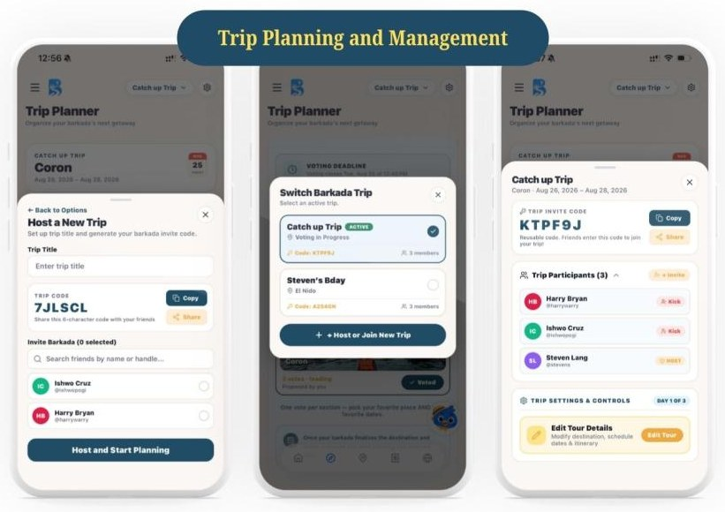
Figure 1. Trip Planning and Management
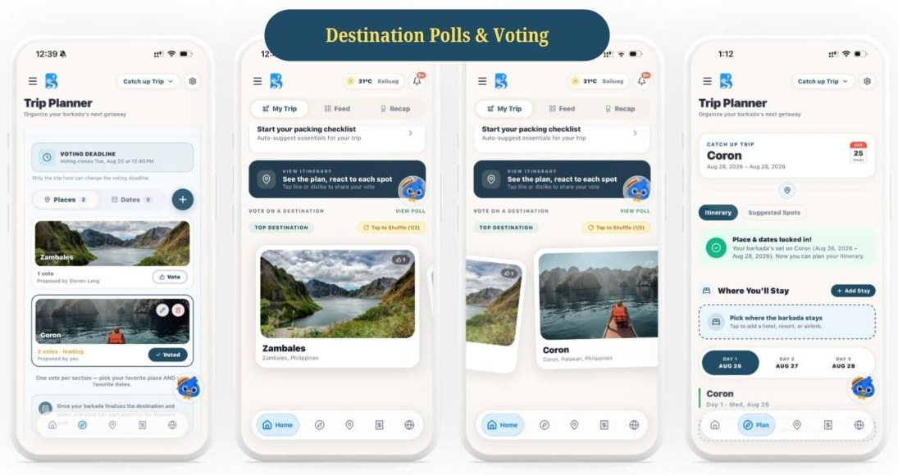
Figure 2. Destination Polls and Voting
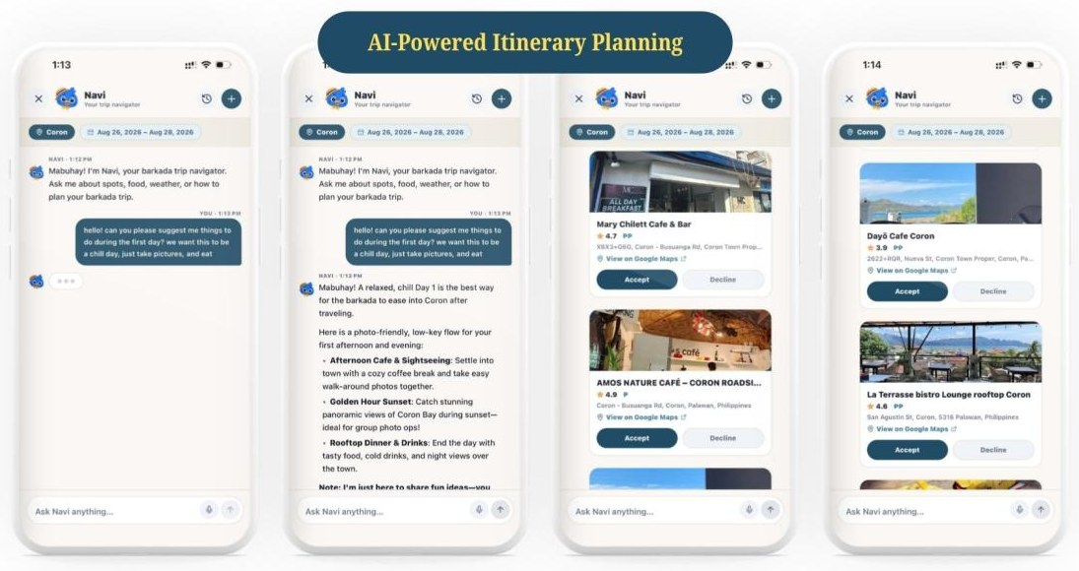
Figure 3. AI-Powered Itinerary Planning (Navi)
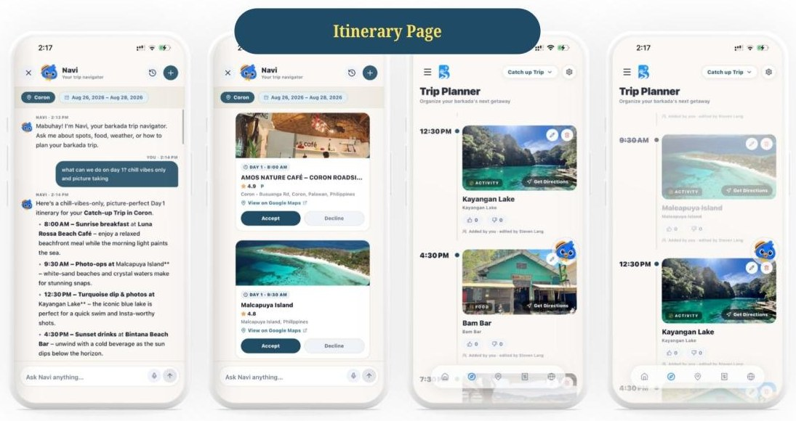
Figure 4. Itinerary Page
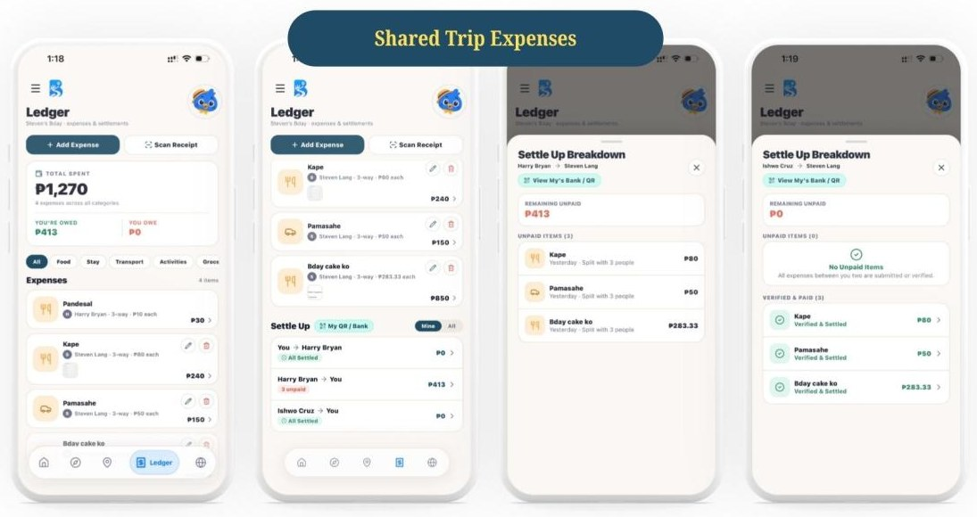
Figure 5. Shared Trip Expenses
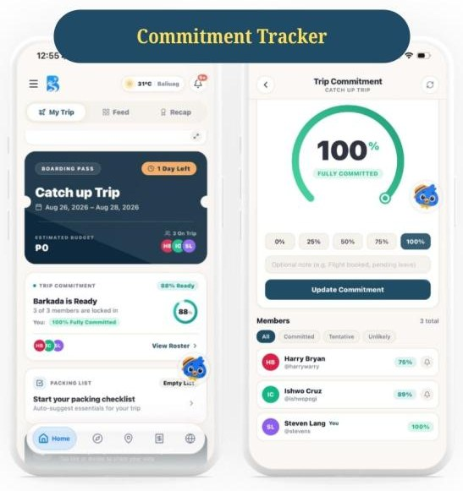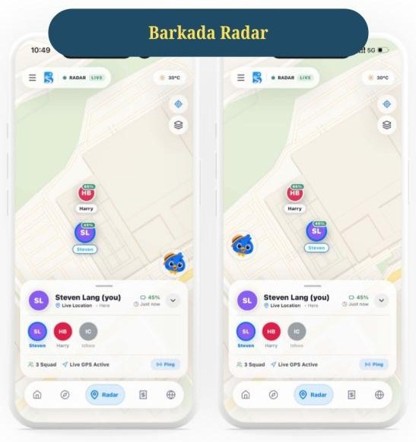
Figure 6. Commitment Tracker (left) and Barkada Radar (right)
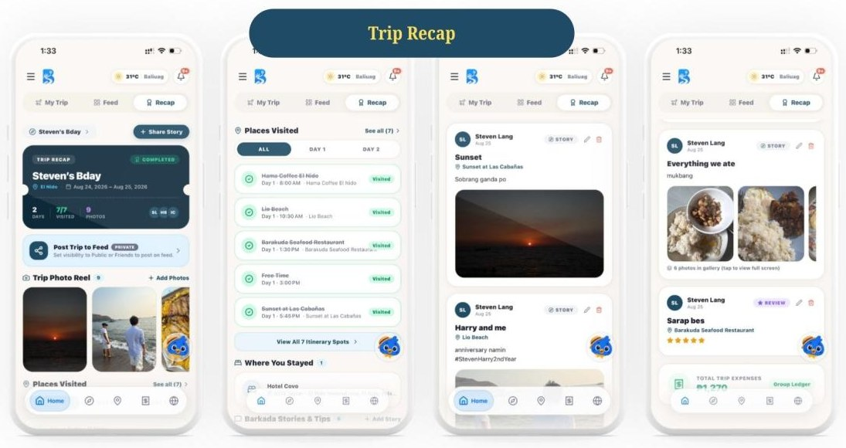
Figure 7. Trip Recap

CHAPTER 3
SYSTEM DEVELOPMENT

Tools and Technologies Used

Software
- • Antigravity – AI-assisted agentic code editor used for full-stack mobile development and git workflow
- • Android Studio – Android virtual devices and native SDK build tooling
- • React Native (Expo SDK 52) – core cross-platform framework delivering native performance
- • Supabase – cloud backend infrastructure (PostgreSQL database, Auth, Storage, and Realtime WebSockets)
- • External APIs & Services – Leaflet.js / OpenStreetMap, Google Gemini AI API, and Expo Push Notifications API

Hardware
- • Development PC/Workstation – multi-core development environment running Node.js and Expo CLI
- • Physical Android & iPhone Devices – tested on physical hardware for native push notification and GPS verification

Development Process

Requirements Gathering
System requirements were identified by analyzing the common problems barkadas face when planning trips, such as endless chat debates, scattered itineraries, and unsettled shared expenses. Functional and non-functional requirements were then documented.

Design
The system flow, use case, database structure, and user interface were designed first. The design prioritized simple navigation, clear trip stages (voting, locked, active, recap), and a layout suited for mobile screens.

Development
The application was built using React Native (Expo SDK 52) with TypeScript and Supabase backend services. Core modules implemented include authentication, trip hosting with 6-character codes, polling, day-by-day itinerary builder, Google Gemini AI integration, Guardian Mode geofencing, expense ledger, real-device push notifications with TourGo branding, and a Facebook-style photo lightbox community feed.

Testing
The application was tested on actual Android and iPhone devices. Test scenarios and test cases were prepared and executed for the core features (login, trip planning, Barkada Radar, and expense ledger) to verify that each feature works as expected.

CHAPTER 4
RESULTS AND TESTING

System Features

Feature 1: Trip Hosting and Joining
Description:
Allows a user to host a trip with destination and date details. The system generates a unique 6-character invite code and designates the creator as organizer. Other members can join instantly by entering the code.

Feature 2: Destination and Date Voting
Description:
Members propose candidate destinations and dates, voting with live synchronized tallies. Organizers can lock the poll, finalizing the travel dates and opening itinerary planning.

Feature 3: Collaborative Itinerary and Commitment Tracker
Description:
Members build day-by-day schedules with chronological time tags and verified coordinates. Travelers can invoke Google Gemini AI to automatically generate comprehensive day schedules tailored to their preferences.

Feature 4: Shared Expenses and Settle Up
Description:
Members record travel expenses with category and split modes (equal or solo). The ledger calculates balances and enables debtors to submit payment proofs for creditor verification.

Feature 5: Barkada Radar and Navi AI Assistant
Description:
Provides an interactive Leaflet map centered on the destination with an organizer-configurable geofenced perimeter circle. Members share live GPS locations and the system alerts on perimeter drift. Integrates native heads-up push notifications with the TourGo icon.

Feature 6: Trip Recap and Community Feed
Description:
After the trip, memories, photos, and ratings are published as a unified itinerary card on the community feed, featuring a Facebook-style full-screen media lightbox modal with swipe and pinch-to-zoom gestures.
(Note: Screens of these features are shown in Chapter 2 – User Interface Design.)

Functional Testing
The following test scenarios and test cases were executed for the core features of the application (Login, Trip Planning, Barkada Radar, and Expense Ledger):
Test Scenarios
Scenario ID | Description
TS-AUTH-01 | Verify that a registered traveler can log in using valid credentials and maintain persistent session storage.
TS-PLAN-01 | Verify that an organizer can create a trip and obtain an auto-generated unique 6-character invite code.
TS-PLAN-02 | Verify that a user can join an existing trip by entering a valid 6-character code.
TS-PLAN-03 | Verify that members can propose options and submit votes in the Destination & Date Poll.
TS-PLAN-04 | Verify that a member can add, edit, and reorder an itinerary stop with time tags under a specific trip day.
TS-PLAN-05 | Verify that Google Gemini AI synthesizes a structured day-plan populated directly into the itinerary.
TS-RADAR-01 | Verify that Guardian Mode renders an accurate circular geofence polygon matching the configured radius in meters.
TS-RADAR-02 | Verify that the Squad panel correctly displays a selected member's live status, distance, and geofence state.
TS-NOTIF-01 | Verify that adding an itinerary stop or activity triggers a native heads-up push notification banner on real devices.
TS-LEDGER-01 | Verify that a user can log an expense with category and equal/solo split mode into the trip ledger.
TS-COMM-01 | Verify that tapping an itinerary photo in the community feed opens the full-screen Facebook-style lightbox modal.

Test Cases
Test Case | Expected Result | Status
Login With Valid Credentials | User Access Granted (Home screen with eagle mascot opens) | Passed
Create Trip With Title & Dates | Trip Created With 6-Character Invite Code | Passed
Join Trip With Valid Code | User Added to Trip as Member | Passed
Propose and Vote in Poll | Option Listed and Vote Counted With Live Tally | Passed
Add Itinerary Item (Day 1) | Item Saved Under Day 1 With Coordinates and Tag | Passed
Generate AI Day-Plan (Gemini) | Structured Multi-Stop Day Schedule Populated | Passed
Open Guardian Radar During Trip | Interactive Map Displaying Geofenced Safe Zone | Passed
View Member in Guardian Panel | Member's Live GPS Pin and Safety Status Displayed | Passed
Trigger Activity Push Alert | Native Heads-Up Banner With TourGo App Icon Shown | Passed
Add Expense (Pinaluwal / Equal) | Expense Saved and Member Debts Generated | Passed
Tap Itinerary Photo in Community | Full-Screen Lightbox Modal Opens With Pinch-Zoom | Passed

Evaluation

Strengths
- • All-in-one collaborative platform unifying planning, budgeting, polling, safety, and community sharing
- • Real-time synchronization across members via Supabase Realtime WebSockets
- • Integrated Guardian Mode geofenced radar with perimeter-drift safety monitoring
- • Zero-cost location architecture leveraging OpenStreetMap, Leaflet, and Photon geocoding

Weaknesses
- • Internet connectivity required for real-time cloud data synchronization
- • No in-app fiat payment processing; settlement tracking is for coordination only
- • Guardian Safety Radar requires hardware GPS and user device permissions

CHAPTER 5
CONCLUSION AND RECOMMENDATIONS

Conclusion
The project successfully developed TourGo, a comprehensive collaborative mobile application and real-time safety coordination platform that gives barkadas a single place to plan, manage, and safely execute group trips. The core features were rigorously implemented and validated on physical hardware: trip hosting with 6-character join codes, destination and date polling, collaborative day-by-day itineraries with Google Gemini AI assistance, itemized expense splitting with settlement tracking, Guardian Mode geofenced radar safety tracking, real-device push notifications with TourGo branding, and a community feed with a Facebook-style photo lightbox. Through this project, practical mastery in cross-platform mobile engineering, cloud database design, third-party API integration, and modern UI/UX design was demonstrated in accordance with the CTELEC4L requirements.

Recommendations
- • Implement offline SQLite caching to enable itinerary and document access in remote Philippine regions without cellular coverage.
- • Incorporate peer-to-peer Bluetooth Low Energy (BLE) mesh tracking for Guardian member tracking during off-grid mountain hikes.
- Add a world travel map and Instagram Story sharing for trip recaps.

