ADVANCE MOBILE APPLICATION DEVELOPMENT
FINAL PROJECT DOCUMENTATION

PROJECT TITLE
TourGo – A Collaborative Group Travel Planning, Destination Discovery, and Itinerary Coordination Platform

Prepared by:
Harry Sevilla

Subject:
Mobile Application Development
Submitted to:
Prof. Paul John D. Cabance
Date Submitted:
October 2026

TABLE OF CONTENTS
CHAPTER 1 – PROJECT OVERVIEW ............................................. 3
Introduction
Project Objectives
Scope of the Project
Limitations
CHAPTER 2 – SYSTEM ANALYSIS AND DESIGN ......................... 5
System Description
System Flow
Use Case Diagram
Database Design
User Interface Design
CHAPTER 3 – SYSTEM DEVELOPMENT ....................................... 11
Tools and Technologies Used
Development Process
CHAPTER 4 – RESULTS AND TESTING ...................................... 12
System Features
Functional Testing
Evaluation
CHAPTER 5 – CONCLUSION AND RECOMMENDATIONS .............. 15
Conclusion
Recommendations

CHAPTER 1
PROJECT OVERVIEW

Introduction
The project entitled "TourGo – A Collaborative Group Travel Planning, Destination Discovery, and Itinerary Coordination Platform" is a full-stack cross-platform mobile application developed for groups of friends, families, and travel companions to collaboratively plan, organize, and coordinate group journeys. It unites Philippine destination discovery, trip hosting and joining via unique alphanumeric invite codes, day-by-day collaborative itinerary planning, Google Gemini AI-powered day schedules, interactive group decision polling, real-time group chat, shared expense splitting and balance ledgers, and branded mobile push notifications into a single, cohesive platform. By consolidating these capabilities, TourGo eliminates the chaos of juggling fragmented chat threads, spreadsheets, navigation maps, and budgeting tools.

Project Objectives

General Objective
To develop a collaborative, real-time mobile travel application that streamlines group trip planning, interactive decision-making, and financial coordination from initial discovery to active travel.

Specific Objectives
- 1. To enable frictionless trip creation and joining using 6-character alphanumeric join codes with responsive native input controls.
- 2. To provide an interactive destination exploration engine with Philippine tourist spots, province guides, weather forecasts, and travel estimates.
- 3. To deliver collaborative day-by-day itinerary management with chronological activity scheduling and Google Gemini AI day-plan generation.
- 4. To streamline group consensus through interactive group polls with synchronized real-time vote tallies.
- 5. To provide a shared financial ledger that calculates equal and custom expense splits, tracking payer balances and debt settlements.

Scope of the Project
The application encompasses the following core functional modules:
- • Authentication and Profiles – Secure email/password login and registration via Supabase Auth, personalized traveler preferences (budget, travel style, pacing), and light/dark theme support.
- • Explore & Destination Discovery – Interactive Philippine map and province directory, curated tourist spots, free places, weather forecasts, category filters, and travel cost/time estimations.
- • Trip Hosting and Enrollment – Create trips with destination, travel dates, and cover photos; auto-generate 6-character alphanumeric join codes; responsive join screen with native tap-to-focus keyboard.
- • Collaborative Day-by-Day Itinerary – Day-by-day activity timelines with timestamps, notes, and activity tags; one-tap Google Gemini AI day itinerary generator tailored to user preferences.
- • Real-Time Group Communication – Instant group messaging powered by Supabase Realtime WebSockets, pinned organizer announcements, and group packing checklists.
- • Interactive Decision-Making Polls – Create and vote on multiple-choice group polls (places, dates, activities) with live vote counters and organizer management.
- • Shared Expense Ledger & Bill Splitting – Log group expenses, assign payers, split costs equally or custom per member, and view real-time net settlement balances.
- • Real-Device Push & In-App Activity Notifications – Branded native push notifications and in-app toast banners with the official TourGo icon and #028BEB theme.
- • Community Travel Feed – Public travel feed to share itineraries, travel stories, photos, like counters, comments, and travel inspiration.
- • Organizer Controls & Cascade Deletion – Comprehensive trip management allowing organizers to edit trip details, manage members, and cleanly delete trips with foreign key cascade cleanup.

Limitations
- • Internet connectivity is required for real-time cloud data synchronization and Supabase WebSockets channels.
- • Dependent on third-party API service limits and quotas (Google Gemini AI and OpenStreetMap public servers).
- • No direct fiat banking or payment gateway transactions; expense splitting and balances are for coordination and accounting records only.
- • Weather forecasts and travel estimates are approximate reference calculations based on open-source public providers.
- • Device notifications require user permission and network connectivity for push delivery.

CHAPTER 2
SYSTEM ANALYSIS AND DESIGN

System Description
TourGo provides a comprehensive, modern mobile solution for group travel planning and coordination. Users authenticate via email and password, customize their travel style and preferences, and access an intuitive home dashboard. A user can either host a new trip—specifying destination and travel dates to generate a unique 6-character join code—or join an active trip using an organizer's code. Inside the trip hub, members collaboratively curate a day-by-day itinerary, generate smart multi-stop itineraries with Google Gemini AI, vote on key group decisions in real-time polls, chat via live messaging, and manage packing lists. While traveling, members log shared expenses to maintain an automated balance sheet showing who owes whom. Activity updates, itinerary changes, and poll additions trigger instant push notifications and in-app toast banners featuring the TourGo app icon. After trips, travelers can share itineraries and stories to the public Community Feed. All data is securely persisted in Supabase (PostgreSQL, Auth, Storage, and Realtime).

System Flow
The overall system flow of the application is as follows:
Start → Login (Email/Password) → Explore / Host / Join Trip (Join Code) → Collaborative Itinerary & AI Day Plan → Group Polls & Live Chat → Expense Logging & Bill Splitting → Push Alerts & Community Feed → End
Detailed flow: The user registers or signs in using their email and password; their profile and travel preferences are loaded. The user can explore Philippine destinations or choose to host a new trip (specifying title, destination, dates, and cover photo to receive an auto-generated 6-character join code) or join an existing trip by entering a valid code. Group members collaboratively add day-by-day itinerary stops or invoke Google Gemini AI to synthesize a customized day schedule. Members vote on group activities or dates through synchronized real-time polls and communicate in the live group chat. During the trip, members log shared expenses, with the system calculating equal or custom splits and tracking who owes whom. Trip updates trigger native device push notifications and in-app toast banners displaying the TourGo app icon. At trip completion, travelers share their stories and photos to the public community feed.

Use Case Diagram
The system involves the following actor and functions:
Actor:
- User – the primary actor. Registered users can explore spots, host or join trips, vote on polls, build itineraries, chat, log expenses, and post to the community feed. The creator of a trip becomes its Organizer, gaining administrative privileges such as editing trip metadata, pinning announcements, and performing cascade trip deletion.
Functions / Use Cases:
- • Login / Register – authenticate via Supabase Auth and manage user profile and travel preferences.
- • Destination Discovery – search Philippine provinces, tourist spots, free places, and weather forecasts.
- • Host / Join Trip – create a new trip with an auto-generated 6-character join code or join using an active code.
- • Collaborative Itinerary & AI Planner – create day stops with chronological times and invoke Gemini AI day-plan generation.
- • Group Polls & Voting – create multiple-choice polls and vote with real-time synchronized tallies.
- • Group Chat & Announcements – chat via live WebSockets and review pinned announcements.
- • Checklist & Packing Management – assign and check off collaborative travel items and packing lists.
- • Shared Expenses & Bill Splitting – record shared purchases, calculate equal/custom splits, and track debt settlements.
- • Community Travel Feed – browse public travel stories, view photo reels, like posts, and post trip recaps.

Database Design
The application uses Supabase (PostgreSQL) for cloud data storage, authentication, and file storage (trip photos and expense receipts). Only the main core tables are shown below; supporting tables (notifications, push tokens, reactions, stays, checklist, and others) are omitted for brevity.

ERD Overview
Entities: Profiles, Trips, Trip Members, Polls and Poll Votes, Itinerary Items, Expenses, Expense Splits, and Community Posts. A Profile can host or join many Trips through Trip Members. Each Trip contains multiple Itinerary Items scheduled by day, interactive Polls that receive member Votes, Shared Expenses with calculated member Splits, and public travel stories published to Community Posts.

Database Tables
Table: profiles
Field | Type | Description
id | UUID (PK) | User ID (linked to Supabase Auth)
email | Text | User email address
full_name | Text | Display name of the user
avatar_url | Text | Profile picture / avatar URL
travel_preferences | JSONB | Traveler preferences (budget, style, pace, dietary)

Table: trips
Field | Type | Description
id | UUID (PK) | Unique trip ID
title | Text | Trip title / name
destination | Text | Destination name / province
start_date / end_date | Date | Trip schedule date range
code | Text (Unique) | 6-character alphanumeric join code
image_url | Text | Cover image URL
created_by | UUID (FK) | Organizer user ID (profiles.id)

Table: trip_members
Field | Type | Description
id | UUID (PK) | Unique membership ID
trip_id | UUID (FK) | Trip joined (trips.id)
user_id | UUID (FK) | Member user ID (profiles.id)
role | Text | organizer / member
joined_at | Timestamp | Timestamp when user joined trip
status | Text | active / archived

Table: polls
Field | Type | Description
id | UUID (PK) | Unique poll ID
trip_id | UUID (FK) | Trip of the poll (trips.id)
question | Text | Poll question or topic
is_closed | Boolean | Active or closed status
created_by | UUID (FK) | Member who created the poll
created_at | Timestamp | Creation timestamp

Table: poll_votes
Field | Type | Description
id | UUID (PK) | Unique vote ID
poll_id | UUID (FK) | Associated poll (polls.id)
user_id | UUID (FK) | Member who voted (profiles.id)

Table: itinerary_items
Field | Type | Description
id | UUID (PK) | Unique itinerary item ID
trip_id | UUID (FK) | Trip of the item (trips.id)
day_number | Integer | Scheduled day number of the trip
title | Text | Activity or stop name
time | Text | Scheduled time (e.g. 09:00 AM)
category | Text | ACTIVITY / FOOD / TRANSPORT / SIGHTSEEING
location | Text | Location name or coordinates
notes | Text | Reminders, tips, or activity notes

Table: expenses
Field | Type | Description
id | UUID (PK) | Unique expense ID
trip_id | UUID (FK) | Trip of the expense (trips.id)
paid_by | UUID (FK) | Member who paid (profiles.id)
title | Text | Expense title / description
amount | Numeric | Total expense amount
currency | Text | Currency code (PHP, USD, etc.)
category | Text | Food, Accommodation, Transport, Activities, Misc
split_type | Text | equal / custom

Table: expense_splits
Field | Type | Description
id | UUID (PK) | Unique split ID
expense_id | UUID (FK) | Associated expense (expenses.id)
user_id | UUID (FK) | Member sharing the expense (profiles.id)
amount_owed | Numeric | Calculated amount owed
is_paid | Boolean | Settlement status (true if settled)
settled_at | Timestamp | Settlement timestamp

Table: community_posts
Field | Type | Description
id | UUID (PK) | Unique post ID
user_id | UUID (FK) | Author of the post (profiles.id)
title / content | Text | Post title and travel narrative
destination | Text | Featured destination name
image_urls | Text[] | Array of photo URLs

User Interface Design
The application features an intuitive, modern user interface with light and dark themes. The core screens, shown with placeholder frames below, include:
- • Trip Planning and Member Hub – host/join trip, 6-character join code, member roster, organizer controls, and cascade trip deletion
- • Interactive Destination Discovery – Philippine map, tourist spots, free places, weather forecasts, and category filters
- • AI-Powered Itinerary Assistant – Google Gemini AI integration generating smart multi-stop day schedules
- • Day-by-Day Collaborative Itinerary – chronological timelines, stop times, location coordinates, notes, and checklist
- • Real-Time Group Chat & Voting Polls – live group chat messaging and interactive multi-option decision polls
- • Shared Trip Expenses & Bill Splitting – itemized expense ledger, equal/custom split breakdowns, and settle-up balances
- • Community Travel Feed & Traveler Profile – public travel feed, stories, photos, like counters, and traveler preference profile
- • Branded Push Notifications – native OS banners and in-app toasts with TourGo App Icon and brand theme

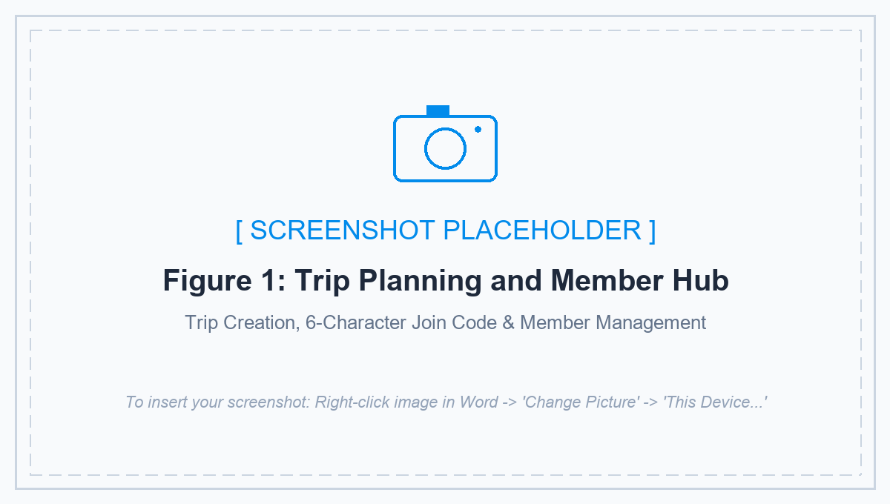
Figure 1. Trip Planning and Member Hub
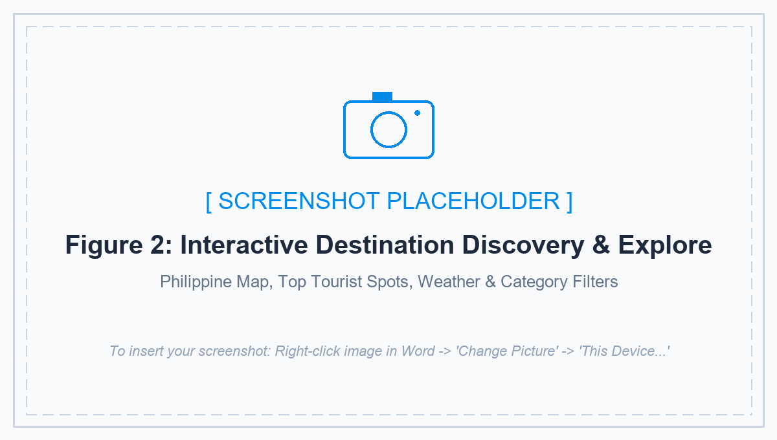
Figure 2. Interactive Destination Discovery & Explore Page
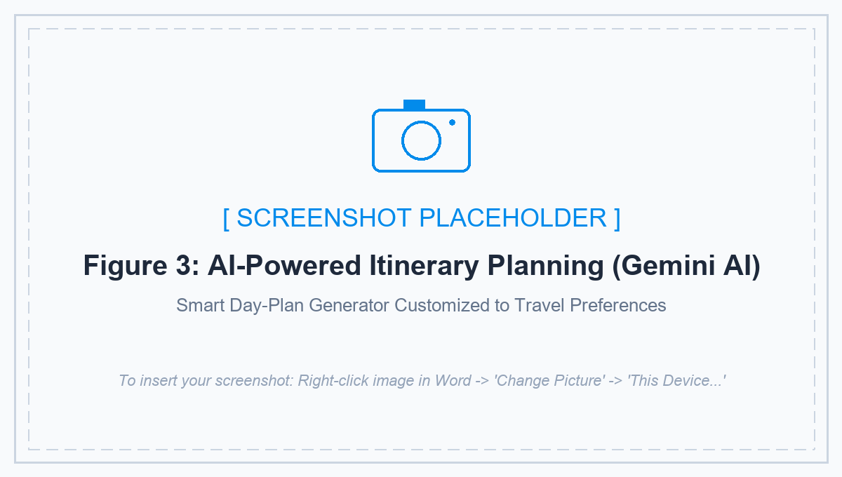
Figure 3. AI-Powered Itinerary Planning (Google Gemini AI)
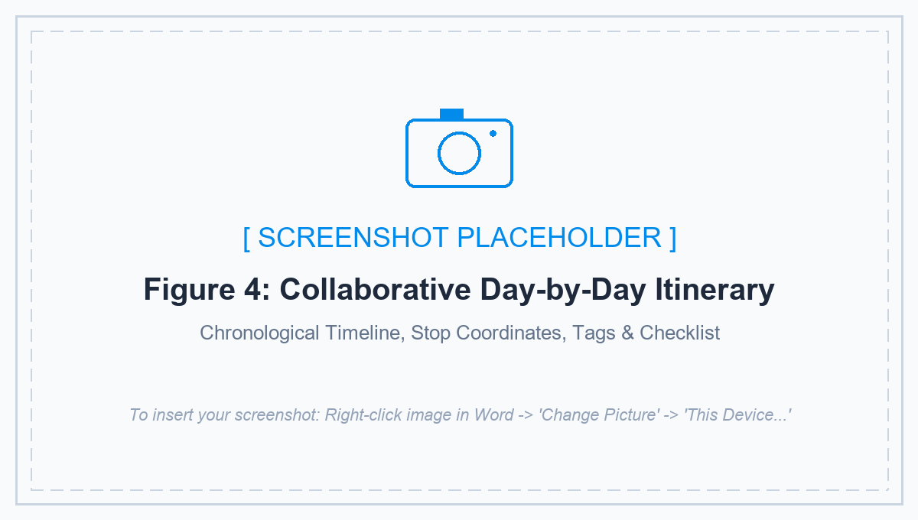
Figure 4. Day-by-Day Collaborative Itinerary

Figure 5. Real-Time Group Chat & Voting Polls Hub
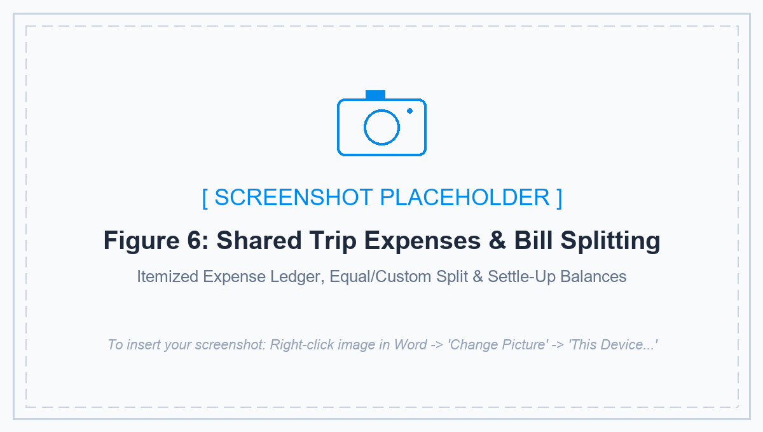
Figure 6. Shared Trip Expenses & Bill Splitting
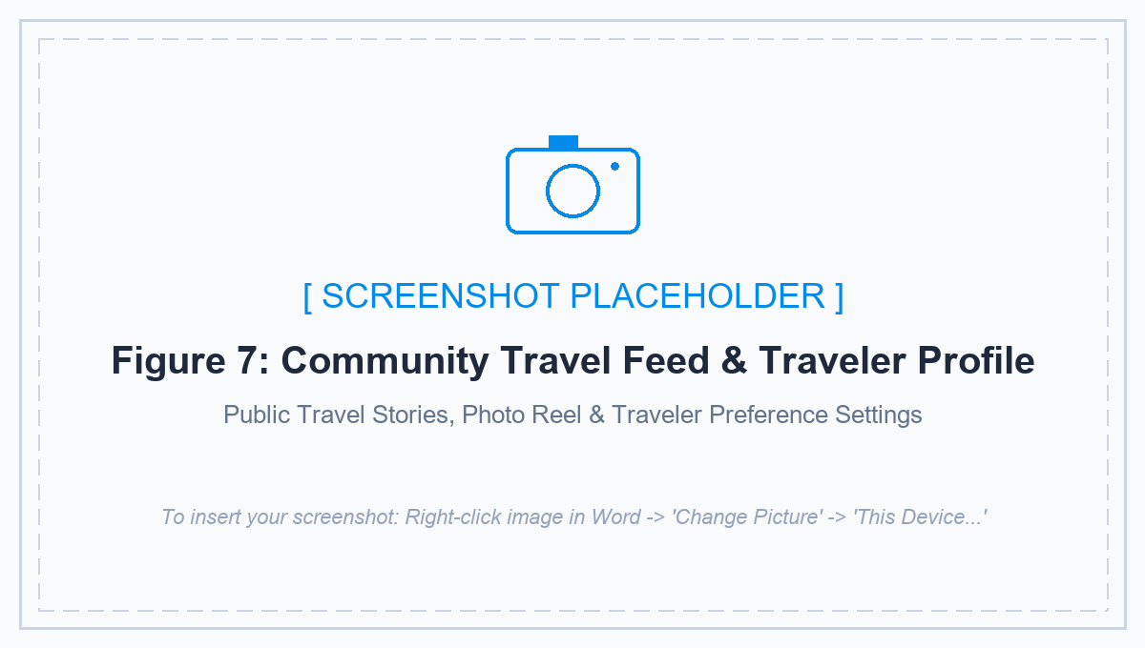
Figure 7. Community Travel Feed & Traveler Profile

CHAPTER 3
SYSTEM DEVELOPMENT

Tools and Technologies Used

Software
- • Antigravity IDE – AI-assisted agentic code editor used for full-stack mobile development and git workflow
- • Android Studio – Android emulators and native SDK build tooling
- • React Native (Expo SDK 52) – cross-platform framework delivering native mobile performance
- • Supabase – cloud backend infrastructure (PostgreSQL database, Auth, Storage, and Realtime WebSockets)
- • External APIs & Services – Google Gemini AI API, OpenStreetMap / Photon geocoding, and Expo Push Notifications API

Hardware
- • Development PC/Workstation – multi-core development environment running Node.js and Expo CLI
- • Physical Android & iPhone Devices – tested on real smartphones for native push notifications, soft keyboard behavior, and touch responsiveness

Development Process

Requirements Gathering
System requirements were identified by analyzing common challenges in group travel coordination, such as fragmented chat threads, disorganized schedules, bill-splitting disputes, and difficult consensus-gathering. Functional and non-functional requirements were established accordingly.

Design
The system flow, use case architecture, database schema, and mobile UI were designed first. Design priorities included seamless tab-based navigation, clean light and dark themes, fast real-time synchronization, and intuitive controls suited for mobile touchscreens.

Development
The application was built using React Native (Expo SDK 52) with TypeScript and Supabase as the backend. Core modules implemented include authentication, trip hosting and code joining, day-by-day itinerary management, Google Gemini AI day-plan generation, real-time group chat, multi-option decision polls, expense ledger and bill splitting, branded real-device push notifications, and a community travel feed.

Testing
The application underwent comprehensive functional testing on physical Android and iOS mobile devices. Test scenarios and test cases were prepared and executed for all core modules (authentication, trip management, AI planning, chat, polls, expense ledger, and push notifications) to ensure robust performance.

CHAPTER 4
RESULTS AND TESTING

System Features

Feature 1: Trip Hosting, Joining, and Management
Description:
Allows a user to host a new trip with destination, travel dates, and cover photo, generating an automatic 6-character alphanumeric join code. Other travelers can join instantly via the Join Trip screen featuring responsive tap-to-focus text input. Organizers have administrative controls including editing details and cascade trip deletion.

Feature 2: Interactive Philippine Destination Discovery
Description:
Provides an interactive explore hub featuring curated Philippine tourist destinations, province directories, free places, real-time weather forecasts, category filters, and travel cost/time estimations.

Feature 3: Day-by-Day Collaborative Itinerary and AI Planner
Description:
Enables members to build chronological daily itineraries with timestamps, location coordinates, notes, and activity tags. Includes one-tap Google Gemini AI integration to automatically synthesize comprehensive multi-stop day plans tailored to user preferences.

Feature 4: Real-Time Group Chat, Polls, and Coordination
Description:
Facilitates real-time group collaboration through instant messaging powered by Supabase Realtime WebSockets, interactive multi-option decision polls with live vote tallies, pinned organizer announcements, and shared packing checklists.

Feature 5: Shared Expenses and Bill Splitting
Description:
Maintains an itemized expense ledger recording group purchases, assigning payers, calculating equal or custom splits among members, and tracking net debt balances for transparent settlement.

Feature 6: Branded Push Notifications and Community Travel Feed
Description:
Delivers native push notifications and in-app toast banners branded with the official TourGo icon and #028BEB theme for real-time trip alerts. Includes a community travel feed where travelers can publish stories, photos, and like posts.
(Note: Screens of these features are shown in Chapter 2 – User Interface Design.)

Functional Testing
The following test scenarios and test cases were executed for the core features of the application (Authentication, Trip Creation & Joining, Collaborative Itinerary, Google Gemini AI Planner, Group Polls, Real-Time Chat, Shared Expenses, and Push Notifications):
Test Scenarios
Scenario ID | Description
TS-AUTH-01 | Verify that a registered user can log in using valid email credentials and access the TourGo dashboard.
TS-TRIP-01 | Verify that a user can create/host a new trip with title, destination, dates, and receive an auto-generated alphanumeric join code.
TS-TRIP-02 | Verify that a user can join an existing trip by entering a code in the Join Trip screen with responsive soft keyboard focus.
TS-TRIP-03 | Verify that an organizer can delete a trip with native confirmation prompt and cascading child record cleanup.
TS-EXPL-01 | Verify that a user can browse Philippine destinations, view weather forecasts, and filter by travel categories.
TS-ITIN-01 | Verify that a trip member can add a day-by-day itinerary stop with activity time, location details, and notes.
TS-AI-01 | Verify that a user can generate a personalized multi-stop day itinerary using the integrated Google Gemini AI travel planner.
TS-POLL-01 | Verify that members can create and vote on group decision polls with synchronized live vote tallies.
TS-CHAT-01 | Verify that group members can send and receive real-time messages within the group chat hub.
TS-EXP-01 | Verify that a member can log an expense with amount, category, and split breakdown among group members.
TS-NOTIF-01 | Verify that real-device push notifications and in-app toast banners trigger with the official TourGo icon upon trip updates.

Test Cases
Test Case | Expected Result | Status
Login With Email & Password | User Authenticated & Dashboard Loaded | Passed
Host / Create New Trip | Trip Created with Alphanumeric Join Code | Passed
Join Trip via Alphanumeric Code | Member Enrolled in Trip & Redirected | Passed
Organizer Delete Trip | Trip Removed with Cascade Foreign Key Cleanup | Passed
Browse Philippine Destinations | Spots, Weather & Route Estimates Displayed | Passed
Add Day-by-Day Itinerary Stop | Stop Saved Under Target Day with Coordinates | Passed
Google Gemini AI Day Plan | Smart Multi-Stop Itinerary Generated | Passed
Create & Vote on Group Poll | Poll Active with Synchronized Live Counts | Passed
Send Real-Time Chat Message | Message Broadcast via Supabase Realtime | Passed
Log Expense & Split Bill | Expense Saved and Member Balances Calculated | Passed
Receive Activity Push Notification | Push Banner Displays TourGo App Icon & Title | Passed

Evaluation

Strengths
- All-in-one platform for barkada trip planning
- • All-in-one platform unifying trip hosting, AI planning, chat, polls, expense splitting, and community feed
- • Real-time cloud synchronization powered by Supabase WebSockets and PostgreSQL
- • Transparent expense splitting with automated balance tracking and settlement calculations

• Integrated Google Gemini AI travel assistant accelerating personalized day itinerary generation
- Internet and third-party API dependent
- • Active internet connectivity required for real-time cloud features and API requests
- • Third-party API quotas apply to Google Gemini AI and OpenStreetMap public tile servers
• No fiat banking integration; expense ledger serves as a collaborative accounting log

CHAPTER 5
CONCLUSION AND RECOMMENDATIONS

Conclusion
The project successfully developed TourGo, a robust and collaborative mobile travel platform that provides groups with an all-in-one environment to plan, coordinate, and enjoy trips together. Core features were fully implemented and validated on physical devices: trip hosting and code joining, destination discovery, collaborative day-by-day itineraries, Google Gemini AI day-plan assistance, real-time group chat, interactive voting polls, shared expense splitting, branded mobile push notifications, and community travel sharing. The project demonstrated the effective integration of cross-platform mobile development, cloud backend synchronization, and artificial intelligence into a cohesive travel utility.

Recommendations
- • Implement offline-first caching with automatic background synchronization when reconnecting to the internet.
- • Incorporate biometric authentication (Fingerprint / Face ID) for faster and more secure mobile sign-in.
- • Integrate direct Philippine airline and bus transport APIs for automated ticket and booking imports, plus exportable PDF itinerary summaries.

