PUBLIC TRANSPORT OPTIMIZATION

INDURDUCTION

In an era where connectivity and efficiency are paramount, our public transportation systems are in need of a transformation. The answer lies in the integration of Internet of Things (IoT) sensors into public transportation vehicles, a visionary project designed to revolutionize the way we experience urban mobility.The primary objective of this project is to bring a seamless, data-driven approach to public transportation. Through the deployment of IoT sensors, we aim to achieve three core functionalities: monitoring ridership, tracking vehicle locations, and predicting arrival times. This trifecta of capabilities will serve as the foundation for an innovative, real-time transit information platform that empowers both commuters and transit authorities alike.

At its core, this initiative seeks to enhance the efficiency and quality of public transportation services. No more waiting at bus stops or train stations uncertain about when the next vehicle will arrive. With our real-time transit information platform, commuters will have access to precise, up-to-the-minute data regarding vehicle locations and expected arrival times. This means reduced wait times, increased predictability, and a smoother overall experience for passengers.

This project's multi-faceted approach involves several key phases. First and foremost, we will define clear and measurable objectives, ensuring that our IoT sensors and transit information platform align with the needs and expectations of the community. Subsequently, we will design a state-of-the-art IoT sensor system, which will be seamlessly integrated into the public transportation fleet. The real magic happens when we develop the real-time transit information platform, where commuters will access a wealth of data at their fingertips. Finally, our team of experts will employ Python, a versatile programming language, to bring it all together.

In a world where time is of the essence, and public transportation serves as a lifeline for countless individuals, this project promises to be a game-changer. By marrying cutting-edge technology with a commitment to improving the daily lives of commuters, our IoT sensor and real-time transit information system will usher in a new era of efficient, high-quality public transportation services. The future is fast approaching, and it looks more connected, convenient, and commuter-friendly than ever before.

SENSORS:

1. GPS (Global Positioning System) Sensors:

These sensors track the location of vehicles in real-time, allowing for route optimization, real-time tracking, and better schedule management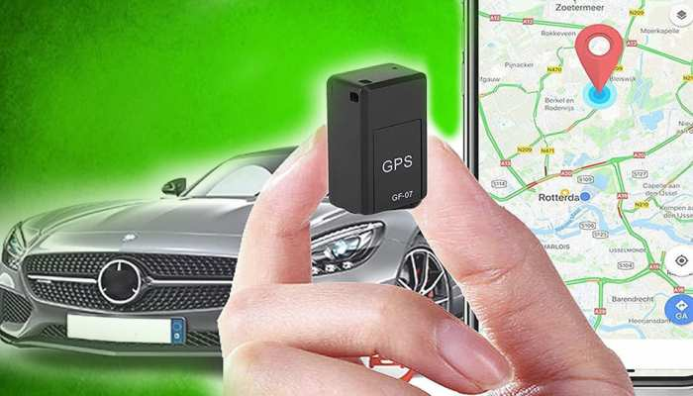

PIN CONFIGURATION:

**VCC (Voltage Supply):**

This is the power supply pin. It typically requires a voltage between 3.3V and 5V, depending on the module's specifications.

**GND (Ground):**

Connect this pin to the ground (0V) of your power supply.

**TX (Transmit):**

This is the pin for transmitting data from the GPS module to your microcontroller or receiver. It sends NMEA sentences, which contain location and other information.

**RX (Receive):**

This pin is for receiving data from your microcontroller or receiver. It's used for sending commands and configuring the GPS module.

**PPS (Pulse-Per-Second):**

Some GPS modules have a PPS output that generates a pulse signal once per second, which can be used for precise timing applications.

**Antenna:**

Connect the GPS antenna to the appropriate antenna connector on the module. The antenna is crucial for receiving GPS signals.

**Enable (EN) or Reset (RST):**

Some modules have an enable or reset pin to turn the module on or reset it.

**Backup Battery:**

In some GPS modules, you may find pins for connecting an optional backup battery or supercapacitor to retain satellite data when the main power source is disconnected.

**PIN DIAGRAM:**

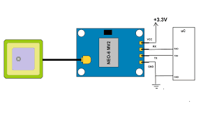

**FUNCTION:**

GPS sensors in public transport optimization perform multifaceted roles, tracking vehicle locations, enabling real-time arrival predictions, optimizing routes, enhancing traffic management, improving security, facilitating accessibility features, and supporting historical data analysis.

These functions collectively improve efficiency, passenger experience, and overall system performance in public transportation networks.

**2. RFID (RADIO-FREQUENCY IDENTIFICATION) SENSORS:**

RFID technology can be used for passenger card scanning, fare collection, and monitoring passenger flow. 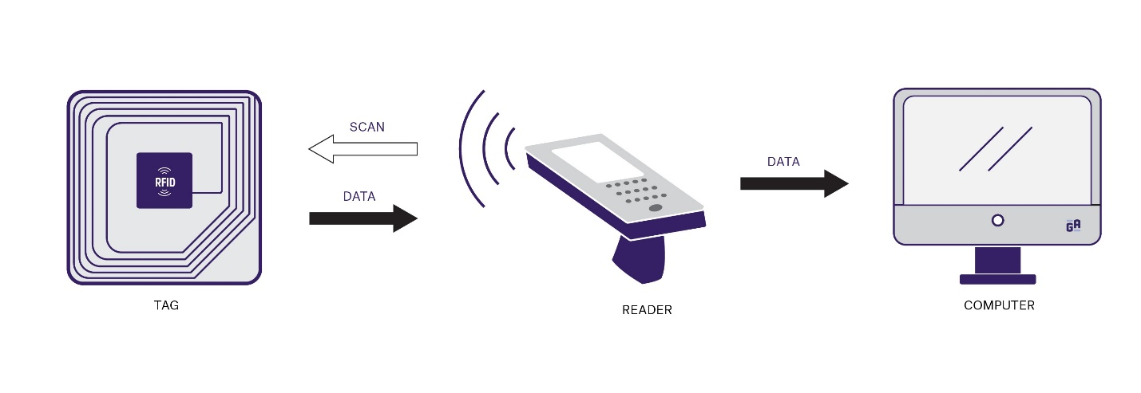

**PIN CONFIGURATION**

**VCC (Voltage Supply):**

This pin is used to provide power to the RFID sensor module and is typically connected to a voltage source, such as +3.3V or +5V.

**GND (Ground):**

Connect this pin to the ground (0V) of your power supply.

**TX (Transmit):**

Some RFID modules have a TX pin for transmitting data to a microcontroller or receiver. This is not always present in all RFID modules.

**RX (Receive):**

Similar to the TX pin, some RFID modules have an RX pin for receiving data from a microcontroller or host system. Not all RFID modules have this pin.

**Antenna:** Connect t

he RFID antenna to the appropriate antenna connector on the module. The antenna is critical for sending and receiving RFID signals.

**Enable (EN) or Reset (RST):**

Some modules have an enable or reset pin to control the module's operation or reset it.

**Wiegand Interface:**

In some RFID modules, you might find pins for the Wiegand interface, which is a common protocol used for access control systems. These pins are typically labeled D0 and D1.

**LED and Buzzer Control:**

RFID modules often have pins to control external LEDs or buzzers to indicate RFID tag detection or other events.

**Trigger/Input**:

Some RFID modules can be triggered externally to initiate scanning or reading of RFID tags. This pin allows for external control of the module.

PIN DIAGRAM

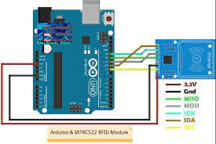

**FUNCTION:**

1. Contactless Ticketing: RFID enables seamless and contactless payment, making fare collection faster and more convenient for passengers.

2. Passenger Tracking: RFID cards or tags allow tracking of passengers' movements within the transport system, enabling data-driven route and schedule optimization.

3. Asset Management: RFID technology tracks and manages vehicles, equipment, and inventory efficiently, ensuring optimal resource allocation and timely maintenance.

4. Access Control: RFID cards enhance security by controlling access to restricted areas and vehicles, reducing unauthorized entry.

5. Real-time Passenger Information: RFID delivers real-time updates on journey details, including arrival times, route changes, and service disruptions, improving the passenger experience.

6. Automated Boarding and Alighting: RFID readers at entry and exit points automate passenger counting, streamlining boarding and alighting processes.

7. Maintenance Planning: RFID tags on vehicle components facilitate predictive maintenance by tracking component usage and wear, reducing downtime.

8. Fare Verification: RFID readers verify passenger fares, reducing fare evasion and enhancing revenue collection.

9. Personalized Services: RFID supports personalized services, like custom route recommendations and passenger notifications based on preferences.

10. Lost and Found: RFID helps match lost items with owners by tracking items with RFID tags.

11. Environmental Impact: RFID data analysis assesses the environmental footprint by optimizing routes and reducing emissions through passenger tracking.

1. CCTV CAMERAS:

Cameras can be used for security and surveillance on public transport vehicles, but they can also assist in monitoring passenger counts and identifying issues like overcrowding or incidents.

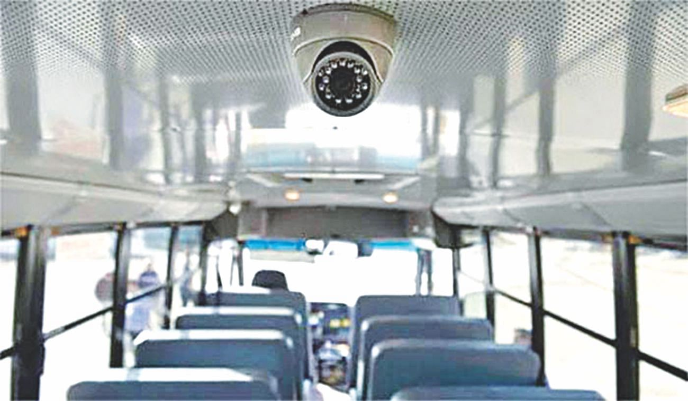

PIN CONFIGURATION

**Power Supply Pins:**

* + VCC (Voltage Supply): Connect to a power source (e.g., +12V or +24V) to provide power to the camera.
  + GND (Ground): Connect to the ground (0V) of the power supply.

**Video Output**:

* + Video Out: This pin provides the analog or digital video signal output from the camera to a recording device or monitoring system.

**Audio Input/Output (optional):**

* + Audio In: Some CCTV cameras support audio input. This pin is used to connect an external microphone or audio source.
  + Audio Out: If supported, this pin provides audio output for connecting to an external speaker or audio recording device.

**Network/Communication (for IP cameras):**

* + Ethernet Port: In the case of IP cameras, there may be an Ethernet port for connecting to a network for remote monitoring and data transmission.
  + RJ45 Connector: This is the physical connector used for Ethernet connections.

**PTZ (Pan-Tilt-Zoom) Control (for PTZ cameras):**

* + RS-485 or RS-232: PTZ cameras may have pins for RS-485 or RS-232 communication to control the camera's pan, tilt, and zoom functions.

**Alarm Input/Output:**

* + Alarm Input: Some cameras support alarm inputs for connecting external sensors or triggers.
  + Alarm Output: These pins allow the camera to trigger external devices, such as alarms or lights, in response to events.

**Reset Button or Pin:**

* + Reset: This pin or button is used to reset camera settings to their default values.

**Configuration and Control:**

* + Configuration Buttons/Pins: Some cameras have buttons or pins for configuration and setup, such as adjusting focus or configuring camera parameters.

PIN DIAGRAM:

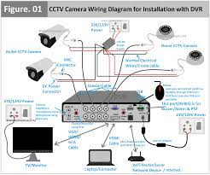

**FUNCTION:**

1. Security and Surveillance: Cameras deter vandalism and provide a secure environment for passengers and staff.

2. Crime Prevention: CCTV footage can aid in deterring and solving crimes that occur on public transport, enhancing passenger safety.

3. Emergency Response: Cameras help monitor incidents in real time, allowing swift responses to emergencies and incidents.

4. Passenger Safety: Video footage can be used to investigate accidents and incidents, ensuring the safety of passengers and preventing false claims.

5. Crowd Monitoring: Cameras can monitor passenger density and help transport authorities manage overcrowding.

6. Driver Behavior: CCTV can monitor driver behavior to ensure adherence to safety regulations and reduce reckless driving.

7. Traffic Management: Cameras assist in monitoring traffic around public transport hubs, facilitating traffic flow and reducing congestion.

8. Evidence Collection: Video footage can serve as evidence in legal matters, such as accidents, disputes, or criminal cases.

9. Data for Planning: Analyzing camera data can provide insights for optimizing routes, schedules, and infrastructure based on passenger behavior.

10. Passenger Information: Some cameras can be used to provide real-time information to passengers, such as next stop announcements or service updates.

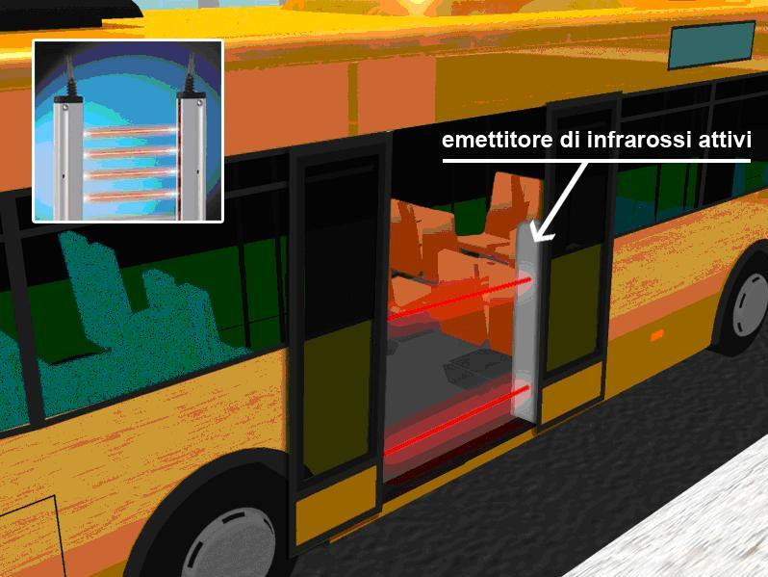**4. WEIGHT SENSORS:**

These can monitor the weight distribution on buses and trains to ensure they are not overloaded, which impacts safety and efficiency.

**PINCONFIGURATION**

**Excitation Voltage (VCC or +):**

This pin provides the power supply voltage to the weight sensor. The voltage is typically in the range of +5V to +12V, depending on the sensor's specifications.

**Ground (GND or -):**

Connect this pin to the ground (0V) of the power supply to complete the circuit.

**Signal Output (OUT or S):**

The sensor's weight measurement signal is typically provided through this pin. It's connected to an analog or digital input on a data acquisition system or controller.

**Temperature Compensation (TEMP or TC):**

Some weight sensors have a pin for temperature compensation, which helps ensure accurate measurements under varying environmental conditions.

**Shield (SHIELD):**

If the sensor has a shielded cable, there may be a pin for grounding the shield to reduce electromagnetic interference.

**Null or Tare (NULL or TARE):**

In some cases, there might be a pin for nulling or taring the sensor to set a zero reference point for weight measurements.

**Excitation Sense (E+ or E-):**

Some sensors may have pins for sensing the excitation voltage, which can be used for calibration and monitoring the health of the sensor.

**Additional Pins (if applicable**):

Depending on the sensor's features, there may be additional pins for specific functions, such as digital communication, configuration, or diagnostics.

PIN DIAGRAM:

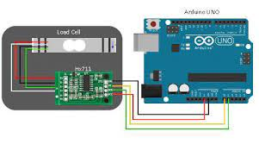V

FUNCTION:

1. Load Monitoring: Weight sensors monitor passenger and cargo loads, ensuring that vehicles do not exceed safe weight limits, which is critical for safety and compliance.

2. Maintenance Management: They provide data on wear and tear, helping schedule maintenance tasks based on actual usage, thus reducing breakdowns and increasing vehicle lifespan.

3. Fuel Efficiency: By monitoring vehicle weight, these sensors contribute to better fuel efficiency, reducing operational costs and environmental impact.

4. Passenger Safety: Weight sensors assist in preventing overcrowding and ensuring that passengers are distributed evenly within the vehicle for a safer and more comfortable journey.

5. Vehicle Tracking: Weight data can help track vehicle location, load distribution, and route optimization, improving operational efficiency.

6. Compliance and Regulations: Weight sensors help public transport operators comply with weight-related regulations and standards, avoiding penalties and ensuring safety.

7. Real-time Alerts: They trigger alerts when vehicles exceed safe weight thresholds, allowing for immediate corrective action.

8. Data for Planning: Weight data analysis can provide insights into route planning and resource allocation, making public transport systems more efficient.

9. Environmental Impact: By optimizing loads, weight sensors contribute to reduced emissions and a smaller environmental footprint.

5.INFRARED SENSORS:

Infrared sensors can detect the presence of passengers getting on or off vehicles, helping in demand analysis and optimizing stops.

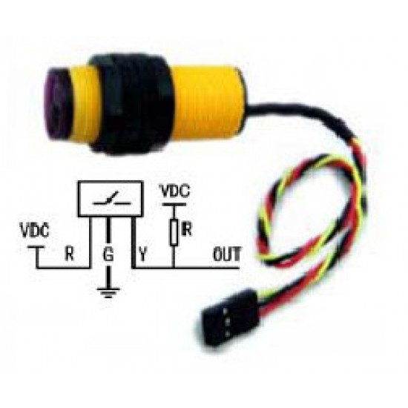

PIN CONFIGURATION

**Power Supply Pins:**

* + VCC or +: This pin is used to provide the power supply voltage to the IR sensor, typically in the range of +5V to +12V.
  + GND or -: Connect this pin to the ground (0V) of the power supply to complete the circuit.

**Signal Output (OUT or S):**

* + This pin provides a digital or analog output signal that changes in response to the detection of infrared radiation (motion or presence). It is connected to a microcontroller or monitoring system.

**Voltage Regulator (if applicable):**

* + Some IR sensors may have pins for an internal voltage regulator to stabilize the supply voltage.

**Enable or Sensitivity Adjustment (EN or SENS):**

* + An optional pin for enabling or adjusting the sensitivity of the sensor. This is particularly useful for fine-tuning the sensor's response.

**Grounding (GND Shield):**

* + If the sensor has a shielded cable, there may be a pin for grounding the shield to reduce electromagnetic interference.

**Additional Pins (if applicable):**

* + Depending on the specific sensor's features, there might be additional pins for such as digital communication, configuration, or diagnostics.

**PIN DIAGRAM:**

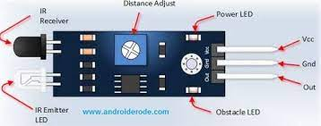

**FUNCTION:**

In the realm of public transport optimization, Infrared (IR) sensors serve as versatile tools with multifaceted functions. These sensors are integral in enhancing passenger safety, operational efficiency, and overall system performance.

IR sensors are primarily deployed for automated door control. By detecting the presence of passengers, they ensure safe boarding and alighting. This not only expedites the boarding process but also prevents accidents and injuries.

Furthermore, IR sensors contribute to effective occupancy monitoring within the vehicle. They can assess the number of passengers on board in real time, aiding in route planning and scheduling adjustments. This data-driven approach allows for improved resource allocation and service optimization, reducing operational costs and enhancing the passenger experience.

IR sensors also support energy conservation by enabling automatic climate control adjustments based on passenger presence. This, in turn, reduces energy consumption, contributing to a greener and more sustainable public transport system.

Moreover, these sensors are essential for security measures, detecting unattended items that may pose a threat. They can trigger alerts to authorities in the event of suspicious objects, ensuring the safety of passengers and infrastructure.

In summary, Infrared sensors play a pivotal role in public transport optimization, facilitating safer and more efficient journeys, cost-effective operations, and environmental sustainability.

6. **ENVIRONMENTAL SENSORS:**

Sensors measuring air quality, temperature, and humidity can provide data for passenger comfort and safety.

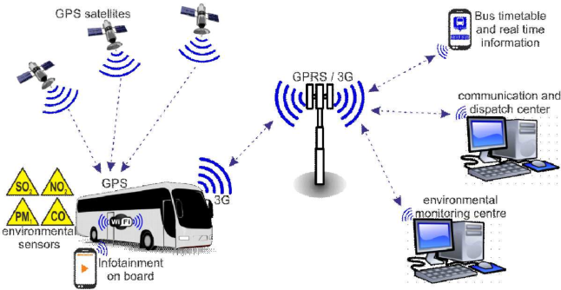

PIN CONFIGURATION

**Power Supply Pins:**

* + VCC or +: This pin is used to provide the power supply voltage to the environmental sensor, typically in the range of +3.3V or +5V.
  + GND or -: Connect this pin to the ground (0V) of the power supply to complete the circuit.

**Signal Output (OUT or S):**

* + This pin provides analog or digital output signals that represent the environmental parameter being measured (e.g., air quality or temperature). It is connected to a microcontroller or monitoring system.

**Communication Pins (if applicable):**

* + Some environmental sensors may support digital communication interfaces like I2C, SPI, or UART, and they have pins for data input/output and clock signals.

**Additional Pins (if applicable):**

* + Depending on the specific sensor's features, there might be additional pins for functions such as configuration, calibration, diagnostics, or specific environmental measurements (e.g., CO2 measurement in an air quality sensor).

**Heater Control (if applicable):**

* + Certain environmental sensors may have pins for controlling a built-in heater to prevent condensation or maintain a specific operating temperature.

**Alarm or Trigger Pins (if applicable):**

* + Some sensors provide pins for setting alarm thresholds or for triggering external devices or alarms when specific environmental conditions are met.

Grounding (GND Shield):

* + If the sensor has a shielded cable, there may be a pin for grounding the shield to reduce electromagnetic interference.

**PIN DIAGRAM:**

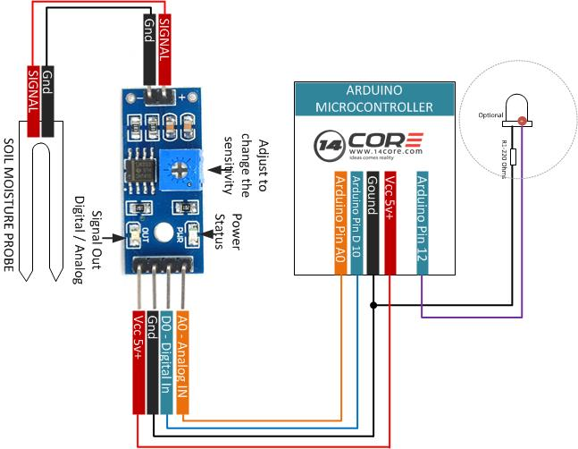

**FUNCTION:**

1. *Air Quality Monitoring:* Environmental sensors measure pollutants and air quality within transport vehicles and at transit hubs. This data helps in assessing and improving the quality of the air passengers breathe during their journeys, ultimately contributing to passenger health and well-being.

2. *Temperature and Humidity Control:* These sensors help regulate climate control systems within public transport, ensuring passenger comfort. They optimize heating, cooling, and ventilation, resulting in energy savings while maintaining a comfortable environment.

3. *Noise Level Monitoring:* By measuring noise levels both inside and outside transport vehicles, these sensors aid in noise pollution reduction. This data can guide route planning and infrastructure changes to minimize noise impact on passengers and the surrounding environment.

4. *Vibration and Acceleration Sensing:* Monitoring vibrations and accelerations is vital for passenger safety and comfort. These sensors help in detecting irregularities, potential mechanical issues, or accidents in real-time.

5. *Weather Conditions:* Environmental sensors gather data on weather conditions such as temperature, precipitation, and road conditions. This information assists in adjusting schedules and routes for better safety and efficiency during adverse weather.

7. PROXIMITY SENSORS:

These sensors can detect the proximity of vehicles or objects, helping to prevent collisions or provide assistance for automated driving systems.

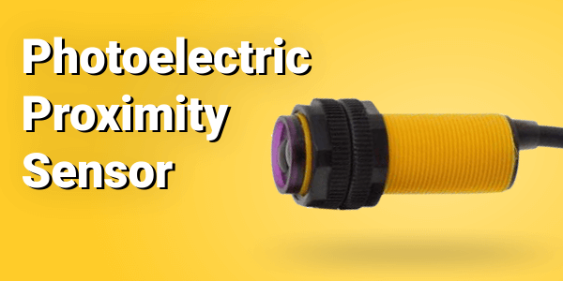

PIN CONFIGURATION

**Power Supply Pins:**

* + VCC or +: This pin is used to provide the power supply voltage to the proximity sensor, typically in the range of +5V to +24V.
  + GND or -: Connect this pin to the ground (0V) of the power supply to complete the circuit.

**Signal Output (OUT or S):**

* + This pin provides a digital or analog output signal that changes based on the proximity or presence of objects. It is connected to a microcontroller or monitoring system.

**Sensitivity Adjustment (SENS or ADJ):**

* + Some proximity sensors have a pin for adjusting the sensor's sensitivity to fine-tune the detection range.

**Trigger or Input (TRIG or IN):**

* + In some cases, there might be a pin for triggering the sensor's operation or for external control.

**Alarm or Indicator (if applicable):**

* + Certain proximity sensors have pins for setting alarm thresholds or for connecting external devices such as indicator lights or alarms when an object is detected.

**Communication Pins (if applicable):**

* + Some sensors may support digital communication interfaces like I2C, SPI, or UART, and they have pins for data input/output and clock signals.

**Shield Grounding (if applicable):**

* + If the sensor has a shielded cable, there may be a pin for grounding the shield to reduce electromagnetic interference.

**Additional Pins (if applicable):**

* + Depending on the specific sensor's features, there might be additional pins for functions such as configuration, calibration, diagnostics, or specific proximity sensing modes.

**PIN DIAGRAM:**

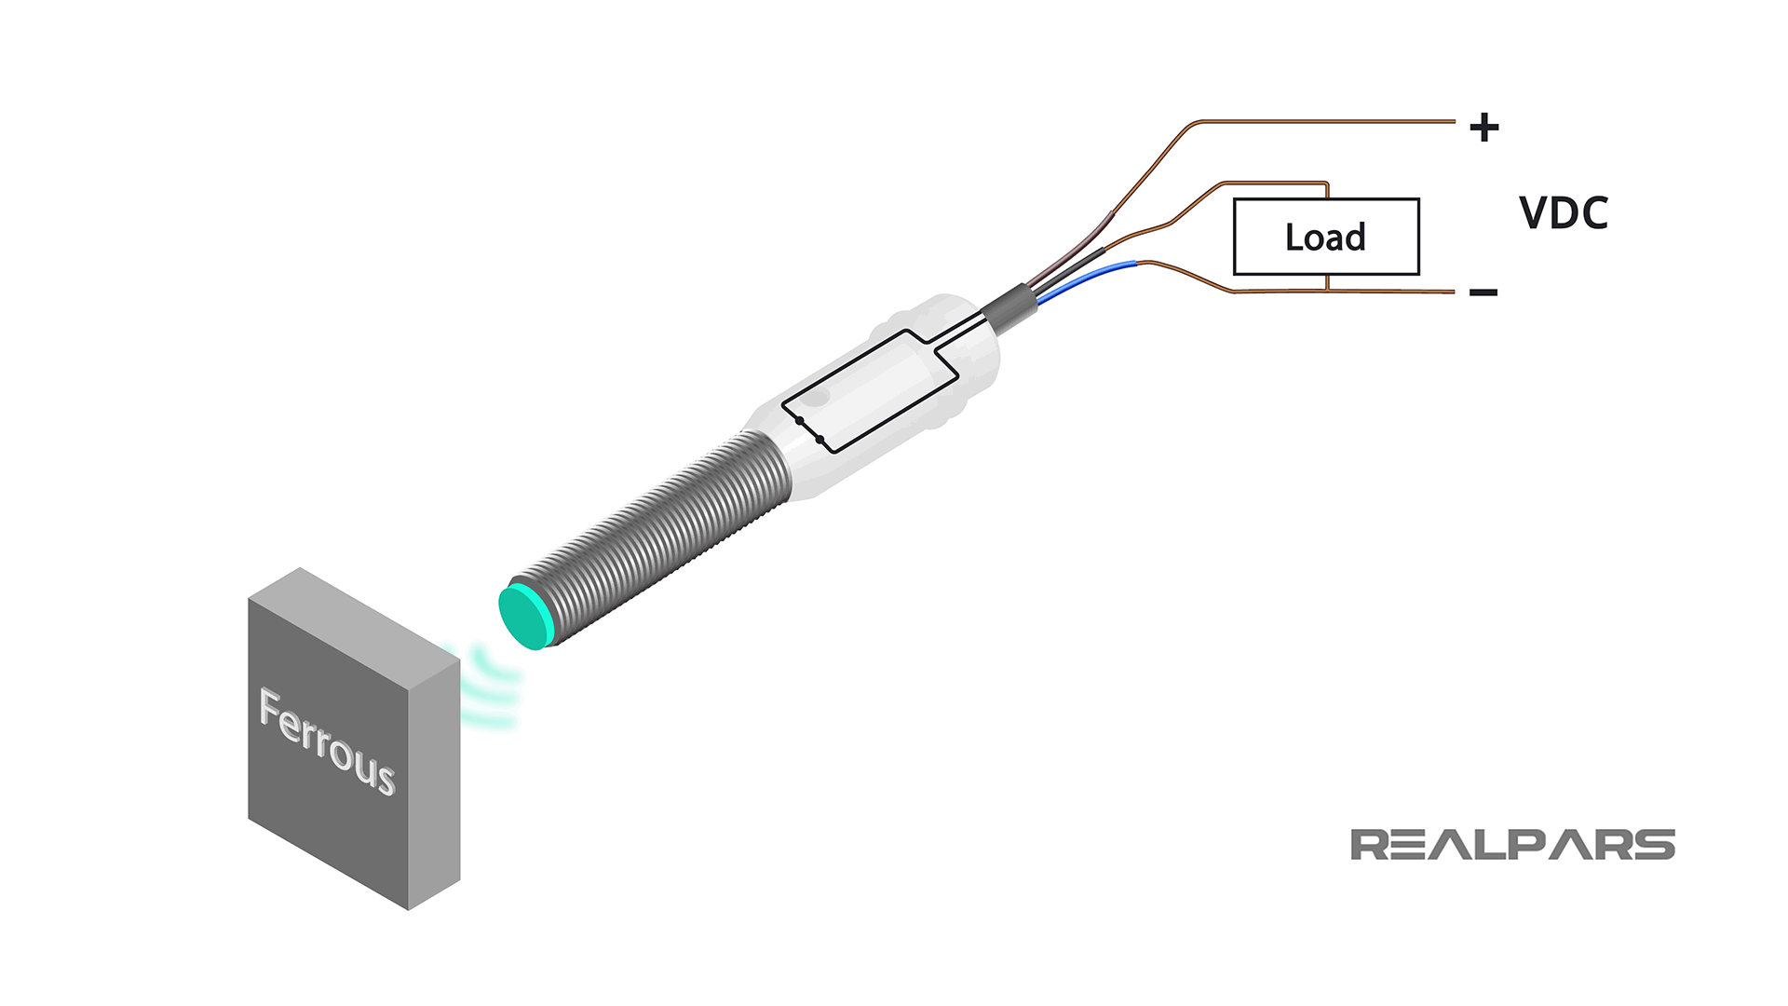

**FUNCTION:**

1. *Automated Door Control:* Proximity sensors detect passengers approaching vehicle doors. This function enables automatic door opening and closing, ensuring safe and efficient boarding and alighting.

2. *Occupancy Monitoring:* Proximity sensors help track passenger numbers in real-time. This data aids in optimizing seating arrangements and alerts when a vehicle reaches capacity, preventing overcrowding.

3. *Fare Collection:* Proximity sensors are used in contactless payment systems. Passengers can simply tap their cards or mobile devices to pay fares, reducing transaction times and improving boarding speed.

4. *Accessibility:* These sensors assist in ensuring accessibility for passengers with reduced mobility. They trigger features like wheelchair ramps or priority seating when needed.

5. *Security:* Proximity sensors can detect unauthorized access or tampering with vehicles during off-hours, enhancing security.

6. *Energy Efficiency:* By controlling lighting, heating, and ventilation based on passenger proximity, these sensors contribute to energy conservation, reducing operational costs.

8. ACCELEROMETERS:

They measure acceleration and deceleration, useful for monitoring driver behavior and optimizing routes for fuel efficiency.

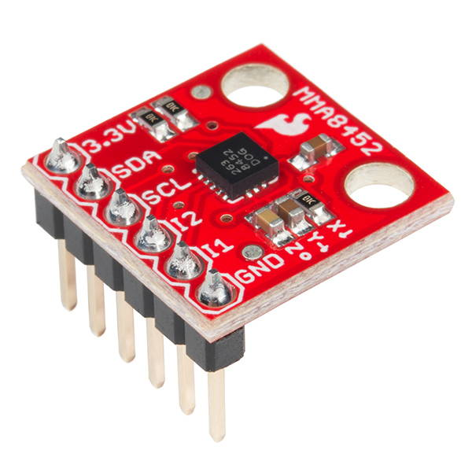

PIN CONFIGURATION

**Power Supply Pins:**

* + VCC or +: This pin is used to provide the power supply voltage to the accelerometer sensor, typically in the range of +3.3V or +5V.
  + GND or -: Connect this pin to the ground (0V) of the power supply to complete the circuit.

**Signal Output Pins:**

* + XOUT, YOUT, ZOUT: These pins provide analog or digital output signals corresponding to the acceleration values along the X, Y, and Z axes. These outputs are typically connected to a microcontroller or monitoring system.

**Voltage Reference (REF or VREF):**

* + Some accelerometers have a pin for an external voltage reference, which can be used to set the sensor's sensitivity or dynamic range.

**Temperature Output (TEMP or TOUT):**

* + Some accelerometers include a pin for temperature output, providing temperature data alongside acceleration data.

**Communication Interface (if applicable):**

* + In some cases, accelerometers may support digital communication interfaces such as I2C or SPI, and they have pins for data input/output and clock signals.

**Grounding (GND Shield):**

* + If the sensor has a shielded cable, there may be a pin for grounding the shield to reduce electromagnetic interference.

**External Control Pins (if applicable):**

* + Depending on the specific accelerometer's features, there might be pins for functions like power-down modes, reset, calibration, or low-pass filtering.

**PIN DIAGRAM:**

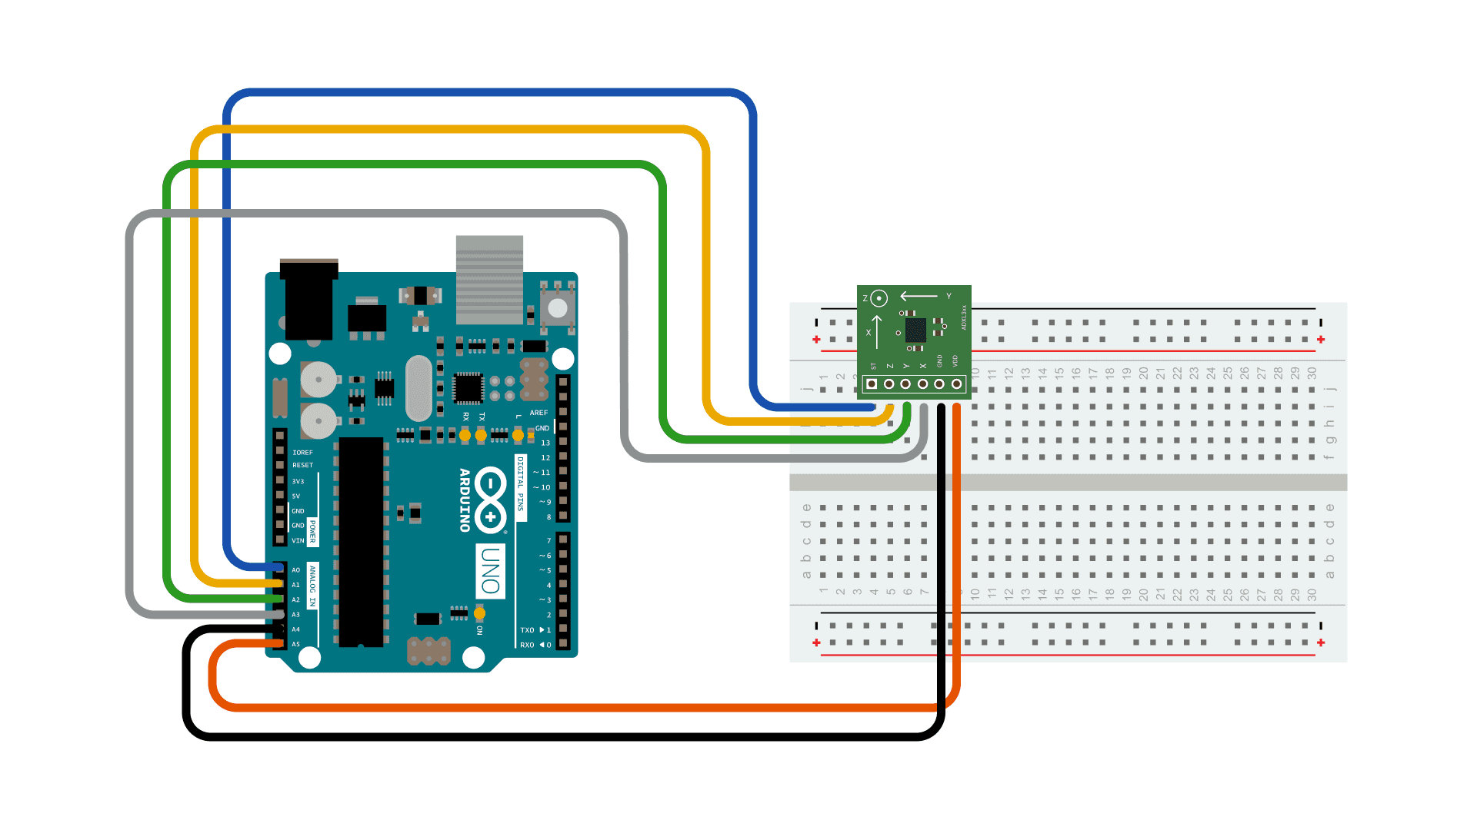

**FUNCTION:**

1. *Vibration Analysis:* Accelerometers monitor vibrations and shocks, helping detect irregularities in vehicle performance. They can identify issues with suspension, brakes, or track conditions, enabling timely maintenance and reducing accidents.

2. *Speed Monitoring:* These sensors measure a vehicle's speed and acceleration, aiding in adherence to speed limits and optimizing driving patterns. This can enhance fuel efficiency and reduce the risk of accidents.

3. *Passenger Safety:* Accelerometers are used in passenger safety systems, triggering airbag deployment during collisions or sudden stops, which can mitigate injuries.

4. *Route Optimization:* By analyzing vehicle movement, accelerometers provide insights into traffic conditions and route efficiency. This data can be used to optimize routes, reduce congestion, and improve on-time performance.

5. *Operational Efficiency:* Accelerometers help in monitoring engine performance and driving habits, leading to better fuel economy, reduced maintenance costs, and extended vehicle lifespans.

6. *Data for Passengers:* Some public transport systems use accelerometers to provide real-time information to passengers about vehicle movements, stops, and expected arrival times.

**9. ULTRASONIC SENSORS:**

These sensors can detect obstacles or pedestrians near the vehicle, contributing to safety and collision avoidanc

**PIN CONFIGURATION**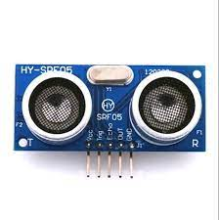

**Power Supply Pins:**

* + VCC or +: This pin is used to provide the power supply voltage to the ultrasonic sensor, typically in the range of +5V to +12V.
  + GND or -: Connect this pin to the ground (0V) of the power supply to complete the circuit.

**Trigger (TRIG):**

* + The trigger pin is used to initiate the ultrasonic sensor's measurement. When a pulse is sent to this pin, the sensor sends out an ultrasonic pulse.

**Echo (ECHO):**

* + The echo pin is used to receive the reflected ultrasonic pulse. The time it takes for the pulse to return is measured, and this duration is used to calculate distance.

**Temperature Compensation (TEMP or TC):**

* + Some ultrasonic sensors may have a pin for temperature compensation to ensure accurate measurements in varying environmental conditions.

**Communication Pins (if applicable):**

* + Some sensors may support digital communication interfaces like I2C or UART, and they have pins for data input/output and clock signals.

**Shield Grounding (if applicable):**

* + If the sensor has a shielded cable, there may be a pin for grounding the shield to reduce electromagnetic interference.

**Additional Pins (if applicable):**

* + Depending on the specific sensor's features, there might be additional pins for functions such as configuration, calibration, or diagnostics.

**Power Supply Pins**:

* + VCC or +: This pin is used to provide the power supply voltage to the ultrasonic sensor, typically in the range of +5V to +12V.
  + GND or -: Connect this pin to the ground (0V) of the power supply to complete the circuit.

PIN DIAGRAM:

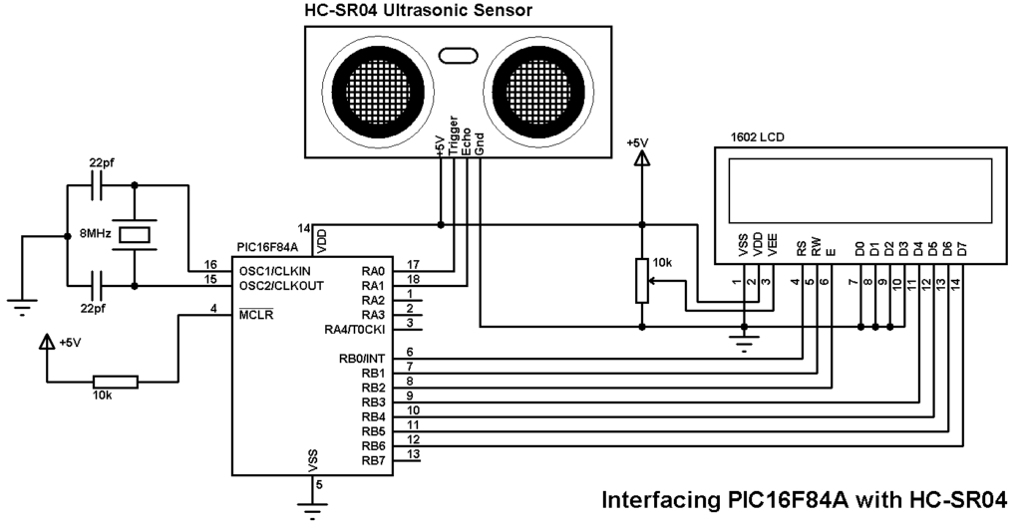

**FUNCTION:**

1. *Obstacle Detection:* Ultrasonic sensors can detect obstacles in the path of vehicles, helping to prevent collisions and ensuring safe operation, particularly in congested urban environments.

2. *Parking Assistance:* These sensors aid in vehicle parking, guiding drivers to available parking spaces with precise measurements, reducing congestion in transport hubs.

3. *Door Control:* Ultrasonic sensors assist in automated door control by detecting passengers' proximity. They facilitate smooth and safe boarding and alighting while minimizing delays.

4. *Passenger Counting:* Ultrasonics can be used to count passengers entering and exiting vehicles. This data is invaluable for route planning, ensuring optimal vehicle deployment based on demand.

5. *Low-Clearance Detection:* Ultrasonic sensors are vital for detecting low-clearance obstacles, preventing damage to vehicles such as buses or trams from bridges, tunnels, or overpasses.

6. *Energy Efficiency:* By optimizing lighting and climate control based on passenger presence, ultrasonic sensors contribute to energy conservation, reducing operational costs.

**ALGORITHM:**

*Step 1: Data Collection*

- Collect real-time data from IoT devices on vehicles, at stops, and from various sensors. This data includes vehicle locations, passenger counts, traffic conditions, weather, and more.

*Step 2: Data Processing*

- Clean, preprocess, and store the collected data in a central database for analysis.

*Step 3: Passenger Demand Prediction*

- Use historical data and machine learning to predict passenger demand for different routes and times.

*Step 4: Route Optimization*

- Develop algorithms to optimize routes based on current traffic conditions, passenger demand, and real-time data. This may involve adjusting routes dynamically during the day.

- Minimize travel times, reduce fuel consumption, and improve service reliability.

*Step 5: Real-Time Tracking*

- Implement real-time tracking of vehicles using GPS data and update passenger information systems (e.g., mobile apps) with accurate arrival times.

*Step 6: Energy Efficiency*

- Optimize energy consumption by adjusting vehicle speeds and routes, and managing vehicle maintenance based on usage and sensor data.

*Step 7: Passenger Information System*

- Create a system for passengers to access real-time information, including vehicle locations, estimated arrival times, and route changes.

- Passengers can receive updates through mobile apps, websites, or displays at stops.

*Step 8: Fleet Management*

- Develop tools for operators to monitor and manage the entire fleet of public transport vehicles.

- Ensure efficient allocation of resources and maintenance scheduling.

*Step 9: Predictive Maintenance*

- Use IoT data to predict maintenance needs for vehicles, minimizing downtime and ensuring safe operation.

- Consider factors like engine health, tire condition, and more.

*Step 10: Security*

- Ensure the security of IoT devices and data. Implement encryption, access controls, and regular security assessments.

*Step 11: Machine Learning for Continuous Improvement*

- Continuously gather data from IoT devices to improve the system further. Train machine learning models to adapt to changing patterns and behaviors.

*Step 12: Feedback Loop*

- Create a feedback loop with passengers and operators to gather input and make ongoing adjustments to the system.

**PROGRAM:**

# Simulated IoT data for vehicles

class Vehicle:

def _init_(self, vehicle_id, current_location):

self.vehicle_id = vehicle_id

self.current_location = current_location

self.passenger_count = 0

def move(self):

# Simulate vehicle movement

lat_change = random.uniform(-0.01, 0.01)

lon_change = random.uniform(-0.01, 0.01)

self.current_location = (self.current_location[0] + lat_change, self.current_location[1] + lon_change)

def pick_up_passengers(self):

# Simulate passenger boarding

passengers_boarded = random.randint(0, 5)

self.passenger_count += passengers_boarded

def drop_off_passengers(self):

# Simulate passenger disembarking

passengers_dropped = random.randint(0, 3)

self.passenger_count -= passengers_dropped

# Simulate a fleet of vehicles

fleet = [Vehicle(vehicle_id, (random.uniform(51.2, 51.5), random.uniform(-0.1, 0.1))) for vehicle_id in range(1, 6)]

# Simulation loop

for _ in range(10):

print("Simulation Step")

for vehicle in fleet:

vehicle.move()

vehicle.pick_up_passengers()

vehicle.drop_off_passengers()

# Perform optimization calculations and route adjustments here

# In a real-world scenario, you would use actual IoT data and optimization algorithms.

# Print simulation status

for vehicle in fleet:

print(f"Vehicle {vehicle.vehicle_id}: Location={vehicle.current_location}, Passengers={vehicle.passenger_count}")

time.sleep(2) # Simulate real-time data updates

**OUTPUT:**

Simulation Step

Vehicle 1: Location=(51.29212865717005, 0.005700512951964787), Passengers=3

Vehicle 2: Location=(51.275476735156246, 0.0020491646307587466), Passengers=1

Vehicle 3: Location=(51.274558847738084, 0.005266329734342755), Passengers=4

Vehicle 4: Location=(51.25899137302052, 0.015746408885210825), Passengers=0

Vehicle 5: Location=(51.25404417037529, 0.004190642806493735), Passengers=2

Simulation Step

Vehicle 1: Location=(51.284540211005676, 0.011356610454842456), Passengers=4

Vehicle 2: Location=(51.275309336611816, 0.009510914534563573), Passengers=3

Vehicle 3: Location=(51.271681425352805, 0.0012842946752724376), Passengers=2

Vehicle 4: Location=(51.27046987041394, 0.021828052786578724), Passengers=1

Vehicle 5: Location=(51.248727990986965, 0.003212500717814548), Passengers=3

...

Simulation Step

Vehicle 1: Location=(51.28140135055198, 0.01770382377899178), Passengers=2

Vehicle 2: Location=(51.2705112278403, 0.0030007812479848667), Passengers=0

Vehicle 3: Location=(51.269243154151915, 0.023799659654896723), Passengers=3

Vehicle 4: Location=(51.268746842637855, 0.021091465501950896), Passengers=1

Vehicle 5: Location=(51.24034614794318, 0.001375692388696232), Passengers=1