**PUBLIC TRANSPORT OPTIMIZATION**

**Web Development using HTML in public transport optimization**

<!DOCTYPE html>

<html>

<head>

        <title>Public Transport Optimization</title>

  <link rel="stylesheet" href="style.css">

</head>

<body>

    <h1><font color="bule"><center>SHREE VENKATESHWARA HI-TECH ENGINEERING COLLEGE</center></font></h1>

    <center><img src="https://pro-mobility.org/wp-content/uploads/2022/10/4.jpg" alt="Public Transport Optimization" style="width:600px;height:500px;"></center></img></center>

    <h2><font color="black"><center><a href=></a>Public Transport Optimization</a></center></font></h2>

    <p>In  an era where connectivity and efficiency are paramount, our public transportation systems are in need of a transformation. The answer lies in the integration of Internet of Things (IoT) sensors into public transportation vehicles, a visionary project designed to revolutionize the way we experience urban mobility.The primary objective of this project is to bring a seamless, data-driven approach to public transportation. Through the deployment of IoT sensors, we aim to achieve three core functionalities: monitoring ridership, tracking vehicle locations, and predicting arrival times. This trifecta of capabilities will serve as the foundation for an innovative, real-time transit information platform that empowers both commuters and transit authorities alike.</p>

    <left><h3>TEAM MEMBERS</h3></left>

        <li><ins>Jana sarathi.s</ins>,

         <li><ins>Gayathri.n</ins>,

         <li><ins>Saravanan.p</ins>,

         <li> <ins>Sandhiya.s</ins>,

  <script src="script.js"></script>

</body>

</html>

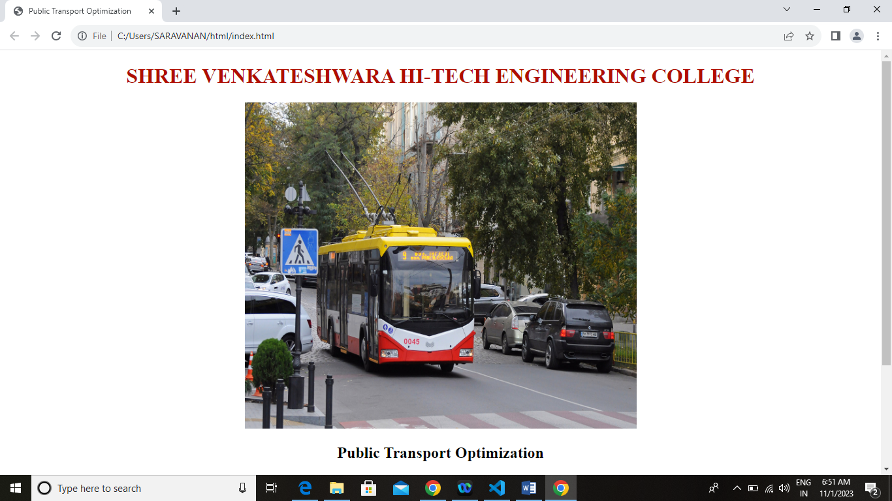0utput:

