BUSINESS REQUIREMENTS DOCUMENT (BRD)
Patient Appointment Scheduling
Outpatient Clinic – Digital & Front-Desk Scheduling Channel
Healthcare Business Analysis Portfolio Project
Domain | Healthcare – Patient Access / Scheduling
Document Type | Business Requirements Document
Version | 1.0
Prepared By | Jana Srikumar – Business Analyst
Purpose | To improve the patient appointment scheduling process through a digital, rules-driven workflow integrated with the EHR
Regulatory Scope | HIPAA Privacy & Security Rules; HITECH Act; 21st Century Cures Act (Information Blocking); ADA / Section 508 accessibility; TCPA (patient communications)

1. Executive Summary
This BRD proposes a digital patient appointment scheduling process that lets patients book, reschedule, and check in for outpatient visits online or through the front desk, with real-time provider availability, insurance eligibility checks, and automated reminders. The goal is to reduce scheduling errors, no-shows, and manual front-desk workload while ensuring patient identity verification, insurance eligibility, and HIPAA-compliant handling of protected health information (PHI) throughout the journey.

2. Business Problem
- Appointments are scheduled manually by phone, leading to long hold times and double-booking.
- Provider availability is not visible to patients in real time.
- Insurance eligibility is often verified only at check-in, causing delays or denied claims.
- High no-show rate due to inconsistent appointment reminders.
- Patient identity mismatches (e.g., duplicate or incorrect MRN) create downstream data quality issues.
- Front-desk staff spend significant time on rescheduling and waitlist management.

3. Business Objectives
- Reduce patient wait time to get an appointment (target scheduling TAT).
- Reduce no-show rate through automated, multi-channel reminders.
- Verify insurance eligibility before the visit, not just at check-in.
- Ensure accurate patient identification at the point of scheduling.
- Give patients self-service visibility into available slots and appointment status.
- Maintain HIPAA-compliant handling of PHI across all scheduling channels.

4. Stakeholders
Stakeholder | Main Role
Patient | Requests, reschedules, and tracks appointments
Front Desk / Care Coordinator | Manages exceptions, waitlists, and manual bookings
Provider (Physician/Clinician) | Defines availability, appointment types, and visit duration
Billing / Insurance Verification Team | Confirms coverage and resolves eligibility issues
Compliance / Privacy Office | Ensures HIPAA, consent, and PHI-handling requirements are met
IT / EHR Team | Maintains the scheduling system and EHR (HL7/FHIR) integration

5. Current (AS-IS) Process
Patient calls clinic → Staff manually checks provider calendar → Appointment booked in system → Reminder call/letter (inconsistent) → Insurance checked at check-in → Visit.
Main pain point: manual scheduling and late eligibility checks increase no-shows, wait times, and front-desk workload.

6. Proposed (TO-BE) Process
Patient requests appointment via portal/app or phone → Patient identity match (MRN + date of birth) → System checks provider availability and appointment type → Real-time insurance eligibility check (X12 270/271 transaction) → Slot held and confirmed → Automated reminder (SMS/email/portal) → Patient check-in. Exceptions (coverage issues, no matching slot) are routed to the front desk and Insurance & Compliance teams for resolution or waitlisting.
The system should automatically confirm straightforward bookings while routing coverage or scheduling exceptions to staff for manual handling.
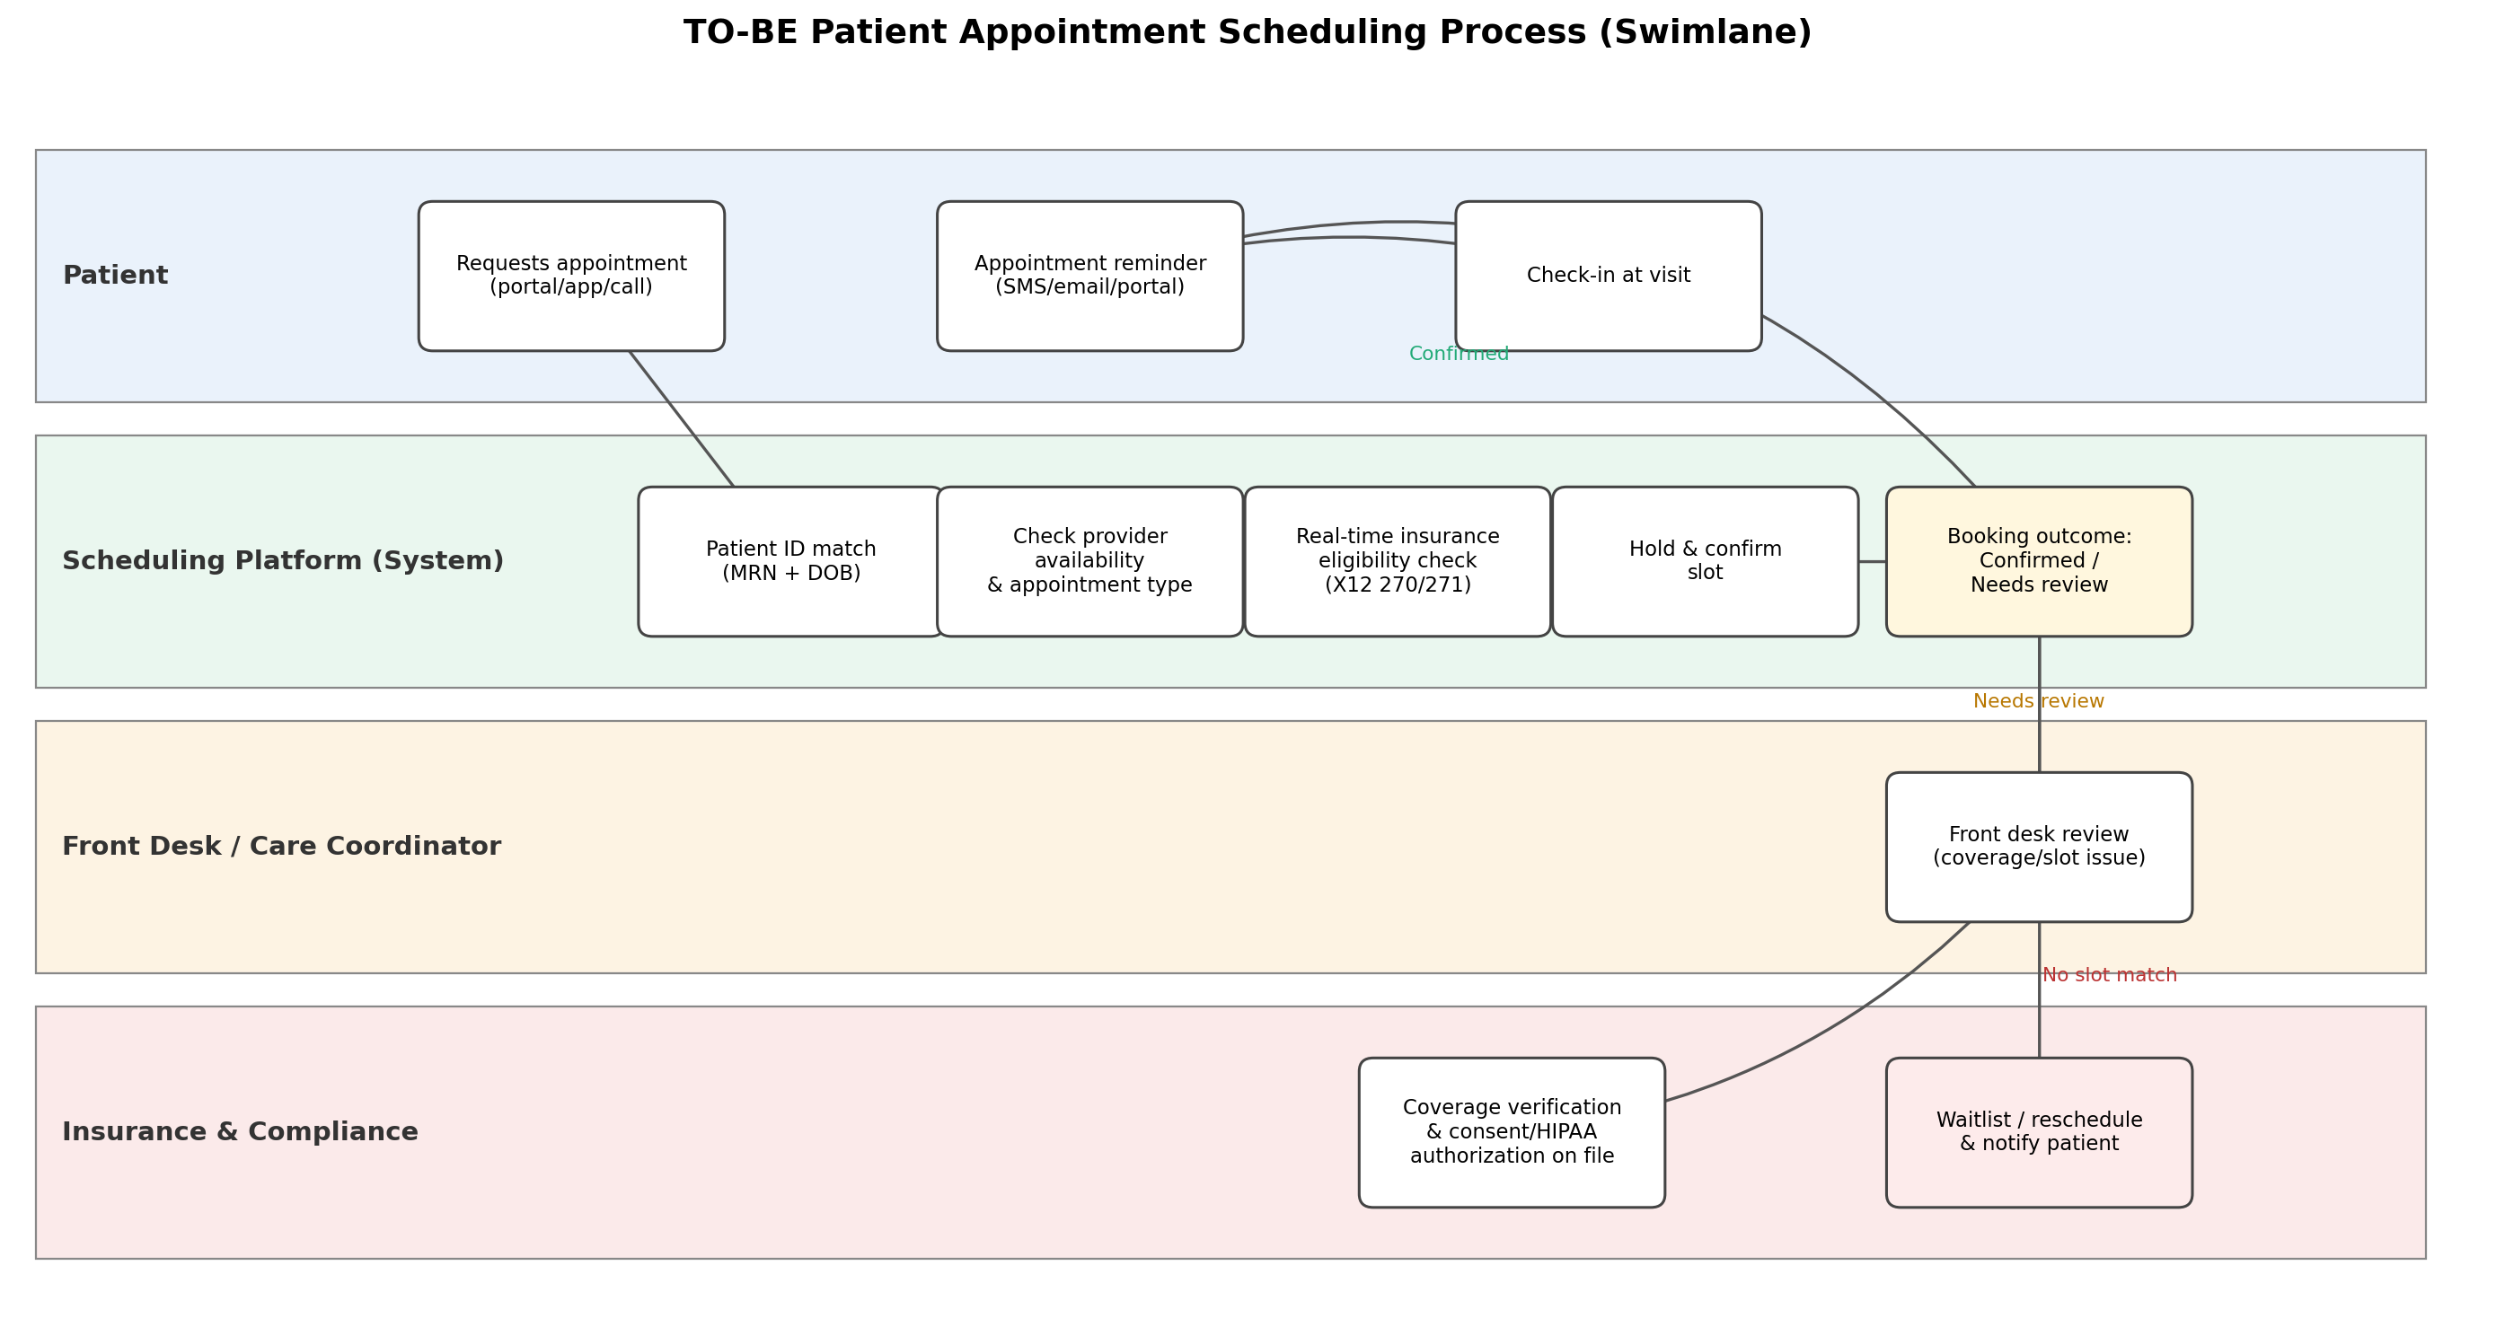
Figure 1: TO-BE Patient Appointment Scheduling Process (Swimlane)

7. Business Requirements
ID | Business Requirement
BR-01 | Patients should be able to request an appointment online, via app, or by phone.
BR-02 | The system should verify patient identity using MRN and date of birth before booking.
BR-03 | The system should show real-time provider availability by appointment type and location.
BR-04 | The system should perform a real-time insurance eligibility check before confirming the appointment.
BR-05 | Confirmed appointments should trigger an automated reminder through the patient's preferred channel.
BR-06 | Appointments with coverage or scheduling issues should be routed to front-desk staff for manual resolution.
BR-07 | Patients should be able to view, reschedule, or cancel their appointment through the portal.
BR-08 | All scheduling and PHI access activity should be logged for HIPAA audit purposes.
BR-09 | Patients must provide consent/authorization on file before PHI is used for scheduling communications.

8. Key Business Rules
Rule | Description
Rule 1 | Patient identity must be confirmed via a two-factor match (e.g., MRN + date of birth, or name + DOB + phone) before a slot is held.
Rule 2 | Double-booking is not permitted; the system must lock a slot for a defined hold window (e.g., 10 minutes) during checkout.
Rule 3 | Insurance eligibility must be verified in real time (X12 270/271) prior to confirmation; self-pay patients bypass this check.
Rule 4 | New patients require a longer default visit duration than established patients, based on appointment type.
Rule 5 | Appointments cancelled with less than 24 hours' notice are flagged as a late cancellation for no-show tracking.
Rule 6 | Patients with 2 or more no-shows in the last 90 days are routed to front-desk confirmation rather than auto self-service booking.
Rule 7 | Eligibility failures or coverage mismatches route the booking to the Insurance & Compliance queue rather than auto-confirming.
Rule 8 | Reminders are sent at defined intervals (e.g., 72 hours and 24 hours before the visit) via the patient's consented channel only.
Rule 9 | PHI shared in reminders is limited to the minimum necessary (e.g., date/time/location), consistent with HIPAA minimum-necessary standard.

9. Functional Requirements
ID | Requirement
FR-01 | System shall allow patients to search available slots by provider, location, and appointment type.
FR-02 | System shall match patient identity against the EHR using MRN and DOB, flagging mismatches for staff review.
FR-03 | System shall integrate with the EHR via HL7/FHIR to read provider schedules and write confirmed appointments.
FR-04 | System shall call the payer eligibility service (X12 270/271) and capture the eligibility response and coverage details.
FR-05 | System shall hold a selected slot for a configurable window before releasing it if booking is not completed.
FR-06 | System shall send automated reminders via SMS, email, or patient portal per the patient's consented channel.
FR-07 | System shall allow patients to cancel or reschedule within policy-defined windows via self-service.
FR-08 | System shall route exceptions (identity mismatch, eligibility failure, no available slot) to the appropriate staff queue.
FR-09 | System shall maintain an audit log of all PHI access and scheduling actions with user ID and timestamp.

10. Non-Functional Requirements
- Security & Privacy: PHI encrypted in transit (TLS 1.2+) and at rest (AES-256); access limited by role per HIPAA minimum-necessary standard.
- Performance: Slot search results should return within 3 seconds; eligibility check responses within 5 seconds, with a manual fallback on timeout.
- Availability: The scheduling platform should maintain at least 99.5% uptime during clinic operating hours.
- Accessibility: Patient-facing scheduling pages should meet WCAG 2.1 AA / Section 508 accessibility standards.
- Audit: PHI access and scheduling actions logged and retained per HIPAA and organizational record-retention policy (typically 6+ years).
- Compliance: Patient communications (SMS/email reminders) must honor consent preferences and comply with TCPA requirements.

11. Data Requirements
Data Area | Examples
Patient | Name, date of birth, MRN, contact details, preferred communication channel/consent
Insurance | Payer name, member ID, group number, eligibility status, copay/coverage details
Provider | NPI, specialty, location, available slots, appointment types offered
Appointment | Date/time, type, status (confirmed/cancelled/no-show/completed), reminder history
Compliance | Consent/authorization on file, PHI access log, communication opt-in status

12. Exception Scenarios
Scenario | Expected Business Action
Patient identity cannot be matched | Route to front desk for manual identity verification before booking.
Insurance eligibility check fails or times out | Hold appointment as pending; route to Insurance & Compliance for manual verification.
No provider slot matches request | Offer nearest alternative slots or add patient to a waitlist and notify when a slot opens.
Patient has repeated no-shows | Require front-desk confirmation rather than auto self-service booking (per Rule 6).
Patient withdraws communication consent | Suppress SMS/email reminders; use only the consented channel or none.
Late cancellation (<24 hours) | Flag as late cancellation, release slot to waitlist, and log for no-show reporting.

13. Key KPIs
KPI | Why It Matters
No-Show Rate | Measures the effectiveness of reminders and confirmation workflows.
Scheduling Turnaround Time (TAT) | Measures how quickly a patient can get an appointment.
Schedule Utilization Rate | Shows how efficiently provider capacity is used.
Self-Service Booking Rate | Share of appointments booked without staff intervention.
Eligibility Verification Rate (Pre-Visit) | Share of visits with insurance confirmed before the appointment, reducing denied claims.
Patient Satisfaction (Scheduling Experience) | Captures patient-perceived ease of booking and communication.

14. Risks and Mitigation
Risk | Mitigation
Incorrect patient identity match (duplicate/merge errors) | Enforce two-factor identity match and route ambiguous matches to staff review.
EHR/eligibility service downtime | Use retry logic and manual front-desk fallback workflow.
PHI exposure in reminders | Limit reminder content to minimum necessary information; encrypt all communications channels.
Non-compliance with HIPAA/TCPA in communications | Involve Compliance in reminder content and consent-capture design before go-live.
Overbooking or slot conflicts | Enforce slot-hold logic and real-time calendar sync with the EHR.

15. Assumptions & Dependencies

Assumptions
- Provider calendars and appointment types are maintained and kept current in the EHR.
- Patients have or can create a portal account, or can continue booking via phone through front desk.

Dependencies
- EHR system (HL7/FHIR interface)
- Payer eligibility service (X12 270/271)
- Patient portal / mobile app
- SMS/email notification service
- Front-desk scheduling workflow tool

16. Acceptance Criteria – Example
Given a returning patient requests an appointment through the portal, when the system confirms an MRN + DOB identity match and a successful real-time eligibility check, then the system should hold and confirm the selected slot, send a reminder per the patient's consented channel, and log the transaction for audit; if eligibility fails, the booking should route to the Insurance & Compliance queue instead of auto-confirming.

17. Regulatory & Compliance References
- HIPAA Privacy Rule and Security Rule – governs use, access, and protection of PHI, including the minimum-necessary standard.
- HITECH Act – strengthens breach notification and security requirements for electronic PHI.
- 21st Century Cures Act (Information Blocking provisions) – supports patient access to their own health information, including scheduling and appointment data.
- ADA / Section 508 – requires patient-facing digital scheduling tools to be accessible.
- TCPA – governs consent requirements for SMS/automated patient communications.

18. Expected Business Benefits
- Reduced no-show rate.
- Shorter time for patients to get an appointment.
- Fewer claim denials through earlier eligibility verification.
- Less manual front-desk scheduling workload.
- Improved patient identity data quality.
- Stronger HIPAA compliance posture across scheduling channels.

