Programming and numerical analysis
Short test 2
2020/10/20

Student id# 19B60096 Name Taerakul Janat

- Add to the pointer_fun code two more functions to perform addition and subtraction.

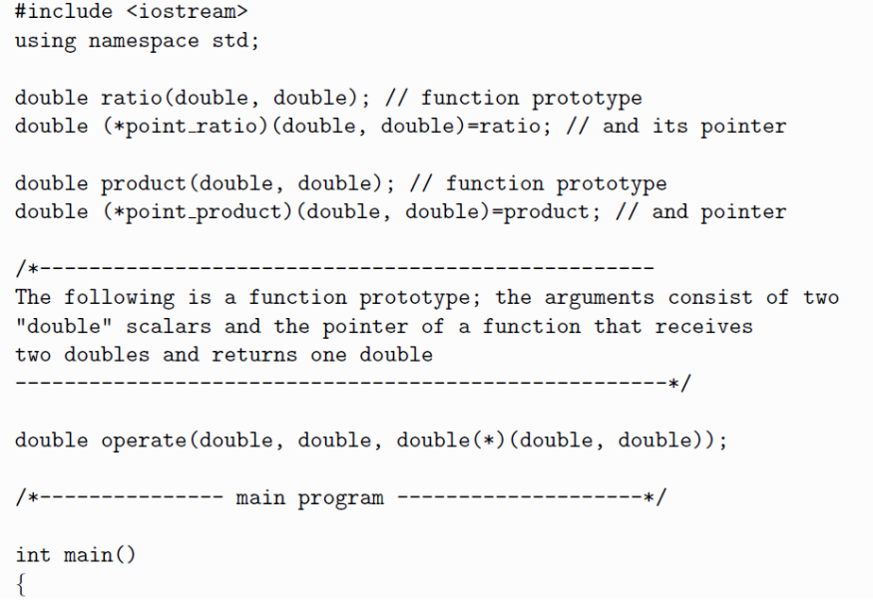
ratio1
ratio1

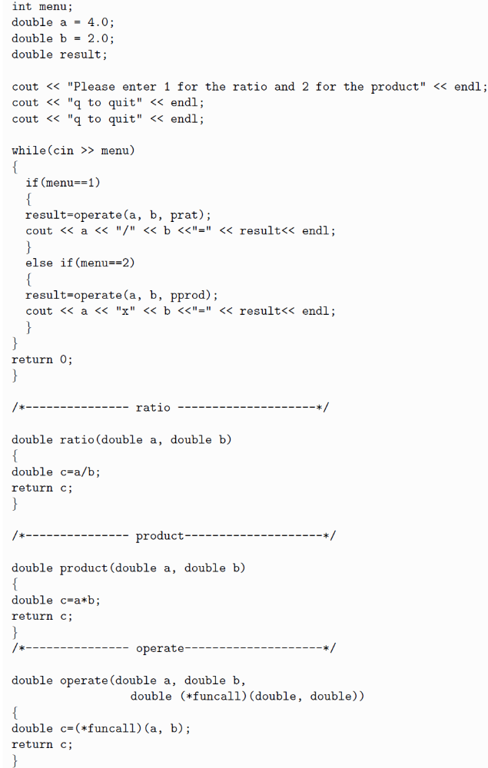
point_product);

point_ratio);

