Machine Learning Approaches to Predicting Same-Day Discharge After Total Hip Arthroplasty Using the ACS NSQIP Data

Tanmoy Jana, PHD¹, Rodney A. Gabriel, MD, MAS^{2,3,4}

Affiliations
¹UCSF Immunogenetics and Transplantation Laboratory, 1100 Van Ness Avenue, Suite 800, San Francisco, CA 94109, United States
²Department of Anesthesiology, University of California, San Diego, La Jolla, CA, USA
³Division of Biomedical Informatics, Department of Medicine, University of California, San Diego, La Jolla, CA, USA

⁴Division of Perioperative Informatics, Department of Anesthesiology, University of California, San Diego, La Jolla, CA, USA

Corresponding Author:

Rodney A. Gabriel
9400 Campus Point Dr, MC 7770
La Jolla, CA 92037
Phone: (858) 249 – 3660
Email: ragabriel@health.ucsd.edu

Keywords: machine learning; same-day discharge; ensemble learning

Word count: 2909 (main text only)

Clinical Trial Number: Not Applicable
Abbreviated Title: Prediction of Same-Day Discharge
Author Contributions:

Disclosure of Funding: Support was provided solely from institutional and/or departmental sources.

Conflicts of Interest: None

Abstract

Background: Predicting same-day discharge using ensemble learning combined with oversampling may improve model performance.

Methods: We compared various predicted models using different demographics, admission sources (such as home nursing facilities and outside emergency departments), current physical status, and preoperative blood test results, along with several factors, including ventilator dependence, chronic obstructive pulmonary disease, ascites, hypertension, renal failure, and others. We compared various predictive models using a combination of demographic features, admission sources (such as home nursing facilities and outside emergency departments), current physical status, and preoperative blood test results. Additional clinical parameters such as any history of chronic obstructive pulmonary disease, ventilator usage, ascites, hypertension, and renal failure. The classical machine learning models, such as random forest, extreme gradient boosting, logistic regression, multilayer perceptron, and adaptive boosting, were evaluated, but the performance of all models was not significantly good due to class imbalance in the electronic health data. To address the situation, the synthetic minority oversampling technique (SMOTE) was applied. The performance of models was compared with and without oversampling using F1-score, recall, accuracy, area under the curve (AUC), and Matthew’s correlation coefficient (MCC).

Results: In this study, 8,296 patients received hip arthroplasty and were able to return home the same day. Most (99.7%) were admitted from home, and their average age was approximately 63 years. Over 95% of patients continued their steroid medications. The cohort primarily consisted of diabetic patients, many of whom had additional conditions such as ascites, renal failure, and dialysis. For model training, 6,637 patients were included in the training dataset, while 1,659 patients were used in the blind dataset for validation. Without oversampling, the extreme gradient boosting classifier model had an F1-score of 0.52, an AUC of 0.79, a recall of 0.52, and an MCC of 0.17. While using SMOTE, the performance of all models improved. The extreme gradient boosting classifier outperformed an F1-score of 0.92, an AUC of 0.97, an accuracy of 0.92, and an MCC of 0.85. The top five features with stronger importance scores in permutation and SHAP analysis were preoperative sodium, ethnicity, race, physical status, and preoperative bilirubin.

Conclusions: Ensemble learning may enhance predictive models for clinical decision-making of patient discharge following total hip arthroplasty. The patient's preoperative characteristics, demographics, and pre-existing conditions may enable to prediction of the length of stay or enable same-day discharge after hip replacement surgery. This approach can support care optimization through early and personalized interventions.

Introduction

Total hip arthroplasty (THA) has become a more popular orthopedic procedure, and we can estimate that more than half a million cases will be performed annually in the United States by 2030 [1]. To meet the increasing demand and popularity, healthcare systems also need to be more advanced in outpatient care. Recent advancements in anesthesia, minimally invasive techniques, and enhanced recovery pathways have made same-day discharge (SDD) for total hip arthroplasty both popular and safe [2-4]. SDD provides several advantages, including greater hospital throughput, reduced healthcare costs, and greater patient satisfaction [5–7]. Returning home on SSD allows better mobility and analgesia for those suffering from hip joint disease. However, patient selection for SSD remains a critical challenge. The American Society of Anesthesiologists (ASA) classification and the Charlson Comorbidity parameters are used traditionally to guide surgery and discharge judgment [8,9]. But using these approaches sometimes fails to discharge readiness due to complex demographic, perioperative, and comorbidity-related factors. As a result, unavoidable circumstances, with unplanned readmissions and prolonged hospital stays, can be seen [10]. Thus, there is an urgent need for more precise, objective, and reproducible tools to identify candidates who can safely undergo SDD following THA. More research is needed to identify methods for predicting which patients may experience complications after total hip replacement. Identification of patient risk profile quantification before hospital discharge and pain management plan. The number of studies that have explored risk factors and, generalizability of current tools and multicenter datasets is not able to integrate well into clinical settings. Predictive models can distinguish between patients who qualify for SDD and patients who need to stay longer as per their preoperative risk assessment. The American College of Surgeons National Surgical Quality Improvement Program (ACS NSQIP) provides a dataset with validated preoperative and postoperative information from various hospitals [11]. Using this NSQIP data, our goal is to develop a prediction model to determine whether a particular patient is at a lower risk of SSD or needs to stay longer due to adverse risk.

Methods

Study Sample and Data Collection

We compiled the data from the ACS NSQIP database for total hip arthroplasty, including 122,265 patients. Among them, 8296 patients who were discharged with SSD are classified as Class 1, while 113969 patients who were not discharged were considered as Class 0. The percentage ratio of the two classes was 6% for Class 1 and 93.21% for Class 0, indicating a highly imbalanced class. To manage this imbalance, we split the data using the “train_test_split” into training and blind sets. The training set included 97,812 patients (6,637 Class 1: SSD, 91,175 Class 0: non-SSD), and the blind set contained 24,453 patients (1,659 Class 1, 22,794 Class 0). We employed five supervised machine learning models to predict SSD: RF, LR, XGBoost, MLP, and AdaBoost. To overcome the class imbalance problem, we used feature selection, model hyperparameter tuning, SMOTE, and cross-validation, and compared all models before and after oversampling. The predictive models were developed based on characteristics of patient profiles, such as: demographics (e.g., age, sex, ethnicity, body mass index, etc.), patient risk class, comorbidities (e.g., diabetes, smoking, obstructive pulmonary disease, heart failure, hypertension, liver status, renal failure, bleeding disorder), preoperative laboratory values (sodium, bilirubin, albumin, alkaline phosphatase, hematocrit, and coagulation factors), and admission status (home, hospital and emergency unit).

In addition, we considered the NSQIP 2014-2016 dataset as an additional blind set containing 20649 patients, where 221 patients were discharged the same day and 20428 patients stayed for a longer time in the hospital, for the performance evaluation of models in real-world situations.

Descriptive Analysis

Python (version 3.12.8) and scikit-learn (version 1.7.1) were used for the whole analysis. The cohort dataset was divided into training and blind subsets for model development and model performance evaluation. During this process, it ensures that any patients present in the blind set were automatically removed from the training set.

Data Balancing using SMOTE

To address the imbalance problem, the SMOTE algorithm was applied to the training dataset.
Imbalanced data may cause significant difficulties for models, as they fail to classify and result in more false positives towards the majority class. In this approach, patterns from the minority class are analyzed, and new synthetic data points are generated based on their nearest neighbors to create a balanced class distribution.

SHAP Analysis
SHapley Additive exPlanations (SHAP) was used to explain the model prediction and the contribution of each feature in predictive outcomes. It also provided feature importance with global and local interpretability with as individualized patient-level predictions.

Feature Dimensionality Reduction: PCA

Principal Component Analysis (PCA) was employed to explain more about feature dimensionality and variance. The analysis is very helpful for the multicollinearity relationship among correlated features and for making an interpretable and simplified model without loss of any information.

Machine learning Classifiers

The five classic machine learning classifiers, including RF, LR, XGBoost, MLP, and AdaBoost were employed to develop prediction models using the NSQIP data in oversampling with cross-validation for screening patients to SSD or not discharged. Each of the classifiers tuned its specific parameters iteratively to get the optimized scores. The chances of over-fitting were also optimized using stratified k-fold and regularization parameters (L1and L2 regularization parameters).

Random forest

RF is a supervised ensemble-based ML classifier that can classify by creating multiple decision trees. During training, several uncorrelated trees create a committee-like environment that has a higher ability for prediction than individual trees. Different parameters of RF were also computed in the grid searching technique to get optimum parameter values, such as: estimator (n_estimators) was set to 1200, random state (random_state) to 92, bootstrap was enabled, and max_features was set to sqrt.

Logistic regression

LR is a probability-based ML classifier that performs binary classification and is assigned a probability score between 0 and 1. During five-fold cross-validation, the LR was trained with the following parameter settings: tolerance set to 0.01, penalty set L2 regularization, solver set to saga, and random_state set to zero.

Extreme gradient boosting

The supervised ensemble XGBoost was used to develop a model based on a multi-layer decision tree-based system. During cross-validation, the XGBoost was trained with the following parameter settings: maximum depth equal to 5 (max_depth), learning rate equal to 0.1 (learning_rate), number of tree estimators set to 1200 (n_estimators), the value of L2 and L1 regularization parameter lambda set to 1 (reg_lambda) and 0 (reg_alpha) with a subsample was set to 0.8 to prevent overfitting. However, these parameters were tuned with grid search to get optimize predicted model performance.

Multi-layer perceptron

MLP is a feedforward conventional neural network with three layers, namely input, hidden, and output layers. During training, MLP activates its activation in the input layer function in the backpropagation technique. The parameters, like hidden layer sizes and maximum iteration set to 100, random state set at 62, and batch size equal to 320, were used to develop the ML model.

Adaptive boosting

AdaBoost is an ensemble learning algorithm that is based on a multi-layer and sequential decision tree-based system. In this study, AdaBoost was used as one of the five classification methods to evaluate its ability to predict same-day discharge outcomes.

K-fold cross-validation

To perform a more robust evaluation of our models, we incorporated stratified K-fold cross-validation to observe the accuracy, precision, recall, F1-score, and AUC scores for different folds. The model was built on the training set and evaluated on the testing set. The models were further evaluated on the blind dataset.

Performance Metrics

Accuracy

Accuracy describes the proportion of correctly predicted samples out of all predictions.

$$Accuracy=\frac{TP+TN}{TP+TN+FP+FN}$$

Precision
Precision measures the proportion of positive predictions that are actually correct. A higher precision value indicates a good prediction model with less number of false positives.
$$Precision=\frac{TP}{TP+FP}$$

Recall

Recall describes how many real positives the model can identify successfully.

$$Recall=\frac{TP}{TP+FN}$$

F1-Score

The F1-score is a performance metric by computes the mean of precision and recall. The metric is important and useful when an imbalanced class distribution is observed.

$$F1= \frac{2TP}{2TP+FP+FN}$$

AUC
We calculated the AUC in the ROC curve. The AUC summarizes the whole ROC curve’s true positive rate versus false positive rate in a range from 0 to 1. While, AUC value tends to 1, indicating classification strength, whereas AUC value near 0.5 suggests random classification.
MCC
We calculated the Matthews Correlation Coefficient (MCC). Positive and non-zero MCC values indicate a stronger model.

$$MCC= \frac{(TP×TN)-(FP×FN)}{\sqrt{(TP+FP)×(TP+FN)×(TN+FP)×(TN+FN)}}$$

Results
Study Population
There were 122265 patients of the two patient cohorts included in the final analysis. In the first cohort, 8296 patients were released for SSD after THA surgery, where most of these patients were admitted directly from home, had the BMI of less than 29 (less obesity), and a lower average age of 63 years, with a lower history of congestive heart failure, renal failure, mild surgical risk profiles, and fewer medicine required for hypertension. In contrast, in another cohort of patients, 113969 (93.2%) had not been released on the same day or required to stay longer and were considered non-SSD, having a BMI would upper of 30, an average age was 66 years, with having history of heart failure, renal failure, shortness of breath, chronic obstructive pulmonary disease (COPD) and medicine required for hypertension, and not having independent functional status and severe risk profiles (Table 1).
Table 1. Patient Characteristics in the two cohorts. Chi-square test was used to compare categorical variables. Abbreviations: SD, standard deviation.

Category | Class0: Non-SSD |  | Class1: SSD |  | p-value
 | n | % | n | %
Total | 113969 | 93.2 | 8296 | 6.78
Female Sex | 63114 | 55.4 | 4001 | 48.2 | <0.0001
Male Sex | 50854 | 44.6 | 4294 | 51.8 | <0.0001
Non-binary/Other Sex | 1 | 0.0 | 1 | 0.0 | <0.0001
Race
White | 79662 | 69.9 | 6430 | 77.5 | <0.0001
Native Hawaiian or Pacific Islander | 256 | 0.2 | 30 | 0.4 | <0.0001
Black or African American | 9255 | 8.1 | 483 | 5.8 | <0.0001
Asian | 1459 | 1.3 | 294 | 3.5 | <0.0001
Unknown/Not Reported | 22873 | 20.1 | 1044 | 12.6 | <0.0001
American Indian or Alaska Native | 464 | 0.4 | 15 | 0.2 | <0.0001
Hispanic ethnicity
No | 87113 | 76.4 | 6890 | 83.1 | <0.0001
Yes | 3690 | 3.2 | 374 | 4.5 | <0.0001
Unknown | 23166 | 20.3 | 1032 | 12.4 | <0.0001
Body Mass Index, mean [SD] | 30.34 [6.26] |  | 29.09 [5.23] |  | <0.0001
Age (years), mean [SD] | 65.66 [11.09] |  | 62.71 [10.53] |  | <0.0001
Transfer Status Before Surgery
Not transferred admitted from home) | 112364 | 98.6 | 8274 | 99.7 | <0.0001
Nursing home/Chronic care/Intermediate care | 440 | 0.4 | 2 | 0.0 | <0.0001
From acute care hospital inpatient | 440 | 0.4 | 6 | 0.1 | <0.0001
Outside emergency department | 465 | 0.4 | 1 | 0.0 | <0.0001
Transfer from other | 118 | 0.1 | 4 | 0.0 | <0.0001
Unknown | 142 | 0.1 | 9 | 0.1 | <0.0001
Comorbidities / Pre-existing conditions
Diabetes
No | 99357 | 87.2 | 7668 | 92.4 | <0.0001
Non-Insulin | 11112 | 9.8 | 487 | 5.9 | <0.0001
Insulin | 3500 | 3.1 | 141 | 1.7 | <0.0001
Current smoker
No | 100010 | 87.8 | 7602 | 91.6 | <0.0001
Yes | 13959 | 12.2 | 694 | 8.4 | <0.0001
Shortness of breath
No | 108657 | 95.3 | 8169 | 98.5 | <0.0001
Moderate Exertion | 5116 | 4.5 | 126 | 1.5 | <0.0001
At Rest | 196 | 0.2 | 1 | 0.0 | <0.0001
Functional Status
Independent | 111336 | 97.7 | 8250 | 99.4 | <0.0001
Partially Dependent | 1963 | 1.7 | 36 | 0.4 | <0.0001
Totally Dependent | 115 | 0.1 | 2 | 0.0 | <0.0001
Unknown | 555 | 0.5 | 8 | 0.1 | <0.0001
Ventilator Dependence
No | 113960 | 100.0 | 8296 | 100 | 0.883
Yes | 9 | 0.0 | 0 | 0.0 | 0.883
History of COPD
No | 109397 | 96.0 | 8162 | 98.4 | <0.0001
Yes | 4572 | 4.0 | 134 | 1.6 | <0.0001
Presence of Ascites
No | 113934 | 100.0 | 8296 | 100 | 0.208
Yes | 35 | 0.0 | 0 | 0.0 | 0.208
History of Congestive Heart Failure
No | 113465 | 99.6 | 8293 | 100 | <0.001
Yes | 504 | 0.4 | 3 | 0.0 | <0.001
Hypertension Requiring Medication
No | 50492 | 44.3 | 4788 | 57.7 | <0.0001
Yes | 63477 | 55.7 | 3508 | 42.3 | <0.0001
Renal Failure
No | 113900 | 99.9 | 8294 | 100 | 0.274
Yes | 69 | 0.1 | 2 | 0.0 | 0.274
Dialysis Dependence
No | 113681 | 99.7 | 8292 | 100 | <0.001
Yes | 288 | 0.3 | 4 | 0.0 | <0.001
Disseminated Cancer
No | 113458 | 99.6 | 8280 | 99.8 | <0.001
Yes | 511 | 0.4 | 16 | 0.2 | <0.001
Chronic Steroid Use
No | 109576 | 96.1 | 8133 | 98.0 | <0.0001
Yes | 4393 | 3.9 | 163 | 2.0 | <0.0001
Weight loss >10% in past 6 months
No | 113711 | 99.8 | 8278 | 99.8 | 0.957
Yes | 258 | 0.2 | 18 | 0.2 | 0.957
Bleeding Disorder
No | 111585 | 97.9 | 8238 | 99.3 | <0.0001
Yes | 2384 | 2.1 | 58 | 0.7 | <0.0001
Surgical risk
1-No Disturb | 3590 | 3.1 | 494 | 6.0 | <0.0001
2-Mild Disturb | 56927 | 49.9 | 5590 | 67.4 | <0.0001
4-Life Threat | 2481 | 2.2 | 39 | 0.5 | <0.0001
3-Severe Disturb | 50825 | 44.6 | 2173 | 26.2 | <0.0001
None assigned | 138 | 0.1 | 0 | 0.0 | <0.0001
5-Moribund | 8 | 0.0 | 0 | 0.0 | <0.0001
Preoperative Lab Values
Sodium, mean [SD] | 139.63 [2.84] |  | 140.16 [2.61] |  | <0.0001
Blood Urea Nitrogen, mean [SD] | 17.94 [7.26] |  | 17.35 [5.73] |  | <0.0001
Creatinine, mean [SD] | 0.92 [0.44] |  | 0.88 [0.32] |  | <0.0001
Albumin, mean [SD] | 4.14 [0.42] |  | 4.24 [0.37] |  | <0.0001
Bilirubin, mean [SD] | 0.57 [0.43] |  | 0.59 [0.37] |  | 0.117
AST / SGOT, mean [SD] | 23.77 [15.85] |  | 24.36 [14.70] |  | 0.078
Alkaline Phosphatase, mean [SD] | 82.96 [32.95] |  | 76.88 [28.08] |  | <0.0001
White Blood Cell Coun, mean [SD] | 7.10 [2.25] |  | 6.83 [1.96] |  | <0.0001
Hematocrit, mean [SD] | 41.14 [4.26] |  | 42.24 [3.75] |  | <0.0001
Platelet Count, mean [SD] | 249.44 [69.19] |  | 252.66 [65.11] |  | <0.001
Partial Thromboplastin Time, mean [SD] | 29.45 [5.10] |  | 29.46 [4.93] |  | 0.952
International Normalized Ratio Prothrombin, mean [SD] | 1.03 [0.28] |  | 1.00 [0.15] |  | <0.0001

Dimensionality Reduction Analysis

We dimensionally reduced the real dataset in PCA that would be non-SMOTE. Then we increased the synthetic datapoints. To better understand the synthetic datapoints, we performed PCA analysis again on real datapoints shown in Figure 1[A-B]. Real samples are shown in blue (Class 0: non-SSD) and red (Class 1: SSD), while synthetic samples are marked in green. This visualization helps to show that the same distribution of real data is also observed in synthetic data.

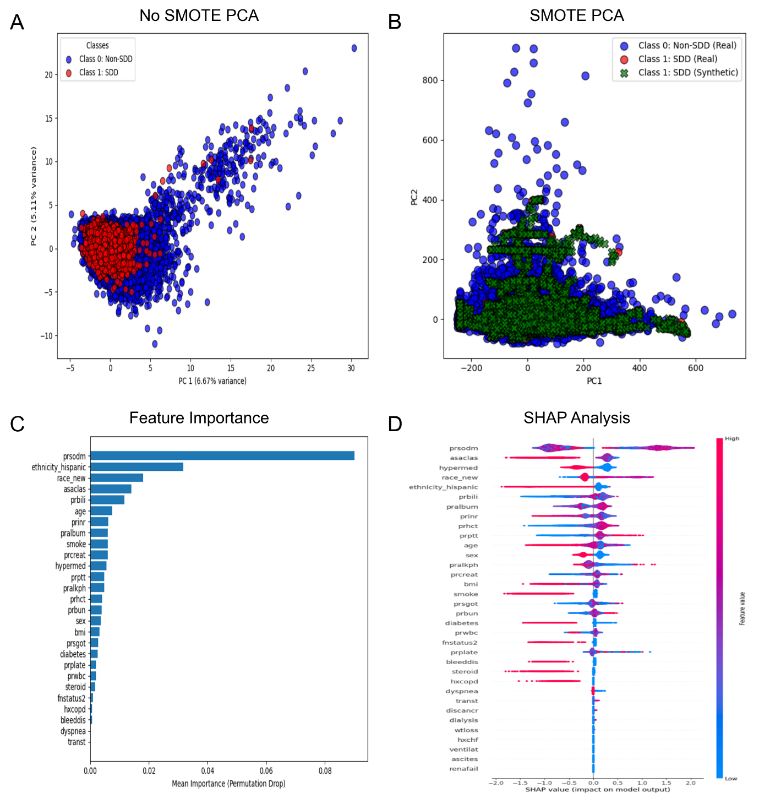
Figure 1. Principal component and feature interpretation plots. Panels show (A) PCA without SMOTE, (B) PCA after SMOTE application, (C) permutation-based feature importance, and (D) SHAP analysis illustrating the contribution of top predictors to model output.

Feature Importance Analysis
The XGBoost model highlighted a set of important predictors associated with same-day discharge outcomes in the following surgery as revealed by both permutation importance (Figure 1C) and SHAP analysis (Figure 1D).
A total of 27 features were ranked based on their importance scores and SHAP values, ranging from high to low. The most influential predictors included prsodm (preoperative sodium), ethnicity_hispanic (Hispanic ethnicity), race_new (race), asaclas (physical status classification), and prbili (preoperative bilirubin). Additional important features are age, smoking status, prinr (preoperative International normalized ratio), pralbum (preoperative albumin), prcreat (preoperative creatinine), prptt (preoperative thromboplastin time), hypermed (hypertension requiring medication), pralkph (preoperative Alkaline phosphatase), prhct (preoperative hematocrit), prbun (preoperative blood urea nitrogen), sex, body mass index, prsgot (preoperative AST / SGOT), prwbc (preoperative white blood cell count), diabetes (comorbidity: diabetes mellitus status), prplate (preoperative platelet count), steroid (comorbidity: chronic steroid use), fnstatus2 (comorbidity: functional status), bleeddis (comorbidity: bleeding disorder), hxcopd (comorbidity: History of any COPD), dyspnea (comorbidity: shortness of breath), and transt (transfer status before surgery).
In summary, these features can discuss more details of patients’ demographics, pre-existing conditions, admission procedure, and preoperative lab values would influence the likelihood of same-day discharge.
Performance Metrics in K-Folds Cross-Validation
We divided the complete two-patient cohort datasets into training and blind sets while maintaining the imbalance distribution: the non-SSD class had 93.2% and the SSD class had 6.8%. Without SMOTE, we used the training dataset to train the five popular classifier models (RF, LR, XGBoost, MLP, and AdaBoost) in a k-fold cross-validation technique. In this technique, models are iteratively trained and tested. For every fold, we calculated the performance metrics, such as F1 score, accuracy, precision, recall, and AUC. The average of these performance metrics across all folds would be considered the final performance of the models. The XGBoost achieved an F1-score of 0.52, a recall of 0.52, an accuracy of 0.93, MCC value of 0.17, with an AUC value of 0.79 (Table 2). The RF model achieved an F1-score of 0.50, a recall value of 0.51, an accuracy of 0.93, an MCC value of 0.07, and an AUC value of 0.79. Similar trends were also observed in the MLP and AdaBoost classifiers. These results indicate that the performance of all the models becomes low due to the imbalance in class distribution. In contrast, we applied SMOTE to generate synthetic samples and verified the representation of the datapoint variance comparison, synthetic versus real datapoints (minority class: SSD) in a PCA plot. We did a k-fold cross-validation process again, and the average performance metrics were computed compared with the non-SMOTE model performances. We found that the performance of all models was improved, where XGBoost performed best with having F1 score of 0.92, a recall of 0.92, an accuracy of 0.92, an MCC value of 0.85, and an AUC value of 0.97 (Table 2). The RF model achieved the second-best model, having an F1 score of 0.90, a recall of 0.90, an accuracy of 0.90, an MCC value of 0.81, and an AUC value of 0.96. Similar trends of better performance were observed in MLP and AdaBoost classifiers. Figure 2A and 2B panels describe how the performance of all models is increased with oversampling and without oversampling, while cross-validation and blind set validation were done.

Performance Metrics in Blind Set Validation
In the case of a blind set, we did not increase the datapoints by using the oversampling technique, and we did not use the dataset for training purposes. Therefore, our objective was to ensure that the data would mimic real data by which the model would be evaluated in an imbalanced distribution. Without SMOTE, the XGBoost achieved an F1-score of 0.52, a recall value of 0.52, an AUC value of 0.79, and MCC value of 0.16. But after applying SMOTE, the XGBoost model increased the performance with an F1-score of 0.57, a recall value of 0.58, an AUC value of 0.72, and MCC value of 0.15. Using SMOTE, other models, including RF, LR, MLP, and AdaBoost, showed better performance compared to the performances of all models without SMOTE (Table 3, Figure 2A and 2B). In additional blind validation, the XGBoost achieved an AUC of 0.65, as shown in Figure 2C. We also compared the AUC scores of all prediction models blind set and additional blind set in Figure 2D. The XGBoost model was also evaluated on training, blind set and additional blind set based on prediction probability and AUC values (Figure 2E and 2F).

Table 2. Performance comparison in Cross-Validation

 | F1 score |  | MCC |  | Recall |  | Accuracy |  | AUC
Models | SMOTE | No SMOTE | SMOTE | No SMOTE | SMOTE | No SMOTE | SMOTE | No SMOTE | SMOTE | No SMOTE
RF | 0.90 | 0.50 | 0.81 | 0.09 | 0.90 | 0.51 | 0.90 | 0.93 | 0.96 | 0.75
LR | 0.76 | 0.47 | 0.53 | 0.14 | 0.76 | 0.64 | 0.76 | 0.61 | 0.83 | 0.69
XGB | 0.92 | 0.52 | 0.85 | 0.17 | 0.92 | 0.52 | 0.92 | 0.93 | 0.97 | 0.79
MLP | 0.82 | 0.49 | 0.65 | 0.04 | 0.82 | 0.50 | 0.82 | 0.93 | 0.90 | 0.71
AdaBoost | 0.90 | 0.49 | 0.80 | 0.06 | 0.90 | 0.50 | 0.90 | 0.93 | 0.96 | 0.76
Table 3. Performance comparison in blind set validation
 | F1 score |  | MCC |  | Recall |  | Accuracy |  | AUC
Models | SMOTE | No SMOTE | SMOTE | No SMOTE | SMOTE | No SMOTE | SMOTE | No SMOTE | SMOTE | No SMOTE
RF | 0.57 | 0.50 | 0.15 | 0.11 | 0.60 | 0.51 | 0.85 | 0.93 | 0.70 | 0.75
LR | 0.50 | 0.47 | 0.12 | 0.14 | 0.61 | 0.64 | 0.70 | 0.62 | 0.66 | 0.69
XGB | 0.57 | 0.52 | 0.15 | 0.16 | 0.58 | 0.52 | 0.88 | 0.94 | 0.72 | 0.79
MLP | 0.54 | 0.49 | 0.13 | 0.05 | 0.60 | 0.51 | 0.78 | 0.93 | 0.68 | 0.70
AdaBoost | 0.56 | 0.49 | 0.14 | 0.08 | 0.59 | 0.50 | 0.86 | 0.93 | 0.70 | 0.76

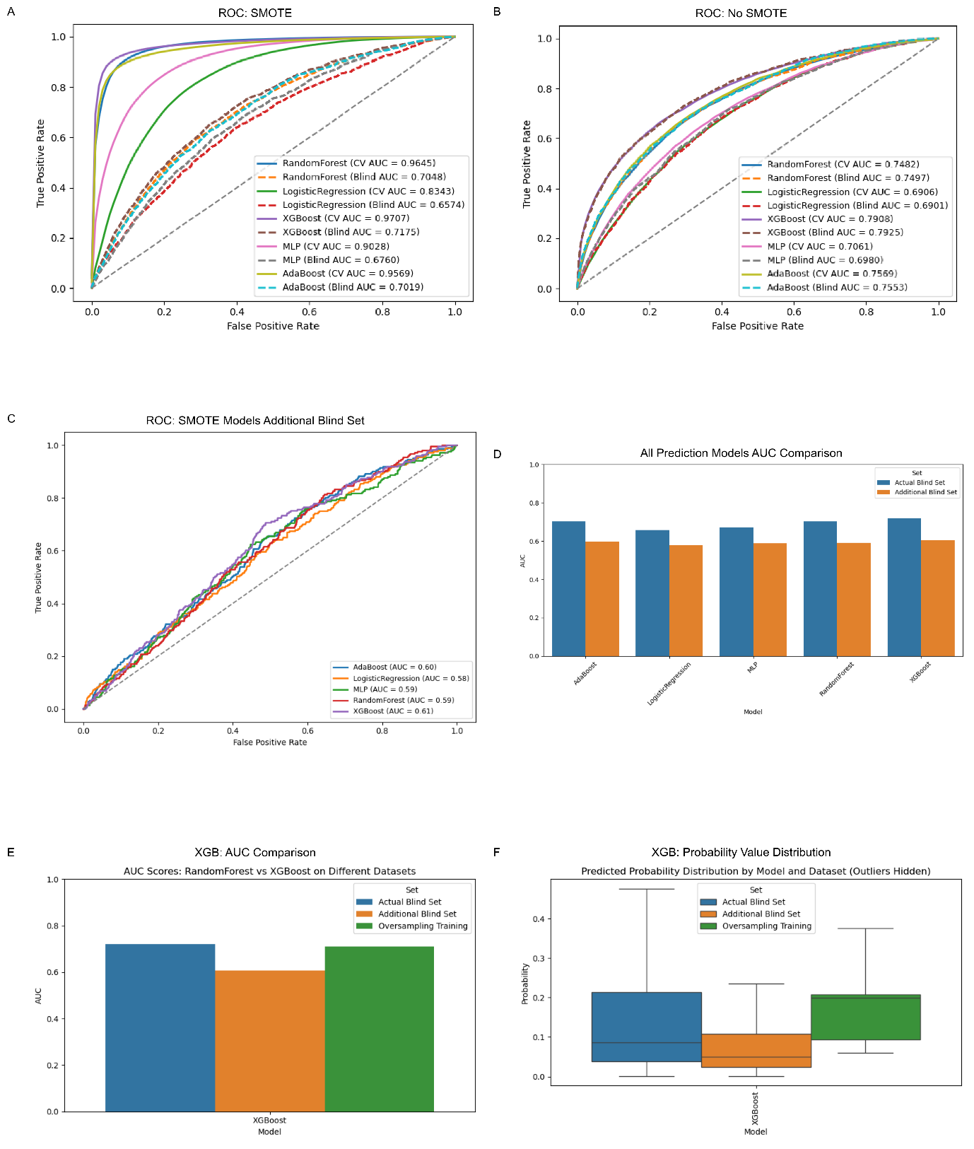

Figure 2. ROC curves for model comparison. Panels show (A) SMOTE-applied training, (B) non-oversampled training, (C) the external blind validation dataset, (D) Comparison AUC values of All prediction models, (E) AUC score comparison of XGBoost model in oversampling training, blind set and additional blind sets and (F) Probability value comparison of XGBoost model in oversampling training, blind set and additional blind sets.

Discussion
We described that using a machine learning model with an oversampling technique on the training set can improve the prediction of same-day discharge outcomes following surgery. In our study population, only 6.8% of patients with mild complications and requiring less medicine for hypertension were qualified for same-day discharge. Most patients were admitted from home. In contrast, 93.2% of patients stayed longer, were not qualified for same-day discharge, had severe complications, were aged more than 66 years, obesity, had shortness of breath, and had a history of COPD. Thus, a detailed investigation of all patients’ preoperative lab results, complications, comorbidities, and demographics is conducted. Discharge is vital to guide postoperative care decisions effectively at the time of hospital discharge. With rapid monitoring and access to electronic media records, artificial intelligence methods are becoming popular and relevant for different predictive analyses. Applying diverse machine learning techniques to the same dataset can enhance our ability to forecast different forecasting outcomes. Such approaches should be more widely adopted in healthcare, given the rapid expansion of electronic medical records. Traditional regression methods remain a fundamental tool for identifying associations between patient characteristics and outcomes.
In our study, we highlighted that using an ensemble learning approach enhances the prediction of same-day discharge. Regression methods are limited by their ability to capture only linear relationships between features and outcomes. Ensemble learning has some advantages because it can combine multiple algorithms to improve outcome prediction. Its effectiveness, however, depends on diversity within the data and across models. Ensemble learning, such as boosting, employing different classifiers, and oversampling, can help create this diversity and achieve class balance. Since under-sampling often results in data loss, oversampling methods can be applied to align the minority class with the majority class. Electronic health data frequently exhibit class imbalance, as certain outcomes may be relatively rare within a population.
The XGBoost performed better than any other models across performance metrics, such as F1 score, MCC, Recall, Accuracy, and AUC. The model established that the model itself is the most effective approach for this predictive task. We also optimized the key learning parameters, such as max_depth,learning_rate,n_estimators, subsample, and colsample_bytree.
Class imbalance, a common challenge in electronic health datasets, was addressed using SMOTE, which synthetically generated minority class samples based on nearest-neighbor interpolation. Incorporating SMOTE into the training dataset substantially improved the model’s ability to identify patients eligible for same-day discharge, particularly enhancing recall and F1 score compared to models trained on unbalanced data. PCA-based dimensionality reduction demonstrated that synthetic samples preserved the distribution and clustering of real data, confirming that SMOTE maintained intrinsic feature relationships and did not introduce major distortions, thereby supporting the reliability of subsequent model training and validation. Feature importance analyses using permutation importance and SHAP revealed 27 clinically relevant predictors influencing discharge likelihood. The top five influential predictors were preoperative sodium, Hispanic ethnicity status, race, physical status classification, and preoperative bilirubin. Our proposed framework can support personalized perioperative care, allowing healthcare providers to identify patients most likely to benefit from expedited recovery pathways while ensuring the efficient use of hospital resources.

Data Availability
https://github.com/janatanmoy5/github.nsqip.io

Reference
[1] Sloan M, Premkumar A, Sheth NP. Projected Volume of Primary Total Joint Arthroplasty in the U.S., 2014 to 2030. J Bone Joint Surg Am. 2018. PMID: 30180053
[2] Pollock M, Somerville L, Firth A, Lanting B. Outpatient THA and TKA: a systematic review. Can J Surg. 2016. PMID: 27378634
[3] Aynardi M, Post Z, Ong A, Orozco F, Sukin DC. Outpatient THA reduces costs. HSS J. 2014. PMID: 25264442
[4] Kort NP, Bemelmans YFL, Schotanus MGM, et al. Outpatient THA: a systematic review. Hip Int. 2017. PMID: 33587170
[5] Arshi A, Leong NL, Wang C, SooHoo NF. Outpatient THA: complication rates. J Am Acad Orthop Surg. 2019. PMID: 30247308
[6] Deo RC. Machine Learning in Medicine. Circulation. 2015. PMID: 26572668
[7] Artificial Intelligence to Identify Arthroplasty Implants From Radiographs of the Hip .PMID: 33281020
[8] Deep Learning Preoperatively Predicts Value Metrics for Primary Total Knee Arthroplasty: Development and Validation of an Artificial Neural Network Model
[9] Validation of the Charlson comorbidity index in patients undergoing revision total hip arthroplasty PMID: 26105762
[10] Comparison of Outpatient vs Inpatient Total Knee Arthroplasty: An ACS-NSQIP Analysis PMID;28237215
[11] Raval MV, Pawlik TM. Practical Guide to Surgical Data Sets: National Surgical Quality Improvement Program (NSQIP) and Pediatric NSQIP. JAMA Surg 2018;153(8):764–65. doi: 10.1001/jamasurg.2018.0486

