Supervised Learning-Driven Prediction of Small-Molecule Modulator Activity Against Protein–Protein Interactions

Tanmoy Jana ¹*, Joy Karmakar¹, Raja Banerjee², Sudipto Saha³

¹School of Medicine, University of California, San Francisco, San Francisco, CA, USA
²Department Of Biotechnology, Maulana Abul Kalam Azad University Of Technology, Kalyani, West Bengal, India

³Division Of Bioinformatics, Bose Institute, Kolkata, West Bengal, India

*Corresponding Author:
Tanmoy.Jana@ucsf.edu

Abstract

Small molecules can be modulated to target protein–protein interactions (PPIs) in the drug discovery process. The structural complexity and interaction patterns of protein-protein interactions (PPIs), as well as evaluating the bioactivity of small molecules, remain a significant challenge. To overcome this bottleneck, we proposed a supervised learning-driven framework for the computational prediction of small-molecule bioactivity, often quantified as half-maximal inhibitory concentration (IC50​). Using multiple supervised regression algorithms, we trained predictive models on a comprehensive dataset of 3,451 small molecules with known bioactivity against 176 distinct biological targets, including 47 PPIs, 91 single proteins, and 38 cell lines. Our analysis demonstrated that a random forest model achieved the best performance with an average R2 of 0.75 and an average RMSE of 0.78 in cross-validation. This strong predictive power was seen in the blind validation set (R2 of 0.74 and RMSE of 0.79), confirming its broader applicability. We also found that RDKit chemical descriptors were highly influential in predicting bioactivity for key PPIs, such as tumor suppressor p53/oncoprotein Mdm2, Menin/Histone-lysine N-methyltransferase mixed lineage leukemia (MLL), Menin/Histone-lysine N-methyltransferase MLL, L15-IL15 receptor, and Transcriptional coactivator YAP1/Transcriptional enhancer factor TEF-1. The proposed framework establishes a generic, scalable, and data-driven strategy for predicting the biological activity of different PPI modulators, making it a valuable resource for computational chemists and drug discovery researchers.

Keywords: small molecules; protein-protein interaction modulator; half-maximal inhibitory concentration; machine learning; descriptors; dimensional; model; biological targets

1. Introduction
Small molecules are a major concern in modern drug discovery due to their ability to modulate biological targets, including protein-protein interactions (PPIs) and thereby influence therapeutic outcomes[1,2]. High-throughput screening (HTS) of large chemical libraries, with their bioactivity, can be both expensive and time-consuming [3-5]. The bioactivity is commonly quantified using the half-maximal inhibitory concentration (IC₅₀), an accepted metric of potency in cheminformatics and drug design [6]. High false-positive rates limit the HTS due to the multiple validation steps needed to follow up for the generation of dose–response curves, with limited accuracy and reliability [5]. To overcome the limitation, a machine learning based approaches give a more précised prediction of IC₅₀ values, can accelerate development, and guide the selection of more promising compounds in less time. To do such predictions, molecular descriptors are numerical presentations of the structure of any molecule used for computational analysis [7]. These descriptor captures a variety of molecular properties- topological, electrostatic, physicochemical, and three-dimensional characteristics are fundamental to quantitative structure–activity relationship (QSAR) studies. Molecular descriptor software tools like PaDEL, RDKit, and PubChem provide comprehensive 2D and 3D descriptors for diverse chemical datasets [8, 9, 10]. These descriptors allow machine learning models to correlate their molecular features to bioactivity, providing a scalable approach to predicting IC₅₀ values across PPI targets. For ensuring both generalizability and biological relevance, we employed a heterogeneous dataset including PPI complexes, single proteins, and cell lines, with PPIs serving as the central focus of this study [11]. Systematic comparisons of RDKit, PaDEL, and PubChem are still limited due to the chemical diversity and heterogeneous bioactivity data. To understand the strengths and limitations of each descriptor is therefore crucial for feature selection for making a more reliable and accurate machine learning model. Here, we benchmark the predictive performance of these descriptor sets for IC₅₀₋based bioactivity modelling. Our freely available tool (https://github.com/janatanmoy5/ppimic50pred) at the GitHub repository evaluates compound coverage, representation of chemical diversity, and performance in machine learning frameworks. By providing this comprehensive comparison, we aim to guide experimental researchers in selecting descriptor types that enhance prediction accuracy and streamline the drug discovery process.

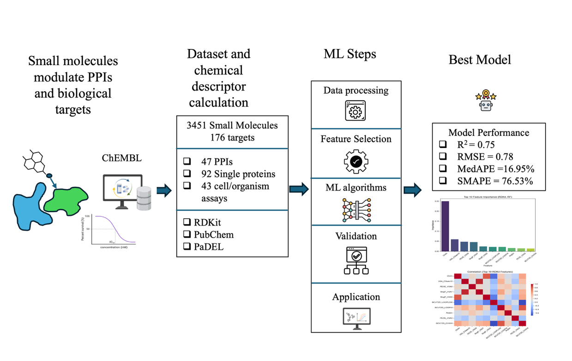
Figure. Graphical Abstract

2. Methods
2.1 Data Sources
We compiled bioactivity data from ChEMBL, focusing on IC₅₀ values for 3,451 small molecules tested across 176 diverse biological targets, including 47 PPI complexes, 91 single proteins, and 38 cell line assays [12]. Single proteins, such as Interleukin-15, Estrogen-related receptor alpha, Orexin receptor 1, and beta-lactamase, provide well-characterized binding sites [13, 14, 15]. Despite extensive research and the availability of databases like 2P2I, TIMBAL, iPPI-DB on PPI modulators, PPIs remain the primary focus of this study [16, 17, 18]. The limited number of PPI-based potential leads is mainly due to their lack of promising bioactivity. To capture compound activity and cellular responses beyond isolated protein binding, cell line assays were included. This heterogeneous dataset enhances model generalizability and allows for learning of meaningful patterns in chemical descriptors across diverse biological targets while maintaining a central focus on PPI modulation. Most small molecules have more than one range of IC50 values. Therefore, we took the highest pChEMBL value, considered as a stronger activity of each small molecule. Because raw IC₅₀ values can also vary widely and sometimes skew analyses, we converted them into a base-10 logarithmic scale Log₁₀ (IC50). This standardization method helps with data distribution and better interpretability for downstream model development.

2.2 Descriptor Generation
We systematically employed three cheminformatic tools for generating chemical descriptors. Such as: RDKit, PaDEL, and PubChem. Then, the bioactivity data is combined with chemical descriptor data for the feature selection process.
2.2.1 RDKit Descriptors
We used RDKit descriptors, which comprise 217 molecular descriptors, and can capture a diverse range of chemical features. Majorly, these molecular descriptors are split into several categories. Physicochemical properties (molecular weight, exact weight, logP, hydrogen donor, hydrogen bond acceptor) describe drug likeness. Topological properties (Chi, Kappa, Balaban, Shannon entropy-based Information content index, Hall–Kier alpha) give chemical shape and branching and complexity of connectivity. Electrostatic descriptor (Electro topological State Index, partial charge) describes electron distribution information. Structural counts (aromatic ring counts, number of rotatable bonds, stereocenter counts) say about flexibility and conformational information. Fragment-based properties (benzene, halogen, urea) can say something about the functional groups enriched with pharmacological relevance. Surface area and partitioning measures (LabuteASA, SMR_VSA, SlogP_VSA) provide molecular recognition and membrane transport.
2.2.2 PaDEL Descriptors
We used PaDEL Descriptors having 1875 descriptors (One & two-dimensional descriptors: 1444 descriptors, and three-dimensional descriptors: 431). Similar to RDKit, PaDEL descriptors give numerous chemical descriptors categories including Physicochemical (nAcid, nBase, hydrophobicity logP), Autocorrelation Descriptors (weighted by atomic mass, van der Waals volume, electronegativity, ionization potential, Geary autocorrelation indices), Burden Eigenvalue Descriptors (BCUT), Geometry Descriptors (SpAbs, SpMax, SpDiam, SpAD, SpMAD, VE, VR), Fragment Counts & Hydrogen Bonding (Hydrigen bond donors/acceptors, number of hydrogens bound to -Oh/-NH atom environments (–OH, –NH, etc.), logP and molar refractivity.
2.2.3 PubChem Descriptors
We compiled 17 physicochemical properties as descriptors from PubChem. These properties give various types of molecular information that were computed by PubChem. Molecular mass-related information includes molecular weight, exact mass, monoisotopic mass, and heavy atom count. For hydrogen bonding capacity information, which comprised the hydrogen bond donor count, the hydrogen bond acceptor count, and the topological polar surface area. The hydrophobicity measure of a molecule is given by XLogP3-AA. Similarly, we got information about structural flexibility (rotatable bond count, covalently bonded unit count, complexity), stereochemistry (defined atom stereocenter count, undefined atom stereocenter count, defined bond stereocenter count, undefined bond stereocenter count), other properties, formal charge, and isotope atom count.

2.3 Dataset
Following the generation of chemical descriptors, rdkit (v2025.03.5), pubchempy (v1.0.4), and padelpy (v0.1.16) were used to prepare the datasets for model development and validation, shown in Table S1. For each descriptor set (RDKit, PubChem, and PaDEL), the data were divided into an 80% training set and a 20% blind set, while preserving the relative distribution of target classes. The blind set was entirely withheld during model development and cross-validation, serving as a completely unseen dataset for unbiased evaluation. The training sets for three descriptor groups were further evaluated using different k-fold cross-validation (k=2, 3,…, 10) to assess the effect of fold size on model performance. Performance metrics were averaged across folds to provide estimates of predictive performance. The blind sets were used only once for final evaluation, providing an unbiased measure of model generalization to previously unseen molecules and scaffolds.
2.3.1 RDKit descriptors: The full RDKit dataset included 3,451 molecules covering 176 biological targets. The training set consisted of 2,760 molecules with 217 descriptors, while the blind set contained 691 molecules with the same descriptor set. The descriptors list is tabulated in Table S2.
2.3.2 PubChem descriptors: The dataset comprised 3,444 molecules with 175 biological targets. The training set included 2,755 molecules (17 descriptors), and the blind set included 689 molecules (17 descriptors).
2.3.3 PaDEL descriptors: Considering 1D, 2D, and 3D descriptors, some molecules lacking complete structural information were excluded, resulting in a dataset of 2,926 molecules spanning 151 biological targets. The training set contained 2,340 molecules (1,875 descriptors), and the blind set included 586 molecules (1,875 descriptors). The descriptors list is tabulated in Table S3.

2.4 Machine Learning Models
We implemented four supervised regression models to predict Log₁₀ (IC50) from high-dimensional chemical descriptor datasets generated with RDKit, PubChem, and PaDEL. All analyses were done in Python (v3.12.8). For classical methods, we used scikit-learn (v1.7.1) and numpy (v1.26.4). PyTorch (v2.6.0) was used for a deep learning approach.
2.4.1 Random Forest (RF)
Random Forest regressor was used for the selection of important features and model development using an ensemble of decision trees. The model was tested in k-fold cross-validation to ensure overall strength. In a grid search, different hyperparameters, such as the number of estimators, the maximum tree depth, the minimum sample splitting, the minimum number of samples, and the maximum feature numbers, were determined to find the best parameters with average root mean squared error in cross-validation.
2.4.2 Gradient Boosting (GB)
Gradient boosting regression was implemented in different cross-validations. Grid searching was also done using different learning rates, number of estimators, random state, maximum leaf nodes, and minimum samples split.
2.4.3 Support Vector Regression (SVR)
Support Vector Regression was evaluated in different cross-validation methods.
2.4.4 Long Short-Term Memory (LSTM)
We implemented an LSTM regressor neural network, and the performance of the model was evaluated using k-fold cross-validation. In an iterative grid search, four activation functions (rectified linear unit: ReLU, tangent, logistic sigmoid function, and leaky ReLU), numbers of layers, hidden nodes, and batch sizes were computed to get the best hyperparameters. In addition, we also added the Adam optimizer, the number of epochs, and the learning rate. We also compared the performance of the LSTM model to other classical machine learning models across three different descriptor sets.
2.5 Model Evaluation
The RF, GB, SVR, and LSTM regression models are tested in different cross-validation using performance metrics: root mean squared error (RMSE), mean squared error (MSE), coefficient of determination (R2), median absolute percentage error (MedAPE), and symmetric mean absolute percentage error (SMAPE). The performance metrics are defined as follows:
$RMSE=\sqrt{\frac{\sum_{i=1}^{n}{{\left(y_{i}-ÿ_{i}\right)}^{2}}}{n}}$ (1)
$MSE = \frac{\sum_{i=1}^{n}{{\left(y_{i}-ÿ_{i}\right)}^{2}}}{n}$ (2)
$R2 = 1-\frac{\sum_{i=1}^{n}{{\left(y_{i}-ÿ_{i}\right)}^{2}}}{\sum_{i=1}^{n}{{\left(y_{i}-ý_{i}\right)}^{2}}}$ (3)
$MedAPE= median\left(\left|y_{i}\right.\left.{-ÿ}_{i}\right|y_{i} × 100\%\right)$ (4)
$SMAPE = \frac{1}{n}\sum_{i=1}^{n}{\frac{\left|y_{i}-\right.\left.ÿ_{i}\right|}{{\left(\left|y_{i}\right|+\left|ÿ_{i}\right|\right)}/2}} × 100\%$ (5)
Here, $y_{i}$ denotes the observed (actual value), $ÿ_{i}$denotes the predicted value, and ý denotes the mean of the observed value.
2.6 Feature Selection
We applied several feature selection approaches: feature importance, feature correlation, variance threshold, and SHAP analysis.
2.6.1 Feature Importance
Feature importance analysis was performed using a random forest regression model for each input chemical descriptor of each descriptor set to predict the Log₁₀ (IC50)within the prediction model. It helps to identify which features can most significantly influence the prediction model's performance and decision-making process.
2.6.2 Feature Correlation
Feature correlation was used to determine whether the features are correlated. The low-variance data with no correlation were also removed.
2.6.3 Variance Threshold
A variance threshold feature selection algorithm was used to filter lower variance feature spaces in a descriptor dataset.
2.6.4 SHAP Analysis
We did SHapley Additive exPlanations (SHAP) analysis to quantify the overall contribution of molecular descriptors to the prediction model. The method provides feature importance at both global and local levels by their SHAP values. It also complements supervised feature importance and feature correlation analysis.

2.9 Overfitting and Underfitting Evaluation
To ensure robust model performance and minimize risks of overfitting or underfitting, we used multiple strategies. First, we conducted feature importance analysis using random forest regression to remove descriptors with zero importance. The feature correlation and SHAP analysis were applied to exclude zero-correlation features. Second, we optimized learning parameters (e.g., learning rate, depth, number of estimators) of machine learning models using randomized and grid search approaches. Third, we performed rigorous k-fold cross-validation (k = 2–10) across training sets, in addition to time-split cross-validation where applicable, to evaluate stability across different data partitions. Finally, blind set evaluation was performed in each k-fold to provide an unbiased measure of generalization to unseen molecules and biological targets. The overall steps are followed to balance model complexity against predictive accuracy as indicated by performance metrics, such as R² and RMSE.
2.10 Structure-Based Clustering
Butina clustering with Morgan fingerprints (radius =2, nBits 2048) from three-dimensional SDF files of 2926 small chemicals out of the 3451 chemicals. Because 525 small chemicals do not have their three-dimensional structures. Pairwise Tanimoto similarity distribution was measured across different cluster sizes and converted into a distance matrix. Unsupervised K-means clustering was applied to both principal component analysis (PCA) and multidimensional scaling (MDS) coordinates to get structurally defined clusters, explaining an orthogonal projection of the chemical fingerprint space. In addition, the applicability domain (AD) was computed to determine the average similarity above the cluster-specific threshold considered within the AD, while the remaining small chemicals were considered outside the AD.

2.11 Feature-Based Clustering
The RDKit descriptors were calculated for 2760 small chemicals to find a correlation with IC50 to retain relevant features. K-means clustering using the correlation matrix with PCA was applied to identify groups of small chemicals with similar physicochemical properties and correlated with bioactivity profiles. Compounds were further assigned to chemical classes based on molecular weight, polarity, aromaticity, flexibility, hydrophobicity, and with remaining compounds labelled as “Other.”

3. Results and Discussions
3.1 Feature Selection
To optimize model performance and interpretability, we applied variance threshold filtering, unsupervised correlation analysis, and supervised feature importance across three descriptor sets: RDKit, PubChem, and PaDEL. For RDKit descriptors (217 features), zero-variance descriptors (e.g., NumRadicalElectrons, SMR_VSA8, fr_aldehyde) were removed, resulting in 195 descriptors being used for model development (Table S2). Figure 1A and S1 describe the top 20 descriptors and all 195 descriptors based on their importance and correlation score. However, we computed models with reduced feature subsets (ranges: 20 to 195 descriptors), and the predictive performance remained consistent, with an average R² of 0.74 and MSE of 0.64 during cross-validation in Figure 1B. Although we used several variance thresholds, feature importances were found to slightly decrease R² and increase RMSE values. Based on feature importance and SHAP values, we did not choose a low number of features; it may have discarded other correlated descriptors. Therefore, we selected 195 descriptors to balance predictive performance with preservation of structural diversity. SHAP analysis further described that during training, the RF model had strong predictive ability, with an R2 value of 0.94 and an RMSE of 0.35 on the RDKit training set of 195 features (Figure 1C, 1D). Figure 1E describes the top 50 highly correlated features. In the analysis, it was revealed that the hierarchy of feature importance with descriptors related to topology, Van der Waals surface (VSA), charge (e.g., electrostatic, electronegative), hydrophobicity, BCUT (Burden-Casher Eigenvalue Connectivity descriptors), functional group, and aromatic ring-based physicochemical properties exerted the most significant influence on predicted Log10 (IC50) values. The feature important and summary plots using SHAP highlight again the top 20 features, such as Chi4n, VSA EState10, PEOE VSA9, SlogP_VSA7, BCUT2D_LOGPHI, BCUT2D_LOGPLOW, SlogP_VSA5, PEOE VSA3, Chi4v, Avglpc, VSA EStatel, MaxAbsEStateIndex, BCUT2D_CHGHI, SlogP_VSA10, NumAromatic Heterocycles, fr NHO, SlogP_VSA8, MinPartialCharge, BCUT2D_CHGLO, and BCUT2D_MRHI, which were captured with average effects across 2,760 small chemicals. For PaDEL descriptors (1,881 features), feature selection retained 1,356 descriptors after applying variance threshold, correlation, and importance filtering. Modeling with this set yielded an average R² of 0.74 and MSE of 0.63, comparable to RDKit. The correlation plot of PaDEL descriptor is also explained in Figure S2. For PubChem descriptors, 17 descriptors were followed in similar steps for model development as shown in Figure S3. Overall, the whole feature selection strategy was applied while preserving informative molecular descriptors to enable better model performance across all descriptor sets.
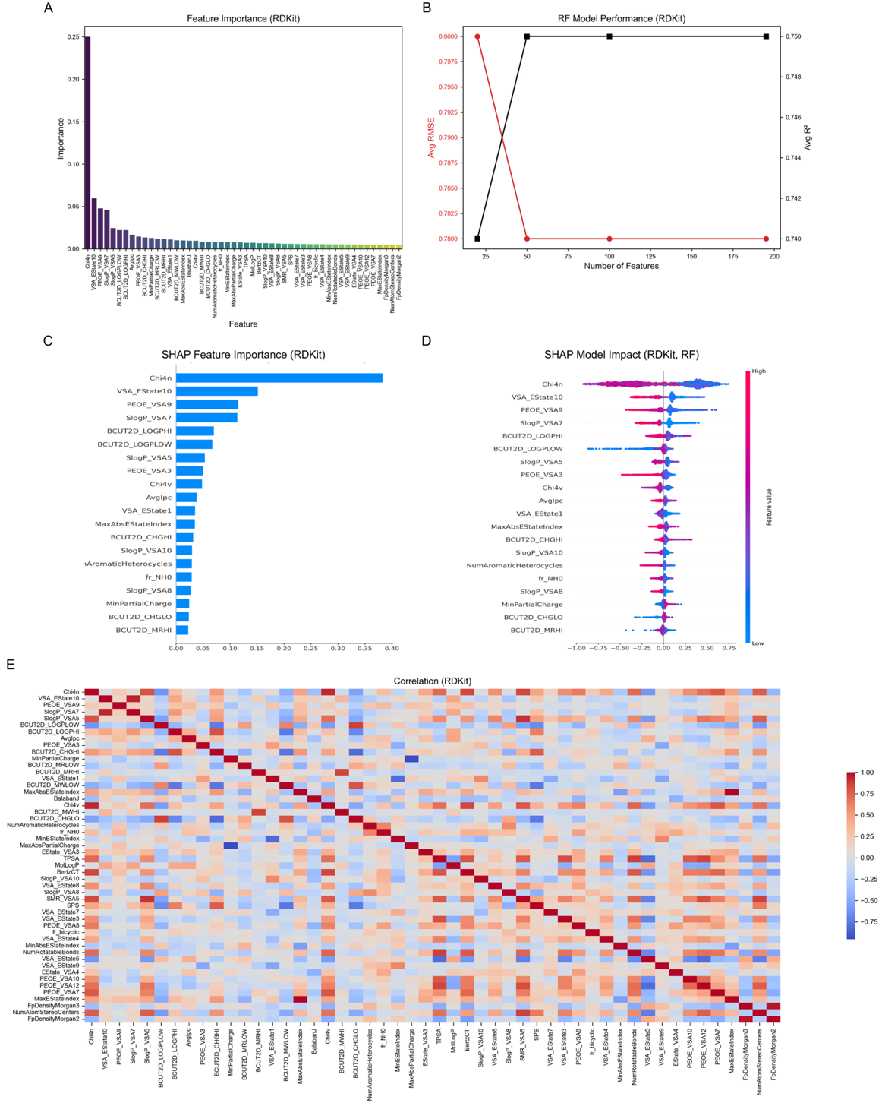
Figure 1. Feature selection. A: Feature importance, B: RF model performance, C: SHAP feature importance, D: SHAP summary of RF model, E: Feature correlation

3.2 Model Performance on Cross-validation set

We compared the predictive performance of four regression-based supervised machine learning models—RF, GB, SVR, and LSTM across different k-fold cross-validations and three descriptor sets: RDKit, PubChem, and PaDEL, as shown in Table 1 and Table S4. In the RDKit descriptor set containing 276 small molecules and 195 features, the RF model achieved a strong predictive performance with an R² value of 0.75 in Figure S5 (A-B), RMSE of 0.78, and MSE value of 0.61, with a relatively low 16.96 % of MedAPE and SMAPE of 76.53% shown. In the case of other regression models- GB, SVR, and LSTM also performed well, with an average R² value of 0.74, confirming that RDKit descriptors provide comparably reliable prediction features with high biological target coverage. In contrast, the PubChem descriptor with 2755 molecules and 17 features, we found weaker model performance with an average R² dropping to 0.56 across all models. The higher RMSE and MSE value indicates that less informative chemical features may compromise the prediction ability of all models (detailed in Table S5). Whereas the PaDEL descriptor with 2340 molecules and 1356 features showed a comparable result to RDKit, the RF achieved an R² value of 0.75 and an RMSE of 0.79, as shown in Table S6. The other GB, SVR, and LSTM performed with an average of 0.74. This result implies that greater computational complexity does not result in a gain in predictive accuracy.
Table 1. Performance of machine learning models using chemical descriptors (RDKit, PubChem, and PaDEL) on the cross-validation dataset. N × p indicates the dataset shape (samples × features)
Descriptors | Models | RMSE | MSE | R² | MedAPE (%) | SMAPE (%) | N × p
RDKit | RF | 0.78 | 0.61 | 0.75 | 16.96 | 76.53 | 2760×195
 | GB | 0.81 | 0.65 | 0.73 | 18.28 | 79.90 | 2760×195
 | SVR | 0.81 | 0.66 | 0.73 | 17.28 | 78.94 | 2760×195
 | LSTM | 0.81 | 0.65 | 0.73 | 17.22 | 78.09 | 2760×195
PubChem | RF | 0.91 | 0.84 | 0.66 | 20.25 | 84.16 | 2755×17
 | GB | 1.04 | 1.08 | 0.56 | 24.30 | 92.21 | 2755×17
 | SVR | 1.14 | 1.30 | 0.47 | 25.42 | 93.08 | 2755×17
 | LSTM | 1.04 | 1.08 | 0.55 | 23.80 | 91.13 | 2755×17
PaDEL | RF | 0.79 | 0.62 | 0.75 | 15.98 | 78.68 | 2340×1356
 | GB | 0.79 | 0.63 | 0.75 | 16.77 | 80.34 | 2340×1356
 | SVR | 0.80 | 0.64 | 0.74 | 17.30 | 81.62 | 2340×1356
 | LSTM | 0.82 | 0.67 | 0.73 | 17.11 | 80.96 | 2340×1356

3.3 Model Performance on Blind Set

Similar to the cross-validation dataset, models were compared in three descriptor sets, respectively, as shown in Table 2. In the RDKit descriptor, the RF model achieved reliable performance with an R² value of 0.74, RMSE of 0.79, and MSE value of 0.63, with a relatively low 15.68.96 % of MedAPE and SMAPE of 78.23%. It is also seen that all models in the PaDEL descriptor performed comparatively similarly to RDKit. In the PubChem descriptor, the model performance was not as good as that of RDKit and PaDEL. In addition, we also compared across different k-fold cross-validation predictive performance (R² and RMSE) of all models in RDKit, ensuring the best model fitting, avoiding overflow or underflow, both training and blind set, as shown in Figure 2 (A-B). RF model performance was compared in two ways: one was cross-validation training with a performance with R² of 0.94, testing R² of 0.75, and blind set R² of 0.74, as shown in Figure 2C. The other way to compare the performance of all models across the blind set in a real setting is shown in Figure 2D.
Table 2. Performance of machine learning models using chemical descriptors (RDKit, PubChem, and PaDEL) on the blind set. N × p indicates the dataset shape (samples × features)
Descriptors | Models | RMSE | MSE | R² | MedAPE (%) | SMAPE (%) | N × p
RDKit | RF | 0.79 | 0.63 | 0.74 | 15.68 | 78.23 | 691×195
 | GB | 0.83 | 0.68 | 0.71 | 18.46 | 80.87 | 691×195
 | SVR | 0.82 | 0.68 | 0.72 | 16.82 | 79.82 | 691×195
 | LSTM | 0.80 | 0.63 | 0.73 | 17.80 | 79.72 | 691×195
PubChem | RF | 0.88 | 0.78 | 0.66 | 18.47 | 80.41 | 689×17
 | GB | 0.99 | 0.98 | 0.57 | 23.16 | 87.40 | 689×17
 | SVR | 1.13 | 1.27 | 0.45 | 24.51 | 90.06 | 689×17
 | LSTM | 1.01 | 1.03 | 0.56 | 23.26 | 88.13 | 689×17
PaDEL | RF | 0.80 | 0.65 | 0.75 | 16.61 | 77.37 | 586×1356
 | GB | 0.82 | 0.65 | 0.75 | 18.89 | 80.14 | 586×1356
 | SVR | 0.80 | 0.64 | 0.75 | 15.97 | 78.49 | 586×1356
 | LSTM | 0.87 | 0.75 | 0.71 | 17.77 | 81.69 | 586×1356

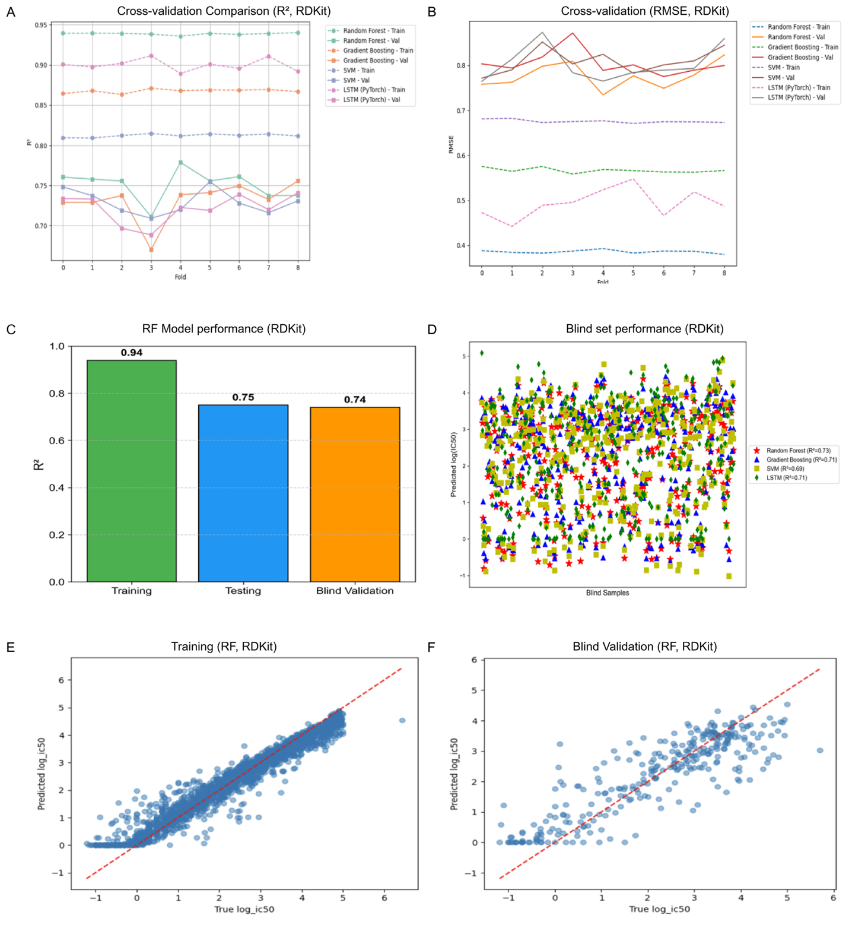

Figure 2. A: Cross-validation comparison (R², RDKit), B: Cross-validation comparison (RMSE, RDKit), C: RF model performance (RDKit), D: Blind set performance (RMSE, RDKit), E: Scatter plot Training (RF, RDKit), F: Blind Validation (RF, RDKit)

3.4 Structure-Based Clustering

Using 2926 three-dimensional structural inputs, Butina clustering identified 1124 clusters, each with a different number of molecules. Figure 3A shows that cluster 0 and cluster 1 contained 149 and 46 compounds, respectively. The distribution of Tanimoto similarities (Figures 3B and 3C) shows that most of the compounds had similarity scores between 0.1 and 0.2, indicating structural diversity present in the dataset. Unsupervised K-means clustering on MDS shows five chemical clusters (0-5) comprising 7%, 57%, 18%, 9%, and 9% of compounds (Figure 3D). A comparable partitioning was also observed with K-means clustering on PCA, also yielding five clusters (0-5) 28%, 19%, 16%, 18% and 19% of chemicals (Figure 3F). The AD analysis further showed that 54 % of compounds are inside AD and 46% of compounds are outside AD on MDS (Figure 3E) and PCA (Figure 3G) projections.
3.5 Feature-Based Clustering

Using the selected 195 RDKit descriptors of 2760 small molecules, the correlation matrix was generated based on their Log10 (IC50) values. KMeans clustering on the PCA-transformed feature space divided the dataset into five clusters, containing 32%, 3%, 12%, 40%, and 13% of compounds, respectively (Figure 3I). According to their molecular weight, polarity, aromaticity, flexibility, and hydrophobicity. The remaining compounds were grouped as other. Most prevalent class was found to be Large-Polar-Aromatic-Flexible-Hydrophobic (36%), containing 36% of small molecules, followed by Large–Polar–Aromatic–Rigid–Hydrophobic (19%), Large–Nonpolar–Aromatic–Rigid–Hydrophobic (11%), Large–Nonpolar–Aromatic–Flexible–Hydrophobic (6%), Medium–Nonpolar–Aromatic–Rigid–Hydrophobic (6%), and Other (22%).

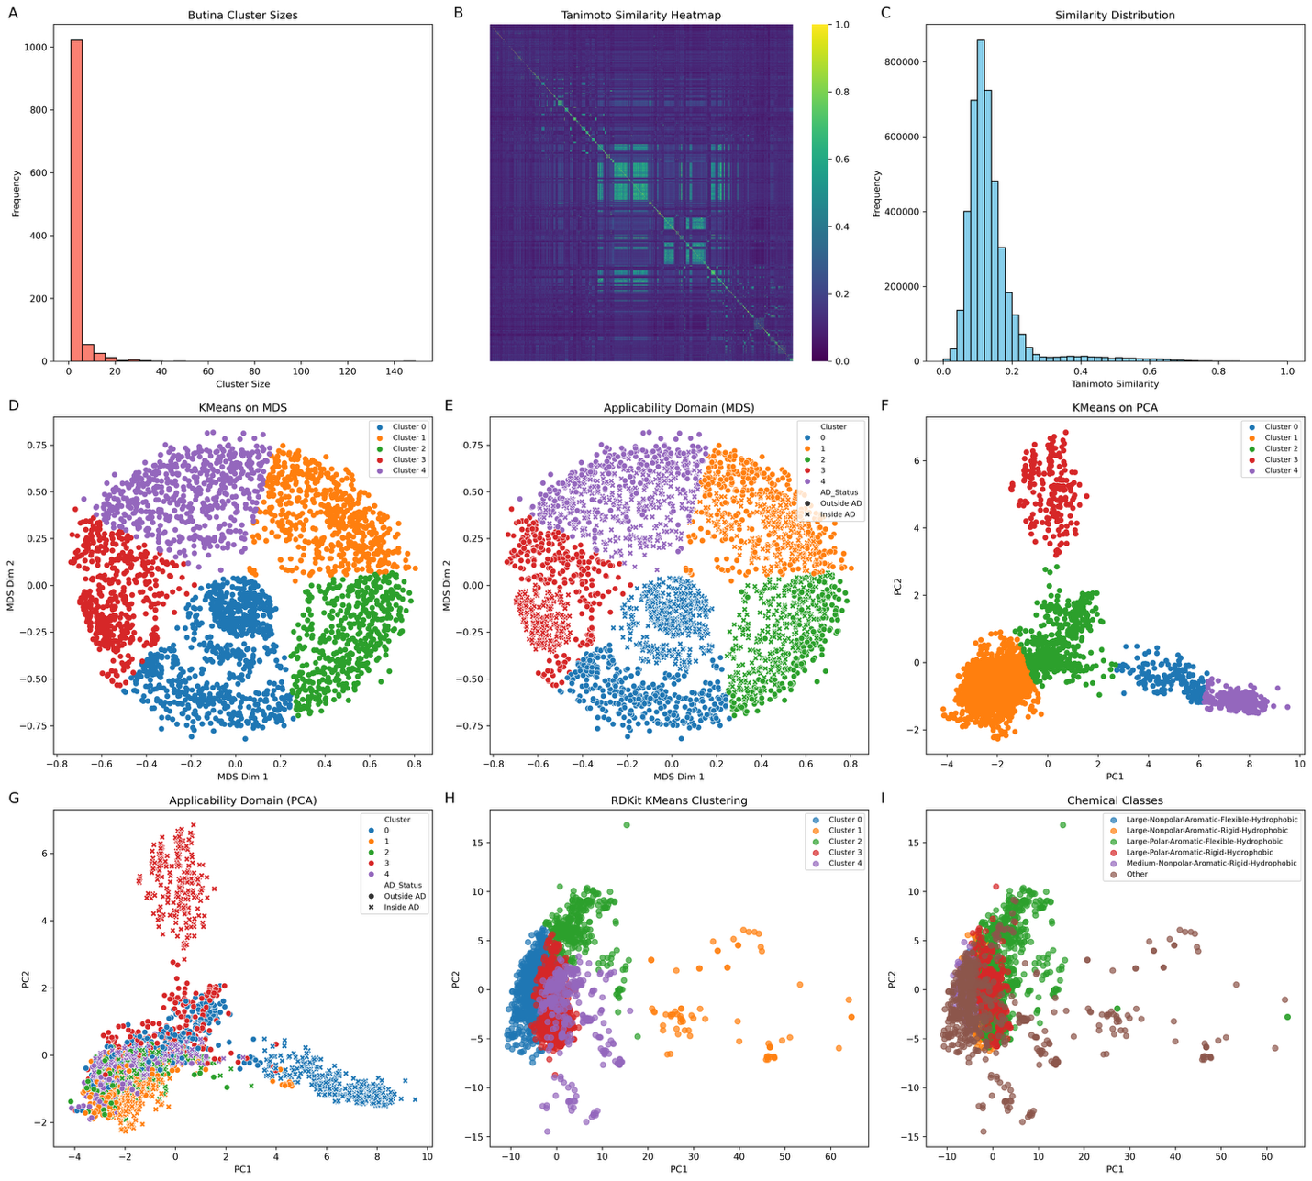
Figure 3. A: KMeans clustering on MDS, B: Applicability Domain on MDS, C: KMeans clustering on PCA, D: Applicability Domain on PCA, E: Tanimoto similarity Heatmap, F: Similarity distribution in Butina clustering, G: Butina clustering, H: KMeans clustering on RDKit Features, I: Chemical classes in KMeans clustering

3.6 Model Generic Multitarget Validation
We created a generic external validation set of 1,528 small molecules for diverse targets, not present in the training or blind validation. This panel included two protein–protein interaction complexes—serine/threonine-protein kinase AKT (CHEMBL2111353) and the Myc proto-oncogene/Transcription factor AP-1 (CHEMBL3885607)—as well as three single-protein targets: estrogen receptor alpha (CHEMBL206), phosphodiesterase 5A (CHEMBL1827), and solute carrier family 26 member 6 (CHEMBL5465351). Figures (4A and 4B) describe predicted vs actual Log₁₀ (IC50) distributions observed in the training set and blind set. In generic external validation, the model achieved R² of 0.10, RMSE of 1.25, MSE of 1.55, and Pearson correlations of 0.31, with density plots of predicted versus observed IC₅₀ values showing reasonable agreement (Fig. 4C) and predicted versus actual Log₁₀ (IC50)described in a scatter plot (Fig. 4D). This result shows a modest expected outcome given the challenges of multi-target prediction and the inherent data heterogeneity. However, we checked for the target carrier family 26 member 6 (CHEMBL5465351), for a published compound ethyl 4-(benzyl(methyl)amino)-3-methylisoxazolo[5,4-d]pyrimidine-6-carboxylate with an experimental Log₁₀ (IC50) of 3 nM, whereas the model predicted 3.43 nM at a pChEMBL value of 6. We found the 14% difference—illustrating that even in a conservative scenario, the framework provides useful quantitative guidance [19]. These results indicate that, despite modest overall variance explained, the model retains predictive power in a target-agnostic context, supporting its potential for broad application in bioactivity screening across novel protein classes.

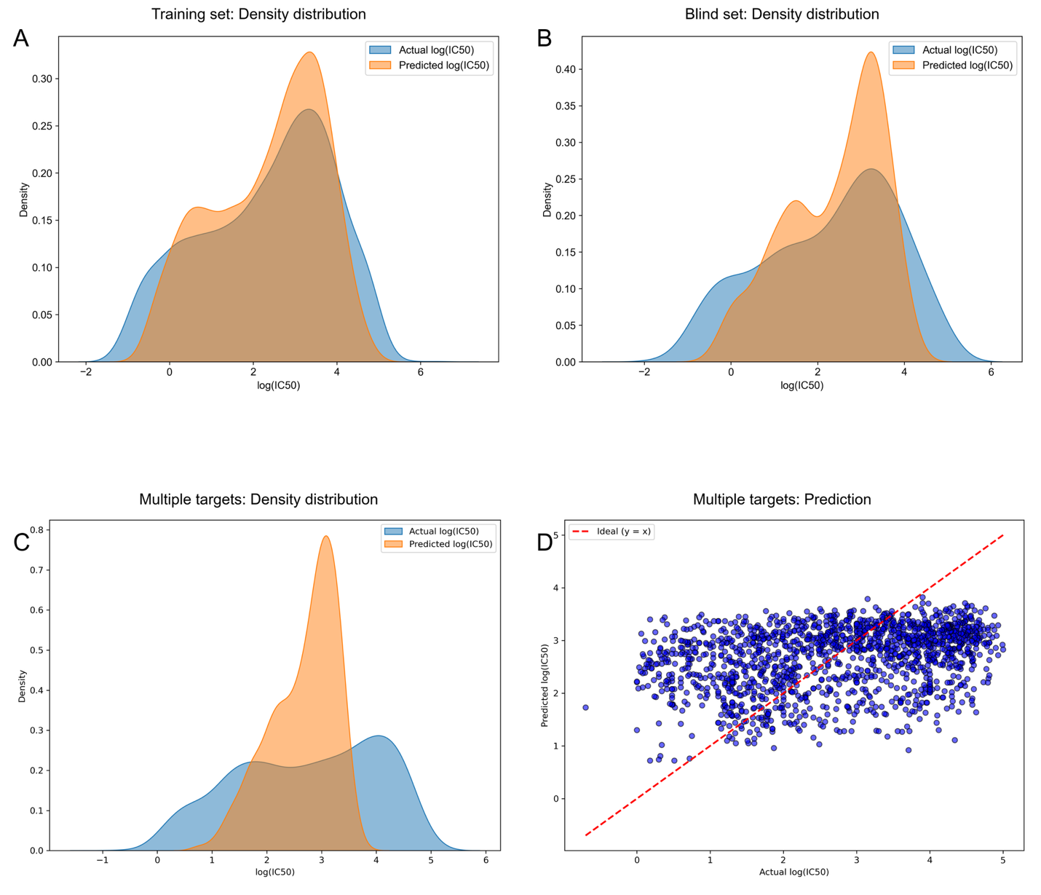

Figure 4. A: Training set: Density distribution, B: Blind set: Density distribution, C: Multiple targets: Density distribution, D: Multiple targets: Prediction

4. Discussion and Conclusion

This study explains how supervised models: RF, GB, SVR, and LSTM can predict the bioactivity as IC50 values of small molecules targeting different biological targets, with well-balanced performance across cross-validation and blind sets. The RF consistently achieved the best balance of (R² ≈ 0.75) and blind validation (R² ≈ 0.74). Among the three descriptors, RDKit and PaDEL provided the strongest prediction compared to the PubChem descriptor and were able to capture topological, electronic, and physicochemical properties. Feature correlation, importance, and SHAP analysis also confirmed that topology, charge distribution, aromaticity, and van der Waals interactions were the important contributors to the prediction model performance. It was also seen that, being PaDEL’s higher-dimensional features, not being able to create more predictive performance compared to RDKit, indicates that coverage of descriptor diversity, rather than quantity, is acceptable for predictive success. Clustering analyses further showed the structural heterogeneity of the dataset, while feature-based clustering grouped molecules by polarity, aromaticity, and hydrophobicity. Applicability domain assessments indicated that 56% of chemicals fell inside and 44% of chemicals fell outside the modeled space. Although multitarget validation produced modest global performance (R² = 0.10), individual cases, such as the accurate prediction of nanomolar inhibitors, demonstrated the framework’s practical value for novel biological contexts. These findings illustrate both the opportunities and limitations to extend QSAR models beyond their training space, particularly for complex targets such as PPIs. Collectively, the results support a descriptor-driven machine learning framework as an acceptable strategy for bioactivity prediction. While current limitations include transferability across highly diverse targets, the proposed work provides a strong foundation for small-molecule-based drug discovery.

Data Availability
The prediction, code, and dataset are available at https://github.com/janatanmoy5/ppimic50pred.
Conflict of interest

The authors declare that they have no conflicts of interest with the contents of this article.

Acknowledgment
No funding

Authors’ contribution
TJ designed the experiment; JK checked the validation part and chemistry part; TJ, JK, RB, and SS wrote the manuscript.

Reference:
[1] Hughes, J. P., Rees, S., Kalindjian, S. B., & Philpott, K. L. (2011). Principles of early drug discovery. Br J Pharmacol, 162(6), 1239–1249. https://doi.org/10.1111/j.1476-5381.2010.01127.x
[2] Lipinski, C. A. (2000). Drug-like properties and the causes of poor solubility and poor permeability. J Pharmacol Toxicol Methods, 44(1), 235–249. https://doi.org/10.1016/s1056-8719(00)00107-6
[3] Macarron, R., Banks, M. N., Bojanic, D., Burns, D. J., Cirovic, D. A., Garyantes, T., Green, D. V., Hertzberg, R. P., Janzen, W. P., Paslay, J. W., Schopfer, U., & Sittampalam, G. S. (2011). Impact of high-throughput screening in biomedical research. Nat Rev Drug Discov, 10(3), 188–195. https://doi.org/10.1038/nrd3368
[4] Swinney, D. C., & Anthony, J. (2011). How were new medicines discovered? Nat Rev Drug Discov, 10(7), 507–519. https://doi.org/10.1038/nrd3480
[5] Davies, G., Semple, H., McCandless, M., Cairns, J., & Holdgate, G. A. (2021). High-Throughput Mechanism of Inhibition. SLAS Discov, 26(2), 248–256. https://doi.org/10.1177/2472555220983809
[6] Sebaugh, J. L. (2011). Guidelines for accurate EC50/IC50 estimation. Pharm Stat, 10(2), 128–134. https://doi.org/10.1002/pst.426
[7] Xue, L., & Bajorath, J. (2000). Molecular descriptors in chemoinformatics, computational combinatorial chemistry, and virtual screening. Comb Chem High Throughput Screen, 3(5), 363–372. https://doi.org/10.2174/1386207003331454
[8] Greg Landrum, Paolo Tosco, Brian Kelley, Ricardo Rodriguez, David Cosgrove, Riccardo Vianello, sriniker, Peter Gedeck, Gareth Jones, Eisuke Kawashima, NadineSchneider, Dan Nealschneider, Andrew Dalke, tadhurst-cdd, Matt Swain, Brian Cole, Samo Turk, Aleksandr Savelev, Alain Vaucher, … Juuso Lehtivarjo. (2025). rdkit/rdkit: 2025_03_6 (Q1 2025) Release (Release_2025_03_6). Zenodo. https://doi.org/10.5281/zenodo.16996017
[9] Kim, S., Chen, J., Cheng, T., Gindulyte, A., He, J., He, S., Li, Q., Shoemaker, B. A., Thiessen, P. A., Yu, B., Zaslavsky, L., Zhang, J., & Bolton, E. E. (2025). PubChem 2025 update. Nucleic Acids Res, 53(D1), D1516–D1525. https://doi.org/10.1093/nar/gkae1059
[10] Yap, C. W. (2011). PaDEL-descriptor: an open source software to calculate molecular descriptors and fingerprints. J Comput Chem, 32(7), 1466–1474. https://doi.org/10.1002/jcc.21707
[11] Ramsundar, B., Kearnes, S., Riley, P., Webster, D., Konerding, D., & Pande, V. (2015, February 6). Massively Multitask Networks for Drug Discovery. arXiv.org. https://arxiv.org/abs/1502.02072
[12] Zdrazil, B., Felix, E., Hunter, F., Manners, E. J., Blackshaw, J., Corbett, S., de Veij, M., Ioannidis, H., Lopez, D. M., Mosquera, J. F., Magarinos, M. P., Bosc, N., Arcila, R., Kiziloren, T., Gaulton, A., Bento, A. P., Adasme, M. F., Monecke, P., Landrum, G. A., & Leach, A. R. (2024). The ChEMBL Database in 2023: a drug discovery platform spanning multiple bioactivity data types and time periods. Nucleic Acids Res, 52(D1), D1180–D1192. https://doi.org/10.1093/nar/gkad1004
[13] Tooke, C. L., Hinchliffe, P., Bragginton, E. C., Colenso, C. K., Hirvonen, V. H. A., Takebayashi, Y., & Spencer, J. (2019). beta-Lactamases and beta-Lactamase Inhibitors in the 21st Century. J Mol Biol, 431(18), 3472–3500. https://doi.org/10.1016/j.jmb.2019.04.002
[14] Hyatt, S. M., Lockamy, E. L., Stein, R. A., McDonnell, D. P., Miller, A. B., Orband-Miller, L. A., Willson, T. M., & Zuercher, W. J. (2007). On the intractability of estrogen-related receptor alpha as a target for activation by small molecules. J Med Chem, 50(26), 6722–6724. https://doi.org/10.1021/jm7012387
[15] Tooke, C. L., Hinchliffe, P., Bragginton, E. C., Colenso, C. K., Hirvonen, V. H. A., Takebayashi, Y., & Spencer, J. (2019). beta-Lactamases and beta-Lactamase Inhibitors in the 21st Century. J Mol Biol, 431(18), 3472–3500. https://doi.org/10.1016/j.jmb.2019.04.002
[16] Higueruelo, A. P., Jubb, H., & Blundell, T. L. (2013). TIMBAL v2: update of a database holding small molecules modulating protein-protein interactions. Database (Oxford), 2013, bat039. https://doi.org/10.1093/database/bat039
[17] Basse, M. J., Betzi, S., Morelli, X., & Roche, P. (2016). 2P2Idb v2: update of a structural database dedicated to orthosteric modulation of protein-protein interactions. Database (Oxford), 2016. https://doi.org/10.1093/database/baw007
[18] Moine-Franel, A., Mareuil, F., Nilges, M., Ciambur, C. B., & Sperandio, O. (2024). A comprehensive dataset of protein-protein interactions and ligand binding pockets for advancing drug discovery. Sci Data, 11(1), 402. https://doi.org/10.1038/s41597-024-03233-z
[19] Chu, T., Karmakar, J., Haggie, P. M., Tan, J. A., Master, R., Ramaswamy, K., Verkman, A. S., Anderson, M. O., & Cil, O. (2023). Selective isoxazolopyrimidine PAT1 (SLC26A6) inhibitors for therapy of intestinal disorders. RSC Med Chem, 14(11), 2342–2347. https://doi.org/10.1039/d3md00302g

