Supervised Learning-Driven Prediction of Small-Molecule Modulator Activity Against Protein–Protein Interactions

Tanmoy Jana ¹*, Joy Karmakar¹, Raja Banerjee², Sudipto Saha³

¹School of Medicine, University of California, San Francisco, San Francisco, CA, USA
²Department Of Biotechnology, Maulana Abul Kalam Azad University Of Technology, Kalyani, West Bengal, India

³Division Of Bioinformatics, Bose Institute, Kolkata, West Bengal, India

*Corresponding Author:
Tanmoy.Jana@ucsf.edu

Supplementary Materials

Supplementary figure legends

Figure S1. RDKit feature correlation
Figure S3. PaDEL feature correlation
Figure S2. PubChem feature correlation
Figure S4. Prediction Performance comparison of three descriptors (RDKit, PubChem, PaDEL) of all models (RF, GB, SVR, and LSTM). Here, RF: Random Forest, GB: Gradient Boosting, SVR/SVR: support vector machine regression, LSTM (PyTorch): Long Short-Term Memory using PyTorch.
Figure S5 (A-B). Random Forest model performance during cross-validation
Table S6. LSTM training and validation performance

Supplementary table legends

Table S1. Three Descriptors (RDKit, PubChem, and PaDEL) comparison: Target Names and number of chemical counts
Table S2. The RDkit descriptor description
Table S3. PaDEL descriptor description
Table S4. Prediction Performance comparison of RDKit Descriptors in different K-Fold Cross-Validations
Table S5. Prediction Performance comparison of PubChem Descriptors in different K-Fold Cross-Validations
Table S6. Prediction Performance comparison of PaDEL Descriptors in different K-Fold Cross-Validations

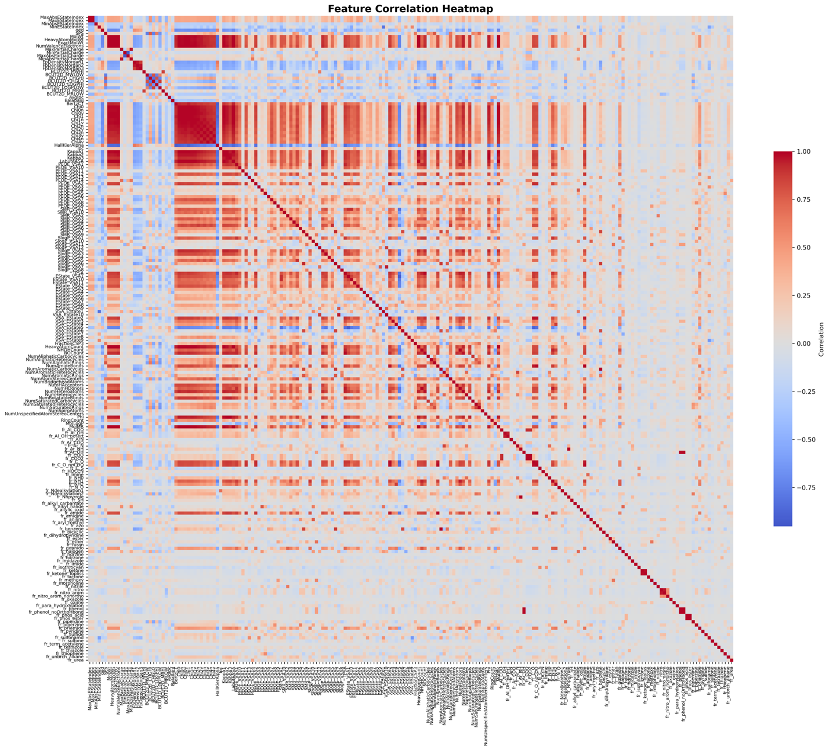

Figure S1

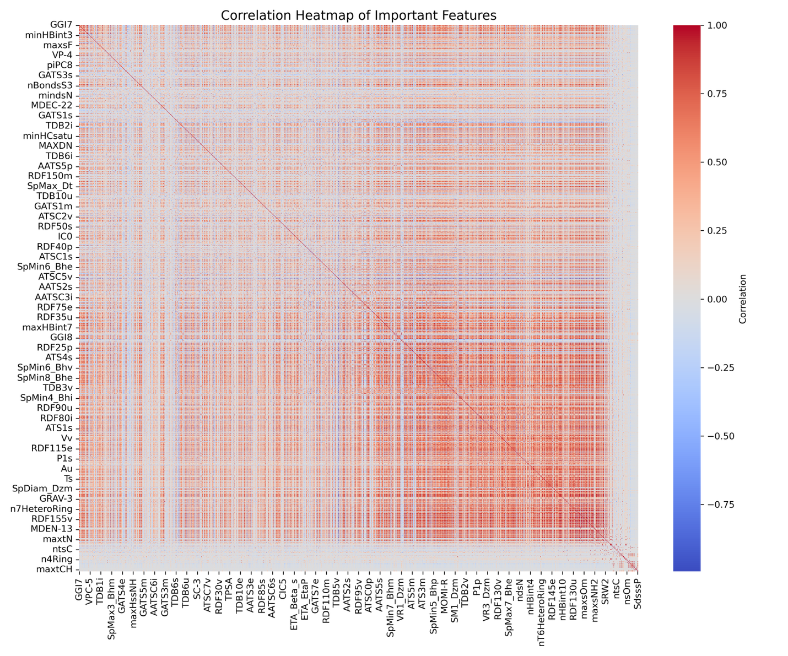

Figure S2
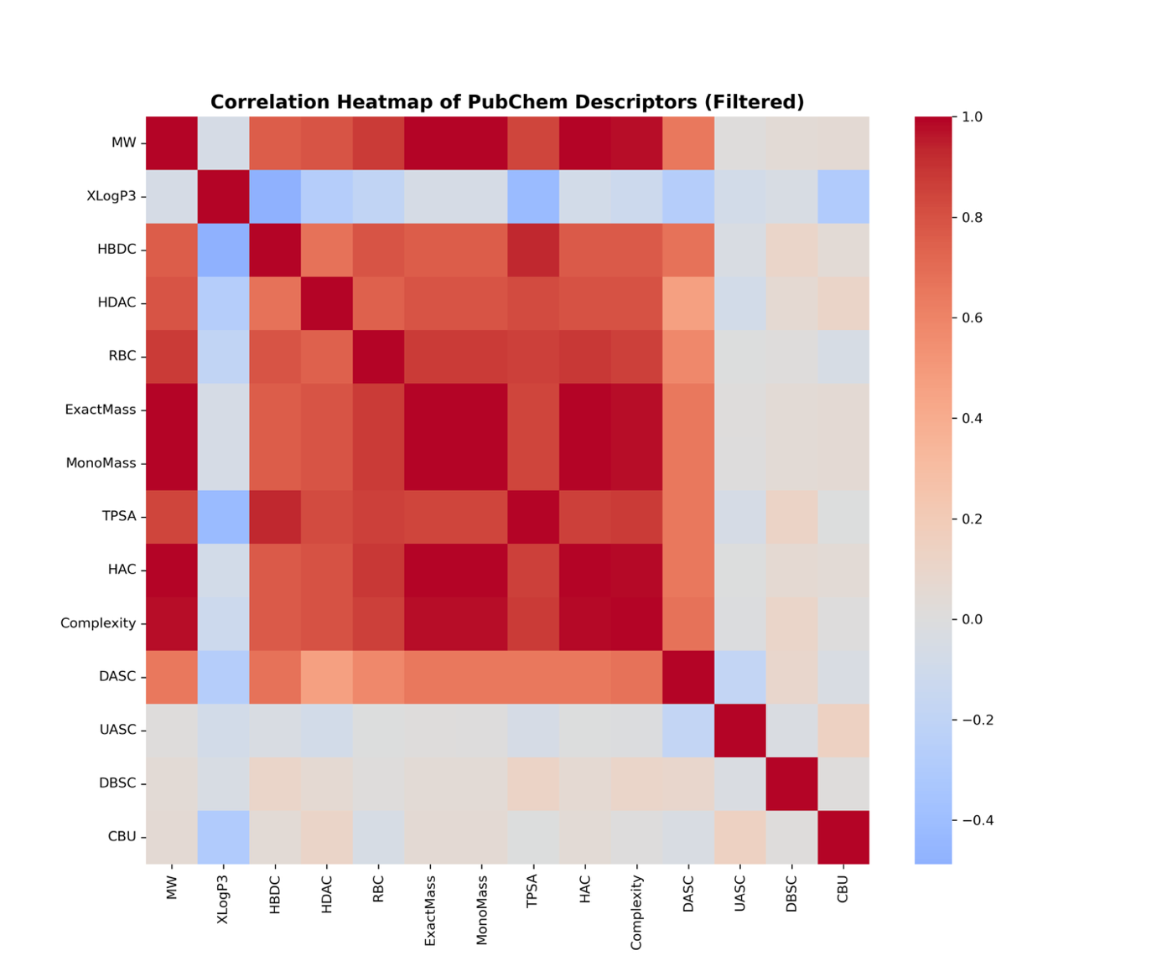

Figure S3

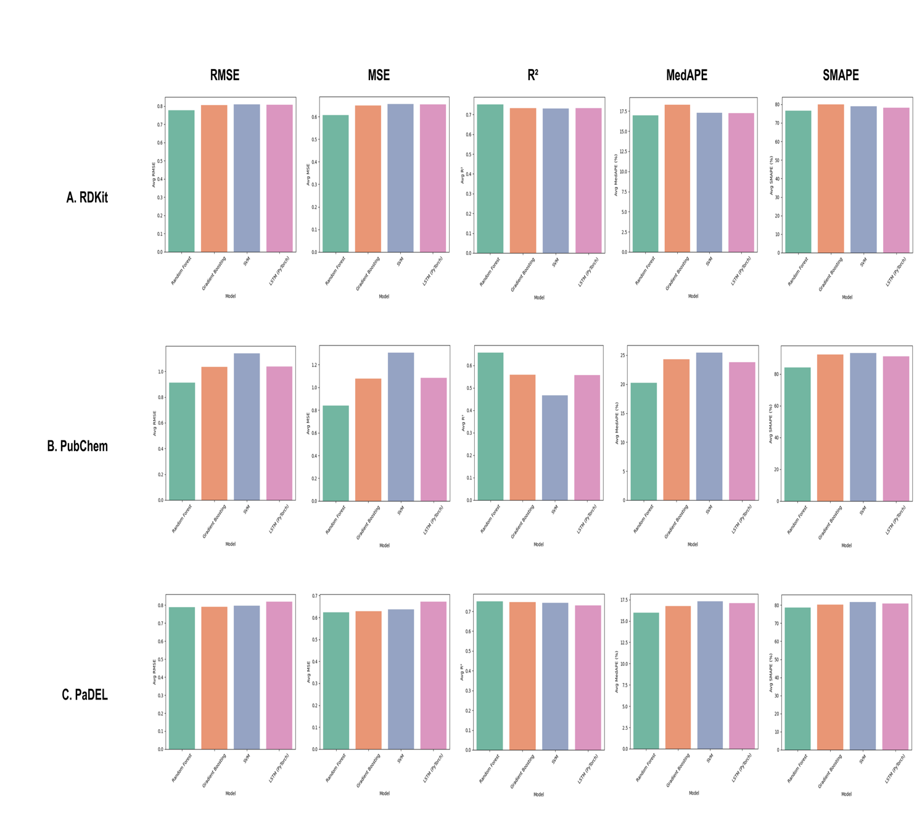

Figure S4

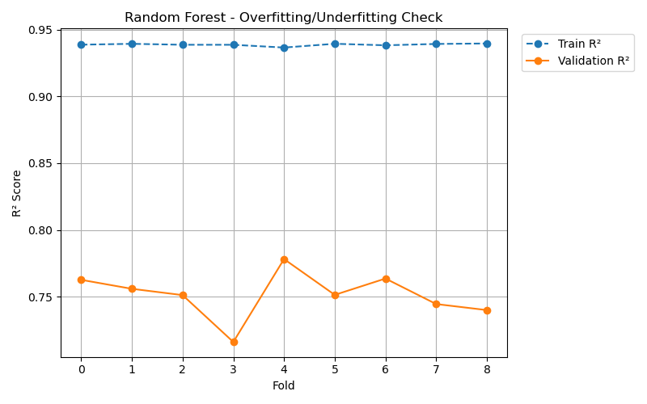

Figure S5 A

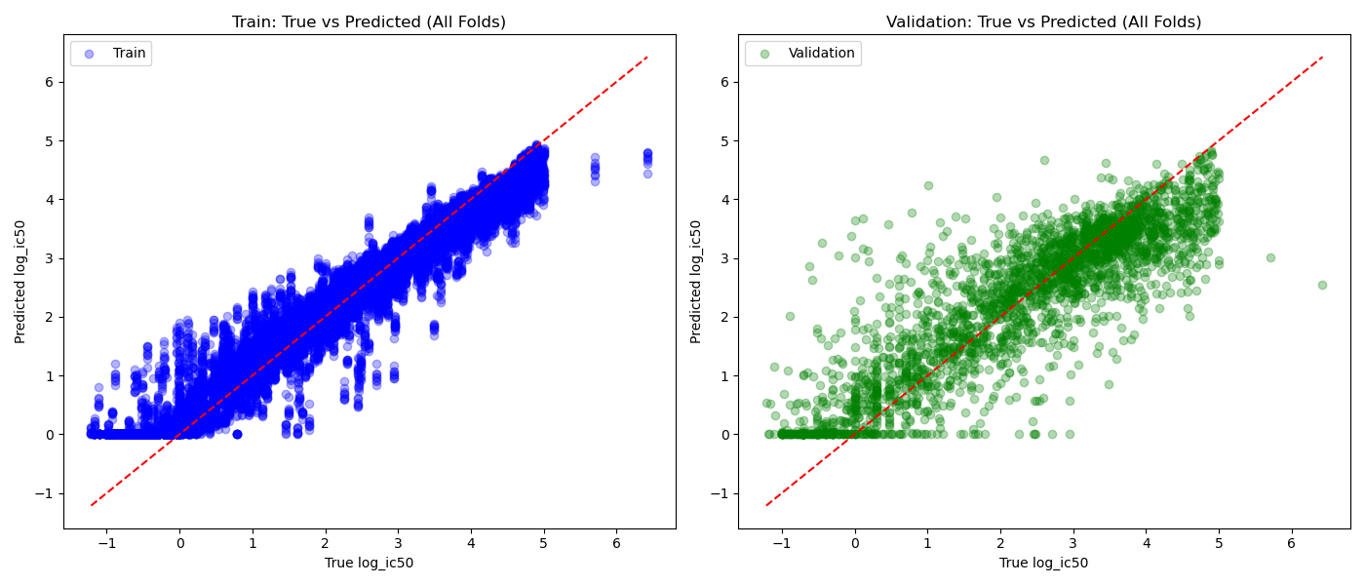

Figure S5 B

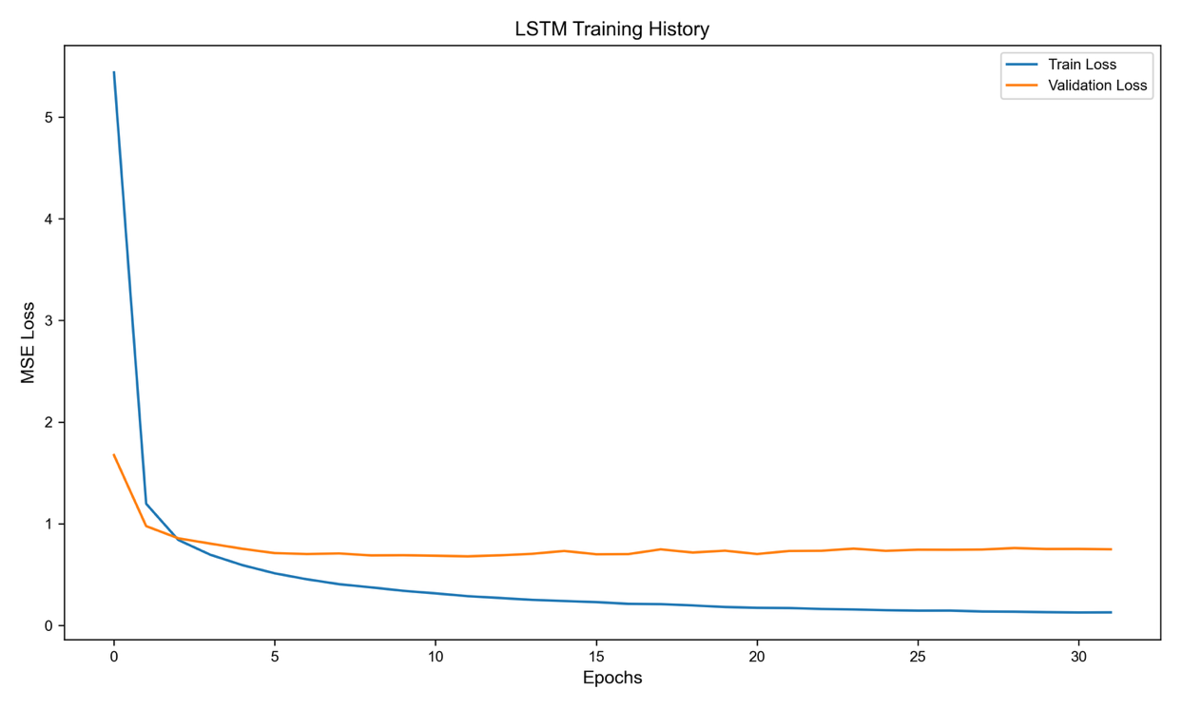
Figure S6

Table S1

Targets | PaDEL | PaDEL Count | RDKit | RDKit Count | PubChem | PubChem Count
A549 | ✓ | 15 | ✓ | 15 | ✓ | 15
ACHN | ✓ | 1 | ✓ | 1 | ✓ | 1
Acetylcholinesterase | ✓ | 1 | ✓ | 1 | ✓ | 1
Acyl coenzyme A:cholesterol acyltransferase 1 | ✓ | 1 | ✓ | 1 | ✓ | 1
Androgen receptor/PELP1 | ✓ | 1 | ✓ | 1 | ✓ | 1
Apoptosis regulator Bcl-2 | ✓ | 64 | ✓ | 122 | ✓ | 124
Apoptosis regulator Bcl-W | ✓ | 3 | ✓ | 3 | ✓ | 3
Apoptosis regulator Bcl-X | ✓ | 124 | ✓ | 212 | ✓ | 212
Apoptotic protease-activating factor 1 | ✓ | 2 | ✓ | 2 | ✓ | 2
Arachidonate 12-lipoxygenase | ✓ | 1 | ✓ | 1 | ✓ | 1
Aryl hydrocarbon receptor nuclear translocator/Endothelial PAS domain-containing protein 1 | ✓ | 53 | ✓ | 53 | ✓ | 53
B-cell lymphoma 6 protein | ✓ | 35 | ✓ | 35 | ✓ | 35
BACH1/MafK | ✓ | 1 | ✓ | 1 | ✓ | 1
BCL-6/NCOR2 | ✓ | 1 | ✓ | 1 | ✓ | 1
BCoR-BCL6 | ✓ | 15 | ✓ | 15 | ✓ | 15
Bcl-2-related protein A1 | ✓ | 5 | ✓ | 5 | ✓ | 5
Bcl-xL/Bcl-2-binding component 3 | × | - | ✓ | 1 | ✓ | 1
Bcl2-antagonist of cell death (BAD) | ✓ | 2 | ✓ | 3 | ✓ | 3
Beta Lactamase | ✓ | 1 | ✓ | 1 | ✓ | 1
Bromodomain adjacent to zinc finger domain protein 2A | ✓ | 1 | ✓ | 1 | ✓ | 1
Bromodomain adjacent to zinc finger domain protein 2B | ✓ | 2 | ✓ | 2 | ✓ | 2
Bromodomain-containing protein 2 | ✓ | 17 | ✓ | 17 | ✓ | 17
Bromodomain-containing protein 3 | ✓ | 31 | ✓ | 31 | ✓ | 31
Bromodomain-containing protein 4 | ✓ | 10 | ✓ | 10 | ✓ | 10
CBP/beta catenin | ✓ | 1 | ✓ | 1 | ✓ | 1
CD40-CD40L | ✓ | 5 | ✓ | 6 | ✓ | 6
CRBN/EZH2 | × | - | ✓ | 2 | ✓ | 2
CREB-binding protein | ✓ | 1 | ✓ | 1 | ✓ | 1
CREB-binding protein/p53 | ✓ | 1 | ✓ | 1 | ✓ | 1
Cannabinoid CB1 receptor | ✓ | 1 | ✓ | 1 | ✓ | 1
Casein kinase I delta | ✓ | 2 | ✓ | 2 | ✓ | 2
Catenin beta-1/Transcription factor 7 | ✓ | 2 | ✓ | 2 | ✓ | 2
Cellular tumor antigen p53/Replication protein A 70 kDa DNA-binding subunit | × | - | ✓ | 1 | ✓ | 1
Cereblon/Histone deacetylase 6 | × | - | ✓ | 1 | ✓ | 1
Cruzipain | ✓ | 1 | ✓ | 1 | ✓ | 1
Cyclin-dependent kinase 2 | ✓ | 1 | ✓ | 1 | ✓ | 1
Cyclophilin A | ✓ | 80 | ✓ | 90 | ✓ | 89
Cyclophilin B | × | - | ✓ | 2 | ✓ | 2
Cysteinyl leukotriene receptor 1 | ✓ | 1 | ✓ | 1 | ✓ | 1
Cytochrome P450 2C9 | ✓ | 1 | ✓ | 1 | ✓ | 1
Cytochrome P450 3A4 | ✓ | 2 | ✓ | 2 | ✓ | 2
DNA (cytosine-5)-methyltransferase 1 | ✓ | 2 | ✓ | 2 | ✓ | 2
DNA repair protein RAD51 homolog 1 | ✓ | 16 | ✓ | 16 | ✓ | 16
DU-145 | ✓ | 1 | ✓ | 1 | ✓ | 1
Daudi | ✓ | 1 | ✓ | 1 | ✓ | 1
Death-associated protein kinase 1 | ✓ | 1 | ✓ | 1 | ✓ | 1
Dipeptidyl peptidase IV | ✓ | 1 | ✓ | 1 | ✓ | 1
Dopamine D3 receptor | × | - | ✓ | 1 | ✓ | 1
EOL1 | × | - | ✓ | 2 | ✓ | 2
Entamoeba histolytica | ✓ | 1 | ✓ | 1 | ✓ | 1
Estrogen receptor alpha | × | - | ✓ | 2 | ✓ | 2
Estrogen receptor beta | ✓ | 1 | ✓ | 1 | ✓ | 1
Estrogen-related receptor alpha | × | - | ✓ | 1 | ✓ | 1
Fanconi anemia group F protein/Transcription factor HES-1 | ✓ | 1 | ✓ | 2 | ✓ | 2
G-protein coupled receptor 35 | ✓ | 1 | ✓ | 1 | ✓ | 1
G-protein coupled receptor 55 | ✓ | 1 | ✓ | 1 | ✓ | 1
Giardia intestinalis | ✓ | 3 | ✓ | 3 | ✓ | 3
Glycogen synthase kinase-3 alpha | ✓ | 1 | ✓ | 1 | ✓ | 1
H9c2 | ✓ | 1 | ✓ | 1 | ✓ | 1
HCT-116 | ✓ | 27 | ✓ | 35 | ✓ | 35
HIF1A/p300/CREB-binding protein | ✓ | 3 | ✓ | 3 | ✓ | 3
HL-60 | ✓ | 5 | ✓ | 5 | ✓ | 5
HeLa | ✓ | 1 | ✓ | 1 | ✓ | 1
HepG2 | ✓ | 1 | ✓ | 1 | ✓ | 1
Hepatitis C virus | ✓ | 1 | ✓ | 1 | ✓ | 1
Histone acetyltransferase RTT109 | ✓ | 2 | ✓ | 2 | ✓ | 2
Histone-lysine N-methyltransferase | ✓ | 1 | ✓ | 1 | ✓ | 1
Histone-lysine N-methyltransferase 2A/WDR5 | ✓ | 33 | ✓ | 33 | ✓ | 33
Histone-lysine N-methyltransferase EZH2 | ✓ | 1 | ✓ | 1 | ✓ | 1
Human immunodeficiency virus type 1 integrase | ✓ | 1 | ✓ | 1 | ✓ | 1
IL15-IL15 receptor | ✓ | 12 | ✓ | 17 | ✓ | 17
Indoleamine 2 | ✓ | 1 | ✓ | 1 | ✓ | 1
Induced myeloid leukemia cell differentiation protein Mcl-1 | ✓ | 26 | ✓ | 30 | ✓ | 30
Integrin alpha-V/beta-3 | ✓ | 1 | ✓ | 1 | ✓ | 1
Interleukin-15 | ✓ | 2 | ✓ | 2 | ✓ | 2
Isocitrate lyase 1 | ✓ | 1 | ✓ | 1 | ✓ | 1
J774.A1 | ✓ | 1 | ✓ | 1 | ✓ | 1
JAR | ✓ | 1 | ✓ | 1 | ✓ | 1
Jurkat | ✓ | 1 | ✓ | 1 | ✓ | 1
K562 | ✓ | 2 | ✓ | 2 | ✓ | 2
KB | ✓ | 4 | ✓ | 4 | ✓ | 4
Keap1-p62 | ✓ | 10 | ✓ | 10 | ✓ | 10
Keap1/Nrf2 | ✓ | 189 | ✓ | 213 | ✓ | 213
Kelch-like ECH-associated protein 1 | ✓ | 9 | ✓ | 12 | ✓ | 12
LNCaP | ✓ | 2 | ✓ | 2 | ✓ | 2
LNCaP C4-2B | × | - | ✓ | 1 | ✓ | 1
Leishmania donovani | ✓ | 1 | ✓ | 1 | ✓ | 1
Leishmania infantum | ✓ | 1 | ✓ | 1 | ✓ | 1
Lysine-specific histone demethylase 1 | ✓ | 14 | ✓ | 17 | ✓ | 14
M17 leucyl aminopeptidase | ✓ | 1 | ✓ | 1 | ✓ | 1
M18 aspartyl aminopeptidase | ✓ | 1 | ✓ | 2 | ✓ | 2
MAP kinase p38 alpha | ✓ | 1 | ✓ | 1 | ✓ | 1
MCF7 | ✓ | 6 | ✓ | 6 | ✓ | 6
MDA-MB-231 | ✓ | 5 | ✓ | 5 | ✓ | 5
MLL1-ASH2L/RbBP5/WDR5/DPY30 | ✓ | 18 | ✓ | 18 | ✓ | 18
MOLM-13 | ✓ | 4 | ✓ | 4 | ✓ | 4
MV4-11 | ✓ | 6 | ✓ | 7 | ✓ | 7
Matrix metalloproteinase 13 | ✓ | 1 | ✓ | 1 | ✓ | 1
Menin | ✓ | 23 | ✓ | 46 | ✓ | 46
Menin/Histone-lysine N-methyltransferase MLL | ✓ | 111 | ✓ | 142 | ✓ | 142
Monoamine oxidase B | ✓ | 1 | ✓ | 1 | ✓ | 1
Mothers against decapentaplegic homolog 3 | ✓ | 1 | ✓ | 1 | ✓ | 1
Myc proto-oncogene protein | ✓ | 1 | ✓ | 1 | ✓ | 1
Myoglobin | ✓ | 1 | ✓ | 1 | ✓ | 1
NAD(+) hydrolase SARM1 | ✓ | 1 | ✓ | 1 | ✓ | 1
NCI-H1417 | ✓ | 1 | ✓ | 1 | ✓ | 1
NCI-H1963 | × | - | ✓ | 1 | ✓ | 1
NCI-H23 | ✓ | 1 | ✓ | 1 | ✓ | 1
NIH3T3 | ✓ | 12 | ✓ | 12 | ✓ | 12
NON-PROTEIN TARGET | ✓ | 2 | ✓ | 2 | ✓ | 2
NRP2-VEGA | × | - | ✓ | 1 | ✓ | 1
Nitric oxide synthase, inducible | ✓ | 1 | ✓ | 1 | ✓ | 1
Nuclear receptor subfamily 4 group A member 1 | ✓ | 1 | ✓ | 1 | ✓ | 1
Orexin receptor 1 | ✓ | 3 | ✓ | 3 | ✓ | 3
PBMC | ✓ | 1 | ✓ | 1 | ✓ | 1
PRMT5/MEP50 complex | ✓ | 1 | ✓ | 1 | ✓ | 1
PTPN9/STAT3 | ✓ | 1 | ✓ | 1 | ✓ | 1
Peptidyl-prolyl cis-trans isomerase NIMA-interacting 1 | ✓ | 1 | ✓ | 1 | ✓ | 1
Peroxisome proliferator-activated receptor gamma/Nuclear receptor corepressor 2 | ✓ | 118 | ✓ | 122 | ✓ | 122
Phospholipase A2 group 1B | ✓ | 2 | ✓ | 2 | ✓ | 2
Photoreceptor-specific nuclear receptor | ✓ | 62 | ✓ | 62 | ✓ | 62
Plasmodium falciparum | ✓ | 1 | ✓ | 1 | ✓ | 1
Prion protein | ✓ | 8 | ✓ | 8 | ✓ | 8
Proteasome assembly chaperone 3 | ✓ | 1 | ✓ | 1 | ✓ | 1
Protein Mdm4 | ✓ | 1 | ✓ | 7 | ✓ | 7
Protein arginine N-methyltransferase 3 | ✓ | 1 | ✓ | 1 | ✓ | 1
Protein cereblon/DNA damage-binding protein 1 | × | - | ✓ | 3 | ✓ | 3
Protein cereblon/Estrogen receptor | × | - | ✓ | 12 | ✓ | 12
Protein cereblon/Histone deacetylase 3 | × | - | ✓ | 1 | ✓ | 1
Protein skinhead-1 | ✓ | 1 | ✓ | 1 | ✓ | 1
Protein tyrosine kinase 2 beta | ✓ | 1 | ✓ | 1 | ✓ | 1
Protein-tyrosine phosphatase LC-PTP | ✓ | 1 | ✓ | 1 | ✓ | 1
Putative hexokinase HKDC1 | ✓ | 2 | ✓ | 2 | ✓ | 2
RAW264.7 | ✓ | 1 | ✓ | 1 | ✓ | 1
Raji | ✓ | 4 | ✓ | 4 | ✓ | 4
Ras and Rab interactor 1/Tyrosine-protein kinase ABL1 | ✓ | 3 | ✓ | 3 | ✓ | 3
Runt-related transcription factor 1/Core-binding factor subunit beta | ✓ | 56 | ✓ | 58 | ✓ | 58
SAOS-2 | ✓ | 10 | ✓ | 10 | ✓ | 10
SGC-7901 | ✓ | 6 | ✓ | 6 | ✓ | 6
SJSA-1 | ✓ | 6 | ✓ | 6 | ✓ | 6
SK-MEL-30 | × | - | ✓ | 1 | ✓ | 1
SUMO-activating enzyme | ✓ | 1 | ✓ | 1 | ✓ | 1
SW-620 | ✓ | 2 | ✓ | 2 | ✓ | 2
Sentrin-specific protease 6 | ✓ | 1 | ✓ | 1 | ✓ | 1
Sentrin-specific protease 7 | ✓ | 1 | ✓ | 1 | ✓ | 1
Serine/threonine protein phosphatase 2B catalytic subunit | × | - | ✓ | 1 | × | -
Serine/threonine-protein kinase Chk1 | ✓ | 1 | ✓ | 1 | ✓ | 1
Serine/threonine-protein kinase PIM1 | ✓ | 4 | ✓ | 4 | ✓ | 4
Serine/threonine-protein kinase PIM2 | ✓ | 11 | ✓ | 11 | ✓ | 11
Steroid 5-alpha-reductase 1 | ✓ | 1 | ✓ | 1 | ✓ | 1
T-cell | ✓ | 1 | ✓ | 1 | ✓ | 1
T47D | ✓ | 2 | ✓ | 2 | ✓ | 2
Transcription intermediary factor 1-alpha | ✓ | 1 | ✓ | 2 | ✓ | 2
Transcriptional coactivator YAP1/Transcriptional enhancer factor TEF-1 | × | - | ✓ | 20 | ✓ | 20
Transcriptional enhancer factor TEF-3 | ✓ | 1 | ✓ | 1 | ✓ | 1
Tumor necrosis factor ligand superfamily member 11 | ✓ | 1 | ✓ | 1 | ✓ | 1
Tumour suppressor p53/oncoprotein Mdm2 | ✓ | 1051 | ✓ | 1137 | ✓ | 1135
Tumour suppressor protein p53/Mdm4 | ✓ | 12 | ✓ | 13 | ✓ | 13
Tyrosyl-DNA phosphodiesterase 1 | ✓ | 1 | ✓ | 1 | ✓ | 1
U2OS | ✓ | 7 | ✓ | 7 | ✓ | 7
Unchecked | ✓ | 91 | ✓ | 135 | ✓ | 135
V79 | ✓ | 1 | ✓ | 1 | ✓ | 1
VEGA-NRP1 | × | - | ✓ | 16 | ✓ | 16
VHL/Estrogen receptor | × | - | ✓ | 3 | ✓ | 3
VHL/Histone deacetylase 3 | × | - | ✓ | 1 | ✓ | 1
VHL/KDM1A/HDAC1/RCOR1 | × | - | ✓ | 1 | ✓ | 1
Vero | ✓ | 3 | ✓ | 3 | ✓ | 3
Voltage-gated N-type calcium channel alpha-1B subunit/Amyloid beta A4 precursor protein-binding family A member 1 | ✓ | 3 | ✓ | 3 | ✓ | 3
Von Hippel-Lindau disease tumor suppressor/Elongin B/Elongin C | × | - | ✓ | 3 | ✓ | 3
WD repeat-containing protein 5 | ✓ | 3 | ✓ | 4 | ✓ | 4
WDR5-MYC | ✓ | 27 | ✓ | 27 | ✓ | 27
YAP1-TEAD4 | ✓ | 6 | ✓ | 6 | ✓ | 6
beta-catenin-B-cell lymphoma 9 protein complex | × | - | ✓ | 1 | ✓ | 1
c-Myc/c-Max | ✓ | 11 | ✓ | 11 | ✓ | 11
p53-binding protein Mdm-2 | ✓ | 318 | ✓ | 356 | ✓ | 354
von Hippel-Lindau disease tumor suppressor/Elongin-B/Elongin-C/Bromodomain-containing protein 4 | × | - | ✓ | 1 | ✓ | 1

Table S2.

RDKIT Descriptor Name | Description
BertzCT | A topological index meant to quantify "complexity" of molecules.
fr_bicyclic | Bicyclic
FractionCSP3 | CalcFractionCSP3( (Mol)mol) -> float :
NumAliphaticCarbocycles | CalcNumAliphaticCarbocycles( (Mol)mol) -> int :
NumAliphaticHeterocycles | CalcNumAliphaticHeterocycles( (Mol)mol) -> int :
NumAliphaticRings | CalcNumAliphaticRings( (Mol)mol) -> int :
NumAmideBonds | CalcNumAmideBonds( (Mol)mol) -> int :
NumAromaticCarbocycles | CalcNumAromaticCarbocycles( (Mol)mol) -> int :
NumAromaticHeterocycles | CalcNumAromaticHeterocycles( (Mol)mol) -> int :
NumAromaticRings | CalcNumAromaticRings( (Mol)mol) -> int :
NumAtomStereoCenters | CalcNumAtomStereoCenters( (Mol)mol) -> int :
NumBridgeheadAtoms | CalcNumBridgeheadAtoms( (Mol)mol [, (AtomPairsParameters)atoms=None]) -> int :
NumHeterocycles | CalcNumHeterocycles( (Mol)mol) -> int :
NumSaturatedCarbocycles | CalcNumSaturatedCarbocycles( (Mol)mol) -> int :
NumSaturatedHeterocycles | CalcNumSaturatedHeterocycles( (Mol)mol) -> int :
NumSaturatedRings | CalcNumSaturatedRings( (Mol)mol) -> int :
NumSpiroAtoms | CalcNumSpiroAtoms( (Mol)mol [, (AtomPairsParameters)atoms=None]) -> int :
NumUnspecifiedAtomStereoCenters | CalcNumUnspecifiedAtomStereoCenters( (Mol)mol) -> int :
Phi | CalcPhi( (Mol)mol) -> float :
BalabanJ | Calculate Balaban's J value for a molecule
qed | Calculate the weighted sum of ADS mapped properties
SPS | Calculates the SpacialScore descriptor. By default, the score is normalized by the number of heavy atoms (nSPS) resulting in a float value,
MaxAbsEStateIndex | Description not found
MaxAbsEStateIndex | Maximum absolute value of electrotopological state (EState) index across atoms; measures the most extreme electronic/topological environment.
MaxEStateIndex | Maximum electrotopological state index among atoms in the molecule.
MinAbsEStateIndex | Minimum absolute value of EState index among atoms.
MinEStateIndex | Minimum electrotopological state index among atoms.
MaxPartialCharge | Maximum Gasteiger partial atomic charge in the molecule.
MinPartialCharge | Minimum Gasteiger partial atomic charge in the molecule.
MaxAbsPartialCharge | Maximum absolute value of Gasteiger partial charge in the molecule.
MinAbsPartialCharge | Minimum absolute value of Gasteiger partial charge in the molecule.
FpDensityMorgan1 | Density of Morgan fingerprint (radius 1): number of bits set divided by number of atoms.
FpDensityMorgan2 | Density of Morgan fingerprint (radius 2): number of bits set divided by number of atoms.
FpDensityMorgan3 | Density of Morgan fingerprint (radius 3): number of bits set divided by number of atoms.
BCUT2D_MWHI | Highest eigenvalue of the Burden matrix weighted by atomic mass.
BCUT2D_MWLOW | Lowest eigenvalue of the Burden matrix weighted by atomic mass.
BCUT2D_CHGHI | Highest eigenvalue of the Burden matrix weighted by atomic partial charge.
BCUT2D_CHGLO | Lowest eigenvalue of the Burden matrix weighted by atomic partial charge.
BCUT2D_LOGPHI | Highest eigenvalue of the Burden matrix weighted by atomic Crippen logP contribution.
BCUT2D_LOGPLOW | Lowest eigenvalue of the Burden matrix weighted by atomic Crippen logP contribution.
BCUT2D_MRHI | Highest eigenvalue of the Burden matrix weighted by atomic molar refractivity contribution.
BCUT2D_MRLOW | Lowest eigenvalue of the Burden matrix weighted by atomic molar refractivity contribution.
Chi0n | Molecular connectivity chi index (order 0, non-valence-corrected).
Chi0v | Valence-corrected molecular connectivity chi index (order 0).
Chi1n | Molecular connectivity chi index (order 1, non-valence-corrected).
Chi1v | Valence-corrected molecular connectivity chi index (order 1).
Chi2n | Molecular connectivity chi index (order 2, non-valence-corrected).
Chi2v | Valence-corrected molecular connectivity chi index (order 2).
Chi3n | Molecular connectivity chi index (order 3, non-valence-corrected).
Chi3v | Valence-corrected molecular connectivity chi index (order 3).
Chi4n | Molecular connectivity chi index (order 4, non-valence-corrected).
Chi4v | Valence-corrected molecular connectivity chi index (order 4).
HallKierAlpha | Hall–Kier alpha descriptor; index of molecular branching and flexibility.
Kappa1 | Kier shape index 1: measures molecular shape relative to linear fragments.
Kappa2 | Kier shape index 2: measures molecular shape relative to branching.
Kappa3 | Kier shape index 3: measures molecular shape relative to cyclic structures.
LabuteASA | Approximate accessible surface area, as defined by Labute (2000).
TPSA | Topological polar surface area: surface area contribution of polar atoms, approximated from topology.
RingCount | Total number of rings in the molecule (aromatic + aliphatic).
EState_VSA10 | EState VSA Descriptor 10 ( 9.17 <= x < 15.00)
EState_VSA11 | EState VSA Descriptor 11 ( 15.00 <= x < inf)
EState_VSA2 | EState VSA Descriptor 2 ( -0.39 <= x < 0.29)
EState_VSA3 | EState VSA Descriptor 3 ( 0.29 <= x < 0.72)
EState_VSA4 | EState VSA Descriptor 4 ( 0.72 <= x < 1.17)
EState_VSA5 | EState VSA Descriptor 5 ( 1.17 <= x < 1.54)
EState_VSA6 | EState VSA Descriptor 6 ( 1.54 <= x < 1.81)
EState_VSA7 | EState VSA Descriptor 7 ( 1.81 <= x < 2.05)
EState_VSA8 | EState VSA Descriptor 8 ( 2.05 <= x < 4.69)
EState_VSA9 | EState VSA Descriptor 9 ( 4.69 <= x < 9.17)
Chi1 | From equations (1),(11) and (12) of Rev. Comp. Chem. vol 2, 367-422, (1991)
Chi0 | From equations (1),(9) and (10) of Rev. Comp. Chem. vol 2, 367-422, (1991)
PEOE_VSA1 | MOE Charge VSA Descriptor 1 (-inf < x < -0.30)
PEOE_VSA10 | MOE Charge VSA Descriptor 10 ( 0.10 <= x < 0.15)
PEOE_VSA11 | MOE Charge VSA Descriptor 11 ( 0.15 <= x < 0.20)
PEOE_VSA12 | MOE Charge VSA Descriptor 12 ( 0.20 <= x < 0.25)
PEOE_VSA13 | MOE Charge VSA Descriptor 13 ( 0.25 <= x < 0.30)
PEOE_VSA14 | MOE Charge VSA Descriptor 14 ( 0.30 <= x < inf)
PEOE_VSA2 | MOE Charge VSA Descriptor 2 (-0.30 <= x < -0.25)
PEOE_VSA3 | MOE Charge VSA Descriptor 3 (-0.25 <= x < -0.20)
PEOE_VSA4 | MOE Charge VSA Descriptor 4 (-0.20 <= x < -0.15)
PEOE_VSA5 | MOE Charge VSA Descriptor 5 (-0.15 <= x < -0.10)
PEOE_VSA6 | MOE Charge VSA Descriptor 6 (-0.10 <= x < -0.05)
PEOE_VSA7 | MOE Charge VSA Descriptor 7 (-0.05 <= x < 0.00)
PEOE_VSA8 | MOE Charge VSA Descriptor 8 ( 0.00 <= x < 0.05)
PEOE_VSA9 | MOE Charge VSA Descriptor 9 ( 0.05 <= x < 0.10)
SlogP_VSA1 | MOE logP VSA Descriptor 1 (-inf < x < -0.40)
SlogP_VSA10 | MOE logP VSA Descriptor 10 ( 0.40 <= x < 0.50)
SlogP_VSA11 | MOE logP VSA Descriptor 11 ( 0.50 <= x < 0.60)
SlogP_VSA12 | MOE logP VSA Descriptor 12 ( 0.60 <= x < inf)
SlogP_VSA2 | MOE logP VSA Descriptor 2 (-0.40 <= x < -0.20)
SlogP_VSA3 | MOE logP VSA Descriptor 3 (-0.20 <= x < 0.00)
SlogP_VSA4 | MOE logP VSA Descriptor 4 ( 0.00 <= x < 0.10)
SlogP_VSA5 | MOE logP VSA Descriptor 5 ( 0.10 <= x < 0.15)
SlogP_VSA6 | MOE logP VSA Descriptor 6 ( 0.15 <= x < 0.20)
SlogP_VSA7 | MOE logP VSA Descriptor 7 ( 0.20 <= x < 0.25)
SlogP_VSA8 | MOE logP VSA Descriptor 8 ( 0.25 <= x < 0.30)
SlogP_VSA9 | MOE logP VSA Descriptor 9 ( 0.30 <= x < 0.40)
SMR_VSA1 | MOE MR VSA Descriptor 1 (-inf < x < 1.29)
SMR_VSA10 | MOE MR VSA Descriptor 10 ( 4.00 <= x < inf)
SMR_VSA2 | MOE MR VSA Descriptor 2 ( 1.29 <= x < 1.82)
SMR_VSA3 | MOE MR VSA Descriptor 3 ( 1.82 <= x < 2.24)
SMR_VSA4 | MOE MR VSA Descriptor 4 ( 2.24 <= x < 2.45)
SMR_VSA5 | MOE MR VSA Descriptor 5 ( 2.45 <= x < 2.75)
SMR_VSA6 | MOE MR VSA Descriptor 6 ( 2.75 <= x < 3.05)
SMR_VSA7 | MOE MR VSA Descriptor 7 ( 3.05 <= x < 3.63)
SMR_VSA8 | MOE MR VSA Descriptor 8 ( 3.63 <= x < 3.80)
SMR_VSA9 | MOE MR VSA Descriptor 9 ( 3.80 <= x < 4.00)
fr_aldehyde | Number of aldehydes
fr_Al_COO | Number of aliphatic carboxylic acids
fr_Al_OH | Number of aliphatic hydroxyl groups
fr_Al_OH_noTert | Number of aliphatic hydroxyl groups excluding tert-OH
fr_alkyl_carbamate | Number of alkyl carbamates (subject to hydrolysis)
fr_alkyl_halide | Number of alkyl halides
fr_allylic_oxid | Number of allylic oxidation sites excluding steroid dienone
fr_amide | Number of amides
fr_amidine | Number of amidine groups
fr_aniline | Number of anilines
fr_Ar_NH | Number of aromatic amines
fr_Ar_COO | Number of Aromatic carboxylic acide
fr_Ar_OH | Number of aromatic hydroxyl groups
fr_Ar_N | Number of aromatic nitrogens
fr_aryl_methyl | Number of aryl methyl sites for hydroxylation
fr_azide | Number of azide groups
fr_azo | Number of azo groups
fr_barbitur | Number of barbiturate groups
fr_benzene | Number of benzene rings
fr_benzodiazepine | Number of benzodiazepines with no additional fused rings
fr_lactam | Number of beta lactams
fr_HOCCN | Number of C(OH)CCN-Ctert-alkyl or C(OH)CCNcyclic
fr_C_O | Number of carbonyl O
fr_C_O_noCOO | Number of carbonyl O, excluding COOH
fr_COO | Number of carboxylic acids
fr_COO2 | Number of carboxylic acids
fr_lactone | Number of cyclic esters (lactones)
fr_diazo | Number of diazo groups
fr_dihydropyridine | Number of dihydropyridines
fr_epoxide | Number of epoxide rings
fr_ester | Number of esters
fr_ether | Number of ether oxygens (including phenoxy)
fr_furan | Number of furan rings
fr_guanido | Number of guanidine groups
fr_Nhpyrrole | Number of H-pyrrole nitrogens
fr_halogen | Number of halogens
HeavyAtomCount | Number of heavy atoms a molecule.
NumHeteroatoms | Number of Heteroatoms
fr_hdrzine | Number of hydrazine groups
fr_hdrzone | Number of hydrazone groups
NumHAcceptors | Number of Hydrogen Bond Acceptors
NumHDonors | Number of Hydrogen Bond Donors
fr_N_O | Number of hydroxylamine groups
fr_imidazole | Number of imidazole rings
fr_imide | Number of imide groups
fr_Imine | Number of Imines
fr_isocyan | Number of isocyanates
fr_isothiocyan | Number of isothiocyanates
fr_ketone | Number of ketones
fr_ketone_Topliss | Number of ketones excluding diaryl, a,b-unsat. dienones, heteroatom on Calpha
fr_methoxy | Number of methoxy groups -OCH3
fr_morpholine | Number of morpholine rings
fr_ArN | Number of N functional groups attached to aromatics
NHOHCount | Number of NHs or OHs
fr_nitrile | Number of nitriles
fr_nitro_arom | Number of nitro benzene ring substituents
fr_nitro | Number of nitro groups
NOCount | Number of Nitrogens and Oxygens
fr_nitroso | Number of nitroso groups, excluding NO2
fr_nitro_arom_nonortho | Number of non-ortho nitro benzene ring substituents
fr_oxazole | Number of oxazole rings
fr_oxime | Number of oxime groups
fr_para_hydroxylation | Number of para-hydroxylation sites
fr_phenol_noOrthoHbond | Number of phenolic OH excluding ortho intramolecular Hbond substituents
fr_phenol | Number of phenols
fr_phos_acid | Number of phosphoric acid groups
fr_phos_ester | Number of phosphoric ester groups
fr_piperdine | Number of piperdine rings
fr_piperzine | Number of piperzine rings
fr_priamide | Number of primary amides
fr_NH2 | Number of Primary amines
fr_prisulfonamd | Number of primary sulfonamides
fr_pyridine | Number of pyridine rings
fr_quatN | Number of quaternary nitrogens
NumRotatableBonds | Number of Rotatable Bonds
fr_NH1 | Number of Secondary amines
fr_sulfonamd | Number of sulfonamides
fr_sulfone | Number of sulfone groups
fr_term_acetylene | Number of terminal acetylenes
fr_Ndealkylation2 | Number of tert-alicyclic amines (no heteroatoms, not quinine-like bridged N)
fr_NH0 | Number of Tertiary amines
fr_tetrazole | Number of tetrazole rings
fr_thiazole | Number of thiazole rings
fr_C_S | Number of thiocarbonyl
fr_thiocyan | Number of thiocyanates
fr_sulfide | Number of thioether
fr_SH | Number of thiol groups
fr_thiophene | Number of thiophene rings
fr_unbrch_alkane | Number of unbranched alkanes of at least 4 members (excludes halogenated alkanes)
fr_urea | Number of urea groups
fr_Ndealkylation1 | Number of XCCNR groups
MolWt | The average molecular weight of the molecule
HeavyAtomMolWt | The average molecular weight of the molecule ignoring hydrogens
ExactMolWt | The exact molecular weight of the molecule
NumRadicalElectrons | The number of radical electrons the molecule has
NumValenceElectrons | The number of valence electrons the molecule has
AvgIpc | This returns the average information content of the coefficients of the characteristic
Ipc | This returns the information content of the coefficients of the characteristic
VSA_EState1 | VSA EState Descriptor 1 (-inf < x < 4.78)
VSA_EState10 | VSA EState Descriptor 10 ( 11.00 <= x < inf)
VSA_EState2 | VSA EState Descriptor 2 ( 4.78 <= x < 5.00)
VSA_EState3 | VSA EState Descriptor 3 ( 5.00 <= x < 5.41)
VSA_EState4 | VSA EState Descriptor 4 ( 5.41 <= x < 5.74)
VSA_EState5 | VSA EState Descriptor 5 ( 5.74 <= x < 6.00)
VSA_EState6 | VSA EState Descriptor 6 ( 6.00 <= x < 6.07)
VSA_EState7 | VSA EState Descriptor 7 ( 6.07 <= x < 6.45)
VSA_EState8 | VSA EState Descriptor 8 ( 6.45 <= x < 7.00)
VSA_EState9 | VSA EState Descriptor 9 ( 7.00 <= x < 11.00)
MolLogP | Wildman-Crippen LogP value
MolMR | Wildman-Crippen MR value

Table S3.

Descriptor type | Number | Descriptor | Class
Acidic group count | 1 | nAcid | 2D
ALOGP | 3 | ALogP, ALogp2, AMR | 2D
APol | 1 | apol | 2D
Aromatic atoms count | 1 | naAromAtom | 2D
Aromatic bonds count | 1 | nAromBond | 2D
Atom count | 14 | nAtom, nHeavyAtom, nH, nB, nC, nN, nO, nS, nP, nF, nCl, nBr, nI, nX | 2D
Autocorrelation | 346 | ATS0m, ATS1m, ATS2m, ATS3m, ATS4m, ATS5m, ATS6m, ATS7m, ATS8m, ATS0v, ATS1v, ATS2v, ATS3v, ATS4v, ATS5v, ATS6v, ATS7v, ATS8v, ATS0e, ATS1e, ATS2e, ATS3e, ATS4e, ATS5e, ATS6e, ATS7e, ATS8e, ATS0p, ATS1p, ATS2p, ATS3p, ATS4p, ATS5p, ATS6p, ATS7p, ATS8p, ATS0i, ATS1i, ATS2i, ATS3i, ATS4i, ATS5i, ATS6i, ATS7i, ATS8i, ATS0s, ATS1s, ATS2s, ATS3s, ATS4s, ATS5s, ATS6s, ATS7s, ATS8s, AATS0m, AATS1m, AATS2m, AATS3m, AATS4m, AATS5m, AATS6m, AATS7m, AATS8m, AATS0v, AATS1v, AATS2v, AATS3v, AATS4v, AATS5v, AATS6v, AATS7v, AATS8v, AATS0e, AATS1e, AATS2e, AATS3e, AATS4e, AATS5e, AATS6e, AATS7e, AATS8e, AATS0p, AATS1p, AATS2p, AATS3p, AATS4p, AATS5p, AATS6p, AATS7p, AATS8p, AATS0i, AATS1i, AATS2i, AATS3i, AATS4i, AATS5i, AATS6i, AATS7i, AATS8i, AATS0s, AATS1s, AATS2s, AATS3s, AATS4s, AATS5s, AATS6s, AATS7s, AATS8s, ATSC0c, ATSC1c, ATSC2c, ATSC3c, ATSC4c, ATSC5c, ATSC6c, ATSC7c, ATSC8c, ATSC0m, ATSC1m, ATSC2m, ATSC3m, ATSC4m, ATSC5m, ATSC6m, ATSC7m, ATSC8m, ATSC0v, ATSC1v, ATSC2v, ATSC3v, ATSC4v, ATSC5v, ATSC6v, ATSC7v, ATSC8v, ATSC0e, ATSC1e, ATSC2e, ATSC3e, ATSC4e, ATSC5e, ATSC6e, ATSC7e, ATSC8e, ATSC0p, ATSC1p, ATSC2p, ATSC3p, ATSC4p, ATSC5p, ATSC6p, ATSC7p, ATSC8p, ATSC0i, ATSC1i, ATSC2i, ATSC3i, ATSC4i, ATSC5i, ATSC6i, ATSC7i, ATSC8i, ATSC0s, ATSC1s, ATSC2s, ATSC3s, ATSC4s, ATSC5s, ATSC6s, ATSC7s, ATSC8s, AATSC0c, AATSC1c, AATSC2c, AATSC3c, AATSC4c, AATSC5c, AATSC6c, AATSC7c, AATSC8c, AATSC0m, AATSC1m, AATSC2m, AATSC3m, AATSC4m, AATSC5m, AATSC6m, AATSC7m, AATSC8m, AATSC0v, AATSC1v, AATSC2v, AATSC3v, AATSC4v, AATSC5v, AATSC6v, AATSC7v, AATSC8v, AATSC0e, AATSC1e, AATSC2e, AATSC3e, AATSC4e, AATSC5e, AATSC6e, AATSC7e, AATSC8e, AATSC0p, AATSC1p, AATSC2p, AATSC3p, AATSC4p, AATSC5p, AATSC6p, AATSC7p, AATSC8p, AATSC0i, AATSC1i, AATSC2i, AATSC3i, AATSC4i, AATSC5i, AATSC6i, AATSC7i, AATSC8i, AATSC0s, AATSC1s, AATSC2s, AATSC3s, AATSC4s, AATSC5s, AATSC6s, AATSC7s, AATSC8s, MATS1c, MATS2c, MATS3c, MATS4c, MATS5c, MATS6c, MATS7c, MATS8c, MATS1m, MATS2m, MATS3m, MATS4m, MATS5m, MATS6m, MATS7m, MATS8m, MATS1v, MATS2v, MATS3v, MATS4v, MATS5v, MATS6v, MATS7v, MATS8v, MATS1e, MATS2e, MATS3e, MATS4e, MATS5e, MATS6e, MATS7e, MATS8e, MATS1p, MATS2p, MATS3p, MATS4p, MATS5p, MATS6p, MATS7p, MATS8p, MATS1i, MATS2i, MATS3i, MATS4i, MATS5i, MATS6i, MATS7i, MATS8i, MATS1s, MATS2s, MATS3s, MATS4s, MATS5s, MATS6s, MATS7s, MATS8s, GATS1c, GATS2c, GATS3c, GATS4c, GATS5c, GATS6c, GATS7c, GATS8c, GATS1m, GATS2m, GATS3m, GATS4m, GATS5m, GATS6m, GATS7m, GATS8m, GATS1v, GATS2v, GATS3v, GATS4v, GATS5v, GATS6v, GATS7v, GATS8v, GATS1e, GATS2e, GATS3e, GATS4e, GATS5e, GATS6e, GATS7e, GATS8e, GATS1p, GATS2p, GATS3p, GATS4p, GATS5p, GATS6p, GATS7p, GATS8p, GATS1i, GATS2i, GATS3i, GATS4i, GATS5i, GATS6i, GATS7i, GATS8i, GATS1s, GATS2s, GATS3s, GATS4s, GATS5s, GATS6s, GATS7s, GATS8s | 2D
Barysz matrix | 91 | SpAbs_DzZ, SpMax_DzZ, SpDiam_DzZ, SpAD_DzZ, SpMAD_DzZ, EE_DzZ, SM1_DzZ, VE1_DzZ, VE2_DzZ, VE3_DzZ, VR1_DzZ, VR2_DzZ, VR3_DzZ, SpAbs_Dzm, SpMax_Dzm, SpDiam_Dzm, SpAD_Dzm, SpMAD_Dzm, EE_Dzm, SM1_Dzm, VE1_Dzm, VE2_Dzm, VE3_Dzm, VR1_Dzm, VR2_Dzm, VR3_Dzm, SpAbs_Dzv, SpMax_Dzv, SpDiam_Dzv, SpAD_Dzv, SpMAD_Dzv, EE_Dzv, SM1_Dzv, VE1_Dzv, VE2_Dzv, VE3_Dzv, VR1_Dzv, VR2_Dzv, VR3_Dzv, SpAbs_Dze, SpMax_Dze, SpDiam_Dze, SpAD_Dze, SpMAD_Dze, EE_Dze, SM1_Dze, VE1_Dze, VE2_Dze, VE3_Dze, VR1_Dze, VR2_Dze, VR3_Dze, SpAbs_Dzp, SpMax_Dzp, SpDiam_Dzp, SpAD_Dzp, SpMAD_Dzp, EE_Dzp, SM1_Dzp, VE1_Dzp, VE2_Dzp, VE3_Dzp, VR1_Dzp, VR2_Dzp, VR3_Dzp, SpAbs_Dzi, SpMax_Dzi, SpDiam_Dzi, SpAD_Dzi, SpMAD_Dzi, EE_Dzi, SM1_Dzi, VE1_Dzi, VE2_Dzi, VE3_Dzi, VR1_Dzi, VR2_Dzi, VR3_Dzi, SpAbs_Dzs, SpMax_Dzs, SpDiam_Dzs, SpAD_Dzs, SpMAD_Dzs, EE_Dzs, SM1_Dzs, VE1_Dzs, VE2_Dzs, VE3_Dzs, VR1_Dzs, VR2_Dzs, VR3_Dzs | 2D
Basic group count | 1 | nBase | 2D
BCUT | 6 | BCUTw-1l, BCUTw-1h, BCUTc-1l, BCUTc-1h, BCUTp-1l, BCUTp-1h | 2D
Bond count | 10 | nBonds, nBonds2, nBondsS, nBondsS2, nBondsS3, nBondsD, nBondsD2, nBondsT, nBondsQ, nBondsM | 2D
BPol | 1 | bpol | 2D
Burden modified eigenvalues | 96 | SpMax1_Bhm, SpMax2_Bhm, SpMax3_Bhm, SpMax4_Bhm, SpMax5_Bhm, SpMax6_Bhm, SpMax7_Bhm, SpMax8_Bhm, SpMin1_Bhm, SpMin2_Bhm, SpMin3_Bhm, SpMin4_Bhm, SpMin5_Bhm, SpMin6_Bhm, SpMin7_Bhm, SpMin8_Bhm, SpMax1_Bhv, SpMax2_Bhv, SpMax3_Bhv, SpMax4_Bhv, SpMax5_Bhv, SpMax6_Bhv, SpMax7_Bhv, SpMax8_Bhv, SpMin1_Bhv, SpMin2_Bhv, SpMin3_Bhv, SpMin4_Bhv, SpMin5_Bhv, SpMin6_Bhv, SpMin7_Bhv, SpMin8_Bhv, SpMax1_Bhe, SpMax2_Bhe, SpMax3_Bhe, SpMax4_Bhe, SpMax5_Bhe, SpMax6_Bhe, SpMax7_Bhe, SpMax8_Bhe, SpMin1_Bhe, SpMin2_Bhe, SpMin3_Bhe, SpMin4_Bhe, SpMin5_Bhe, SpMin6_Bhe, SpMin7_Bhe, SpMin8_Bhe, SpMax1_Bhp, SpMax2_Bhp, SpMax3_Bhp, SpMax4_Bhp, SpMax5_Bhp, SpMax6_Bhp, SpMax7_Bhp, SpMax8_Bhp, SpMin1_Bhp, SpMin2_Bhp, SpMin3_Bhp, SpMin4_Bhp, SpMin5_Bhp, SpMin6_Bhp, SpMin7_Bhp, SpMin8_Bhp, SpMax1_Bhi, SpMax2_Bhi, SpMax3_Bhi, SpMax4_Bhi, SpMax5_Bhi, SpMax6_Bhi, SpMax7_Bhi, SpMax8_Bhi, SpMin1_Bhi, SpMin2_Bhi, SpMin3_Bhi, SpMin4_Bhi, SpMin5_Bhi, SpMin6_Bhi, SpMin7_Bhi, SpMin8_Bhi, SpMax1_Bhs, SpMax2_Bhs, SpMax3_Bhs, SpMax4_Bhs, SpMax5_Bhs, SpMax6_Bhs, SpMax7_Bhs, SpMax8_Bhs, SpMin1_Bhs, SpMin2_Bhs, SpMin3_Bhs, SpMin4_Bhs, SpMin5_Bhs, SpMin6_Bhs, SpMin7_Bhs, SpMin8_Bhs | 2D
Carbon types | 9 | C1SP1, C2SP1, C1SP2, C2SP2, C3SP2, C1SP3, C2SP3, C3SP3, C4SP3 | 2D
Chi chain | 10 | SCH-3, SCH-4, SCH-5, SCH-6, SCH-7, VCH-3, VCH-4, VCH-5, VCH-6, VCH-7 | 2D
Chi cluster | 8 | SC-3, SC-4, SC-5, SC-6, VC-3, VC-4, VC-5, VC-6 | 2D
Chi path cluster | 6 | SPC-4, SPC-5, SPC-6, VPC-4, VPC-5, VPC-6 | 2D
Chi path | 32 | SP-0, SP-1, SP-2, SP-3, SP-4, SP-5, SP-6, SP-7, ASP-0, ASP-1, ASP-2, ASP-3, ASP-4, ASP-5, ASP-6, ASP-7, VP-0, VP-1, VP-2, VP-3, VP-4, VP-5, VP-6, VP-7, AVP-0, AVP-1, AVP-2, AVP-3, AVP-4, AVP-5, AVP-6, AVP-7 | 2D
Constitutional | 12 | Sv, Sse, Spe, Sare, Sp, Si, Mv, Mse, Mpe, Mare, Mp, Mi | 2D
Crippen logP and MR | 2 | CrippenLogP, CrippenMR | 2D
Detour matrix | 11 | SpMax_Dt, SpDiam_Dt, SpAD_Dt, SpMAD_Dt, EE_Dt, VE1_Dt, VE2_Dt, VE3_Dt, VR1_Dt, VR2_Dt, VR3_Dt | 2D
Eccentric connectivity index | 1 | ECCEN | 2D
Atom type electrotopological state | 489 | nHBd, nwHBd, nHBa, nwHBa, nHBint2, nHBint3, nHBint4, nHBint5, nHBint6, nHBint7, nHBint8, nHBint9, nHBint10, nHsOH, nHdNH, nHsSH, nHsNH2, nHssNH, nHaaNH, nHsNH3p, nHssNH2p, nHsssNHp, nHtCH, nHdCH2, nHdsCH, nHaaCH, nHCHnX, nHCsats, nHCsatu, nHAvin, nHother, nHmisc, nsLi, nssBe, nssssBem, nsBH2, nssBH, nsssB, nssssBm, nsCH3, ndCH2, nssCH2, ntCH, ndsCH, naaCH, nsssCH, nddC, ntsC, ndssC, naasC, naaaC, nssssC, nsNH3p, nsNH2, nssNH2p, ndNH, nssNH, naaNH, ntN, nsssNHp, ndsN, naaN, nsssN, nddsN, naasN, nssssNp, nsOH, ndO, nssO, naaO, naOm, nsOm, nsF, nsSiH3, nssSiH2, nsssSiH, nssssSi, nsPH2, nssPH, nsssP, ndsssP, nddsP, nsssssP, nsSH, ndS, nssS, naaS, ndssS, nddssS, nssssssS, nSm, nsCl, nsGeH3, nssGeH2, nsssGeH, nssssGe, nsAsH2, nssAsH, nsssAs, ndsssAs, nddsAs, nsssssAs, nsSeH, ndSe, nssSe, naaSe, ndssSe, nssssssSe, nddssSe, nsBr, nsSnH3, nssSnH2, nsssSnH, nssssSn, nsI, nsPbH3, nssPbH2, nsssPbH, nssssPb, SHBd, SwHBd, SHBa, SwHBa, SHBint2, SHBint3, SHBint4, SHBint5, SHBint6, SHBint7, SHBint8, SHBint9, SHBint10, SHsOH, SHdNH, SHsSH, SHsNH2, SHssNH, SHaaNH, SHsNH3p, SHssNH2p, SHsssNHp, SHtCH, SHdCH2, SHdsCH, SHaaCH, SHCHnX, SHCsats, SHCsatu, SHAvin, SHother, SHmisc, SsLi, SssBe, SssssBem, SsBH2, SssBH, SsssB, SssssBm, SsCH3, SdCH2, SssCH2, StCH, SdsCH, SaaCH, SsssCH, SddC, StsC, SdssC, SaasC, SaaaC, SssssC, SsNH3p, SsNH2, SssNH2p, SdNH, SssNH, SaaNH, StN, SsssNHp, SdsN, SaaN, SsssN, SddsN, SaasN, SssssNp, SsOH, SdO, SssO, SaaO, SaOm, SsOm, SsF, SsSiH3, SssSiH2, SsssSiH, SssssSi, SsPH2, SssPH, SsssP, SdsssP, SddsP, SsssssP, SsSH, SdS, SssS, SaaS, SdssS, SddssS, SssssssS, SSm, SsCl, SsGeH3, SssGeH2, SsssGeH, SssssGe, SsAsH2, SssAsH, SsssAs, SdsssAs, SddsAs, SsssssAs, SsSeH, SdSe, SssSe, SaaSe, SdssSe, SssssssSe, SddssSe, SsBr, SsSnH3, SssSnH2, SsssSnH, SssssSn, SsI, SsPbH3, SssPbH2, SsssPbH, SssssPb, minHBd, minwHBd, minHBa, minwHBa, minHBint2, minHBint3, minHBint4, minHBint5, minHBint6, minHBint7, minHBint8, minHBint9, minHBint10, minHsOH, minHdNH, minHsSH, minHsNH2, minHssNH, minHaaNH, minHsNH3p, minHssNH2p, minHsssNHp, minHtCH, minHdCH2, minHdsCH, minHaaCH, minHCHnX, minHCsats, minHCsatu, minHAvin, minHother, minHmisc, minsLi, minssBe, minssssBem, minsBH2, minssBH, minsssB, minssssBm, minsCH3, mindCH2, minssCH2, mintCH, mindsCH, minaaCH, minsssCH, minddC, mintsC, mindssC, minaasC, minaaaC, minssssC, minsNH3p, minsNH2, minssNH2p, mindNH, minssNH, minaaNH, mintN, minsssNHp, mindsN, minaaN, minsssN, minddsN, minaasN, minssssNp, minsOH, mindO, minssO, minaaO, minaOm, minsOm, minsF, minsSiH3, minssSiH2, minsssSiH, minssssSi, minsPH2, minssPH, minsssP, mindsssP, minddsP, minsssssP, minsSH, mindS, minssS, minaaS, mindssS, minddssS, minssssssS, minSm, minsCl, minsGeH3, minssGeH2, minsssGeH, minssssGe, minsAsH2, minssAsH, minsssAs, mindsssAs, minddsAs, minsssssAs, minsSeH, mindSe, minssSe, minaaSe, mindssSe, minssssssSe, minddssSe, minsBr, minsSnH3, minssSnH2, minsssSnH, minssssSn, minsI, minsPbH3, minssPbH2, minsssPbH, minssssPb, maxHBd, maxwHBd, maxHBa, maxwHBa, maxHBint2, maxHBint3, maxHBint4, maxHBint5, maxHBint6, maxHBint7, maxHBint8, maxHBint9, maxHBint10, maxHsOH, maxHdNH, maxHsSH, maxHsNH2, maxHssNH, maxHaaNH, maxHsNH3p, maxHssNH2p, maxHsssNHp, maxHtCH, maxHdCH2, maxHdsCH, maxHaaCH, maxHCHnX, maxHCsats, maxHCsatu, maxHAvin, maxHother, maxHmisc, maxsLi, maxssBe, maxssssBem, maxsBH2, maxssBH, maxsssB, maxssssBm, maxsCH3, maxdCH2, maxssCH2, maxtCH, maxdsCH, maxaaCH, maxsssCH, maxddC, maxtsC, maxdssC, maxaasC, maxaaaC, maxssssC, maxsNH3p, maxsNH2, maxssNH2p, maxdNH, maxssNH, maxaaNH, maxtN, maxsssNHp, maxdsN, maxaaN, maxsssN, maxddsN, maxaasN, maxssssNp, maxsOH, maxdO, maxssO, maxaaO, maxaOm, maxsOm, maxsF, maxsSiH3, maxssSiH2, maxsssSiH, maxssssSi, maxsPH2, maxssPH, maxsssP, maxdsssP, maxddsP, maxsssssP, maxsSH, maxdS, maxssS, maxaaS, maxdssS, maxddssS, maxssssssS, maxSm, maxsCl, maxsGeH3, maxssGeH2, maxsssGeH, maxssssGe, maxsAsH2, maxssAsH, maxsssAs, maxdsssAs, maxddsAs, maxsssssAs, maxsSeH, maxdSe, maxssSe, maxaaSe, maxdssSe, maxssssssSe, maxddssSe, maxsBr, maxsSnH3, maxssSnH2, maxsssSnH, maxssssSn, maxsI, maxsPbH3, maxssPbH2, maxsssPbH, maxssssPb, sumI, meanI, hmax, gmax, hmin, gmin, LipoaffinityIndex, MAXDN, MAXDP, DELS, MAXDN2, MAXDP2, DELS2 | 2D
Extended topochemical atom | 43 | ETA_Alpha, ETA_AlphaP, ETA_dAlpha_A, ETA_dAlpha_B, ETA_Epsilon_1, ETA_Epsilon_2, ETA_Epsilon_3, ETA_Epsilon_4, ETA_Epsilon_5, ETA_dEpsilon_A, ETA_dEpsilon_B, ETA_dEpsilon_C, ETA_dEpsilon_D, ETA_Psi_1, ETA_dPsi_A, ETA_dPsi_B, ETA_Shape_P, ETA_Shape_Y, ETA_Shape_X, ETA_Beta, ETA_BetaP, ETA_Beta_s, ETA_BetaP_s, ETA_Beta_ns, ETA_BetaP_ns, ETA_dBeta, ETA_dBetaP, ETA_Beta_ns_d, ETA_BetaP_ns_d, ETA_Eta, ETA_EtaP, ETA_Eta_R, ETA_Eta_F, ETA_EtaP_F, ETA_Eta_L, ETA_EtaP_L, ETA_Eta_R_L, ETA_Eta_F_L, ETA_EtaP_F_L, ETA_Eta_B, ETA_EtaP_B, ETA_Eta_B_RC, ETA_EtaP_B_RC | 2D
FMFDescriptor | 1 | FMF | 2D
Fragment complexity | 1 | fragC | 2D
Hbond acceptor count | 4 | nHBAcc, nHBAcc2, nHBAcc3, nHBAcc_Lipinski | 2D
Hbond donor count | 2 | nHBDon, nHBDon_Lipinski | 2D
Hybridization ratio | 1 | HybRatio | 2D
Information content | 42 | IC0, IC1, IC2, IC3, IC4, IC5, TIC0, TIC1, TIC2, TIC3, TIC4, TIC5, SIC0, SIC1, SIC2, SIC3, SIC4, SIC5, CIC0, CIC1, CIC2, CIC3, CIC4, CIC5, BIC0, BIC1, BIC2, BIC3, BIC4, BIC5, MIC0, MIC1, MIC2, MIC3, MIC4, MIC5, ZMIC0, ZMIC1, ZMIC2, ZMIC3, ZMIC4, ZMIC5 | 2D
Kappa shape indices | 3 | Kier1, Kier2, Kier3 | 2D
Largest chain | 1 | nAtomLC | 2D
Largest Pi system | 1 | nAtomP | 2D
Longest aliphatic chain | 1 | nAtomLAC | 2D
Mannhold LogP | 1 | MLogP | 2D
McGowan volume | 1 | McGowan_Volume | 2D
Molecular distance edge | 19 | MDEC-11, MDEC-12, MDEC-13, MDEC-14, MDEC-22, MDEC-23, MDEC-24, MDEC-33, MDEC-34, MDEC-44, MDEO-11, MDEO-12, MDEO-22, MDEN-11, MDEN-12, MDEN-13, MDEN-22, MDEN-23, MDEN-33 | 2D
Molecular linear free energy relation | 6 | MLFER_A, MLFER_BH, MLFER_BO, MLFER_S, MLFER_E, MLFER_L | 2D
Path counts | 22 | MPC2, MPC3, MPC4, MPC5, MPC6, MPC7, MPC8, MPC9, MPC10, TPC, piPC1, piPC2, piPC3, piPC4, piPC5, piPC6, piPC7, piPC8, piPC9, piPC10, TpiPC, R_TpiPCTPC | 2D
Petitjean number | 1 | PetitjeanNumber | 2D
Ring count | 68 | nRing, n3Ring, n4Ring, n5Ring, n6Ring, n7Ring, n8Ring, n9Ring, n10Ring, n11Ring, n12Ring, nG12Ring, nFRing, nF4Ring, nF5Ring, nF6Ring, nF7Ring, nF8Ring, nF9Ring, nF10Ring, nF11Ring, nF12Ring, nFG12Ring, nHeteroRing, n3HeteroRing, n4HeteroRing, n5HeteroRing, n6HeteroRing, n7HeteroRing, n8HeteroRing, n9HeteroRing, n10HeteroRing, n11HeteroRing, n12HeteroRing, nG12HeteroRing, nFHeteroRing, nF4HeteroRing, nF5HeteroRing, nF6HeteroRing, nF7HeteroRing, nF8HeteroRing, nF9HeteroRing, nF10HeteroRing, nF11HeteroRing, nF12HeteroRing, nFG12HeteroRing, nTHeteroRing, nT4HeteroRing, nT5HeteroRing, nT6HeteroRing, nT7HeteroRing, nT8HeteroRing, nT9HeteroRing, nT10HeteroRing, nT11HeteroRing, nT12HeteroRing, nTG12HeteroRing | 2D
Rotatable bonds count | 4 | nRotB, RotBFrac, nRotBt, RotBtFrac | 2D
Rule of five | 1 | LipinskiFailures | 2D
Topological | 3 | topoRadius, topoDiameter, topoShape | 2D
Topological charge | 21 | GGI1, GGI2, GGI3, GGI4, GGI5, GGI6, GGI7, GGI8, GGI9, GGI10, JGI1, JGI2, JGI3, JGI4, JGI5, JGI6, JGI7, JGI8, JGI9, JGI10, JGT | 2D
Topological distance matrix | 11 | SpMax_D, SpDiam_D, SpAD_D, SpMAD_D, EE_D, VE1_D, VE2_D, VE3_D, VR1_D, VR2_D, VR3_D | 2D
Topological polar surface area | 1 | TopoPSA | 2D
Van der Waals volume | 1 | VABC | 2D
Vertex adjacency information (magnitude) | 1 | vAdjMat | 2D
Walk counts | 20 | MWC2, MWC3, MWC4, MWC5, MWC6, MWC7, MWC8, MWC9, MWC10, TWC, SRW2, SRW3, SRW4, SRW5, SRW6, SRW7, SRW8, SRW9, SRW10, TSRW | 2D
Weight | 2 | MW, AMW | 2D
Weighted path | 5 | WTPT-1, WTPT-2, WTPT-3, WTPT-4, WTPT-5 | 2D
Wiener numbers | 2 | WPATH, WPOL | 2D
XLogP | 1 | XLogP | 2D
Zagreb index | 1 | Zagreb | 2D
3D autocorrelation | 80 | TDB1u, TDB2u, TDB3u, TDB4u, TDB5u, TDB6u, TDB7u, TDB8u, TDB9u, TDB10u, TDB1m, TDB2m, TDB3m, TDB4m, TDB5m, TDB6m, TDB7m, TDB8m, TDB9m, TDB10m, TDB1v, TDB2v, TDB3v, TDB4v, TDB5v, TDB6v, TDB7v, TDB8v, TDB9v, TDB10v, TDB1e, TDB2e, TDB3e, TDB4e, TDB5e, TDB6e, TDB7e, TDB8e, TDB9e, TDB10e, TDB1p, TDB2p, TDB3p, TDB4p, TDB5p, TDB6p, TDB7p, TDB8p, TDB9p, TDB10p, TDB1i, TDB2i, TDB3i, TDB4i, TDB5i, TDB6i, TDB7i, TDB8i, TDB9i, TDB10i, TDB1s, TDB2s, TDB3s, TDB4s, TDB5s, TDB6s, TDB7s, TDB8s, TDB9s, TDB10s, TDB1r, TDB2r, TDB3r, TDB4r, TDB5r, TDB6r, TDB7r, TDB8r, TDB9r, TDB10r | 3D
Charged partial surface area | 29 | PPSA-1, PPSA-2, PPSA-3, PNSA-1, PNSA-2, PNSA-3, DPSA-1, DPSA-2, DPSA-3, FPSA-1, FPSA-2, FPSA-3, FNSA-1, FNSA-2, FNSA-3, WPSA-1, WPSA-2, WPSA-3, WNSA-1, WNSA-2, WNSA-3, RPCG, RNCG, RPCS, RNCS, THSA, TPSA, RHSA, RPSA | 3D
Gravitational index | 9 | GRAV-1, GRAV-2, GRAV-3, GRAVH-1, GRAVH-2, GRAVH-3, GRAV-4, GRAV-5, GRAV-6 | 3D
Length over breadth | 2 | LOBMAX, LOBMIN | 3D
Moment of inertia | 7 | MOMI-X, MOMI-Y, MOMI-Z, MOMI-XY, MOMI-XZ, MOMI-YZ, MOMI-R | 3D
Petitjean shape index | 3 | geomRadius, geomDiameter, geomShape | 3D
RDF | 210 | RDF10u, RDF15u, RDF20u, RDF25u, RDF30u, RDF35u, RDF40u, RDF45u, RDF50u, RDF55u, RDF60u, RDF65u, RDF70u, RDF75u, RDF80u, RDF85u, RDF90u, RDF95u, RDF100u, RDF105u, RDF110u, RDF115u, RDF120u, RDF125u, RDF130u, RDF135u, RDF140u, RDF145u, RDF150u, RDF155u, RDF10m, RDF15m, RDF20m, RDF25m, RDF30m, RDF35m, RDF40m, RDF45m, RDF50m, RDF55m, RDF60m, RDF65m, RDF70m, RDF75m, RDF80m, RDF85m, RDF90m, RDF95m, RDF100m, RDF105m, RDF110m, RDF115m, RDF120m, RDF125m, RDF130m, RDF135m, RDF140m, RDF145m, RDF150m, RDF155m, RDF10v, RDF15v, RDF20v, RDF25v, RDF30v, RDF35v, RDF40v, RDF45v, RDF50v, RDF55v, RDF60v, RDF65v, RDF70v, RDF75v, RDF80v, RDF85v, RDF90v, RDF95v, RDF100v, RDF105v, RDF110v, RDF115v, RDF120v, RDF125v, RDF130v, RDF135v, RDF140v, RDF145v, RDF150v, RDF155v, RDF10e, RDF15e, RDF20e, RDF25e, RDF30e, RDF35e, RDF40e, RDF45e, RDF50e, RDF55e, RDF60e, RDF65e, RDF70e, RDF75e, RDF80e, RDF85e, RDF90e, RDF95e, RDF100e, RDF105e, RDF110e, RDF115e, RDF120e, RDF125e, RDF130e, RDF135e, RDF140e, RDF145e, RDF150e, RDF155e, RDF10p, RDF15p, RDF20p, RDF25p, RDF30p, RDF35p, RDF40p, RDF45p, RDF50p, RDF55p, RDF60p, RDF65p, RDF70p, RDF75p, RDF80p, RDF85p, RDF90p, RDF95p, RDF100p, RDF105p, RDF110p, RDF115p, RDF120p, RDF125p, RDF130p, RDF135p, RDF140p, RDF145p, RDF150p, RDF155p, RDF10i, RDF15i, RDF20i, RDF25i, RDF30i, RDF35i, RDF40i, RDF45i, RDF50i, RDF55i, RDF60i, RDF65i, RDF70i, RDF75i, RDF80i, RDF85i, RDF90i, RDF95i, RDF100i, RDF105i, RDF110i, RDF115i, RDF120i, RDF125i, RDF130i, RDF135i, RDF140i, RDF145i, RDF150i, RDF155i, RDF10s, RDF15s, RDF20s, RDF25s, RDF30s, RDF35s, RDF40s, RDF45s, RDF50s, RDF55s, RDF60s, RDF65s, RDF70s, RDF75s, RDF80s, RDF85s, RDF90s, RDF95s, RDF100s, RDF105s, RDF110s, RDF115s, RDF120s, RDF125s, RDF130s, RDF135s, RDF140s, RDF145s, RDF150s, RDF155s | 3D
WHIM | 91 | L1u, L2u, L3u, P1u, P2u, E1u, E2u, E3u, Tu, Au, Vu, Ku, Du, L1m, L2m, L3m, P1m, P2m, E1m, E2m, E3m, Tm, Am, Vm, Km, Dm, L1v, L2v, L3v, P1v, P2v, E1v, E2v, E3v, Tv, Av, Vv, Kv, Dv, L1e, L2e, L3e, P1e, P2e, E1e, E2e, E3e, Te, Ae, Ve, Ke, De, L1p, L2p, L3p, P1p, P2p, E1p, E2p, E3p, Tp, Ap, Vp, Kp, Dp, L1i, L2i, L3i, P1i, P2i, E1i, E2i, E3i, Ti, Ai, Vi, Ki, Di, L1s, L2s, L3s, P1s, P2s, E1s, E2s, E3s, Ts, As, Vs, Ks, Ds | 3D

Table S4.

Kfold | Model | AvgRMSE | AvgMSE | AvgR² | AvgMedAPE(%) | AvgSMAPE(%)
2 | RF | 0.829 | 0.6873 | 0.7177 | 18.6466 | 79.9779
2 | GB | 0.842 | 0.7089 | 0.7088 | 19.0893 | 81.8591
2 | SVR | 0.8628 | 0.7445 | 0.694 | 18.6059 | 81.7704
2 | LSTM | 0.8583 | 0.7367 | 0.6975 | 18.1648 | 81.4304
3 | RF | 0.8021 | 0.6436 | 0.7357 | 17.6069 | 78.7549
3 | GB | 0.811 | 0.6578 | 0.7299 | 18.6044 | 80.8307
3 | SVR | 0.8272 | 0.6844 | 0.719 | 18.2495 | 80.3841
3 | LSTM | 0.8341 | 0.6962 | 0.7142 | 17.6261 | 79.2042
4 | RF | 0.7916 | 0.6268 | 0.7426 | 17.1389 | 77.3645
4 | GB | 0.8078 | 0.6527 | 0.7317 | 18.3958 | 80.1055
4 | SVR | 0.8199 | 0.6722 | 0.7238 | 17.6031 | 79.7897
4 | LSTM | 0.819 | 0.6709 | 0.7242 | 17.2603 | 78.8675
5 | RF | 0.787 | 0.6195 | 0.7453 | 17.0895 | 77.0642
5 | GB | 0.8045 | 0.6474 | 0.7337 | 18.4781 | 80.1997
5 | SVR | 0.8144 | 0.6636 | 0.7271 | 17.4957 | 79.4142
5 | LSTM | 0.8119 | 0.6599 | 0.7287 | 17.6522 | 79.0241
6 | RF | 0.783 | 0.6131 | 0.7476 | 16.9576 | 76.6907
6 | GB | 0.8059 | 0.6498 | 0.732 | 18.3794 | 79.9894
6 | SVR | 0.8104 | 0.6569 | 0.7293 | 17.4967 | 79.2315
6 | LSTM | 0.8079 | 0.6537 | 0.7311 | 17.5491 | 77.807
7 | RF | 0.7831 | 0.6136 | 0.7476 | 16.9895 | 76.5393
7 | GB | 0.806 | 0.65 | 0.7323 | 18.3578 | 79.8213
7 | SVR | 0.81 | 0.6563 | 0.7298 | 17.1677 | 79.0237
7 | LSTM | 0.8233 | 0.6786 | 0.721 | 17.6855 | 78.9346
8 | RF | 0.7812 | 0.6111 | 0.7488 | 16.4537 | 75.9685
8 | GB | 0.8079 | 0.6541 | 0.7305 | 18.5037 | 79.8927
8 | SVR | 0.8121 | 0.6602 | 0.7284 | 17.0989 | 78.8937
8 | LSTM | 0.8069 | 0.6518 | 0.7319 | 17.128 | 77.317
9 | RF | 0.7783 | 0.6066 | 0.7504 | 16.9517 | 76.5251
9 | GB | 0.8049 | 0.6485 | 0.7325 | 18.2784 | 79.8958
9 | SVR | 0.809 | 0.6551 | 0.7305 | 17.2808 | 78.9408
9 | LSTM | 0.8077 | 0.6534 | 0.7314 | 17.2245 | 78.0919
10 | RF | 0.7813 | 0.6112 | 0.7484 | 16.5218 | 75.9953
10 | GB | 0.8085 | 0.6547 | 0.7303 | 18.0636 | 79.9365
10 | SVR | 0.8086 | 0.6551 | 0.7303 | 17.3441 | 78.7169
10 | LSTM | 0.8072 | 0.6527 | 0.7315 | 16.8854 | 77.367

Table S5.

Kfold | Model | RMSE | MSE | R² | MedAPE (%) | SMAPE (%)
2 | RF | 0.965 | 0.9316 | 0.6207 | 22.1764 | 88.06
2 | GB | 1.0593 | 1.1227 | 0.5428 | 24.2731 | 91.789
2 | SVR | 1.1779 | 1.3877 | 0.435 | 26.4215 | 94.9156
2 | LSTM | 1.0976 | 1.2048 | 0.5095 | 25.6699 | 93.8234
3 | RF | 0.9562 | 0.9155 | 0.6272 | 20.8467 | 86.6917
3 | GB | 1.0519 | 1.1076 | 0.5491 | 23.7445 | 92.2441
3 | SVR | 1.1552 | 1.3377 | 0.4564 | 26.0198 | 93.944
3 | LSTM | 1.0609 | 1.1276 | 0.5415 | 24.4133 | 91.9217
4 | RF | 0.9296 | 0.8648 | 0.6472 | 20.479 | 85.3181
4 | GB | 1.0468 | 1.097 | 0.5525 | 24.5865 | 92.2225
4 | SVR | 1.1515 | 1.3284 | 0.458 | 25.8194 | 93.75
4 | LSTM | 1.0442 | 1.0912 | 0.5551 | 24.583 | 92.0172
5 | RF | 0.931 | 0.8686 | 0.6461 | 20.5735 | 84.8339
5 | GB | 1.0452 | 1.0955 | 0.5536 | 24.522 | 92.2092
5 | SVR | 1.1493 | 1.3237 | 0.4612 | 25.7936 | 93.4915
5 | LSTM | 1.0455 | 1.0963 | 0.5538 | 23.5374 | 91.0706
6 | RF | 0.922 | 0.8515 | 0.652 | 19.9976 | 84.7819
6 | GB | 1.0515 | 1.1075 | 0.5479 | 24.2694 | 92.5525
6 | SVR | 1.1456 | 1.3161 | 0.4635 | 26.0027 | 93.4025
6 | LSTM | 1.0398 | 1.084 | 0.5583 | 23.2962 | 91.1565
7 | RF | 0.9171 | 0.8426 | 0.6565 | 20.6343 | 84.3038
7 | GB | 1.0408 | 1.0844 | 0.5578 | 23.9926 | 92.228
7 | SVR | 1.1393 | 1.3002 | 0.4702 | 25.2941 | 93.0221
7 | LSTM | 1.0361 | 1.0741 | 0.5621 | 23.6958 | 91.3822
8 | RF | 0.9207 | 0.8495 | 0.651 | 20.0383 | 84.5432
8 | GB | 1.0436 | 1.0909 | 0.5518 | 24.4609 | 92.3968
8 | SVR | 1.143 | 1.309 | 0.4634 | 25.45 | 93.2093
8 | LSTM | 1.0418 | 1.0879 | 0.5538 | 23.9747 | 91.2961
9 | RF | 0.9141 | 0.8387 | 0.6582 | 20.3681 | 84.1366
9 | GB | 1.0378 | 1.0811 | 0.5595 | 24.3002 | 91.998
9 | SVR | 1.1395 | 1.3035 | 0.47 | 25.7233 | 93.1983
9 | LSTM | 1.0321 | 1.0707 | 0.5645 | 23.4127 | 90.685
10 | RF | 0.9133 | 0.8383 | 0.6567 | 20.251 | 84.1582
10 | GB | 1.0358 | 1.0783 | 0.5587 | 24.3003 | 92.2076
10 | SVR | 1.1393 | 1.3037 | 0.4668 | 25.4167 | 93.0835
10 | LSTM | 1.037 | 1.0822 | 0.5576 | 23.7977 | 91.1289

Table S6.

Kfold | Model | RMSE | MSE | R² | MedAPE (%) | SMAPE (%)
2 | RF | 0.8513 | 0.7251 | 0.711 | 17.9757 | 83.4071
2 | GB | 0.852 | 0.726 | 0.7104 | 19.329 | 84.518
2 | SVR | 0.8601 | 0.74 | 0.705 | 18.5874 | 84.8082
2 | LSTM | 0.8895 | 0.7913 | 0.6842 | 19.66 | 85.8534
3 | RF | 0.8137 | 0.6627 | 0.7359 | 17.0504 | 80.5795
3 | GB | 0.8143 | 0.664 | 0.7354 | 17.5325 | 82.0657
3 | SVR | 0.825 | 0.6816 | 0.7285 | 18.1769 | 82.873
3 | LSTM | 0.8711 | 0.7589 | 0.697 | 18.8863 | 84.4106
4 | RF | 0.8044 | 0.6479 | 0.7414 | 16.9085 | 80.487
4 | GB | 0.8131 | 0.6619 | 0.7358 | 17.5495 | 81.8134
4 | SVR | 0.8194 | 0.6722 | 0.7317 | 17.9651 | 82.5797
4 | LSTM | 0.8418 | 0.709 | 0.7162 | 17.6983 | 82.0275
5 | RF | 0.7994 | 0.6415 | 0.7438 | 16.6058 | 79.6129
5 | GB | 0.7946 | 0.6335 | 0.7467 | 17.4364 | 81.0315
5 | SVR | 0.8092 | 0.6571 | 0.7376 | 17.5046 | 82.049
5 | LSTM | 0.8338 | 0.6957 | 0.7218 | 17.7607 | 81.8287
6 | RF | 0.7945 | 0.6329 | 0.7474 | 16.8265 | 79.5653
6 | GB | 0.8044 | 0.6492 | 0.741 | 17.4319 | 81.3851
6 | SVR | 0.8056 | 0.6511 | 0.74 | 17.3922 | 81.852
6 | LSTM | 0.8416 | 0.7096 | 0.7158 | 17.6455 | 82.701
7 | RF | 0.7946 | 0.6339 | 0.746 | 16.347 | 79.2097
7 | GB | 0.7998 | 0.6417 | 0.7426 | 16.9436 | 80.9946
7 | SVR | 0.8039 | 0.6487 | 0.7395 | 17.1662 | 81.609
7 | LSTM | 0.8222 | 0.6763 | 0.7278 | 16.9108 | 80.9146
8 | RF | 0.7907 | 0.6272 | 0.7487 | 16.0637 | 78.9184
8 | GB | 0.7961 | 0.6357 | 0.7449 | 17.0644 | 80.3324
8 | SVR | 0.8025 | 0.6464 | 0.7403 | 17.4287 | 81.6472
8 | LSTM | 0.8353 | 0.6988 | 0.7186 | 17.0027 | 82.0261
9 | RF | 0.7966 | 0.6372 | 0.7454 | 16.3645 | 79.3389
9 | GB | 0.7932 | 0.6314 | 0.7472 | 17.3816 | 81.3334
9 | SVR | 0.8002 | 0.6427 | 0.7428 | 17.2345 | 81.4064
9 | LSTM | 0.8407 | 0.7078 | 0.716 | 17.6891 | 82.1518
10 | RF | 0.7878 | 0.6236 | 0.7501 | 15.9826 | 78.6798
10 | GB | 0.7911 | 0.6291 | 0.7475 | 16.7672 | 80.3359
10 | SVR | 0.7968 | 0.6373 | 0.7441 | 17.2957 | 81.6198
10 | LSTM | 0.8185 | 0.6715 | 0.7299 | 17.1095 | 80.9563

