Q1 Develop a simple web page to perform basic arithmetic operations. Take two
integer inputs from the user, select the operation to be performed using a
dropdown. Include a button “Calculate” to perform the selected operation, and
then display the result in the same web page.
Index.html
<!DOCTYPE html>
<html lang="en">
<head>
<meta charset="UTF-8">
<meta name="viewport" content="width=device-width, initial-scale=1.0">
<title>Calculator</title>
<style>
body {
font-family: Arial, sans-serif;
margin: 0;
padding: 0;
background-color: #f0f0f0;
}
.container {
max-width: 400px;
margin: 50px auto;
padding: 20px;
background-color: #fff;
border-radius: 8px;
box-shadow: 0 4px 8px rgba(0, 0, 0, 0.1);
}
h2 {
text-align: center;
}
input, select, button {
width: 100%;
padding: 10px;
margin: 10px 0;
border: 1px solid #ccc;
border-radius: 4px;
}
button {
background-color: #4CAF50;
color: white;
cursor: pointer;
}
button:hover {
background-color: #45a049;
}
.result {
font-size: 20px;
font-weight: bold;
color: #333;
text-align: center;
}
</style>
</head>
<body>
<div class="container">
<h2>Simple Calculator</h2>
<form method="POST">
{% csrf_token %}
<input type="number" name="num1" required placeholder="Enter first number" />
<input type="number" name="num2" required placeholder="Enter second number" />
<select name="operation" required>
<option value="add">Add</option>
<option value="subtract">Subtract</option>
<option value="multiply">Multiply</option>
<option value="divide">Divide</option>
</select>
<button type="submit">Calculate</button>
</form>

{% if result is not None %}
<div class="result">
Result: {{ result }}
</div>
{% endif %}
</div>
</body>
</html>

views.py
from django.shortcuts import render

def index(request):
result = None
if request.method == 'POST':
try:
num1 = int(request.POST.get('num1'))
num2 = int(request.POST.get('num2'))
operation = request.POST.get('operation')

if operation == 'add':
result = num1 + num2
elif operation == 'subtract':
result = num1 - num2
elif operation == 'multiply':
result = num1 * num2
elif operation == 'divide':
if num2 != 0:
result = num1 / num2
else:
result = 'Cannot divide by zero'

except ValueError:
result = 'Invalid input'

return render(request, 'index.html', {'result': result})

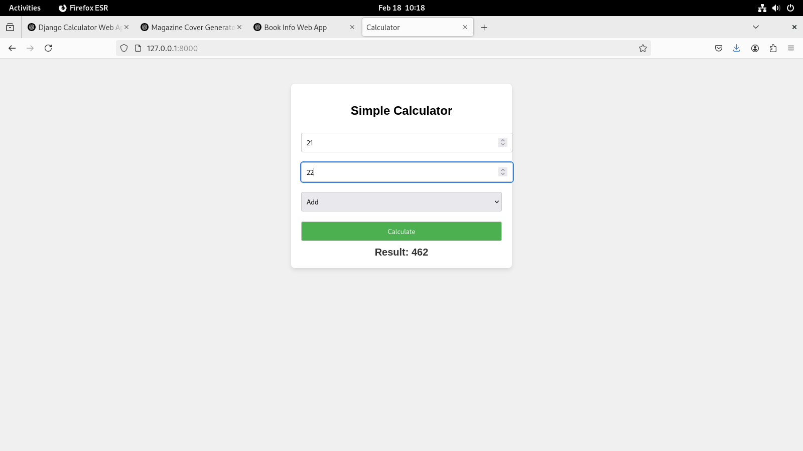
Q2 Develop a simple web form that generates the front cover for a magazine. The
form should provide the options for selecting the image, background color,
changing font size, color etc. Input messages must be taken from the user so
as to display it on the front cover with legible font family and font size. The
front cover developed should be proportionate to the web page size. Place the
css files inside static folder.
cover_form.html
{% load static %}
<!DOCTYPE html>
<html lang="en">
<head>
<meta charset="UTF-8">
<meta name="viewport" content="width=device-width, initial-scale=1.0">
<title>Magazine Cover Generator</title>
<link rel="stylesheet" href="{% static 'css/styles.css' %}">
</head>
<body>

<div class="form-container">
<h1>Generate Magazine Front Cover</h1>
<form method="post">
{% csrf_token %}
<label for="title">Magazine Title:</label>
<input type="text" id="title" name="title" required><br><br>
<label for="subtitle">Subtitle:</label>
<input type="text" id="subtitle" name="subtitle" required><br><br>
<label for="background_color">Background Color:</label>
<input type="color" id="background_color" name="background_color"><br><br>
<label for="font_size">Font Size:</label>
<input type="range" id="font_size" name="font_size" min="10" max="100" value="36"><br><br>
<label for="font_color">Font Color:</label>
<input type="color" id="font_color" name="font_color"><br><br>
<label for="image_url">Cover Image URL:</label>
<input type="url" id="image_url" name="image_url" required><br><br>
<button type="submit">Generate Cover</button>
</form>
</div>

<div class="cover-preview" style="background-color: {{ background_color }};">
<img src="{{ image_url }}" alt="Cover Image" class="cover-image">
<h2 style="color: {{ font_color }}; font-size: {{ font_size }}px;">{{ title }}</h2>
<p style="color: {{ font_color }}; font-size: {{ font_size }}px;">{{ subtitle }}</p>
</div>

</body>
</html>

style.css
/* styles.css */

body {
font-family: Arial, sans-serif;
background-color: #f4f4f4;
text-align: center;
margin: 0;
padding: 0;
}

h1 {
color: #333;
}

.form-container {
margin: 20px;
padding: 20px;
background-color: #fff;
border-radius: 8px;
box-shadow: 0 4px 8px rgba(0, 0, 0, 0.1);
}

form {
max-width: 500px;
margin: auto;
text-align: left;
}

input[type="text"], input[type="color"], input[type="range"], input[type="url"] {
width: 100%;
padding: 8px;
margin: 10px 0;
border-radius: 5px;
border: 1px solid #ccc;
}

button {
padding: 10px 20px;
background-color: #28a745;
color: white;
border: none;
border-radius: 5px;
cursor: pointer;
}

button:hover {
background-color: #218838;
}

.cover-preview {
width: 100%;
max-width: 400px;
margin: 20px auto;
padding: 20px;
border-radius: 8px;
box-shadow: 0 4px 8px rgba(0, 0, 0, 0.1);
}

.cover-preview img {
width: 100%;
height: auto;
border-radius: 5px;
}

.cover-preview h2, .cover-preview p {
margin: 10px 0;
}

views.py
from django.shortcuts import render

def cover_form(request):
if request.method == "POST":
# Retrieve form values from the POST request
title = request.POST.get("title")
subtitle = request.POST.get("subtitle")
background_color = request.POST.get("background_color")
font_size = request.POST.get("font_size")
font_color = request.POST.get("font_color")
image_url = request.POST.get("image_url")
context = {
"title": title,
"subtitle": subtitle,
"background_color": background_color,
"font_size": font_size,
"font_color": font_color,
"image_url": image_url,
}
return render(request, "cover_form.html", context)
return render(request, "cover_form.html")

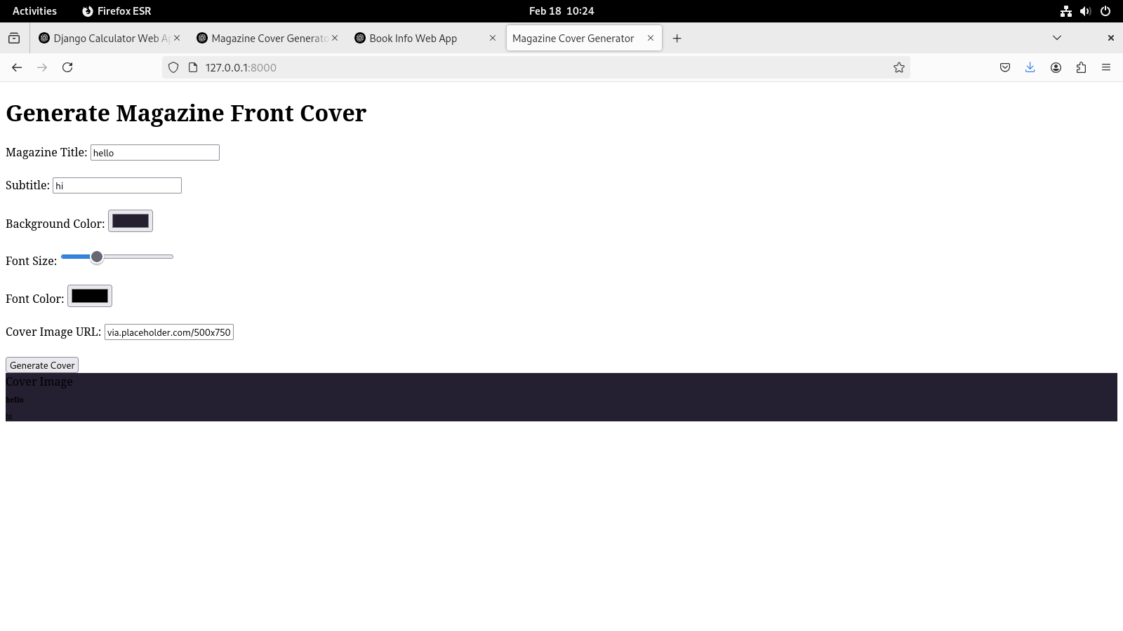
Q3 Design a simple web application to provide information about a book. The
home page of the application should display the cover page of the book along
with three hyperlinks: Metadata, Reviews, Publisher info. Give provision to
revert to home page from any other page.
Home.html
{% load static %}
<!DOCTYPE html>
<html lang="en">
<head>
<meta charset="UTF-8">
<meta name="viewport" content="width=device-width, initial-scale=1.0">
<title>Book Info - Home</title>
<link rel="stylesheet" href="{% static 'style.css' %}">
</head>
<body>
<div class="container">
<header>
<h1>Book Information</h1>
<img src="{% static 'book/cover.jpg' %}" alt="Book Cover" class="book-cover">
</header>

<nav>
<ul>
<li><a href="{% url 'metadata' %}">Metadata</a></li>
<li><a href="{% url 'reviews' %}">Reviews</a></li>
<li><a href="{% url 'publisher_info' %}">Publisher Info</a></li>
</ul>
</nav>
</div>
</body>
</html>

metadata.html
{% load static %}
<!DOCTYPE html>
<html lang="en">
<head>
<meta charset="UTF-8">
<meta name="viewport" content="width=device-width, initial-scale=1.0">
<title>Book Metadata</title>
<link rel="stylesheet" href="{% static 'style.css' %}">
</head>
<body>
<div class="container">
<header>
<h1>Book Metadata</h1>
</header>
<section>
<p><strong>Title:</strong> Decisions</p>
<p><strong>Author:</strong> John Doe</p>
<p><strong>Genre:</strong> Fiction</p>
<p><strong>Publication Year:</strong> 2023</p>
</section>
<footer>
<a href="{% url 'home' %}">Back to Home</a>
</footer>
</div>
</body>
</html>

publisher_info.html
{% load static %}
<!DOCTYPE html>
<html lang="en">
<head>
<meta charset="UTF-8">
<meta name="viewport" content="width=device-width, initial-scale=1.0">
<title>Publisher Info</title>
<link rel="stylesheet" href="{% static 'style.css' %}">
</head>
<body>
<div class="container">
<header>
<h1>Publisher Info</h1>
</header>
<section>
<p><strong>Publisher:</strong> ABC Publishing House</p>
<p><strong>Location:</strong> New York, USA</p>
</section>
<footer>
<a href="{% url 'home' %}">Back to Home</a>
</footer>
</div>
</body>
</html>

reviews.html
{% load static %}
<!DOCTYPE html>
<html lang="en">
<head>
<meta charset="UTF-8">
<meta name="viewport" content="width=device-width, initial-scale=1.0">
<title>Book Reviews</title>
<link rel="stylesheet" href="{% static 'style.css' %}">
</head>
<body>
<div class="container">
<header>
<h1>Book Reviews</h1>
</header>
<section>
<p><strong>Review 1:</strong> Amazing book! A must-read.</p>
<p><strong>Review 2:</strong> Quite an interesting storyline and deep characters.</p>
</section>
<footer>
<a href="{% url 'home' %}">Back to Home</a>
</footer>
</div>
</body>
</html>

style.css
body {
font-family: Arial, sans-serif;
background-color: #f4f4f4;
margin: 0;
padding: 0;
}

.container {
width: 80%;
margin: 0 auto;
padding: 20px;
text-align: center;
}

header h1 {
font-size: 2rem;
}

.book-cover {
width: 200px;
height: auto;
margin: 20px;
}

nav ul {
list-style: none;
padding: 0;
}

nav ul li {
display: inline;
margin: 10px;
}

nav ul li a {
text-decoration: none;
font-size: 1.2rem;
color: #333;
}

footer a {
text-decoration: none;
font-size: 1rem;
color: #007bff;
}

views.py
from django.shortcuts import render

# Home page view
def home(request):
return render(request, 'home.html')

# Metadata page view
def metadata(request):
return render(request, 'metadata.html')

# Reviews page view
def reviews(request):
return render(request, 'reviews.html')

# Publisher info page view
def publisher_info(request):
return render(request, 'publisher_info.html')
