Q1 Write a JavaScript program to perform an online quiz
<!DOCTYPE html>
<html lang="en">
<head>
<meta charset="UTF-8">
<meta name="viewport" content="width=device-width, initial-scale=1.0">
<title>Online Quiz</title>
<!-- <style>
body {
font-family: Arial, sans-serif;
background-color: #f4f4f4;
text-align: center;
}
#quiz-container {
max-width: 600px;
margin: 20px auto;
padding: 20px;
background-color: #fff;
border-radius: 8px;
box-shadow: 0 0 10px rgba(0, 0, 0, 0.1);
}
#result {
font-weight: bold;
margin-top: 20px;
}
</style> -->
</head>
<body>
<div id="quiz-container">
<h2>Online Quiz</h2>
<p id="question"></p>
<div id="options-container"></div>
<button onclick="nextQuestion()">Next</button>
<p id="result"></p>
</div>
<script>
const quizData = [
{
question: "What is the capital of France?",
options: ["Berlin", "Madrid", "Paris", "Rome"],
correctAnswer: "Paris"
},
{
question: "Which planet is known as the Red Planet?",
options: ["Earth", "Mars", "Venus", "Jupiter"],
correctAnswer: "Mars"
},
{
question: "What is the largest mammal?",
options: ["Elephant", "Blue Whale", "Giraffe", "Lion"],
correctAnswer: "Blue Whale"
}
];
let currQuesIdx = 0;
let score = 0;
function dispQues() {
const currentQuestion = quizData[currQuesIdx];
const quesEle = document.getElementById("question");
const optCont = document.getElementById("options-container");
quesEle.textContent = currentQuestion.question;
optCont.innerHTML = "";
currentQuestion.options.forEach((option, index) => {
const optionElement = document.createElement("button");
optionElement.textContent = option;
optionElement.onclick = () => checkAnswer(option);
optCont.appendChild(optionElement);
});
}
function checkAnswer(selAns) {
const currentQuestion = quizData[currQuesIdx];
if (selAns === currentQuestion.correctAnswer) {
score++;
}
if (currQuesIdx < quizData.length - 1) {
currQuesIdx++;
dispQues();
} else {
dispRes();
}
}
function dispRes() {
const resEle = document.getElementById("result");
resEle.textContent = `Your score: ${score} out of ${quizData.length}`;
}
function nextQuestion() {
if (currQuesIdx < quizData.length - 1) {
currQuesIdx++;
dispQues();
} else {
dispRes();
}
}
dispQues();
</script>
</body>
</html>
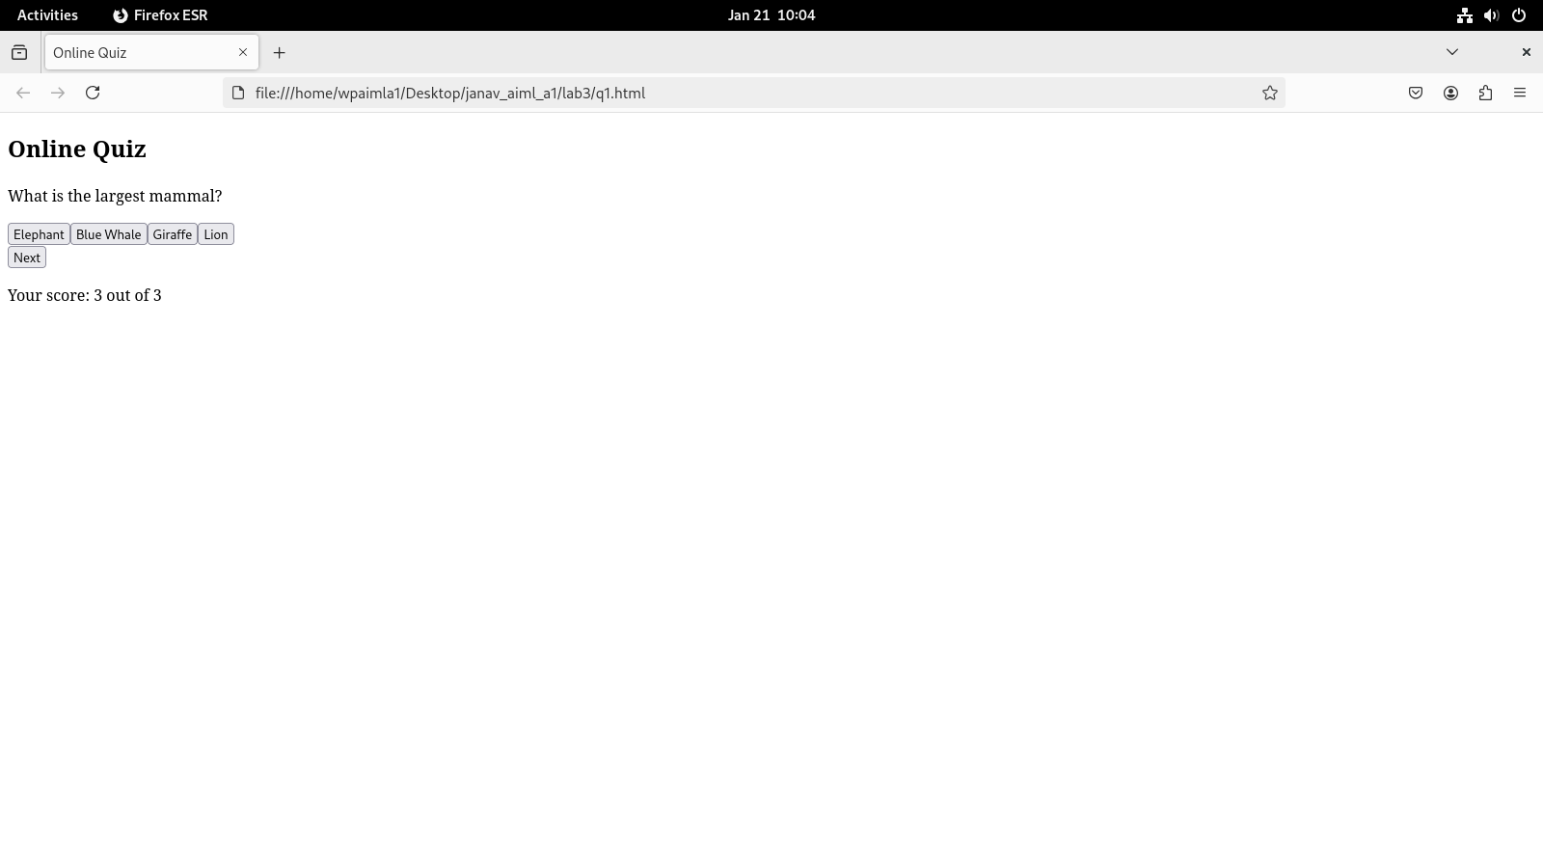

Q2 Write a JavaScript program to Wish a user at different hours of a day. Use
appropriate dialog boxes for wishing the user. Display the dynamic clock on the
web page. Make use of CSS and HTML5 elements for creative and attractive
design.
<!DOCTYPE html>
<html lang="en">
<head>
<meta charset="UTF-8">
<meta name="viewport" content="width=device-width, initial-scale=1.0">
<title>Greetings and Clock</title>
<style>
body {
font-family: 'Arial', sans-serif;
text-align: center;
margin: 20px;
background-color: #f4f4f4;
}
.clock-container {
position: absolute;
top: 45%;
left: 50%;
transform: translate(-50%, -50%);
}
#clock {
font-size: 24px;
margin-top: 20px;
color: #07e29d;
}
#greeting {
font-size: 18px;
margin-top: 20px;
color: #2153e8;
}
</style>
</head>
<body>
<div class="clock-container">
<h2 style="color: #d41078">Dynamic Clock and Greetings</h2>
<div id="clock"></div>
<div id="greeting"></div>
</div>
<script>
function updateClock() {
const now = new Date();
const hours = now.getHours();
const minutes = now.getMinutes();
const seconds = now.getSeconds();
const formattedTime = `${formatDigit(hours)}:${formatDigit(minutes)}:${formatDigit(seconds)}`;
document.getElementById("clock").textContent = formattedTime;
let greeting;
if (hours <= 6 || hours >= 22) {
greeting = 'Good Night';
} else if (hours > 6 && hours < 12) {
greeting = 'Good Morning!';
} else if (hours < 16) {
greeting = 'Good Afternoon!';
} else if (hours < 22) {
greeting = 'Good Evening!';
}
document.getElementById("greeting").textContent = greeting;
setTimeout(updateClock, 1000);
}
function formatDigit(digit) {
return digit < 10 ? `0${digit}` : digit;
}
updateClock();
</script>
</body>
</html>
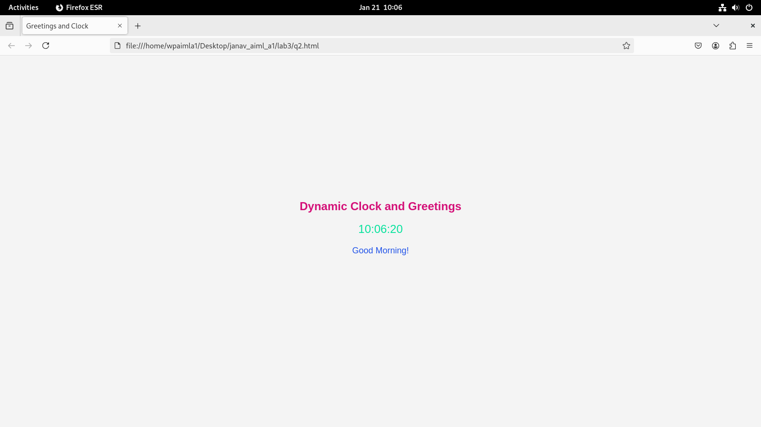

Q3 Write the java script program to display the grade [A, B,C,D] based on the marks
entered by student(take the input into text boxes). Enter the marks of 4 subjects and
calculate the average( using button). If the avg>90 then A, avg>80 then B, if avg>70
then C, if avg>60 then D.
<!DOCTYPE html>
<html lang="en">
<head>
<meta charset="UTF-8">
<meta name="viewport" content="width=device-width, initial-scale=1.0">
<title>Grade Calculator</title>
<style>
body{
font-family: Arial, sans-serif;
text-align: center;
margin: 20px;
}
label{
display: block;
padding: 5px;
}
button{
margin-top: 5px;
}
</style>
</head>
<body>
<h2>Enter your marks of the four subjects</h2>
<label for="subject1">
subject1:
<input type="text" id="subject1" required>
</label>
<label for="subject2">
subject2:
<input type="text" id="subject2" required>
</label>
<label for="subject3">
subject3:
<input type="text" id="subject3" required>
</label>
<label for="subject4">
subject4:
<input type="text" id="subject4" required>
</label>
<button onclick="calculateGrade()">Calculate Grade</button>
<p id="result"></p>
<script>
function calculateGrade()
{
const s1=parseFloat(document.getElementById("subject1").value)||0;
const s2=parseFloat(document.getElementById("subject2").value)||0;
const s3=parseFloat(document.getElementById("subject3").value)||0;
const s4=parseFloat(document.getElementById("subject4").value)||0;
const avg=(s1+s2+s3+s4)/4;
let garde;
if (avg > 90) {
grade = "A";
} else if (avg > 80) {
grade = "B";
} else if (avg > 70) {
grade = "C";
} else if (avg > 60) {
grade = "D";
} else {
grade = "F";
}
const res=document.getElementById("result");
res.textContent = `Your average is ${avg.toFixed(2)}. Your grade is ${grade}.`;
}
</script>
</body>
</html>
