Q1 Create a Register page and Success page with the following requirements:
i.
Register page should contain four input TextBoxes for UserName, Password,
Email id and Contact Number and also a button to submit. Make the username as
compulsory field and other fields as optional.
ii.
On button click, Success page is displayed with message "Welcome
{UserName}" and also his Email and Contact Number has to be displayed.
iii. Use secure technique to send details to the Success page (Hint: use csrftoken) 4)
Design a website with two pages.

views.py
# registration/views.py
from django.shortcuts import render, redirect
from .forms import RegisterForm
from django.http import HttpResponse

def register(request):
if request.method == 'POST':
form = RegisterForm(request.POST)
if form.is_valid():
username = form.cleaned_data['username']
email = form.cleaned_data['email']
contact = form.cleaned_data['contact']
# Redirect to success page with user data as query parameters
return redirect(f"/success/?username={username}&email={email}&contact={contact}")
else:
form = RegisterForm()
return render(request, 'registration/register.html', {'form': form})

def success(request):
# Retrieve user data from query parameters
username = request.GET.get('username')
email = request.GET.get('email')
contact = request.GET.get('contact')
# Render the success page with user details
return render(request, 'registration/success.html', {'username': username, 'email': email, 'contact': contact})

register.html

# registration/views.py
from django.shortcuts import render, redirect
from .forms import RegisterForm
from django.http import HttpResponse

def register(request):
if request.method == 'POST':
form = RegisterForm(request.POST)
if form.is_valid():
username = form.cleaned_data['username']
email = form.cleaned_data['email']
contact = form.cleaned_data['contact']
# Redirect to success page with user data as query parameters
return redirect(f"/success/?username={username}&email={email}&contact={contact}")
else:
form = RegisterForm()
return render(request, 'registration/register.html', {'form': form})

def success(request):
# Retrieve user data from query parameters
username = request.GET.get('username')
email = request.GET.get('email')
contact = request.GET.get('contact')
# Render the success page with user details
return render(request, 'registration/success.html', {'username': username, 'email': email, 'contact': contact})

success.html

{% load static %}
<!DOCTYPE html>
<html lang="en">
<head>
<meta charset="UTF-8">
<meta name="viewport" content="width=device-width, initial-scale=1.0">
<title>Success</title>
<link rel="stylesheet" href="{% static 'css/styles.css' %}">
</head>
<body>
<div class="container">
<h1>Welcome {{ username }}!</h1>
<p>Email: {{ email }}</p>
<p>Contact Number: {{ contact }}</p>
<a href="/">Go back to Register Page</a>
</div>
</body>
</html>

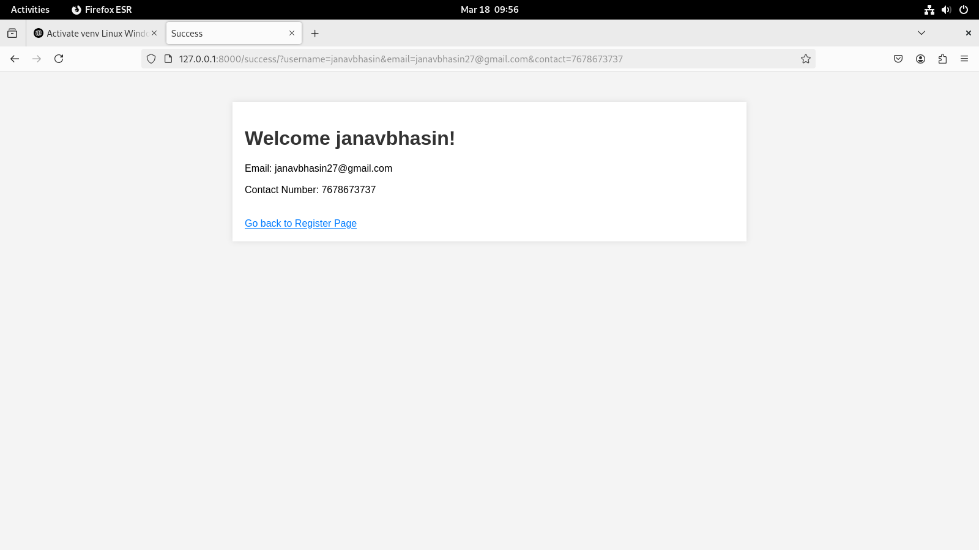
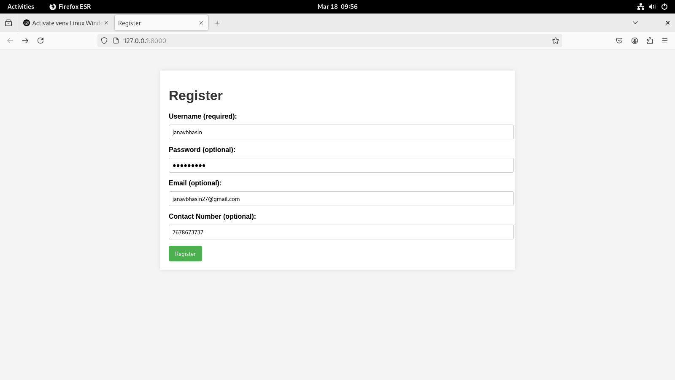

Q2 “How is the book ASP.NET with c# by Vipul Prakashan?” Give the user three choice : i) Good
ii) Satisfactory iii) Bad. Provide a VOTE button. After user votes, present the result in
percentage using labels next to the choices

views.py

# voting/views.py
from django.shortcuts import render
from .models import BookVote

def vote(request):
if request.method == 'POST':
choice = request.POST.get('vote_choice')
if choice:
# Update the vote count for the selected choice
vote = BookVote.objects.get(choice=choice)
vote.count += 1
vote.save()

# Fetch the vote counts for each choice
total_votes = sum(vote.count for vote in BookVote.objects.all())
if total_votes > 0:
good_percentage = (BookVote.objects.get(choice='Good').count / total_votes) * 100
satisfactory_percentage = (BookVote.objects.get(choice='Satisfactory').count / total_votes) * 100
bad_percentage = (BookVote.objects.get(choice='Bad').count / total_votes) * 100
else:
good_percentage = satisfactory_percentage = bad_percentage = 0

context = {
'good_percentage': good_percentage,
'satisfactory_percentage': satisfactory_percentage,
'bad_percentage': bad_percentage,
'total_votes': total_votes,
}
return render(request, 'voting/vote.html', context)

vote.html

# voting/views.py
from django.shortcuts import render
from .models import BookVote

def vote(request):
if request.method == 'POST':
choice = request.POST.get('vote_choice')
if choice:
# Update the vote count for the selected choice
vote = BookVote.objects.get(choice=choice)
vote.count += 1
vote.save()

# Fetch the vote counts for each choice
total_votes = sum(vote.count for vote in BookVote.objects.all())
if total_votes > 0:
good_percentage = (BookVote.objects.get(choice='Good').count / total_votes) * 100
satisfactory_percentage = (BookVote.objects.get(choice='Satisfactory').count / total_votes) * 100
bad_percentage = (BookVote.objects.get(choice='Bad').count / total_votes) * 100
else:
good_percentage = satisfactory_percentage = bad_percentage = 0

context = {
'good_percentage': good_percentage,
'satisfactory_percentage': satisfactory_percentage,
'bad_percentage': bad_percentage,
'total_votes': total_votes,
}
return render(request, 'voting/vote.html', context)

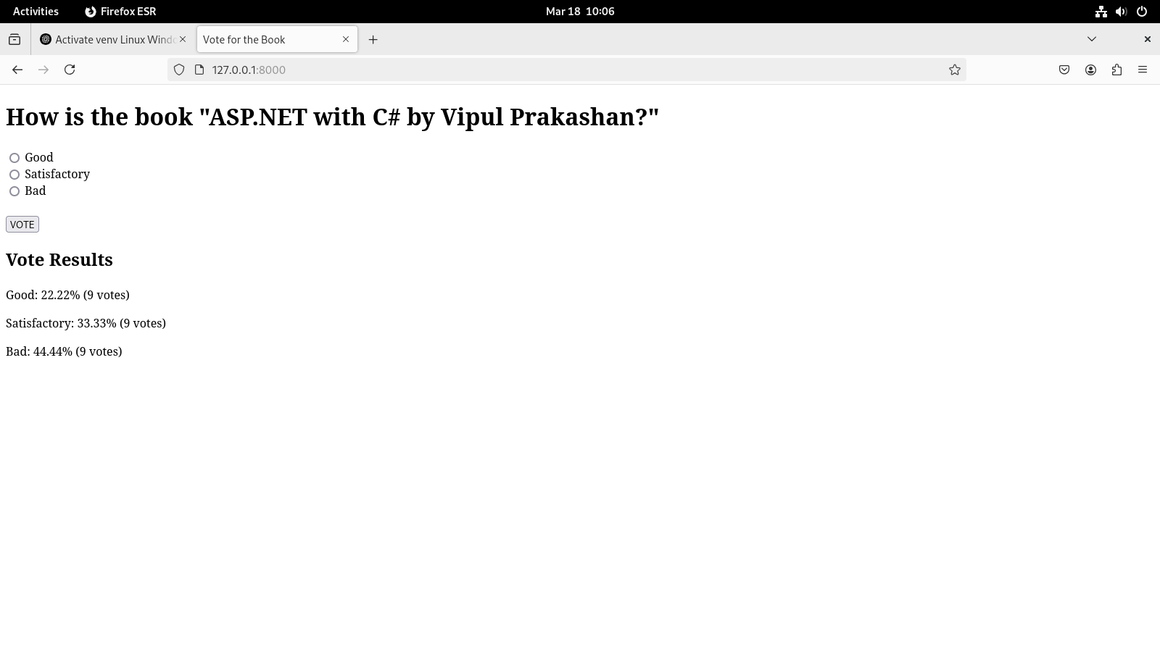
Q3 Create a website with two pages. Page 1 has two TextBoxes (name and total marks)
and one ‘Calculate’ Button as shown in the figure. On clicking the ‘Calculate’ Button,
CGPA (total marks/50) along with the name should be displayed in the Page 2. Use
Django sessions to store the information.

views.py

# calculate/views.py
from django.shortcuts import render, redirect

def page1(request):
if request.method == 'POST':
name = request.POST.get('name')
total_marks = request.POST.get('total_marks')

if name and total_marks:
# Store data in session
request.session['name'] = name
request.session['total_marks'] = total_marks
return redirect('page2') # Redirect to page 2 to show result
return render(request, 'calculate/page1.html')

def page2(request):
name = request.session.get('name')
total_marks = request.session.get('total_marks')

if name and total_marks:
try:
total_marks = float(total_marks) # Ensure marks are numeric
cgpa = total_marks / 50 # CGPA calculation
except ValueError:
cgpa = None
else:
cgpa = None

return render(request, 'calculate/page2.html', {'name': name, 'cgpa': cgpa})

page1.html

<!-- calculate/templates/calculate/page1.html -->
<!DOCTYPE html>
<html lang="en">
<head>
<meta charset="UTF-8">
<meta name="viewport" content="width=device-width, initial-scale=1.0">
<title>Page 1 - Calculate CGPA</title>
</head>
<body>
<h1>Enter your name and total marks</h1>
<form method="POST">
{% csrf_token %}
<label for="name">Name:</label>
<input type="text" id="name" name="name" required><br><br>

<label for="total_marks">Total Marks:</label>
<input type="text" id="total_marks" name="total_marks" required><br><br>

<button type="submit">Calculate</button>
</form>
</body>
</html>

page2.html

<!-- calculate/templates/calculate/page2.html -->
<!DOCTYPE html>
<html lang="en">
<head>
<meta charset="UTF-8">
<meta name="viewport" content="width=device-width, initial-scale=1.0">
<title>Page 2 - Result</title>
</head>
<body>
<h1>CGPA Result</h1>

{% if name and cgpa %}
<p>Hello, {{ name }}!</p>
<p>Your CGPA is: {{ cgpa|floatformat:2 }}</p>
{% else %}
<p>Invalid data. Please try again.</p>
{% endif %}

<a href="{% url 'page1' %}">Go Back to Page 1</a>
</body>
</html>

