Q1
Develop a web application using Django framework to demonstrate the transfer of
multiple parameters between web pages. User should be presented with a dropdown
list containing car manufacturers, a text box which takes model name of the
manufacturer and a submit button. On submitting the web page, the user is forwarded
to a new page. This new page should display the selected car manufacturer name and
the model name.

Index.html

<!DOCTYPE html>
<html>
<head>
<title>Select Car Manufacturer</title>
</head>
<body>
<h1>Select a Car Manufacturer</h1>
<form method="post">
{% csrf_token %}
<label for="manufacturer">Car Manufacturer:</label>
<select name="manufacturer" id="manufacturer">
<option value="Toyota">Toyota</option>
<option value="BMW">BMW</option>
<option value="Mercedes">Mercedes</option>
<option value="Honda">Honda</option>
</select><br><br>

<label for="model_name">Car Model:</label>
<input type="text" id="model_name" name="model_name" required><br><br>

<button type="submit">Submit</button>
</form>
</body>
</html>

result.html

<!DOCTYPE html>
<html>
<head>
<title>Car Model Information</title>
</head>
<body>
<h1>Car Information</h1>
<p><strong>Manufacturer:</strong> {{ manufacturer }}</p>
<p><strong>Model Name:</strong> {{ model_name }}</p>
<br>
<a href="{% url 'index' %}">Go Back</a>
</body>
</html>

views.py

from django.shortcuts import render

# View to display the form
def index(request):
if request.method == 'POST':
manufacturer = request.POST.get('manufacturer')
model_name = request.POST.get('model_name')
return render(request, 'car_app/result.html', {'manufacturer': manufacturer, 'model_name': model_name})
return render(request, 'car_app/index.html')

# View to display the result
def result(request):
manufacturer = request.GET.get('manufacturer')
model_name = request.GET.get('model_name')
return render(request, 'car_app/result.html', {'manufacturer': manufacturer, 'model_name': model_name})

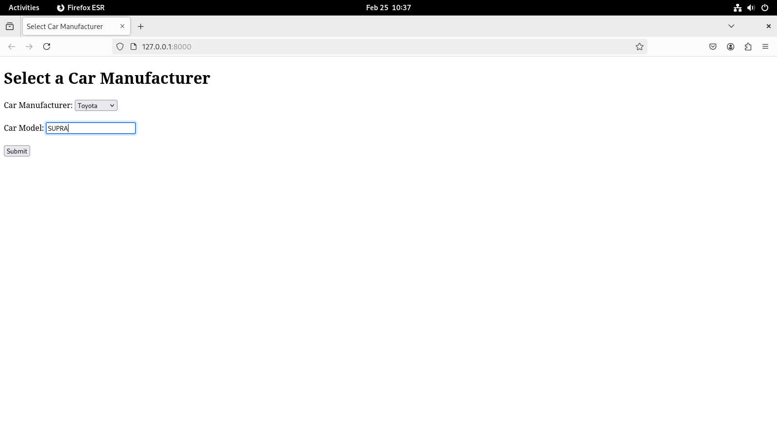

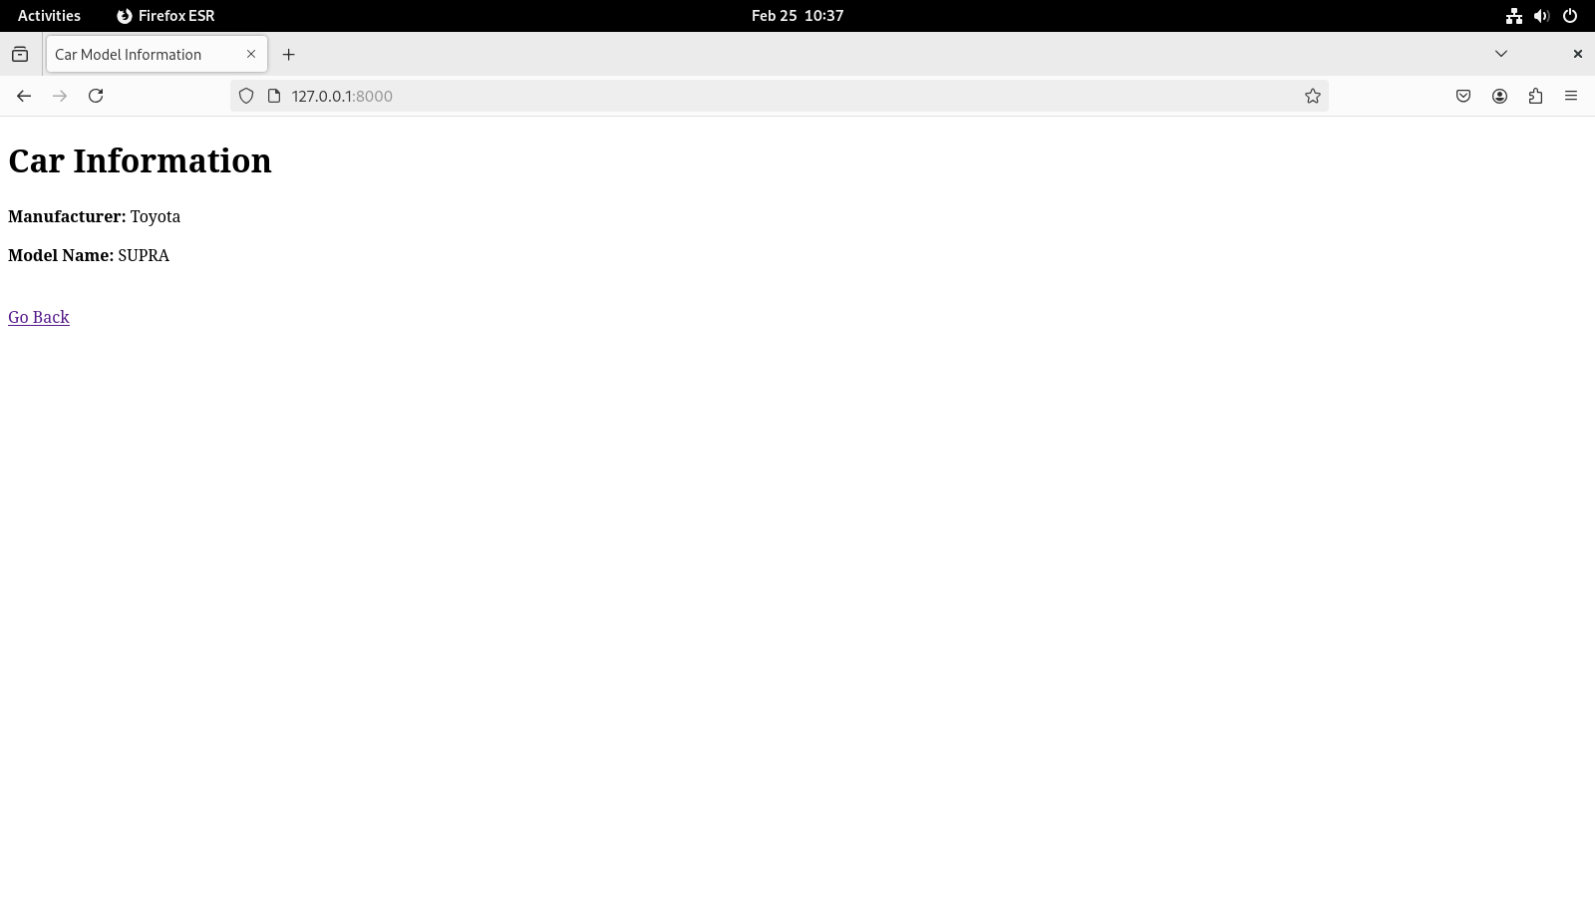
Q2
Create a page firstPage.html with two TextBoxes [Name, Roll], DropDownList
[Subjects], and a button. Create another page secondPage.html with a label and a
button. When the user clicks the button in first Page, he should be sent to the second
page and display the contents passed from first page in the label. The button in second
page should navigate the user back to firstPage. Use Django sessions to transfer
information.

FirstPage.html

<!DOCTYPE html>
<html lang="en">
<head>
<meta charset="UTF-8">
<meta name="viewport" content="width=device-width, initial-scale=1.0">
<title>First Page</title>
</head>
<body>
<h1>Enter Your Information</h1>
<form method="POST">
{% csrf_token %}
<label for="name">Name:</label>
<input type="text" id="name" name="name" required><br><br>

<label for="roll">Roll Number:</label>
<input type="text" id="roll" name="roll" required><br><br>

<label for="subject">Select Subject:</label>
<select id="subject" name="subject" required>
{% for subject in subjects %}
<option value="{{ subject }}">{{ subject }}</option>
{% endfor %}
</select><br><br>

<button type="submit">Submit</button>
</form>
</body>
</html>

secondPage.html

<!DOCTYPE html>
<html lang="en">
<head>
<meta charset="UTF-8">
<meta name="viewport" content="width=device-width, initial-scale=1.0">
<title>Second Page</title>
</head>
<body>
<h1>Information Submitted</h1>
<p><strong>Name:</strong> {{ name }}</p>
<p><strong>Roll Number:</strong> {{ roll }}</p>
<p><strong>Subject:</strong> {{ subject }}</p><br>

<a href="{% url 'first_page' %}"><button>Go Back</button></a>
</body>
</html>

views.py

from django.shortcuts import render, redirect
from django.http import HttpResponse

# First page to collect user info
def first_page(request):
subjects = ['Math', 'Physics', 'Chemistry', 'Biology', 'History', 'Literature', 'Philosophy', 'Psychology', 'Business Management', 'Accounting']

if request.method == 'POST':
# Save form data to session
name = request.POST.get('name')
roll = request.POST.get('roll')
subject = request.POST.get('subject')

# Store the data in session
request.session['name'] = name
request.session['roll'] = roll
request.session['subject'] = subject

# Redirect to second page
return redirect('second_page')

return render(request, 'firstPage.html', {'subjects': subjects})

# Second page to display the info
def second_page(request):
# Get the data from the session
name = request.session.get('name', 'N/A')
roll = request.session.get('roll', 'N/A')
subject = request.session.get('subject', 'N/A')

return render(request, 'secondPage.html', {
'name': name,
'roll': roll,
'subject': subject
})

