Design the student bio-data form using button, label, textbox, radio button, table and
checkbox using CSS.
<!DOCTYPE html>
<html>
<head>
<title>Student Bio-Data</title>
<meta charset="utf-8">
<meta name="viewport" content="width=device-width, initial-scale=1">
<link rel="stylesheet" href="https://maxcdn.bootstrapcdn.com/bootstrap/4.5.2/css/bootstrap.min.css">
<script src="https://ajax.googleapis.com/ajax/libs/jquery/3.5.1/jquery.min.js"></script>
<script src="https://cdnjs.cloudflare.com/ajax/libs/popper.js/1.16.0/umd/popper.min.js"></script>
<script src="https://maxcdn.bootstrapcdn.com/bootstrap/4.5.2/js/bootstrap.min.js"></script>
</head>
<body>
<h3>Student Bio-Data</h3>
<div class="container">
<form>
<div class="form-group">
<label for="inputname1">Please Enter Your Name</label>
<input type="text" class="form-control" id="inputname1" placeholder="eg. Janav Bhasin">
</div>
<div class="form-group">
<label for="inputreg1">Please Enter Your Registration Number</label>
<input type="text" class="form-control" id="inputreg1" placeholder="eg. 220962049">
</div>
<div class="form-check">
<input type="checkbox" class="form-check-input" id="confirmDetails">
<label class="form-check-label" for="confirmDetails">Please Tick The Checkbox to confirm your details</label>
</div>
<button type="submit" class="btn btn-primary">Submit</button>
</form><br><br>
<p class="font-weight-bold">Choices for choosing an Elective :</p> <br> <br>
<div class="table-responsive col-lg-8 col-lg-offset-2 col-md-10 col-md-offset-1">
<table class="table table-striped">
<tbody>
<tr>
<th>Field of Study</th>
<th>Elective</th>
<th>Are you choosing this Open-Elective ?</th>
</tr>
<tr>
<td>Finance</td>
<td>Financial Technology</td>
<td>
<input type="radio" name="radios1" id="radio1" />
<label for="radio1">Yes</label>
<input type="radio" name="radios1" id="radio2" />
<label for="radio2">No</label>
</td>
</tr>
<tr>
<td>Computer Science</td>
<td>Big Data Analytics</td>
<td>
<input type="radio" name="radios2" id="radio1" />
<label for="radio1">Yes</label>
<input type="radio" name="radios2" id="radio2" />
<label for="radio2">No</label>
</td>
</tr>
</tbody>
</table>
</div>
</div>
</body>
</html>

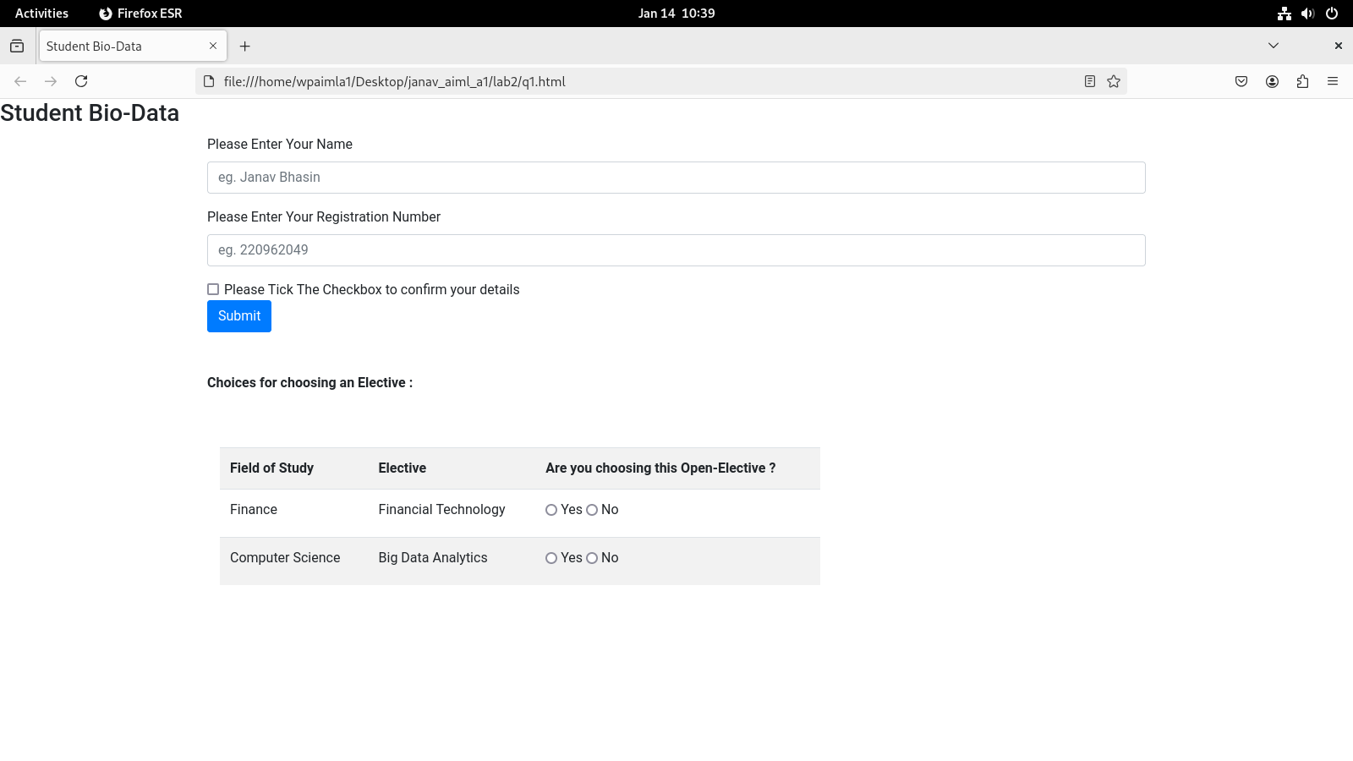

Create a web page using bootstrap as mentioned. Divide the page in to 2 parts top and
bottom, then divide the bottom into 3 parts and design each top and bottom part using
different input groups, input, badges, buttons and button groups. Make the design more
attractive using bootstrap.

<!DOCTYPE html>
<html lang="en">
<head>
<meta charset="UTF-8">
<meta name="viewport" content="width=device-width, initial-scale=1.0">
<title>Form with Input Groups, Buttons, Badges</title>
<link rel="stylesheet" href="https://maxcdn.bootstrapcdn.com/bootstrap/4.5.2/css/bootstrap.min.css">
<style>
.container {
height: 100vh;
display: flex;
flex-direction: column;
}
.top {
flex: 1;
background-color: lightblue;
padding: 20px;
}
.bottom {
flex: 1;
display: flex;
flex-direction: row;
}
.left, .middle, .right {
flex: 1;
padding: 20px;
}
.left {
background-color: lightgreen;
}
.middle {
background-color: lightyellow;
}
.right {
background-color: lightcoral;
}
</style>
</head>
<body>

<div class="container">
<div class="top">
<h2>Top Section with Inputs and Buttons</h2>
<form>
<div class="form-group">
<label for="emailInput">Email address</label>
<div class="input-group mb-3">
<div class="input-group-prepend">
<span class="input-group-text">@</span>
</div>
<input type="email" class="form-control" id="emailInput" placeholder="Enter email">
</div>
</div>
<div class="form-group">
<label for="usernameInput">Username</label>
<div class="input-group mb-3">
<input type="text" class="form-control" id="usernameInput" placeholder="Enter username">
<div class="input-group-append">
<span class="input-group-text">.com</span>
</div>
</div>
</div>
<div class="form-group">
<label>Button Group</label>
<div class="btn-group" role="group" aria-label="Basic example">
<button type="button" class="btn btn-secondary">Left</button>
<button type="button" class="btn btn-secondary">Middle</button>
<button type="button" class="btn btn-secondary">Right</button>
</div>
</div>
<div class="form-group">
<label>Notifications</label>
<button class="btn btn-info">
Notifications <span class="badge badge-light">4</span>
</button>
</div>
<button type="submit" class="btn btn-success">Submit</button>
</form>
</div>
<div class="bottom">
<div class="left">
<h3>Left Section</h3>
<p>This is the left section of the bottom half.</p>
<div class="input-group mb-3">
<input type="text" class="form-control" placeholder="Search left...">
<div class="input-group-append">
<button class="btn btn-primary" type="button">Search</button>
</div>
</div>
</div>
<div class="middle">
<h3>Middle Section</h3>
<p>This is the middle section of the bottom half.</p>
<div class="input-group mb-3">
<input type="text" class="form-control" placeholder="Search middle...">
<div class="input-group-append">
<button class="btn btn-secondary" type="button">
Search <span class="badge badge-light">3</span>
</button>
</div>
</div>
</div>
<div class="right">
<h3>Right Section</h3>
<p>This is the right section of the bottom half.</p>
<div class="input-group mb-3">
<input type="text" class="form-control" placeholder="Search right...">
<div class="input-group-append">
<button class="btn btn-success" type="button">
Search <span class="badge badge-light">5</span>
</button>
</div>
</div>
</div>
</div>
</div>

<script src="https://ajax.googleapis.com/ajax/libs/jquery/3.5.1/jquery.min.js"></script>
<script src="https://cdnjs.cloudflare.com/ajax/libs/popper.js/1.16.0/umd/popper.min.js"></script>
<script src="https://maxcdn.bootstrapcdn.com/bootstrap/4.5.2/js/bootstrap.min.js"></script>

</body>
</html>

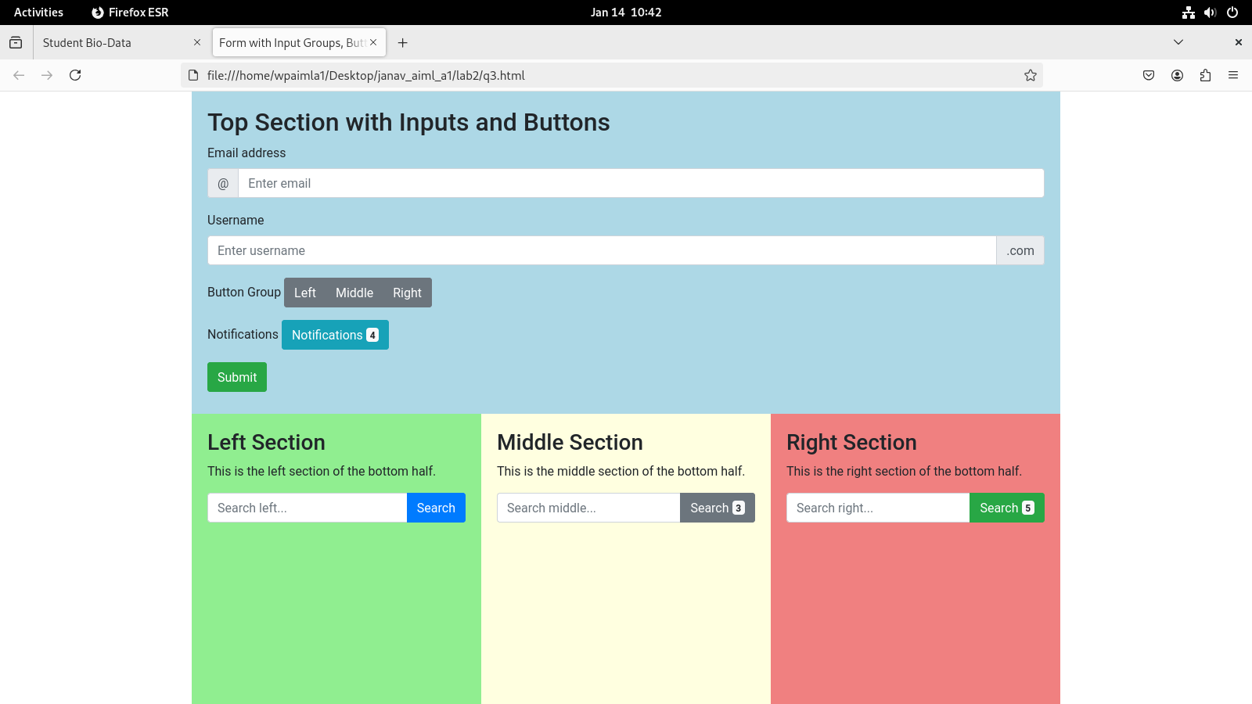

Design your class timetable using bootstrap table and carousel.
<!DOCTYPE html>
<html lang="en" xmlns="http://www.w3.org/1999/xhtml">
<head>
<meta charset="utf-8" />
<meta name="viewport" content="width=device-width, initial-scale=1" />
<title>CSE AIML-A1</title>
<link rel="stylesheet" href="https://maxcdn.bootstrapcdn.com/bootstrap/4.4.1/css/bootstrap.min.css">
<script src="https://ajax.googleapis.com/ajax/libs/jquery/3.4.1/jquery.min.js"></script>
<script src="https://cdnjs.cloudflare.com/ajax/libs/popper.js/1.16.0/umd/popper.min.js"></script>
<script src="https://maxcdn.bootstrapcdn.com/bootstrap/4.4.1/js/bootstrap.min.js"></script>
<link rel="stylesheet" href="https://maxcdn.bootstrapcdn.com/bootstrap/3.3.7/css/bootstrap-theme.min.css" integrity="sha384-rHyoN1iRsVXV4nD0JutlnGaslCJuC7uwjduW9SVrLvRYooPp2bWYgmgJQIXwl/Sp" crossorigin="anonymous"/>
<script src="https://maxcdn.bootstrapcdn.com/bootstrap/3.3.7/js/bootstrap.min.js" integrity="sha384-Tc5IQib027qvyjSMfHjOMaLkfuWVxZxUPnCJA7l2mCWNIpG9mGCD8wGNIcPD7Txa" crossorigin="anonymous"></script>
</head>
<body>
<div class="container text-center">
<div><h1>TimeTable</h1></div>
<div class="row">
<div class="col-md-1 border"></div>
<div class="col-md-1 border" style="background-color: aliceblue;">8:00-9:00</div>
<div class="col-md-1 border" style="background-color: aliceblue;">9:00-10:00</div>
<div class="col-md-1 border" style="background-color: aliceblue;">10:00-10:30</div>
<div class="col-md-1 border" style="background-color: aliceblue;">10:30-11:30</div>
<div class="col-md-1 border" style="background-color: aliceblue;">11:30-12:30</div>
<div class="col-md-1 border" style="background-color: aliceblue;">12:30-1:00</div>
<div class="col-md-1 border" style="background-color: aliceblue;">1:00-2:00</div>
<div class="col-md-1 border" style="background-color: aliceblue;">2:00-3:00</div>
<div class="col-md-1 border" style="background-color: aliceblue;">3:00-3:30</div>
<div class="col-md-1 border" style="background-color: aliceblue;">3:30-4:30</div>
</div>
<div class="row">
<div class="col-md-1 border" style="background-color: orange;">MON</div>
<div class="col-md-1 border">WP</div>
<div class="col-md-1 border">PE-I</div>
<div class="col-md-1 border" style="background-color: lightgray;">Break</div>
<div class="col-md-1 border">EEFM</div>
<div class="col-md-1 border">PE-II</div>
<div class="col-md-2 border" style="background-color: lightgray;">Lunch Break</div>
<div class="col-md-3 border"></div>
</div>
<div class="row">
<div class="col-md-1 border" style="background-color: orange;">TUE</div>
<div class="col-md-1 border"></div>
<div class="col-md-3 border">WP</div>
<div class="col-md-2 border" style="background-color: lightgray;">Lunch Break</div>
<div class="col-md-1 border">EEFM</div>
<div class="col-md-1 border">OE</div>
<div class="col-md-1 border" style="background-color: lightgray;">Break</div>
<div class="col-md-1 border"></div>
</div>
<div class="row">
<div class="col-md-1 border" style="background-color: orange;">WED</div>
<div class="col-md-1 border">EEFM</div>
<div class="col-md-1 border">PE-II</div>
<div class="col-md-1 border" style="background-color: lightgray;">Break</div>
<div class="col-md-1 border">OE</div>
<div class="col-md-1 border">DL</div>
<div class="col-md-2 border" style="background-color: lightgray;">Lunch Break</div>
<div class="col-md-3 border"></div>
</div>
<div class="row">
<div class="col-md-1 border" style="background-color: orange;">THU</div>
<div class="col-md-1 border"></div>
<div class="col-md-3 border">PCAP</div>
<div class="col-md-2 border" style="background-color: lightgray;">Lunch Break</div>
<div class="col-md-1 border">PE-I</div>
<div class="col-md-1 border">DL</div>
<div class="col-md-1 border" style="background-color: lightgray;">Break</div>
<div class="col-md-1 border">PCAP</div>
</div>
<div class="row">
<div class="col-md-1 border" style="background-color: orange;">FRI</div>
<div class="col-md-1 border"></div>
<div class="col-md-1 border">PE-II</div>
<div class="col-md-1 border" style="background-color: lightgray;">Break</div>
<div class="col-md-1 border">PCAP</div>
<div class="col-md-1 border">OE</div>
<div class="col-md-2 border" style="background-color: lightgray;">Lunch Break</div>
<div class="col-md-3 border"></div>
</div>
<div class="row">
<div class="col-md-1 border" style="background-color: orange;">SAT</div>
<div class="col-md-1 border"></div>
<div class="col-md-3 border">PPL</div>
<div class="col-md-2 border" style="background-color: lightgray;">Lunch Break</div>
<div class="col-md-1 border">PE-I</div>
<div class="col-md-1 border">DL</div>
<div class="col-md-1 border" style="background-color: lightgray;">Break</div>
<div class="col-md-1 border">PCAP</div>
</div>
</div>
</body>
</html>
