Q1 Design a web site using Django, which is a website directory – A site containing
links to other websites. A web page has different categories.
• A category table has a name, number of visits, and number of likes.
• A page table refers to a category, has a title, URL, and many views.
Design a form that populates the above database and displays it.
Views.py
from django.shortcuts import render, redirect
from .models import Category, Page
from .forms import CategoryForm, PageForm

def index(request):
categories = Category.objects.all()
return render(request, 'directory/index.html', {'categories': categories})

def category_detail(request, category_id):
category = Category.objects.get(id=category_id)
pages = Page.objects.filter(category=category)
return render(request, 'directory/category_detail.html', {'category': category, 'pages': pages})

def add_category(request):
if request.method == 'POST':
form = CategoryForm(request.POST)
if form.is_valid():
form.save()
return redirect('index')
else:
form = CategoryForm()
return render(request, 'directory/add_category.html', {'form': form})

def add_page(request):
if request.method == 'POST':
form = PageForm(request.POST)
if form.is_valid():
form.save()
return redirect('index')
else:
form = PageForm()
return render(request, 'directory/add_page.html', {'form': form})

add_category.html
<h2>Add Category</h2>
<form method="post">
{% csrf_token %}
{{ form.as_p }}
<button type="submit">Add</button>
</form>

add_page.html
<h2>Add Page</h2>
<form method="post">
{% csrf_token %}
{{ form.as_p }}
<button type="submit">Add</button>
</form>

category_detail.html

<h2>Category: {{ category.name }}</h2>
<ul>
{% for page in pages %}
<li><a href="{{ page.url }}" target="_blank">{{ page.title }}</a> - Views: {{ page.views }}</li>
{% endfor %}
</ul>

index.html

<h1>Website Directory</h1>
<a href="{% url 'add_category' %}">Add Category</a> |
<a href="{% url 'add_page' %}">Add Page</a>
<ul>
{% for category in categories %}
<li><a href="{% url 'category_detail' category.id %}">{{ category.name }}</a> - Visits: {{ category.visits }}, Likes: {{ category.likes }}</li>
{% endfor %}
</ul>

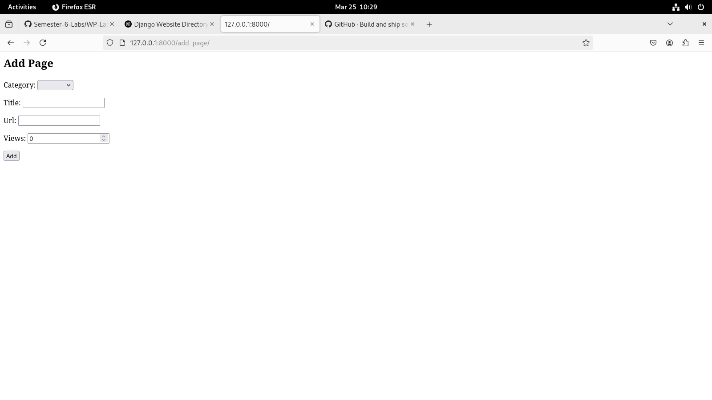
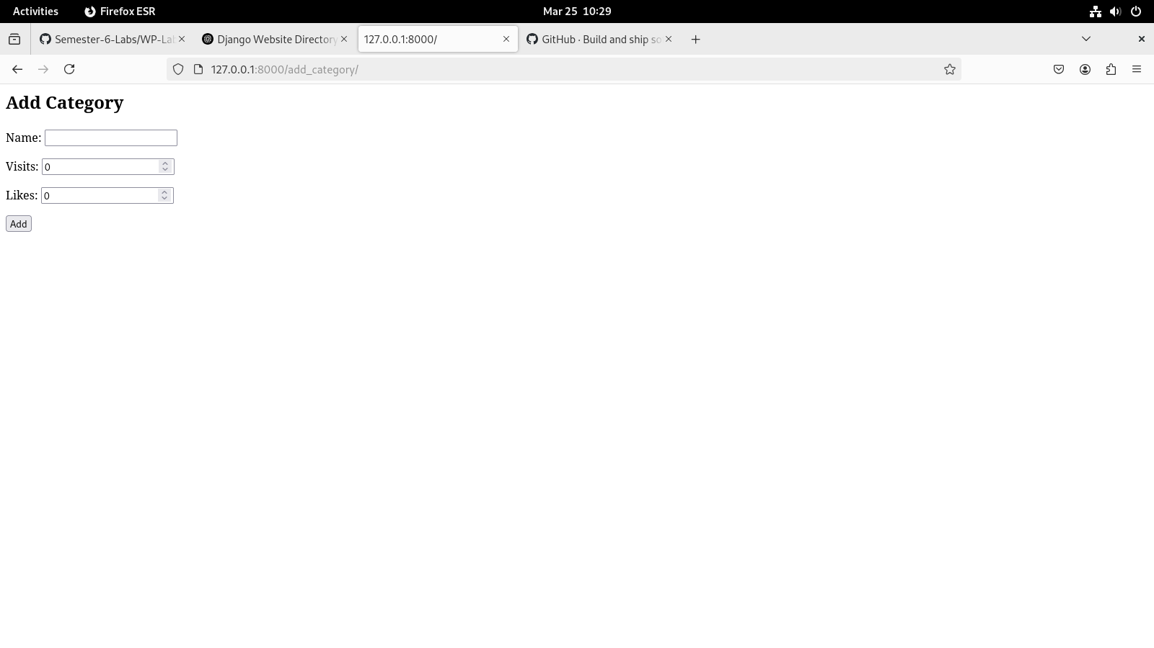
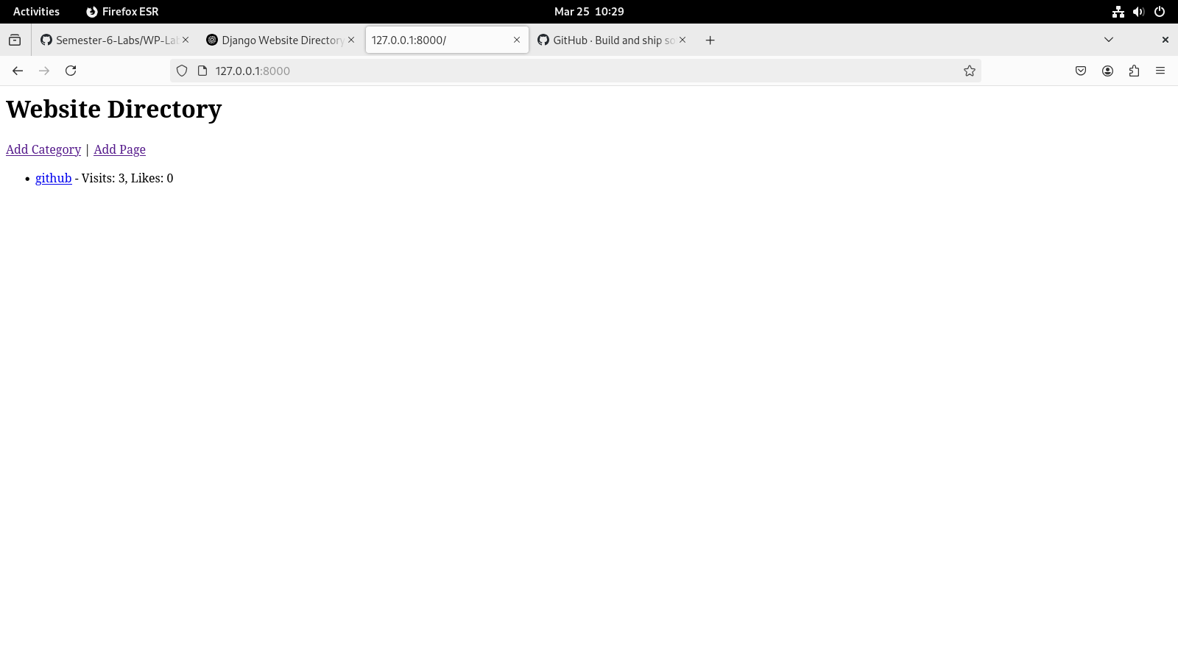
Q2 Consider the following tables:
WORKS(person-name,Company-name,Salary)
LIVES(Person_name, Street, City)
Assume Table data suitably. Design a Django webpage and include an option to
insert data into WORKS table by accepting data from the user using TextBoxes.
Also, include an option to retrieve the names of people who work for a
particular company along with the cities they live in (particular company name
must be accepted from the user).
Views.py

from django.shortcuts import render, redirect
from .forms import WORKSForm, CompanySearchForm
from .models import WORKS, LIVES

def insert_works(request):
if request.method == 'POST':
form = WORKSForm(request.POST)
if form.is_valid():
form.save()
return redirect('insert_works')
else:
form = WORKSForm()
return render(request, 'employee_app/insert_works.html', {'form': form})

def search_employees(request):
results = []
if request.method == 'POST':
form = CompanySearchForm(request.POST)
if form.is_valid():
company = form.cleaned_data['company_name']
results = WORKS.objects.filter(company_name=company).values('person_name')
results = [
{
'person_name': r['person_name'],
'city': LIVES.objects.filter(person_name=r['person_name']).first().city
}
for r in results if LIVES.objects.filter(person_name=r['person_name']).exists()
]
else:
form = CompanySearchForm()
return render(request, 'employee_app/search_employees.html', {'form': form, 'results': results})

insert_works.html

<h2>Insert into WORKS Table</h2>
<form method="post">
{% csrf_token %}
{{ form.as_p }}
<button type="submit">Insert</button>
</form>

search_employees.html

<h2>Search Employees by Company</h2>
<form method="post">
{% csrf_token %}
{{ form.as_p }}
<button type="submit">Search</button>
</form>

{% if results %}
<h3>Results:</h3>
<ul>
{% for r in results %}
<li>{{ r.person_name }} - {{ r.city }}</li>
{% endfor %}
</ul>
{% endif %}

