Q1 Write a web page which contains table with 3 X 3 dimensions (fill some data) and one
image. Style the rows with alternate color. Move the table and image together from
right to left when button is clicked.
<!DOCTYPE html>
<html lang="en">
<head>
<meta charset="UTF-8">
<meta name="viewport" content="width=device-width, intial-scale=1.0">
<title>TABLE AND IMAGE MOVE</title>
<style>
body{
font-family: Arial, sans-serif;
overflow: hidden;
}
table{
width: 300px;
border-collapse: collapse;
margin: 20px;
transition: transform 2s ease-in-out;
}
th,td{
border: 1px solid #ccc;
padding: 10px;
text-align: center;
}
tr:nth-child(even){
background-color: #f2f2f2;
}
#image{
width: 150px;
height: 150px;
transition: transform 2s ease-in-out;
}
button{
padding: 10px 20px;
font-size: 16px;
cursor: pointer;
background-color: #4cAF50;
color: white;
border: none;
margin-top: 20px;
}
button:hover{
background-color: #45a049;
}
</style>
</head>
<body>
<table>
<tr>
<th>Name</th>
<th>Age</th>
<th>Gender</th>
</tr>
<tr>
<td>John</td>
<td>25</td>
<td>Male</td>
</tr>
<tr>
<td>Mary</td>
<td>30</td>
<td>Female</td>
</tr>
<tr>
<td>Mike</td>
<td>35</td>
<td>Male</td>
</tr>
</table>
<img id="image" src="/home/wpaimla1/Desktop/janav_aiml_a1/lab4/q1.jpg" alt="Sample Image">
<br><br><br>
<button onclick="moveElements()">Move Elements</button>
<script>
function moveElements()
{
document.querySelector('table').style.transform='translateX(200px)';
document.querySelector('#image').style.transform='translateX(200px)';
}
</script>
</body>
</html>

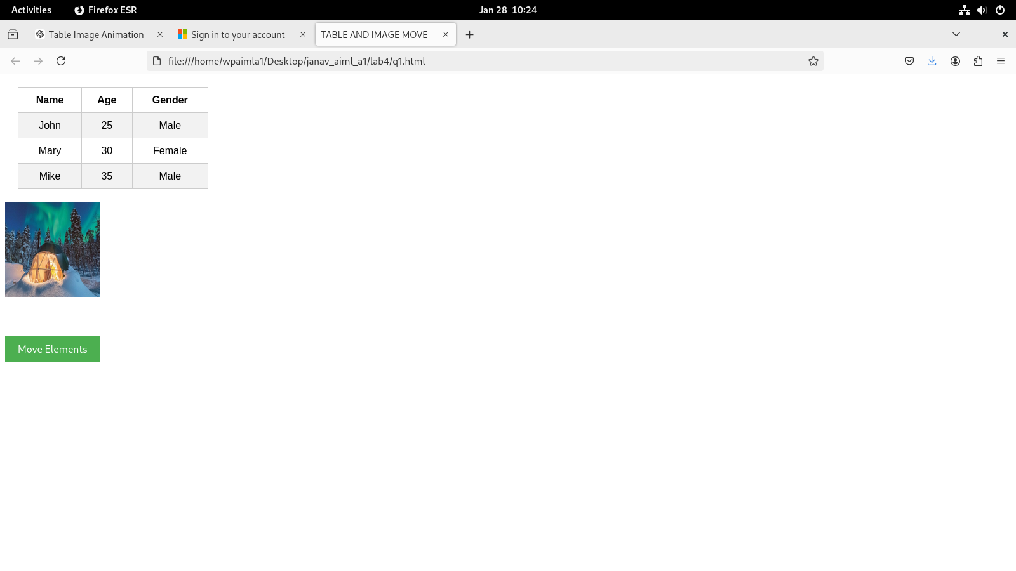
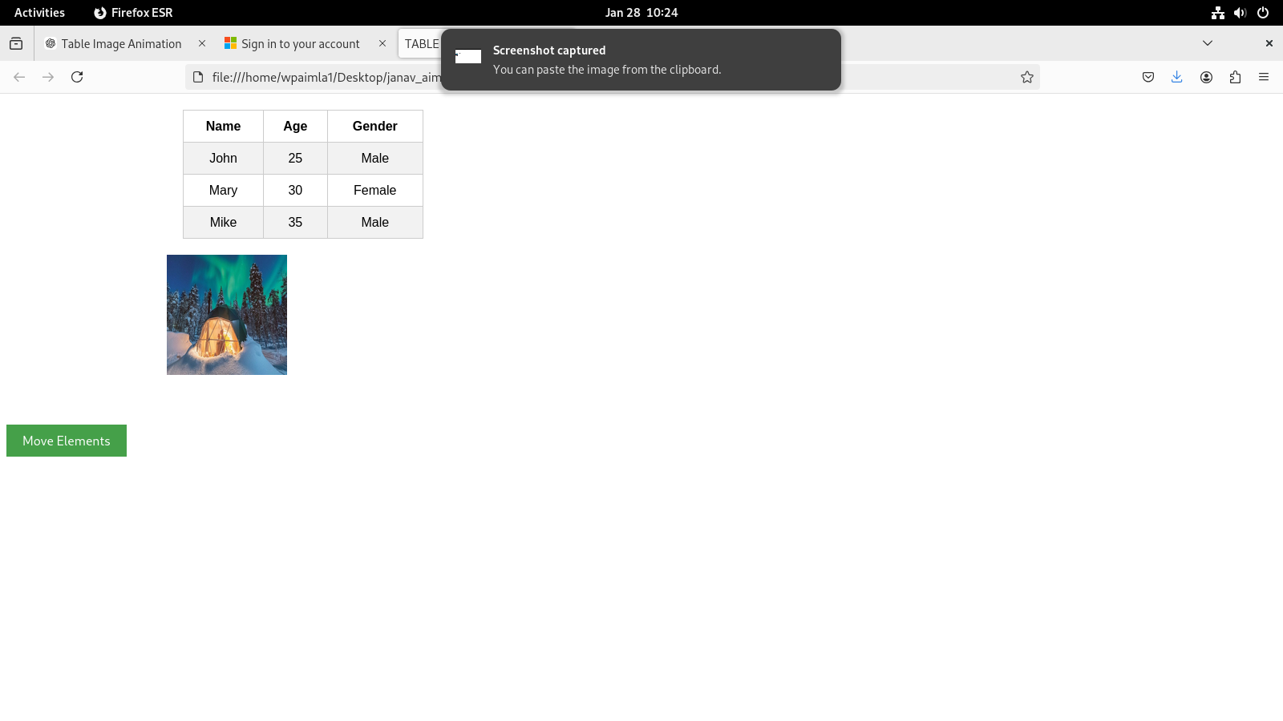

Q2 Design a calculator to perform basic arithmetic operations. Use textboxes and buttons
to design web page.
<!DOCTYPE html>
<html lang="en">
<head>
<meta charset="UTF-8">
<meta name="viewport" content="width=device-width, initial-scale=1.0">
<title>Simple Calculator</title>
<style>
body {
font-family: Arial, sans-serif;
display: flex;
justify-content: center;
align-items: center;
height: 100vh;
margin: 0;
background-color: #f4f4f4;
}
.calculator {
background-color: #fff;
padding: 20px;
border-radius: 10px;
box-shadow: 0 0 10px rgba(0, 0, 0, 0.1);
}
input[type="text"] {
width: 230px;
height: 40px;
font-size: 20px;
text-align: right;
margin-bottom: 20px;
padding: 5px;
}
.buttons {
display: grid;
grid-template-columns: repeat(4, 1fr);
gap: 10px;
}
button {
font-size: 20px;
padding: 20px;
background-color: #4CAF50;
color: white;
border: none;
border-radius: 5px;
cursor: pointer;
transition: background-color 0.3s;
}
button:hover {
background-color: #45a049;
}
button:active {
background-color: #388e3c;
}
</style>
</head>
<body>
<div class="calculator">
<input type="text" id="display" disabled>
<div class="buttons">
<button class="btn" data-value="7">7</button>
<button class="btn" data-value="8">8</button>
<button class="btn" data-value="9">9</button>
<button class="btn operator" data-value="/">&#247;</button>
<button class="btn" data-value="4">4</button>
<button class="btn" data-value="5">5</button>
<button class="btn" data-value="6">6</button>
<button class="btn operator" data-value="*">&times;</button>
<button class="btn" data-value="1">1</button>
<button class="btn" data-value="2">2</button>
<button class="btn" data-value="3">3</button>
<button class="btn operator" data-value="-">-</button>
<button class="btn" data-value="0">0</button>
<button class="btn" data-value=".">.</button>
<button class="btn equal" data-value="=">=</button>
<button class="btn operator" data-value="+">+</button>
<button class="btn clear" data-value="C">C</button>
</div>
</div>
<script src="https://code.jquery.com/jquery-3.6.0.min.js"></script>
<script>
$(document).ready(function() {
let cur = '';
let prev = '';
let op = '';
let res = false;
function update(value) {
$('#display').val(value);
}
$('.btn').click(function() {
const val = $(this).data('value');
if (val === 'C') {
cur = '';
prev = '';
op = '';
update('');
} else if (val === '=') {
if (prev && op) {
cur = eval(prev + op + cur).toString();
update(cur);
res = true;
}
} else if ($(this).hasClass('operator')) {
if (res) {
prev = cur;
res = false;
} else {
prev = cur;
}
op = val;
cur = '';
} else {
if (res) {
cur = val;
res = false;
} else {
cur += val;
}
update(cur);
}
});
});
</script>
</body>
</html>
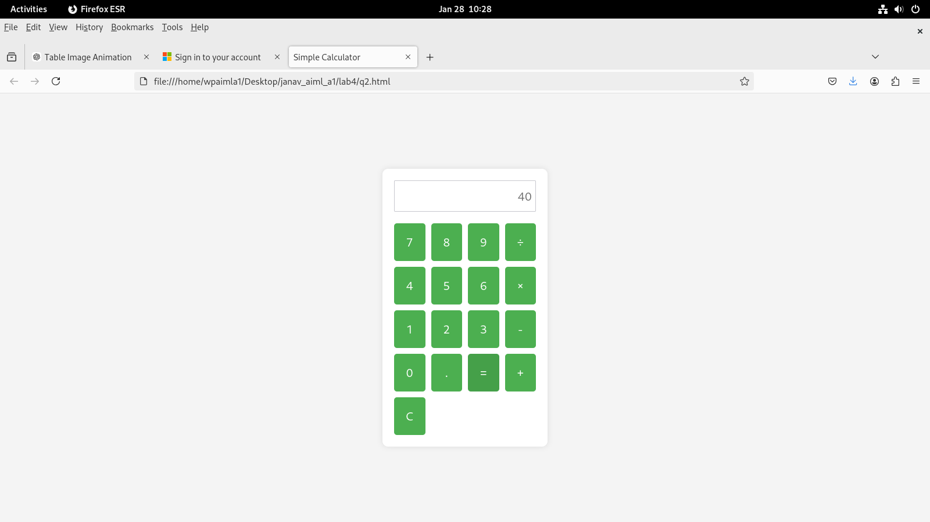

Q3 Create a web page to design a birthday card shown below.
<!DOCTYPE html>
<html lang="en">
<head>
<meta charset="UTF-8">
<meta name="viewport" content="width=device-width, initial-scale=1.0">
<title>Birthday Card Generator</title>
<style>
body {
font-family: Arial, sans-serif;
display: flex;
justify-content: space-between;
padding: 20px;
background-color: #f9f9f9;
}
.customizations {
max-width: 300px;
}
.card {
width: 400px;
height: 400px;
border: 2px solid #000;
padding: 20px;
box-sizing: border-box;
background-color: #ffffff;
position: relative;
display: flex;
flex-direction: column;
align-items: center;
text-align: center;
}
.card img {
width: 250px;
margin-top: 20px;
}
#greetingTextOutput {
margin-top: 10px;
font-weight: bold;
}
label {
margin-bottom: 10px;
display: block;
}
select, input, button {
width: 100%;
padding: 8px;
margin-bottom: 10px;
border-radius: 5px;
border: 1px solid #ccc;
}
.card-output {
border-radius: 10px;
background-color: #ffffff;
padding: 20px;
box-sizing: border-box;
text-align: center;
}
.card-output p {
margin: 10px 0;
font-size: 20px;
}
button {
background-color: #4CAF50;
color: white;
font-size: 16px;
cursor: pointer;
border: none;
}
button:hover {
background-color: #45a049;
}
</style>
</head>
<body>

<div class="customizations">
<h3>Customize Your Card</h3>
<label for="bgColor">Choose a Background Color:</label>
<select id="bgColor">
<option value="lightblue">Light Blue</option>
<option value="lightpink">Light Pink</option>
<option value="lightgreen">Light Green</option>
<option value="lightyellow">Light Yellow</option>
<option value="lightgray">Light Gray</option>
</select>

<label for="font">Choose a Font:</label>
<select id="font">
<option value="Arial, sans-serif">Arial</option>
<option value="Georgia, serif">Georgia</option>
<option value="Courier New, monospace">Courier New</option>
<option value="Tahoma, sans-serif">Tahoma</option>
<option value="Times New Roman, serif">Times New Roman</option>
</select>

<label for="fontSize">Specify Font Size (px):</label>
<input type="number" id="fontSize" value="20">

<label>Choose a Border Style:</label>
<label><input type="radio" name="borderStyle" value="none" checked> None</label>
<label><input type="radio" name="borderStyle" value="double"> Double</label>
<label><input type="radio" name="borderStyle" value="solid"> Solid</label>

<label for="addPicture">
<input type="checkbox" id="addPicture"> Add Default Picture
</label>

<label for="greetingText">Enter Greeting Text:</label>
<input type="text" id="greetingText" placeholder="Happy Birthday!">

<button id="updateCard">Update</button>
</div>

<div class="card-output">
<h3>Your Custom Birthday Card</h3>
<div class="card" id="birthdayCard">
<p id="greetingTextOutput">Happy Birthday!</p>
<img src="/home/wpaimla1/Desktop/janav_aiml_a1/lab4/q3.jpeg" alt="Birthday Image" id="birthdayImage" style="display: none;">
</div>
</div>

<script src="https://code.jquery.com/jquery-3.6.0.min.js"></script>
<script>
$(document).ready(function() {
$('#updateCard').click(function() {
var bgColor = $('#bgColor').val();
var font = $('#font').val();
var fontSize = $('#fontSize').val() + 'px';
var borderStyle = $("input[name='borderStyle']:checked").val();
var greetingText = $('#greetingText').val();
var addPicture = $('#addPicture').prop('checked');
$('#birthdayCard').css({
'background-color': bgColor,
'font-family': font,
'font-size': fontSize,
'border': borderStyle === 'none' ? 'none' : (borderStyle + ' 5px')
});

$('#greetingTextOutput').text(greetingText);

if (addPicture) {
$('#birthdayImage').show();
} else {
$('#birthdayImage').hide();
}
});
});
</script>

</body>
</html>
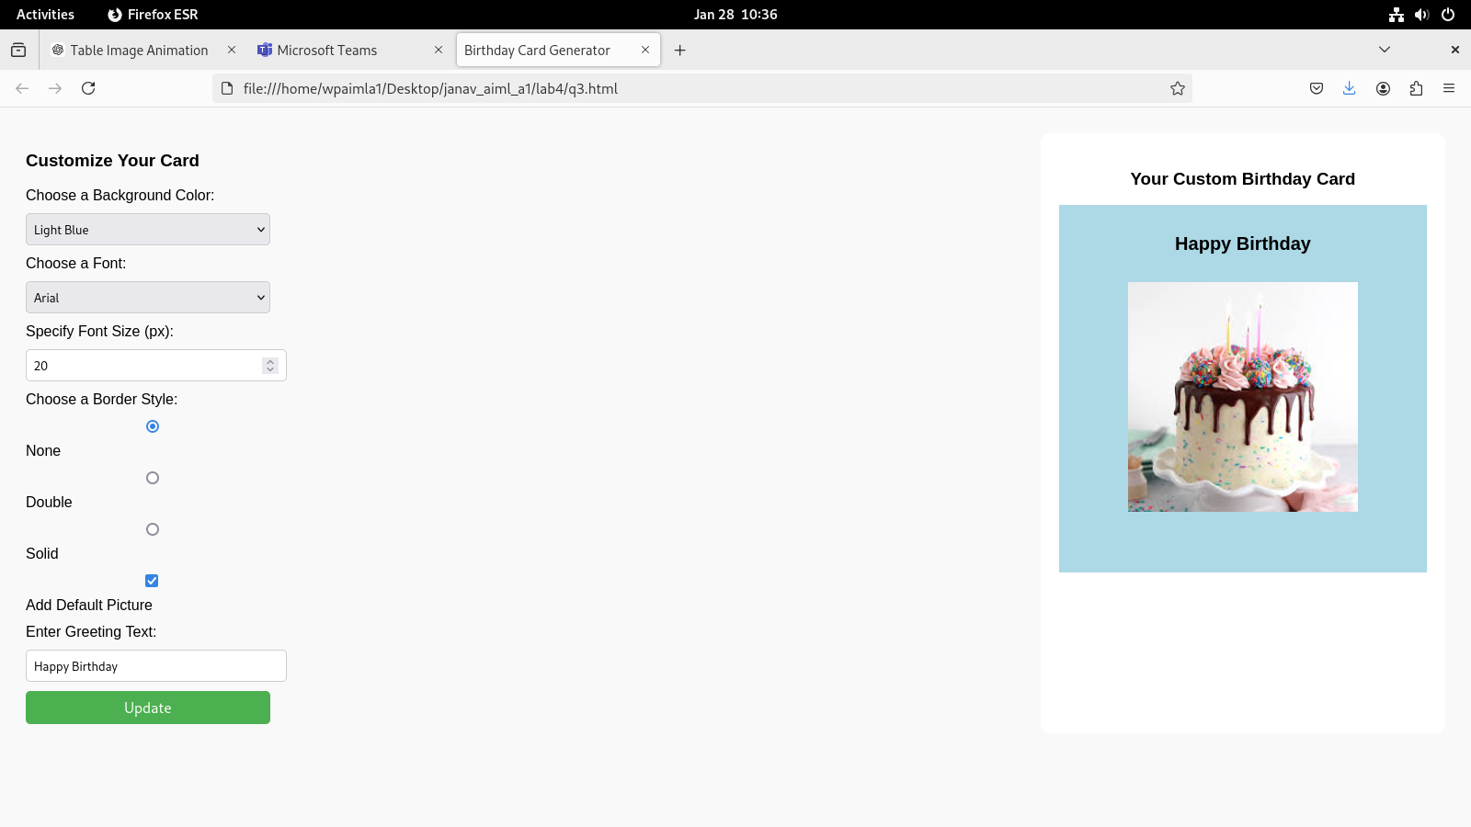

Q4 Design a webpage. The page contains:
• Dropdown list with HP, Nokia, Samsung, Motorola, Apple as items.
• Checkbox with Mobile and Laptop as items. Textbox where you enter quantity.
• There is a button with text as ‘Produce Bill’.
On Clicking Produce Bill button, alert should be displayed with total amount.
<!DOCTYPE html>
<html lang="en">
<head>
<meta charset="UTF-8">
<meta name="viewport" content="width=device-width, initial-scale=1.0">
<title>Product Bill</title>
<style>
body {
font-family: Arial, sans-serif;
padding: 20px;
background-color: #f4f4f4;
}
.container {
background-color: #fff;
padding: 20px;
border-radius: 8px;
box-shadow: 0 0 10px rgba(0, 0, 0, 0.1);
max-width: 400px;
margin: 0 auto;
}
select, input, button {
width: 100%;
padding: 10px;
margin: 10px 0;
border-radius: 5px;
border: 1px solid #ccc;
}
button {
background-color: #4CAF50;
color: white;
font-size: 16px;
cursor: pointer;
border: none;
}
button:hover {
background-color: #45a049;
}
.checkbox-group {
display: flex;
justify-content: space-between;
}
</style>
</head>
<body>
<div class="container">
<h2>Product Bill</h2>
<label for="product">Choose a product:</label>
<select id="product">
<option value="HP">HP</option>
<option value="Nokia">Nokia</option>
<option value="Samsung">Samsung</option>
<option value="Motorola">Motorola</option>
<option value="Apple">Apple</option>
</select>
<label>Choose type:</label>
<div class="checkbox-group">
<label>
<input type="checkbox" id="mobile"> Mobile
</label>
<label>
<input type="checkbox" id="laptop"> Laptop
</label>
</div>
<label for="quantity">Enter Quantity:</label>
<input type="number" id="quantity" min="1" value="1">
<button id="produceBill">Produce Bill</button>
</div>
<script src="https://code.jquery.com/jquery-3.6.0.min.js"></script>
<script>
$(document).ready(function() {
$('#produceBill').click(function() {
var product = $('#product').val();
var mobileChecked = $('#mobile').prop('checked');
var laptopChecked = $('#laptop').prop('checked');
var quantity = $('#quantity').val();
var totalAmount = 0;
var prices = {
HP: { mobile: 300, laptop: 800 },
Nokia: { mobile: 250, laptop: 700 },
Samsung: { mobile: 350, laptop: 900 },
Motorola: { mobile: 200, laptop: 650 },
Apple: { mobile: 500, laptop: 1200 }
};
if (mobileChecked) {
totalAmount += prices[product].mobile * quantity;
}
if (laptopChecked) {
totalAmount += prices[product].laptop * quantity;
}
if (totalAmount > 0) {
alert('Total Bill: $' + totalAmount);
} else {
alert('Please select at least one item to calculate the bill.');
}
});
});
</script>

</body>
</html>
